**INFSCI1073/TELCOM2727 Final Project (Pharmacy)**

**Sourabh Acharya (**[**SOA25@pitt.edu**](mailto:SOA25@pitt.edu)**), Arun Kumar Rajendra Kumar (**[ARR105@pitt.edu](mailto:ARR105@pitt.edu)**)**

**Date: April 27, 2017**

**GetWell App**

**Documentation:**

Our project contains an APK file, Prezi slides (for Mac and Windows), www folder (Phonegap).

We faced the following challenges in the project:

1. Since there was no server available, we could not retrieve the patient’s data from a central database. Also, we could not post the medication checks to the server once the patient approved the regimen.
2. We could not make any API calls.
3. We could create API key.
4. Phonegap server could not set up the C-class IPv4 addresses for hosting our application.
5. Implementing a single page architecture.

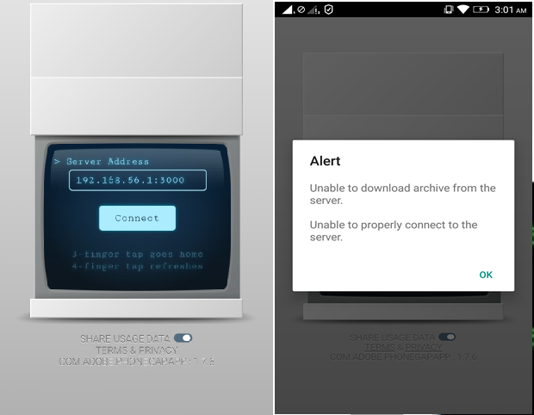

Figure 1: Phonegap server issue

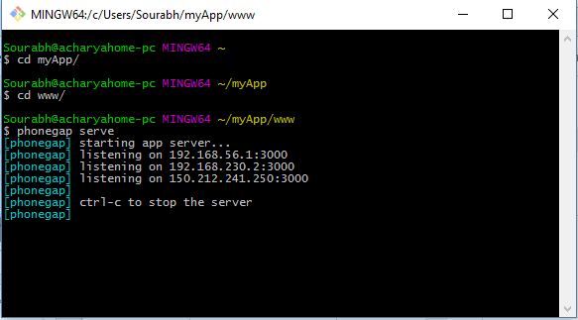

Figure 2: Phonegap CLI

**Limitations:**

User needs to have signed up a Google account in order to register his medications as events during the week being tracked. Since, we are building an Android app which would require the user to ultimately download the APK from the Google Play Store, we expect users to be familiar with other Google Apps such as GCalendar and Gmail.

**Features:**

1. Push notification implemented using phonegap
2. Medication tracked using Google Calendar.
3. Survey taken by non-adhering patients.
4. Report sent to localhost.