LIBRARY MANAGEMENT APPLICATION

Capstone Project Report submitted in partial fulfilment of the requirements for the award of the degree of
Masters of Science in Data Science (M.Sc.)



SUBMITTED BY:
SOURABH BARALA (23MSD7044)

Under the Guidance of:
Prof. A. Manimaran

VIT-AP University
Andhra Pradesh

ACKNOWLEDGEMENT
I would like to thank Prof. A. Manimaran for his guidance, support, and patience during the completion of this project.

INDEX
1. Problem Statement.................................................................1
2. Project Description.................................................................2
3. Source Code...........................................................................4
4. Result and Discussion............................................................5
5. Snapshot.................................................................................6
6. Conclusion.............................................................................10
7. Future Direction.....................................................................11

Problem Statement

For the smooth functioning of college libraries, there is always a need for a way to manage library-related data, for example, data on different books available, number of copies available, issue records etc.
These records should be stored in a way such that they are easy to access, read and update, moreover, records should not get corrupted with time and should not leak, hence should only be accessed by the admin.

Project Description

This project aims to build a Library Management Application which allows the handling of library data efficiently and in a user-friendly way.
The application handles two types of data:
- Student/Faculty data
- Book data

Application Aim and Features

- The application has two windows, one for students/faculty, and another one for books.
- Admin can switch between two windows with the help of buttons.
- On the student/Faculty window, a person's record can be fetched by entering the ID of the person.
- A person's record contains his/her ID, name, phone number, hosteler status, and book issue data.
- If a student/faculty is already registered, then books issue data, and personal data can be updated or deleted.
- The application has buttons: for adding students/ faculty, updating/deleting current records and issuing/collecting books.
- Only two books can be issued by a person (student/faculty) at a time.
- Personal details, book's ISBN and date is recorded while issuing a book.
- In the book window, the admin can enter a book's ISBN to check if a book is available in the library.
- The book's details can be updated or deleted if a book is available.
- Book details contain the book's ISBN, title, author, publication, total copies, and available copies.
- If a book is not available, then details can be added with the number of copies.

Source Code

Source code can be found here:

Result and Discussion

Fundamental library management functions like entering and updating student/faculty or book details and issue details can be successfully performed by the application.
Some of the challenges faced during development were:
- Managing components of each window.
- Since the application has many buttons and functions, there were frequent bugs in the code.
- Miss alignment of text.
- Data type error on entering data from the database.
- Loop holes which could lead to data corruption during application use were very frequent.

Snapshot

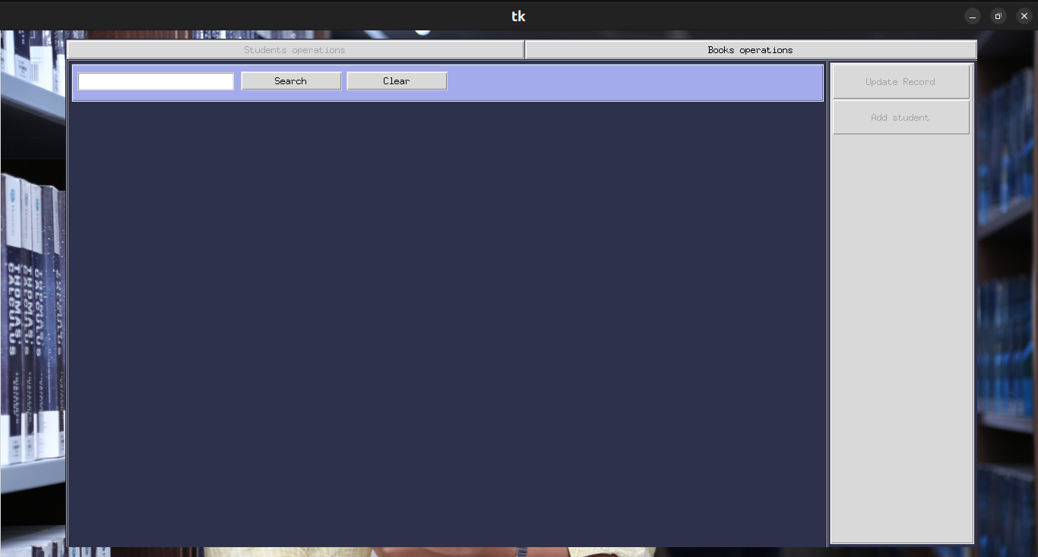
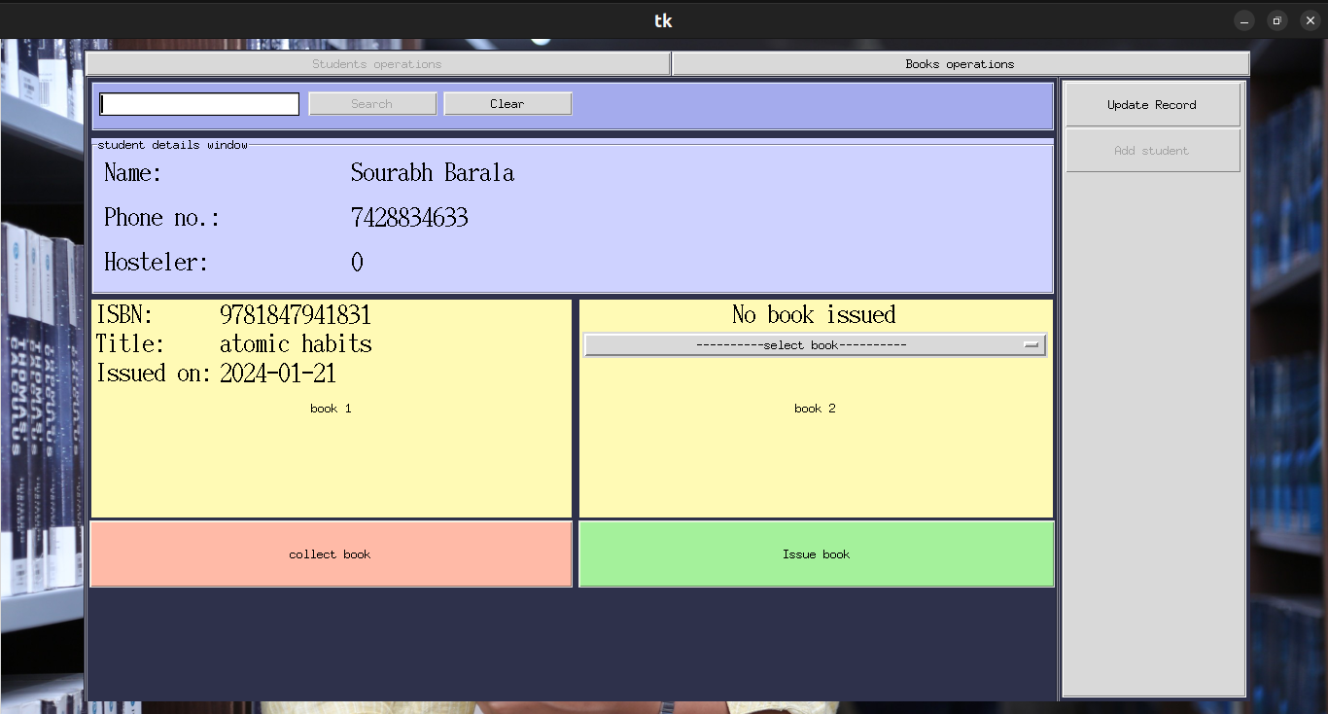
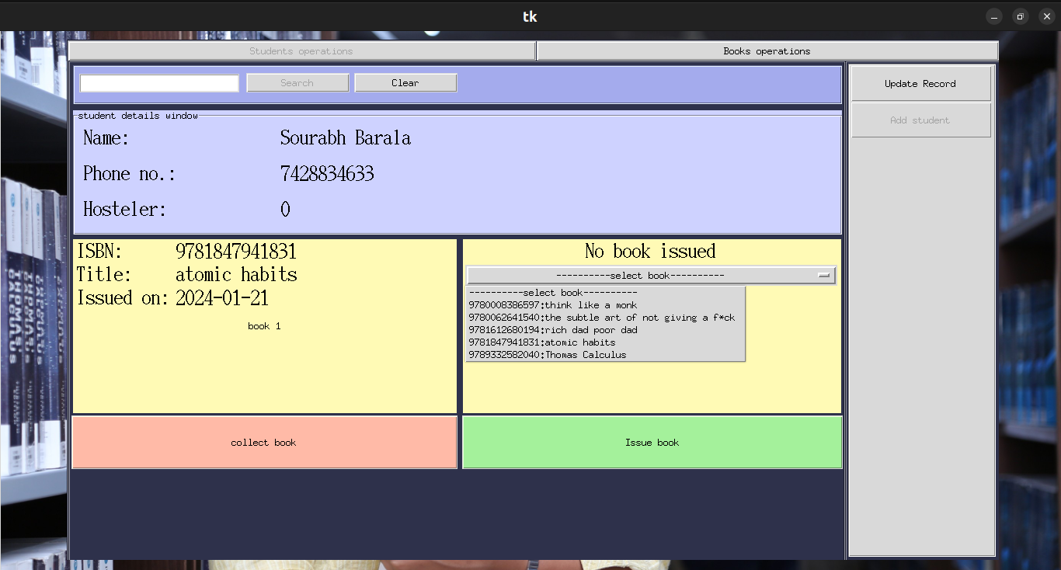
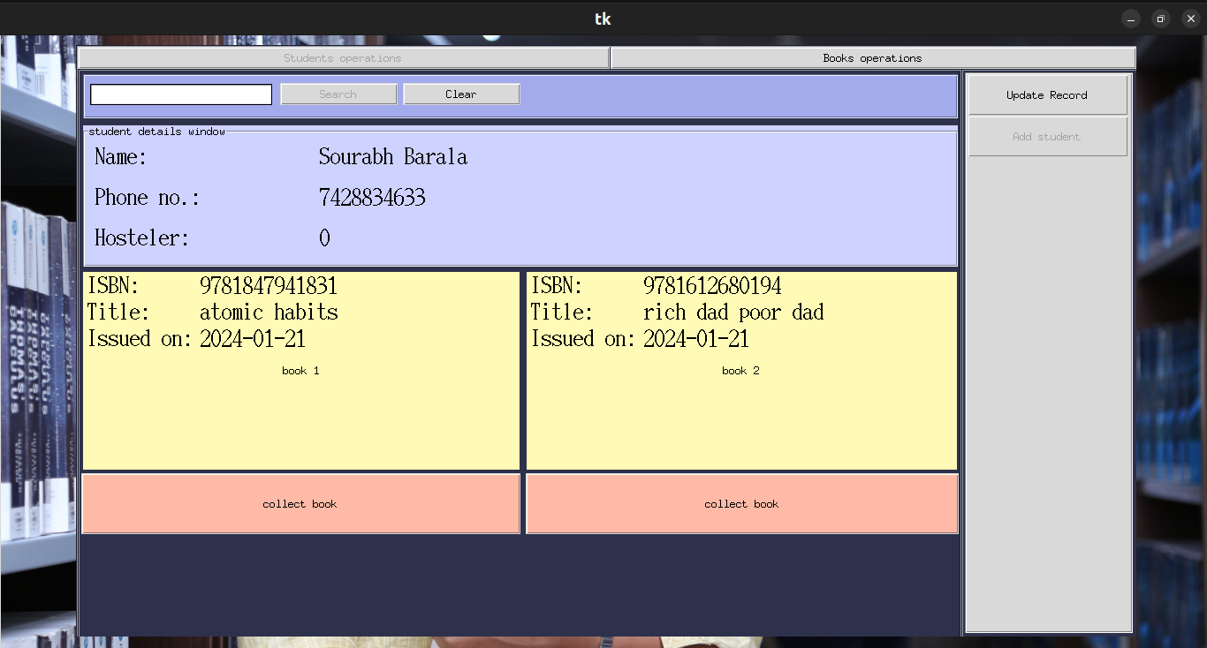

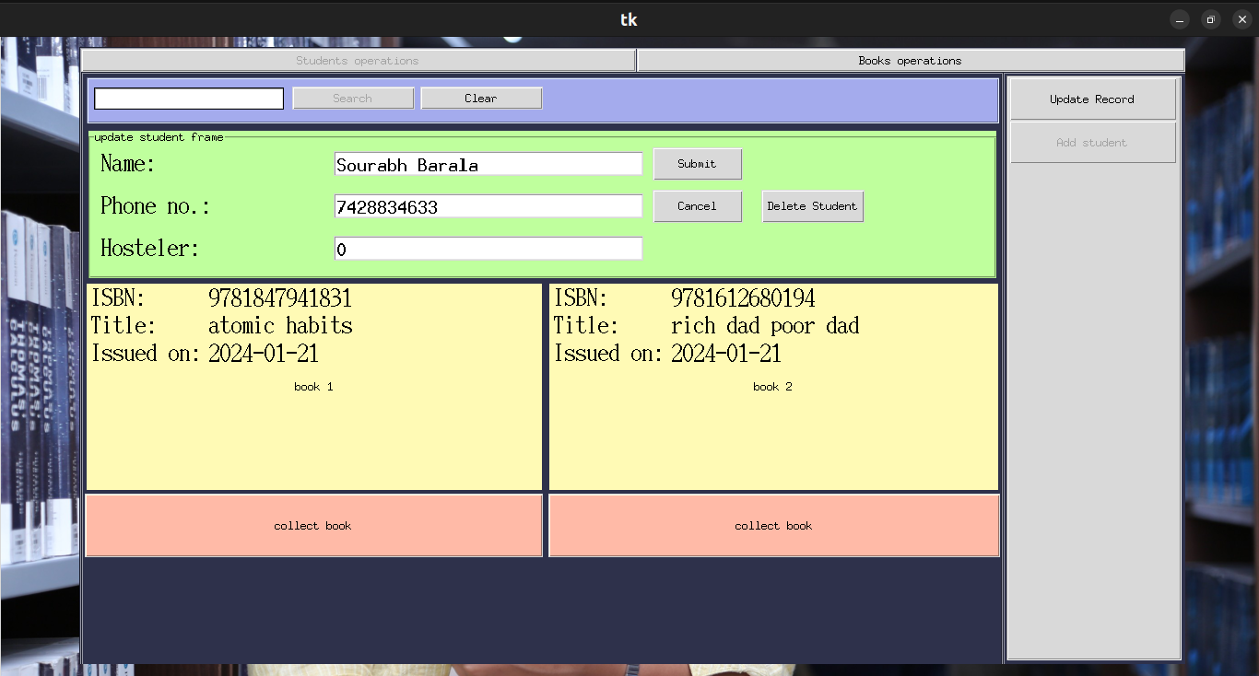
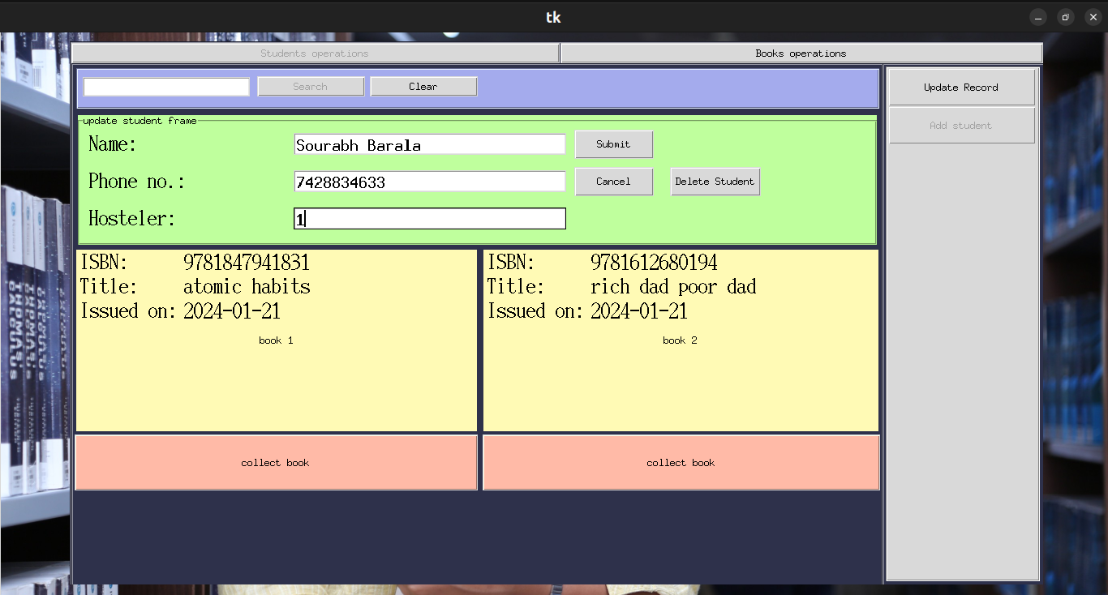
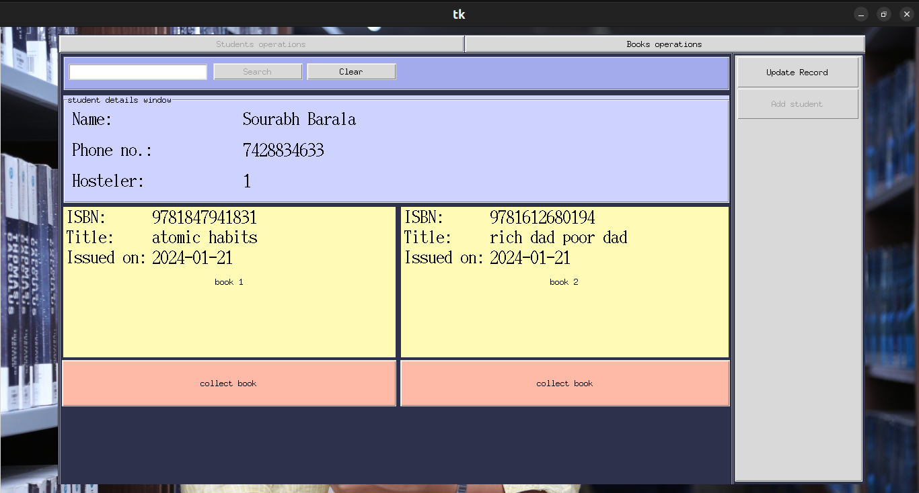

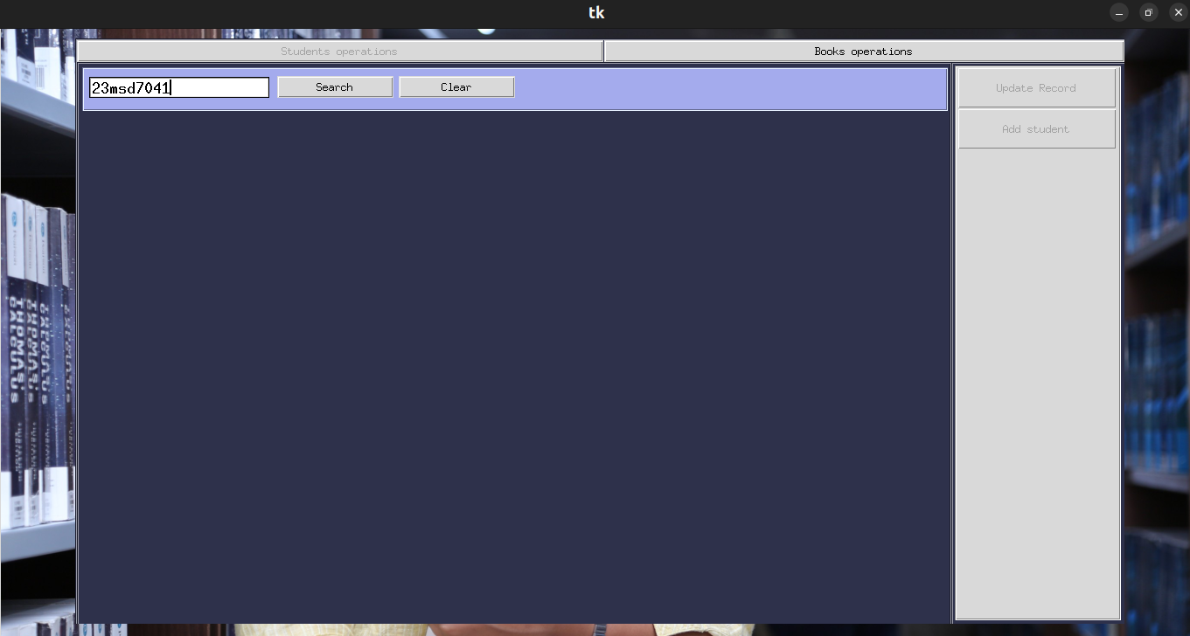
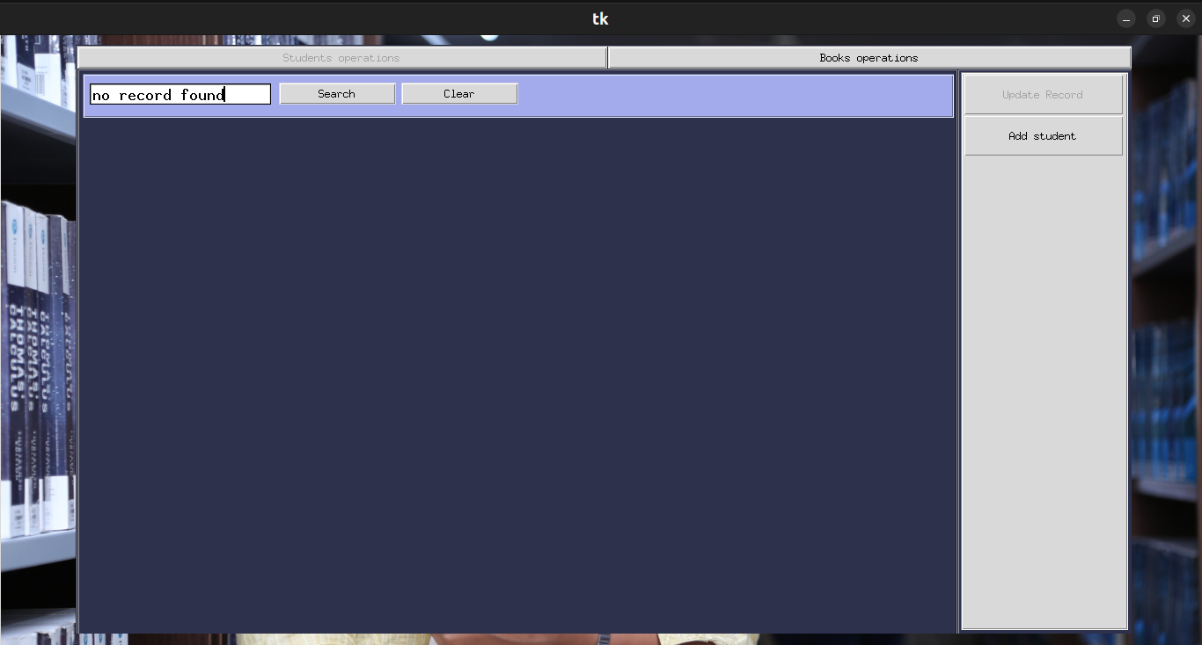
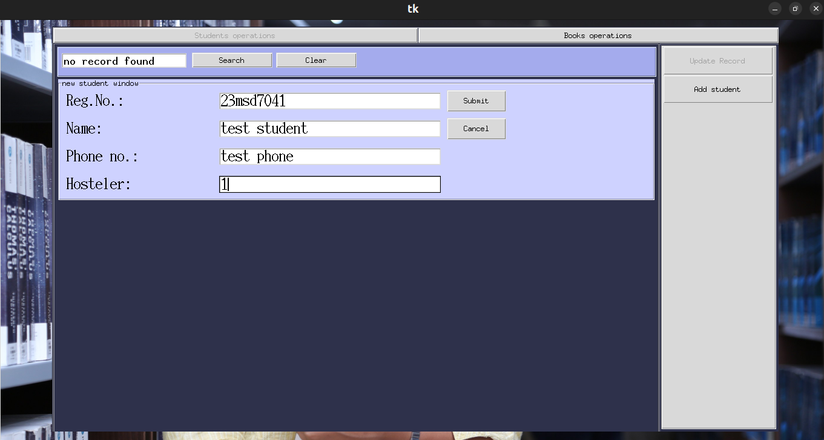
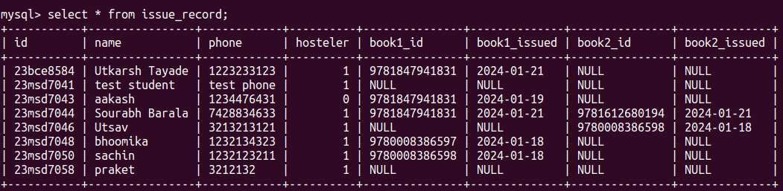

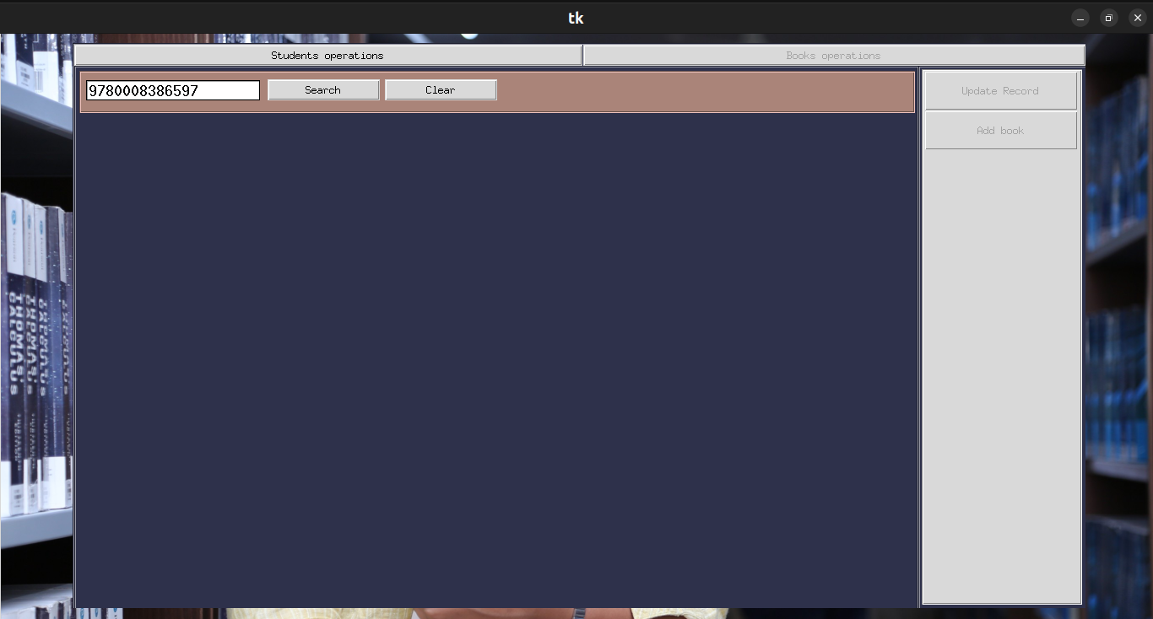
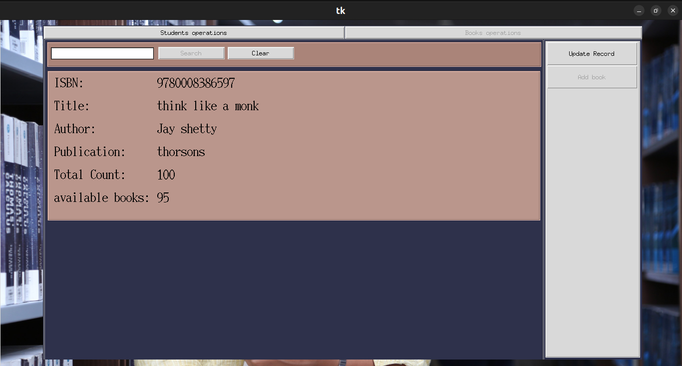
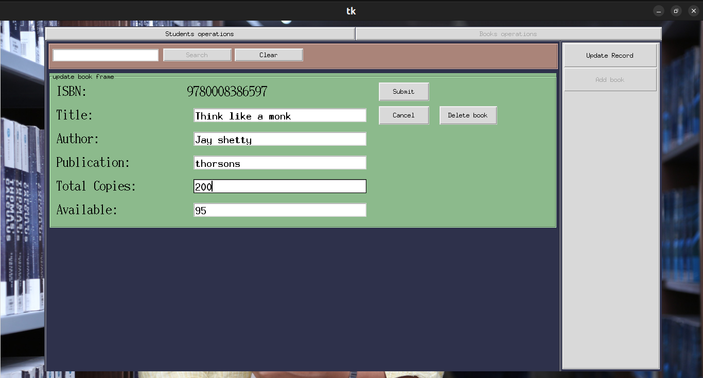
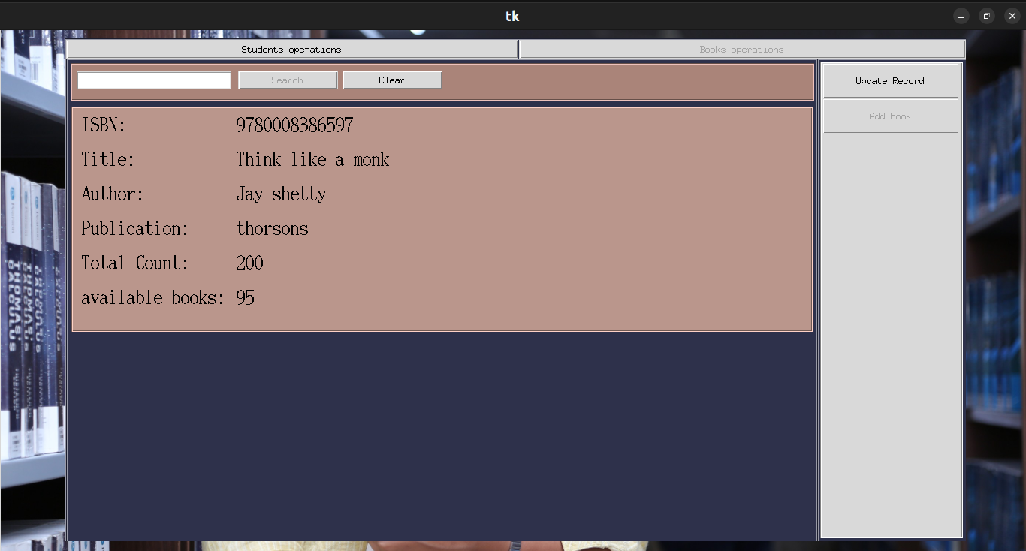
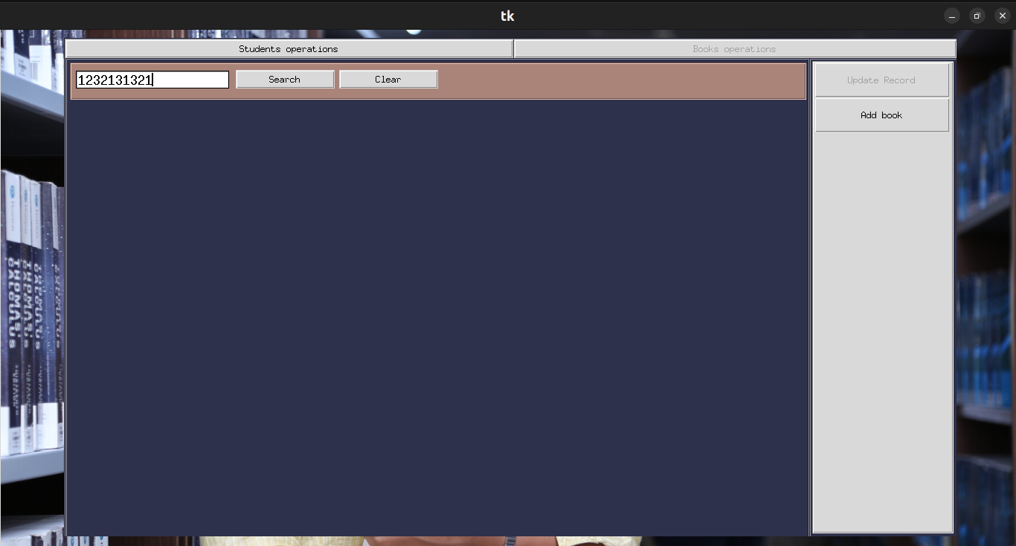
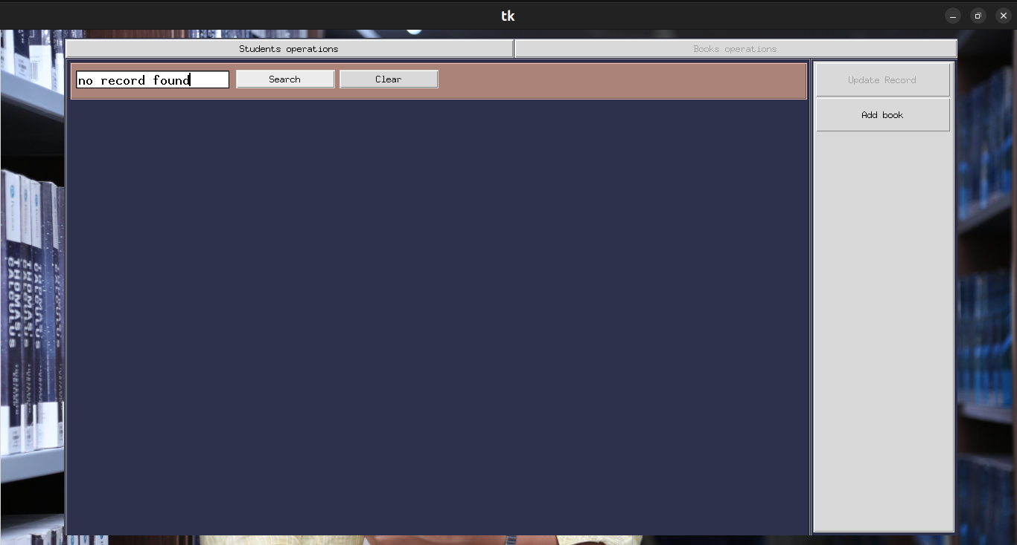

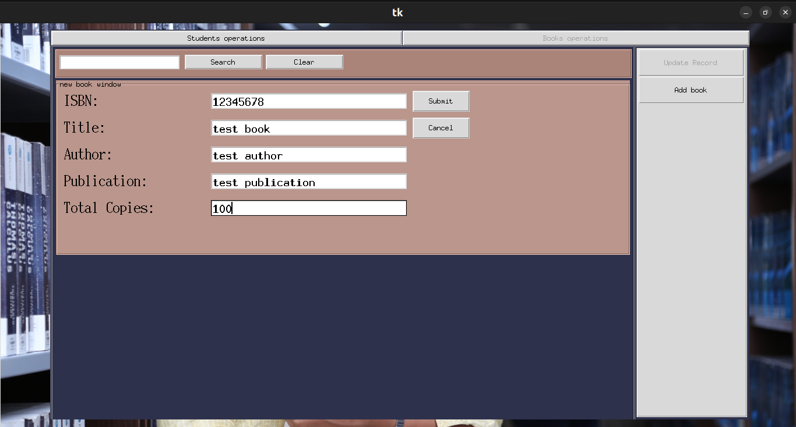
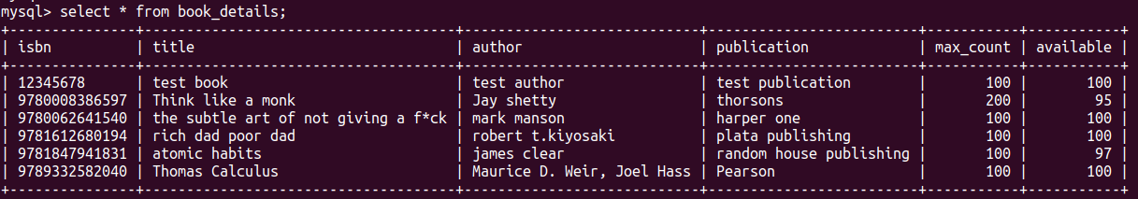

Conclusion

Library management at first might seem like a small project, but it is a project that demands creativity. A developer can make it as complex project as he wishes to.
While developing this application, the lesson I learned is using classes and objects with the GUI library could have made managing components easier.
This application can store and present data and let users interact with it in a user-friendly way. Data is stored in a way such it cannot be corrupted and can only be accessed by admin.
Some of the limitations of this application are:
- Application only enters issue data of two books.
- The application doesn't contain a table to show all available books.
- While entering issue data, a book must be chosen from the drop-down menu only, there is no search book option for issuing.

Future Direction

While the application performs basic library management tasks, there is room for improvement.
- The user interface can be improved.
- A feature to add issue data of more than one book can be added.
- A feature for finding late submissions of books can be added.
- Graphs can be included to give a better visual representation of data.
- A feature for getting an alert when a book is about to be out of stock can be added.

