NCMS IoT Platform
Deployment & Handover Guide
Everything needed to install, configure, and run the application on your own server
Version 1.0 | 2026

Table of Contents

1. Introduction
This document is a complete handover guide for the NCMS platform. It gives you everything needed to install the application on your own server, configure it, and get it running — without requiring further involvement from the development team.
NCMS is a device management platform. It lets administrators register devices, monitor which ones are online, and roll out firmware, application, and configuration updates to a fleet of devices from a single web application.
The application is made up of two components that are installed and run together:
Component | What it does
API | Handles device registration and data requests.
Host | The web administration interface your team will use, and the connection to the messaging system that talks to devices.

Follow the sections in order. Each one builds on the previous step, ending with a working, verified installation and a summary checklist for your records.

2. Prerequisites
Before you begin, make sure you have the following in place:
- A Linux server (Ubuntu/Debian recommended) with administrator (sudo) access.
- The .NET 10 runtime installed on the server.
- A PostgreSQL database (installed on the server, or a managed/remote database service).
- Nginx, used as the reverse proxy in front of the application.
- An MQTT message broker reachable by both the server and your devices (see Section 8).
- A domain name pointed at the server, and optionally certbot for a free TLS certificate.
- A way to copy files onto the server, such as scp, rsync, or an equivalent file transfer tool.

2.1 Install the runtime and database
# .NET 10 runtime
sudo apt-get update && sudo apt-get install -y aspnetcore-runtime-10.0
dotnet --info # confirm the runtime is installed

# PostgreSQL (skip if using a managed/remote database)
sudo apt-get install -y postgresql
sudo -u postgres psql -c "CREATE DATABASE ncms_iot;"
sudo -u postgres psql -c "CREATE USER ncms WITH PASSWORD 'CHANGE_ME';"
sudo -u postgres psql -c "GRANT ALL PRIVILEGES ON DATABASE ncms_iot TO ncms;"

2.2 Create a service account and folders
The application should not run as the root user. Create a dedicated, low-privilege account and the folders the application will use:
sudo useradd --system --no-create-home --shell /usr/sbin/nologin ncms
sudo mkdir -p /var/www/ncms/api /var/www/ncms/host /etc/ncms/pki /var/lib/ncms/files
sudo chown -R ncms:ncms /var/www/ncms /var/lib/ncms/files
sudo chown -R ncms:ncms /etc/ncms/pki && sudo chmod 750 /etc/ncms/pki
sudo apt-get install -y nginx

3. Build the Application
Build both components in Release mode. This produces a self-contained set of files for each component, ready to run on the server (the server only needs the .NET runtime installed, not the full development toolchain).
dotnet publish NCMS.IoT.Api/NCMS.IoT.Api.csproj -c Release -o build-output/api
dotnet publish NCMS.IoT.Host/NCMS.IoT.Host.csproj -c Release -o build-output/host
This produces two sets of files — build-output/api and build-output/host — containing everything needed to run each component.

4. Copy the Application Files to the Server
Copy each set of build files to its matching location on the server. This step is repeated every time a new version is deployed (see Section 13).
scp -r build-output/api/* user@server:/var/www/ncms/api/
scp -r build-output/host/* user@server:/var/www/ncms/host/
Note: rsync only copies changed files and is faster for repeat deployments, for example: rsync -az build-output/api/ user@server:/var/www/ncms/api/
After copying, make sure the files on the server are owned by the service account created in Section 2.2:
sudo chown -R ncms:ncms /var/www/ncms/api /var/www/ncms/host

4.1 Where things live on the server
Location | Contents
/var/www/ncms/api | API application files.
/var/www/ncms/host | Host (web interface) application files.
/etc/ncms/pki | Shared security certificate used to identify devices (Section 7).
/var/lib/ncms/files | Uploaded firmware and configuration files, shared by both components.

5. Database Setup
The application creates its own database tables and a default administrator account the first time it runs. To make the first start smooth and predictable, run the included database setup tool once beforehand:
cd /var/www/ncms/api
sudo -u ncms dotnet NCMS.IoT.DbMigrator.dll
This prepares the database and creates the default administrator account without starting the full application.
The default administrator account created for first login is:
Field | Value
Email | admin@ncms.local
Password | Admin@12345

Important: This account and password are the same for every installation of this application, so they must be changed immediately after your first login. See Section 6 of the User Manual for how to change a password, or create a new administrator account and disable this one.

6. Application Configuration
Each component reads its settings from a file named appsettings.Production.json, placed alongside its application files. Create this file on the server for each component, using the content below as a starting point.

6.1 /var/www/ncms/api/appsettings.Production.json
{
"ConnectionStrings": {
"IoTDatabase": "Host=127.0.0.1;Port=5432;Database=ncms_iot;Username=ncms;Password=CHANGE_ME"
},
"RootCa": {
"CertificatePath": "/etc/ncms/pki/ca.crt",
"PrivateKeyPath": "/etc/ncms/pki/ca.key",
"IssuerOrganization": "NCMS IoT Platform"
},
"Ztp": {
"CertRenewalUrl": "https://your-domain.example.com/api/v1/certificates/renew",
"TelemetryIntervalSeconds": 60,
"StatusIntervalSeconds": 30,
"CertRenewalThresholdDays": 90,
"Broker": {
"Host": "CHANGE_ME_BROKER_HOST",
"Port": 8883,
"KeepAliveSeconds": 60,
"SessionExpirySeconds": 300
}
},
"FileStorage": {
"StoragePath": "/var/lib/ncms/files",
"PublicBaseUrl": "https://your-domain.example.com",
"FirmwareUrlSegment": "firmware-files",
"ConfigUrlSegment": "config-files"
}
}

6.2 /var/www/ncms/host/appsettings.Production.json
{
"ConnectionStrings": {
"IoTDatabase": "Host=127.0.0.1;Port=5432;Database=ncms_iot;Username=ncms;Password=CHANGE_ME"
},
"RootCa": {
"CertificatePath": "/etc/ncms/pki/ca.crt",
"PrivateKeyPath": "/etc/ncms/pki/ca.key",
"IssuerOrganization": "NCMS IoT Platform"
},
"Ztp": {
"CertRenewalUrl": "https://your-domain.example.com/api/v1/certificates/renew",
"TelemetryIntervalSeconds": 60,
"StatusIntervalSeconds": 30,
"CertRenewalThresholdDays": 90,
"Broker": {
"Host": "CHANGE_ME_BROKER_HOST",
"Port": 8883,
"KeepAliveSeconds": 60,
"SessionExpirySeconds": 300
}
},
"DevicePresence": {
"SweepIntervalSeconds": 30,
"OfflineAfterMissedHeartbeats": 3
},
"Mqtt": {
"BrokerHost": "CHANGE_ME_BROKER_HOST",
"BrokerPort": 8883,
"ClientId": "ncms-client",
"Username": "ncms-client",
"KeepAliveSeconds": 60,
"ReconnectDelaySeconds": 5,
"MaxPendingMessages": 1000,
"Topics": {
"Telemetry": "d/+/telemetry",
"Heartbeat": "d/+/heartbeat",
"Events": "d/+/events",
"OtaStatus": "d/+/ota/res"
}
},
"FileStorage": {
"StoragePath": "/var/lib/ncms/files",
"PublicBaseUrl": "https://your-domain.example.com",
"FirmwareUrlSegment": "firmware-files",
"ConfigUrlSegment": "config-files"
}
}

6.3 Values you must update for your environment
Setting | What to change
ConnectionStrings → IoTDatabase (both files) | Replace CHANGE_ME with the database password set in Section 2.1. Update the host/port/database/username too if different from the defaults shown.
Ztp → CertRenewalUrl (both files) | Replace your-domain.example.com with your application’s real public web address.
Ztp → Broker → Host / Port (both files) | Replace CHANGE_ME_BROKER_HOST with the MQTT broker address set up in Section 8.
Mqtt → BrokerHost / BrokerPort (Host file only) | The same broker address and port, used by the Host to connect to the broker directly.
Mqtt → Username (Host file only) | The broker account created for the application in Section 8, if different from the default shown.
FileStorage → PublicBaseUrl (both files) | Replace your-domain.example.com with your application’s real public web address.

sudo chown ncms:ncms /var/www/ncms/api/appsettings.Production.json /var/www/ncms/host/appsettings.Production.json
sudo chmod 640 /var/www/ncms/api/appsettings.Production.json /var/www/ncms/host/appsettings.Production.json
Note: The database connection, certificate paths, file storage path, and public web address must be identical in both files, or devices and file downloads may stop working correctly.

7. Security Certificates
The application uses a security certificate to establish trusted identities for devices. Both components must read the exact same certificate files, from the location set in Section 6.
- Bring your own certificate: place your certificate and its private key in that location, then restrict access to the private key to the service account only.
- Let the application generate one: leave the location empty and the application creates a self-signed certificate automatically the first time it starts. Start only one of the two components first so they don’t each generate their own certificate — the second component will then find and reuse the one already created.
Note: Keep a secure backup of the certificate’s private key, separate from your regular data backups. Losing it prevents issuing or renewing device certificates.

8. MQTT Broker Setup
NCMS uses an MQTT message broker to communicate with devices in the field — for status updates, and to deliver firmware, application, and configuration changes. Any standard MQTT broker can be used; this guide does not require a specific product. Use whichever broker your organization already standardizes on, or install a lightweight one if you do not have one yet.
- Install the broker on a server reachable by both the application and the devices in the field — the same server as the application, or a separate one.
- Configure it to accept connections over TLS rather than plain text, using a server certificate (commonly on port 8883), and disable any unencrypted listener reachable from outside the server.
- Create a dedicated broker account for the application with a strong password, and separate credentials for devices, following your broker’s device-provisioning approach.
- Apply access rules so each device can only use its own topics, while the application account has the broader access it needs.
- Enter the broker address, port, and application credentials into the Host’s settings file (Section 6.2). Only the Host connects to the broker — the API does not.
- Confirm the broker starts automatically on boot, and test that a connection with valid credentials succeeds while one without is refused.

9. Application Services
Register each component as a system service so it starts automatically and restarts if it stops unexpectedly. Create the following two files on the server.

9.1 /etc/systemd/system/ncms-api.service
[Unit]
Description=NCMS API
After=network.target

[Service]
WorkingDirectory=/var/www/ncms/api
ExecStart=/usr/bin/dotnet /var/www/ncms/api/NCMS.IoT.Api.dll
Restart=always
RestartSec=10
User=ncms
Environment=ASPNETCORE_ENVIRONMENT=Production
Environment=ASPNETCORE_URLS=http://127.0.0.1:5001

[Install]
WantedBy=multi-user.target

9.2 /etc/systemd/system/ncms-host.service
[Unit]
Description=NCMS Host (web interface)
After=network.target ncms-api.service

[Service]
WorkingDirectory=/var/www/ncms/host
ExecStart=/usr/bin/dotnet /var/www/ncms/host/NCMS.IoT.Host.dll
Restart=always
RestartSec=10
User=ncms
Environment=ASPNETCORE_ENVIRONMENT=Production
Environment=ASPNETCORE_URLS=http://127.0.0.1:5002

[Install]
WantedBy=multi-user.target

9.3 Start the services
sudo systemctl daemon-reload
sudo systemctl enable --now ncms-api
sudo systemctl enable --now ncms-host
sudo systemctl status ncms-api ncms-host
Note: Both components listen only on the server itself (127.0.0.1), so they are never reachable directly from outside — all external traffic must go through Nginx.

10. Reverse Proxy (Nginx)
Nginx sits in front of the application and routes incoming web traffic to the right place: the API, the administration interface, and device file downloads. Create the following configuration file, replacing the placeholder domain with your own.

10.1 /etc/nginx/sites-available/ncms.conf
server {
listen 80;
server_name your-domain.example.com;

client_max_body_size 512m;

location /api/v1/ {
proxy_pass http://127.0.0.1:5001/api/v1/;
proxy_set_header Host $host;
}

location /firmware-files/ {
alias /var/lib/ncms/files/;
}

location /config-files/ {
alias /var/lib/ncms/files/;
}

location / {
proxy_pass http://127.0.0.1:5002;
proxy_set_header Host $host;
proxy_set_header Upgrade $http_upgrade;
proxy_set_header Connection keep-alive;
}
}
sudo ln -s /etc/nginx/sites-available/ncms.conf /etc/nginx/sites-enabled/
sudo nginx -t && sudo systemctl reload nginx

10.2 TLS with Let’s Encrypt
sudo apt-get install -y certbot python3-certbot-nginx
sudo certbot --nginx -d your-domain.example.com

# Firewall: only allow web traffic (80/443) from outside
sudo ufw allow 'Nginx Full'

11. Security Checklist
Before handing the system over for regular use, work through the following:
- Change the password of the default administrator account created in Section 5 (or create a new administrator account and disable the default one).
- Confirm the public web address only works over TLS (https), not plain http.
- Confirm the firewall only allows web traffic (80/443) from outside — the application and database should not be reachable directly.
- Confirm the MQTT broker only accepts encrypted, authenticated connections (Section 8).
- Confirm configuration files and the certificate’s private key are only readable by the service account, not by other users on the server.
- Set up regular database backups, and store a copy of the certificate’s private key somewhere safe outside the server.
- Record the server’s access details (SSH access, database password, broker credentials) somewhere secure and share them only with people who need them.

12. Verification
Once everything is running, confirm the deployment works end to end:
- Open the application’s public web address in a browser — the sign-in page should load.
- Check the application logs (sudo journalctl -u ncms-host -f) to confirm it connected to the MQTT broker.
- Sign in with the administrator account and confirm the Dashboard shows the expected device count.
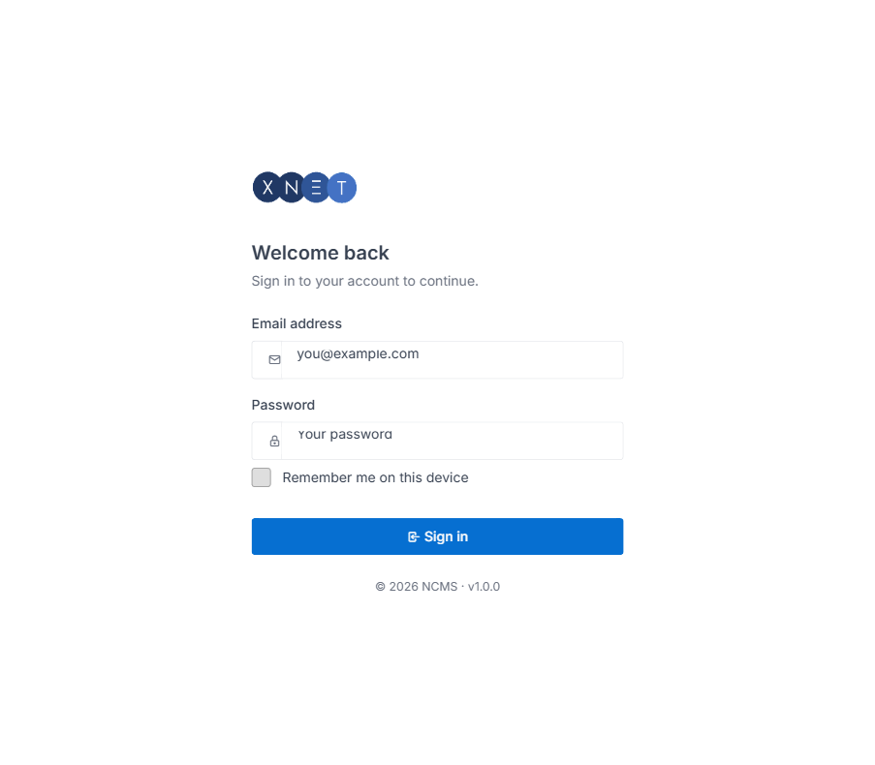
Figure 12.1 — NCMS sign-in page, confirming the application is reachable through Nginx.
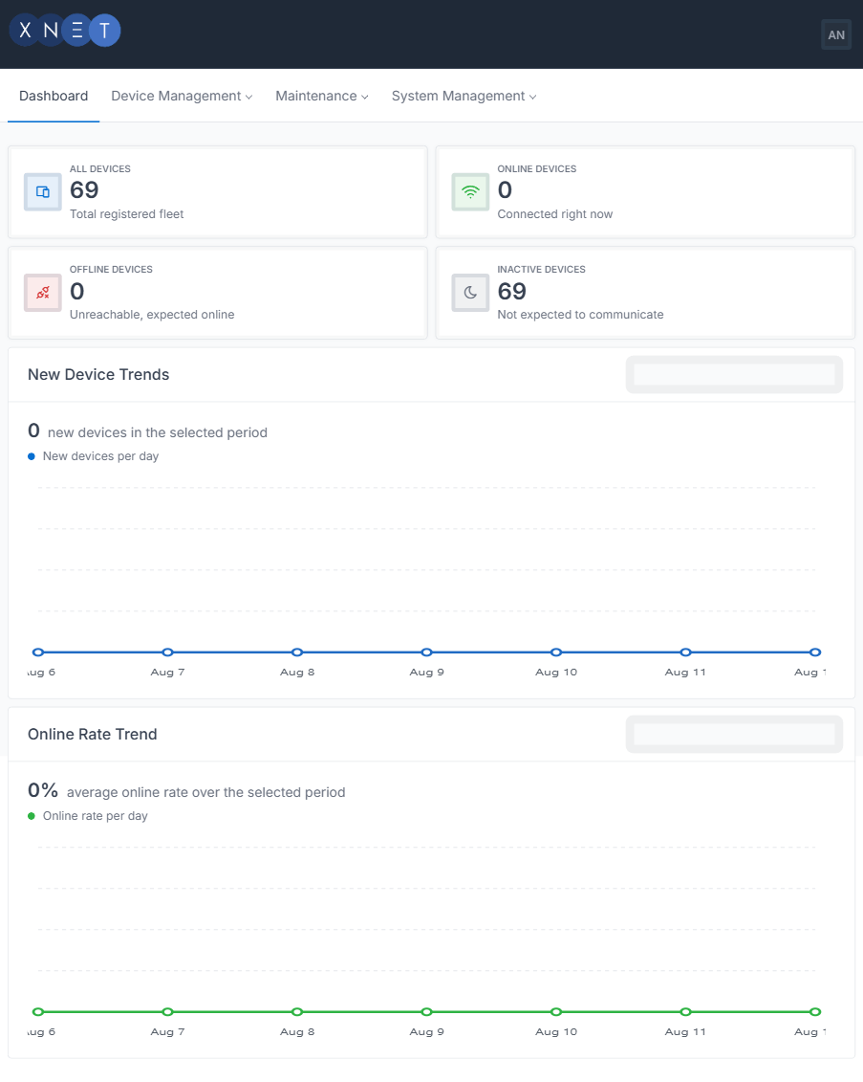
Figure 12.2 — Dashboard after a successful login, confirming database connectivity.

13. Updating and Redeploying
To install a new version of the application, repeat the build-and-copy steps, then restart the services:
# Build (Section 3), then copy the new files over the old ones (Section 4):
scp -r build-output/api/* user@server:/var/www/ncms/api/
scp -r build-output/host/* user@server:/var/www/ncms/host/
sudo chown -R ncms:ncms /var/www/ncms/api /var/www/ncms/host

# If the update changes the database structure, run the database setup tool again (Section 5):
cd /var/www/ncms/api && sudo -u ncms dotnet NCMS.IoT.DbMigrator.dll

# Restart both services:
sudo systemctl restart ncms-api ncms-host
Note: Copying new application files over the old ones does not touch appsettings.Production.json, so your configuration is preserved across updates.

14. Handover Summary
At the end of this process, you should have:
- The application installed, configured, and running as two services on your server.
- A working web address for the administration interface, secured with TLS.
- A database holding the application’s data, with backups in place.
- An MQTT broker configured and connected to the application.
- The default administrator account replaced or its password changed.
- Configuration files, certificates, and access credentials stored securely.

From this point, your team owns and operates the installation. Refer to the User Manual for day-to-day use of the application, and to Section 13 of this guide whenever a new version needs to be installed.

