NCMS IoT Platform
User Manual
A guide to the NCMS Host web application: device fleet management, firmware and configuration deployment, and system administration
Version 1.0 | 2026

Table of Contents

1. Introduction
NCMS (the Network/Device Configuration Management System) is a fleet management platform for IoT devices such as gateways and routers. Administrators use the NCMS web application to register devices, monitor their online status, distribute firmware and application updates, push configuration profiles, and manage users and permissions.
This manual covers the Host web application — the browser-based administration console — and walks through each of its main areas using the actual application screens.

1.1 Signing in
Open the NCMS web address in a browser. You will land on the sign-in page.
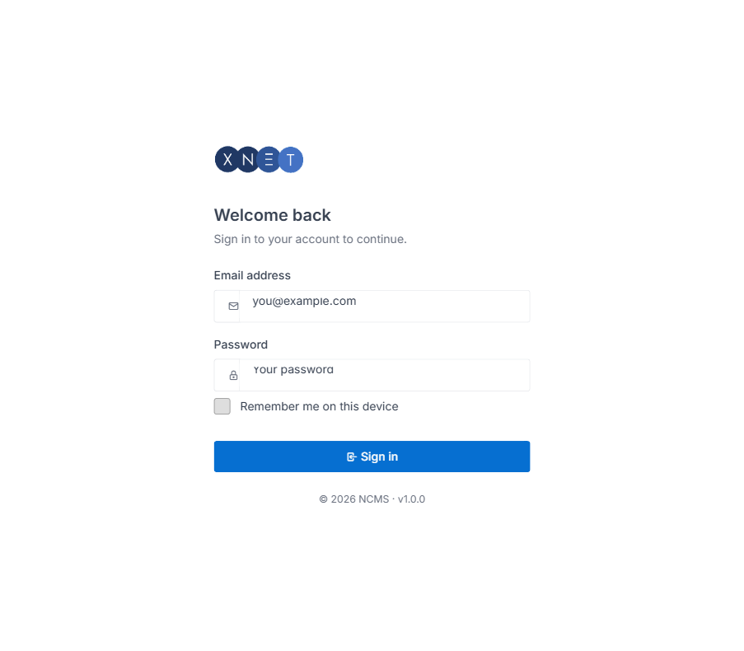
Figure 1.1 — The NCMS sign-in page.
- Enter your email address and password.
- Optionally check "Remember me on this device" to stay signed in on that browser.
- Select Sign in.
Tip: If you do not have an account yet, ask a System Management administrator to create one for you from the User Manage screen (Section 6.1).

2. Getting Around the Application
After signing in you land on the Dashboard. The top navigation bar groups every other screen into four menus: Dashboard, Device Management, Maintenance, and System Management. The menu items you see depend on the permissions assigned to your account.
Menu | Contains
Dashboard | Fleet-wide summary: device counts, online/offline status, and trend charts.
Device Management | Devices (the registered fleet) and Hardware Inventory (stock of devices not yet activated).
Maintenance | Firmware Packages, Application Packages, Configuration Profiles, and the Firmware/Application/Configuration Tasks used to roll them out to devices.
System Management | User Manage, Role Manage, and the Audit Log.

Tip: On narrower screens the top menu collapses behind a hamburger icon in the top-left corner; tap it to open the same navigation as a full-screen list.

3. Dashboard
The Dashboard is the landing page after login. It gives an at-a-glance summary of the device fleet.
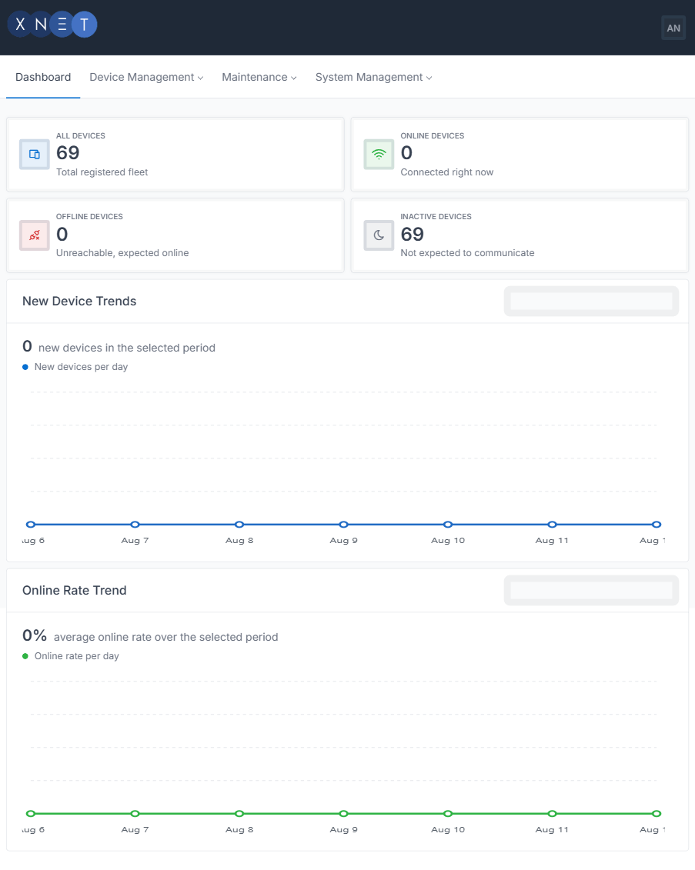
Figure 3.1 — The Dashboard, showing fleet totals and trend charts.

3.1 What you see
- All Devices — the total number of devices registered in the system.
- Online Devices — devices currently connected and communicating.
- Offline Devices — devices expected to be online but currently unreachable.
- Inactive Devices — devices not currently expected to communicate (e.g. decommissioned or in storage).
- New Device Trends — a chart of newly registered devices over a selectable period (7/14/30 days).
- Online Rate Trend — the average percentage of the fleet online over the same selectable period.

4. Device Management

4.1 Devices
The Devices screen lists every device registered in the fleet, with its current status, firmware version, agent version, and network details.
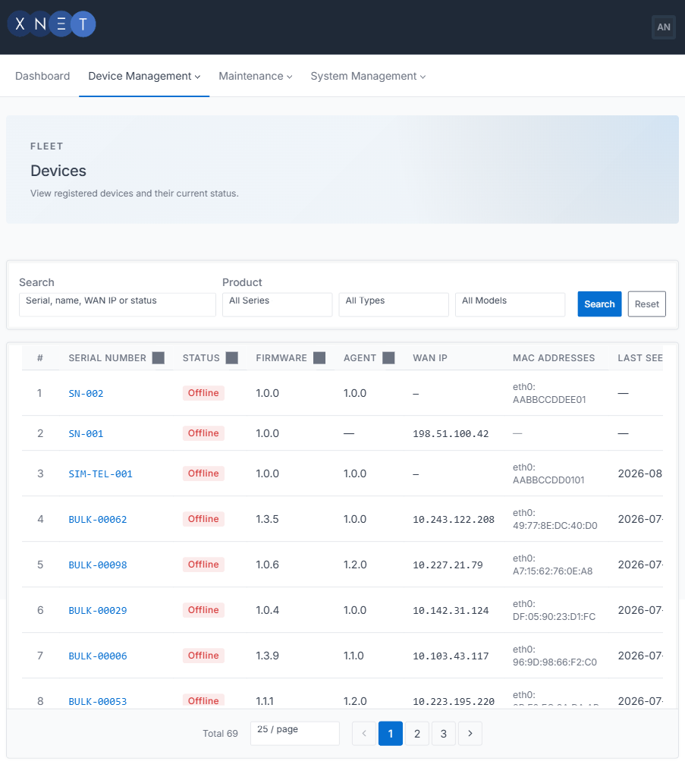
Figure 4.1 — The Devices list, with search and product filters.

Searching and filtering
- Type a serial number, device name, WAN IP, or status into the Search box.
- Optionally narrow the list further with the Series, Type, and Model filters.
- Select Search to apply the filters, or Reset to clear them.

Sorting and paging
- Select any column heading (Serial Number, Status, Firmware, Agent, Last Seen) to sort by that column.
- Use the page-size selector and the numbered pager at the bottom of the table to move through large fleets.

Viewing a device
Select a device’s serial number to open its details page.
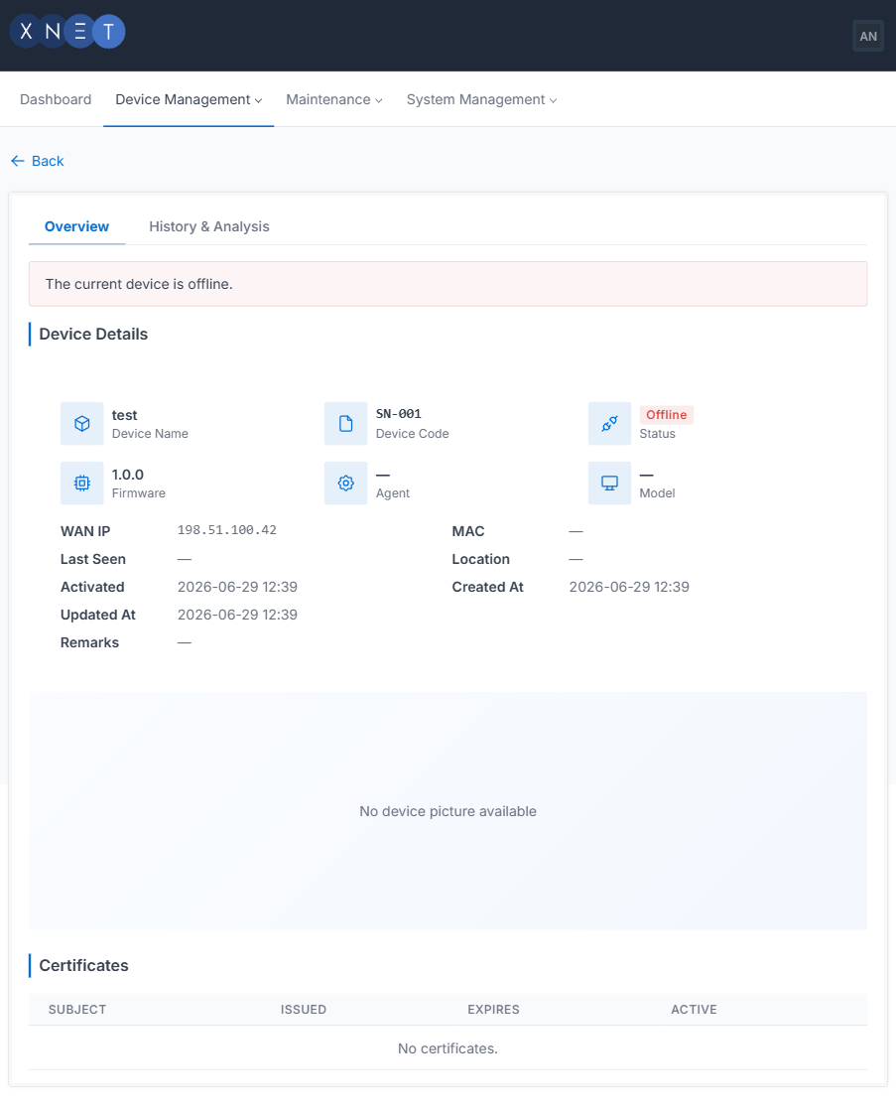
Figure 4.2 — Device Details, showing identity, network, and certificate information.
- Overview tab — device identity (name, code, model, firmware, agent), network details (WAN IP, MAC address), key dates, and any TLS client certificates issued to the device.
- History & Analysis tab — historical telemetry and event data for the device.

4.2 Hardware Inventory
Hardware Inventory tracks devices that have been manufactured or purchased but are not yet activated in the field — useful for stock control before a device is provisioned and appears in the Devices list.
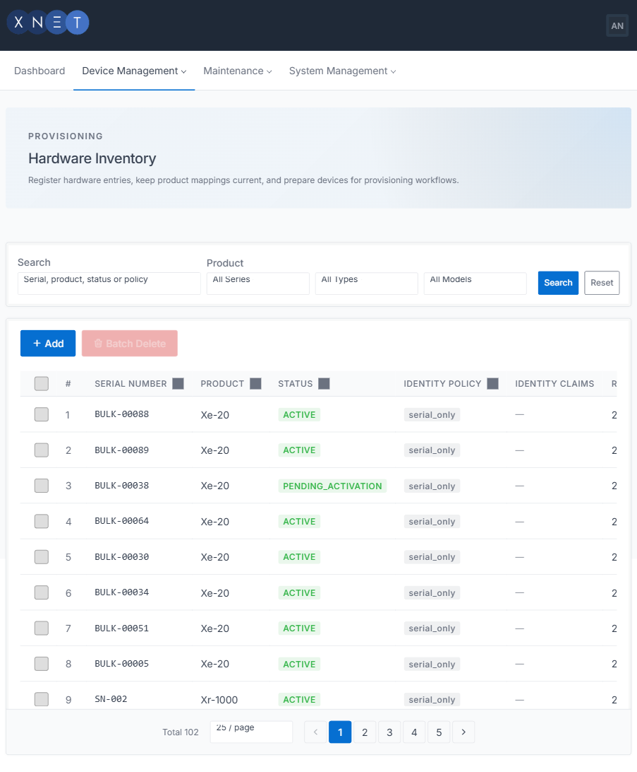
Figure 4.3 — Hardware Inventory.

5. Maintenance
The Maintenance menu is where firmware, application, and configuration content is uploaded, and where rollouts to devices are tracked. Each content type follows the same pattern: a Packages/Profiles screen to manage the content itself, and a Tasks screen to track its deployment to devices.

5.1 Firmware Packages
Firmware Packages lists uploaded firmware images available to deploy to devices, grouped by product compatibility and version.
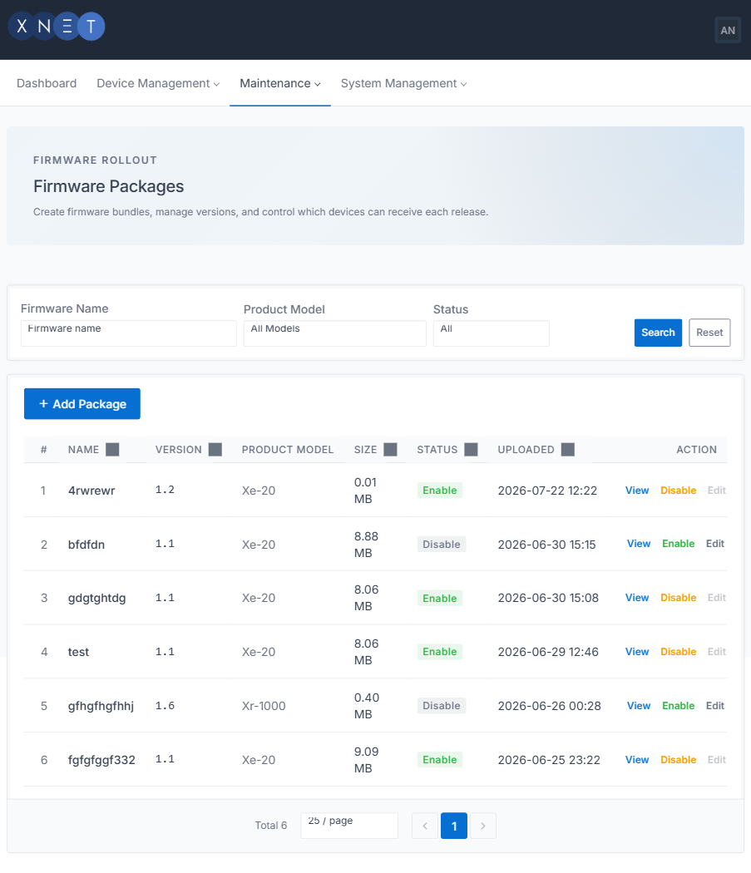
Figure 5.1 — Firmware Packages.
- Upload a new firmware version and set which device models it is compatible with.
- Enable or disable a firmware version to control whether it can be selected for new rollouts.
- Set dependencies between package versions where a device must be on a minimum version before upgrading further.

5.2 Application Packages
Application Packages manages installable applications that can be pushed to devices independently of firmware, following the same versioning and compatibility model as Firmware Packages.
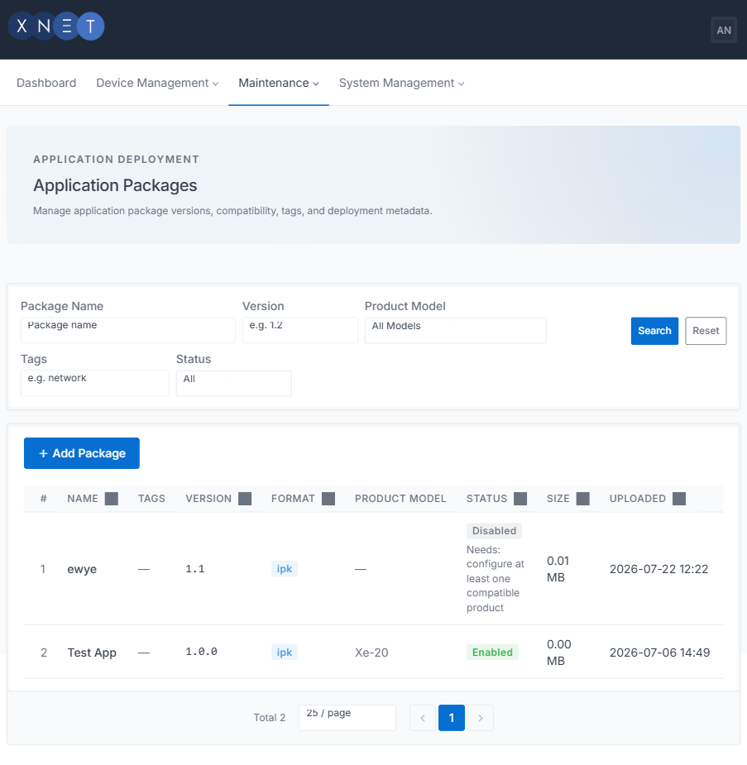
Figure 5.2 — Application Packages.

5.3 Configuration Profiles
Configuration Profiles define reusable device configuration templates (for example, network or Modbus gateway settings) that can be applied to one or more devices.
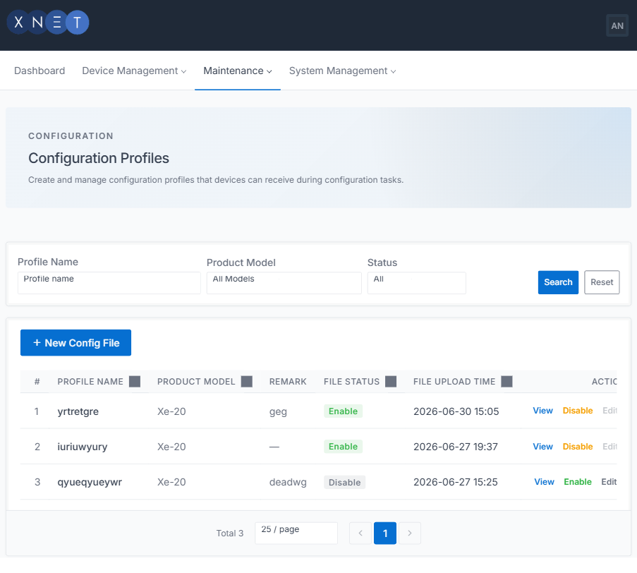
Figure 5.3 — Configuration Profiles.

5.4 Firmware Tasks
Firmware Tasks tracks the rollout of a firmware package to one or more devices: which devices were targeted, their upgrade progress, and the outcome (succeeded, failed, or in progress) of each device’s upgrade.
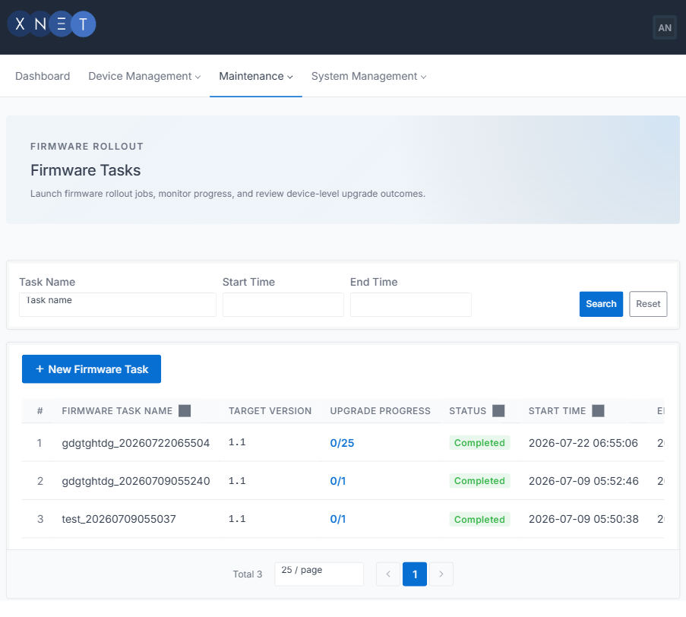
Figure 5.4 — Firmware (Upgrade) Tasks.

Creating a rollout
- From Firmware Packages, choose the version to deploy and start a new task, or create one directly from Firmware Tasks.
- Select the target devices (individually, or by product/model filter).
- Confirm the task. Devices receive the update the next time they check in over MQTT.
- Track progress on the Firmware Tasks screen; each device’s status updates as it reports back.

5.5 Application Tasks
Application Tasks tracks the rollout of application packages to devices, in the same way Firmware Tasks tracks firmware rollouts.
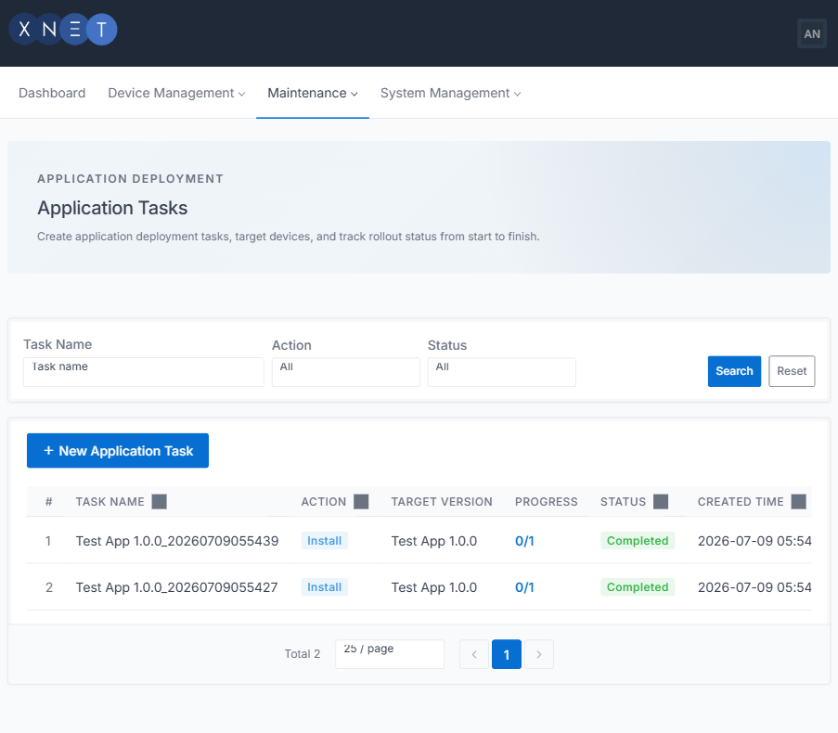
Figure 5.5 — Application Tasks.

5.6 Configuration Tasks
Configuration Tasks tracks the rollout of a configuration profile to devices, showing which devices have received and applied the profile.
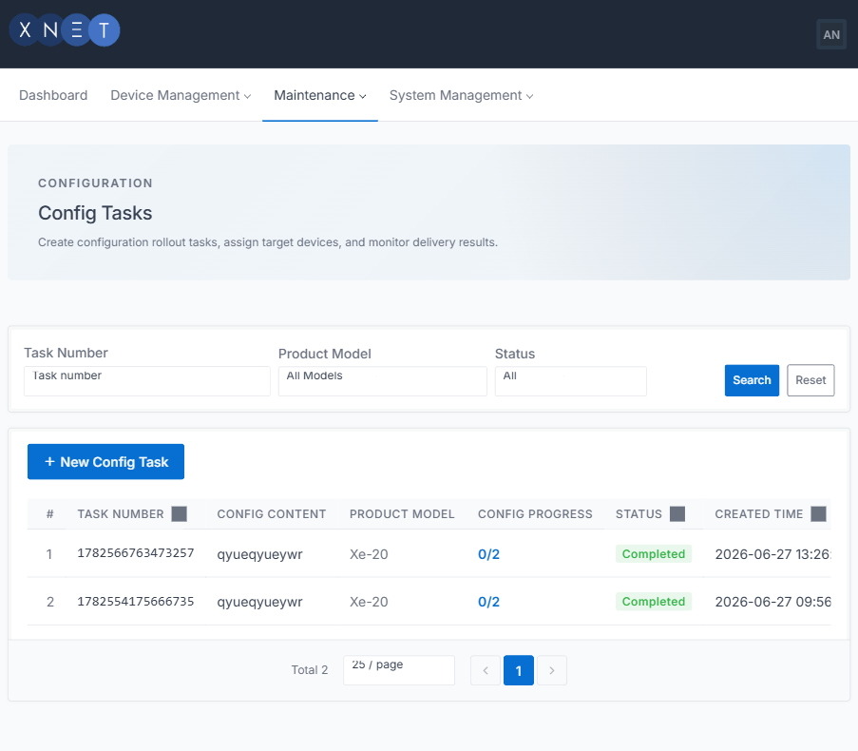
Figure 5.6 — Configuration Tasks.

6. System Management

6.1 User Manage
User Manage lists the administrator/operator accounts that can sign in to the Host application, and is where new accounts are created and existing ones are edited, activated, or deactivated.
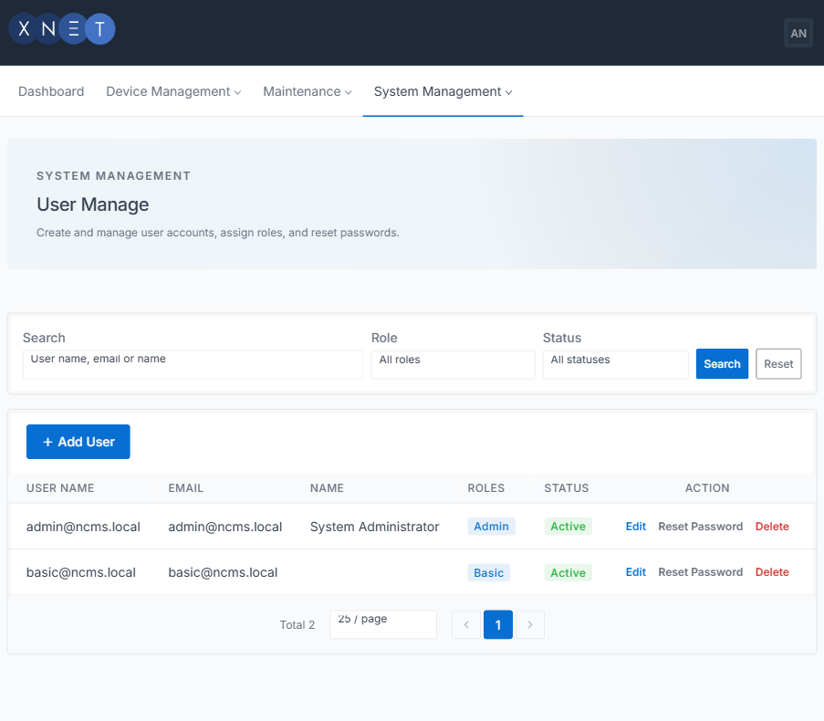
Figure 6.1 — User Manage.

Creating a user
- Select the option to add a new user.
- Enter the person’s name and email address.
- Assign one or more roles that define what the account can access (see Section 6.2).
- Save. The new user can sign in using the credentials configured for the account.

6.2 Role Manage
Role Manage defines the permission sets assigned to users. Each role bundles a set of permissions (for example, the ability to view devices, deploy firmware, or manage other users) that can be granted together.
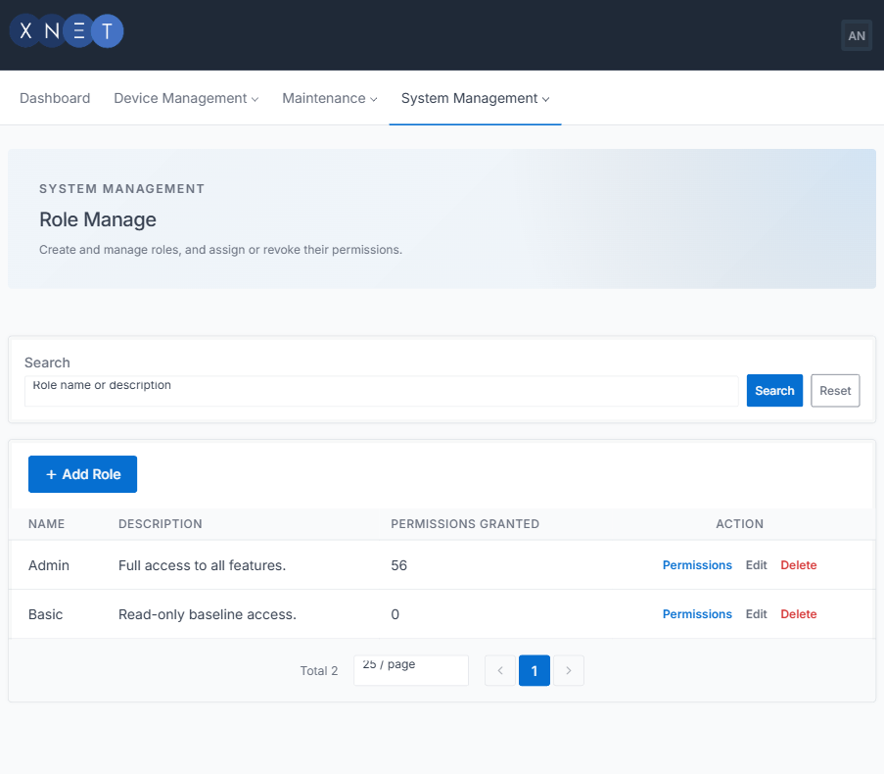
Figure 6.2 — Role Manage.
Tip: Follow the principle of least privilege: give a role only the permissions the people who will hold it actually need, particularly for System Management permissions.

6.3 Audit Log
The Audit Log records login/logout history and security-related events — failed logins, password changes, and role or permission changes — for accountability and troubleshooting.
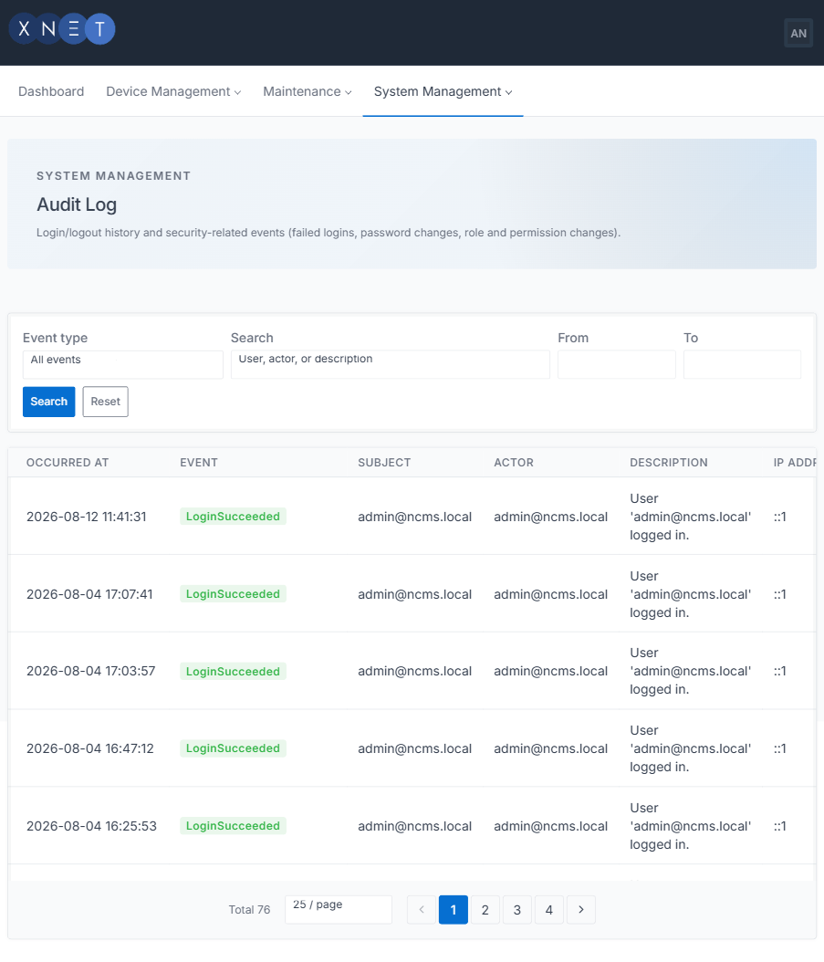
Figure 6.3 — Audit Log.

Searching the log
- Event type — filter to a specific kind of event (e.g. LoginSucceeded, LoginFailed, RoleChanged).
- Search — free-text match against the user, actor, or event description.
- From / To — restrict results to a date range.

7. Troubleshooting
Symptom | What to check
A device stays Offline after a firmware/config task is created | The device must check in over MQTT to receive the update — confirm it has network connectivity and can reach the broker.
Cannot see a menu item you expect | Menu items are permission-gated. Ask a System Management administrator to review your assigned role in Role Manage.
Forgot your password | Ask an administrator with User Manage access to reset your account, or use the sign-in page’s password reset option if enabled.
Upload of a firmware/application file fails | Very large files may exceed the server’s upload limit; contact your system administrator.

