**Google Analytics**

**Steps to Create analytics project on Google cloud platform**

1. Go to [https://analytics.google.com/analytics/](https://analytics.google.com/analytics/web) and Sign up for analytics

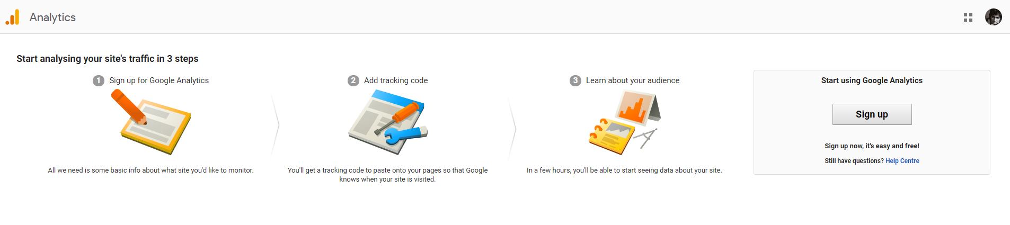

1. Select Web App and give it a Project Name and App Name (Even though you’ve selected web you can track Web, Android and IOS with the same tracking ID)

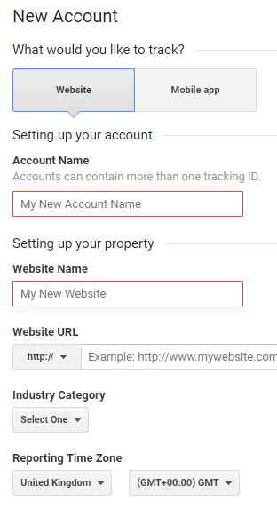

1. Click on Get Tracking ID at the bottom of the same page which will generate a unique tracking ID(UA-*********-**), which you can use to call analytics from your app

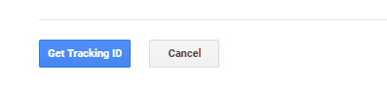

**Steps to integrate the Google Analytics in your Mobile App**

[react-native-google-analytics-bridge](https://github.com/idehub/react-native-google-analytics-bridge) we can use google analytics’ web config for both React and React Native

1. Install react-native-google-analytics-bridge package in your app by running npm install –save react-native-google-analytics-bridge
2. Run react-native link package in your android and IOS folders

**Usage:**

1. Initialization

import { GoogleAnalyticsTracker } from 'react-native-google-analytics-bridge'

const googleAnalytics = new GoogleAnalyticsTracker('UA-*********-*')

1. Track screen views

googleAnalytics.trackScreenView(currentScreen)

1. Track events

tracker.trackEvent(“testCategory”, “testAction”)

**Steps to integrate Google Analytics on Web**

1. Install [react-ga](https://github.com/react-ga/react-ga) package on web by running npm install –save react-ga

**Usage**

1. Initializing and Tracking PageView

import ReactGA from 'react-ga'

ReactGA.initialize('UA-*********-*')

ReactGA.pageview(window.location.pathname + window.location.search)