**Firebase Crashlytics**

**Credentials to be used**

**Account:** [**fgalpintest@gmail.com**](mailto:fgalpintest@gmail.com)

**Password**

**Crashlytics setup for iOS**

To get started, you need a Firebase app with Firebase Crashlytics enabled

**Create a Firebase app**

1. Login to Firebase and add a project
2. Add new app to your firebase project by navigating to general tab and select iOS

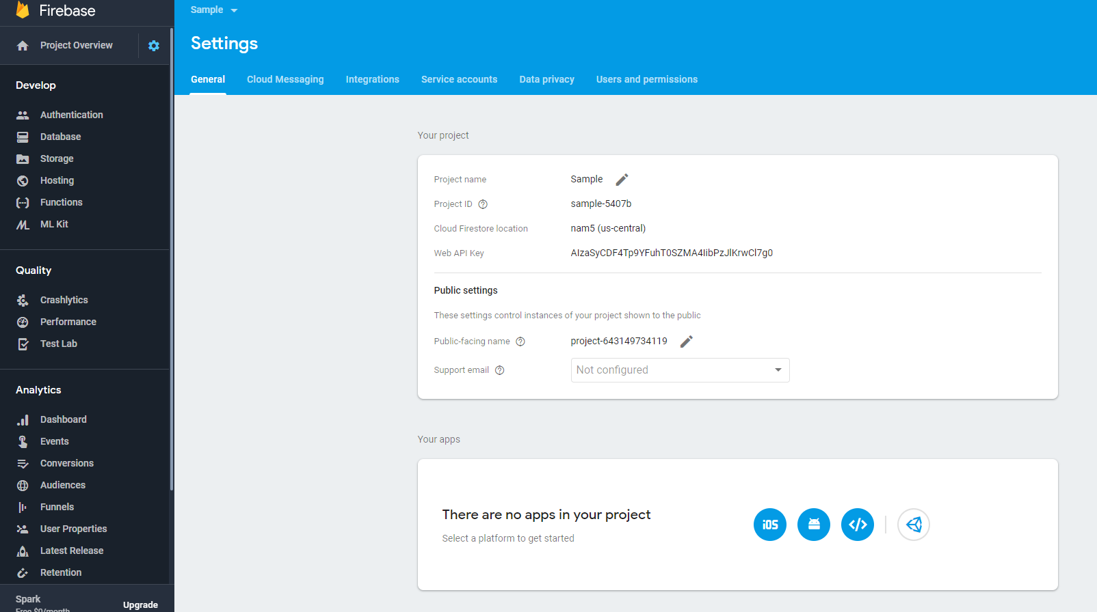

1. Register iOS app by adding following
   1. iOS bundle ID – com.fg.alpine
   2. App nickname(optional)
   3. App Store ID (optional)
2. Download GoogleService-Info.plist and add to the root of your Xcode project and add it to all targets

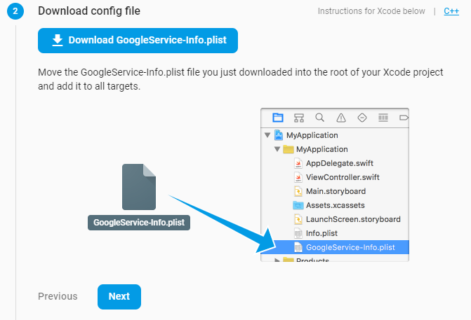

1. Add firebase SDK by running in your Terminal on MacOS
   1. $ pod init
   2. Open your Podfile and add pod 'Firebase/Core'
   3. Save the file and direct to your iOS folder(cd IOS), run from your terminal: $ pod install
2. Add Initialization code. Open your AppDelegate.m file from xcode
   1. Add @import Firebase;
   2. FirebaseApp.configure() ;

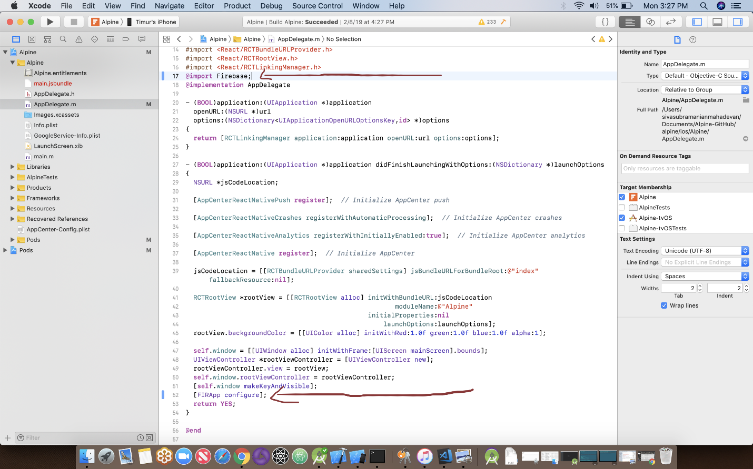

1. Run your app to verify installation

[**Adding Crashlytics to your app**](https://firebase.google.com/docs/crashlytics/get-started)

You can reference the hyperlink for reference

1. Add Crashlytics frameworks to your Xcode workspace

To get started, add the Crashlytics SDK framework files to your project. For most projects, the easiest way to do that is by adding the Crashlytics [CocoaPods](https://cocoapods.org/), but, if your project can't support CocoaPods, you can also add the files manually.

1. Add framework via CocoaPods
   1. Open a new terminal window, and navigate to your Xcode project’s directory
   2. Open your Podfile, and add the highlighted lines:
2. If you get an error about CocoaPods being unable to find compatible versions, run: **$ pod repo update**
3. From your terminal, install the pod’s dependencies: **$pod install**

**Linking app to Fabric**

1. Visit <https://fabric.io/firebase_migration?clientId=ios%3Acom.sample&projectId=sample-5407b&platform=ios>
2. Sign up/in with fabric with account on the top
3. Select Link your apps to Firebase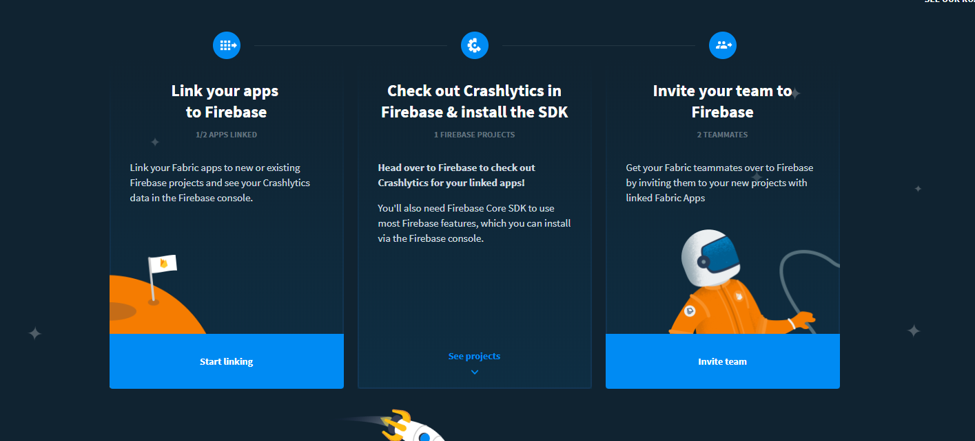
4. Your apps will start showing up on the left just drag and drop them on to your link as shown below and you’re done

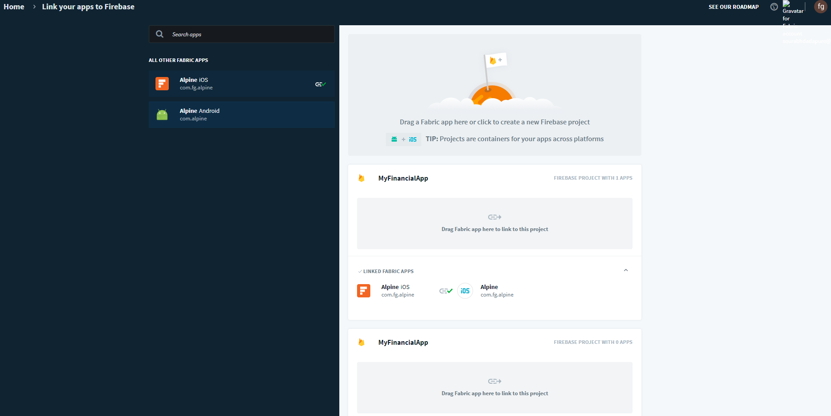

1. Crash your app and see the analytics on Firebase console