**Infra Setup:**

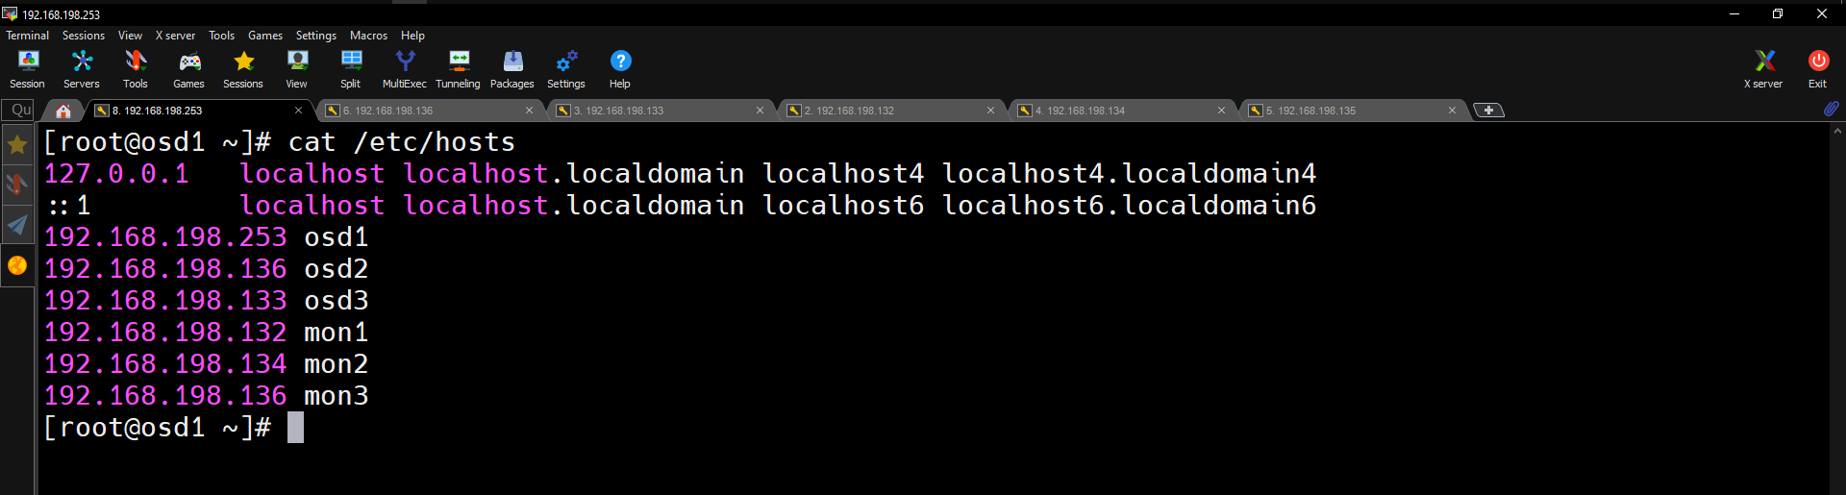

**Create a Ceph User**

Create a new user named '**cephuser**' on all nodes.

Fire this command on every node:

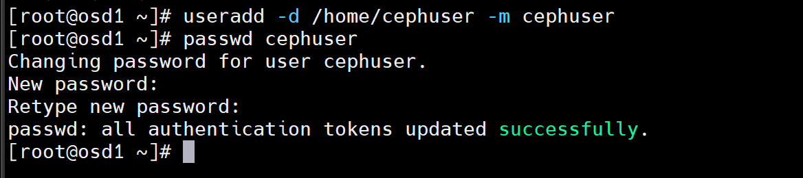

useradd -d /home/cephuser -m cephuser  
 passwd cephuser

After creating the new user, we need to configure sudo for 'cephuser'. He must be able to run commands as root and to get root privileges without a password.

Run the command below to create a sudoers file for the user and edit the /etc/sudoers file with sed.

echo "cephuser ALL = (root) NOPASSWD:ALL" | sudo tee /etc/sudoers.d/cephuser  
chmod 0440 /etc/sudoers.d/cephuser  
sed -i s'/Defaults requiretty/#Defaults requiretty'/g /etc/sudoers

### Install and Configure NTP

Install NTP to synchronize date and time on all nodes. Run the ntpdate command to set a date and time via NTP protocol, we will use the us pool NTP server. Then start and enable NTP server to run at boot time.

yum install -y ntp ntpdate ntp-doc  
ntpdate 0.us.pool.ntp.org  
hwclock --systohc  
systemctl enable ntpd.service  
systemctl start ntpd.service

If you face this error



Fire this command on every node:

sed -i 's/mirrorlist/#mirrorlist/g' /etc/yum.repos.d/CentOS-Linux-*

sed -i 's|#baseurl=http://mirror.centos.org|baseurl=http://vault.centos.org|g' /etc/yum.repos.d/CentOS-Linux-*

yum install epel-release

### Disable SELinux

Disable SELinux on all nodes by editing the SELinux configuration file with the sed stream editor.

sed -i 's/SELINUX=enforcing/SELINUX=disabled/g' /etc/selinux/config

### Configure Hosts File

Edit the /etc/hosts file on all node with the vim editor and add lines with the IP address and hostnames of all cluster nodes.

vim /etc/hosts

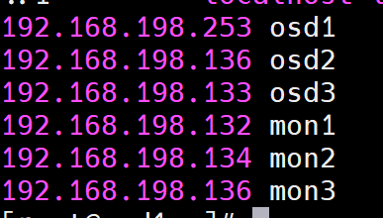

### Configure the SSH Server

I will login to my first monitor node which is my admin node also

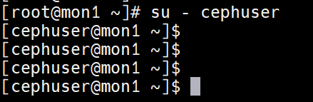

ssh-keygen

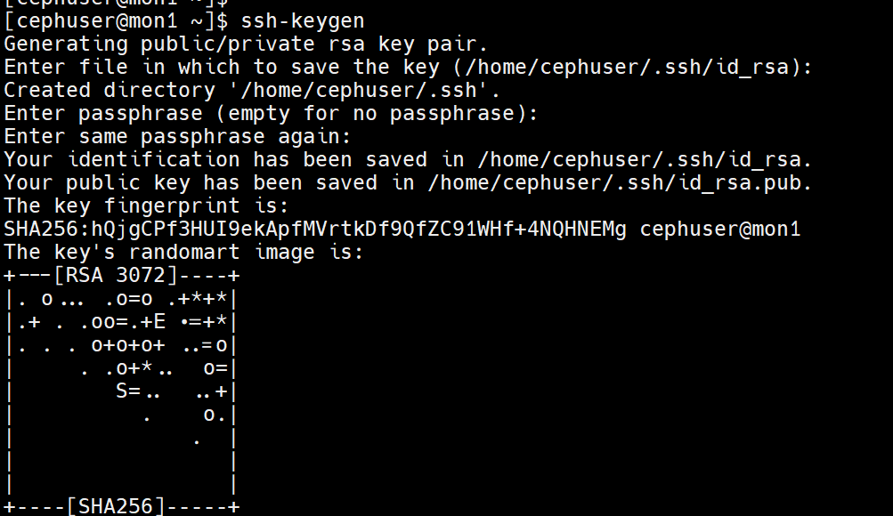

leave passphrase blank/empty.

vim ~/.ssh/config

Host mon1

Hostname mon1

User cephuser

Host mon2

Hostname mon2

User cephuser

Host mon3

Hostname mon3

User cephuser

Host osd1

Hostname osd1

User cephuser

Host osd2

Hostname osd2

User cephuser

Host osd3

Hostname osd3

User cephuser

Hostname client

User cephuser

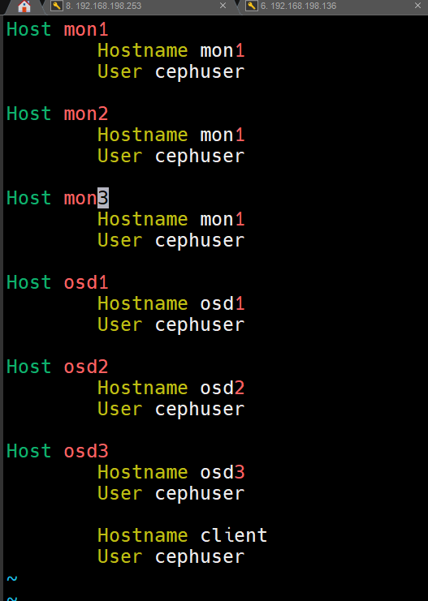

ssh-copy-id osd1  
ssh-copy-id osd2  
ssh-copy-id osd3  
ssh-copy-id mon1

ssh-copy-id mon2

ssh-copy-id mon3

Now you can simply login in to any server with password from mon1

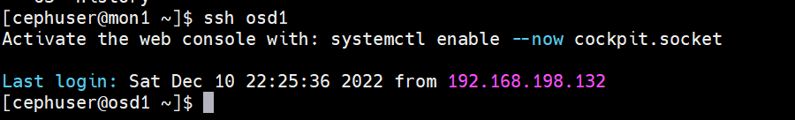

## Configure Firewalld

For safer note please disable and stop firewalld service on all the nodes

sudo systemctl disable --now firewalld

Fire this command only on mon1 on node / admin node

sudo dnf -y install dnf-plugins-core

sudo dnf -y install https://dl.fedoraproject.org/pub/epel/epel-release-latest-8.noarch.rpm

sudo dnf config-manager --set-enabled powertools

Install Git

sudo dnf install git -y

Install git repository

sudo git clone https://github.com/ceph/ceph-ansible.git

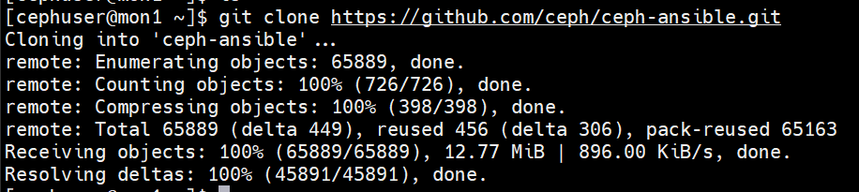

cd ceph-ansible/

git checkout stable-5.0

git branch

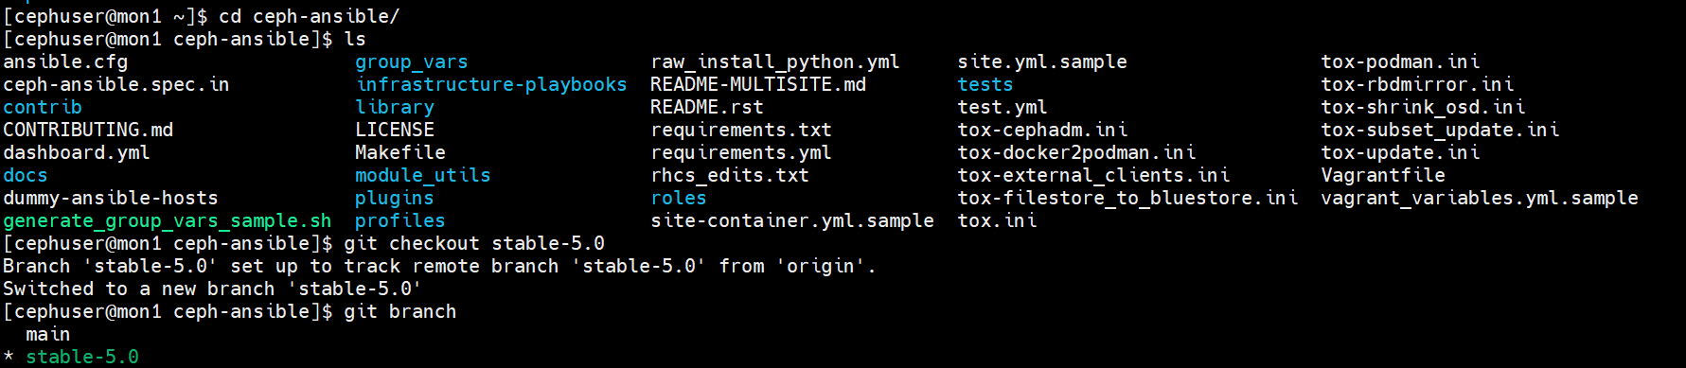

Install Ansible

sudo yum install python3-pip & sudo pip3 install -r requirements.txt

sudo yum -y install python3 python3-pip

pip3 install ansible  
sudo pip3 install --upgrade setuptools

####################################

sudo dnf install python3-pip

pip3 install ansible –user

cp group_vars/all.yml.sample group_vars/all.yml

vi group_vars/all.yml

Make sure these lines are uncommented and edited as under below:

---

dummy:

ceph_release_num: 15

cluster: ceph

mon_group_name: mons

osd_group_name: osds

rgw_group_name: rgws

mds_group_name: mdss

nfs_group_name: nfss

rbdmirror_group_name: rbdmirrors

client_group_name: clients

iscsi_gw_group_name: iscsigws

mgr_group_name: mgrs

rgwloadbalancer_group_name: rgwloadbalancers

grafana_server_group_name: grafana-server

configure_firewall: True

ntp_service_enabled: true

ntp_daemon_type: chronyd

ceph_repository_type: cdn

ceph_origin: repository

ceph_repository: community

ceph_stable_release: octopus

monitor_interface: ens160

cp group_vars/osds.yml.sample group_vars/osds.yml

dummy:

copy_admin_key: true

devices:

- /dev/sdb

vi hosts

# Ceph admin user for SSH and sudo

[all:vars]

ansible_ssh_user=cephuser

ansible_become=true

ansible_become_method=sudo

ansible_become_user=root

#Ceph Monitor Nodes

[mons]

mon1

mon2

mon3

#Ceph MDS Nodes

[mdss]

mon1

mon2

mon3

#Ceph RGWS Nodes

[rgws]

mon1

mon2

mon3

#Set OSD

[osds]

osd1

osd2

osd3

#Grafan-Server

[grafana-server]

osd1

osd2

osd3

ansible-playbook -i hosts site.yml

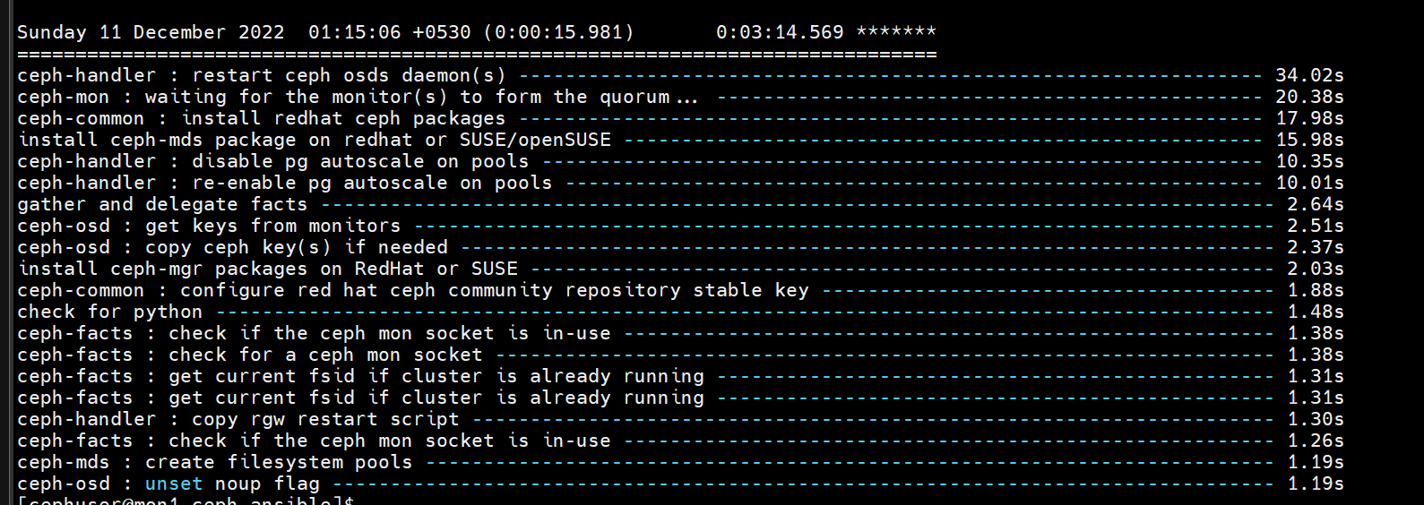

sudo ceph config set mon mon_warn_on_insecure_global_id_reclaim false

sudo ceph config set mon mon_warn_on_insecure_global_id_reclaim_allowed false

