

SYMBIOSIS INSTITUTE OF TECHNOLOGY
(Established under section 3 of the UGC Act 1956) Re-accredited by NAAC with “A” Grade

NAME – SOURABH GUPTA PRN :25070122191

Batch – B3 COURSE – JAVA

Experiment 6-
Write a Java program to demonstrate the use of an inner class, an anonymous class

AIM –
Write a Java program to demonstrate the use of an inner class, an anonymous class

Program 6

/**
* index
*/
class College {
String collegeName = "SIT PUNE";

// Inner Class
class Student {
void display() {
System.out.println("Student belongs to " + collegeName);
}
}
}

interface Greeting {
void sayHello();
}

public class index {
public static void main(String[] args) {

// Inner class object
College college = new College();
College.Student student = college.new Student();

// Call display() method
student.display();

// Anonymous class
Greeting g = new Greeting() {
@Override
public void sayHello() {
System.out.println("Hello from anonymous class ");
}
};

// Call interface method
g.sayHello();
}
}

Output

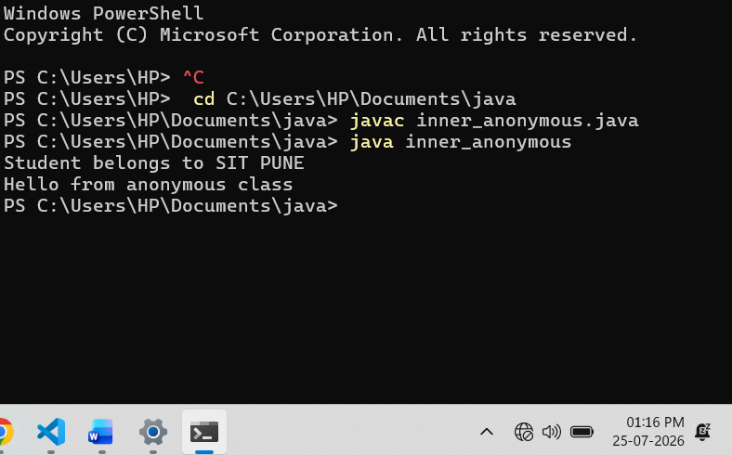

EXERCISE

6.1 .Create a Vehicle program where an inner class displays vehicle details and anonymous class performs an action.

Program 6.1 -
class Vehicle {

String vehicleName = "Honda City";
String type = "Car";
int speed = 120;

// Inner Class
class Details {
void displayDetails() {
System.out.println("Vehicle Name : " + vehicleName);
System.out.println("Vehicle Type : " + type);
System.out.println("Top Speed : " + speed + " km/h");
}
}
}

// Interface
interface Action {
void performAction();
}

public class VehicleDemo {

public static void main(String[] args) {

// Create Vehicle object
Vehicle vehicle = new Vehicle();

// Create Inner Class object
Vehicle.Details details = vehicle.new Details();

// Display vehicle details
details.displayDetails();

// Anonymous Class
Action action = new Action() {
@Override
public void performAction() {
System.out.println("Vehicle is now moving...");
}
};

// Perform action
action.performAction();
}
}

Screenshot 6.1 –

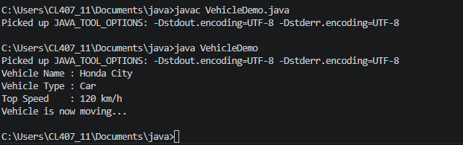

6.2 Develop a Food Delivery Application where an inner class handles order details and anonymous classes handle delivery status updates.

Program 6.2 -

class FoodDelivery {

String customerName = "Sourabh Gupta";
String foodItem = "Veg Burger";
int quantity = 2;

// Inner Class
class OrderDetails {
void displayOrder() {
System.out.println("Customer Name : " + customerName);
System.out.println("Food Item : " + foodItem);
System.out.println("Quantity : " + quantity);
}
}
}

// Interface
interface DeliveryStatus {
void updateStatus();
}

public class FoodDeliveryDemo {

public static void main(String[] args) {

// Create FoodDelivery object
FoodDelivery order = new FoodDelivery();

// Create Inner Class object
FoodDelivery.OrderDetails details = order.new OrderDetails();

// Display Order Details
details.displayOrder();

// Anonymous Class
DeliveryStatus status = new DeliveryStatus() {
@Override
public void updateStatus() {
System.out.println("Order is out for delivery.");
}
};

// Update Delivery Status
status.updateStatus();
}
}

Screenshot 6.2 –

