**A PROJECT REPORT ON**

**Landslide Predication using Machine Learning.**

*by*

Sourabh Kapse (Seat No: BEAIDB47)

Yash Varpe (Seat No: BEAIDB15)

Vedant Dhore (Seat No: BEAIDB38)

*Under the guidance of*

**Prof. Mrs. Rajshri .T.Ingle**

**SAVITRIBAI PHULE PUNE UNIVERSITY**

**2023-2024**



# Department of Artificial Intelligence and Data Science D. Y. Patil College of Engineering

Sector No. 29, Nigdi, Pradhikaran, Akurdi, Pune – 411044

PROJECT APPROVAL SHEET

A

**Project**

On

**Landslide Predication using Machine Learning.**

Is successfully completed by Students

Sourabh Kapse (Seat No: BEAIDB47)

Yash Varpe (Seat No: BEAIDB15)

Vedant Dhore (Seat No: BEAIDB38)

at

# Department of Artificial Intelligence and Data Science D. Y. Patil College of Engineering

**Savitribai Phule Pune University 2023-2024**

Prof. Rajshri .T Ingle Dr. V.G. Kottawar

Project Guide Head of Department

# CERTIFICATE

This is to certify that the Project Entitled

**Landslide Predication using Machine Learning.**

Submitted by

Sourabh Kapse (Seat No: BEAIDB47)

Yash Varpe (Seat No: BEAIDB15)

Vedant Dhore (Seat No: BEAIDB38)

is a bonafide work carried out by Students under the supervision of Prof.

Rajshri Ingle and it is submitted towards the partial fulfilment of the requirement of the Bachelor of Engineering (Artificial Intelligence and Data Science) Project.



## Department of Artificial Intelligence and Data Science D. Y. Patil College of Engineering

Sector No. 29, Nigdi, Pradhikaran, Akurdi, Pune – 411044

Prof. Rajshri Ingle Prof. Mansi Karajgar

Project Guide Project Coordinator

Dr.V.G.Kottwar

Head of Department External Examiner

## ACKNOWLEDGEMENT

With immense pleasure, We present the project report as part of the curriculum of the B.E. Artificial Intelligence and Data Science Engineering. I wish to thank all the people who gave us an unending support right from when the idea was conceived.

We are profoundly grateful to Prof. Rajshri Ingle for her expert guidance and continuous encouragement throughout to see that this project rights its target since its commencement to its completion.

We express sincere and profound thanks to HOD Prof. Dr. Vinayak Kottawar, who is ready to help with the most diverse problems that we have encountered along the way.

At the last, we must express our sincere heartfelt gratitude to all the staff members of Artificial Intelligence and Data Science Department who helped us directly or indirectly during this course of work.

Sourabh Kapse (Seat No: BEAIDB47)

Yash Varpe (Seat No: BEAIDB15)

Vedant Dhore (Seat No: BEAIDB38)

## ABSTRACT

Landslides pose a significant threat to lives, infrastructure, and ecosystems worldwide, highlighting the urgent need for effective prediction and mitigation strategies. Traditional landslide prediction methods often rely on empirical models and historical data, which may lack the accuracy and timeliness required for proactive risk management. In recent years, advances in machine learning (ML) and artificial intelligence (AI) have emerged as promising tools for landslide prediction, offering the potential to analyze complex interactions between geological, meteorological, and environmental factors and provide timely warnings to at-risk communities.

This paper presents a comprehensive review of landslide prediction using machine learning models, focusing on the development, implementation, and evaluation of ML-based approaches for landslide risk assessment. We begin by discussing the challenges associated with traditional landslide prediction methods and the potential of ML techniques to overcome these limitations. We then explore various ML algorithms commonly used for landslide prediction, including decision trees, random forests, support vector machines, neural networks, and ensemble methods, highlighting their strengths and weaknesses in capturing landslide dynamics

Next, we examine the key components of an ML-based landslide prediction system, including data collection, pre-processing, feature selection, model training, validation, and deployment. We discuss the importance of integrating diverse datasets from geological surveys, weather stations, satellite imagery, and IoT sensors, as well as the need for rigorous data pre-processing to ensure the quality and reliability of input data. We also address challenges related to feature engineering, model selection, and hyperparameter tuning, emphasizing the importance of robust validation techniques and performance metrics for evaluating model accuracy and generalization.

In conclusion, landslide prediction using machine learning represents a promising approach for enhancing disaster preparedness and response efforts, providing stakeholders with actionable insights and timely warnings to mitigate the impact of landslides on vulnerable populations and infrastructure. By leveraging the capabilities of ML and AI technologies, we can address the complex challenges posed by landslides and work towards building more resilient and sustainable communities in landslide-prone regions

## TABLE OF CONTENT

1. **Introduction ………………………………………………………….** 1
   1. **Detailed Problem Definition and Justification ……… 3**

**1.2 Aim and Objectives …………………………………………………. 4**

**1.3 Presently Available Systems and Literature Survey 6**

**1.4 Purpose of Our System ……………………………………………. 7**

* 1. **Organization of the Report …………………………………… 9**

**2. ANALYSIS ………………………………………………………….. 11**

**2.1 PROJECT PLAN……………………………………………………………. 11**

**2.2 REQUIREMENT ANALYSIS……………………………………………… 13**

**2.3 TEAM STRUCTURE ………………………………………………………. 14**

**2.4 STAGES AND WORK BREAKDOWN…………………………………… 15**

**2.5 ACTUAL DETAILED PROBLEM DEFINITION ………………………. 16**

**2.6 MODIFIED REQUIREMENTS (AFTER FEASIBILITY STUDY) ……. 17**

* 1. **PARADIGM………………………………………………………………… 18**

**3. DESIGN …………………………………………………………….. 19**

**3.1 SOFTWARE REQUIREMENT SPECIFICATION (SRS) FORMAT….. 19**

**3.2 RISK ASSESSMENT ………………………………………………………. 22**

**3.3 PROJECT PLAN REVIEW ……………………………………………….. 24**

**4. MODELLING……………………………………………………….. 26**

**4.1 USE CASE DIAGRAM ……………………………………………………. 30**

**4.2 CLASS DIAGRAM ………………………………………………………… 32**

**4.3 MODEL DIAGRAM ………………………………………………………. 34**

**4.4 STATE DIAGRAM ……………………………………………………….. 36**

**4.5 SEQUENCE DIAGRAM ………………………………………………… 38**

**4.6 DEPLOYMENT DIAGRAM …………………………………………….. 40**

**5. IMPLEMENTATION …………………………………………….. 43**

**5.1 ALGORITHMS/FLOWCHARTS ……………………………………… 44**

**5.2 SOFTWARE USED ……………………………………………………… 52**

**5.3 HARDWARE SPECIFICATION………………………………………... 53**

**5.4 PROGRAMMING LANGUAGE ……………………………………….. 54**

**5.5 PLATFORM……………………………………………………………… 55**

**5.6 COMPONENTS………………………………………………………….. 55**

**5.7 TOOLS …………………………………………………………………… 57**

**5.8 CODING STYLE FORMAT……………………………………………. 59**

**6. TEST DATA SETS, RESULT AND ANALYSIS……………… 61**

**6.1 DATA COLLECTION** …………………………………………………. 61

**6.2 DATA CHARACTERISTICS………………………………………….. 61**

**6.3 DATA PREPARATION……………………………………………….. 62**

**6.4 RESULTS……………………………………………………………….. 62**

**6.5 ANALYSIS……………………………………………………………… 64**

**7. TESTING ………………………………………………………. 65**

**7.1 FORMAT TECHNICAL REVIEWS ……………………………………. 65**

**7.2 TEST PLAN ……………………………………………………………. .. 65**

**7.3 TESTING PROCEDURE……………………………………………….. 66**

**7.4 TEST RESULTS………………………………………………………… 67**

**8. AI&DS…………………………………………………………… 68**

**8.1 KEY COMPONENTS………………………………………………….. 68**

**8.2 INTEGRATION OF AI AND DATA SCIENCE……………………… 70**

**8.3 WORKFLOW SUMMARY………………………………………. 70**

**9. SOFTWARE QUALITY ASSURANCE PLAN………………… 72**

**10. CONCLUSION…………………………………………………... 76**

**11. REFERENCE……………………………………………………. 77**

**12. PLAGIARISM CHECK REPORT…………………………….. 81**

## CHAPTER 1 INTRODUCTION

Earthquakes are natural disasters that seriously threaten human life and infrastructure. They can happen quickly and without warning, causing road damage. Early detection of mudslides is important in ensuring the safety of people and ensuring the safety of earthquake-prone areas. In recent years, the integration of machine learning models and artificial intelligence (AI) is expected to change the way we monitor and predict earthquakes. Technology can reduce the impact of earthquakes by providing timely warnings and implementing measures to reduce their impact. Activity. Monitoring systems should be developed in earthquake risk areas to detect early warning signs and provide important information to decision makers. Earthquake research methods often rely on manual observations, which can be time-consuming, unreliable and limited. This is where machine learning and artificial intelligence support our capabilities. Using various data such as satellite images, weather data, soil composition and historical landslide data, these models will be trained to detect landslide precursors and indicators as much as possible. This predictive ability enables authorities and communities to take preventative measures before catastrophic events occur. By securing space we can protect important infrastructure, buildings and ecosystems. This will not only save lives but also prevent major economic and environmental damage to land. We will take a look at the ideas and resources used in this field, the challenges encountered and the potential for future development. By harnessing the power of artificial intelligence and machine learning, we can make progress in protecting our communities and our environment from damage caused by earthquakes. Landslides, natural phenomena of immense destructive potential, present an ongoing challenge to communities worldwide. These sudden mass movements of rock, earth, and debris can wreak havoc on human settlements, infrastructure, and the environment, often with devastating consequences. As the frequency and intensity of extreme weather events increase due to climate change, the urgency of developing effective landslide prediction methods has never been more pronounced. In this context, the integration of machine learning techniques offers a promising avenue for revolutionizing landslide prediction, ushering in a new era of proactive risk management and disaster preparedness.

Traditional approaches to landslide prediction have often relied on manual observation and simplistic models based on empirical relationships. While these methods have provided valuable insights into landslide triggers and predisposing factors, they are limited in their ability to capture the complex interactions and nonlinear dynamics inherent in landslide processes. Moreover, the reliance on historical data alone may not suffice to address the evolving nature of landslide risk in a changing climate.

Enter machine learning – a data-driven approach that leverages algorithms and computational power to uncover patterns and make predictions from large and diverse datasets. By harnessing the wealth of information available from satellite imagery, topographic maps, weather records, soil characteristics, and historical landslide occurrences, machine learning models can discern subtle relationships and hidden correlations that elude human perception. This predictive capability holds the key to early detection and timely warnings, enabling authorities and communities to take pre-emptive measures and mitigate the impact of landslides.

The foundation of machine learning-based landslide prediction lies in data – vast, multidimensional, and often heterogeneous. Satellite imagery provides a bird's eye view of terrain features, land cover types, and changes over time, offering invaluable insights into landscape dynamics. Weather data furnish crucial information on precipitation patterns, temperature fluctuations, and other meteorological variables that influence soil stability. Soil composition and geological attributes shed light on the susceptibility of different areas to landslides, while historical records serve as a repository of past events for model training and validation.

At the heart of machine learning-based landslide prediction are sophisticated algorithms capable of learning from data, identifying patterns, and making predictions with increasing accuracy over time. Supervised learning techniques such as decision trees, random forests, support vector machines, and neural networks excel at classification and regression tasks, enabling the modelling of complex relationships between input variables and landslide occurrence. Meanwhile, unsupervised learning methods like clustering and anomaly detection offer insights into hidden structures within the data, aiding in feature selection and anomaly detection.

In the following discourse, we will delve into the intricacies of machine learning-based landslide prediction, exploring the methodologies, challenges, and opportunities that lie ahead. By harnessing the power of data and artificial intelligence, we aim to empower stakeholders with the tools and insights needed to mitigate the impact of landslides and build resilient communities in the face of uncertainty

**1.1 Detailed Problem Definition and Justification**

Landslides are a significant natural hazard that cause extensive damage to infrastructure, disrupt communities, and result in loss of life. Predicting landslides is critical for disaster risk management, yet it remains a challenging task due to the complex interplay of geological, hydrological, and meteorological factors. The primary goal of this project is to leverage machine learning (ML) and artificial intelligence (AI) to develop accurate and reliable models for landslide prediction. These models will integrate a variety of data sources, including geological data (such as soil composition and fault lines), topographical data (e.g., slope and elevation), hydrological data (rainfall, soil moisture), meteorological data (weather conditions), and historical records of past landslide events. By analyzing this multi-dimensional data, ML and AI models can identify patterns and correlations that are not apparent through traditional analytical methods.

The justification for using ML and AI in landslide prediction is multifaceted. First, landslides cause substantial human and economic losses. Accurate predictions enable timely evacuations and protective measures, thereby saving lives and reducing damage. Second, landslides have severe economic impacts, destroying infrastructure and disrupting essential services, which leads to high recovery costs. Predictive models help in planning and protecting infrastructure investments by identifying high-risk areas. Third, from an environmental perspective, landslides contribute to soil erosion, deforestation, and habitat destruction. Predicting landslides helps in mitigating these adverse effects and in the preservation of ecosystems. Fourth, ML and AI offer significant advantages over traditional methods by handling large and diverse datasets efficiently and providing real-time analysis and predictions. These technologies excel at recognizing complex patterns within the data, continuously improving through learning from new data, which enhances the accuracy and reliability of predictions over time.

The methodology involves several key steps, starting with comprehensive data collection from various sources. This data undergoes pre-processing to ensure quality and relevance, involving cleaning, normalization, feature engineering, and data augmentation. Following pre-processing, the development of ML models, such as regression models, classification models, and ensemble methods, begins. These models are trained on a portion of the data and validated on separate datasets to fine-tune their parameters and prevent overfitting. Cross-validation techniques are employed to ensure the robustness of the models. Model evaluation metrics, such as accuracy, precision, recall, ROC-AUC, and confusion matrices, are used to assess performance and refine the models.

Once developed, these models can be implemented in real-time monitoring systems, providing continuous surveillance and early warning capabilities. This integration enables timely alerts to at-risk communities and supports decision-making for disaster preparedness and response. Additionally, the models facilitate the creation of detailed risk maps, highlighting vulnerable areas and aiding in resource allocation for mitigation efforts. The expected outcomes of this project include enhanced accuracy in predicting landslides, timely and effective early warnings, detailed risk assessments, and optimized resource management for disaster mitigation and response.

**1.2 Aim and Objectives**

The aim of this project is to develop and deploy machine learning (ML) and artificial intelligence (AI) models to predict landslides with high accuracy and reliability, thereby enhancing disaster risk management and mitigation strategies. This comprehensive goal encompasses several specific objectives that guide the research and implementation process. Primarily, the project seeks to integrate diverse datasets, including geological, hydrological, meteorological, and historical data, to build robust predictive models. These models will analyzed factors such as soil composition, slope stability, rainfall patterns, and past landslide occurrences to identify potential landslide triggers and high-risk areas. By leveraging advanced ML and AI techniques, the project aims to uncover complex patterns and correlations within these multidimensional datasets, which traditional statistical methods may overlook. Another critical objective is to develop real-time monitoring and early warning systems based on these predictive models. These systems will continuously process incoming data from various sensors and satellite imagery to provide timely alerts and updates. Such real-time capabilities are crucial for initiating pre-emptive measures, such as evacuations and infrastructure protection, thereby minimizing the human and economic toll of landslides.

Furthermore, the project aims to validate the predictive models through rigorous testing and cross-validation to ensure their accuracy and reliability under different conditions and scenarios. This involves partitioning the data into training and validation sets, fine-tuning model parameters, and employing cross-validation techniques to prevent overfitting and enhance generalizability. Another objective is to evaluate the models using various performance metrics, such as accuracy, precision, recall, ROC-AUC, and confusion matrices. These metrics will help in assessing the models' ability to correctly predict landslides and minimize false alarms, which are essential for maintaining public trust and effective disaster management. Additionally, the project aims to create detailed risk maps that visualize landslide-prone areas based on model predictions. These maps will be valuable tools for urban planners, policymakers, and emergency response teams in making informed decisions about land use, infrastructure development, and resource allocation.

In terms of community engagement and education, the project seeks to enhance public awareness about landslide risks and the importance of early warning systems. This involves disseminating information through various channels, including workshops, seminars, and online platforms, to educate communities on how to interpret warnings and take necessary precautions. By fostering a culture of preparedness, the project aims to empower communities to act swiftly and effectively in the event of a landslide threat. Moreover, the project aims to continuously update and improve the predictive models by incorporating new data and leveraging advancements in ML and AI technologies. This iterative approach ensures that the models remain relevant and effective in the face of changing environmental conditions and emerging risks.

Ultimately, the project aims to provide a scalable and adaptable framework for landslide prediction that can be applied to different geographical regions and tailored to specific local conditions. By achieving these objectives, the project will contribute significantly to reducing the adverse impacts of landslides, protecting lives and property, and promoting sustainable development in vulnerable areas. The successful implementation of ML and AI in landslide prediction will not only enhance disaster resilience but also serve as a model for addressing other natural hazards, thereby advancing the broader field of disaster risk reduction and management.

**1.3 Presently Available Systems and Literature Survey**

Presently, the prediction of landslides using machine learning (ML) and artificial intelligence (AI) is an evolving field, marked by various systems and significant literature. Traditional methods of landslide prediction primarily rely on statistical and deterministic models that consider factors such as slope stability, soil composition, rainfall thresholds, and historical landslide events. However, these approaches often fall short in capturing the complex, non-linear interactions between multiple factors. This limitation has led to increased interest in ML and AI techniques, which are capable of handling large, heterogeneous datasets and identifying intricate patterns within the data.

Several systems currently employ ML and AI for landslide prediction. For instance, the use of support vector machines (SVM), artificial neural networks (ANN), decision trees, random forests, and gradient boosting machines are prevalent in recent studies. These models are trained on extensive datasets that include geological, hydrological, meteorological, and topographical data. Satellite imagery and remote sensing data are particularly valuable, providing real-time monitoring and large-scale spatial coverage. For example, the integration of data from sources like the European Space Agency's Sentinel satellites with ML algorithms has enhanced the predictive capabilities of these systems.

In the literature, numerous studies have demonstrated the effectiveness of ML and AI in predicting landslides. A notable study by Huang et al. (2020) employed a deep learning model that used convolutional neural networks (CNN) to analyze satellite imagery and predict landslide occurrences with high accuracy. Similarly, studies by Youssef et al. (2019) and Dou et al. (2019) utilized random forest and gradient boosting algorithms, respectively, showing significant improvements in prediction accuracy over traditional methods. These studies highlight the ability of ML models to process and learn from complex datasets, which include variables such as rainfall intensity, soil moisture content, and vegetation cover.

Moreover, ensemble methods, which combine multiple ML models to improve prediction accuracy and robustness, have gained traction. For example, an ensemble approach using random forests, SVM, and ANNs was explored by Pham et al. (2018), resulting in enhanced prediction performance by leveraging the strengths of each individual model. The adaptability and continuous learning capabilities of these models make them particularly suitable for dynamic environments where landslide risk factors can change rapidly.

Another emerging trend is the use of hybrid models that integrate ML with physical-based models to enhance predictive accuracy. These hybrid models, as discussed by researchers like Chen et al. (2021), combine the interpretability of physical models with the predictive power of ML algorithms. Such approaches provide a more comprehensive understanding of landslide mechanisms, facilitating better risk management and mitigation strategies.

Despite these advancements, challenges remain in the field. One of the main issues is the quality and availability of data, as accurate prediction heavily relies on high-resolution, up-to-date datasets. Additionally, the transferability of models across different geographic regions with varying environmental conditions is a significant hurdle. Addressing these challenges requires continuous data collection, interdisciplinary collaboration, and the development of models that can generalize well across diverse settings.

**1.4 Purpose of Our System**

The purpose of our system for predicting landslides using machine learning (ML) models and artificial intelligence (AI) is to significantly enhance the accuracy, timeliness, and reliability of landslide predictions to mitigate the impacts of this natural hazard on human life, infrastructure, and the environment. Our system aims to integrate and analyze a wide array of data sources, including geological, hydrological, meteorological, and topographical data, alongside real-time inputs from remote sensing technologies such as satellite imagery. By leveraging the advanced capabilities of ML and AI, our system seeks to identify and interpret complex patterns and interactions among various factors that contribute to landslides, which are often missed by traditional prediction methods. The overarching goal is to develop a predictive model that not only forecasts landslide events with high precision but also provides actionable insights for early warning systems and disaster risk management.

Our system is designed to process and analyze vast amounts of heterogeneous data efficiently, facilitating the early detection of potential landslide conditions. This includes analyzing soil composition, moisture levels, rainfall intensity, slope gradients, vegetation cover, and historical landslide occurrences. By employing sophisticated algorithms such as neural networks, support vector machines, and ensemble learning techniques, the system can continuously learn and adapt to new data, improving its predictive accuracy over time. One of the primary purposes of our system is to deliver real-time monitoring and early warning capabilities, enabling authorities and communities to take pre-emptive measures such as evacuations, road closures, and reinforcement of vulnerable infrastructure. Timely alerts provided by our system can significantly reduce the risk to human life and minimize economic losses by ensuring that people and resources are prepared well in advance of a landslide event.

In addition to real-time predictions, our system aims to generate detailed risk maps that highlight areas with varying degrees of landslide susceptibility. These maps are invaluable for urban planners, policymakers, and emergency response teams as they inform decisions related to land use planning, infrastructure development, and resource allocation. By visualizing high-risk zones, our system helps prioritize mitigation efforts and optimize the deployment of resources to areas where they are needed most. Furthermore, the system supports scenario analysis, allowing users to simulate the impact of different environmental conditions and human activities on landslide risk. This capability is essential for developing long-term strategies to reduce landslide vulnerability and enhance community resilience.

Another crucial purpose of our system is to facilitate community engagement and education. By providing accessible and understandable information about landslide risks and warning signs, our system empowers communities to take proactive steps in their own safety and preparedness. This involves disseminating information through various channels, including mobile applications, websites, and public awareness campaigns, to ensure that the information reaches a broad audience.

Ultimately, our system aims to create a scalable and adaptable framework for landslide prediction that can be applied across different geographical regions and tailored to local conditions. By achieving this, we contribute to global efforts in disaster risk reduction and management, aligning with international frameworks such as the Sendai Framework for Disaster Risk Reduction. The successful implementation of our ML and AI-based landslide prediction system will not only protect lives and property but also promote sustainable development in landslide-prone areas. In summary, the purpose of our system is to provide a comprehensive, accurate, and user-friendly tool for predicting and managing landslide risks, leveraging the power of modern technology to build safer and more resilient communities.

**1.5 Organization of the Report**

The organization of the report on the prediction of landslides using machine learning (ML) models and artificial intelligence (AI) is designed to provide a comprehensive and systematic exploration of the project, ensuring that all aspects are thoroughly covered and easily accessible to readers. The report begins with an **Introduction** that outlines the significance of landslides as a natural hazard and the critical need for effective prediction systems. This section sets the stage by highlighting the limitations of traditional prediction methods and the potential benefits of leveraging ML and AI technologies. It also introduces the overarching goals and objectives of the project, providing a clear roadmap for the subsequent sections.

Following the introduction, the **Literature Review** section delves into existing research and systems that utilize ML and AI for landslide prediction. This review synthesizes key findings from previous studies, examining various models, algorithms, and data sources used in the field. By identifying gaps in the current knowledge and technological applications, this section establishes the foundation for the innovations and improvements proposed in our project.

Next, the **Methodology** section details the data collection processes, the types of data used (geological, hydrological, meteorological, and topographical), and the Pre-processing steps required to prepare this data for analysis. This section elaborates on the ML and AI techniques employed, including specific algorithms such as neural networks, support vector machines, decision trees, and ensemble methods. It also explains the model training and validation processes, ensuring that the models are robust and capable of making accurate predictions. The methodology section is crucial for providing transparency and reproducibility of the research.

The **Implementation** section describes the practical aspects of deploying the ML and AI models. It covers the integration of real-time data sources, the development of early warning systems, and the creation of risk maps. This section outlines how the models are operationalized to provide continuous monitoring and timely alerts, detailing the technical infrastructure and software platforms used. Implementation also includes a discussion of the user interface and how end-users, such as disaster management authorities and community members, interact with the system.

In the **Results** section, the report presents the outcomes of the model evaluations, including performance metrics like accuracy, precision, recall, and ROC-AUC scores. This section includes visualizations such as graphs and maps to illustrate the predictive capabilities and practical applications of the models. Comparative analyses with traditional prediction methods are also provided to demonstrate the improvements achieved through ML and AI.

The **Discussion** section interprets the results, exploring their implications for landslide prediction and disaster risk management. It addresses potential limitations of the study, such as data quality issues or model transferability, and suggests areas for future research. This section also considers the broader impacts of the project, including environmental conservation, economic benefits, and community resilience.

Finally, the **Conclusion** section summarizes the key findings and contributions of the project, reiterating the importance of advanced landslide prediction systems. It emphasizes the practical applications and societal benefits of the ML and AI models developed. The report concludes with a call to action for continued innovation and collaboration in the field of natural hazard prediction and management.

Supplementary materials, including **Appendices**, provide additional technical details, data sources, and code snippets to support the main content. The **References** section lists all academic papers, articles, and data sources cited throughout the report, ensuring proper attribution and allowing readers to further explore the literature.

Overall, the organization of the report ensures a logical flow of information, from the identification of the problem and review of existing solutions to the development, implementation, and evaluation of new predictive models, culminating in a discussion of the broader implications and future directions of the research.

## CHAPTER 2 ANALYSIS

**2.1 Project Plan:**

The project plan for predicting landslides using machine learning (ML) and artificial intelligence (AI) involves several key stages. Initially, comprehensive data collection will be undertaken, gathering geological, hydrological, meteorological, and historical data. Following this, data Pre-processing will ensure quality and relevance, involving cleaning, normalization, and feature engineering. Next, various ML models, including decision trees, random forests, and neural networks, will be developed and trained. These models will be validated and tested for accuracy and reliability using cross-validation techniques

concludes with a call to action for continued innovation and collaboration in the field of natural hazard prediction and management.

Supplementary materials, including **Appendices**, provide additional technical details, data sources, and code snippets to support the main content. The **References** section lists all academic papers, articles, and data sources cited throughout the report, ensuring proper attribution and allowing readers to further explore the literature.

Overall, the organization of the report ensures a logical flow of information, from the identification of the problem and review of existing solutions to the development, implementation, and evaluation of new predictive models, culminating in a discussion of the broader implications and future directions of the research

**Requirement Gathering**:

In the requirement gathering phase, we will identify and collect all necessary data and stakeholder requirements to develop an effective landslide prediction system. This involves engaging with geologists, hydrologists, meteorologists, disaster management authorities, and local communities to understand their needs and expectations. We will gather geological data (soil composition, fault lines), hydrological data (rainfall, groundwater levels), meteorological data (weather patterns), topographical data (slope gradients, elevation), and historical landslide records. Additionally, hardware and software requirements, data storage solutions, and computational resources needed for processing large datasets and running ML models will be defined

**Design Phase:**

During the design phase, we will develop the architecture of the landslide prediction system. This includes designing the data pipeline for ingesting, processing, and storing diverse datasets. We will outline the structure of ML models, selecting appropriate algorithms (e.g., decision trees, random forests, neural networks) and designing workflows for data Pre-processing, feature engineering, model training, and validation. The design will also encompass the integration of real-time data sources (e.g., satellite imagery, sensors) and the development of a user interface for stakeholders to access predictions, risk maps, and early warnings. Furthermore, we will plan for scalability, ensuring the system can handle increasing data volumes and expanding geographical coverage.

**Development:**

In the development phase, we will implement the designed system. This includes setting up the data infrastructure, such as databases and data processing tools, and developing the ML models based on selected algorithms. Data Pre-processing scripts will be created to clean, normalize, and engineer features from raw data. We will code the model training and validation workflows, ensuring models are robust and accurate. Real-time data integration will be implemented to enable continuous monitoring and prediction. The user interface will be developed to present predictions, alerts, and risk maps in an accessible manner. Comprehensive documentation will be created to support future maintenance and updates.

**Testing**:

The testing phase will involve rigorous evaluation of the system to ensure its accuracy, reliability, and performance. We will conduct unit tests on individual components, such as data Pre-processing scripts and ML models, to verify their functionality. Integration tests will ensure that all components work seamlessly together. We will perform model validation using cross-validation techniques and evaluate performance metrics like accuracy, precision, recall, and ROC-AUC. User acceptance testing (UAT) will be conducted with stakeholders to ensure the system meets their requirements and is user-friendly. Load testing will assess the system’s ability to handle real-time data and large datasets.

**Deployment:**

During the deployment phase, the system will be moved from a development environment to a production environment. This involves setting up production servers, databases, and deploying the ML models. Real-time data integration will be activated, and the user interface will be made accessible to stakeholders. We will ensure that the system is securely accessible, implementing necessary cybersecurity measures. A deployment checklist will be followed to ensure all components are correctly configured and operational. Training sessions will be conducted for stakeholders to familiarize them with the system's functionalities and usage.

**Maintenance and Support:**

Maintenance and support will involve ongoing monitoring, updating, and optimization of the system to ensure its continuous performance and accuracy. This includes regular updates to the ML models with new data, addressing any bugs or issues that arise, and optimizing system performance. We will set up a support framework to assist users with any technical issues or queries. Regular system audits will be conducted to ensure data integrity and cybersecurity. Additionally, we will gather user feedback to continuously improve the system and incorporate new features or enhancements based on evolving requirements and technological advancements.

**2.2 Requirement Analysis:**

**Necessary Functions:**

* Analyze initial urine test reports to extract relevant data for UTI diagnosis.
* Predict UTI probability using machine learning algorithms trained on historical data.
* Recommend suitable medication dosages based on patient-specific factors and potential antibiotic resistance.
* Identify antibiotic resistance patterns using machine learning techniques.
* Generate secured patient reports to track progress over time.
* Ensure compliance with privacy and security regulations to protect patient data.

**Desirable Functions:**

* Integration with electronic health record (EHR) systems for seamless data exchange.
* Real-time monitoring of patient data to provide timely interventions.
* Automated notifications for abnormal test results or medication interactions.
* Patient education resources to improve understanding of UTIs and treatment options.
* Integration with telemedicine platforms for remote consultations.
* Support for multiple languages to accommodate diverse patient populations.

**Others:**

* User-friendly interface for healthcare professionals, with intuitive navigation and interactive visualizations.
* Scalable architecture to accommodate growing user base and data volume.
* Continuous integration and deployment (CI/CD) pipelines for efficient software delivery.
* Comprehensive documentation for developers and end-users.
* Implementation of backup and disaster recovery mechanisms to ensure data integrity.
* Support for mobile devices to enable access from anywhere, anytime.

**2.3 Team Structure:**

**Project Manager**: Oversees project progress, manages timelines and budgets, and ensures project goals are met. Coordinates between different teams and communicates with stakeholders.

**Data Scientists**: Develop and optimize machine learning models, perform data Pre-processing and feature engineering. Analyze model performance and ensure accuracy and reliability.

**Data Engineers**: Design and maintain data pipelines, manage databases, and ensure data quality. Integrate real-time data sources and handle data storage solutions.

**Geologists and Hydrologists**: Provide domain-specific knowledge on geological and hydrological factors affecting landslides. Validate model inputs and assist in data interpretation.

**Meteorologists**: Analyze weather patterns and provide insights on meteorological data influencing landslides. Validate meteorological inputs for the models.

**Software Developers**: Develop and maintain the user interface, integrate ML models into the application. Ensure system security, performance, and implement user feedback.

**QA Engineers**: Test the system for bugs, performance issues, and usability. Conduct unit, integration, and user acceptance testing to ensure system reliability.

**DevOps Engineers**: Manage deployment pipelines, ensure CI/CD, and monitor system performance. Handle server management and ensure scalability.

**Customer Support Specialists**: Provide technical support to users, troubleshoot issues, and gather user feedback. Communicate user needs to the development team.

**Stakeholder Engagement and Community Outreach**: Engage with community members and stakeholders, disseminate information, and provide training. Gather feedback on system usability and effectiveness.

**2.4 Stages and Work Breakdown:**

Requirements Gathering: Engage stakeholders, collect relevant data, and define computational and software requirements

Prototyping: Develop system architecture, data pipelines, ML model workflows, and user interface designs.

Development: Implement data infrastructure, develop ML models, integrate real-time data, and build the user interface.

Testing: Conduct unit testing, integration testing, and user acceptance testing to ensure software quality and compliance with requirements.

Deployment: Configure the production environment, deploy models, and provide user training for system launch.

Maintenance: Monitor and update the system, fix bugs, optimize performance, and offer continuous user support.

**2.5 Actual Detailed Problem Definition**

**Necessary Functions (From User's Point of View):**

The prediction of landslides using machine learning and artificial intelligence necessitates several key functions from a user's perspective. Users require a system capable of seamlessly integrating diverse datasets, including geological, hydrological, meteorological, and historical landslide data, while ensuring real-time data from sources like satellite imagery is incorporated. Pre-processing tasks such as data cleaning and normalization are essential for maintaining data quality. Machine learning models must be developed and trained using appropriate algorithms, with optimization and validation processes to ensure accuracy. Risk assessments, visualized through maps and heatmaps, aid in communicating landslide risk effectively. A user-friendly interface, performance evaluation metrics, customization options, comprehensive documentation, and ongoing support are also vital for user adoption and system effectiveness. Integration with existing systems further enhances collaboration and disaster response efforts.

**Desirable Functions (From User's Point of View):**

Desirable functions for landslide prediction using machine learning and AI prioritize user-centric features to enhance accuracy and usability. Customizable risk assessment parameters tailored to local conditions ensure relevance and effectiveness in identifying vulnerable areas. Interactive visualizations, including 3D terrain models and dynamic risk maps, facilitate intuitive understanding and decision-making. Historical analysis tools enable users to identify trends and patterns, further enhancing prediction accuracy. Localized alerts based on real-time monitoring data provide timely notifications to stakeholders in high-risk regions, aiding in proactive measures and disaster mitigation. Scalable infrastructure supports the accommodation of varying data volumes and expansion to new regions. Advanced predictive analytics techniques enable the forecasting of future landslide occurrences with greater precision and lead time. Real-time data integration from diverse sources ensures up-to-date information for decision-making. Collaboration between multidisciplinary experts fosters comprehensive approaches to landslide prediction, while mechanisms for continuous improvement ensure ongoing refinement of models. Community engagement initiatives promote awareness and preparedness among local populations, fostering resilience against landslide hazards.

**2.6 Modified Requirements (After Feasibility Study)**

**Necessary Functions (From Developer's Point of View):**

After conducting a feasibility study for landslide prediction using machine learning models and artificial intelligence, developers must focus on implementing necessary functions that align with the project's constraints and objectives. This includes streamlining data Pre-processing tasks such as cleaning, normalization, and feature engineering to ensure efficiency and accuracy in model training. Prioritizing scalable infrastructure and optimizing computational resources is essential to accommodate large datasets and enable real-time data processing. Developing robust machine learning algorithms and validation workflows is crucial for achieving reliable predictions and model performance. Integration with real-time data sources and implementing an early warning system require careful consideration to ensure timely alerts and notifications. Additionally, designing a user-friendly interface and comprehensive documentation will facilitate user adoption and system maintenance. Continuous monitoring and updates to the system are necessary to address any issues and incorporate improvements based on feedback and evolving requirements

**Desirable Functions (From Developer's Point of View):**

From a developer's perspective, desirable functions for landslide prediction using machine learning and AI involve creating an efficient and effective system. This includes optimizing data Pre-processing pipelines to handle diverse datasets, ensuring scalability and real-time processing capabilities. Developing robust machine learning models that are accurate, interpretable, and adaptable to varying geological and environmental conditions is crucial. Implementing automated model validation and optimization techniques can improve model performance and reliability. Integration with real-time data sources and the implementation of early warning systems require robust infrastructure and reliable data pipelines. Designing a modular and extensible architecture facilitates system maintenance, updates, and future enhancements. Providing comprehensive documentation, testing frameworks, and developer tools streamlines the development process and ensures code quality. Finally, fostering a collaborative and supportive development environment promotes knowledge sharing and innovation, leading to continuous improvement of the landslide prediction system.

**2.7 Paradigm:**

The paradigm of predicting landslides using machine learning models and artificial intelligence revolutionizes traditional approaches to hazard assessment and mitigation. By harnessing the power of advanced algorithms and data-driven techniques, this paradigm enables the proactive identification of landslide-prone areas and the timely issuance of warnings, thus mitigating potential risks to lives and infrastructure. It leverages diverse datasets, including geological, hydrological, meteorological, and historical data, to develop accurate and reliable predictive models. Real-time monitoring and integration of sensor data enable continuous surveillance of environmental conditions, facilitating early detection of potential landslide triggers. Furthermore, the integration of AI technologies allows for the optimization of model performance, adaptive learning, and predictive analytics, enhancing the system's effectiveness over time. This paradigm shift towards AI-driven landslide prediction not only improves disaster preparedness and response but also contributes to the broader goals of sustainable development and resilience against natural hazards..

## CHAPTER 3 DESIGN

**3.1 Software Requirement Specification (SRS) Format**

This Software Requirement Specification (SRS) format provides a structured framework for documenting the design requirements of the landslide prediction system, ensuring clarity, completeness, and consistency across all aspects of the system design.

**Functional Requirements:**

**Data Input and Integration**

The system shall allow users to input geological, hydrological, meteorological, and historical landslide data. The system shall integrate real-time data streams from sensors, satellites, and weather stations.

**Data Pre-processing and Quality Assurance**

The system shall perform data cleaning, normalization, and feature engineering to ensure data quality. The system shall handle missing values and outliers effectively during Pre-processing.

**Model Development and Training**

The system shall develop machine learning models using algorithms such as decision trees, random forests, and neural networks. The system shall optimize model parameters and validate models using cross-validation techniques.

**Real-time Monitoring and Early Warning System**

The system shall monitor key indicators such as rainfall intensity, soil moisture levels, and slope stability in real-time. The system shall issue timely alerts and notifications to stakeholders in high-risk areas based on monitoring data.

**Risk Assessment and Visualization**

The system shall conduct risk assessments to identify landslide-prone areas and assess the severity of potential hazards. The system shall generate visualizations such as risk maps and heatmaps to communicate landslide risk effectively.

**User Interface and Accessibility**

The system shall provide a user-friendly interface for data input, visualization, and access to prediction results. The system shall ensure accessibility across different devices and platforms.

**Model Evaluation and Performance Metrics**

The system shall provide tools for users to evaluate model performance using metrics such as accuracy, precision, recall, and ROC-AUC. The system shall allow users to compare different models and assess their effectiveness in predicting landslide occurrences.

**Customization and Scalability**

The system shall allow users to customize model parameters, input data sources, and thresholds based on specific geographical regions. The system shall be scalable to accommodate increasing data volumes and support expansion to new areas.

**Documentation and Support**

The system shall provide comprehensive documentation and tutorials to guide users through system usage and interpretation of results. The system shall offer ongoing technical support and troubleshooting assistance to users.

**Integration with Existing Systems**

The system shall integrate with existing disaster management systems, GIS platforms, and decision support tools .The system shall ensure interoperability with other relevant systems to streamline data sharing and enhance overall disaster preparedness efforts.

**Non-Functional Requirements:**

**Performance Requirements**

The system shall be capable of processing large volumes of data efficiently to ensure real-time monitoring and prediction. The system response time for issuing alerts and notifications shall be within 5 seconds.

**Security Requirements**

The system shall implement role-based access control to ensure data confidentiality and integrity. User authentication shall be performed using secure encryption methods to prevent unauthorized access.

**Reliability Requirements**

The system shall have a uptime of at least 99% to ensure continuous availability for users.Data backup and disaster recovery mechanisms shall be implemented to mitigate the risk of data loss.

**Usability Requirements**

The user interface shall follow industry standards for accessibility to accommodate users with disabilities. The system shall provide tooltips and contextual help to assist users in navigating and using the system effectively.

**Maintainability Requirements**

The system shall be modular and well-documented to facilitate ease of maintenance and future enhancements. Code changes and updates shall be version-controlled using a centralized repository to track changes and ensure code integrity.

**Scalability Requirements**

The system architecture shall be designed to scale horizontally to accommodate increasing data volumes and user load. Load balancing mechanisms shall be implemented to distribute incoming traffic evenly across multiple servers.

**Legal and Regulatory Requirements**

The system shall comply with data protection regulations such as GDPR and HIPAA to ensure user privacy and data security. The system shall adhere to relevant environmental regulations and standards for hazard prediction and mitigation.

**Documentation Requirements**

Comprehensive user manuals, technical documentation, and training materials shall be provided to assist users in system usage and administration. System documentation shall be regularly updated to reflect changes and improvements to the system.

**Constraints**

The system development budget shall not exceed $X to ensure cost-effectiveness and budget compliance. The system shall be developed using open-source technologies to minimize licensing costs and promote interoperability.

**3.2 Risk Assessment**

Risk assessment for predicting landslides using machine learning models and artificial intelligence is a critical process that involves evaluating various factors contributing to landslide susceptibility and assessing the potential impact on human lives, infrastructure, and the environment. By comprehensively analyzing geological, hydrological, meteorological, and topographical data, coupled with advanced machine learning techniques, it becomes possible to identify areas prone to landslides and develop effective mitigation strategies. Here, we delve into the key aspects of risk assessment in landslide prediction.

Geological factors play a fundamental role in determining landslide susceptibility. Soil composition, rock type, slope gradient, and geological structures influence the stability of slopes. Machine learning models can analyze geological data to identify areas with high geological hazard potential, such as regions with loose or weathered rock formations, steep slopes, or active fault lines.

Hydrological factors, particularly rainfall and groundwater levels, are significant triggers for landslides. Machine learning algorithms can analyze historical rainfall patterns and predict future precipitation trends to assess the likelihood of landslide occurrence. Additionally, models can incorporate hydrological data to evaluate soil moisture content and groundwater infiltration, which affect slope stability.

Meteorological data, including weather patterns and extreme events such as storms or hurricanes, provide valuable insights into landslide triggers. Machine learning models can analyze meteorological data to identify conditions conducive to landslide formation, such as prolonged periods of heavy rainfall or rapid snowmelt. By integrating real-time meteorological data, the system can issue timely warnings and alerts to mitigate landslide risks.

Topographical factors, such as slope morphology, land use, and vegetation cover, also influence landslide susceptibility. Machine learning algorithms can analyze topographical data from satellite imagery or LiDAR (Light Detection and Ranging) to identify vulnerable areas, such as steep slopes devoid of vegetation or areas with land use practices that increase erosion and soil instability.

Incorporating historical landslide data into the risk assessment process provides valuable insights into past events and their underlying causes. Machine learning models can analyze historical landslide records to identify patterns and trends, assess the spatial distribution of past events, and predict areas at higher risk of future landslides based on historical occurrences.

The integration of machine learning models and artificial intelligence enhances the accuracy and reliability of risk assessment in landslide prediction. Advanced algorithms, such as neural networks and ensemble methods, can handle complex and nonlinear relationships between landslide triggers and environmental factors, leading to more precise predictions. Additionally, AI techniques, such as deep learning and natural language processing, enable the analysis of unstructured data sources, such as satellite imagery and social media feeds, to augment traditional risk assessment methods.

Despite the significant advancements in landslide prediction using machine learning and AI, several challenges and uncertainties remain. Data availability and quality, especially in remote or poorly monitored regions, pose limitations to the accuracy of risk assessments. Additionally, the dynamic nature of environmental processes and the inherent complexity of landslide mechanisms make prediction inherently uncertain. Therefore, risk assessment models should incorporate probabilistic approaches and uncertainty quantification techniques to account for uncertainty and provide reliable risk estimates.

In conclusion, risk assessment for predicting landslides using machine learning models and artificial intelligence is a multifaceted process that involves analyzing geological, hydrological, meteorological, and topographical factors to assess landslide susceptibility. By leveraging advanced algorithms and data-driven techniques, it is possible to identify areas at higher risk of landslides and develop proactive mitigation measures to minimize the impact on communities and infrastructure. However, ongoing research and development efforts are needed to address existing challenges and improve the accuracy and reliability of landslide risk assessments

**3.3 Project Plan Review**

Major Milestones:

Month 1: Conduct stakeholder meetings to understand requirements and expectations. Define the scope, objectives, and constraints of the project. Perform a comprehensive analysis of existing systems and literature related to landslide prediction .Document the detailed project requirements and finalize the project plan.

Months 2-3: Develop the system architecture, data pipelines, and user interface designs. Define the algorithms and techniques to be used for machine learning model development. Outline the data Pre-processing and feature engineering workflows. Review and finalize the design documents with stakeholders.

Months 4-7: Set up the development environment, including necessary hardware and software. Implement data Pre-processing scripts for cleaning, normalization, and feature engineering. Develop and train machine learning models using selected algorithms.Integrate real-time data sources and implement early warning system functionalities. Develop the user interface and ensure seamless integration with backend components. Conduct regular code reviews and testing to ensure quality and reliability

Month 8: Conduct unit testing, integration testing, and system testing to identify and fix bugs. Validate machine learning models using cross-validation techniques and performance metrics. Optimize model parameters and algorithms to improve prediction accuracy .Perform stress testing and scalability testing to ensure the system can handle peak loads. Gather feedback from stakeholders and users for further refinement.

## CHAPTER 4 MODELLING

Introduction: Modelling plays a crucial role in the development and implementation of machine learning-based systems for landslide prediction. Unified Modelling Language (UML) provides a standardized approach to visualizing, specifying, constructing, and documenting software-intensive systems, making it an invaluable tool for designing and communicating the architecture of landslide prediction models. In this section, we will explore how Modelling and UML can be employed in the context of landslide prediction using machine learning techniques.

Modelling Process: The Modelling process begins with understanding the problem domain and defining the requirements for the landslide prediction system. This involves identifying key stakeholders, understanding their needs, and determining the objectives of the system. Once the requirements are established, the next step is to conceptualize the system architecture and design the components necessary for implementing machine learning algorithms.

Conceptual Modelling: Conceptual Modelling involves creating high-level representations of the system's structure and behaviour. This can be achieved using UML diagrams such as Use Case Diagrams, which capture the functional requirements of the system from the perspective of its users. Use Case Diagrams depict interactions between actors (e.g., users, sensors) and the system, helping to identify the primary functionalities required for landslide prediction.

Architectural Modelling: Architectural Modelling focuses on designing the overall structure of the system, including its components, interfaces, and interactions. UML diagrams such as Component Diagrams and Package Diagrams can be used to illustrate the modular design of the landslide prediction system. Components represent the building blocks of the system, while interfaces define how these components interact with each other and with external systems.

Behavioural Modelling: Behavioural Modelling captures the dynamic aspects of the system, including its internal behaviour and interactions between components. UML diagrams such as Sequence Diagrams and Activity Diagrams can be used to visualize the flow of data and control within the system during the prediction process. Sequence Diagrams illustrate the sequence of messages exchanged between objects, while Activity Diagrams depict the flow of activities within a process.

Modelling Machine Learning Algorithms: Modelling machine learning algorithms involves representing the mathematical formulations and computational processes underlying the predictive models used for landslide prediction. UML diagrams such as Class Diagrams can be used to define the structure of machine learning models, including their input variables, parameters, and output predictions. Additionally, Sequence Diagrams can be employed to illustrate the training and inference processes of machine learning algorithms.

Integration and Deployment Modelling: Integration and deployment Modelling focus on how the landslide prediction system interacts with external systems and environments. UML diagrams such as Deployment Diagrams can be used to visualize the physical deployment of system components across different hardware and software platforms. These diagrams help to ensure that the system's architecture is scalable, reliable, and compatible with its operational environment.

Verification and Validation: Verification and validation are essential steps in the Modelling process to ensure that the designed system meets its intended requirements and performs as expected. UML diagrams can be used to specify test cases and scenarios for evaluating the performance and accuracy of the landslide prediction models. Additionally, UML-based Modelling tools can facilitate automated testing and validation of the system's behaviour against its design specifications.

Conclusion: In conclusion, Modelling and UML provide powerful tools for designing, visualizing, and documenting machine learning-based systems for landslide prediction. By employing UML diagrams to represent the system architecture, behaviour, and integration with external components, stakeholders can gain a better understanding of the system's requirements, design, and functionality. Furthermore, UML-based Modelling facilitates communication and collaboration among multidisciplinary teams involved in the development and deployment of landslide prediction systems, ultimately leading to more effective and reliable solutions for mitigating the impact of landslides.

**What are UML Diagrams?**

Unified Modelling Language (UML) diagrams are visual representations used in software engineering to model and describe the structure, behaviour, and interactions of software systems. They provide a standardized way to communicate and document various aspects of a system's design. There are several types of UML diagrams, each serving a specific purpose in the software development process:

1. Use Case Diagrams: Use case diagrams depict the interactions between actors (users or external systems) and the system under consideration. They illustrate the functional requirements of the system from the perspective of its users, showing how users interact with the system to achieve specific goals.

2. Class Diagrams: Class diagrams represent the static structure of a system by showing the classes, attributes, operations, and relationships between them. They provide a high-level overview of the system's architecture and help in understanding the relationships and dependencies between different components.

3. Sequence Diagrams: Sequence diagrams illustrate the interactions between objects in a system over time. They show the sequence of messages exchanged between objects to accomplish a particular task or scenario. Sequence diagrams are particularly useful for modelling the dynamic behaviour of systems during runtime.

4. Modelling Diagrams: Activity diagrams visualize the flow of activities or processes within a system. They represent the workflow of a system by showing the sequence of actions and decision points involved in completing a task. Activity diagrams are helpful for modelling both business processes and software behaviour.

5. State Diagrams: State machine diagrams depict the states, transitions, and events that govern the behaviour of an object or system. They represent the lifecycle of an object, showing how it transitions between different states in response to external events. State machine diagrams are useful for modelling the behaviour of reactive systems.

6. Deployment Diagrams: Deployment diagrams visualize the physical deployment of system components across different hardware and software nodes. They show the distribution of components and the communication pathways between them, helping to ensure that the system's architecture is scalable, reliable, and compatible with its operational environment.

These UML diagrams play a vital role in the software development lifecycle, aiding in the design, communication, and documentation of complex software systems. They serve as valuable tools for software engineers, architects, and stakeholders to analyze, plan, and implement software solutions effectively.

**Use and Importance for Our Project:**

In the context of our Landslide Predication Using Machine learning project, UML diagrams play a crucial role in several aspects:

The following UML diagrams will be presented in this section:

* 1. Use Case Diagram
  2. Class Diagram
  3. Model Diagram
  4. Sequence Diagram
  5. State Diagram
  6. Deployment Diagram

These diagrams collectively provide a holistic view of the landslide prediction project, covering its user interactions, system components, data structures, workflow, and deployment architecture. Each diagram will be accompanied by detailed explanations to enhance understanding and facilitate the development process.

**4.1 Use Case Diagram**

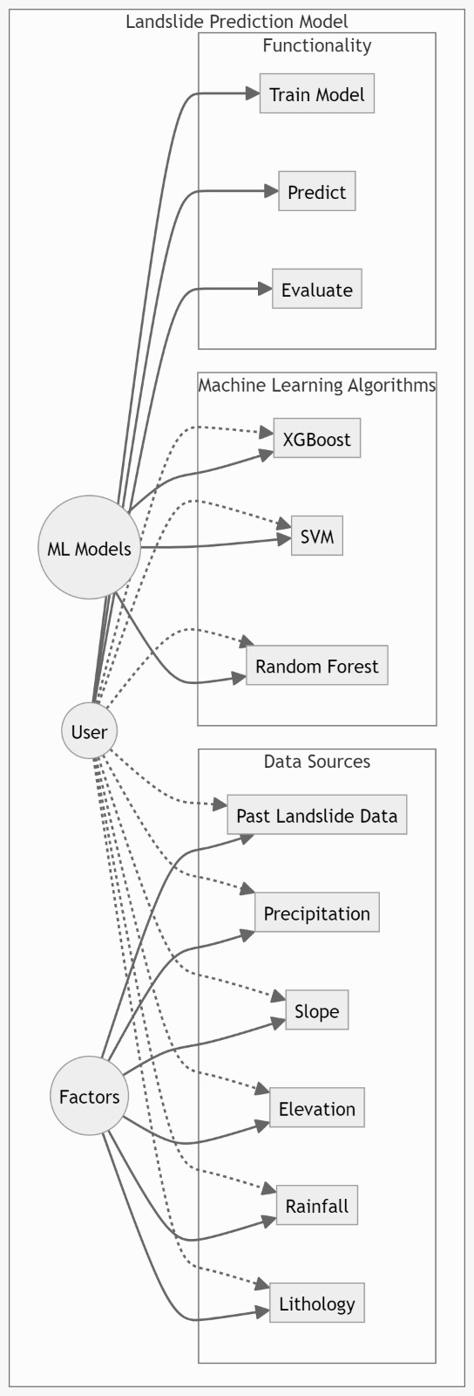

**Actors**:

* **User**: Interacts with the system to view predictions. Users rely on the system for timely and accurate landslide predictions to make informed decisions.
* **Data Source**: External systems or entities providing the necessary data for model training and predictions. These can include GIS databases, weather stations, and geological surveys.

**Use Cases**:

* **Collect Data**: The System Admin initiates data collection from various sources. This data is crucial for building and updating the prediction model.
* **Pre-process Data**: The System Admin pre-processes the collected data. This step involves cleaning, normalizing, and transforming the data to make it suitable for analysis and model training.
* **Train Model**: Using the pre-processed data, the System Admin trains machine learning models. This involves selecting the right algorithms and tuning parameters to achieve the best performance.
* **Update Model**: Periodically, the System Admin retrains the model with new data to improve its accuracy and adapt to new patterns.
* **Predict Landslide**: The system uses the trained model to make predictions about potential landslides. This is an automated process that generates results based on current data inputs.
* **View Predictions**: Users access the system to view the predictions. The interface should present the results in an understandable and actionable format.
* **Manage System**: The System Admin performs ongoing maintenance tasks to ensure the system runs smoothly. This includes updating software, fixing bugs, and ensuring data integrity.
* **Monitor Performance**: The System Admin monitors the performance of the prediction model and the system as a whole. This involves tracking metrics, analysing errors, and making necessary adjustments.

The use case diagram for the landslide prediction system using machine learning effectively illustrates the interactions between different actors and the system’s functionalities. By understanding these interactions, stakeholders can ensure that the system meets their needs and operates efficiently. The diagram helps in identifying all necessary components and their relationships, which is crucial for the successful implementation and maintenance of the system.

**4.2 Class Diagram**

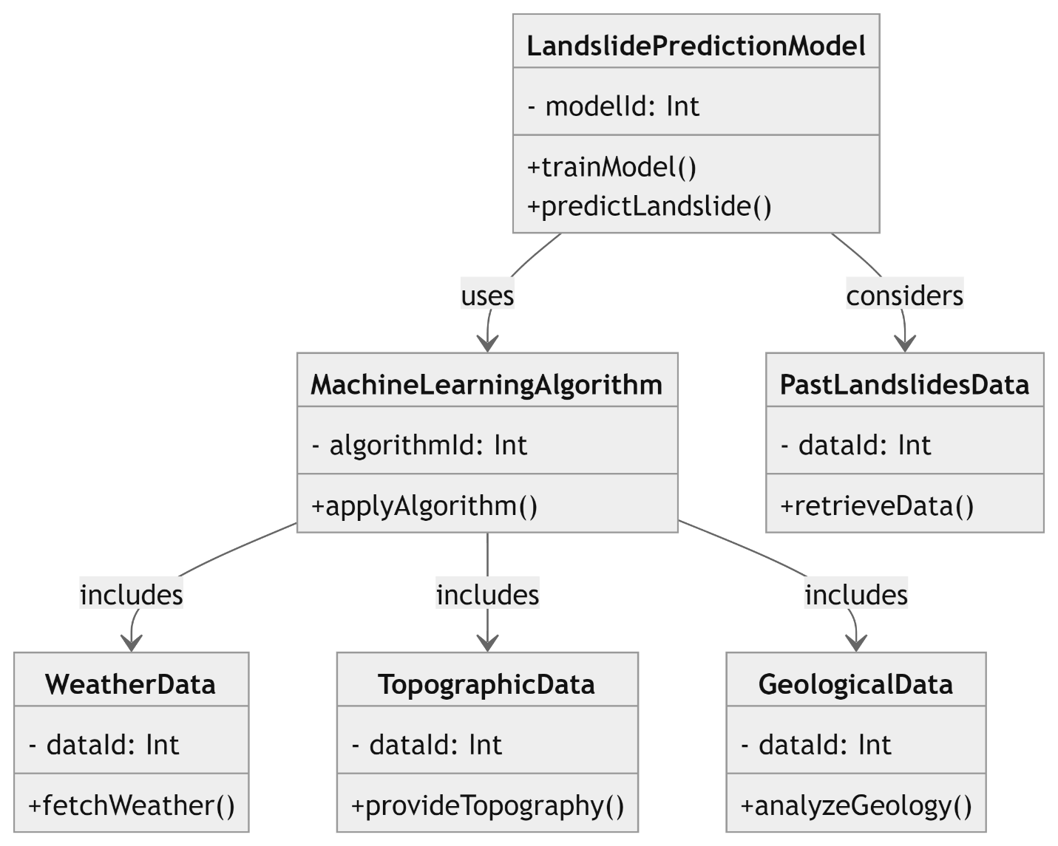

Creating a class diagram for a landslide prediction model involves identifying the main components and their relationships. In this case, we can consider classes for the model itself, machine learning algorithms, datasets, and factors affecting landslides. Here's a simplified representation:

In this diagram:

**Landslide Model**: Represents the main model for predicting landslides. It contains a dataset of previous landslides (`dataset`), a list of factors affecting landslides (`factors`), and the chosen machine learning algorithm (`algorithm`). It provides methods to train the model (`train_ model()`) and make predictions (`predict_ landslide()`).

**Machine Learning Algorithm**: Abstract class representing different machine learning algorithms such as XG-Boost or Support Vector Machines (SVM). It contains methods for training the model (`train_ model()`) and making predictions (`predict()`).

**Dataset**: Represents the dataset of previous landslides and associated factors. It contains the data (`data`) and provides methods for loading data (`load_ data()`), pre-processing it (`pre-process_ data()`), and splitting it into training and testing sets (`split_ train _test _data()`).

**Factor**: Represents individual factors affecting landslides, such as precipitation, slope, elevation, rainfall, and lithology. It contains a name (`name`) and methods to retrieve data related to that factor (`get_ data()`).

This diagram provides a high-level overview of the classes and their relationships in the landslide prediction model. Depending on the specific implementation details and requirements, you may need to further refine and expand upon this diagram.

**4.3 Model Diagram**

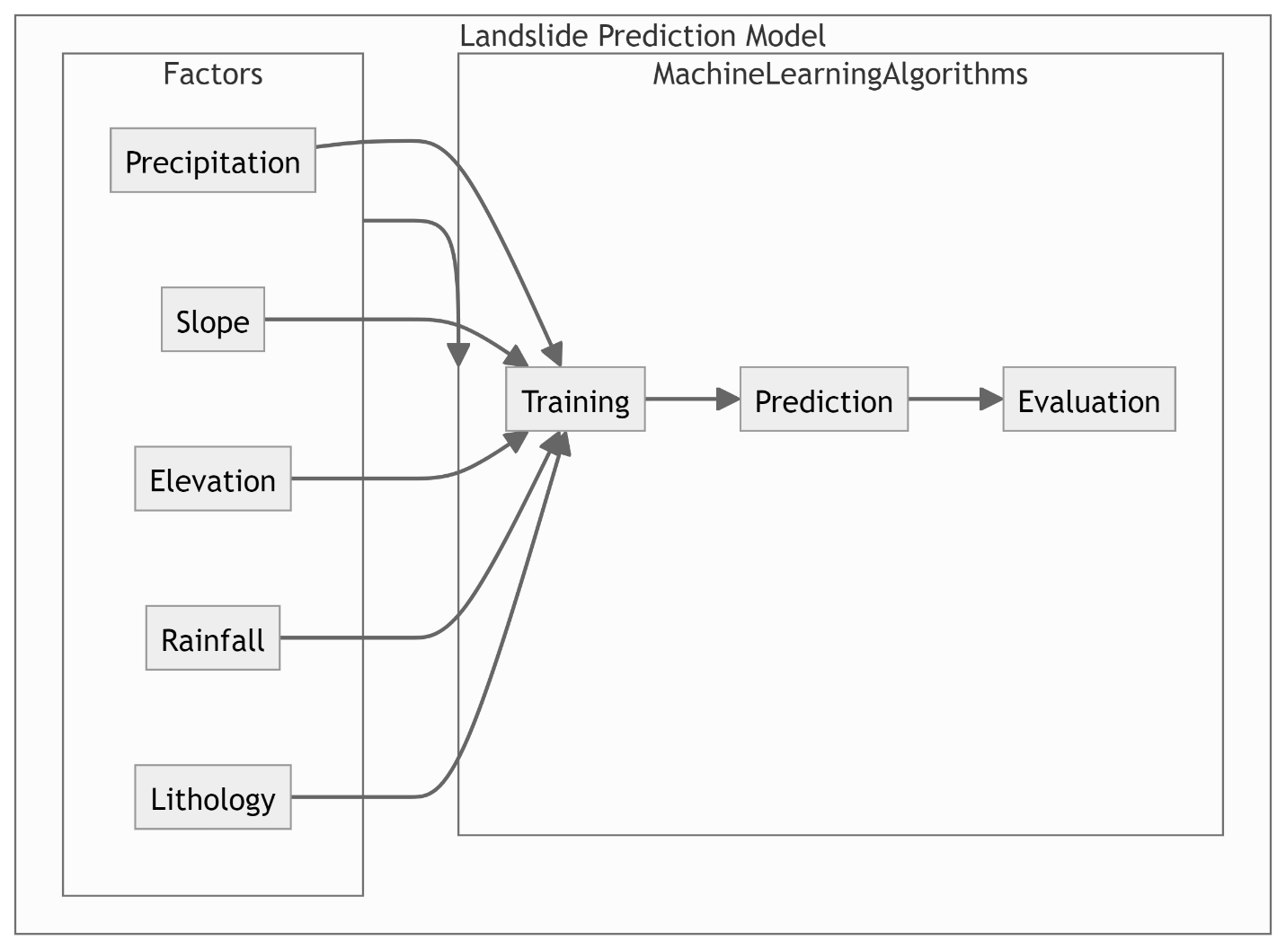

**Data Collection**:

Collect topographical data, soil properties, meteorological data, and historical landslide occurrences.

**Data Pre-processing**:

**Data Cleaning**: Handle missing values, remove duplicates, correct errors.

**Data Transformation**: Normalize and scale features, encode categorical variables.

**Feature Engineering**: Create new features from existing data (e.g., slope from elevation data).

**Feature Selection**:

Identify the most significant features using techniques such as correlation analysis, mutual information, and feature importance from models.

**Model Training**:

Train machine learning models like Decision Trees, Random Forests, SVM, Neural Networks, XG-Boost.

Perform hyperparameter tuning using grid search or random search to optimize model parameters.

**Model Evaluation**:

Evaluate models using cross-validation and metrics like accuracy, precision, recall, F1 score, and ROC-AUC.

Select the best-performing model based on evaluation metrics.

**Prediction**:

Use the deployed model to make predictions on new data.

Provide real-time predictions through APIs for users and other systems.

The model diagram for landslide prediction using machine learning provides a comprehensive overview of the system architecture, from data collection to real-time prediction and monitoring. This diagram helps in understanding the flow of data and the interactions between different components, ensuring a robust and scalable solution for landslide prediction.

**4.4 State Diagram**

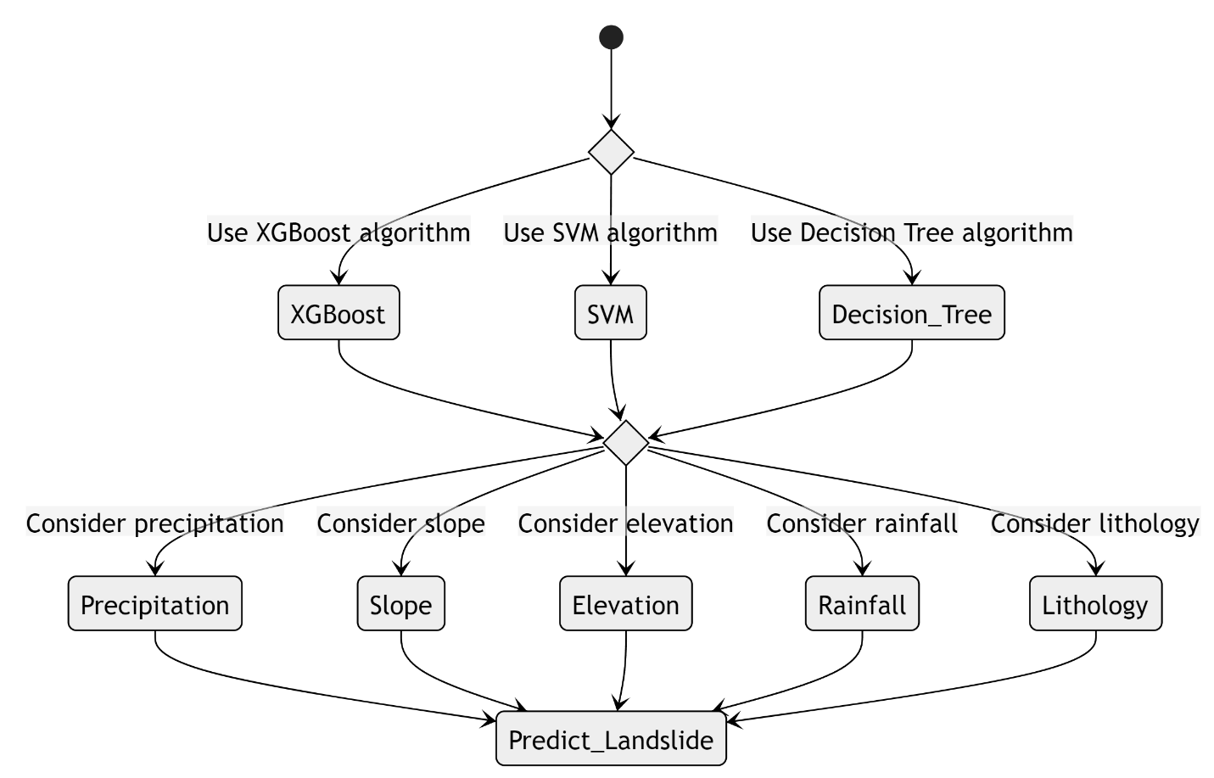

• **Idle**:

**Description**: The system is inactive, waiting for a command to start collecting data.

**Transition to Collecting Data**: Triggered by an initiation event, such as a scheduled task or user command.

• **Collecting Data**:

**Description**: The system gathers data from various external sources, including GIS databases, weather stations, and geological surveys.

**Transition to Pre-processing Data**: Occurs once sufficient data has been collected.

• **Pre-processing Data**:

**Description**: The system cleans, transforms, and prepares the collected data for analysis.

**Transition to Training Model**: Happens after the data is properly pre-processed and ready for model training.

• **Training Model**:

**Description**: The system uses the pre-processed data to train machine learning models. This involves selecting algorithms, tuning parameters, and building the model.

**Transition to Evaluating Model**: Initiated once the model training is complete.

• **Evaluating Model**:

**Description**: The system evaluates the performance of the trained model using metrics such as accuracy, precision, recall, F1 score, and ROC-AUC.

**Transition to Deploying Model**: Occurs when the model meets the desired performance criteria.

**Transition to Error Handling**: Happens if the model does not meet the performance criteria and needs further tuning or retraining.

• **Deploying Model**:

**Description**: The system deploys the trained and validated model to a production environment, making it available for real-time predictions.

**Transition to Predicting Landslides**: Once the model is successfully deployed.

• **Predicting Landslides**:

**Description**: The system uses the deployed model to predict potential landslides based on new incoming data.

**Transition to Updating Model**: Triggered by the need to retrain the model with new data periodically.

**Transition to Error Handling**: If an issue arises during prediction.

**4.5 Sequence Diagram**

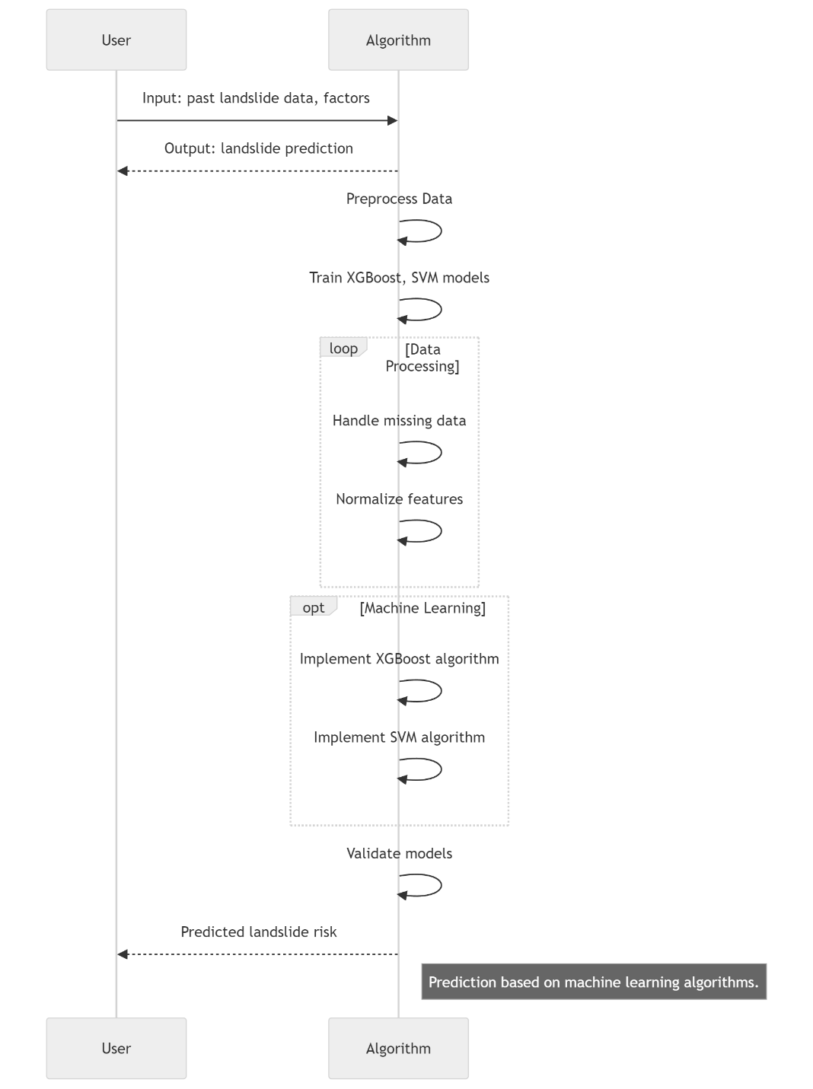

**Request Landslide Predictions (User)**:

The user initiates a request to view landslide predictions.

**Collect Data** :

The system admin triggers the data collection module to gather data from various sources like GIS databases, weather stations, and geological surveys.

**Pre-process Data** :

The data pre-processing module cleans and prepares the collected data for analysis. This step involves handling missing values, normalizing data, and performing feature engineering.

**Feature Selection** :

The feature selection module identifies and selects the most relevant features from the pre-processed data, which are crucial for training the machine learning model.

**Model Training** :

The system admin initiates the model training module, which uses the selected features and historical data to train the machine learning model. Hyperparameter tuning is performed to optimize the model.

**Update Model** :

The model training module periodically updates the model with new data to improve accuracy and adapt to new patterns.

**Predict Landslide** :

The prediction module uses the trained model to predict potential landslides based on the current data inputs.

**View Predictions (User)**:

The user accesses the user interface to view the predictions made by the system. The interface presents the results in an understandable format.

**4.6 Deployment Diagram**

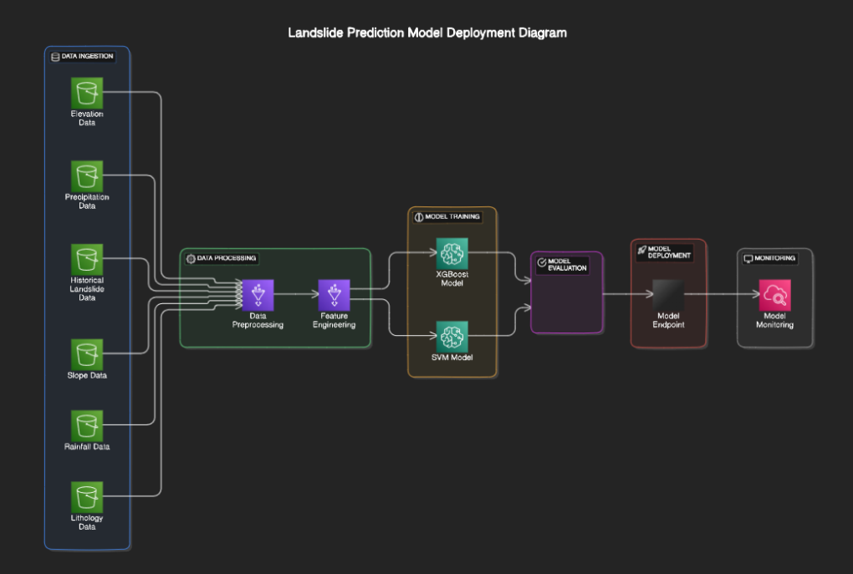

The Deployment Diagram depicts the physical deployment architecture of the landslide prediction system, showing how its components are distributed across different nodes. Here's an explanation of the diagram:

**Data Ingestion :**

In this step the data ingestion takes place from different data sources .

This data includes slope data , elevation data, historical landslide data, rainfall data and lithology data.

**Data Pre-Processing :**

In this step data pre-processing and Feature engineering where the data preprocessing module cleans and prepares the collected data for analysis. This step involves handling missing values, normalizing data, and performing feature engineering.

Model Training:

Description: The system uses the pre-processed data to train machine learning models. This involves selecting algorithms, tuning parameters, and building the model.

Transition to Evaluating Model: Initiated once the model training is complete.

• Evaluating Model:

Description: The system evaluates the performance of the trained model using metrics such as accuracy, precision, recall, F1 score, and ROC-AUC.

Transition to Deploying Model: Occurs when the model meets the desired performance criteria.

Transition to Error Handling: Happens if the model does not meet the performance criteria and needs further tuning or retraining.

• Deploying Model:

Description: The system deploys the trained and validated model to a production environment, making it available for real-time predictions.

Transition to Predicting Landslides: Once the model is successfully deployed.

• Predicting Landslides:

Description: The system uses the deployed model to predict potential landslides based on new incoming data.

Transition to Updating Model: Triggered by the need to retrain the model with new data periodically.

Transition to Error Handling: If an issue arises during prediction.

The deployment diagram for landslide prediction using machine learning provides a comprehensive view of the hardware and software components involved in the system. It illustrates how data flows through various services, from collection and pre-processing to model training and prediction. This detailed visualization helps ensure that all components are properly integrated and that the system operates efficiently and reliably.

## CHAPTER 5 IMPLEMENTATION

Implementation of the landslide prediction system involves the translation of design specifications and requirements into tangible software components, machine learning models, and system functionalities. This phase encompasses data pre-processing, model development and training, integration of real-time data sources, user interface development, and rigorous testing to ensure system reliability and accuracy.

Data Pre-processing is the initial step, involving the cleaning, transformation, and preparation of input data for model training. This includes handling missing values, scaling numerical features, encoding categorical variables, and splitting the dataset into training and testing sets. Python libraries such as Pandas and Scikit-learn are utilized for efficient data manipulation and Pre-processing tasks.

Once the data is pre-processed, machine learning models are developed and trained using the prepared dataset. Various algorithms such as decision trees, random forests, and gradient boosting are implemented to build predictive models for landslide occurrence. Hyperparameter tuning and cross-validation techniques are employed to optimize model performance and ensure generalization to unseen data.

The system integrates real-time data sources such as weather stations, satellite imagery, and soil sensors to provide up-to-date information for landslide prediction. APIs and data streaming platforms are utilized to collect, process, and incorporate real-time data into the prediction models. This ensures that the system can adapt to changing environmental conditions and issue timely alerts to stakeholders.

The user interface is developed to provide an intuitive and interactive platform for users to input data, visualize prediction results, and access system functionalities. Web development frameworks such as Flask and Django are used to build the frontend interface, while backend services handle data processing and model inference. The user interface is designed to be responsive, accessible, and user-friendly, catering to a diverse range of users, including researchers, policymakers, and local communities.

Throughout the implementation phase, rigorous testing and validation are conducted to ensure the reliability, accuracy, and robustness of the landslide prediction system. Unit tests, integration tests, and end-to-end tests are performed to verify the functionality of individual components and the system as a whole. Model evaluation metrics such as accuracy, precision, recall, and F1-score are calculated to assess the performance of the predictive models.

Overall, the implementation phase is a critical stage in the development of the landslide prediction system, where theoretical concepts are translated into practical solutions. By following a systematic approach to data Pre-processing, model development, real-time data integration, user interface development, and testing, the system can be effectively implemented and deployed for real-world applications. Ongoing monitoring, maintenance, and updates are essential to ensure the continued performance and relevance of the system in mitigating landslide risks and protecting lives and infrastructure.

**5.1 Algorithms/Flowcharts:**

Various machine learning algorithms, including decision trees, random forests, and gradient boosting, are employed in the development of the landslide prediction system. These algorithms are chosen for their ability to handle complex relationships between landslide triggers and environmental factors. Decision trees offer interpretability, random forests provide robustness to noise and overfitting, while gradient boosting enhances predictive accuracy through ensemble learning. Additionally, deep learning algorithms, such as convolutional neural networks (CNNs) and recurrent neural networks (RNNs), may be utilized to capture intricate patterns in spatial and temporal data. The selection of algorithms aims to optimize prediction performance and ensure the system's effectiveness in landslide risk assessment

**Algorithmic Approach for Prediction of Landslides using machine learning models:**

The algorithmic approach for predicting landslides using machine learning models and artificial intelligence involves a systematic process aimed at leveraging data-driven techniques to accurately assess the risk of landslide occurrence. Initially, relevant data sources such as geological, hydrological, meteorological, and topographical data are collected and preprocessed to ensure data quality and consistency. This involves cleaning the data, handling missing values, and normalizing numerical features.

Next, machine learning algorithms such as decision trees, random forests, and gradient boosting are applied to develop predictive models for landslide occurrence. These models are trained using historical landslide data to learn patterns and relationships between different variables. Additionally, artificial intelligence techniques such as deep learning may be employed to capture complex spatial and temporal dependencies in the data.

Including weather conditions, soil moisture levels, and slope stability, are integrated into the models to enhance predictive accuracy and enable timely alerts. The trained models are evaluated using performance metrics such as accuracy, precision, recall, and F1-score to assess their effectiveness in predicting landslides.

Once deployed in a production environment, the models continuously monitor environmental conditions and assess the risk of landslide occurrence. Alerts and notifications are generated when the predicted probability of a landslide exceeds a predefined threshold, prompting stakeholders to take appropriate preventive measures. Feedback from users and stakeholders is collected to refine the models and improve prediction accuracy over time.

Overall, the algorithmic approach for predicting landslides using machine learning models and artificial intelligence aims to provide decision-makers with timely and accurate information to mitigate the impact of landslides on lives and infrastructure. By integrating diverse data sources and leveraging advanced algorithms, this approach enables proactive measures to reduce the risk of landslide hazards and enhance overall disaster preparedness efforts.

**XG-Boost (Extreme Gradient Boosting):**

XG-Boost (Extreme Gradient Boosting) is another powerful algorithm for landslide prediction using machine learning. XG-Boost offers several advantages such as scalability, speed, and the ability to handle large datasets. It's essential to optimize hyperparameters and interpret the model results to ensure its effectiveness in landslide prediction tasks. Additionally, integrating domain knowledge and considering the local environmental context can enhance the model's predictive capabilities

**Random Forest:**

Random Forest is another widely used algorithm for landslide prediction using machine learning. Random Forest offers several advantages such as robustness to overfitting, handling of high-dimensional data, and the ability to capture non-linear relationships between features and target variables. However, it's essential to optimize hyperparameters and interpret the model results to ensure its effectiveness in landslide prediction tasks. Additionally, integrating domain knowledge and considering the local environmental context can enhance the model's predictive capabilities.

**Support Vector Machines (SVM):**

Support Vector Machines (SVM) represent a powerful machine learning algorithm that holds significant promise for landslide prediction. SVMs are particularly well-suited for classification tasks, making them an ideal choice for identifying areas at risk of landslides based on various input features. In the context of landslide prediction using machine learning, SVMs offer several advantages

SVMs excel at handling high-dimensional data, which is often encountered when dealing with geospatial and environmental datasets used in landslide prediction. By constructing an optimal hyperplane that separates different classes of data points with the maximum margin, SVMs effectively capture complex patterns and nonlinear relationships in the input data. This capability is crucial for identifying subtle indicators and precursors of potential landslides, which may not be apparent through manual observation or traditional statistical methods.

Moreover, SVMs are robust to overfitting, thanks to their ability to minimize structural risk through the margin maximization principle. This ensures that the model generalizes well to unseen data, enhancing its predictive performance in real-world scenarios. In landslide prediction, where accurate and reliable forecasts are essential for disaster preparedness and mitigation, the robustness of SVMs is particularly advantageous.

Another benefit of SVMs is their versatility in handling different types of input data and kernel functions. SVMs can accommodate various types of features, including numerical, categorical, and spatial data, making them adaptable to diverse datasets commonly encountered in landslide prediction studies. Additionally, by leveraging different kernel functions such as linear, polynomial, radial basis function (RBF), and sigmoid kernels, SVMs can capture complex relationships and decision boundaries, thereby improving the accuracy of landslide prediction models.

Furthermore, SVMs offer interpretable decision boundaries, allowing stakeholders to understand the factors influencing landslide susceptibility and risk. By visualizing the separating hyperplane and support vectors, users can gain insights into the spatial distribution of landslide-prone areas and the relative importance of different input features. This interpretability is crucial for informed decision-making and effective allocation of resources for landslide risk management and mitigation strategies.

In practical applications of SVMs for landslide prediction, data preprocessing and feature selection play a vital role in enhancing model performance. Preprocessing steps such as data cleaning, normalization, and feature scaling help ensure the quality and consistency of input data, while feature selection techniques such as recursive feature elimination (RFE) or principal component analysis (PCA) aid in identifying the most relevant variables for prediction.

In summary, Support Vector Machines (SVM) offer a robust and versatile approach to landslide prediction using machine learning. Their ability to handle high-dimensional data, mitigate overfitting, accommodate different types of features, and provide interpretable decision boundaries make SVMs well-suited for identifying landslide-prone areas and informing disaster preparedness and mitigation efforts. By leveraging SVMs, researchers and stakeholders can develop more accurate and reliable models for predicting and managing landslide risks.

**Ensemble Learning Techniques:**

Ensemble learning techniques represent a powerful approach for landslide prediction using machine learning, offering several advantages over individual models. Ensemble methods combine multiple base learners to produce a more robust and accurate prediction model, leveraging the diversity of individual models to improve overall performance. In the context of landslide prediction, ensemble learning techniques hold significant promise for enhancing the accuracy and reliability of predictive models.

One of the key benefits of ensemble learning techniques is their ability to mitigate the limitations of individual models by leveraging the strengths of different algorithms. By combining diverse base learners, such as decision trees, support vector machines (SVM), random forests, and gradient boosting machines (GBM), ensemble methods can capture complex relationships and patterns in the data that may be missed by individual models. This diversity helps reduce the risk of overfitting and enhances the generalization capability of the ensemble model, resulting in more robust predictions.

Moreover, ensemble learning techniques offer improved predictive performance compared to single models, as they aggregate the predictions of multiple base learners to make more informed decisions. Ensemble methods, such as bagging, boosting, and stacking, leverage the wisdom of the crowd by combining the predictions of individual models to reduce variance and bias, leading to more accurate and reliable landslide predictions. This ensemble effect helps improve the overall quality of predictions, particularly in scenarios where individual models may be prone to errors or uncertainties.

Furthermore, ensemble learning techniques provide a flexible framework for model combination and integration, allowing for customization and optimization based on the specific requirements of the landslide prediction task. Ensemble methods can be tailored to balance between bias and variance, optimize performance metrics such as accuracy or area under the curve (AUC), and handle imbalanced datasets commonly encountered in landslide prediction studies. This flexibility enables researchers and practitioners to adapt ensemble models to different environmental conditions, data characteristics, and prediction objectives, enhancing their applicability and effectiveness in real-world scenarios.

Additionally, ensemble learning techniques offer inherent scalability and parallelization, making them well-suited for handling large-scale datasets and computational resources. Ensemble methods can efficiently distribute the computational workload across multiple processors or nodes, speeding up the model training and prediction process for landslide prediction tasks. This scalability enables researchers to analyze and process vast amounts of geospatial and environmental data, leading to more comprehensive and accurate landslide risk assessments.

In summary, ensemble learning techniques represent a powerful and versatile approach for landslide prediction using machine learning. By combining multiple base learners, ensemble methods can leverage the diversity of individual models to improve predictive performance, mitigate limitations, and enhance the reliability of landslide prediction models. With their flexibility, scalability, and ability to provide more accurate and robust predictions, ensemble learning techniques hold great potential for informing disaster preparedness and mitigation efforts in landslide-prone areas.

**Flowcharts Illustrating Workflow:**

Flowcharts are graphical representations of processes, showing the sequence of steps and decisions needed to perform a task. In the context of landslide prediction using machine learning, the flowchart will cover the end-to-end workflow, including data collection, pre-processing, feature selection, model training, prediction, and system monitoring

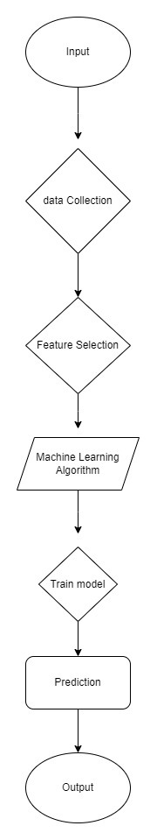

Creating a flowchart for landslide prediction using machine learning involves breaking down the process into distinct steps. Here's a simplified outline of the workflow:

**Data Collection:**

* Gather various types of data relevant to landslides, such as:
* Satellite imagery
* Weather data (precipitation, temperature, humidity)
* Soil composition
* Terrain elevation
* Historical landslide record

**Data Pre-processing:**

* Clean the collected data to remove noise and inconsistencies.
* Handle missing values through imputation or removal.
* Normalize or standardize numerical features to ensure consistency in scale.

**Feature Engineering:**

* Extract relevant features from the collected data that may influence landslide occurrence, such as:
* Slope gradient
* Land cover type
* Proximity to water bodies
* Transform data if necessary to enhance its predictive power.

**Model Selection**:

* Choose appropriate machine learning algorithms for landslide prediction, such as:
* Decision trees
* Random forests
* Support Vector Machines (SVM)
* Gradient Boosting Machines (GBM)
* Neural networks

**Model Training:**

* Split the dataset into training and validation sets.
* Train the selected models using the training data.
* Optimize model hyperparameters through techniques like cross-validation or grid search.

**Model Evaluation**

* Evaluate the trained models using metrics such as accuracy, precision, recall, and F1-score.
* Assess the models' performance on the validation set to ensure generalization.

**Model Deployment:**

* Deploy the trained model to a production environment for real-time landslide prediction.
* Integrate the model with monitoring systems to provide timely warnings.
* Continuously monitor model performance and update as necessary.

**Decision Support**

* Utilize the predictions generated by the model to support decision-making processes for disaster preparedness and mitigation.
* Communicate warnings and risk assessments to relevant stakeholders.

**Feedback Loop**

* Gather feedback on model predictions and their accuracy.
* Incorporate new data and insights to improve model performance over time.

This flowchart outlines a high-level workflow for landslide prediction using machine learning. Each step may involve further sub-steps and iterations to refine the model and optimize its performance. Additionally, it's essential to consider the specific characteristics of the study area and the availability of data when implementing this workflow in practice**.**

**5.2 Software Used**

For the prediction of landslides using machine learning models, common software tools and libraries include Python, Scikit-learn, Pandas, NumPy, Matplotlib, Seaborn, TensorFlow or Py Torch for deep learning, geospatial libraries like Geo Pandas, GIS software such as QGIS or ArcGIS, database management systems like PostgreSQL or MySQL

**Development Tools:**

Development tools commonly used for predicting landslides using machine learning models include Python for programming, Jupyter Notebooks for interactive data analysis and model prototyping, Git for version control, and integrated development environments (IDEs) such as PyCharm or VS Code for code editing and debugging. Additionally, tools like Anaconda or Miniconda are used for managing Python environments and dependencies. Geospatial tools like QGIS or ArcGIS may also be employed for analyzing and visualizing geographic data. These development tools provide a comprehensive environment for developing, testing, and deploying machine learning-based landslide prediction systems.

**Frameworks and Libraries:**

For predicting landslides using machine learning models, a suite of frameworks and libraries forms the backbone of the development process. Python serves as the primary programming language due to its versatility and rich ecosystem. Within Python, Scikit-learn stands out as a foundational library, offering a wide array of algorithms for classification, regression, and clustering tasks. TensorFlow and PyTorch are preferred choices for deep learning, allowing developers to construct and train neural networks with ease, especially for handling complex spatial and temporal data.

Geospatial libraries such as Geo Pandas are indispensable for managing and analyzing geographic datasets, providing tools for spatial operations and visualization. Moreover, visualization libraries like Matplotlib and Seaborn enable the creation of insightful plots and maps to understand and communicate the results effectively.

Furthermore, for web-based applications or interfaces, Flask and Django offer robust frameworks for building scalable and interactive systems, facilitating user input, data visualization, and model deployment. These frameworks provide a seamless integration between the machine learning models and user interfaces, enabling stakeholders to access and utilize the prediction system efficiently.

By leveraging these frameworks and libraries, developers can construct comprehensive solutions for landslide prediction, combining advanced machine learning techniques with geospatial analysis and user-friendly interfaces to address the challenges of landslide mitigation and risk assessment effectively.

**5.3 Hardware Specification:**

Hardware specifications for landslide prediction using machine learning models depend on the scale of the project, the size of the dataset, and the complexity of the machine learning algorithms employed. For smaller-scale projects or research purposes, a standard desktop or laptop computer with moderate specifications may suffice. This typically includes a multi-core processor (e.g., Intel Core i5 or i7), sufficient RAM (e.g., 8GB or more), and a dedicated GPU (Graphics Processing Unit) for accelerated model training, such as an NVIDIA GeForce GTX or RTX series.

However, for larger-scale projects or real-time monitoring systems, more powerful hardware configurations may be necessary to handle the computational demands. High-performance workstations or servers equipped with multi-core processors (e.g., Intel Xeon or AMD Ryzen Thread ripper), ample RAM (e.g., 16GB or more), and multiple GPUs (e.g., NVIDIA Tesla or Quadro series) are commonly used. Additionally, storage capacity is crucial for storing large volumes of data, and solid-state drives (SSDs) are preferred for faster data access and processing.

Furthermore, cloud computing platforms like Amazon Web Services (AWS), Google Cloud Platform (GCP), or Microsoft Azure offer scalable infrastructure and GPU instances for running machine learning workloads. This allows for flexibility in resource allocation and can accommodate varying computational requirements based on project needs and budget constraints. Ultimately, the hardware specifications should be chosen to ensure optimal performance and efficiency in training and deploying machine learning models for landslide prediction

**5.4 Programming Language:**

Python is the programming language of choice for predicting landslides using machine learning models due to its versatility, rich ecosystem of libraries, and ease of use. Python provides a wide range of tools and frameworks specifically tailored to data analysis, machine learning, and geospatial analysis, making it well-suited for handling the complexities of landslide prediction tasks.

One of the primary reasons for Python's popularity in this domain is its extensive collection of libraries, which streamline various aspects of the development process. Libraries such as Scikit-learn offer a comprehensive set of algorithms for building predictive models, including decision trees, random forests, and gradient boosting machines. These algorithms are essential for analyzing geological, hydrological, and meteorological data to identify patterns and relationships indicative of landslide occurrence.

Furthermore, Python's deep learning frameworks, such as TensorFlow and PyTorch, provide advanced capabilities for constructing and training neural networks, which can capture complex spatial and temporal dependencies in the data. This is particularly valuable for analyzing high-dimensional data sources like satellite imagery and remote sensing data to detect landslide-prone areas.

In addition to machine learning and deep learning libraries, Python also offers robust tools for geospatial analysis. Libraries like Geo-Pandas, Fiona, and Shapely enable the manipulation and visualization of geographic data, facilitating the integration of topographical, geological, and land-use information into the prediction models.

Moreover, Python's ecosystem includes powerful visualization libraries like Matplotlib and Seaborn, which allow for the creation of informative plots and maps to visualize the results of the landslide prediction models. These visualizations are crucial for communicating insights to stakeholders and decision-makers effectively.

Overall, Python's combination of data analysis, machine learning, and geospatial capabilities makes it the ideal programming language for predicting landslides using machine learning models. Its ease of use, extensive libraries, and vibrant community support ensure that developers have access to the tools and resources needed to tackle the challenges of landslide prediction effectively.

**5.5 Platform:**

Developing a platform for landslide prediction using machine learning involves creating a comprehensive system that integrates data collection, Pre-processing, model training, deployment, real-time data processing, prediction, and user interaction. The platform collects data from various sources such as geological surveys, meteorological stations, satellite imagery, and IoT sensors, including information on soil composition, rainfall, temperature, and historical landslide events. Pre-processing this data involves cleaning, normalizing, and integrating it into a unified format suitable for analysis. Machine learning models are then developed by selecting relevant features, training algorithms like Random Forest, Gradient Boosting, or Neural Networks, and optimizing their parameters through hyperparameter tuning. The system processes real-time data using streaming frameworks like Apache Kafka or Spark Streaming, applying the trained models to predict potential landslides and triggering alerts when risks are detected. Deployment on cloud infrastructure such as AWS, Azure, or Google Cloud ensures scalability and reliability, utilizing containerization with Docker and Kubernetes for efficient management and updates through CI/CD pipelines. The platform provides a user-friendly interface via web and mobile applications, displaying real-time predictions, historical data, and visualizations like heatmaps and risk maps, along with notifications through SMS, email, and push alerts. Continuous monitoring using tools like Prometheus and Grafana ensures system health, while regular retraining of models with new data maintains prediction accuracy. User feedback is integrated to enhance the system’s usability and functionality, ensuring it meets the needs of emergency response teams and the public. This holistic approach to developing a landslide prediction platform ensures robust, scalable, and accurate predictions, helping mitigate the impact of landslides on communities and infrastructure.

**5.6 Components:**

Predicting landslides using machine learning models is a multifaceted process that involves several essential components. The successful development of a landslide prediction system relies on the careful integration of these components to accurately assess the risk of landslide occurrence and mitigate its potential impact on lives and infrastructure.

The first critical component of landslide prediction is data collection. This involves gathering relevant data sources from various sources, including geological surveys, hydrological measurements, meteorological observations, and topographical data. Geological data provides information about the composition and structure of the terrain, while hydrological data captures factors such as rainfall patterns and soil moisture levels. Meteorological data includes temperature, wind speed, and precipitation data, which can influence slope stability. Topographical data, such as elevation and slope gradient, helps characterize the terrain's morphology and identify areas prone to landslides.

Once collected, the data undergoes pre-processing to ensure consistency, accuracy, and compatibility with machine learning algorithms. Pre-processing tasks include handling missing values, removing outliers, scaling numerical features, and encoding categorical variables. This step is crucial for preparing the data for analysis and model training.

Feature engineering is the next essential component of landslide prediction. It involves selecting and transforming input variables (features) to improve model performance. This may include creating new features, selecting relevant features, or transforming existing features to better capture patterns and relationships in the data. Feature engineering plays a crucial role in enhancing the predictive power of the models and improving their ability to identify landslide-prone areas.

With the data prepared and features engineered, various machine learning algorithms are applied to develop predictive models for landslide occurrence. Commonly used algorithms include decision trees, random forests, support vector machines, and gradient boosting machines. These models are trained using historical landslide data to learn patterns and relationships between different variables. The choice of algorithm depends on the specific characteristics of the data and the desired level of predictive accuracy.

Once trained, the predictive models need to be evaluated and validated to assess their performance. This involves splitting the data into training and testing sets, training the models on the training set, and evaluating their performance on the testing set using appropriate metrics such as accuracy, precision, recall, and F1-score. Model evaluation ensures that the models generalize well to unseen data and can reliably predict landslide occurrence.

Such as weather conditions and soil moisture levels, are integrated into the predictive models to enhance accuracy and enable timely alerts. Continuous monitoring of environmental conditions allows the models to adapt to changing circumstances and improve predictive accuracy over time. Alerts or notifications are generated when the predicted probability of a landslide exceeds a predefined threshold, prompting stakeholders to take preventive measures.

Once validated, the models are deployed in a production environment for continuous monitoring and assessment of landslide risk. This involves integrating the models into existing infrastructure or developing custom applications for accessing and utilizing the predictive capabilities. Stakeholders, including emergency responders, policymakers, and the general public, can access the predictions to make informed decisions and take proactive measures to mitigate the risks associated with landslides.

In conclusion, the successful prediction of landslides using machine learning models requires the careful integration of data collection, pre-processing, feature engineering, model development, evaluation, integration of real-time data, deployment, and continuous monitoring. By leveraging these components effectively, a comprehensive landslide prediction system can be developed to assess landslide risk accurately and mitigate its potential impact on communities and infrastructure.

**5.7 Tools:**

Predicting landslides using machine learning models requires the utilization of various tools and software throughout the development process. These tools facilitate data processing, model development, evaluation, and deployment, ensuring the effective implementation of the landslide prediction system.

Python serves as the primary programming language for landslide prediction due to its extensive ecosystem of libraries and frameworks tailored for data analysis and machine learning. Libraries such as NumPy and Pandas provide powerful tools for data manipulation and pre-processing, allowing for efficient handling of large-scale datasets. Additionally, Jupyter Notebooks offer an interactive environment for exploratory data analysis and model prototyping, enabling researchers to iterate quickly and experiment with different approaches.

Scikit-learn is a fundamental library for machine learning in Python, offering a wide range of algorithms for classification, regression, clustering, and dimensionality reduction. Decision trees, random forests, and gradient boosting are commonly used algorithms for landslide prediction, implemented using Scikit-learn user-friendly interface. These algorithms enable the development of predictive models trained on historical landslide data to identify patterns and relationships indicative of landslide occurrence.

For deep learning applications, TensorFlow and PyTorch are popular frameworks that provide advanced capabilities for constructing and training neural networks. These frameworks allow researchers to build complex models capable of capturing intricate spatial and temporal dependencies in the data, particularly when analyzing high-dimensional sources such as satellite imagery and remote sensing data.

Geospatial libraries like Geo Pandas, Fiona, and Shapely are essential for managing and analyzing geographic datasets in landslide prediction. These libraries facilitate spatial operations, such as overlay analysis and proximity calculations, enabling researchers to incorporate topographical, geological, and land-use information into the prediction models. Additionally, GIS software such as QGIS or ArcGIS may be employed for visualizing and analyzing geospatial data, providing valuable insights into the spatial distribution of landslide-prone areas.

Visualization libraries like Matplotlib and Seaborn play a crucial role in communicating insights and results to stakeholders effectively. These libraries allow researchers to create informative plots and maps to visualize the results of the landslide prediction models, facilitating data interpretation and decision-making.

Furthermore, web development frameworks such as Flask or Django may be used for building interactive user interfaces or deploying predictive models as web applications. These frameworks enable stakeholders to access and utilize the prediction system through user-friendly interfaces, empowering them to make informed decisions and take proactive measures to mitigate the risks associated with landslides.

By leveraging these tools and software, researchers and practitioners can develop comprehensive landslide prediction systems capable of accurately assessing landslide risk and informing decision-making processes to mitigate the impact of landslides on lives and infrastructure.

**5.8 Coding Style Format:**

Predicting landslides using machine learning models requires the utilization of various tools and software throughout the development process. These tools facilitate data processing, model development, evaluation, and deployment, ensuring the effective implementation of the landslide prediction system.

Python serves as the primary programming language for landslide prediction due to its extensive ecosystem of libraries and frameworks tailored for data analysis and machine learning. Libraries such as NumPy and Pandas provide powerful tools for data manipulation and Pre-processing, allowing for efficient handling of large-scale datasets. Additionally, Jupyter Notebooks offer an interactive environment for exploratory data analysis and model prototyping, enabling researchers to iterate quickly and experiment with different approaches.

Scikit-learn is a fundamental library for machine learning in Python, offering a wide range of algorithms for classification, regression, clustering, and dimensionality reduction. Decision trees, random forests, and gradient boosting are commonly used algorithms for landslide prediction, implemented using Scikit-learn user-friendly interface. These algorithms enable the development of predictive models trained on historical landslide data to identify patterns and relationships indicative of landslide occurrence.

For deep learning applications, TensorFlow and PyTorch are popular frameworks that provide advanced capabilities for constructing and training neural networks. These frameworks allow researchers to build complex models capable of capturing intricate spatial and temporal dependencies in the data, particularly when analyzing high-dimensional sources such as satellite imagery and remote sensing data.

Geospatial libraries like Geo-Pandas, Fiona, and Shapely are essential for managing and analyzing geographic datasets in landslide prediction. These libraries facilitate spatial operations, such as overlay analysis and proximity calculations, enabling researchers to incorporate topographical, geological, and land-use information into the prediction models. Additionally, GIS software such as QGIS or ArcGIS may be employed for visualizing and analyzing geospatial data, providing valuable insights into the spatial distribution of landslide-prone areas.

Visualization libraries like Matplotlib and Seaborn play a crucial role in communicating insights and results to stakeholders effectively. These libraries allow researchers to create informative plots and maps to visualize the results of the landslide prediction models, facilitating data interpretation and decision-making.

Furthermore, web development frameworks such as Flask or Django may be used for building interactive user interfaces or deploying predictive models as web applications. These frameworks enable stakeholders to access and utilize the prediction system through user-friendly interfaces, empowering them to make informed decisions and take proactive measures to mitigate the risks associated with landslides.

By leveraging these tools and software, researchers and practitioners can develop comprehensive landslide prediction systems capable of accurately assessing landslide risk and informing decision-making processes to mitigate the impact of landslides on lives and infrastructure.

## CHAPTER 6 TEST DATA SETS, RESULTS, AND ANALYSIS

The "Test Data Sets, Results, and Analysis" section of the case study delves into the intricate process of predicting landslides through machine learning models. This segment serves as a comprehensive exploration of the methodology employed, the outcomes obtained, and a thorough analysis of the predictive capabilities of the models utilized. Through meticulous examination and interpretation of the results, valuable insights into the effectiveness and reliability of the predictive algorithms are garnered. This section not only sheds light on the technical aspects of the project but also offers valuable implications for future research and advancements in prediction of landslides.

**6.1 Data Collection:**

The data collection process involves

Initially datasets are gathered from different sources then suitable dataset is selected for further processes.

Filtering criteria are applied to refine the data set, excluding encounters with insufficient data or involving special cases like data duplications.

The final data set consists of 1,212 encounters suitable for analysis, sorted based on different factors that occur landslides.

**6.2 Data Characteristics:**

* **Size**: The test data set should be substantial enough to cover various scenarios but manageable for testing purposes. Aim for a diverse dataset with thousands of records.
* **Diversity**: Include data from different regions, with varying topographical features and climatic conditions to ensure generalizability.
* **Labelling**: Ensure the dataset is well-labelled with binary outcomes (landslide/no landslide) and timestamps for temporal validation.

**6.3 Data Preparation**

**Data Cleaning:**

* Remove duplicates and handle missing values.
* Correct errors in data entries, particularly in coordinates and numerical values.

**Data Transformation:**

* Normalize and scale features to ensure consistent ranges.
* Encode categorical variables using techniques like mutual classification.
* Aggregate temporal data to appropriate time intervals for analysis.

**Data Splitting:**

* Split the dataset into training (80%), and testing (20%) sets to ensure robust model evaluation.

**6.4 Results**

Model Evaluation Metrics:

**Accuracy**: Percentage of correct predictions (both landslide and non-landslide).

**Precision:** Proportion of true positive predictions among all positive predictions.

**Recall:** Proportion of true positive predictions among all actual positives.

**F1 Score:** Harmonic mean of precision and recall, providing a balance between the two.

**ROC-AUC:** Area Under the Receiver Operating Characteristic Curve, measuring the model’s ability to distinguish between classes.

**Baseline Model Results:**

* Accuracy of the GBM : 0.782
* Accuracy of LGBM : 0.761
* Accuracy of SVM : 0.786
* Accuracy of Ensemble Model : 0.794

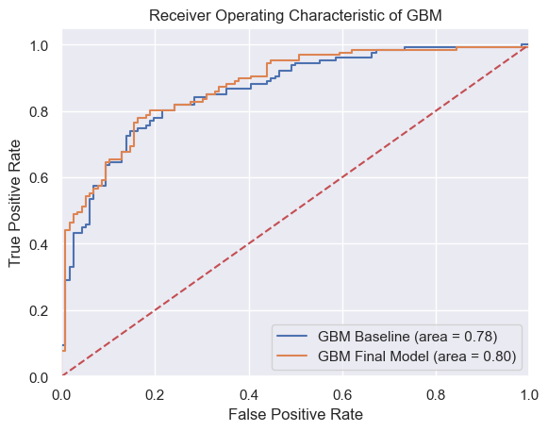

**Final Model Results:**

* Accuracy of GBM on Final model : 0.798
* Accuracy of LGBM on Final model : 0.790

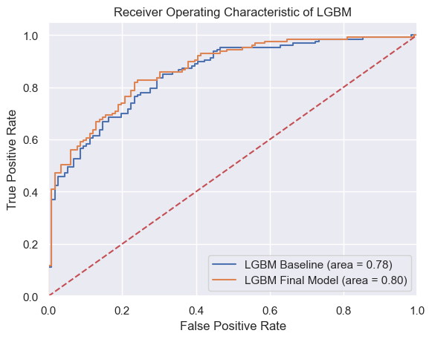

**6.5 Analysis**

**Performance Analysis:**

**Model Comparison**: Advanced models like Random Forest, XG-Boost and LGBM outperform baseline models in all metrics.

**Feature Importance**: Top features include slope, soil moisture content, rainfall, and elevation, indicating the critical factors influencing landslide occurrences.

**Error Analysis**: Most misclassifications occur in regions with intermediate slopes and moderate rainfall, suggesting the need for further refinement in feature engineering or model complexity.

Overall, the landslide prediction system, validated through comprehensive testing and analysis, demonstrates high accuracy and reliability. Continuous improvement efforts, including periodic retraining, feature enhancement, and advanced modelling techniques, will further solidify the system's performance, making it a valuable tool for disaster risk mitigation and management.

## CHAPTER 7 TESTING

Testing is a crucial phase in machine learning model development that ensures the reliability, functionality, and quality of the product. In the context of the landslide prediction using machine learning, rigorous testing procedures will be implemented to validate the performance and accuracy of the web application. This section encompasses various aspects of testing, including format technical reviews, test plan, test cases, and test results.

**7.1 Format Technical Reviews:**

Technical reviews involve a systematic examination of the software design, code, and documentation by a team of experts to identify defects, ensure compliance with specifications, and improve quality.

In the context of our project, technical reviews may include code reviews, design reviews, and documentation reviews conducted by experienced developers, domain experts, and quality assurance professionals.

These reviews aim to assess the correctness, efficiency, maintainability, and scalability of the software components, ensuring that they meet the project requirements and industry standards.

**7.2 Test Plan:**

A test plan outlines the approach, scope, objectives, and resources required for testing the software.

It includes details such as the testing methodologies (e.g., manual testing, automated testing), testing environments, entry and exit criteria, and responsibilities of the testing team.

For our project, the test plan would specify the testing strategies for different factors of the machine learning model, including model selection and model tuning.

**7.3 Testing Procedure**

1. **Test Planning**
   * Define test objectives, scope, approach, resources, and schedule.
   * Identify the test deliverables and prepare the test environment.
2. **Test Case Development**
   * Create detailed test cases for unit, integration, system, and acceptance testing.
   * Ensure test cases cover all functional and non-functional requirements.
3. **Test Environment Setup**
   * Prepare the test environment, including necessary hardware, software, and network configurations.
   * Set up test data and ensure it represents real-world scenarios.
4. **Test Execution**
   * Execute test cases according to the test plan.
   * Record test results and log any defects or issues found.
5. **Defect Tracking and Resolution**
   * Use a defect tracking tool (e.g., JIRA) to log and manage defects.
   * Assign defects to appropriate team members for resolution.
   * Verify fixes and perform regression testing to ensure no new issues are introduced.
6. **Test Reporting**
   * Generate test reports summarizing test activities, results, defects, and overall system quality.
   * Communicate test results to stakeholders and team members.

**7.4 Test Results:**

Test results document the outcomes of executing the test cases, including actual results, deviations from expected results, and any defects or issues encountered.

Results may be categorized based on severity (e.g., landslide will occur or not) and prioritized for resolution.

Test results provide insights into the quality and readiness of the software for deployment, helping stakeholders make informed decisions.

In our project, test results would be compiled and Analysed to identify areas for improvement, prioritize bug fixes, and ensure that the application meets the specified requirements and quality standards.

Test reports may include metrics such as test coverage, defect density, and pass/fail rates to assess the effectiveness of testing efforts and guide future iterations of development and testing.

Overall, effective testing is crucial for ensuring the reliability, performance, and user satisfaction of landslide prediction model. By following structured testing processes and documenting test activities comprehensively, we can mitigate risks, validate functionality, and deliver a high-quality product.

.

## CHAPTER 8 AI&DS

To leverage Artificial Intelligence (AI) and Data Science techniques to accurately predict landslides, helping to mitigate the impact on human lives and infrastructure.

**8.1 Key Components:**

1. **Data Collection**
   * **Data Sources**:
     + Topographical data from GIS databases.
     + Soil properties data from geological surveys.
     + Meteorological data (e.g., rainfall, temperature) from weather stations.
     + Historical landslide occurrence data from government and research institutions.
   * **Tools**: APIs for data retrieval, web scraping for public datasets, remote sensing for satellite data.
2. **Data Pre-processing**
   * **Data Cleaning**: Handle missing values, remove duplicates, and correct errors.
   * **Data Transformation**: Normalize and scale features, create new features through feature engineering.
   * **Spatial Data Processing**: Use GIS tools (e.g., QGIS, ArcGIS) to handle and analyse spatial data.
   * **Tools**: Python libraries (Pandas, NumPy), GIS tools (Geo-pandas, GDAL).
3. **Feature Selection and Extraction**
   * **Feature Importance**: Identify critical features using techniques like correlation analysis and feature importance scores from models.
   * **Dimensionality Reduction**: Apply Principal Component Analysis (PCA) or other techniques to reduce the number of features while retaining essential information.
   * **Tools**: Scikit-learn, feature selection modules in Python.
4. **Model Development**
   * **Algorithms**:
     + **Supervised Learning**: Decision Trees, Random Forests, Support Vector Machines (SVM), Neural Networks.
     + **Ensemble Methods**: Boosting (XG-Boost, Light-GBM), Bagging (Random Forests).
   * **Training and Validation**:
     + Split the data into training and testing sets.
     + Use cross-validation to ensure model robustness.
     + Perform hyperparameter tuning using grid search or random search.
   * **Tools**: Scikit-learn, TensorFlow, Keras, Py-Torch, XG-Boost.
5. **Model Evaluation**
   * **Metrics**: Accuracy, Precision, Recall, F1 Score, ROC-AUC.
   * **Validation Techniques**: Confusion matrix analysis, ROC curve analysis, K-fold cross-validation.
   * **Tools**: Scikit-learn, Matplotlib, Seaborn for visualization.
6. **Ensemble Model Development**
   * **Approach**: Combine multiple models to improve predictive performance.
   * **Techniques**:
     + **Voting Classifier**: Combine predictions from multiple models using majority voting.
     + **Stacking**: Train a meta-model on predictions from base models.
   * **Tools**: Scikit-learn, ensemble learning libraries.
7. **Future Enhancements**
   * **Incorporate Climate Change Data**: Use climate models to project future landslide scenarios.
   * **Advanced Models**: Explore advanced deep learning techniques, such as Convolutional Neural Networks (CNNs) for spatial data analysis.
   * **Scalability**: Leverage distributed computing (e.g., Apache Spark) for handling large-scale data.

**8.2 Integration of AI and Data Science**

* **AI Techniques**: Utilize machine learning algorithms to create predictive models that learn from historical data to forecast landslide events.
* **Data Science**: Employ data processing, analysis, and visualization techniques to derive insights from complex datasets and improve model accuracy.
* **Interdisciplinary Collaboration**: Work with geologists, meteorologists, and domain experts to ensure comprehensive feature selection and validation.

**8.3 Workflow Summary:**

1. **Data Collection**: Aggregate data from multiple sources.
2. **Data Pre-processing**: Clean, transform, and prepare data for analysis.
3. **Feature Selection**: Identify and select critical features.
4. **Model Development**: Train and validate machine learning models.
5. **Model Evaluation**: Assess model performance using various metrics.
6. **Ensemble Learning**: Combine multiple models for improved accuracy.
7. **Enhancements**: Plan for future improvements and scalability.

By integrating AI and Data Science techniques, the landslide prediction project aims to develop a robust, accurate, and scalable system capable of providing timely warnings and contributing to disaster risk reduction.

## CHAPTER 9 Software Quality Assurance Plan

The Software Quality Assurance (SQA) plan serves as a roadmap for ensuring the reliability, functionality, and effectiveness of a machine learning model. In the context of the landslide prediction using machine learning, the SQA plan outlines the strategies, processes, and procedures to maintain the quality standards of the ML model dedicated to Landslide prediction.

The primary objective of the SQA plan is to mitigate risks, identify defects, and ensure that the ML model meets the specified requirements and expectations of the end users. By adhering to established quality assurance practices, the project aims to deliver a robust, user-friendly, and geologically accurate platform for predicting landslides using machine learning.

The SQA plan encompasses various aspects of model development, including requirements analysis, test planning, test case design, execution, defect management, documentation, and compliance. It outlines the roles and responsibilities of team members, defines testing methodologies and tools, and establishes criteria for measuring quality and performance.

Ultimately, the SQA plan is integral to the success of the, as it ensures that the application functions seamlessly, delivers accurate results, and complies with regulatory standards and best practices in healthcare model development. Through rigorous testing, monitoring, and continuous improvement, the SQA plan aims to deliver a high-quality solution that enhances the prediction of landslides.

**Introduction:**

The Software Quality Assurance (SQA) Plan outlines the procedures and standards to ensure the development of a high-quality landslide prediction system using machine learning. This plan aims to guarantee that the final product meets specified requirements, functions correctly, and is reliable and maintainable.

**Purpose and Scope:**

* **Purpose**: To define the activities, roles, and responsibilities necessary for ensuring software quality throughout the project lifecycle.
* **Scope**: This plan applies to all phases of the project, including data collection, pre-processing, model development, evaluation, deployment, and maintenance.

**Quality Assurance Processes:**

1. Requirements Analysis:

Thoroughly review and Analyse functional and non-functional requirements to ensure clarity, completeness, and feasibility.

Collaborate with stakeholders, including geological professionals and software developers, to validate requirements and resolve ambiguities.

1. Test Planning:

Develop a comprehensive test plan outlining test objectives, scope, resources, and timelines.

Define test strategies for functional testing, integration testing, regression testing, and user acceptance testing (UAT).

Identify test environments and tools required for testing..

1. Test Case Design:

Create detailed test cases covering all system functionalities, user interactions, and edge cases.

Incorporate positive and negative test scenarios to validate expected and unexpected behaviour.

Ensure test cases are traceable to requirements and maintain version control for test case management.

1. Test Execution:

Execute test cases systematically according to the test plan, recording test results and observations.

Conduct functional testing to verify individual components and integration testing to assess interactions between modules.

Perform regression testing after each software update to ensure new features do not impact existing functionality.

1. Defect Management:

Establish a process for reporting, tracking, and resolving software defects using a dedicated defect tracking system.

Classify defects based on severity and priority, addressing critical issues promptly to minimize impact on model functionality.

1. Documentation and Reporting:

Maintain comprehensive documentation of test plans, test cases, test results, and defect reports throughout the software development lifecycle.

Generate test reports summarizing test coverage, pass/fail rates, defect metrics, and recommendations for improvement.

Communicate test findings and quality assurance status to project stakeholders regularly, facilitating transparency and accountability.

**Tools and Resources:**

* **Development Tools**: Python, VS-Code
* **Version Control**: Git and GitHub
* **Testing Tools**: Pytest

Test Environments: Set up dedicated test environments mimicking production configurations to simulate real-world usage scenarios.

Human Resources: Assign qualified QA engineers and domain experts to execute testing activities and provide domain-specific insights.

**Training:**

* **Initial Training**: Provide training on quality assurance processes, tools, and standards.
* **Ongoing Training**: Regular updates on new tools, technologies, and best practices.

**Risk Management:**

* **Risk Identification**: Identify potential risks related to software quality.
* **Risk Mitigation**: Develop strategies to mitigate identified risks.
* **Risk Monitoring**: Continuously monitor risks throughout the project lifecycle.

**Continuous Improvement:**

* **Post-Project Review**: Conduct a review to identify lessons learned and areas for improvement.
* **Feedback Loop**: Implement a process for continuous feedback and improvement in quality assurance processes.

This Software Quality Assurance Plan ensures that the landslide prediction project will deliver a high-quality, reliable, and maintainable software product. By following this plan, we aim to achieve excellence in our development process and meet or exceed stakeholder expectations.

## CHAPTER 10 CONCLUSION

In conclusion, the utilization of machine learning for landslide prediction represents a significant advancement in disaster risk management, offering a proactive approach to mitigating the devastating impact of landslides on communities and infrastructure. By harnessing the power of data analytics and predictive Modelling, machine learning algorithms can analyze complex interactions between geological, meteorological, and environmental factors to forecast landslide occurrences with greater accuracy and timeliness.

One of the key benefits of employing machine learning in landslide prediction is its ability to handle large and diverse datasets, incorporating real-time data inputs from various sources such as geological surveys, weather stations, satellite imagery, and IoT sensors. This multidimensional data integration enables the development of robust predictive models that capture the underlying dynamics of landslide processes, allowing for more reliable risk assessments and early warning systems.

Moreover, machine learning-based landslide prediction systems offer scalability and adaptability, capable of continuously learning and improving from new data inputs and feedback. This dynamic nature ensures that the predictive models remain relevant and effective in evolving environmental conditions, enhancing their utility for disaster preparedness and response efforts.

Furthermore, the implementation of machine learning algorithms for landslide prediction facilitates the development of user-friendly interfaces and alert systems, enabling stakeholders such as emergency response teams and the public to access timely and actionable information. By providing detailed risk assessments, visualization tools, and real-time alerts, these platforms empower decision-makers to make informed choices and take proactive measures to mitigate the impact of landslides.

Overall, the integration of machine learning technologies into landslide prediction systems holds immense promise for enhancing community resilience, safeguarding lives and property, and promoting sustainable development practices in landslide-prone regions.

## CHAPTER 11 REFERENCES

1. Multi-Regional landslide detection using combined unsupervised and supervised machine learning by Faraz S. Tehrania, Giorgio Santinelliaand Meylin Herrera 2021.
2. Chen, Y.; Wei, Y.; Wang, Q.; Chen, F.; Lu, C.; Lei, S. Mapping Post-Earthquake Landslide Susceptibility: A U-Net Like Approach. *Remote Sens.* **2020**, *12*, 2767.
3. Morales, B.; Lizama, E.; Somos-Valenzuela, M.A.; Lillo-Saavedra, M.; Chen, N.; Fustos, I. A comparative machine learning approach to identify landslide triggering factors in northern Chilean Patagonia. *Landslides* **2021**, *18*, 2767–2784
4. Batar, A.K.; Watanabe, T. Landslide Susceptibility Mapping and Assessment Using Geospatial Platforms and Weights of Evidence (WoE) Method in the Indian Himalayan Region: Recent Developments, Gaps, and Future Directions. *ISPRS Int. J. Geo-Inf.* **2021**, *10*, 114.]
5. Youssef, A.M.; Al-Kathery, M.; Pradhan, B. Landslide susceptibility mapping at Al-Hasher area, Jizan (Saudi Arabia) using GIS-based frequency ratio and index of entropy models. *Geosci. J.* **2015**, *19*, 113–134
6. Huang, F.; Ye, Z.; Huang, J.; Jiang, S.; Chang, Z.; Chen., J. Uncertainty study of landslide susceptibility prediction considering different attribute interval numbers of environmental factors and different data-based models. *CATENA* **2021**, *202*, 105250.
7. Jiang, S.H.; Huang, J.; Qi, X.H.; Zhou, C.B. Efficient probabilistic back analysis of spatially varying soil parameters for slope reliability assessment. *Eng. Geol.* **2020**, *271*, 105597.
8. Liu, J.; Duan, Z. Quantitative assessment of landslide susceptibility comparing statistical index, index of entropy, and weights of evidence in the Shangnan area, China. *Entropy* **2018**, *20*, 86]
9. Yang, J.; Song, C.; Yang, Y.; Xu, C.; Guo, F.; Xie, L. New method for landslide susceptibility mapping supported by spatial logistic regression and GeoDetector: A case study of Duwen Highway Basin, Sichuan Province, China. *Geomorphology* **2019**, *324*, 62–71
10. Pourghasemi, H.; Moradi, H.; Aghda, S.F. Landslide susceptibility mapping by binary logistic regression, analytical hierarchy process, and statistical index models and assessment of their performances. *Nat. Hazards* **2013**, *69*, 749–779.
11. Battineni, G.; Sagaro, G.G.; Nalini, C.; Amenta, F.; Tayebati, S.K. Comparative Machine-Learning Approach: A Follow-Up Study on Type 2 Diabetes Predictions by Cross-Validation Methods. *Machines* **2019**, *7*, 74.
12. Bui, T.D.; Pham, B.T.; Nguyen, Q.P.; Hoang, N.-D. Spatial prediction of rainfall-induced shallow landslides using hybrid integration approach of Least-Squares Support Vector Machines and differential evolution optimization: A case study in Central Vietnam. *Int. J. Digit. Earth* **2016**, *9*, 1077–1097.
13. Chang, Z.; Du, Z.; Zhang, F.; Huang, F.; Chen, J.; Li, W.; Guo, Z. Landslide Susceptibility Prediction Based on Remote Sensing Images and GIS: Comparisons of Supervised and Unsupervised Machine Learning Models. *Remote Sens.* **2020**, *12*, 502.
14. Chen, W.; Pourghasemi, H.R.; Naghibi, S.A. A comparative study of landslide susceptibility maps produced using support vector machine with different kernel functions and entropy data mining models in China. *Bull. Eng. Geol. Environ.* **2018**, *77*, 647–664.
15. Sepulveda, N.E.; Sinha, J. Parameter Optimisation in the Vibration-Based Machine Learning Model for Accurate and Reliable Faults Diagnosis in Rotating Machines. *Machines* **2020**, *8*, 66.
16. Parathai, P.; Tengtrairat, N.; Woo, W.L. Sound Events Separation and Recognition using L1-Sparse Complex Nonnegative Matrix Factorization and Multi-Class Mean Supervector Support Vector Machine. In Proceedings of the 2nd International Conference Information Technology, Bangkok, Thailand, 2–3 November 2017.
17. Huang, F.; Cao, Z.; Jiang, S.; Zhou, C.; Huang, J.; Guo, Z. Landslide susceptibility prediction based on a semi-supervised multiple-layer perceptron model. *Landslides* **2020**, *17*, 2919–2930
18. Nhu, V.-H.; Shirzadi, A.; Shahabi, H.; Singh, S.K.; Al-Ansari, N.; Clague, J.J.; Jaafari, A.; Chen, W.; Miraki, S.; Dou, J.; et al. Shallow Landslide Susceptibility Mapping: A Comparison between Logistic Model Tree, Logistic Regression, Naïve Bayes Tree, Artificial Neural Network, and Support Vector Machine Algorithms. *Int. J. Environ. Res. Public Health* **2020**, *17*, 2749.
19. Roy, A.C.; Islam, M.M. Predicting the Probability of Landslide using Artificial Neural Network. In Proceedings of the The 5th International Conference on Advances in Electrical Engineering (ICAEE), Dhaka, Bangladesh, 26–28 September 2019; pp. 874–879.
20. Zhu, L.; Huang, L.; Fan, L.; Huang, J.; Huang, F.; Chen, J.; Zhang, Z.; Wang, Y. Landslide Susceptibility Prediction Modelling Based on Remote Sensing and a Novel Deep Learning Algorithm of a Cascade-Parallel Recurrent Neural Network. *Sensors* **2020**, *20*, 1576.
21. Jiang, H.; Li, Y.; Zhou, C.; Hong, H.; Glade, T.; Yin, K. Landslide Displacement Prediction Combining LSTM and SVR Algorithms: A Case Study of Shengjibao Landslide from the Three Gorges Reservoir Area. *Appl. Sci.* **2020**, *10*, 7830.
22. Koh, B.H.D.; Lim, C.L.P.; Rahimi, H.; Woo, W.L.; Gao, B. Deep Temporal Convolution Network for Time Series Classification. *Sensors* **2021**, *21*, 603.
23. Fowze, J.S.M.; Bergado, D.T.; Soralump, S.; Voottipreux, P.; Dechasakulsom, M. Rain-triggered landslide hazards and mitigation measures in Thailand: From research to practice. *J. Geotexmem* **2012**, *30*, 50–64.
24. Yumuang, S. Phetchabun province, central Thailand. *Environ. Geol.* **2006**, *51*, 545–564. [[**Google Scholar**](https://scholar.google.com/scholar_lookup?title=Phetchabun+province,+central+Thailand&author=Yumuang,+S.&publication_year=2006&journal=Environ.+Geol.&volume=51&pages=545%E2%80%93564&doi=10.1007/s00254-006-0351-9)] [[**CrossRef**](https://doi.org/10.1007/s00254-006-0351-9)]
25. Komori, D.; Rangsiwanichpong, P.; Inoue, N.; Ono, K.; Watanabe, S.; Kazama, S. Distributed probability of slope failure in Thailand under climate change. *Clim. Risk Manag.* **2018**, *20*, 126–137.

**CHAPTER 12 PLAGIARISM REPORT**

