NexusAI Pro
Ad Copy Pack
Facebook, Instagram and Google Search | 3 ready-made creatives | Platform: WarriorPlus

How to use this file
- Pick one creative and one primary text, then run two or three combinations against each other. Keep the one with the lower cost per click and the better click-through rate.
- Replace [YOUR AFFILIATE LINK] with your own tracking link in every ad.
- Send traffic to the sales page through your affiliate link so the sale is tracked to you.
- Add a UTM tag to each ad so you can see which one brings buyers.
- Ad policy basics: no income promises, no before-and-after claims, no text that points at personal traits (avoid lines like "Are you broke?"), and no claim that the product is connected to Meta or Google.

Creative 1: Skip the blank page
Best for: Freelancers and anyone who writes emails and proposals

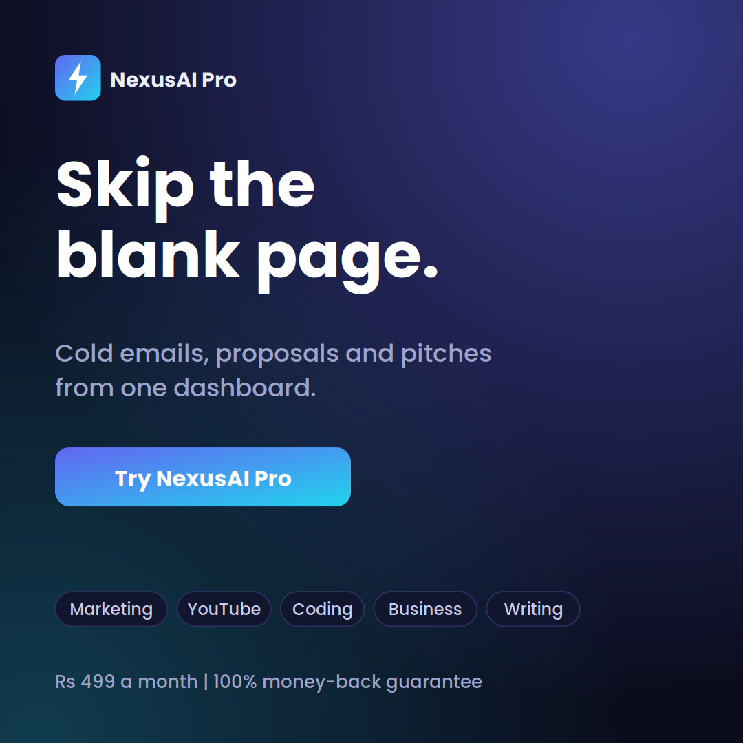
Primary text
Cold emails, proposals and pitches are a pain when you start from nothing. NexusAI Pro has a cold email writer, a pitch builder and a pricing planner in one dashboard. Pick a tool, describe the job, and edit the draft in your own voice. Rs 499 a month, 100% money-back guarantee on the Pro plan.
Headline
Skip the Blank Page
Description
Try the tools first
Button
Learn More
Destination
[YOUR AFFILIATE LINK]

Creative 2: Hooks, titles and scripts
Best for: YouTubers, Reels and short-form creators

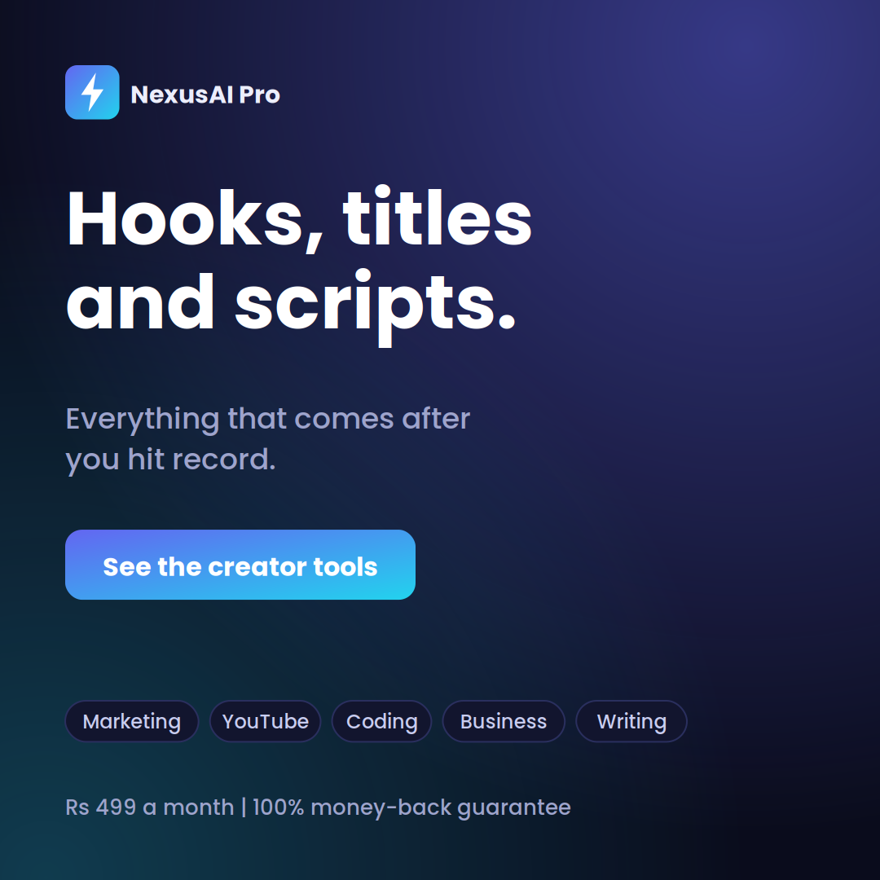
Primary text
The video is shot. Now you need a title, a hook, tags and a script for the next one. NexusAI Pro has a YouTube script writer, title ideas, a tags extractor and a Reels hook writer in the same dashboard. Try the tools first, upgrade if they fit how you work.
Headline
Hooks, Titles and Scripts
Description
50 tools, 5 categories
Button
Learn More
Destination
[YOUR AFFILIATE LINK]

Creative 3: One plan, 50 tools
Best for: General audience that already pays for AI apps

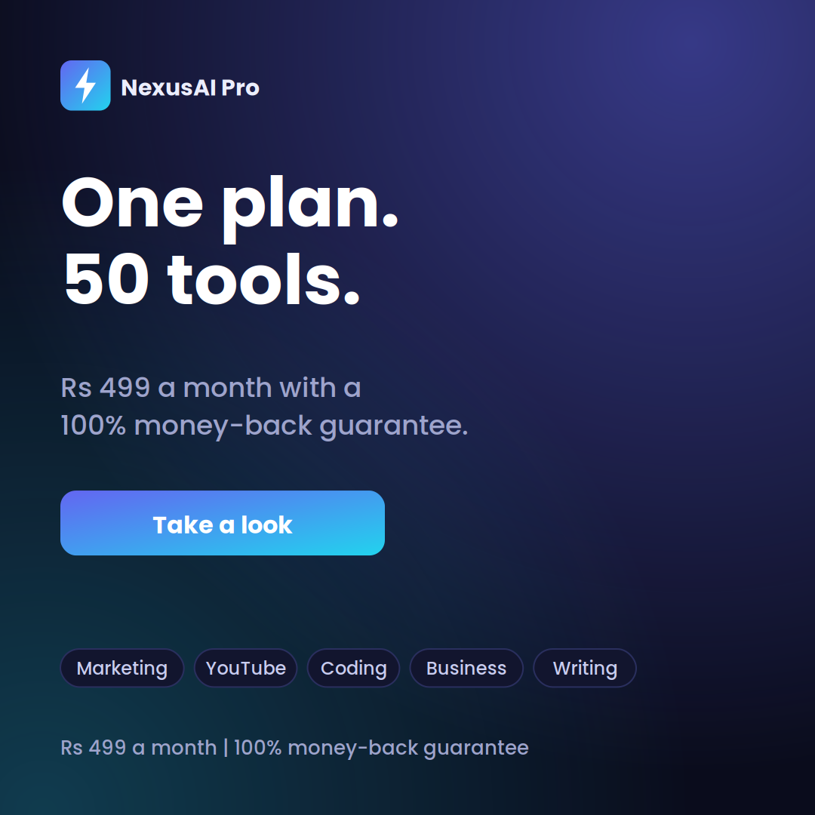
Primary text
Five AI apps means five logins and five bills. NexusAI Pro puts 50 tools in one dashboard, covering marketing, YouTube, coding, business and writing. The Pro plan is Rs 499 a month and comes with a 100% money-back guarantee.
Headline
50 AI Tools in One Dashboard
Description
Rs 499 a month
Button
Sign Up
Destination
[YOUR AFFILIATE LINK]

Primary text bank (Facebook and Instagram)
Mix and match with any creative. Each one stands alone.

Text 1
How many AI tools are you paying for right now? NexusAI Pro puts 50 of them in one dashboard for Rs 499 a month. Try the dashboard first, then decide.
Text 2
Cold emails. YouTube scripts. SQL queries. Cover letters. Most people use four different apps for that list. NexusAI Pro puts all of it in one place, with a 100% money-back guarantee on the Pro plan.
Text 3
New client, blank page, deadline tomorrow. NexusAI Pro has a cold email writer, a pitch builder and a pricing planner, so you start with a draft instead of a cursor.
Text 4
The video is shot. Now you need a title, a hook, tags and a description. NexusAI Pro has a tool for each one, plus a script writer for the next video.
Text 5
Need a SQL query, a bug fix or a cleaner version of that function? NexusAI Pro has an AI bug fixer, a SQL generator and a code refactor tool in one dashboard. Read the output, test it, ship it.
Text 6
Naming a product, writing an ad, working out pricing. Small business owners do all of it. NexusAI Pro helps with the first draft of each, so your time goes to the decisions.
Text 7
Not sure you need another AI subscription? Fair. Open the NexusAI Pro dashboard and try the tools first. If you upgrade and it is not for you, there is a 100% money-back guarantee.
Text 8
Five AI apps, five logins, five bills. Or one dashboard with 50 tools at Rs 499 a month. See which setup fits how you work.

Headlines (40 characters or fewer)
- 50 AI Tools in One Dashboard
- One Dashboard. Rs 499 a Month.
- Skip the Blank Page
- Try the Tools Before You Pay
- Stop Juggling AI Subscriptions
- Hooks, Titles and Scripts
- Proposals Without the Stress
- AI Tools for Real Work
- 100% Money-Back Guarantee
- Cold Emails, Scripts, SQL, Done

Descriptions (30 characters or fewer)
- Rs 499 a month
- Try the tools first
- 100% money-back guarantee
- 50 tools, 5 categories
- Cancel anytime
- Built for freelancers

Google Search ads
Headlines up to 30 characters. Descriptions up to 90 characters.

Ad 1: General AI tools
- 50 AI Tools, One Dashboard
- Rs 499 a Month
- Try the Tools First
Cold emails, ad copy, YouTube scripts, SQL and more in a single dashboard.
Pro plan includes a 100% money-back guarantee. See what is inside.
Ad 2: AI copywriting
- AI Copywriting Tools
- Ads, Emails, Pitches
- Take a Look Inside
Write cold emails, ad copy and SEO outlines faster. Pick a tool and get a draft.
50 tools in one place for Rs 499 a month. 100% money-back guarantee.
Ad 3: YouTube
- YouTube Script Writer
- Titles, Hooks and Tags
- All in One Dashboard
Scripts, title ideas, tags and Reels hooks from one AI dashboard.
Part of a 50-tool suite for Rs 499 a month. Try it before you upgrade.
Ad 4: Coding
- AI Bug Fixer and SQL Tool
- Code Refactor Included
- 50 Tools, Rs 499 a Month
Fix bugs, write SQL and clean up code faster. Review the output, then ship it.
One dashboard for coding, marketing and writing. 100% money-back guarantee.

Keyword ideas
- Start with phrase match: AI tools for freelancers, AI email writer, YouTube script generator, AI SQL generator, AI cover letter generator, AI tools dashboard.
- Add negative keywords: free download, crack, mod apk, jailbreak, login, course, jobs.

Targeting ideas for India
- Interests: freelancing, YouTube creators, digital marketing, small business, online jobs, coding and software development.
- Test two or three audiences at once, with one creative per ad set, before you scale anything.
- Start small. Run each combination for a few days, then keep the winner and pause the rest.
- Placements: let the platform choose at first, then check which placement brings real clicks.

