NexusAI Pro
Banner Pack
5 sizes | PNG files included in the banners folder | Platform: WarriorPlus

How to use this file
- Each banner below is a ready-to-use PNG. Find the same file name in the banners folder.
- Link every banner to your own tracking link: [YOUR AFFILIATE LINK]
- Do not edit the price, the guarantee or the product name.
- Add alt text when you place a banner on a page. A suggestion is given under each one.

1080 x 1080 square
File: banner-1080x1080.png | Best for: Instagram and Facebook feed, Pinterest, blog posts

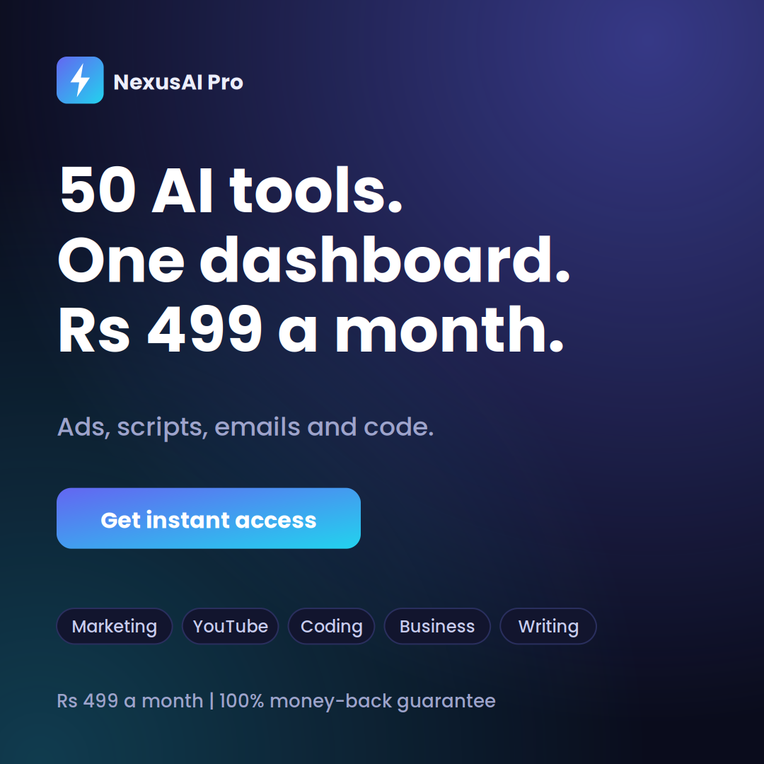
Alt text
50 AI tools in one dashboard for Rs 499 a month. Get instant access.
Caption options
- Counting your AI subscriptions? There is a simpler setup. Link in bio.
- 50 tools, one dashboard, one price. Take a look.

1200 x 628 landscape
File: banner-1200x628.png | Best for: Link previews, Facebook link posts, blog headers, email headers

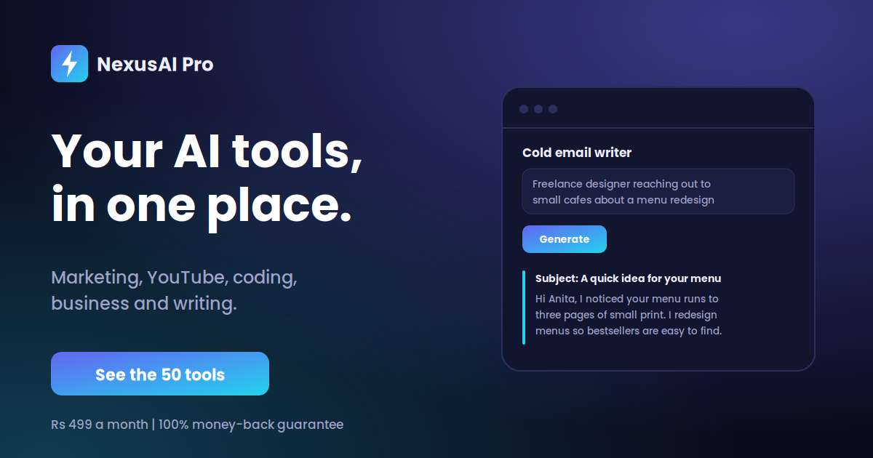
Alt text
NexusAI Pro: your AI tools in one place. See the 50 tools.
Caption options
- Marketing, YouTube, coding, business and writing tools, all in one dashboard.
- Try the tools first, then decide.

300 x 250 medium rectangle
File: banner-300x250.png | Best for: Website sidebars and in-content ad slots

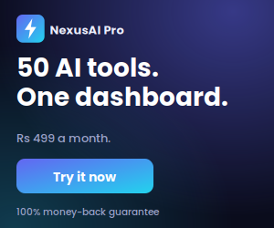
Alt text
50 AI tools. One dashboard. Rs 499 a month. Try it now.
Caption options
- Rs 499 a month for 50 AI tools. 100% money-back guarantee.
- One dashboard instead of five AI apps.

728 x 90 leaderboard
File: banner-728x90.png | Best for: Top or bottom of blog pages and forums


Alt text
50 AI tools in one dashboard. Learn more.
Caption options
- Rs 499 a month. 100% money-back guarantee.
- All your AI tools in one place.

1080 x 1920 story
File: banner-1080x1920.png | Best for: Instagram and Facebook Stories, Reels cover, WhatsApp status

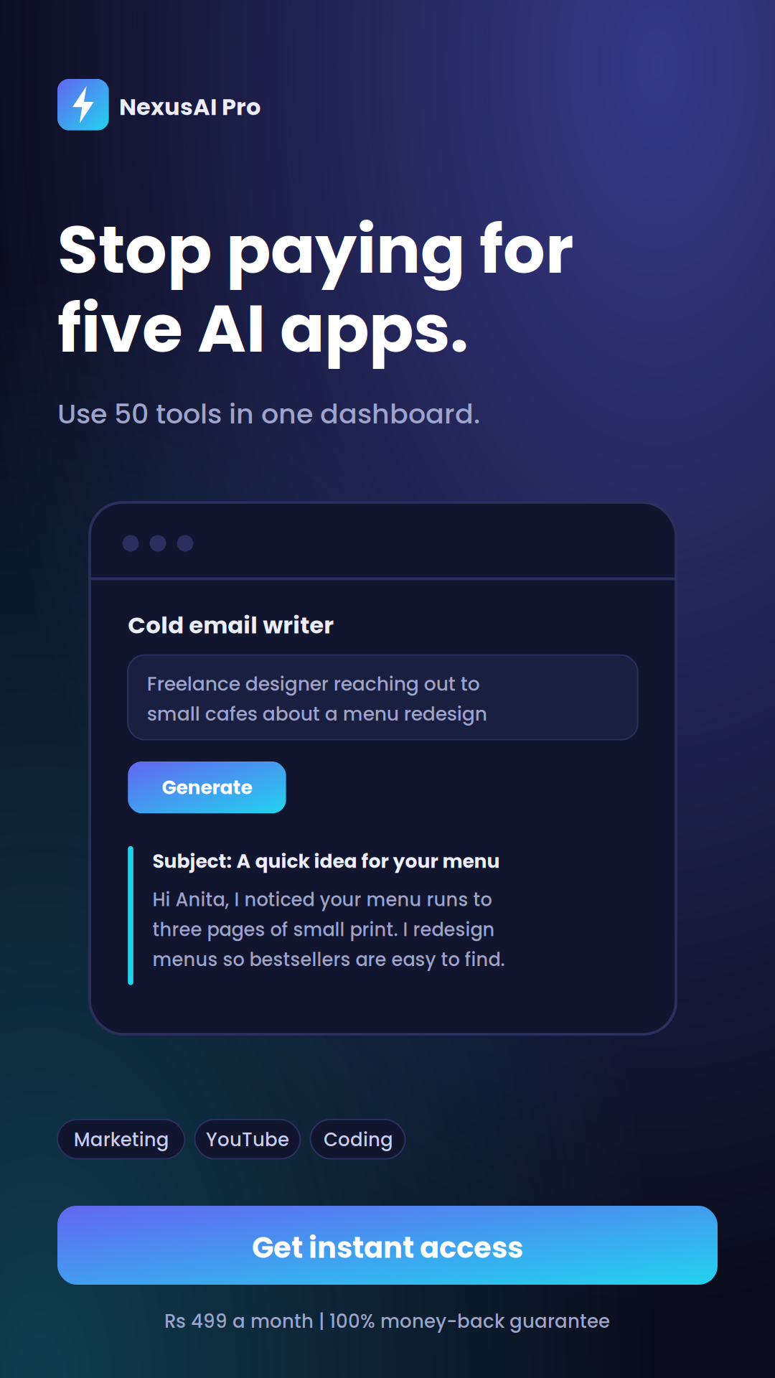
Alt text
Stop paying for five AI apps. Use 50 tools in one dashboard.
Caption options
- Swipe up or tap the link to see the tools.
- One dashboard. 50 tools. Rs 499 a month.

HTML code for your page

Paste this where you want a banner to appear. Change the link and the file path.
<a href="[YOUR AFFILIATE LINK]" target="_blank" rel="noopener sponsored">
<img src="banners/banner-300x250.png" width="300" height="250"
alt="NexusAI Pro: 50 AI tools in one dashboard">
</a>
Tip: add rel="sponsored" to affiliate links. It keeps you in line with search engine guidelines.

Want to make your own?
- Use the same dark background, the lightning bolt logo and a headline of six words or fewer.
- Show the price and the money-back guarantee on every banner.
- Use one button with a clear action: Try it now, See the 50 tools or Get instant access.
- Do not put more than one offer on a banner.

