NexusAI Pro
Social Media Posts
Written in American English | Facebook, Instagram, X, LinkedIn, messaging apps and short video | 4 post graphics

Before you post
- Only say you used the product if you actually have. Every post here is written as a recommendation, not a personal review.
- Replace [YOUR AFFILIATE LINK] and add your own touch. Posts that sound like you do better than copied ones.
- Keep the disclosure line (or use #ad) where the platform requires it.
- Do not promise income or results.

Post graphics

social-1.png
Pair with the first poll post.
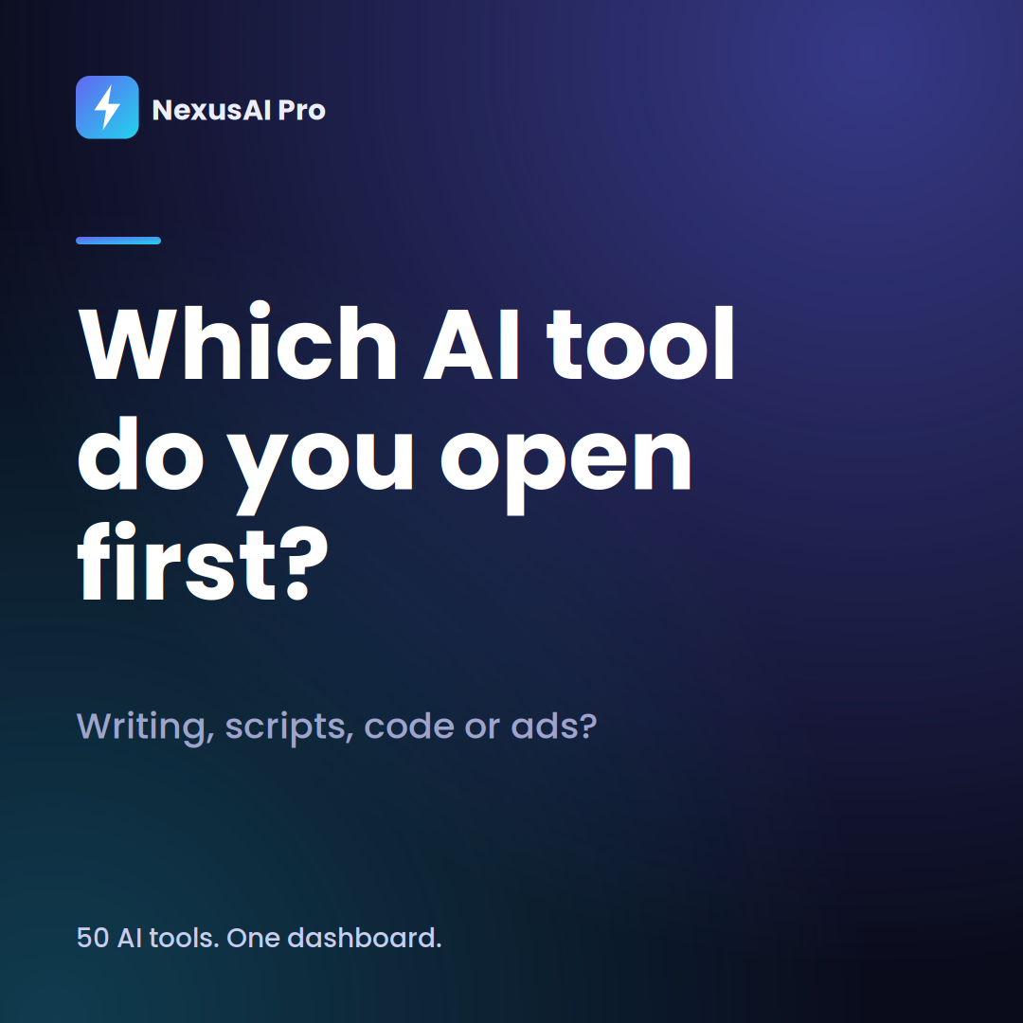
social-2.png
Pair with the five categories post.
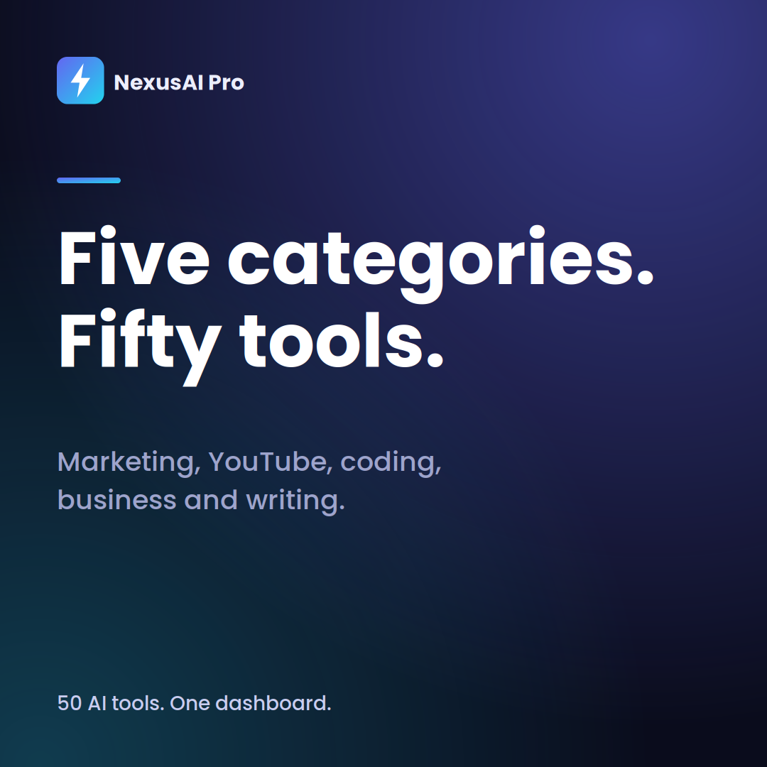
social-3.png
Pair with the try-first post.
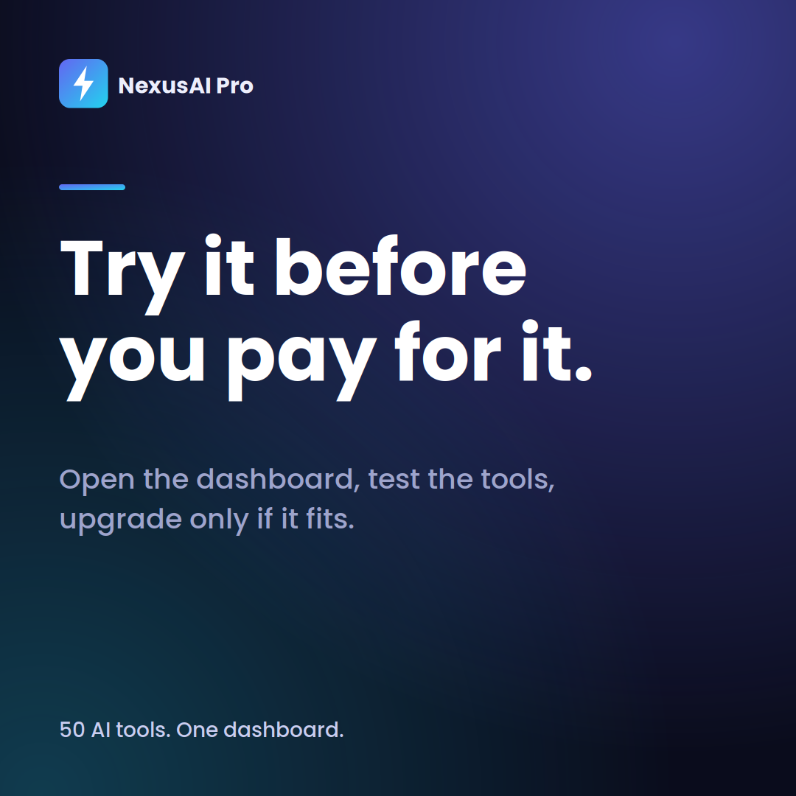
social-4.png
Pair with the subscription pile post.
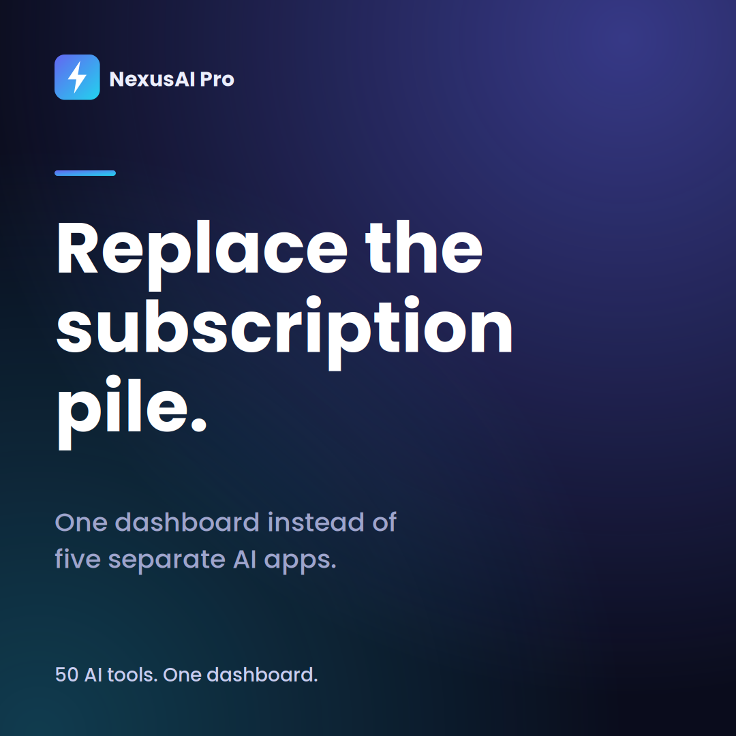

Facebook posts

Post 1
Quick poll for anyone who uses AI at work: how many different tools are you paying for? Most of us end up with a writing tool, a script tool and a couple we forgot to cancel. NexusAI Pro puts 50 tools in one dashboard for Rs 499 a month. Tell me your number in the comments, and I'll drop the link.
Post 2
Five categories. Fifty tools. Marketing, YouTube, coding, business and writing, all in one dashboard. If you use AI for work more than a couple of times a month, it's worth a look. You can try the tools before you upgrade. [YOUR AFFILIATE LINK]
Post 3
Cold emails are hard, mostly because of the blank page. A tool that hands you a first draft makes the whole thing easier. NexusAI Pro has a cold email writer, a pitch builder and a pricing planner built for exactly that. [YOUR AFFILIATE LINK]
Post 4
Creators, here's a list: script, title, hook, tags, description. That's five jobs after you've already made the video. NexusAI Pro has a tool for each one. Take a look: [YOUR AFFILIATE LINK]
Post 5
Something I like about this one: you can try the dashboard before you pay. No guessing. If you upgrade to Pro and it isn't for you, there's a 100% money-back guarantee. Details here: [YOUR AFFILIATE LINK]
Post 6
If you write code, you know the small stuff eats your day. A SQL query that won't behave, a function that got out of hand, a layout you'd rather not build by hand. NexusAI Pro has an AI bug fixer, a SQL generator and a code refactor tool. Always read the output and test it, but it saves a lot of detours. [YOUR AFFILIATE LINK]
Post 7
Running a small business means you're the marketing team, the strategist and the person who names things. NexusAI Pro helps with the first draft of ads, pitches, pricing ideas and brand names. You still make the calls. [YOUR AFFILIATE LINK]
Post 8
Which one sounds like you? A) I pay for too many AI apps. B) I use AI only once in a while. If it's A, you might want to see what one dashboard with 50 tools looks like: [YOUR AFFILIATE LINK]

Instagram captions

Caption 1
Which AI tool do you open first? Writing, scripts, code or ads? NexusAI Pro puts 50 of them in one dashboard, so you stop switching tabs. Link in bio.
#AItools #freelancer #contentcreator #productivity #smallbusiness
Caption 2
Your video is done. Your title is not. A script writer, title ideas, a tags extractor and a Reels hook writer, all in one place. Tap the link in our bio.
#YouTubeTips #contentcreator #reels #creatoreconomy #AItools
Caption 3
Proposals, cold emails and pitches without the blank page. That's the whole idea. Try the dashboard first, then decide. Link in bio.
#freelancing #freelancelife #coldemail #productivity #AItools
Caption 4
One dashboard instead of five AI apps. 50 tools across five categories for Rs 499 a month, with a 100% money-back guarantee. Link in bio.
#AIforbusiness #smallbusinessowner #worksmarter #AItools #sidehustle
Caption 5
Developers: a SQL generator, a bug fixer and a code refactor tool walk into a dashboard. Read the output, test it, ship it. Link in bio.
#coding #developer #SQL #webdevelopment #AItools
Caption 6
Students and job seekers: cover letters, grammar checks and article summaries in one place. Try the dashboard first. Link in bio.
#studentlife #jobsearch #coverletter #careeradvice #AItools

X (Twitter) posts
Each is 280 characters or fewer.

Post 1
How many AI tools are you paying for? NexusAI Pro puts 50 in one dashboard for Rs 499 a month. Try it before you upgrade. [YOUR AFFILIATE LINK]
Post 2
Cold email. YouTube script. SQL query. Cover letter. Four jobs, four apps. Or one dashboard. [YOUR AFFILIATE LINK]
Post 3
Most people don't need five AI subscriptions. They need one place that does the job. [YOUR AFFILIATE LINK]
Post 4
Blank page problem? Pick a tool, describe the job, edit the draft. That's the whole workflow. [YOUR AFFILIATE LINK]
Post 5
The 100% money-back guarantee is the reason I'd try it before deciding anything. Dashboard first, upgrade later. [YOUR AFFILIATE LINK]
Post 6
Freelancers: proposals, cold emails and pricing ideas in one dashboard. Rs 499 a month. [YOUR AFFILIATE LINK]
Post 7
Creators: script, title, hook, tags. One dashboard, no tab hopping. [YOUR AFFILIATE LINK]
Post 8
Developers: SQL generator, bug fixer, code refactor. Read the output, test it, ship it. [YOUR AFFILIATE LINK]

LinkedIn posts

Post 1
Here's a pattern I keep noticing. People pay for one AI tool to write, another for scripts, another for code, and a fourth for something they signed up for during a free trial. None of them is expensive. Together, they add up, and the switching costs you time. NexusAI Pro takes a simple approach: 50 tools, five categories, one dashboard, Rs 499 a month. It won't replace your judgment, and it isn't trying to. It just gets you past the first draft faster. You can try it here: [YOUR AFFILIATE LINK]
Post 2
For freelancers and consultants: the hardest part of a proposal is usually the first paragraph. A tool that gives you a rough draft to edit changes how the whole afternoon goes. NexusAI Pro has a cold email writer, a pitch builder, a pricing planner and a cover letter tool. Worth a look: [YOUR AFFILIATE LINK]
Post 3
A small team doesn't need a dozen AI subscriptions. It needs a few tools everyone actually opens. That's the idea behind NexusAI Pro: marketing, business, writing and coding tools in a single dashboard, with a 100% money-back guarantee on the Pro plan. Details: [YOUR AFFILIATE LINK]

Messages for WhatsApp, Telegram and DMs

Message 1
Hey [Name], saw you work with content, so this might be useful. NexusAI Pro has 50 AI tools in one dashboard, like a script writer and cold email writer. You can try it before you pay. [YOUR AFFILIATE LINK]
Message 2
Hey [Name], quick one. If you're paying for more than one AI app, this might save you some tabs. 50 tools, Rs 499 a month, 100% money-back guarantee. [YOUR AFFILIATE LINK]
Message 3
Hi everyone, sharing a tool I think this group would like. It has tools for ads, YouTube scripts, emails and code, all in one dashboard. Try it first and see: [YOUR AFFILIATE LINK]
Message 4
Hey [Name], you asked about tools for writing proposals. This one has a cold email writer, a pitch builder and a pricing planner. Take a look: [YOUR AFFILIATE LINK]

Replies to common questions
Is it free?
You can open the dashboard and try the tools first. The Pro plan is Rs 499 a month and includes extras like the Bulk Generator and PDF export.
What if I don't like it?
The Pro plan comes with a 100% money-back guarantee. Check the sales page for the exact refund steps.
How is it different from the AI apps I already use?
It's a set of ready-made tools. You pick a cold email writer or a script writer instead of writing your own prompt each time. Whether that suits you depends on how you work.
Does it work in Hindi?
I don't want to guess on that one. Check the product page or ask the support team to be sure.

Short video scripts (about 30 seconds)
For Reels, Shorts and TikTok. Say it in your own words.

Script 1: The subscription pile
- Hook (0-3 sec): "How many AI apps are you paying for? Be honest."
- Beat 1 (3-12 sec): Show your phone or desktop with a few AI apps open. "Writing here, scripts there, code somewhere else."
- Beat 2 (12-25 sec): Screen-record the NexusAI Pro dashboard. Pick one tool and generate something. "This puts 50 tools in one dashboard."
- Call to action (25-30 sec): "You can try it first. Link in my bio."
Script 2: Cold email in one minute
- Hook: "Stop staring at a blank email."
- Beat 1: Open the cold email writer. Type a short description of the person you're writing to.
- Beat 2: Show the draft. "Edit it, make it yours, send it."
- Call to action: "The link is in my bio if you want to try it."
Script 3: After the video is done
- Hook: "You finished the video. Now the hard part."
- Beat 1: "Title, hook, tags, description." Show the title tool and the tags extractor.
- Beat 2: "Same dashboard has a script writer for the next one."
- Call to action: "Check the link in my bio."
Script 4: Is it worth Rs 499?
- Hook: "Is it worth Rs 499 a month? Depends on you."
- Beat 1: "If you use AI once a month, no. A free tool is fine."
- Beat 2: "If you use it most days for different jobs, one dashboard can replace several apps. And there's a 100% money-back guarantee."
- Call to action: "Try the dashboard first. Link in my bio."

Story ideas
- Poll sticker: Which do you open first, writing tools or code tools?
- Question box: What's the one task you wish AI handled for you?
- Screen recording: one tool, one result, no voiceover.
- Quiz sticker: How many AI tools does NexusAI Pro include? (50)
- Link sticker with the line: Try the dashboard first.

