ESP8266 Temperature / Humidity
Web server
Description:- This project is about monitoring temperature humidity on a server with the help of SOC(system on chip / ESP8266) without using any microcontroller.
Components required:-
Hardware:-
• ESP8266 ESP-01 Wi-Fi Module
•USB TTL Serial Cable
•3.3 V 800mA Voltage Regulator
• DHT11 #386Sensor (comes with 10K resistor)
•Push button(1 )
•Mini breadboard
•Jumper wires
Software:-
•Arduino IDE (1.6.4 or higher)
•DHT11 sensor library(ZIP file)
•PL2303 Profilic Driverinstaller

Connections:-
TTL ESP8266
• RX TX
•TX RX
• GND GND3.3V (optional if you are not using external supply)
There are following steps :-
Step1:-Add DHT library to arduino ( go to sketch-> include library->add .ZIP library that you have downloaded)
Step2:- Unzip the portable.zip file and paste it into your Arduino installation directory. To verify it is successfully added go to Tools menu-> Boards->Boards manager->
NOTE: - If not then go to File->preferences->Additional Board Manager URLs
And paste the following url int this: -
http://arduino.esp8266.com/stable/package_esp8266com_index.json
and then follow the following screen.
You should now have the esp8266 as an option there since you've added it to the Additional Boards. You will see installed option instead of install. If this does not happens then restart your Arduino IDE and go to following window again then check for esp8266 and it will show esp8266 is already installed.
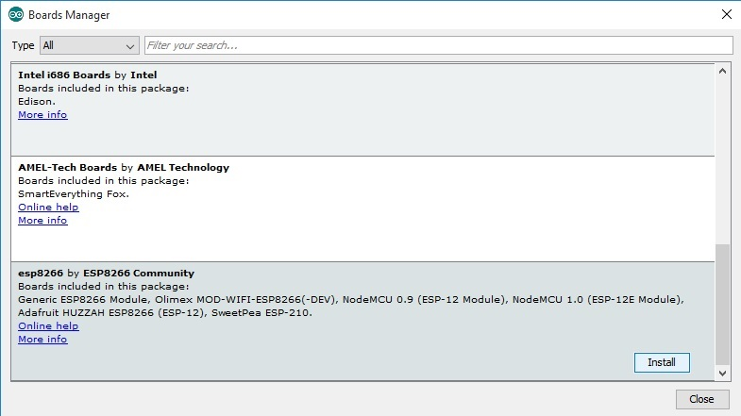
Step3:- Now, You have configured the ESP8266 board. Choose the board "Generic ESP8266 Module" from list.
Step4:- From the Tools -> Programmer menu item, select esptoolif it is not showing then choose AVRISP mk11
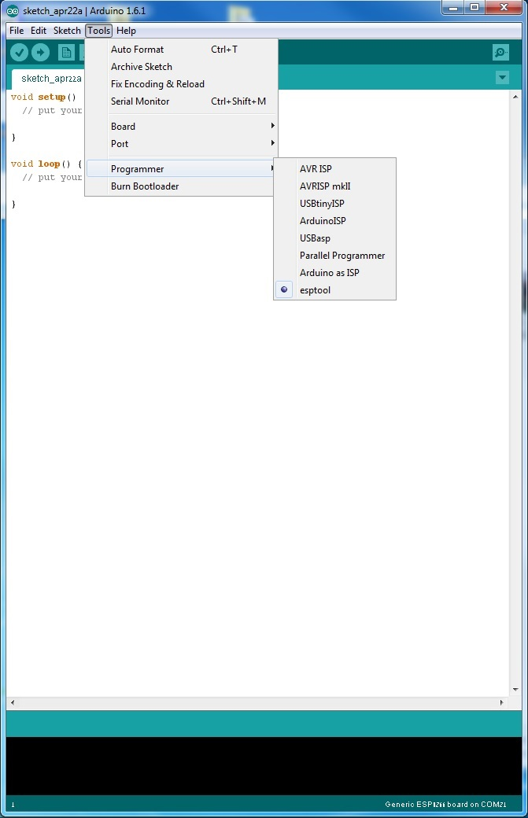
NOTE:- In the current version of this tool the programmer option doesn't exist, and doesn't needed to be configured - Just ignore this step)
Step5:- connect the usb ttl and Install the latest profilic driver from zip shared.
(i) Extract PL2303.zip file and open extracted folder PL2303.
(ii) Then double click on PL2303_64bit_Installer.exe file.
(iii) Then follow installation instructions from opened window.
After installation of driver restart your pc and open arduino ide and connect the circuit with the ttl and check the board(Generic ESP8266 Module) and port(COM port) in tools menu.
Step6:- PROGRAMMING PART
Use the EPS8266.ino
Step7:- Now compile the program by clicking on the round Check icon(Verify) and make sure the program compiles successfully.
If everything is set, the program will compile ok:
Uploading to the ESP8266
To upload your compiled program to the ESP8266:
1. Disconnect power to the ESP by removing vcc pin of ESP .
2. Bring GPIO0 to ground (press AND HOLD DOWN the pushbutton).
3. Power up the ESP using now put vcc wire into 3.3v pin of ttl chip.
4. Release the pushbutton.
5. Click the round right arrow icon to upload the program.
If you have errors in communications, check your connections and that you have the serial port selected appropriately. Hopefully the right color wires from the serial cable are connected to the ESP-01 module.

Server Running
Open the Arduino IDE serial terminal by using the menu Tools -> Serial Monitor. Set the baud rate in the bottom left (red circle below) to 115,200 baud (default for current firmware, older firmware was 9,600 baud). You should see a screen like that below:

When the project powers up you'll get some random characters then some periods as the ESP8266 connects to the router where you specified the SSID and password in your Arduino sketch (you did change that, yes? If not, change the program and upload the new program).
When the ESP8266 connects to your router, It will say "DHT Weather Reading Server". Note the IP Address (in blue circle) for the next step.

Step8:- open your browser and paste that link and hit enter
you will get a window showing
"Hello from the weather esp8266, read from /temp or /humidity"
Step9:- after that enter your ip/temp to view the temperature and ip/humidity to view the humidity.
NOTE:- If you are having problem with the serial monitor that is not showing some data then check the router id and passward that you have enter and make sure that both id and passward is same as of your router.

