**Spring Data Jpa**

{Earlier we used JDBC for manual mapping but ORM does auto mapping for us and we will use that in this tut.}

Java(Objects and Classes) 🡪 Databases(Table and Rows)

Jpa 🡪 Java Persistence API has standard specification

Hibernate/Ibatis 🡪 Framework Providers which provides ORM implementation based on JPA specifications so that switching b/w these frameworks becomes easy.

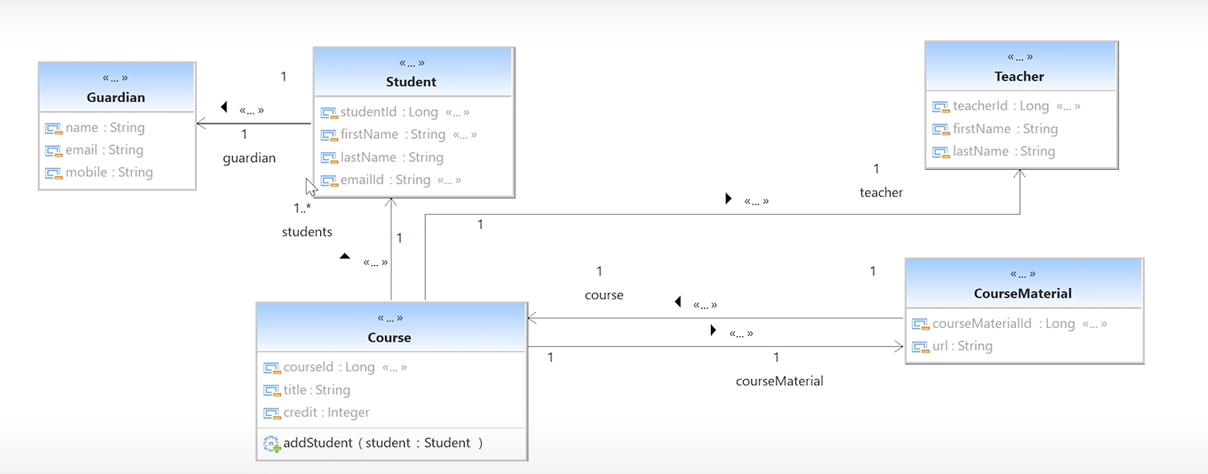

JPQL 🡪 uses classes for query

Native 🡪 uses tables and column for query

JPA supports both JPQL and Native

@Modifying and @Transactional allows modification and re-committing of row after it has been modified.

FetchType.Eager 🡪 Automatically fetches the child data when you fetch the parent data

FetchType.lazy 🡪 Conditonal fetching of Child data.

With parameter “Optional” we can set if we want to mandate the child data while saving the parent data