**INTERNATIONAL INSTITUTE OF PROFESSIONAL STUDIES**

**DEVI AHILYA VISHWAVIDYALAYA, INDORE**



**PROJECT REPORT ON**

**Online Wholesale Shopping Mobile Application**

**Wholesaler Hub**

**Guided By: Submitted By:**

Dr. Shaligram Prajapat Karan Ahiriya

Sourabh Patidar

**CERTIFICATE**

This is to certify that the project report entitled “Wholesaler Hub” which is being submitted by

**Karan Ahiriya** (IT-2K17-24), **Sourabh Patidar**(IT-2K17-56)

to the **International Institute Of Professional Studies** for the **Master of Technology In Information Technology** is a record of bona fide project work ,carried out under the supervision and guidance.

The result contained in the project report has not been submitted to any other university or institute for the award of a degree or diploma.

Internal Examiner External Examiner

**ACKNOWLEDGEMENT**

We acknowledge our sincere thanks to those who have contributed significantly to this project. It is a pleasure to extend deep gratitude to our internal guide Mr.Shaligram Prajapat. IIPS, for his valuable guidance and support and to continuously prompt us for the progress of the project. We thank him for his valuable suggestions towards our project, which helped us in making this project more efficient and user friendly. We thank and acknowledge each and every ones efforts that helped us in some or the other way for small and significant things.

**ABSTRACT**

The project aims at developing the mobile application for the formal and informal merchants to sell and advertise their footwear on single platform.

These would allow easy access to the retailer in rural areas.

The objective of this project is to create an e-commerce application which is uses and have a simplest of functionalities that every user can be able to use.

The application allow retailer to buy wholesale goods from majority of wholesaler.

**TABLE OF CONTENTS-**

**INTRODUCTION**

* THE CLIENT ORGANISATION
* AIM
* OBJECTIVE
* PROBLEM STATEMENT
* FUNCTION

**SYSTEM REQUIREMENT ANALYSIS**

* INFORMATION GATHERING
* SYSTEM FEASIBILITY
* ECONOMIC FEASIBILITY
* TECHNICAL FEASIBILITY
* BEHAVIRAL FEASIBLITY

**USED TECHNOLOGY DESCRIPTION**

* FLUTTER
* GOOGLE FIREBASE

**IMPLEMENTATION**

* USER INTERFACE DESIGN AND IMPLEMENTATION

**DESCRIPTION**

* MODULE DESCRIPTION
* SPECIFICATION
* PROJECT RESOURCES
* PEOPLE
* MINIMUM REQUIREMENT
* TECHNOLOGY USED
* CONSTRAINTS

**TESTING**

* UNIT TESTING
* INTEGRATION TESTING
* VALIDATION TESTING
* WHITEBOX TESTING

**RESULTS AND CHALLENGES**

* CHALLENGES
* FINAL RESULT

**CONCLUTIONS**

* LIMITATIONS
* SCOPE FOR FUTURE WORK

**REFERENCES**

**INTRODUCTION**

**THE CLIENT ORGANISATION-**

The small foot wear shop where the manufacturing and wholesaling of foot wear is carried out by the offline process, where the manufacturing is done five days a week and on weekend the manufactured items are then loaded into loading vehicle and then delivered to the customers (retailers in rural areas or small shop owners).

The problem here is that it requires lots of extra time in delivering the items.

Having the mobile app helps the wholesaler to have prior knowledge of required items and it also make selling convenient.

On the other hand the retailer also browses the items before purchasing them and select the required items so the wholesaler makes the arrangement.

**AIM-**

To design and develop a mobile application for retailer to buy foot wears directly from manufactures or from majority of wholesalers.

This project brings manufacturers and wholesalers to the retailers through the application.

The project developed is a mobile application that will help user to purchase foot wear in bulk. The software will provide the user with graphical interface which will help them to chose appropriate product and provide easy way to buy things in wholesale price.

**OBJECTIVE-**

* To make the shopping convenient for retailer in terms of time and transport charges.
* Customers have access to wide variety of product with reasonable price.
* To decrease the price of the products for customers.
* Customers can also compare the actual value of the products.
* It also offers customers to browse the wholesale goods in case if they also want to be retailer.
* It offers single platforms for the selling as well advertisements of the products.

**PROBLEM STATEMENT-**

The projects can save the time and transport charges for the retailer in rural areas.

It provides retailer in rural areas to buy wide range of footwear products on single platform.

Overall at last it provides customers with a reasonable price of products because in some of the case the manufacturer acts as the wholesaler.

Current Scenario-The application which are available for the same does not provide the convenient interface.

Especially in rural or remote areas the current exiting alternatives does not have much impact on target user it may be because of they want easy and reliable application.

**Functions-**

The application will be primarily used by two types of user. First will be the general user who wishes to make a purchase. Second will be the administrator of the software. The administrator is the super user of the application. He has the entire control of the system.

Apart from this application has two users one who is creating catalogue of product they want to sell and other is who make purchase.

Application works in simple way for user who is going to purchase i.e. open, register(if first time user),browse, purchase ,make payment, give feedback and for the wholesaler it works as follows just register ,upload the catalogue of product and receive a request of purchase, and sell.

The major functions specific to the two types of the above mentioned users are:

**The Administrator**

* Add product
* View user transaction
* Watch user activities

**The General user**

* Registration
* Login to the site
* Browse products and Purchase them

**Performance Issues**

Factors critical in deciding the performance of the software are:

**Internet Connection**

Being predominantly a mobile application, fast internet connection is a necessity. Slow connection may hamper performance.

**Server Performance**

Performance may also be hampered by excessive traffic.

**SYSTEM REQUIREMENT ANALYSIS**

**INFORMATION GATHERING-**

As the goal of the application is ease of use and to provide an interactive interface, extensive research has been done to gain an insight into the needs and behaviours of various users. The working of the application is made convenient and easy to use for the end user. User provides regular feedback on the project. Users can classify into two types based on their knowledge of the products that suit their needs. They can be classified as users who know about the product that could satisfy their needs and users who have to figure out the product that would satisfy their needs. Users who know about the product should be able to find the product easily with the click of a button. Such users can search for the product by using the product name as the search term. Users who have to figure out the product that would satisfy their needs could use a search term to find a list of products and then should be able to filter the results based on various parameters like product type ,manufacturer, price range ,platform supported etc. The users should be able to view the complete specification of the product and various images at different Zoom levels. The user should be able to read the customer reviews for the product and the ratings provided. They should be able to write their own reviews. They should be able to print out the specifications for a product or email the product page to a older user etc .To increase the ease of use the user should be able to add a product to the shopping cart by dragging a product and dropping it in the shopping cart. A user should able to edit the contents of a shopping cart. They should be able to update the quantities of the products added to the cart and remove the products from the cart.

Other than this, we have done a lot of research on various other methods of building this application whích was able to incorporate a few stronger features into the application and biggest advantage of developing a application from flutter and dart is that the minimum viable product can be dispatched for firsthand use. The tools and controls used in the application are visual studio code for editing a code and emulator for testing a written code .

**System Feasibility**

The system feasibility can be divided into the following sections:

* Economic Feasibility -The project is economically feasible as the only cost involved is having a computer with the minimum requirements mentioned earlier. For the users to access the application, the only cost involved will be in getting access to the Internet.
* Technical Feasibility -To deploy the application, the only technical aspects needed are mentioned below:
* Behavioural Feasibility- The application requires no special technical guidance and all the views available in the application are self explanatory. The users are well guided with warning and failure messages for all the actions taken.

**SYSTEM ANALYSIS-**

After carefully analyzing the requirements and functionality of the application. We had two important diagrams by the end of the analysis phase. They are the ER diagram and data flow diagram which were the basis for finding out entities and relationships between them, the flow of information.

**DATA FLOW DIAGRAM**

**CONTEXT LEVEL DFD**

**ONLINE SHOPPING**

**PRODUCTS**

**USER**

**SECOND LEVEL DFD**

VIEW SPECIFICATIONS

APPLY FILTERS

SEARCH

PRODUCTS

USER

**SECOND LEVEL DFD**

CHECK OUT

EDIT CART

PRODUCTS

ADD TO CART

USER

**USED TECHNOLOGY DESCRIPTION**

**FLUTTER-**

What is Flutter?

Flutter is an open-source mobile SDK developer can use to build native-looking Android and iOS applications from the same code base. Flutter has been around since 2015 when Google introduced it and remained in the beta stage before its official launch in December 2018. Since then, the buzz around Flutter has been growing stronger.

Flutter — here’s how it works

Widgets

The central idea behind Flutter is the use of widgets. It’s by combining different widgets that developers can build the entire UI. Each of these widgets defines a structural element (like a button or menu), a stylistic element (a font or color scheme), a layout aspect (like padding), and many others.

Flutter also provides developers with reactive-style views. To avoid performance issues deriving from using a compiled programming language to serve as the JavaScript bridge, Flutter uses Dart. It compiles Dart ahead of time (AOT) into the native code for multiple platforms.

Today, Flutter is the only mobile SDK that offers reactive views without the need for a JavaScript bridge. That’s why so many mobile developers have been trying it out in their projects.

Here are some more benefits Flutter brings to mobile software development.

Extra advantage: Dart programming language

One of the most interesting features of Flutter is the language it uses: Dart. Like other systems that use reactive views, Flutter refreshes the view tree for every new frame. To accomplish that, it creates many objects that may live for no more than one frame. Dart uses generational garbage collection that has proven to be very efficient for this type of systems.

Moreover, Dart has a “tree shaking” compiler that only includes the code you need in your app. Even if you need just a widget or two, you can use its large library of widgets freely.

Finally, Dart comes with a repository of software packages for extending the capabilities of apps. For example, it offers a few packages that help to access Firebase so that developers can build server less apps. Another package allows accessing a Redux data store or makes it easier to access platform services and hardware like the camera.

Benefits of Flutter

It saves you time and money

Flutter is a cross-platform development tool. That means software developers can use the same code base for building an iOS and Android app. Cross-platform development is the best method for saving time and resources throughout the development process.

Excellent performance

Flutter offers outstanding performance for two reasons. First, is uses Dart, which compiles into native code. Second, Flutter has its own widgets, so there’s no need to access OEM ones. As a result, there’s less communication between the app and the platform. These two features of Flutter ensure fast app startup times and fewer performance issues in general.

Quick development thanks to hot reload

Flutter is gaining a lot of traction among mobile developers because of hot reload. Hot reload allows to instantly view the changes applied to the code on emulators, simulators, and hardware. The changed code is reloaded in less than a second. All the while, the app is running and developers don’t need to waste time on restarting it.

That makes building UIs, adding new features, and fixing bugs easier. If an app encounters an error, it’s usually possible to fix it and then continue using the app as if it never happened. Even if you’re forced to do a full app reload, you can be sure that it’s completed in no time, accelerating the development process.

Open-source

Flutter is an open-source technology surrounded by an active community of developers who provide support, contribute to the tool’s extensive documentation, and develop helpful resources. Both Dart and Flutter are free to use.

**GOOGLE FIREBASE-**

It’s a Real-time Database Real-time data is the way of the future. Nothing compares to it. Most databases require you to make HTTP calls to get and sync your data. Most databases give you data only when you ask for it. When you connect your app to Firebase, you’re not connecting through normal HTTP. You’re connecting through a Web Socket. Web Sockets are much, much faster than HTTP. You don’t have to make individual Web Socket calls, because one socket connection is plenty. All of your data syncs automatically through that single Web Socket as fast as your client’s network can carry it.

Firebase sends you new data as soon as it’s updated. When your client saves a change to the data, all connected clients receive the updated data almost instantly.

**PROS-**

* Email & password, Google, Facebook, and Github authentication
* Realtime data
* Ready-made api
* Built in security at the data node level
* File storage backed by Google Cloud Storage
* Static file hosting
* Treat data as streams to build highly scalable applications
* Don’t worry about your infrastructure!

IMPLEMENTATION

**USER INTERFACE DESIGN AND IMPLEMENTATION**

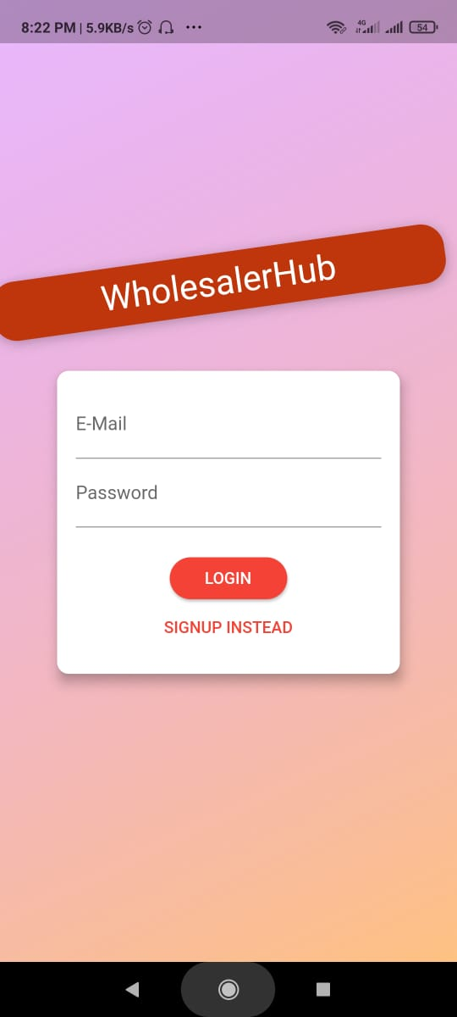

**LOGIN PAGE**

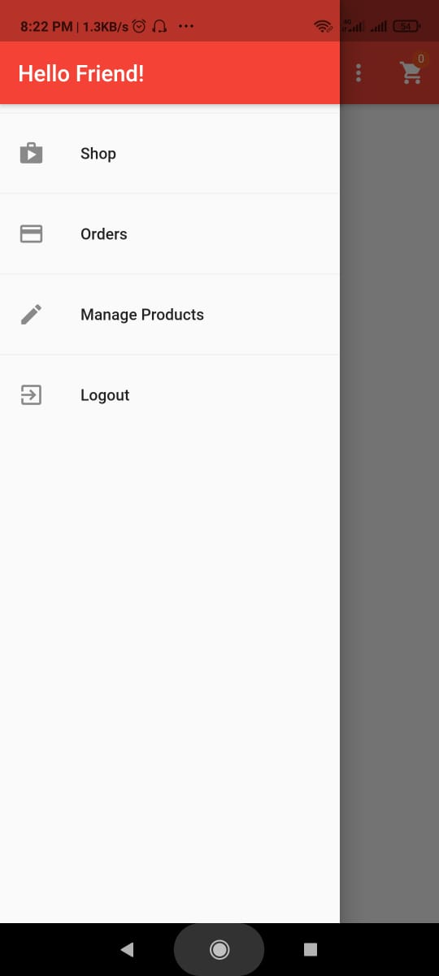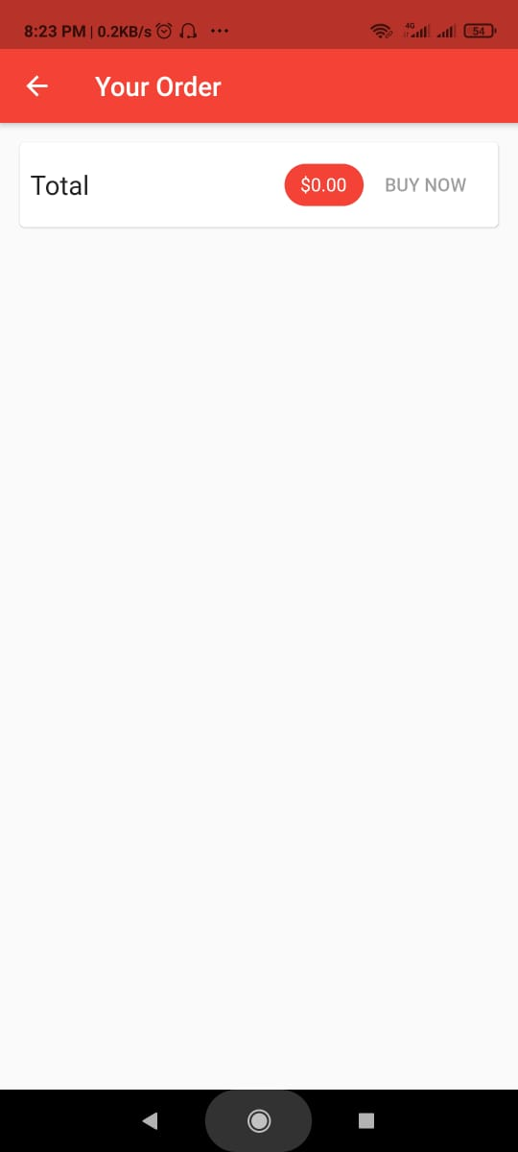

**Account page Order page**

**DESCRIPTION**

**Module Description-**

Here going to participate too actors. They are User and Merchants. Merchants will update their product for sales. User enters this system and select their product and add to cart.

System Features

In the life of the software development, problem analysis provides a base for design and development phase. The problem is analyzed so that sufficient matter is provided to design a new system. Large problems are sub-divided into smaller once to make them understandable and easy for finding solutions. Same in this project all the task are sub-divided and categorized.

System Modules:

Merchant

* Register and login
* View Product
* Add to cart
* My order
* Place order

User

* Register and login
* Upload Product details

Module Description:

Register Login Module:-

In login module the customer and merchants can login to the   application if they already created their account and signed in.

View Product:

User enters this system view the product via direct and search option.

Add to cart:

Users select their product and book the product

My Order: User can see their own order details.

Upload product details:

Merchants can upload their product details like Name, Description, Image, Quantity, Quality.

**Project Resources-**

* **People**

The software will be developed by a two people.The members of the group are:

* Karan Ahiriya
* Sourabh Patidar

**Hardware and Software Requirements**

The minimum hardware requirements are:

**Server side:**

Memory: 2GB RAM

Processor: Minimum Dual core

**Client side:**

Memory: 2GB RAM

Processor: Minimum Dual core

**Minimum software requirements -**

**Server Side:**

As application developed on Flutter, must be installed on server side. For database purpose we use Firebase.

**Client Side:**

Android version above 4.1.

**TECNOLOGY USED-**

For developing this application the resources being used are:

* Dart
* Flutter
* Visual studio
* Google Firebase

**Management and Technical Constraints-**

* **Managerial Constraints**
* Completing the project in the designated time period is the biggest constraint ahead.
* To include all the function of the project above mentioned in the application will be another constraint.
* Distributing and completing tasks will be another constraint.
* **Technical Constraints**
* The software will be developed in platforms which are open sources and continuously evolving .So as such there will be no specific technical constraints. More over being a mobile application the software will be accessed via android policies. So it will be platform independent. Few technical constraints which might come in the way are:
* Database designed should be normalized.
* The credential of user should be encrypted and then store in the database.
* The transfer of funds for purchasing should be through a secured connection.

**TESTING**

A Software testing is a process of running with intent of finding errors in software. Software testing assures the quality of software and represents final review of other phases of software like specification, design, code generation etc.

**Unit Testing**-

Unit testing emphasizes the verification effort on the smallest unit of software design i.e. a software component or module. Unit testing is a dynamic method for verification, where program is actually compiled and executed. Unit testing is performed in parallel with the coding phase, Unit testing tests units or modules not the whole software.

We have tested each view/module of the application individually. As the modules were build up testing was carried out simultaneously, tracking out each and every kind of input and checking the corresponding output until module is working correctly.

The functionality of the modules was also tested as separate units, Each of the three modules was tested as separate unit, In each module all the functionalities were jested in isolation. In the Shop Products Module when a product has been added to cart it has been made sure that if the item already exists in the shopping cart then the quantity is increased by one else new item is created in the shopping cart. Also the state of the system alter a product has been dragged in to the shopping cart is same as the state of the system if it was added by clicking the add to cart button, Also it has been ensured that all the images or the products displayed in the shop products page are drag gable and have the product property so that they can be dropped in the cart area. In the Product Description Module it has been tested that all the images are displayed properly. Users can add review and the as soon as a user adds a review it is updated in the view customer review tab, It has been checked to see if the whole page refreshes or a partial page update happens when a user writes a review. In the cart details it has been tested that when a user edits a quantity or removes product from the cart, the total price is updated accordingly. It has been checked to see whole page refreshes or a partial page update happens when a user edits the cart. Visual Studio has in built support for testing the application. The unit testing was done using visual studio without the need of any external application. Various methods have been created for the purpose of unit testing. Test cases are automatically generated for these methods. The tests run under the emulator context which means settings from code file are automatically picked up once the test case starts running. Methods were written to retrieve all the manufacturers from the database, us that match a certain search term, products that match certain filter criteria, all was that belong to a particular product etc.

**Integration Testing**-

In integration testing a system consisting of different modules is tested for problems arising from component interaction. Integration testing should be developed from the system specification. Firstly, a minimum configuration must be integrated and tested. In my project I have done integration testing in a bottom up fashion i.e. in this project I have started construction and testing with atomic modules. After unit testing the modules are integrated one by one and then tested the system for problems arising from component interaction.

**Validation Testing** –

It provides final assurances that software meets all functional, behavioural and performance requirement. Black box testing techniques are used. There are three main components - Validation test criteria (no. in place of no. & char in place of char) - Configuration review (to ensure the completeness of s/w configuration.) - Alpha & Beta testing-Alpha testing is done at developer's site i.e. at home & Beta testing once it is deployed. Since I have not deployed my application, I could not do the Beta testing.

Test Cases-I have used a number of test cases for testing the product. There were different cases for which different inputs were used to check whether desired output is produced or not.

1. Addition of a new product to the cart should create a new row in the shopping cart.

2. Addition of an existing product to the cart has to update the quantity of the product.

3. Any changes to items in the cart have to update the summary correctly.

4. Because same page is inserting data into more than one table in the database atomicity of the transaction is tested.

5 The state of the system after a product has been dragged in to the cart should be same as the state of the system if the same product is added to the cart by clicking a button.

**White Box Testing**-

In white box testing knowing the internal working of the product, tests can be conducted to ensure that internal operations are performed according to specification and all internal components have been adequately exercised. In white box testing logical path through the software are tested by providing test cases that exercise specific sets of conditions and loops. Using white-box testing software developer can derive test cases that

• Guarantee that all independent paths within a module have been exercised at least once.

• Exercise all logical decisions on their true and false side. • Exercise all loops at their boundaries and within their operational bound.

• Exercise internal data structure to ensure their validity. At every stage of project development we have tested the logics of the program supplying the invalid inputs and generating the respective error messages. All the loops and conditional statements are tested to the boundary conditions and validated properly.

**RESULTS AND CHALLENGES**

**CHALLENGES-**

We have tried to develop to this application with the alternatives but the technologies are very complex in nature.

The great advantage the used technologies product is providing is that we can deploy Minimum Viable Product with ease i.e., we can deploy the initial working product and then update according to our future needs.

The challenges most user face are in development it require lots of different scenario to work on.

**FINAL RESULT-**

The final result is the MVP (minimum viable product) that is ready for deployment for initial targeted user.

It is initially for single shop of footwear and few of customers that are retailers of rural areas.

It is most basic application than alternatives, as it does not provide any complex and advance features.

**CONCLUTIONS**

**LIMITATION-**

Initial application does not infused with safe and secure online payment gate way.

And is most basic application that works initially for single shop and few of initial retailers.

It does not provide the complex features that the alternatives provide like handling quantities of a user and same time.

It does not targeted initially for general users and it still in the development phase.

**SCOPE FOR FUTURE WORK-**

As the initial working is for the single shop, later it can be generalized for more than one and for different varieties of products.

We can add many more features that are incorporated by current alternatives like delivering at doorsteps and many more.

Initial application does not infused with safe and secure online payment gate way.

It lacks the features that are highly advance in nature like suggestion of desired products and many more.

**REFERENCES-**

Online courses at udemy.

Documentation provided by Google.

At best is help of peers and their knowledge.