Software Requirement Specification(SRS) for

Online Shopping System(OSS)

1. **Introduction**

**1 .1 Purpose:**

This document is meant to delineate the features of OSS, so as to serve as a guide to the developers on one hand and a software validation document for the prospective client on the other.

The Online Shopping System (OSS) for electronics item shop web application is intended to provide complete solutions for vendors as well as customers through a single get way using

the internet.It will enable vendors to setup online shops, customer to browse through the shop and purchase them online without having to visit the shop physically. The

administration module will enable a system administrator to approve and reject requests for new shops and maintain various lists of shop category.

**1 .2 Scope:**

This system allows the customer’s to maintain their cart for add

or remove the product over the internet.

**1 .3 Definitions:**

OSS- Online shopping System (for electronics item

shop)

SRS- Software Requirement Specification

GUI- Graphical User Interface

Stackholder- The person who will participate in system

Ex. Customer, Administrator, Visitor etc.

**1.4 References:**

**1.5 Overview:**

This system provides an easy solution for customers to buy the product without going to the shop and also to shop owner to sale the product.

This proposed system can be used by any naïve users and it does not require any educational level,experience or

technical expertise in computer field but it will be of good use if user has the good knowledge of how to operate a

computer.

**2.Overall Description:**

The Online Shopping system (OSS) application enables vendors to set up online shops, customers to browse through the shops, and a system administrator to approve and reject requests for new shops and maintain lists of shop categories. Also the developer is designing

an online shopping site to manage the items in the shop and also help customers to purchase them online without visiting the shop physically.The online shopping system will use the internet as the sole method for selling goods to its consumers.

**2.1 Product Perspective:**

This product aimed toward a person who don’t

want to visit

the shop as he might don’t get time for that or

might not interested in visiting there and dealing

with lot of formalities.

**2.2 Product Functions:**

OSS should support this use case:

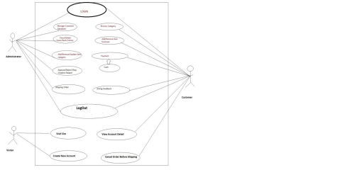

**2.3 User Characeristics:**

User should be familiar with the terms like

login,register,order system etc.

**2.4 Principle Actors:**

2 Principle Actors are Customer and

Administrator.

**2.5 General Constraints:**

A full internet connection is required for OSS.

**2.6 Assumptions and Dependencies**:

Working of OSS need Internet Connection.

**3. Specific Requirements**:

**3.1 Functional Requirements:**

This section provides requirement overview of the system.

Various functional modules that can be implemented by the system will be -

**3.1 Description:**

**3.1.1 Registration**

If customer wants to buy the product then he/she must be

registered, unregistered user can’t go to the shopping

cart.

**3.1.2 Login**

Customer logins to the system by entering valid user id

and password for the shopping.

**3.1.3 Changes to Cart**

Changes to cart means the customer after login or registration can make order or \cancel order of the product

from the shopping cart.

**3.1.4 Payment**

In this system we are dealing the mode of payment by Cash.We will extend this to credit card,debit card etc in the future.

**3.1.5 Logout**

After ordering or surfing for the product customer has to logout.

**3.1.6 Report Generation**

After ordering for the product,the syste will sent one copy of the bill to the customer’s Email-address and another one for the system data base.

**3.2 Non-Functional Requirements:**

Following Non-Functional Requirements will be there in the insurance to the internet:

(i) Secure access to consumer’s confidential data.

**(ii)** 24X7 availability**.**

**(iii)** Better component design to get better performance at peak time.

**(iv)** Flexible service based architecture will be highly desirable for future extension.Non-Functional Requirements define system properties and constraints.

Various other Non-Functional Requirements are:

➢ **Security**

➢ **Reliability**

➢ **Maintainability**

➢ **Portability**

➢ **Extensibility**

➢ **Reusability**

➢ **Compatibility**

➢ **Resource Utilization**

**3.3 Performance Requirements:**

In order to maintain an acceptable speed at maximum number of uploads allowed from a particular customer as any number of users can access to the system at any time.

Also the connections to the servers will be based on the attributes of the user like his location and server will be working 24X7 times.

**3.4 Technical issues:**

This system will work on client-server architecture. It will require an internet

server and which will be able to run Flutter application.

**4 . Interface Requirement:**

Various interfaces for the product could be

1). Login Page

2). Registration Form

3). There will be a screen displaying information

about product that the shop having.

4). If the customers select the buy button

then another screen of shopping cart will be

opened.

5). After ordering for the product,the system will

sent one copy of the bill to the customer’s Email

address

**Software Interface:**

1.Operating System: Android Ultimate

2.Dart and Flutter

**Hardware Interface:**

Hardware requirements for insurance on internet will be same for both parties which are as follows: Processor:Dual Core

RAM:2 GB

Hard Disk:320 GB

NIC:For each party

**Communication Interfaces:**

The two parties should be connected by LAN or WAN for the communication purpose.

|  |
| --- |
| SENDER SENDER |

|  |
| --- |
| RECEIVER |

Communication channel

**5.System Design Specification:**

**5.1 Architecture Design:**

5.1.1 Data Flow Diagram(DFD):

It is a way of representing system requirements in graphical form;this led to modular design.A DFD describes a data flow(logical) rather than how they are processed.So they do not depend upon

software,hardware,data structure or file organization.It is also known as ‘bubble sort’.

A DFD is a structured analysis and a design tool that can be used for flowcharting in place of ,or in

association with ,information-oriented and process oriented system flowcharts.

A DFD is considered as an abstract of the logic of information-oriented or process-oriented system flowchart.The four basic symbols used to construct data flow diagrams are-

A rectangle represents a data source or destination.

A directed line represents flow of data.

An Oval represents a process that transforms into

streams.

An Open ended rectangle represents storage.

The points at which data is transformed are called as nodes.The principle processes that take place at nodes are:

1.Combining data streams

2.Splitting data streams

3.Modifiying data streams

|  |
| --- |
| General  User |
| Customer |
|  |
| Admin |

|  |
| --- |
| Request |

|  |
| --- |
| Server |

|  |
| --- |
| Request |

|  |
| --- |
| Databas  e |

**CONTEXT ANALYSIS DIAGRAM(CAD)**

|  |
| --- |
| ADMINISTRATOR |

|  |
| --- |
| ONLINE  SHOPPING  SYSTEM |

|  |
| --- |
| CUSTOMER |

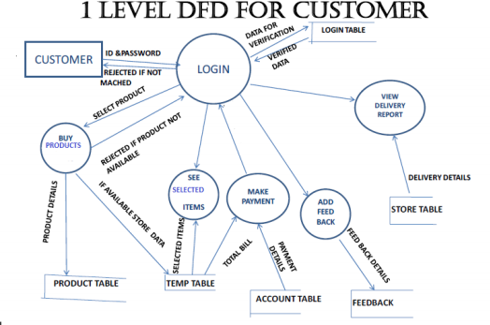**E-R DIAGRAM**

PROD_NAME

PRO_ID

PRICE

QUANTITY

|  |
| --- |
| PRODUCT |

|  |
| --- |
| USER_NAME |

|  |
| --- |
| USER_ID |

|  |
| --- |
| DOB |

|  |
| --- |
| **BUY PRODUCT** |

|  |
| --- |
| CUSTOMER  DETAILS |

|  |
| --- |
| PHONE_NO |

|  |
| --- |
| GENDER |

|  |
| --- |
| E_mail add |

|  |
| --- |
| ADDRESS |

|  |
| --- |
| MAKE PAYMENT |

|  |
| --- |
| FEEDBACK |

|  |
| --- |
| DELIVERY |