**Name: SOURABH PATKAR**

**Roll Number: 243212**

**Module: SDM**

**Topic: Git / Github / branching / merge / Jira / scrum**

**GIT COMMANDS**

**1)git init**

**2)git add .**

**3)git commit -m "first commit"**

**4)git branch -M main**

**5)git remote add origin https://github.com/ankushv1499/Mysql.git**

**6)git push -u origin main**

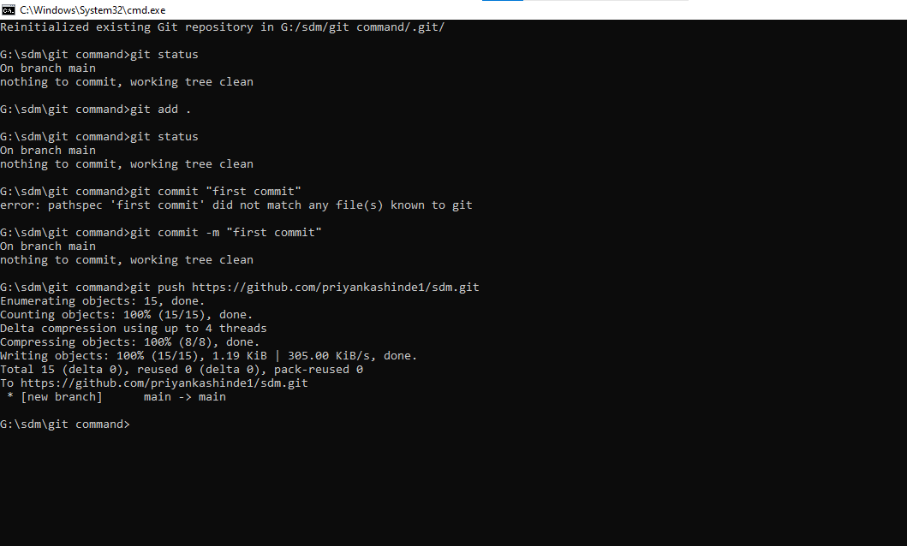

**6) Create Branch :Added branch to repository**

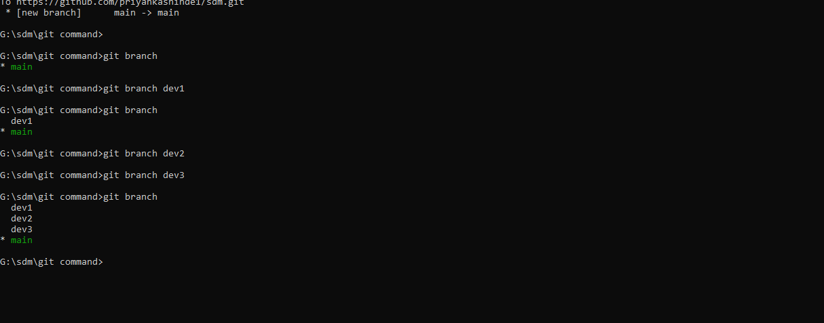

**7)git checkout branch**

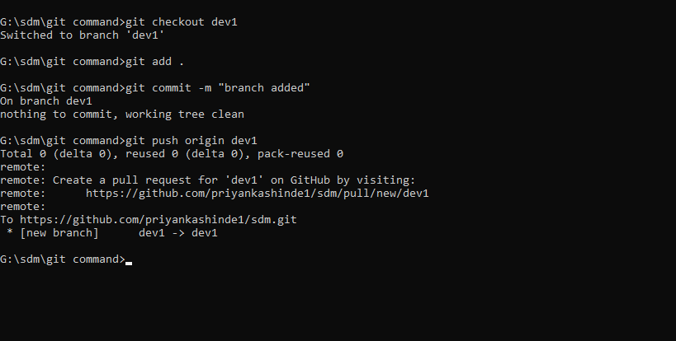

8) added file in branch

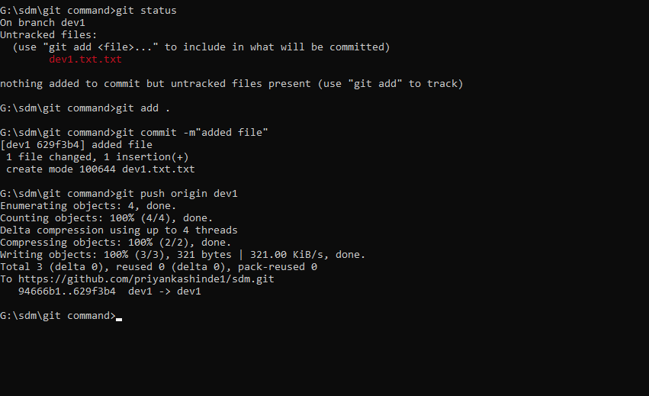

9)Branch checkout

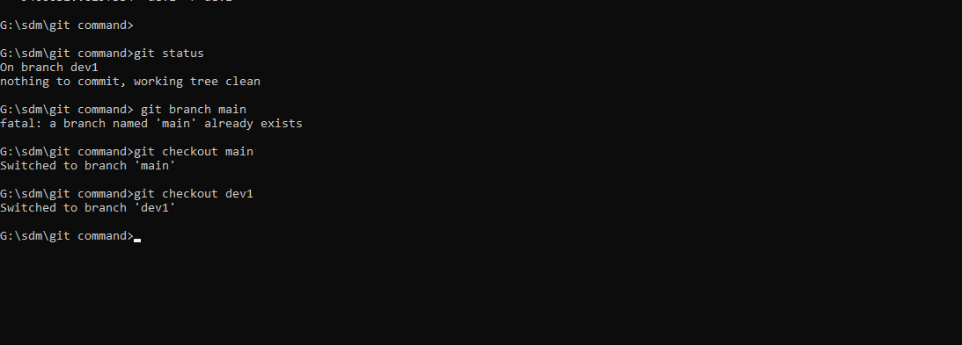

10) push branch to repo

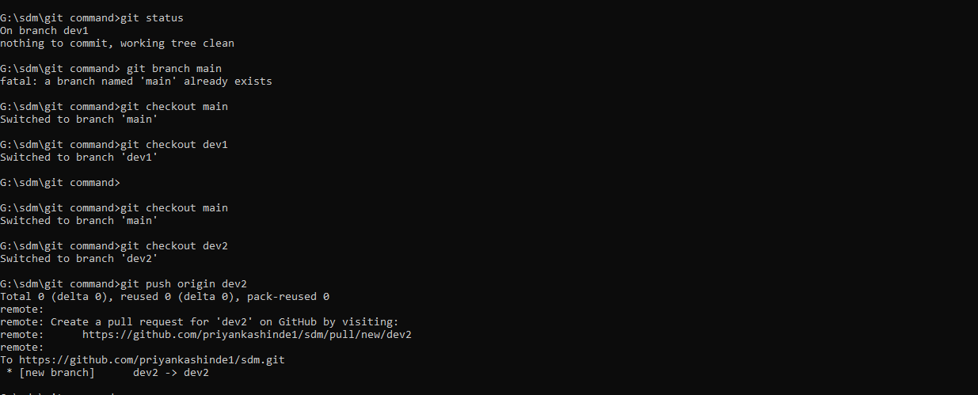

11)Push data in dev2 branch

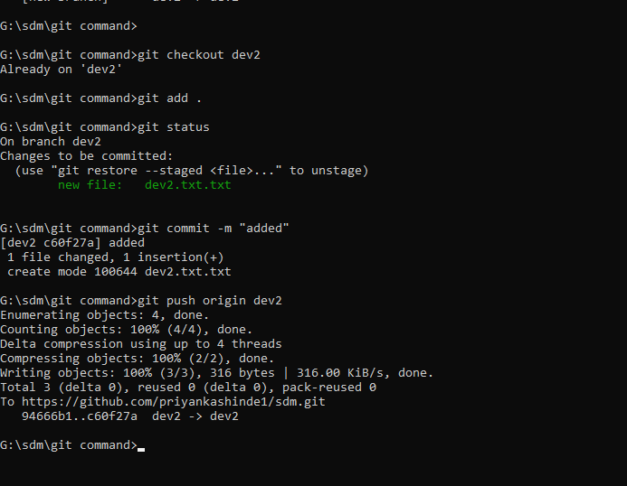

**Jira Scrum**

