**https://www.digitalocean.com/community/tutorials/how-to-install-prometheus-on-ubuntu-16-04**

**Introduction**

[Prometheus](https://prometheus.io/) is a powerful, open-source monitoring system that collects metrics from your services and stores them in a time-series database. It offers a multi-dimensional data model, a flexible query language, and diverse visualization possibilities through tools like [Grafana](https://grafana.com/).

By default, Prometheus only exports metrics about itself (e.g. the number of requests it’s received, its memory consumption, etc.). But, you can greatly expand Prometheus by installing *exporters*, optional programs that generate additional metrics.

Exporters — both the official ones that the Prometheus team maintains as well as the community-contributed ones — provide information about everything from infrastructure, databases, and web servers to messaging systems, APIs, and more.

Some of the most popular choices include:

* [node_exporter](https://github.com/prometheus/node_exporter) - This produces metrics about infrastructure, including the current CPU, memory and disk usage, as well as I/O and network statistics, such as the number of bytes read from a disk or a server’s average load.
* [blackbox_exporter](https://github.com/prometheus/blackbox_exporter) - This generates metrics derived from probing protocols like HTTP and HTTPS to determine endpoint availability, response time, and more.
* [mysqld_exporter](https://github.com/prometheus/mysqld_exporter) - This gathers metrics related to a MySQL server, such as the number of executed queries, average query response time, and cluster replication status.
* [rabbitmq_exporter](https://github.com/kbudde/rabbitmq_exporter) - This outputs metrics about the [RabbitMQ](https://www.rabbitmq.com/) messaging system, including the number of messages published, the number of messages ready to be delivered, and the size of all the messages in the queue.
* [nginx-vts-exporter](https://github.com/hnlq715/nginx-vts-exporter) - This provides metrics about an Nginx web server using the [Nginx VTS module](https://github.com/vozlt/nginx-module-vts), including the number of open connections, the number of sent responses (grouped by response codes), and the total size of sent or received requests in bytes.

You can find a more complete list of both official and community-contributed exporters on [Prometheus’ website](https://prometheus.io/docs/instrumenting/exporters/).

In this tutorial, you’ll install, configure, and secure Prometheus and Node Exporter to generate metrics that will make it easier to monitor your server’s performance.

**Prerequisites**

Before following this tutorial make sure you have:

* One Ubuntu 16.04 Droplet, set up by following the [Initial Server Setup with Ubuntu 16.04 tutorial](https://www.digitalocean.com/community/tutorials/initial-server-setup-with-ubuntu-16-04), including a sudo non-root user and a firewall.
* Nginx installed by following the first two steps of the [How To Install Nginx on Ubuntu 16.04](https://www.digitalocean.com/community/tutorials/how-to-install-nginx-on-ubuntu-16-04) tutorial.

**Step 1 — Creating Service Users**

For security purposes, we’ll begin by creating two new user accounts, **prometheus** and **node_exporter**. We’ll use these accounts throughout the tutorial to isolate the ownership on Prometheus’ core files and directories.

Create these two users, and use the --no-create-home and --shell /bin/false options so that these users can’t log into the server.

* sudo useradd --no-create-home --shell /bin/false prometheus
* sudo useradd --no-create-home --shell /bin/false node_exporter

Copy

Before we download the Prometheus binaries, create the necessary directories for storing Prometheus’ files and data. Following standard Linux conventions, we’ll create a directory in /etc for Prometheus’ configuration files and a directory in /var/lib for its data.

* sudo mkdir /etc/prometheus
* sudo mkdir /var/lib/prometheus

Copy

Now, set the user and group ownership on the new directories to the **prometheus** user.

* sudo chown prometheus:prometheus /etc/prometheus
* sudo chown prometheus:prometheus /var/lib/prometheus

Copy

With our users and directories in place, we can now download Prometheus and then create the minimal configuration file to run Prometheus for the first time.

**Step 2 — Downloading Prometheus**

First, download and unpack the current stable version of Prometheus into your home directory. You can find the latest binaries along with their checksums on the [Prometheus download page](https://prometheus.io/download/).

* cd ~
* curl -LO https://github.com/prometheus/prometheus/releases/download/v2.0.0/prometheus-2.0.0.linux-amd64.tar.gz

Copy

Next, use the sha256sum command to generate a checksum of the downloaded file:

* sha256sum prometheus-2.0.0.linux-amd64.tar.gz

Copy

Compare the output from this command with the checksum on the Prometheus download page to ensure that your file is both genuine and not corrupted.

Output

e12917b25b32980daee0e9cf879d9ec197e2893924bd1574604eb0f550034d46 prometheus-2.0.0.linux-amd64.tar.gz

If the checksums don’t match, remove the downloaded file and repeat the preceding steps to re-download the file.

Now, unpack the downloaded archive.

* tar xvf prometheus-2.0.0.linux-amd64.tar.gz

Copy

This will create a directory called prometheus-2.0.0.linux-amd64 containing two binary files (prometheus and promtool), consoles and console_libraries directories containing the web interface files, a license, a notice, and several example files.

Copy the two binaries to the /usr/local/bin directory.

* sudo cp prometheus-2.0.0.linux-amd64/prometheus /usr/local/bin/
* sudo cp prometheus-2.0.0.linux-amd64/promtool /usr/local/bin/

Copy

Set the user and group ownership on the binaries to the **prometheus** user created in Step 1.

* sudo chown prometheus:prometheus /usr/local/bin/prometheus
* sudo chown prometheus:prometheus /usr/local/bin/promtool

Copy

Copy the consoles and console_libraries directories to /etc/prometheus.

* sudo cp -r prometheus-2.0.0.linux-amd64/consoles /etc/prometheus
* sudo cp -r prometheus-2.0.0.linux-amd64/console_libraries /etc/prometheus

Copy

Set the user and group ownership on the directories to the **prometheus** user. Using the -R flag will ensure that ownership is set on the files inside the directory as well.

* sudo chown -R prometheus:prometheus /etc/prometheus/consoles
* sudo chown -R prometheus:prometheus /etc/prometheus/console_libraries

Copy

Lastly, remove the leftover files from your home directory as they are no longer needed.

* rm -rf prometheus-2.0.0.linux-amd64.tar.gz prometheus-2.0.0.linux-amd64

Copy

Now that Prometheus is installed, we’ll create its configuration and service files in preparation of its first run.

**Step 3 — Configuring Prometheus**

In the /etc/prometheus directory, use nano or your favorite text editor to create a configuration file named prometheus.yml. For now, this file will contain just enough information to run Prometheus for the first time.

* sudo nano /etc/prometheus/prometheus.yml

Copy

**Warning:** Prometheus’ configuration file uses the [YAML format](http://www.yaml.org/start.html), which strictly forbids tabs and requires two spaces for indentation. Prometheus will fail to start if the configuration file is incorrectly formatted.

In the global settings, define the default interval for scraping metrics. Note that Prometheus will apply these settings to every exporter unless an individual exporter’s own settings override the globals.

Prometheus config file part 1 - /etc/prometheus/prometheus.yml

global:

scrape_interval: 15s

Copy

This scrape_interval value tells Prometheus to collect metrics from its exporters every 15 seconds, which is long enough for most exporters.

Now, add Prometheus itself to the list of exporters to scrape from with the following scrape_configs directive:

Prometheus config file part 2 - /etc/prometheus/prometheus.yml

...

scrape_configs:

- job_name: 'prometheus'

scrape_interval: 5s

static_configs:

- targets: ['localhost:9090']

Copy

Prometheus uses the job_name to label exporters in queries and on graphs, so be sure to pick something descriptive here.

And, as Prometheus exports important data about itself that you can use for monitoring performance and debugging, we’ve overridden the global scrape_interval directive from 15 seconds to 5 seconds for more frequent updates.

Lastly, Prometheus uses the static_configs and targets directives to determine where exporters are running. Since this particular exporter is running on the same server as Prometheus itself, we can use localhost instead of an IP address along with the default port, 9090.

Your configuration file should now look like this:

Prometheus config file - /etc/prometheus/prometheus.yml

global:

scrape_interval: 15s

scrape_configs:

- job_name: 'prometheus'

scrape_interval: 5s

static_configs:

- targets: ['localhost:9090']

Copy

Save the file and exit your text editor.

Now, set the user and group ownership on the configuration file to the **prometheus** user created in Step 1.

* sudo chown prometheus:prometheus /etc/prometheus/prometheus.yml

Copy

With the configuration complete, we’re ready to test Prometheus by running it for the first time.

**Step 4 — Running Prometheus**

Start up Prometheus as the **prometheus** user, providing the path to both the configuration file and the data directory.

* sudo -u prometheus /usr/local/bin/prometheus \
* --config.file /etc/prometheus/prometheus.yml \
* --storage.tsdb.path /var/lib/prometheus/ \
* --web.console.templates=/etc/prometheus/consoles \
* --web.console.libraries=/etc/prometheus/console_libraries

Copy

The output contains information about Prometheus’ loading progress, configuration file, and related services. It also confirms that Prometheus is listening on port 9090.

Output

level=info ts=2017-11-17T18:37:27.474530094Z caller=main.go:215 msg="Starting Prometheus" version="(version=2.0.0, branch=HEAD, re

vision=0a74f98628a0463dddc90528220c94de5032d1a0)"

level=info ts=2017-11-17T18:37:27.474758404Z caller=main.go:216 build_context="(go=go1.9.2, user=root@615b82cb36b6, date=20171108-

07:11:59)"

level=info ts=2017-11-17T18:37:27.474883982Z caller=main.go:217 host_details="(Linux 4.4.0-98-generic #121-Ubuntu SMP Tue Oct 10 1

4:24:03 UTC 2017 x86_64 prometheus-update (none))"

level=info ts=2017-11-17T18:37:27.483661837Z caller=web.go:380 component=web msg="Start listening for connections" address=0.0.0.0

:9090

level=info ts=2017-11-17T18:37:27.489730138Z caller=main.go:314 msg="Starting TSDB"

level=info ts=2017-11-17T18:37:27.516050288Z caller=targetmanager.go:71 component="target manager" msg="Starting target manager...

"

level=info ts=2017-11-17T18:37:27.537629169Z caller=main.go:326 msg="TSDB started"

level=info ts=2017-11-17T18:37:27.537896721Z caller=main.go:394 msg="Loading configuration file" filename=/etc/prometheus/promethe

us.yml

level=info ts=2017-11-17T18:37:27.53890004Z caller=main.go:371 msg="Server is ready to receive requests."

If you get an error message, double-check that you’ve used YAML syntax in your configuration file and then follow the on-screen instructions to resolve the problem.

Now, halt Prometheus by pressing CTRL+C, and then open a new systemd service file.

* sudo nano /etc/systemd/system/prometheus.service

Copy

The service file tells systemd to run Prometheus as the **prometheus** user, with the configuration file located in the /etc/prometheus/prometheus.yml directory and to store its data in the /var/lib/prometheus directory. (The details of systemd service files are beyond the scope of this tutorial, but you can learn more at [Understanding Systemd Units and Unit Files](https://www.digitalocean.com/community/tutorials/understanding-systemd-units-and-unit-files#where-are-systemd-unit-files-found).)

Copy the following content into the file:

Prometheus service file - /etc/systemd/system/prometheus.service

[Unit]

Description=Prometheus

Wants=network-online.target

After=network-online.target

[Service]

User=prometheus

Group=prometheus

Type=simple

ExecStart=/usr/local/bin/prometheus \

--config.file /etc/prometheus/prometheus.yml \

--storage.tsdb.path /var/lib/prometheus/ \

--web.console.templates=/etc/prometheus/consoles \

--web.console.libraries=/etc/prometheus/console_libraries

[Install]

WantedBy=multi-user.target

Copy

Finally, save the file and close your text editor.

To use the newly created service, reload systemd.

* sudo systemctl daemon-reload

Copy

You can now start Prometheus using the following command:

* sudo systemctl start prometheus

Copy

To make sure Prometheus is running, check the service’s status.

* sudo systemctl status prometheus

Copy

The output tells you Prometheus’ status, main process identifier (PID), memory use, and more.

If the service’s status isn’t active, follow the on-screen instructions and re-trace the preceding steps to resolve the problem before continuing the tutorial.

Output

● prometheus.service - Prometheus

Loaded: loaded (/etc/systemd/system/prometheus.service; disabled; vendor preset: enabled)

Active: active (running) since Fri 2017-07-21 11:40:40 UTC; 3s ago

Main PID: 2104 (prometheus)

Tasks: 7

Memory: 13.8M

CPU: 470ms

CGroup: /system.slice/prometheus.service

...

When you’re ready to move on, press Q to quit the status command.

Lastly, enable the service to start on boot.

* sudo systemctl enable prometheus

Copy

Now that Prometheus is up and running, we can install an additional exporter to generate metrics about our server’s resources.

**Step 5 — Downloading Node Exporter**

To expand Prometheus beyond metrics about itself only, we’ll install an additional exporter called Node Exporter. Node Exporter provides detailed information about the system, including CPU, disk, and memory usage.

First, download the current stable version of Node Exporter into your home directory. You can find the latest binaries along with their checksums on [Prometheus’ download page](https://prometheus.io/download/).

* cd ~
* curl -LO https://github.com/prometheus/node_exporter/releases/download/v0.15.1/node_exporter-0.15.1.linux-amd64.tar.gz

Copy

Use the sha256sum command to generate a checksum of the downloaded file:

* sha256sum node_exporter-0.15.1.linux-amd64.tar.gz

Copy

Verify the downloaded file’s integrity by comparing its checksum with the one on the download page.

Output

7ffb3773abb71dd2b2119c5f6a7a0dbca0cff34b24b2ced9e01d9897df61a127 node_exporter-0.15.1.linux-amd64.tar.gz

If the checksums don’t match, remove the downloaded file and repeat the preceding steps.

Now, unpack the downloaded archive.

* tar xvf node_exporter-0.15.1.linux-amd64.tar.gz

Copy

This will create a directory called node_exporter-0.15.1.linux-amd64 containing a binary file named node_exporter, a license, and a notice.

Copy the binary to the /usr/local/bin directory and set the user and group ownership to the **node_exporter** user that you created in Step 1.

* sudo cp node_exporter-0.15.1.linux-amd64/node_exporter /usr/local/bin
* sudo chown node_exporter:node_exporter /usr/local/bin/node_exporter

Copy

Lastly, remove the leftover files from your home directory as they are no longer needed.

* rm -rf node_exporter-0.15.1.linux-amd64.tar.gz node_exporter-0.15.1.linux-amd64

Copy

Now that you’ve installed Node Exporter, let’s test it out by running it before creating a service file for it so that it starts on boot.

**Step 6 — Running Node Exporter**

The steps for running Node Exporter are similar to those for running Prometheus itself. Start by creating the Systemd service file for Node Exporter.

* sudo nano /etc/systemd/system/node_exporter.service

Copy

This service file tells your system to run Node Exporter as the **node_exporter** user with the default set of collectors enabled.

Copy the following content into the service file:

Node Exporter service file - /etc/systemd/system/node_exporter.service

[Unit]

Description=Node Exporter

Wants=network-online.target

After=network-online.target

[Service]

User=node_exporter

Group=node_exporter

Type=simple

ExecStart=/usr/local/bin/node_exporter

[Install]

WantedBy=multi-user.target

Copy

Collectors define which metrics Node Exporter will generate. You can see Node Exporter’s complete list of collectors — including which are enabled by default and which are deprecated — in the [Node Exporter README file](https://github.com/prometheus/node_exporter/blob/master/README.md#enabled-by-default).

If you ever need to override the default list of collectors, you can use the --collectors.enabled flag, like:

Node Exporter service file part - /etc/systemd/system/node_exporter.service

...

ExecStart=/usr/local/bin/node_exporter --collectors.enabled meminfo,loadavg,filesystem

...

Copy

The preceding example would tell Node Exporter to generate metrics using only the meminfo, loadavg, and filesystem collectors. You can limit the collectors to however few or many you need, but note that there are no blank spaces before or after the commas.

Save the file and close your text editor.

Finally, reload systemd to use the newly created service.

* sudo systemctl daemon-reload

Copy

You can now run Node Exporter using the following command:

* sudo systemctl start node_exporter

Copy

Verify that Node Exporter’s running correctly with the status command.

* sudo systemctl status node_exporter

Copy

Like before, this output tells you Node Exporter’s status, main process identifier (PID), memory usage, and more.

If the service’s status isn’t active, follow the on-screen messages and re-trace the preceding steps to resolve the problem before continuing.

Output

● node_exporter.service - Node Exporter

Loaded: loaded (/etc/systemd/system/node_exporter.service; disabled; vendor preset: enabled)

Active: active (running) since Fri 2017-07-21 11:44:46 UTC; 5s ago

Main PID: 2161 (node_exporter)

Tasks: 3

Memory: 1.4M

CPU: 11ms

CGroup: /system.slice/node_exporter.service

Lastly, enable Node Exporter to start on boot.

* sudo systemctl enable node_exporter

Copy

With Node Exporter fully configured and running as expected, we’ll tell Prometheus to start scraping the new metrics.

**Step 7 — Configuring Prometheus to Scrape Node Exporter**

Because Prometheus only scrapes exporters which are defined in the scrape_configs portion of its configuration file, we’ll need to add an entry for Node Exporter, just like we did for Prometheus itself.

Open the configuration file.

* sudo nano /etc/prometheus/prometheus.yml

Copy

At the end of the scrape_configs block, add a new entry called node_exporter.

Prometheus config file part 1 - /etc/prometheus/prometheus.yml

...

- job_name: 'node_exporter'

scrape_interval: 5s

static_configs:

- targets: ['localhost:9100']

Copy

Because this exporter is also running on the same server as Prometheus itself, we can use localhost instead of an IP address again along with Node Exporter’s default port, 9100.

Your whole configuration file should look like this:

Prometheus config file - /etc/prometheus/prometheus.yml

global:

scrape_interval: 15s

scrape_configs:

- job_name: 'prometheus'

scrape_interval: 5s

static_configs:

- targets: ['localhost:9090']

- job_name: 'node_exporter'

scrape_interval: 5s

static_configs:

- targets: ['localhost:9100']

Copy

Save the file and exit your text editor when you’re ready to continue.

Finally, restart Prometheus to put the changes into effect.

* sudo systemctl restart prometheus

Copy

Once again, verify that everything is running correctly with the status command.

* sudo systemctl status prometheus

Copy

If the service’s status isn’t set to active, follow the on screen instructions and re-trace your previous steps before moving on.

Output

● prometheus.service - Prometheus

Loaded: loaded (/etc/systemd/system/prometheus.service; disabled; vendor preset: enabled)

Active: active (running) since Fri 2017-07-21 11:46:39 UTC; 6s ago

Main PID: 2219 (prometheus)

Tasks: 6

Memory: 19.9M

CPU: 433ms

CGroup: /system.slice/prometheus.service

We now have Prometheus and Node Exporter installed, configured, and running. As a final precaution before connecting to the web interface, we’ll enhance our installation’s security with basic HTTP authentication to ensure that unauthorized users can’t access our metrics.

**Step 8 — Securing Prometheus**

Prometheus does not include built-in authentication or any other general purpose security mechanism. On the one hand, this means you’re getting a highly flexible system with fewer configuration restraints; on the other hand, it means it’s up to you to ensure that your metrics and overall setup are sufficiently secure.

For simplicity’s sake, we’ll use Nginx to add basic HTTP authentication to our installation, which both Prometheus and its preferred data visualization tool, Grafana, fully support.

Start by installing apache2-utils, which will give you access to the htpasswd utility for generating password files.

* sudo apt-get update
* sudo apt-get install apache2-utils

Copy

Now, create a password file by telling htpasswd where you want to store the file and which username you’d like to use for authentication.

**Note:** htpasswd will prompt you to enter and re-confirm the password you’d like to associate with this user. Also, make note of both the username and password you enter here, as you’ll need them to log into Prometheus in Step 9.

* sudo htpasswd -c /etc/nginx/.htpasswd sammy

Copy

The result of this command is a newly-created file called .htpasswd, located in the /etc/nginx directory, containing the username and a hashed version of the password you entered.

Next, configure Nginx to use the newly-created passwords.

First, make a Prometheus-specific copy of the default Nginx configuration file so that you can revert back to the defaults later if you run into a problem.

* sudo cp /etc/nginx/sites-available/default /etc/nginx/sites-available/prometheus

Copy

Then, open the new configuration file.

* sudo nano /etc/nginx/sites-available/prometheus

Copy

Locate the location / block under the server block. It should look like:

/etc/nginx/sites-available/default

...

location / {

try_files $uri $uri/ =404;

}

...

Copy

As we will be forwarding all traffic to Prometheus, replace the try_files directive with the following content:

/etc/nginx/sites-available/prometheus

...

location / {

auth_basic "Prometheus server authentication";

auth_basic_user_file /etc/nginx/.htpasswd;

proxy_pass http://localhost:9090;

proxy_http_version 1.1;

proxy_set_header Upgrade $http_upgrade;

proxy_set_header Connection 'upgrade';

proxy_set_header Host $host;

proxy_cache_bypass $http_upgrade;

}

...

Copy

These settings ensure that users will have to authenticate at the start of each new session. Additionally, the reverse proxy will direct all requests handled by this block to Prometheus.

When you’re finished making changes, save the file and close your text editor.

Now, deactivate the default Nginx configuration file by removing the link to it in the /etc/nginx/sites-enabled directory, and activate the new configuration file by creating a link to it.

* sudo rm /etc/nginx/sites-enabled/default
* sudo ln -s /etc/nginx/sites-available/prometheus /etc/nginx/sites-enabled/

Copy

Before restarting Nginx, check the configuration for errors using the following command:

* sudo nginx -t

Copy

The output should indicate that the syntax is ok and the test is successful. If you receive an error message, follow the on-screen instructions to fix the problem before proceeding to the next step.

Output of Nginx configuration tests

nginx: the configuration file /etc/nginx/nginx.conf syntax is ok

nginx: configuration file /etc/nginx/nginx.conf test is successful

Then, reload Nginx to incorporate all of the changes.

* sudo systemctl reload nginx

Copy

Verify that Nginx is up and running.

* sudo systemctl status nginx

Copy

If your output doesn’t indicate that the service’s status is active, follow the on-screen messages and re-trace the preceding steps to resolve the issue before continuing.

Output

● nginx.service - A high performance web server and a reverse proxy server

Loaded: loaded (/lib/systemd/system/nginx.service; enabled; vendor preset: en

Active: active (running) since Mon 2017-07-31 21:20:57 UTC; 12min ago

Process: 4302 ExecReload=/usr/sbin/nginx -g daemon on; master_process on; -s r

Main PID: 3053 (nginx)

Tasks: 2

Memory: 3.6M

CPU: 56ms

CGroup: /system.slice/nginx.service

Copy

At this point, we have a fully-functional and secured Prometheus server, so we can log into the web interface to begin looking at metrics.

**Step 9 — Testing Prometheus**

Prometheus provides a basic web interface for monitoring the status of itself and its exporters, executing queries, and generating graphs. But, due to the interface’s simplicity, the Prometheus team [recommends](https://prometheus.io/docs/visualization/browser/) [installing and using Grafana](https://prometheus.io/docs/visualization/grafana/) for anything more complicated than testing and debugging.

In this tutorial, we’ll use the built-in web interface to ensure that Prometheus and Node Exporter are up and running, and we’ll also take a look at simple queries and graphs.

To begin, point your web browser to http://your_server_ip.

In the HTTP authentication dialogue box, enter the username and password you chose in Step 8.

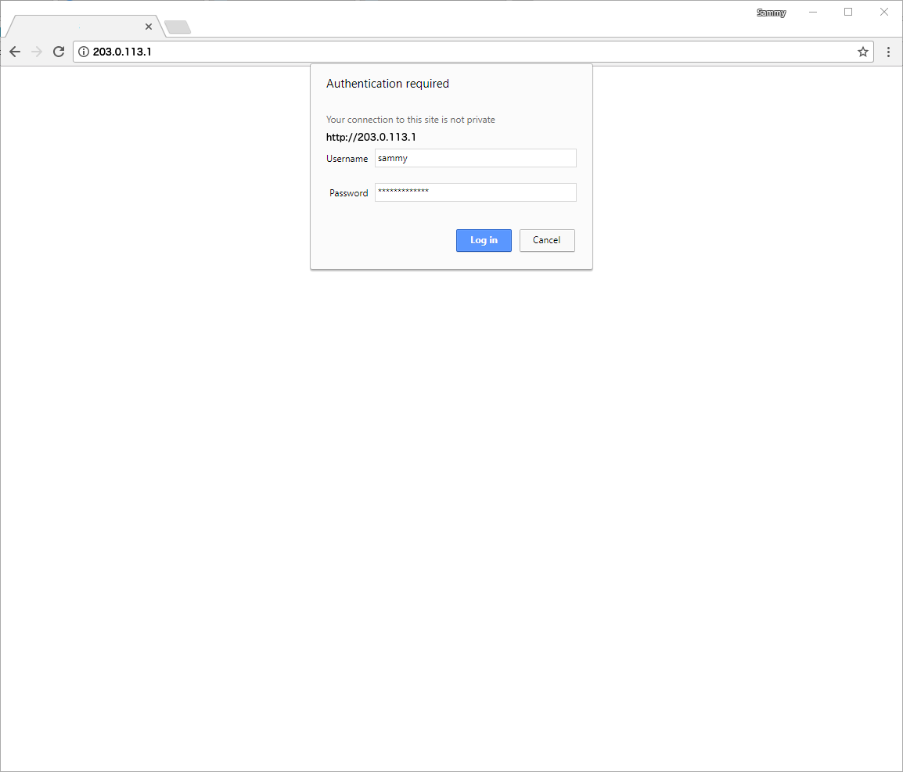

Once logged in, you’ll see the **Expression Browser**, where you can execute and visualize custom queries.

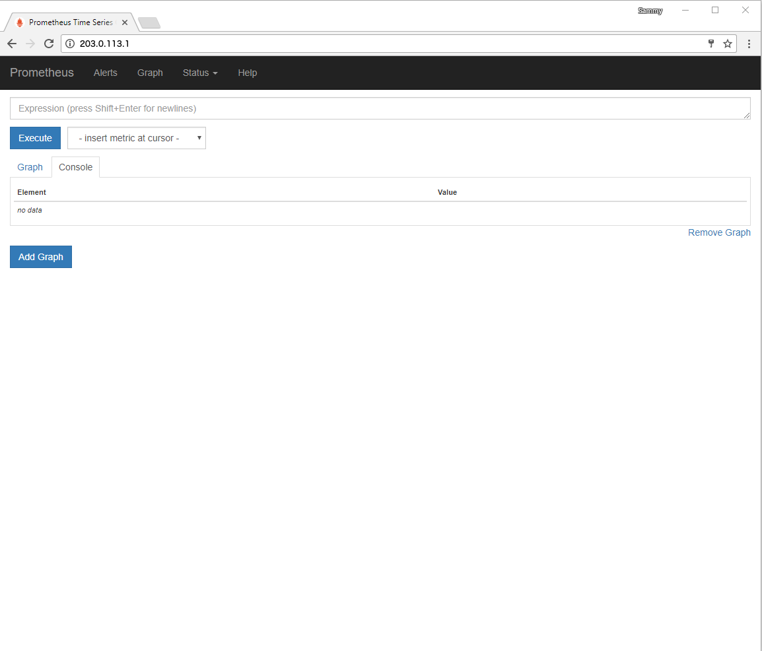

Before executing any expressions, verify the status of both Prometheus and Node Explorer by clicking first on the **Status** menu at the top of the screen and then on the **Targets** menu option. As we have configured Prometheus to scrape both itself and Node Exporter, you should see both targets listed in the UP state.

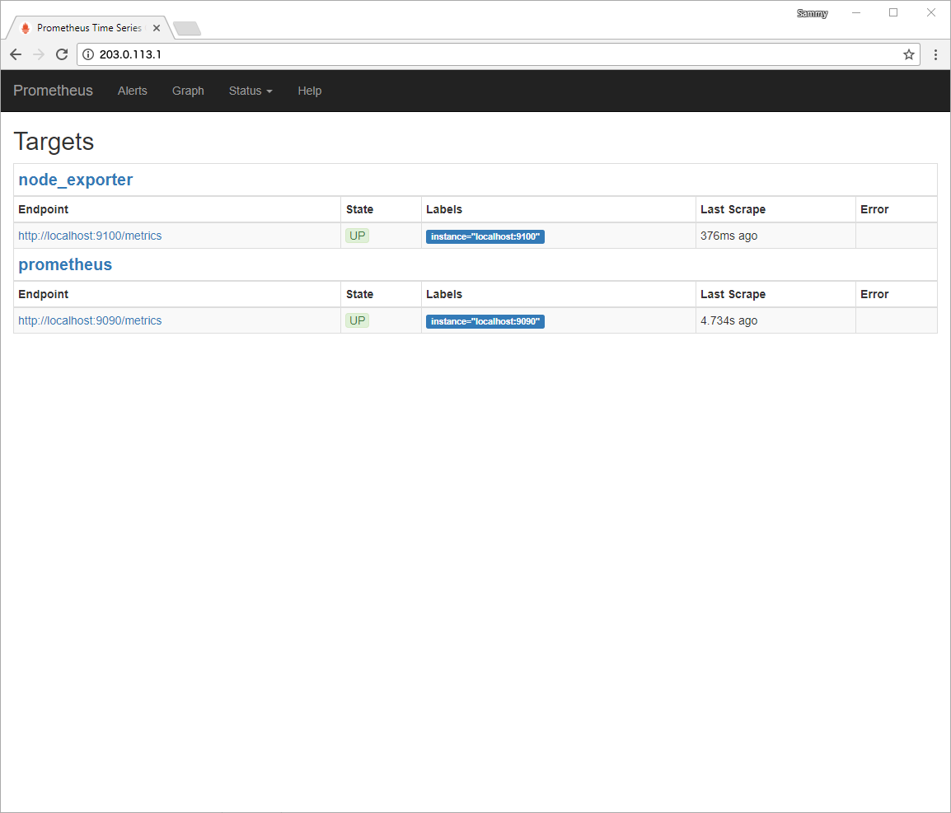

If either exporter is missing or displays an error message, check the service’s status with the following commands:

* sudo systemctl status prometheus

Copy

* sudo systemctl status node_exporter

Copy

The output for both services should report a status of Active: active (running). If a service either isn’t active at all or is active but still not working correctly, follow the on-screen instructions and re-trace the previous steps before continuing.

Next, to make sure that the exporters are working correctly, we’ll execute a few expressions against Node Exporter.

First, click on the **Graph** menu at the top of the screen to return to the **Expression Browser**.

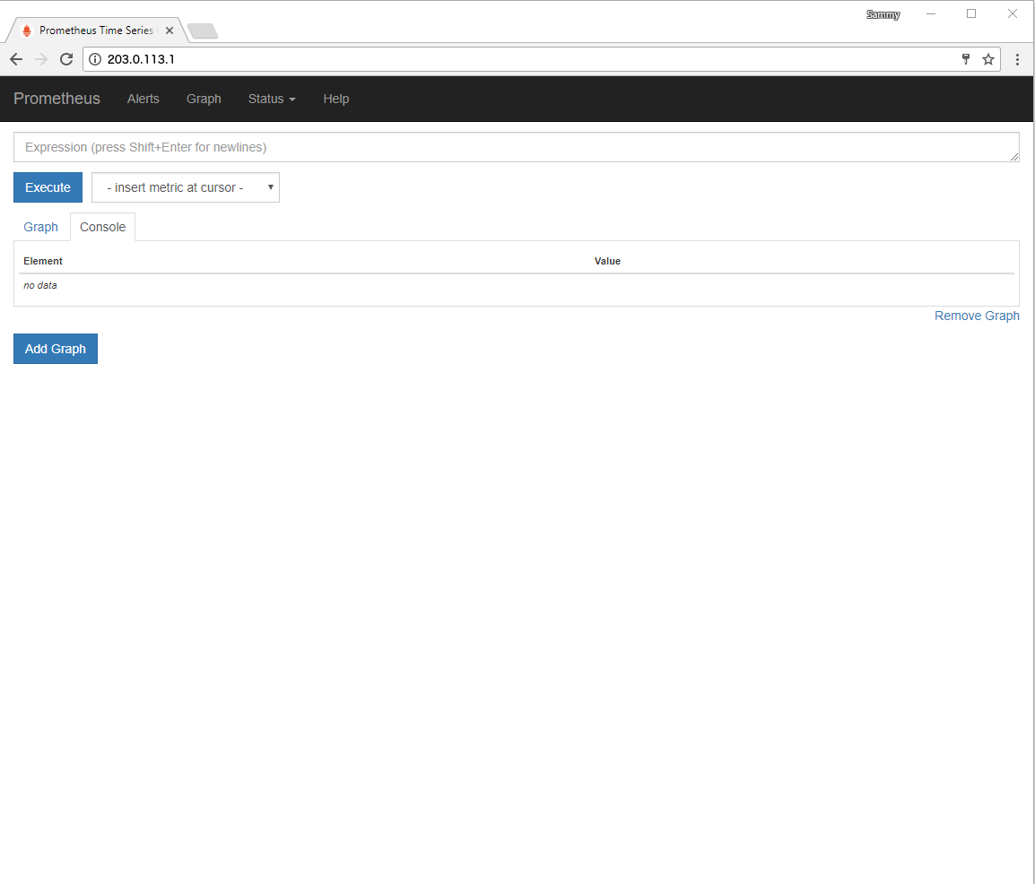

In the **Expression** field, type node_memory_MemAvailable and press the **Execute** button to update the **Console** tab with the amount of memory your server has.

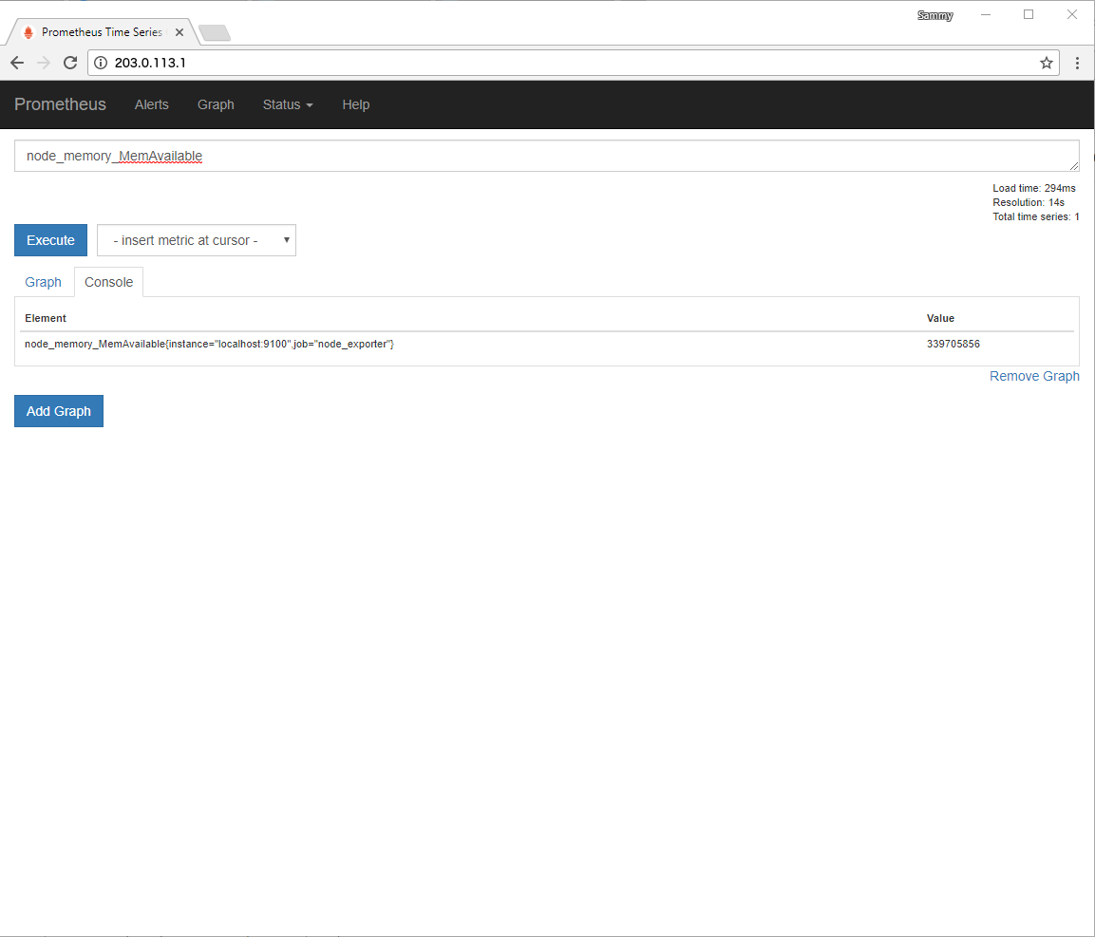

By default, Node Exporter reports this amount in bytes. To convert to megabytes, we’ll use math operators to divide by 1024 twice.

In the **Expression** field, enter node_memory_MemAvailable/1024/1024 and then press the **Execute** button.

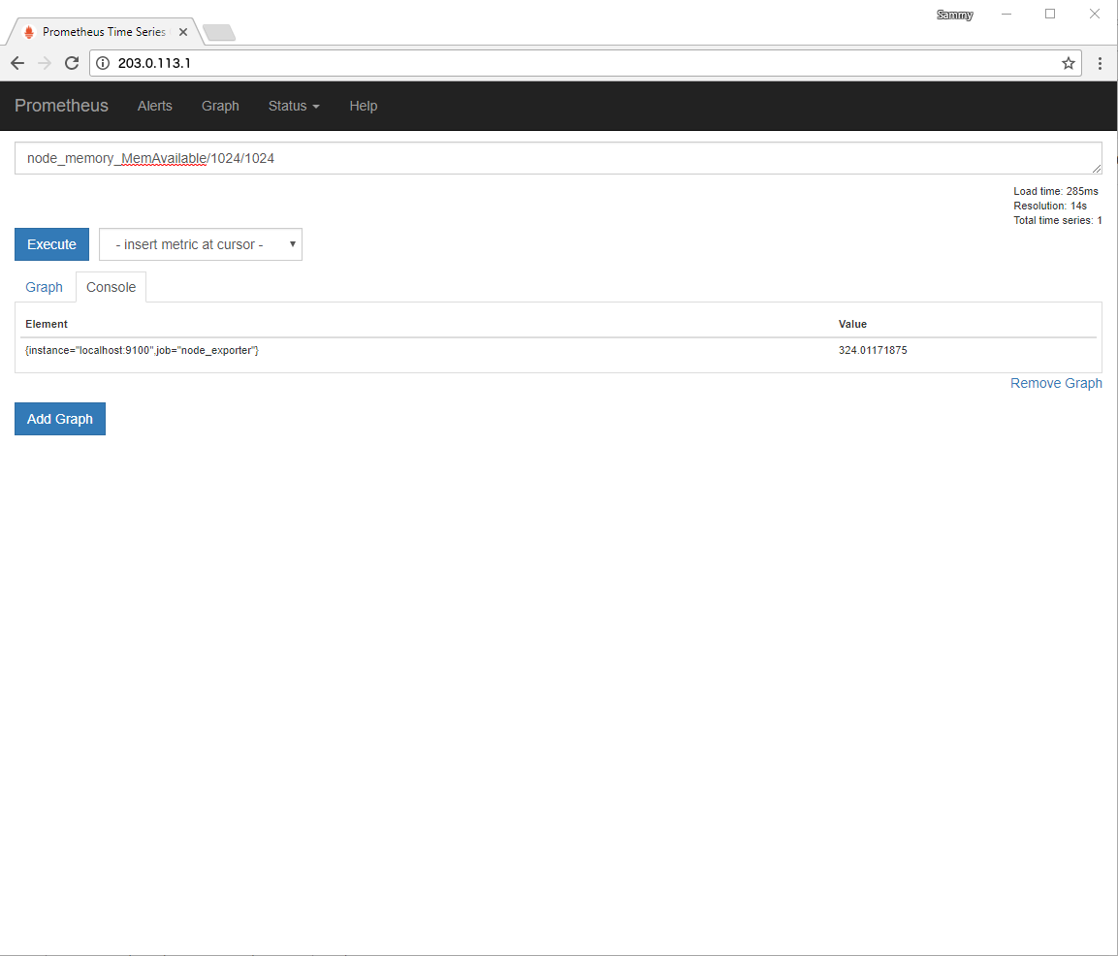

The **Console** tab will now display the results in megabytes.

If you want to verify the results, execute the free command from your terminal. (The -h flag tells free to report back in a human-readable format, giving us the amount in megabytes.)

* free -h

Copy

This output contains details about memory usage, including available memory displayed in the **available** column.

Output

total used free shared buff/cache available

Mem: 488M 144M 17M 3.7M 326M 324M

Swap: 0B 0B 0B

In addition to basic operators, the Prometheus query language also provides many functions for aggregating results.

In the **Expression** field, type avg_over_time(node_memory_MemAvailable[5m])/1024/1024 and click on the **Execute** button. The result will be the average available memory over the last 5 minutes in megabytes.

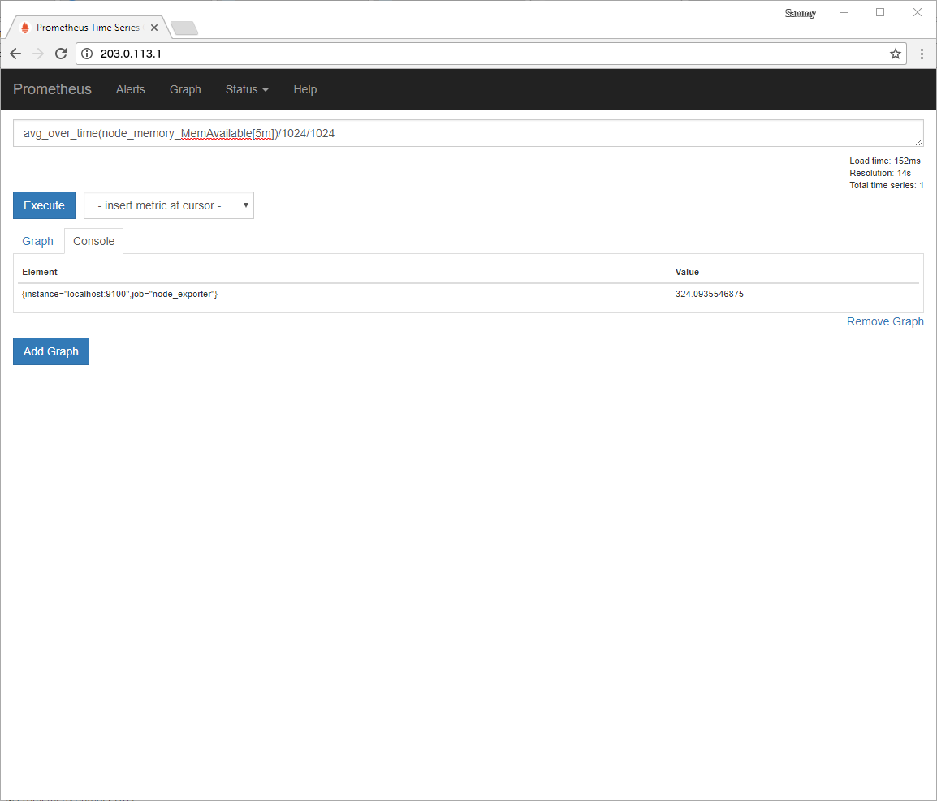

Now, click on the **Graph** tab to display the executed expression as a graph instead of as text.

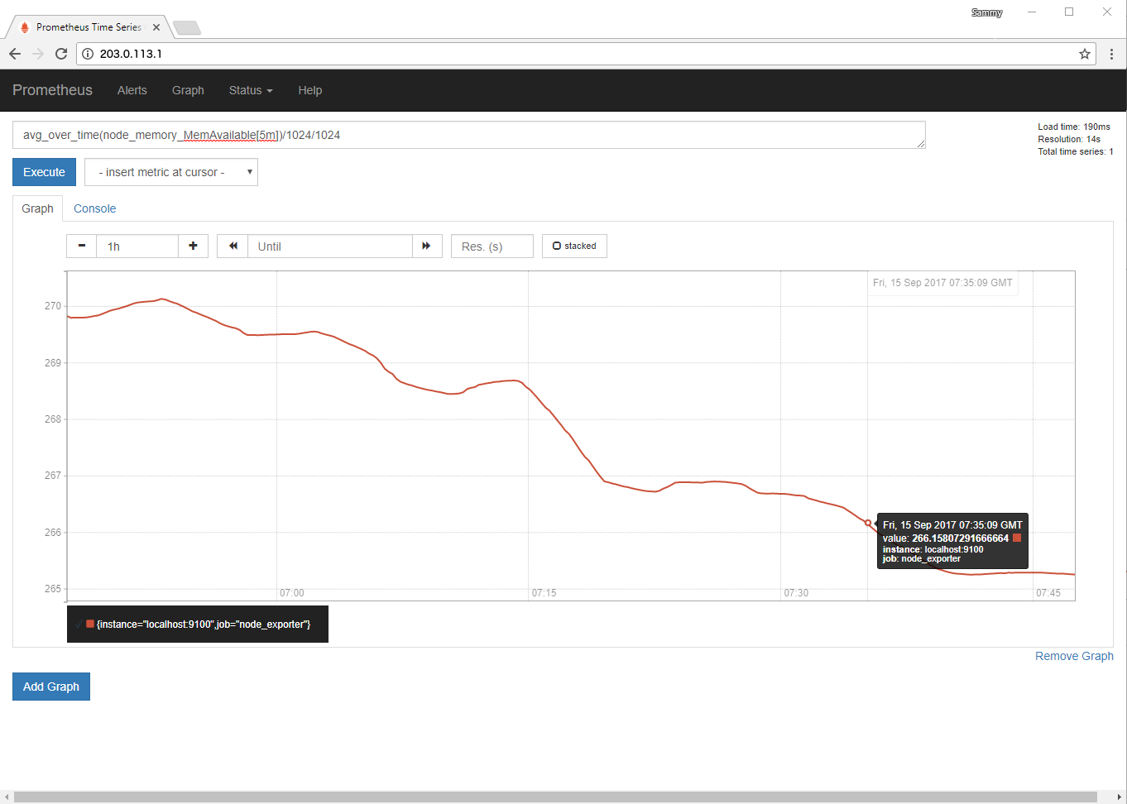

Finally, while still on this tab, hover your mouse over the graph for additional details about any specific point along the graph’s X and Y axes.

If you’d like to learn more about creating expressions in Prometheus’ built-in web interface, see the [Querying Prometheus](https://prometheus.io/docs/querying/basics/) portion of the official documentation.

**Conclusion**

In this tutorial we downloaded, configured, secured, and tested a complete Prometheus installation with one additional exporter.

If you’d like to learn more about how Prometheus works under the hood, take a look at [How To Query Prometheus on Ubuntu 14.04](https://www.digitalocean.com/community/tutorials/how-to-query-prometheus-on-ubuntu-14-04-part-1#step-2-%E2%80%94-installing-the-demo-instances). (Since you already have Prometheus installed, you can skip the first step.)

To see what else Prometheus can do, visit [the official Prometheus documentation](https://prometheus.io/docs/introduction/overview/).

And, to learn more about extending Prometheus, check out the [list of available exporters](https://prometheus.io/docs/instrumenting/exporters/) as well as the [official Grafana website](https://grafana.com/).