IR Reasoner: Real-Time Infrared Object Detection by Visual Reasoning

1. INTRODUCTION 3
1.1 Background and Context 3
1.2 Problem Statement 3
1.3 Research Aim and Objectives 4
1.4 Research Questions 5
1.5 Methodological Overview 5
1.6 Significance of the Study 5
1.7 Scope and Limitations 6
1.8 Structure of the Dissertation 7
2. LITERATURE REVIEW 8
2.1 Introduction to Thermal Infrared Object Detection 8
2.2 Challenges in Thermal Infrared Object Detection 9
2.3 Evolution of Object Detection Architectures 11
2.4 YOLO-Based Approaches in Thermal Imaging 13
2.5 Attention Mechanisms and Visual Reasoning 14
2.6 Visual Reasoning in Infrared Detection 16
2.7 Computational Efficiency and Real-Time Constraints 16
2.9 Evaluation Metrics and Real-Time Performance 17
2.10 Research Gap 18
3. METHODOLOGY 19
3.1 Research Philosophy 19
3.2 Research Approach 20
3.3 Data Collection 20
3.4 Research Strategy 21
3.5 The Baseline YOLOv8 Architecture 21
3.6 Proposed YOLOv8-IR-Reasoner 22
3.7 Data Preprocessing 22
3.8 Training Configuration 23
3.9 Evaluation Metrics and Data Analysis Technique 23
3.10 Time Horizon 24
3.11 Research Ethics 24
REFERENCES 25

1. INTRODUCTION

1.1 Background and Context
Object detection technology has come a long way from hand-crafted feature extractors and sliding window classifiers to deep learning-powered architectures. Being the backbone of autonomous vehicles, ADAS systems, and surveillance across large regions, the current methods of object detection are somewhere between perception and interference [1]. With added understanding of spatial belonging within a scene, deep learning models such as CNN are propelling the innovation forward, one major development being the YOLO (You Only Look Once) family that offers detection with both speed and accuracy. Within a single pass, it basically divides images into grids and predicts bounding boxes and class probabilities to facilitate detection in real time, raising its importance especially in safety-critical needs [2].

Thermal infrared (TIR) imaging relies on the emission of radiation instead of the reflection of light like conventional RGB cameras. By detecting heat signatures, they can detect objects in darkness, fog, or through mild occlusion, cases where RGB cameras fail [3]. However, in safety-critical systems such as the ADAS, thermal infrared poses challenges, like low resolution, thermal noise, lack of texture, and poor contrast.

Additionally, unlike RGB datasets, thermal ones are not abundant and therefore limit the training capacity of machine learning models. Early methods relied on handcrafted features, which failed under variability. Deep learning has facilitated some improvements but still makes the same structural assumptions, compromising accuracy in the face of randomness. AV-based thermal detection, for example, deals with long-range imaging, cluttered scenes, and small object sizes, all of which degrade detection quality [4].

1.2 Problem Statement
Most YOLO architectures have local processing, where convolutional filters are applied to image patches, neglecting the need for global semantic-spatial relationships that are critical for dealing with blurry edges and occlusions typical of thermal images [5]. This becomes problematic in infrared imaging, in which objects are not always distinguishable by local features alone.

Due to the lack of texture, low contrast, and noise, TIR can lead to false positives when placed in crowded regions. In such cases, relying solely on convolutional representations leads to inconsistent predictions. In long-range imaging, overlapping of objects with similar or subtle differences in temperature can make even the modern YOLO adaptations for infrared data struggle. The accuracy of this can be improved, but the persistent challenge is the lack of consistency across complex scenarios [6]. Also, better accuracy comes at the cost of computational power, as real-time systems cannot handle heavy architecture.

1.3 Research Aim and Objectives
Aim: To develop and train a real-time infrared object detector by integrating a self-attention visual reasoning module into a YOLO framework and testing its performance on the challenging data of thermal urban driving.

Objectives:
- To conduct a comprehensive review of the recent state-of-the-art developments in thermal infrared object detection and YOLO’s adaptation to it.
- To process the Teledyne FLIR ADAS Thermal Dataset v2 by transforming MS COCO JSON annotations to YOLO TXT format for supervised learning.
- To train a baseline model using a standard, unaltered YOLO detector (such as YOLOv8) on the thermal dataset and set up baseline performance.
- To develop and integrate a lightweight CHANNEL-based visual reasoning module into the feature extraction levels (neck/backbone) of the baseline YOLO model.
- To perform an ablation study to compare the performance of the baseline model with that of the improved "YOLO+Reasoner" model using standard metrics of mAP@0.5 and mAP@0.5:0.95, Precision, and Recall.
- To thoroughly analyse the computational trade-offs between enhanced detection performance and real-time processing latency (measured in Frames Per Second - FPS).

1.4 Research Questions
- How effective is the standard YOLOv8 model on thermal infrared datasets in real-time?
- Can detection accuracy be improved in low-contrast and occluded environments using a channel-based visual reasoning module?
- How is inference speed affected in the presence of a reasoning module, especially in real-time?
- Is there a trade-off between accuracy (mAP) and the computational power of frames per second after the integration?

1.5 Methodological Overview
This project adopts a quantitative, experimental, design-based methodological structure that can be described as a comparative ablation. It does this by maintaining a very controlled environment with regard to the dataset, hardware, and hyperparameters, thus isolating the impact of adding a visual reasoning module to a standard convolutional object detector.

Teledyne FLIR ADAS Thermal Dataset v2, which is an open-access secondary dataset available on the Teledyne fler OEM website, will be used in this project. This dataset comprises around 26,442 fully annotated frames (9,711 thermal images and 9,233 RGB pairs). For data preprocessing, 8-bit and 14-bit images will be normalized, along with annotations in the form of MS COCO JSON, with bounding boxes of 15 classes, such as Person, Car, Bike, and Dog. A 70–20–10 split is applied for training, validation, and testing. Since the dataset is public and for autonomous driving research, there is no personally identifiable information (PII) involved.

A baseline YOLOv8 model will be trained initially to record metrics like mAP, Precision, FPS, and Recall. This will create a reasoning model that employs channel attention and global pooling to model inter-channel dependencies.

1.6 Significance of the Study
This study is aimed at improving the performance of object detection within the randomized events of real-world contexts, which also includes its constraints. In autonomous systems, especially in safety-critical systems like the ADAS, both accuracy and immediacy are priorities. Since infrared object detection systems offer imaging without relying on lighting conditions, thermal imaging systems are gaining popularity among autonomous vehicles due to their accuracy and consistency [7].

However, the accuracy significantly depends on how well the detection model can interpret the data, as many recent studies have indicated that existing models often struggle to balance robustness and computational feasibility. This raises the risk of false alarms in ambiguous regions. A lightweight network based on YOLOv8 managed to improve the detection incrementally [8]. However, there is a need for structural innovation, which this study aims to explore.

A channel-based visual reasoning module that goes beyond local convolutional operations is projected to produce significantly better results. For example, reasoning-based models suppress irrelevant activations while enhancing regions with meaningful object presence. This behaviour is particularly useful in populated or cluttered scenes.

In parallel to this, computational efficiency is also a critical aspect to reduce model size and inference time. This can be useful in resource-constrained environments such as edge-based ADAS systems or low-power surveillance systems [9]. With better accuracy and speed, this model could influence future model design strategies.

1.7 Scope and Limitations
The study is primarily focused on the use of infrared object detection and relies on the FLIR ADAS dataset. This dataset, despite being realistic, only offers a limited set of scenarios and may not consider other variations in weather conditions or population. Additionally, the proposed module for reasoning is kept lightweight, which may compromise its ability to capture complex global dependencies.

Further, the experiment will use GPU acceleration, which is not always accessible in real-world systems like ADAS, Drones, or Edge cameras. Most usually work on low computation power or small embedded GPUs (like Jetson boards) [11].

1.8 Structure of the Dissertation
The dissertation will be structured as five distinct chapters:

- Introduction: This is the first chapter that will present background context on the topic, along with the problem statement, aim, objectives, research questions, and significance of the study.
- Literature Review: This is the second chapter, which reviews the current literature/ studies on real-time infrared object detection by visual reasoning.
- Methodology: This is the third chapter where the methods and strategy used for conducting the experiment will be described. This includes research philosophy, methods of data collection, research ethics, and techniques for analysing the data.
- Results and Discussion: This is the fourth chapter, which discusses and streamlines the findings in the context of research objectives and questions, thus translating them into real-world scenarios.
- Conclusion and Recommendations: This is the fifth and final chapter where the research findings are concluded, and recommendations are made for further research.

2. LITERATURE REVIEW

2.1 Introduction to Thermal Infrared Object Detection
Fundamentally, object detection involves localizing and classifying entities within a given frame, typically producing bounding boxes, class labels, and confidence scores as outputs. When all of these entities are brought together through learning-based inference, it predicts the image [12]. However, the detection models that are being widely used depend upon the visible-spectrum (RGB) imagery. RGB cameras are rich with information, but fail to perform in conditions like darkness, glare, or meteorological distortions [3]. To overcome this, a new interest in thermal infrared (IR) imaging is on the rise, which is not presented as a replacement but as an augmentation of perception, expected to help overcome the limitations of RGB cameras.
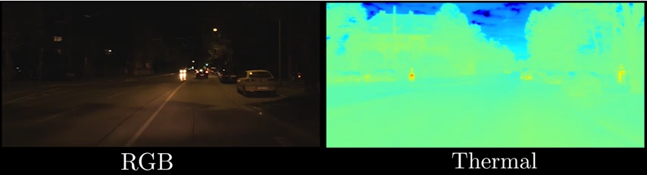
Figure 1: RGB vs Thermal Image (Source: Zürn, 2020)
The span of the electromagnetic spectrum of thermal imaging typically varies between 0.9 μm and 14 μm, which is quite expansive [13]. Within this range, long-wave infrared (LWIR) systems operate specifically in the 8–14 μm band. Within this regime, sensors fail to capture reflected photons like RGB systems. Instead, they register emitted radiation, also known as heat signatures, and make the objects appear as silhouettes of different shades, with dissolved texture and faintly glowing contours. For example, a pedestrian invisible to RGB may appear as a luminous form in IR.
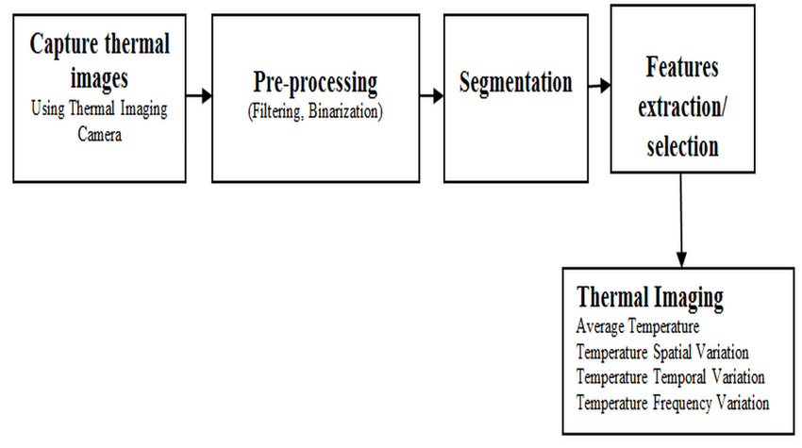
Thermal Imaging Processing Pipeline (Source: Dey et al. 2017)
The thermal imaging processing pipeline involves capturing images using a thermal camera, which is then pre-processed through filtering and binarization. The processed image is then segmented, and features are extracted, after which four key thermal features are derived in the final output: average temperature, spatial variation, temporal variation, and frequency variation [14]. In most modern uncooled systems, Infrared detectors like microbolometers work by converting incident radiation into electrical resistance changes. They are noisy, but are preferred for their lower cost and compact size. On the other hand, cooled detectors offer better sensitivity and precision, but at significantly higher prices due to their higher operational complexity [7].
Optically, a standard glass is not suitable as it blocks the infrared wavelengths, while materials such as germanium or silicon are employed due to their transmissive properties in the IR spectrum, particularly around 7–14 μm. Further, when coated, they minimise reflection losses and improve the efficiency of energy transfer [13].

2.2 Challenges in Thermal Infrared Object Detection
Thermal Infrared (TIR) based image detection has its own challenges and limitations. These challenges are largely physics-based, inherited from the properties of thermal radiation [15]. One of the biggest challenges is the lack of texture and color information in TIR, as their sensors capture only the thermal profile of the image, unlike the detection of light reflection in RGB cameras [16]. Due to this, objects appear as grayscale blobs, and details like edges, patterns, and gradients are either hard to discern or completely absent. Discriminative feature extraction becomes inherently difficult, especially when compared to RGB imagery, where surface variation is abundant [15].
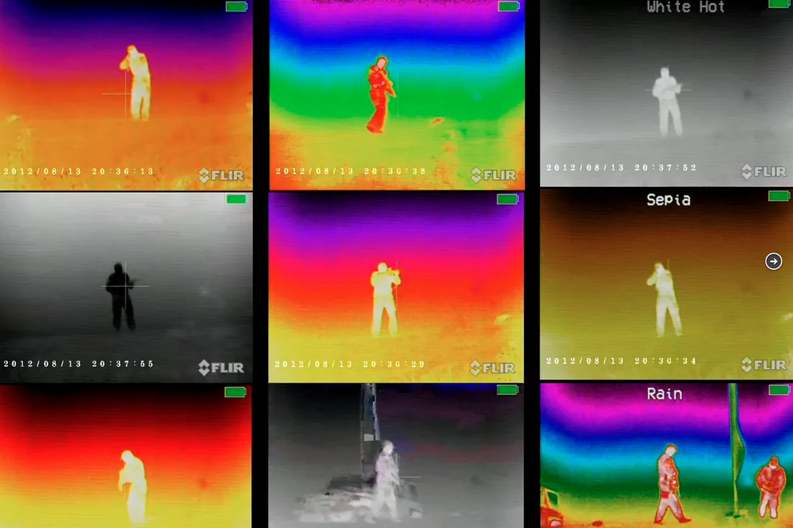
FLIR Thermal Images (Source: Holler, 2020)
TIR-based images have low spatial resolution, often less than 640x480 pixels, as a result of diffusion-driven heat transfer and optical smoothing [17] [18]. Due to this, the lack of fine-grained patterns and rich local details compromises the effectiveness of architectural components like anchor-based detectors (e.g., Faster R-CNN) and attention mechanisms [19] [20]. The absence of these details makes learned filters struggle to activate and undermines performance.

Noise is another persistent challenge with TIR-based images, such as with uncooled microbolometer sensors that work by converting incident radiation into electrical resistance changes [21] [22] [17]. They are widely used for their cost efficiency, but they introduce noise sources such as Johnson noise, thermal conductance noise, and 1/f noise [24]. Further, they are also susceptible to fixed-pattern noise, temporal drift, and non-uniform responses across individual pixels [18] [23].

TIR-based images also have a low signal-to-noise ratio (SNR) and a low signal-to-clutter ratio (SCR), which makes small or distant objects, such as sun-heated roads and buildings, blend into the background noise [21]. Additionally, thermal sensors rely on non-uniformity correction (NUC) to differentiate between pixels in terms of gain and offset. When this arrangement is missing, fixed-pattern noise can bring spatial artefacts and violate the assumptions of stationarity and translation invariance, which is usually created by deep learning models like CNNs [25]. Overall, these issues combined suggest conventional detection frameworks are vulnerable to misalignment with the statistical and physical nature of thermal data.

2.3 Evolution of Object Detection Architectures
From traditional methods like sliding window classifiers to sophisticated deep learning architectures such as YOLO, the evolution of object detection has come a long way. It reflects a persistent struggle between accuracy and computational expediency. Recent studies indicate their broad classification as two-stage, one-stage detectors, and continuous refinement of YOLO models [15]. Two-stage frameworks, like the Faster R-CNN, work on a regional proposal mechanism, which later undergoes two stages of classification and refinement. Studies suggest this design allows precise localisation and enhanced detection of small objects, but as a tradeoff with inference latency [19]. This compromises its reliability in systems where real-time detection is required, such as the ADAS.
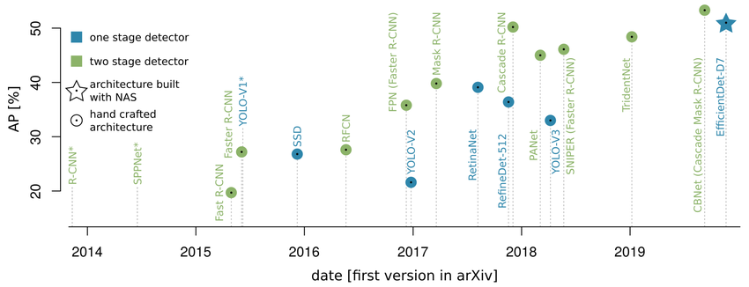
Evolution of milestone architectures for object detection from late 2013 to 2019 (Source: Hoeser and Kuenzer, 2020)

One-stage detectors, such as Single Shot Multibox Detector (SSD) and initial YOLO architectures, work on a rather unified process of object prediction. These architectures directly regress bounding boxes and class probabilities from the image in a single forward pass [19]. Due to this, they are faster and more suitable for real-time applications. In essence, two stage are better with accuracy while one-stage methods are better with speed. Current YOLO models are a game-changer as they are both fast and accurate, compared to their previous models. Here is how the model has evolved:

- YOLOv1 began by dividing an image into a grid-like structure and predicting bounding boxes and class probabilities for each cell [4].
- YOLOv2 came with integrated anchor boxes, batch normalization, and dimension clusters for better prediction [6].
- YOLOv3 brought Feature Pyramid Network (FPN) for large and multi-scale detection [25].
- YOLOv4 came with a more optimized Cross Stage Partial Network (CSPNet) backbone, mosaic data augmentation, and other such components [25]
- YOLOv5 introduced a more intuitive UI for better compatibility with different model sizes [25].
- YOLOv7 and YOLOv8 are among the most recent models that introduced architectural re-parameterization and a planned aggregate network to enhance efficiency and accuracy [25].

Recent studies suggest YOLO as the dominant paradigm in real-time detection that has achieved 60+ FPS when optimised appropriately [16]. However, their nature of being heavily convolution-centric, which performs well in local pattern extraction, is limited in modeling the global context.

2.4 YOLO-Based Approaches in Thermal Imaging
YOLO-based approaches have progressively entrenched themselves as the standard for real-time thermal infrared (TIR) object detection, along with Single Shot Multibox Detector (SSD) variants [26]. These developments, along with an innovative architectural design, were embraced due to their ability to deliver high-speed inference when there are limitations in situations, such as UAV monitoring, autonomous driving, and robotics. Empirical data-based studies have confirmed that new YOLO versions have delivered impressive accuracy with speed, particularly useful in high-temperature regions [1] [6].

Till this time, a variety of key strategies were adopted for the modification of the core YOLO architecture, such as reducing the weight of backbones to ease the complexity in computation, or the use of attention blocks for improving focus on salient features of the image [25] [28]. Researchers have also discussed feature fusion mechanisms and attention modules in length due to their ability to overcome the noisy and featureless thermal data. Improvements like YOLO-SDLUWD with fusion pathways and YOLO-CIR with the ability to coordinate split attention modules have improved multiscale representation, small target detection, and salient feature extraction [27].

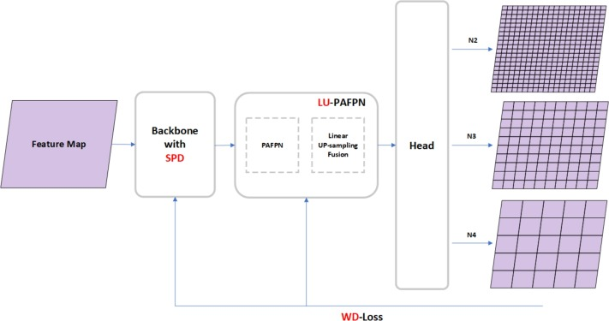
YOLO-SDLUWD detection network (Source: Zhu et al. 2025)

However, direct application of vanilla YOLO to thermal imagery proves insufficient. Recent literature suggests improvements till now are lightweight modifications and lack a complete redesign, resulting in an “acceptable feature representation”. Real-time detection, which exceeds 60FPS, is still an aspirational goal [15]. With emerging designs like anchor-free heads and GhostNet’s compact architectures, the lightweight paradigm can be further reinforced [22]. Overall, the current modifications signal a need for a reasoning-based architecture to achieve real-time capturing efficiency.

2.5 Attention Mechanisms and Visual Reasoning
Attention mechanisms have been an important development throughout the evolution of deep learning for visual reasoning. They are usually perceived as a singular concept, but involve incremental development of feature selection, contextual modelling, and reasoning. In the most basic sense, the attention mechanism works on the principle of dynamic weight allocation, in which salient features of an image are amplified and irrelevant signals are suppressed [29].
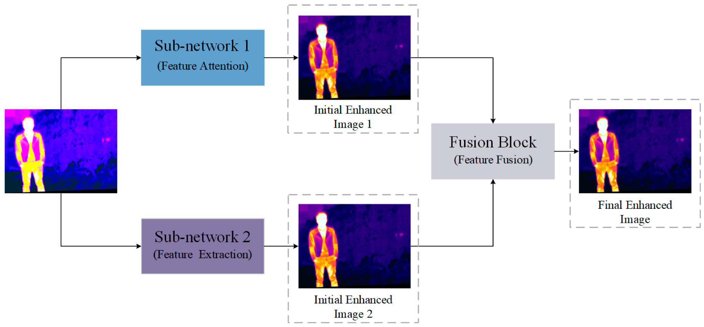
Network architecture diagram with two parallel sub-networks to extract features at different scales, and feature fusion through a fusion block (Source: Gao et al. 2023)

Channel attention works in an introspective manner by prioritizing the important features through feature map recalibration and assigning importance accordingly. This laid the groundwork for more advanced attention-driven paradigms and enabled transformer-based detection models [19]. On the other hand, self-attention models long-range dependencies, which are quite limited in standard CNNs due to their local receptive fields [29]. Therefore, self-attention models create a global relational map in a sequence (e.g., pixels in an image or tokens in a Transformer) to allow the regions to influence each other.

This progression has played a crucial role in culminating transformer-based architectures, which were initially developed for natural language processing. In computer vision, they offered far better global reasoning capabilities. For instance, the architecture of Vision Transformers (ViTs) is built upon stacked self-attention layers for a comprehensive understanding of the visual, which is a significant improvement from what CNNs can do. However, within real-time constraints, their computational complexity makes them impractical as they are highly resource-intensive [29].

Along with pure attention, proper visual reasoning also uses graph-based reasoning and spatial memory models, such as in Graph R-CNN. They work by seeing objects as nodes in the context of a graph, which allows them to model each object and its background distinctively [19]. Additionally, many models are also augmented with memory to store information from scenes and objects viewed previously, and therefore, use it in sequential reasoning and improve tracking. However, the tradeoff between reasoning and efficiency still exists, as all of this requires a significant amount of computational power, thus requiring more time. Therefore, even highly efficient models tend to sacrifice some reasoning depth for speed.

2.6 Visual Reasoning in Infrared Detection
Recent developments in visual reasoning models come with an awareness of the context, which aids in better interpretation. In essence, these infrared detection models capture the heat patterns and define relationships with themselves within the frame. This is done by creating query-key-value interactions across feature maps and capturing thermal cues in detail, including the ones with low signals [30]. Further, when global multi-head attention is combined with local and channel attention, it creates a hybrid version with better long-range contextual awareness with fine-grained localisation [31]. This is highly needed in environments where small and/or broader semantics are complex.

In terms of Average Precision (AP), such hybrid mechanisms have also produced positive empirical results when tested in cluttered and low-contrast environments [32]. Class Activation Maps (CAMs) are also interpretability-driven components that offer visual tracking of the area and movement of attention, thus improving interpretability and reasoning capability [33]. This helps overcome a persistent challenge in thermal imaging due to limited pixel representation and the lack of distinct features.

2.7 Computational Efficiency and Real-Time Constraints
Developments like visual tracing in CAMs have managed to maintain a decent 30 FPS and reach close to real-time performance when optimized, indicating that interpretability-driven augments can help with the biggest challenge in real-time infrared object detection. For instance, the recent transformer-based detectors, such as RT-DETR variants, have demonstrated a near real-time performance (~30 FPS) [34]. A variety of such reasoning models have been integrated, but the gap lies in the lack of their specific use in recent YOLO models, such as the YOLOv8, for thermal detection. Therefore, how channel-based reasoning works with these more complex frameworks is an under-investigated area that continues to evolve.

True real-time performance in object detection calls for compressed models to reduce the computational power. Techniques like quantization have been proven to reduce numerical precision (e.g., FP32 to INT8) and can reduce the size of the model by nearly four times [35]. Another technique, known as pruning, can omit redundant weights, while lightweight architectures that are built using depthwise convolutions and compact layers can further help reduce and ease the computational needs.

However, recent tests indicate a persistent problem that adds more complexity to computation. Edge AI platforms such as NVIDIA Jetson devices boost speed by using GPU acceleration and optimised inference engines. On the other hand, general-purpose systems like Raspberry Pi struggle to exceed even 5–10 FPS under similar workloads. Additionally, ill-optimized models can drop as low as 3 FPS [36].

To overcome this limitation, tools like TensorRT and TensorFlow Lite (TFLite) can further optimize the framework by enabling hardware-specific acceleration. This significantly reduces latency and improves throughput [37]. Overall, studies indicate that there is a triadic dependency on the model’s efficiency, hardware capability, and inference framework for real-time usage. Skipping any of them will put the entire system in a compromised state.

2.9 Evaluation Metrics and Real-Time Performance
How well an object detection system works depends on accuracy-centric and system-level metrics. The COCO-style metric mAP@[0.5:0.95] is considered a dominating technology with widespread adoption. By computing mAP across a range of Intersection-over-Union (IoU) thresholds, it penalises loose bounding boxes and rewards precise localisation, thus improving assessment over the single-threshold metrics like mAP@0.5 [38]. Metrics like precision, recall, and F1-score, along with mAP, remain valuable. Precision quantifies how correct the detections are, recall tells how complete it is, and F1 provides a harmonic balance between the two. Derived usually from confusion matrices and precision-recall curves, these metrics underpin the computation of average precision itself [38].

Studies argue that reliance on accuracy is not sufficient, especially in real-time systems. This indicates a need for a joint evaluation of both speed and accuracy, which is adopted in modern YOLO-based systems [39]. Additionally, energy efficiency is increasingly considered, especially for embedded deployments where power budgets are limited. Overall, a system-centric evaluation is more beneficial than a model-centric one, as its performance relies on hardware potential, the nature of the dataset, and unique constraints specific to tasks.

2.10 Research Gap
The infrared object detection technology has undergone significant developments, but the inherent constraints of the speed vs. accuracy tradeoff appear under-addressed. Limitations like low contrast, high noise, and limited detail have been mitigated, but only to a limited level, restricting its ability to be used in real-world scenarios.

The current studies indicate that conventional CNN-based detectors have significantly improved computation power, but their bias towards local feature extraction undermines their reliability in border contexts. On the other hand, transformer-based models do help overcome this limitation with their global reasoning, but it comes at the cost of computational efficiency and inference speed, particularly for real-time deployment on edge devices.

The YOLO-based models with their incremental architectural improvements were notable attempts to bridge this gap, significantly enhancing backbone efficiency, feature fusion, and detection heads. However, they don’t fundamentally rethink feature interpretation, due to which the semantic reasoning limitation remains. There is a lack of and a need for systematic evaluation of the IR Reasoner framework within modern YOLOv8 architectures. Additionally, channel-based reasoning is an under-explored area and can help better exploit intensity-driven thermal representations.

The integration between lightweight reasoning mechanisms and the latest YOLO-based models is expected to have promising results. Studying how the combination of two affects the accuracy and speed of image detection can help mitigate the long-standing challenges of the applicability of infrared image detection in real-time scenarios.

3. METHODOLOGY
Using the Saunders’ Research Onion, here is a systematic explanation of the methods adopted in this research:
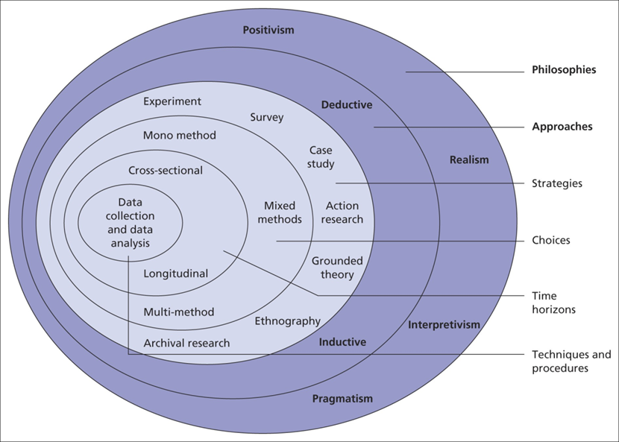
Saunders’ Research Onion (Source: Getitdoneex, 2025)

3.1 Research Philosophy
The positivist philosophy was adopted for this research, as it views reality as objective and measurable, independent of the observer. Research based on this philosophy tests hypotheses using controlled experimentation and observation [46]. In this study, the performance of the proposed model is quantified using numerical metrics such as precision, recall, and mAP. Since the results are treated as measurable outcomes instead of being viewed subjectively, the positivist philosophy was chosen. Particularly for studies involving machine learning, this philosophy allows continuous validation of performance through what statistics suggest. Studies on machine learning, like this research, require iterative and consistently similar results for validating the experiment statistically. Having standardised datasets, controlled experimentation is also supported by the stance of positivism.

3.2 Research Approach
For this study, the deductive research approach was chosen as a suitable method to formulate a hypothesis based on existing knowledge. This approach moves from general theories to specific observations. In this study, a theoretical understanding of the current emerging technologies was developed in the beginning. The hypothesis that a lightweight reasoning module in YOLOv8 can improve image detection without compromising speed in real-time was tested through empirical methods using controlled experiments. In computer vision research, theories on architectural developments are validated through benchmarking, instead of focusing on their subjective meaning [47].

3.3 Data Collection
This study is based purely on secondary data available online, along with the simulated data during the experimentation of the proposed model. The literature, recent developments, and emerging technologies in the field were sourced from credible and reliable sources, such as IEEE papers, case studies, journal articles, and reports.

The thermal dataset used was sourced from the Teledyne website, where it is publicly available to download and use. This method is ideal for studies that use pre-existing datasets and are used to train models. The dataset included annotated thermal images of the real-world roads, from which only thermal images were used in this research.

Overall, there were 15 object classes in the dataset, which were remapped into contiguous class identifiers, ranging between 0 and 14. This was done for better compatibility with YOLOv8 training requirements. A subset of 1000 training images and 250 validation images was chosen to include enough variations without compromising computation capacity. Since YOLOv8 expects three-channel image input, grayscale thermal images were replicated across three channels before training.

3.4 Research Strategy
This study uses the experimental research strategy called the quantitative comparative design. This strategy, when used with positivist philosophy, establishes causal relationships by focusing on controlling variables [46].

Overall, two models were evaluated in this research: A baseline YOLOv8 detector and the proposed version with the IR-Reasoner module. They were trained and tested in the same conditions and with the same datasets and under the same conditions. This includes:

- Dataset split
- Augmentation settings
- Hyperparameters
- Training epochs
- Hardware configuration

This way, the reasoning module becomes the only reason for any anomaly noticed. With such a controlled comparison, the ablation-style experimental setup, which is often used in deep learning research, can be imitated.

3.5 The Baseline YOLOv8 Architecture
The model used as the baseline is the YOLOv8s, a small variant of the YOLOv8 family. This model was chosen because, in real-time applications, it offered a balance between detection accuracy and speed. The family follows an on-stage detection method that performs both object localisation and classification together. The 3 major components of the architecture included:

- Backbone for feature extraction
- Neck for feature aggregation
- Detection head for final prediction

3.6 Proposed YOLOv8-IR-Reasoner
The model proposed improves the range of YOLOv8 and global context interpretation by including a lightweight IR-Reasoner module. By applying spatial self-attention, this reasoning module features maps while preserving feature dimensions through residual connections.

Three Reasoner blocks were inserted before the detection head at:

- P3 scale
- P4 scale
- P5 scale

These locations have rich and high-level features, which make understanding more contextual and meaningful. Moreover, no changes were made to the components of the architecture, ensuring that performance differences originate only from the reasoning mechanism.

3.7 Data Preprocessing
The dataset was preprocessed before training for consistency and compatibility. Every thermal image was resized to a dimension of 640x640 pixels. Further, annotation labels were formatted as per YOLO specifications. To improve the generalisation of the dataset further, data augmentation techniques applied included:

- Horizontal flipping
- Mosaic augmentation
- Scaling
- Translation
- MixUp augmentation

Since thermal images do not have the shades of RGB, the colour augmentations, such as HSV modifications, rotation, and shearing, were disabled. This helped preserve the realistic object orientation within driving scenarios.

3.8 Training Configuration
The baseline and proposed models were trained on Google Colab, using the NVIDIA T4 GPU hardware. The primary training setting comprised:

- Epochs: 100
- Batch size: 16
- Learning rate: 0.003
- Image size: 640x640
- Random seed: 42
- Mosaic augmentation probability: 1.0
- MixUp probability: 0.1
- Horizontal flip probability: 0.5

3.9 Evaluation Metrics and Data Analysis Technique
For analysing the secondary data collected and generated in this research, the quantitative experimental analysis technique was used, which included performance-based metrics like:

- Precision
- Recall
- mAP@0.5
- mAP@0.5:0.95
- Frames per second

The analysis involved comparing the performance of baseline models and their modified versions. In addition to that, it was also analysed how computational efficiency and accuracy affect each other. This is because improvements in detection performance must not come at the cost of unacceptable latency.

3.10 Time Horizon
This research tests the capability of new models based on the most recent developments. Therefore, the most suitable time horizon for this research is cross-sectional. In it, the data is collected at a specific point in time instead of over a time period. Both models are evaluated after a fixed training process consisting of 100 epochs.

This method is particularly suited when the goal is to compare outcomes under the same conditions at a particular point in time, which is exactly what this study is doing by comparing the current and a proposed model under identical conditions. Unlike longitudinal research for temporal change, this research emphasises comparative performance.

3.11 Research Ethics
The research is based purely on secondary data and does not involve any primary data collected from human participants. Therefore, there are no ethical risks regarding their privacy and consent. The literature background in this research was sourced from publicly available domains, such as research papers, theses, and case studies. Further, the thermal dataset used is also available publicly and is free to download and use for academic research. This data doesn’t involve any personal information, making it safe to use. Also, the experimental design and the use of a large number of sources ensure a variety of knowledge and perspectives were considered to minimise bias.

REFERENCES
[1] V. Breive and T. Sledevic, "Person detection in thermal images: A comparative analysis of YOLOv8 and YOLOv9 models," in Proc. 2024 IEEE Open Conf. Electrical, Electronic and Information Sciences (eStream), 2024, pp. 1–4.
[2] X. Luo and X. Zhu, "YOLO-SMUG: An efficient and lightweight infrared object detection model for unmanned aerial vehicles," Drones, vol. 9, no. 4, p. 245, 2025.
[3] Z. Zhang, J. Huang, G. Hei, and W. Wang, "YOLO-IR-free: An improved algorithm for real-time detection of vehicles in infrared images," Sensors, vol. 23, no. 21, p. 8723, 2023.
[4] C. Jiang, H. Ren, X. Ye, J. Zhu, H. Zeng, Y. Nan, M. Sun, X. Ren, and H. Huo, "Object detection from UAV thermal infrared images and videos using YOLO models," Int. J. Appl. Earth Obs. Geoinf., vol. 112, p. 102912, 2022.
[5] V. Tripathi, C. Mishra, N. Verma, U. Dey, and N. Sharma, "Real-time human detection in thermal images: Challenges and solutions with thermosense," in AIP Conf. Proc., vol. 3297, no. 1, p. 080005, 2025.
[6] U. K. Turmaganbet, D. M. Zhexebay, D. A. Turlykozhayeva, A. A. Skabylov, S. N. Akhtanov, S. A. Temesheva, P. C. Masalim, and M. Tao, "Thermal infrared object detection with YOLO models," Eurasian Phys. Tech. J., vol. 22, no. 2(52), pp. 121–132, 2025.
[7] M. Nawaz, S. Khan, M. Daud, M. Asim, G. A. Anwar, A. R. Shahid, H. P. A. Ho, T. Chan, D. P. Kong, and W. Yuan, "Improving autonomous vehicle cognitive robustness in extreme weather with deep learning and thermal camera fusion," IEEE Open J. Veh. Technol., vol. 6, pp. 426–441, 2025.
[8] H. T. Dinh and E. T. Kim, "A lightweight network based on YOLOv8 for improving detection performance and the speed of thermal image processing," Electronics, vol. 14, no. 4, p. 783, 2025.
[9] S. V. Eramplackal, "Comparative analysis of YOLO variants for object detection in thermal images," Ph.D. dissertation, Dept. Computing, Nat. College of Ireland, Dublin, Ireland, 2025.
[10] Y. Zhao, "Infrared object detection for autonomous driving based on YOLOv8 with data augmentation," in Proc. Fifth Int. Conf. Intelligent Traffic Systems and Smart City (ITSSC 2025), vol. 13792, pp. 230–237, 2025.
[11] J. Fickenscher, S. Reinhart, F. Hannig, J. Teich, and M. E. Bouzouraa, "Convoy tracking for ADAS on embedded GPUs," in Proc. 2017 IEEE Intelligent Vehicles Symp. (IV), 2017, pp. 959–965.
[12] Z. Zou, K. Chen, Z. Shi, Y. Guo, and J. Ye, “Object detection in 20 years: A survey,” Proceedings of the IEEE, vol. 111, no. 3, pp. 257–276, 2023.
[13] M. Vollmer, “Infrared thermal imaging,” in Computer Vision: A Reference Guide. Cham: Springer, 2020, pp. 1–4.
[14] N. Dey, A. S. Ashour, and A. S. Althoupety, “Thermal imaging in medical science,” in Recent Advances in Applied Thermal Imaging for Industrial Applications, pp. 87–117, 2017.
[15] N. Bustos et al., “A systematic literature review on object detection using near infrared and thermal images,” Neurocomputing, vol. 560, p. 126804, 2023.
[16] C. Yang et al., “Learning diverse fine-grained features for thermal infrared tracking,” Expert Systems with Applications, vol. 238, p. 121577, 2024.
[17] D. Poster, S. Hu, and N. M. Nasrabadi, “Long-range thermal target detection in data-limited settings using restricted receptive fields,” Sensors, vol. 23, no. 18, p. 7806, 2023.
[18] Y. Zhang, P. Zhou, and L. Chen, “Dual-branch feature encoding framework for infrared images super-resolution reconstruction,” Scientific Reports, vol. 14, no. 1, p. 9379, 2024.
[19] N. M. Sadic et al., “Utilization of infrared images for object detection: A survey,” Journal of Optics, pp. 1–8, 2025.
[20] C. Wang et al., “EEA-Net: Edge-enhanced assistance network for infrared small target detection,” Machine Vision and Applications, vol. 35, no. 4, p. 70, 2024.
[21] S. Shahapurkar et al., “Challenges in infrared small-target detection: A benchmark of YOLO models on UAV and bird infrared imagery,” in Proc. 10th Int. Conf. Signal Processing and Communication (ICSC), 2025, pp. 315–320.
[22] J. Yu, H. Wang, S. Zhou, and S. Li, “Infrared target detection based on interval sampling weighting and 3D attention head in complex scenario,” Applied Sciences, vol. 14, no. 1, p. 249, 2023.
[23] M. J. Amiri et al., “A low-cost passive thermal IR imaging system for automated hidden object detection using AI,” in Proc. 11th Int. Symp. Telecommunications (IST), 2024, pp. 524–530.
[24] P. K. Yadav et al., “Advancements of uncooled infrared microbolometer materials: A review,” Sensors and Actuators A: Physical, vol. 342, p. 113611, 2022.
[25] J. Zhu, C. Qin, and D. Choi, “YOLO-SDLUWD: YOLOv7-based small target detection network for infrared images in complex backgrounds,” Digital Communications and Networks, vol. 11, no. 2, pp. 269–279, 2025.
[26] S. A. Magalhães et al., “Evaluating the single-shot multibox detector and YOLO deep learning models for the detection of tomatoes in a greenhouse,” Sensors, vol. 21, no. 10, p. 3569, 2021.
[27] J. Zhou et al., “YOLO-CIR: The network based on YOLO and ConvNeXt for infrared object detection,” Infrared Physics & Technology, vol. 131, p. 104703, 2023.
[28] J. Jiang, X. Yang, and Y. Li, “IIANet: Information interactivity attention network with adversarial learning for infrared small object detection,” Computer Vision and Image Understanding, vol. 237, p. 103839, 2023.
[29] M. H. Guo et al., “Attention mechanisms in computer vision: A survey,” Computational Visual Media, vol. 8, no. 3, pp. 331–368, 2022.
[30] M. M. Gündoğan et al., “IR reasoner: Real-time infrared object detection by visual reasoning,” in Proc. IEEE/CVF Conf. Computer Vision and Pattern Recognition (CVPR), 2023, pp. 422–430.
[31] W. Wang, J. Xu, and R. Zhang, “Optimized small object detection in low resolution infrared images using super resolution and attention-based feature fusion,” PLOS ONE, vol. 20, no. 7, p. e0328223, 2025.
[32] J. Fan et al., “IRSDT: A framework for infrared small target tracking with enhanced detection,” Sensors, vol. 23, no. 9, p. 4240, 2023.
[33] M. Zhang et al., “Thermodynamics-inspired multi-feature network for infrared small target detection,” Remote Sensing, vol. 15, no. 19, p. 4716, 2023.
[34] C. Guo et al., “An efficient reparameterized small object detection transformer for thermal infrared images,” Scientific Reports, vol. 15, no. 1, p. 44599, 2025.
[35] S. Boddu and A. Mukherjee, “Efficient edge deployment of quantized YOLOv4-Tiny for aerial emergency object detection on Raspberry Pi 5,” arXiv preprint arXiv:2506.09300, 2025.
[36] Pi Man, “Real-time object detection on SBCs: Raspberry Pi vs edge AI,” 2026. [Online]. Available: https://raspberrypi.ink/real-time-object-detection-raspberry-pi-vs-npu/ (accessed Apr. 26, 2026).
[37] G. Verma et al., “Performance evaluation of deep learning compilers for edge inference,” in Proc. IEEE Int. Parallel and Distributed Processing Symp. Workshops (IPDPSW), 2021, pp. 858–865.
[38] Q. Guo et al., “AIE-YOLO: Effective object detection method in extreme driving scenarios via adaptive image enhancement,” Science Progress, vol. 107, no. 3, 2024.
[39] M. Chaman et al., “Benchmarking YOLO-based deep learning models for real-time object detection in hybrid ADAS and intelligent transportation systems,” Results in Engineering, p. 108942, 2025.
[40] J. Zhang et al., “MS-YOLO: Infrared object detection for edge deployment via MobileNetV4 and SlideLoss,” in Proc. Int. Joint Conf. Neural Networks (IJCNN), 2025, pp. 1–8.
[41] J. Holler, “Object detection on thermal images,” 2020. [Online]. Available: https://medium.com/@joehoeller/object-detection-on-thermal-images-f9526237686a (accessed Apr. 26, 2026).
[42] J. Zürn, “Bridging the day-night domain gap in semantic segmentation with thermal images,” 2020. [Online]. Available: https://jannik-zuern.medium.com/bridging-the-day-night-domain-gap-in-semantic-segmentation-with-thermal-images-6d54ffb2ee7f (accessed Apr. 26, 2026).
[43] T. Hoeser and C. Kuenzer, “Object detection and image segmentation with deep learning on earth observation data: A review—Part I: Evolution and recent trends,” Remote Sensing, vol. 12, no. 10, p. 1667, 2020.
[44] P. Gao, W. Zhang, Z. Wang, H. Ma, and Z. Lyu, “A dual convolutional neural network with attention mechanism for thermal infrared image enhancement,” Electronics, vol. 12, no. 20, p. 4300, 2023.
[45] Getitdoneex, “The Research Onion Explained: Layers, Methodology, and Application” 2025. [Online]. Available: https://getitdoneex.com/the-research-onion-explained-layers-methodology-and-application/ (accessed May 3, 2026).
[46] Y. S. Park, L. Konge, and A. R. Artino Jr., “The positivism paradigm of research,” Academic Medicine, vol. 95, no. 5, pp. 690–694, 2020.
[47] D. Bhatt, C. Patel, H. Talsania, J. Patel, R. Vaghela, S. Pandya, K. Modi, and H. Ghayvat, “CNN variants for computer vision: History, architecture, application, challenges and future scope,” Electronics, vol. 10, no. 20, p. 2470, 2021.

