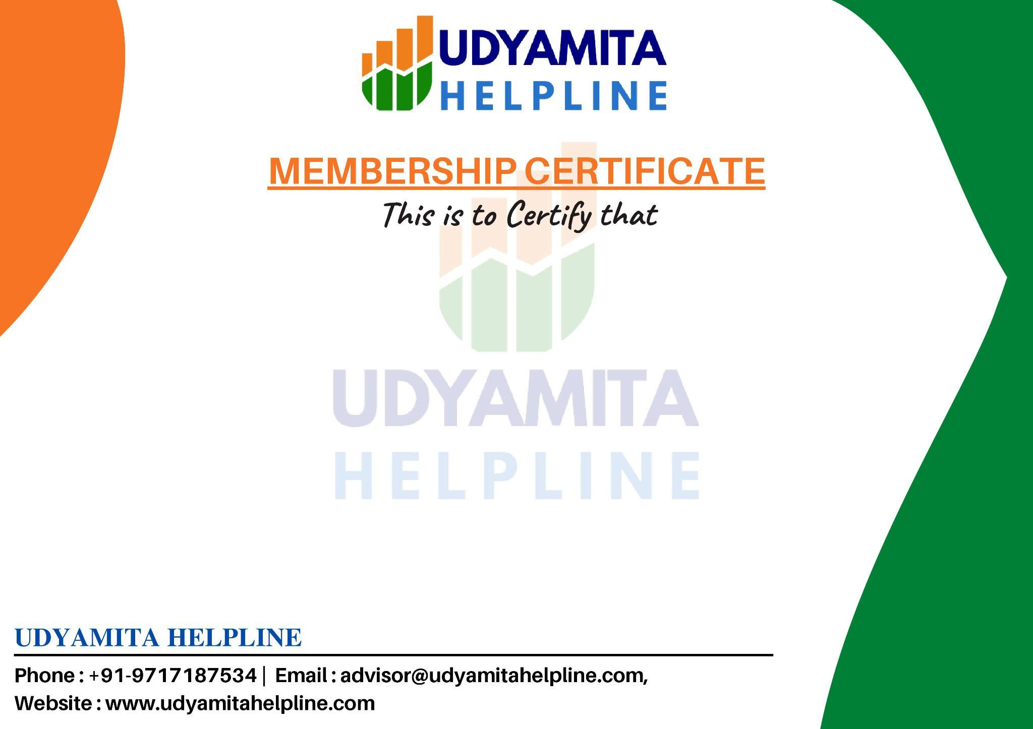

M/s {Customer Name}
is a proud member of
Udyamita Helpline
for the period {Period}

Date : {Date}
Membership No.: {Member}

