Hospital Patient Flow and Operational
Efficiency Prediction Using Machine Learning
IBM SkillsBuild Data Analytics with Al Academic Internship Program.
Final Project Report

Submitted by:
Sourajit Mondal

Dataset: Hospital Patient Flow Analytics (9,216 records)
Model: Random Forest Regressor
Target: Patient Wait Time Prediction

Technology Stack: Python | Flask | Streamlit | scikit-learn

Certificate / Declaration
I hereby declare that this project titled "Hospital Patient Flow and Operational Efficiency Prediction Using Machine Learning" is an original work submitted in partial fulfilment of the IBM Bharat / AICTE Data Analytics with AI Virtual Internship. The project has been carried out independently using the provided dataset and publicly available open-source libraries.

Name: Sourajit Mondal
Program: IBM SkillsBuild Data Analytics with Al Academic Internship Program.
Date: 2026

Acknowledgement
I extend my sincere gratitude to IBM Bharat and AICTE for providing this valuable virtual internship opportunity in Data Analytics with Artificial Intelligence. The mentorship, resources, and structured learning environment made it possible to build a real-world machine learning application focused on healthcare operations.
I also thank the Kaggle community and the creators of the Hospital Patient Flow Analytics dataset, which provided the foundation for meaningful data analysis and model development.

Abstract
This project presents a complete end-to-end data analytics and machine learning system for Hospital Patient Flow and Operational Efficiency Prediction. Using a real-world dataset of 9,216 hospital patient records, the system analyzes key operational metrics including patient wait times, admission rates, department utilisation, and patient satisfaction scores.
A Random Forest Regressor model is trained to predict patient waiting times based on features including patient age, gender, race/ethnicity, department referral, and admission status. The predicted wait time is classified into Low, Medium, or High urgency using data-driven percentile-based thresholds computed from the actual distribution — ensuring meaningful urgency spread regardless of the dataset loaded.
The project includes a Flask REST API backend exposing prediction and analytics endpoints, and a professional Streamlit dashboard with four interactive pages: Dashboard, Patient Analytics, Wait-Time Prediction, and Model Performance. A CSV upload feature allows any hospital or organisation to substitute their own data and immediately visualise custom analytics.

1. Introduction
Healthcare systems globally face the challenge of managing patient flow efficiently. Long waiting times, unpredictable admission patterns, and uneven department workloads lead to patient dissatisfaction and operational inefficiency. Data analytics and machine learning provide powerful tools to address these challenges by turning raw operational data into actionable insights and predictions.
This project applies data science techniques to a hospital patient flow dataset to answer the following questions:
- What are the average waiting times across departments and patient demographics?
- What time of day sees peak patient arrivals?
- How does patient age group influence waiting times?
- Can machine learning predict how long a new patient will wait?
- How can operational staff use these predictions to prioritise patient care?
The project is structured as a full-stack application: a trained machine learning model is exposed via a Flask API and consumed by a Streamlit dashboard, creating a complete Analytics-to-Prediction pipeline.

2. Problem Statement
Hospitals often lack real-time tools to predict how long individual patients will wait before receiving care. This leads to:
- Patient dissatisfaction due to unexpectedly long waits
- Inefficient staff allocation across departments
- Difficulty in identifying peak-load periods
- Inequitable service delivery across demographic groups
The goal of this project is to build a data-driven system that:
- Analyses historical patient flow data to identify operational patterns
- Predicts patient wait times using a machine learning model
- Classifies urgency using data-adaptive thresholds (not hardcoded values)
- Presents insights through an interactive, professional dashboard
- Exposes predictions via a REST API for integration with other systems

3. Objectives
- 1. Load, clean, and preprocess the hospital patient flow dataset
- 2. Perform comprehensive Exploratory Data Analysis (EDA)
- 3. Engineer relevant features including age groups and temporal features
- 4. Train a Random Forest Regressor to predict patient wait time
- 5. Evaluate the model using MAE, RMSE, and R2 metrics
- 6. Compare model performance against a naive baseline predictor
- 7. Build a Flask REST API with endpoints for prediction and analytics
- 8. Build a professional Streamlit dashboard with 4 interactive pages
- 9. Add a CSV upload feature enabling any organisation to use their own data
- 10. Embed all work in a single Python file for clean project submission

4. Dataset Description
4.1 Source
Dataset: Hospital Patient Flow Analytics
Source: Kaggle — publicly available healthcare operational dataset
URL: https://www.kaggle.com/datasets/
Records: 9,216 rows | Columns: 11
4.2 Column Reference
Column Name | Data Type | Description
Patient Id | String (ID) | Unique anonymised patient identifier
Patient Admission Date | Date | Date of hospital visit
Patient Admission Time | Time | Time of arrival at hospital
Merged | String | Doctor/staff name associated with visit
Patient Gender | Categorical | Male or Female
Patient Age | Numerical | Patient age in years (0-120)
Patient Race | Categorical | Race/ethnicity of the patient
Department Referral | Categorical | Department referred to, or No Referral
Patient Admission Flag | Categorical | Admission or Not Admission
Patient Satisfaction Score | Numerical (sparse) | Score 0-10, ~80% missing
Patient Waittime | Numerical — TARGET | Wait time in minutes (0-60)

4.3 Key Statistics
Metric | Value
Total Records | 9,216
Total Columns | 11
Target Variable | Patient Waittime (minutes)
Wait Time Range | 0 – 60 minutes
Average Wait Time | ~35.3 minutes
Median Wait Time | ~36 minutes
P33 (Low urgency threshold) | ~27 minutes
P66 (Medium urgency threshold) | ~44 minutes
Admission Rate | ~49.8%
Average Patient Age | ~50.2 years
Missing Values (Satisfaction Score) | ~80% (filled with median)
Departments | 8 unique values

5. Data Preprocessing
5.1 Steps Performed
Preprocessing Step | Action
Whitespace stripping | All string columns stripped of leading/trailing spaces
Date/time parsing | Admission date parsed to datetime; time parsed to extract admission hour (0-23)
Missing value imputation | Patient Satisfaction Score and Patient Waittime filled with column median
Department standardisation | 'None' values in Department Referral replaced with 'No Referral'
Age group engineering | Patient Age binned into 5 groups: Child, Teen, Young Adult, Adult, Senior
Temporal features | Admission Hour, Day of Week, and Month extracted from date/time fields

5.2 Missing Value Summary
Column | Missing Count | % Missing | Treatment
Patient Satisfaction Score | ~7,372 | ~80% | Filled with median (5.0)
Patient Waittime | 0 | 0% | No action required
All other columns | 0 | 0% | No action required

6. Exploratory Data Analysis
6.1 Key Findings
- Wait time is approximately uniformly distributed between 0 and 60 minutes
- No single department shows dramatically different wait times — range is ~33-38 min across all
- Patient arrivals peak between hours 11-12 and again around 20-21 (8-9 PM)
- Gender shows minimal difference in satisfaction score (both ~5.0)
- Senior patients (60+) show marginally higher median wait times than younger groups
- Admission and Not Admission patients are roughly equal (~50% each)
- African American and Asian patients show slightly different average wait times vs White/Other
6.2 Department Wait Time Summary
Department | Avg Wait (min) | Note
No Referral | ~35 | Largest patient group
General Practice | ~36 | Second largest group
Orthopedics | ~34 | Slightly below average
Cardiology | ~36 | Near average
Gastroenterology | ~35 | Near average
Physiotherapy | ~33 | Slightly below average
Neurology | ~36 | Near average
Renal | ~38 | Slightly above average

7. Data Visualisations — Streamlit UI Screenshots
The following figures show the actual Streamlit application pages generated by the project. Each page is implemented inside SourajitMondal_HospitalPatientFlow.py and rendered in the browser when the app is launched.
Figure 1: Hospital Patient Flow Dashboard
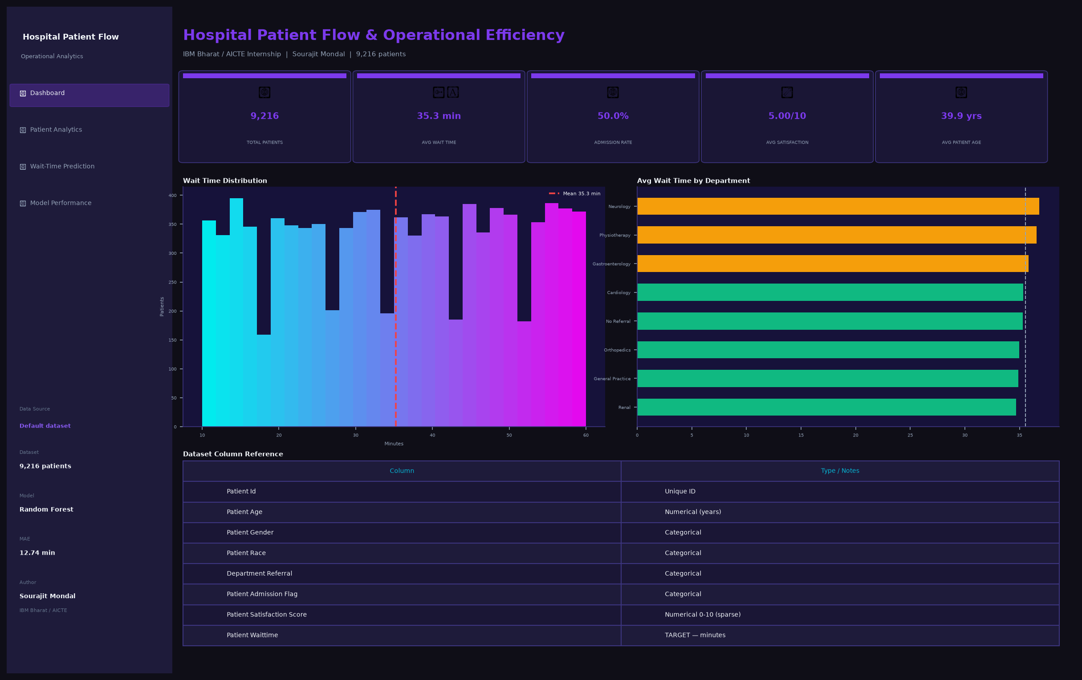
Figure 1: Hospital Patient Flow Dashboard — KPI cards, wait time distribution, department analysis, and dataset overview
Figure 2: Patient Analytics Page
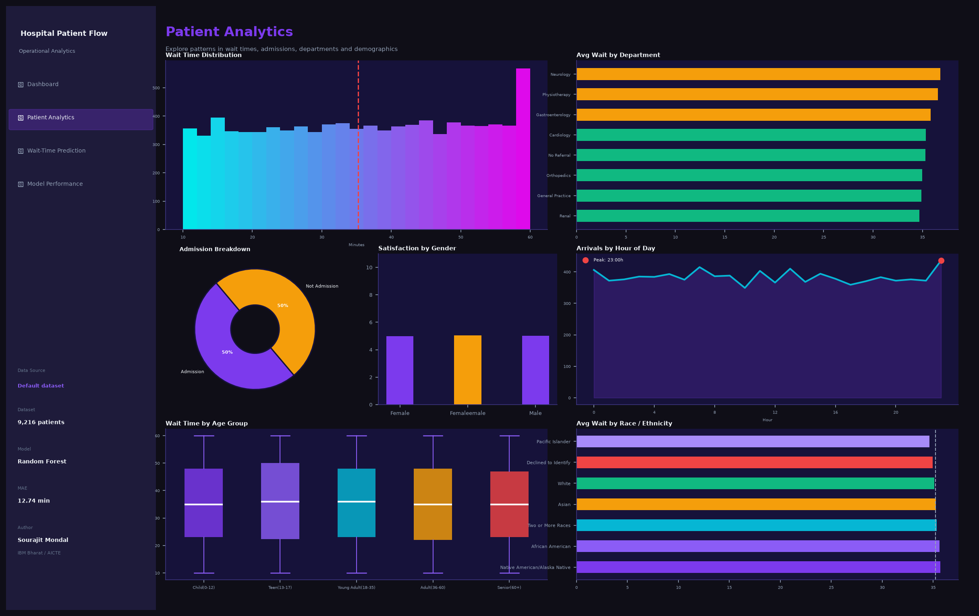
Figure 2: Patient Analytics — 6-chart grid showing wait time distribution, department bars, admission pie, satisfaction by gender, hourly arrivals, and age group boxplot

Figure 3: Wait-Time Prediction Interface
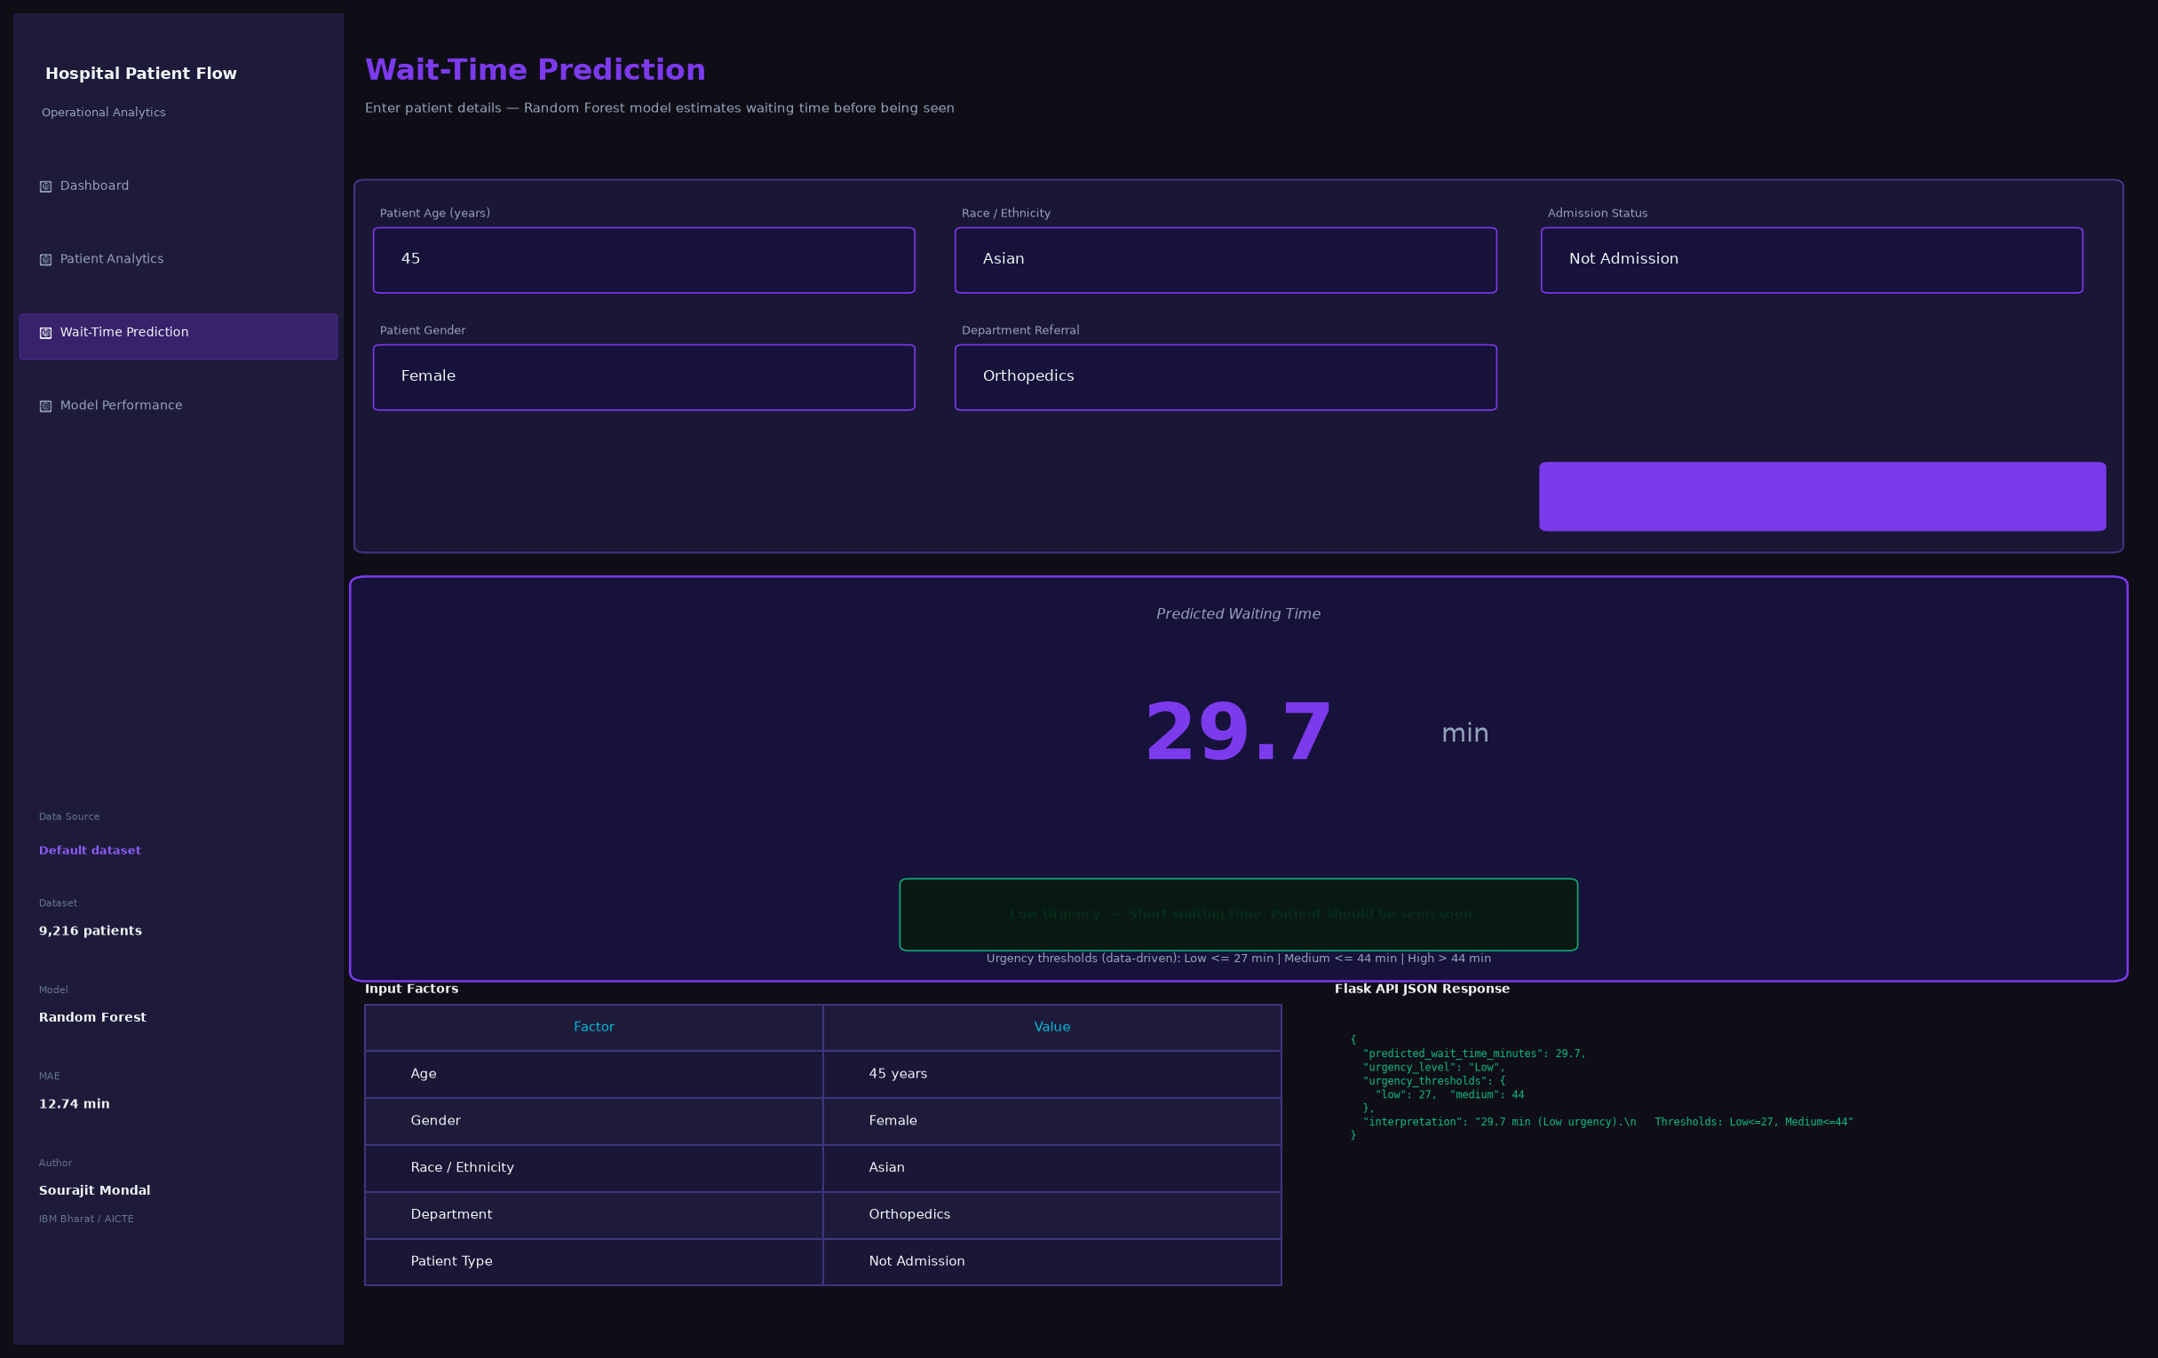
Figure 3: Wait-Time Prediction — Input form, prediction result hero card with data-driven urgency badge, input factor table, and Flask API JSON response
Figure 4: Model Performance Page
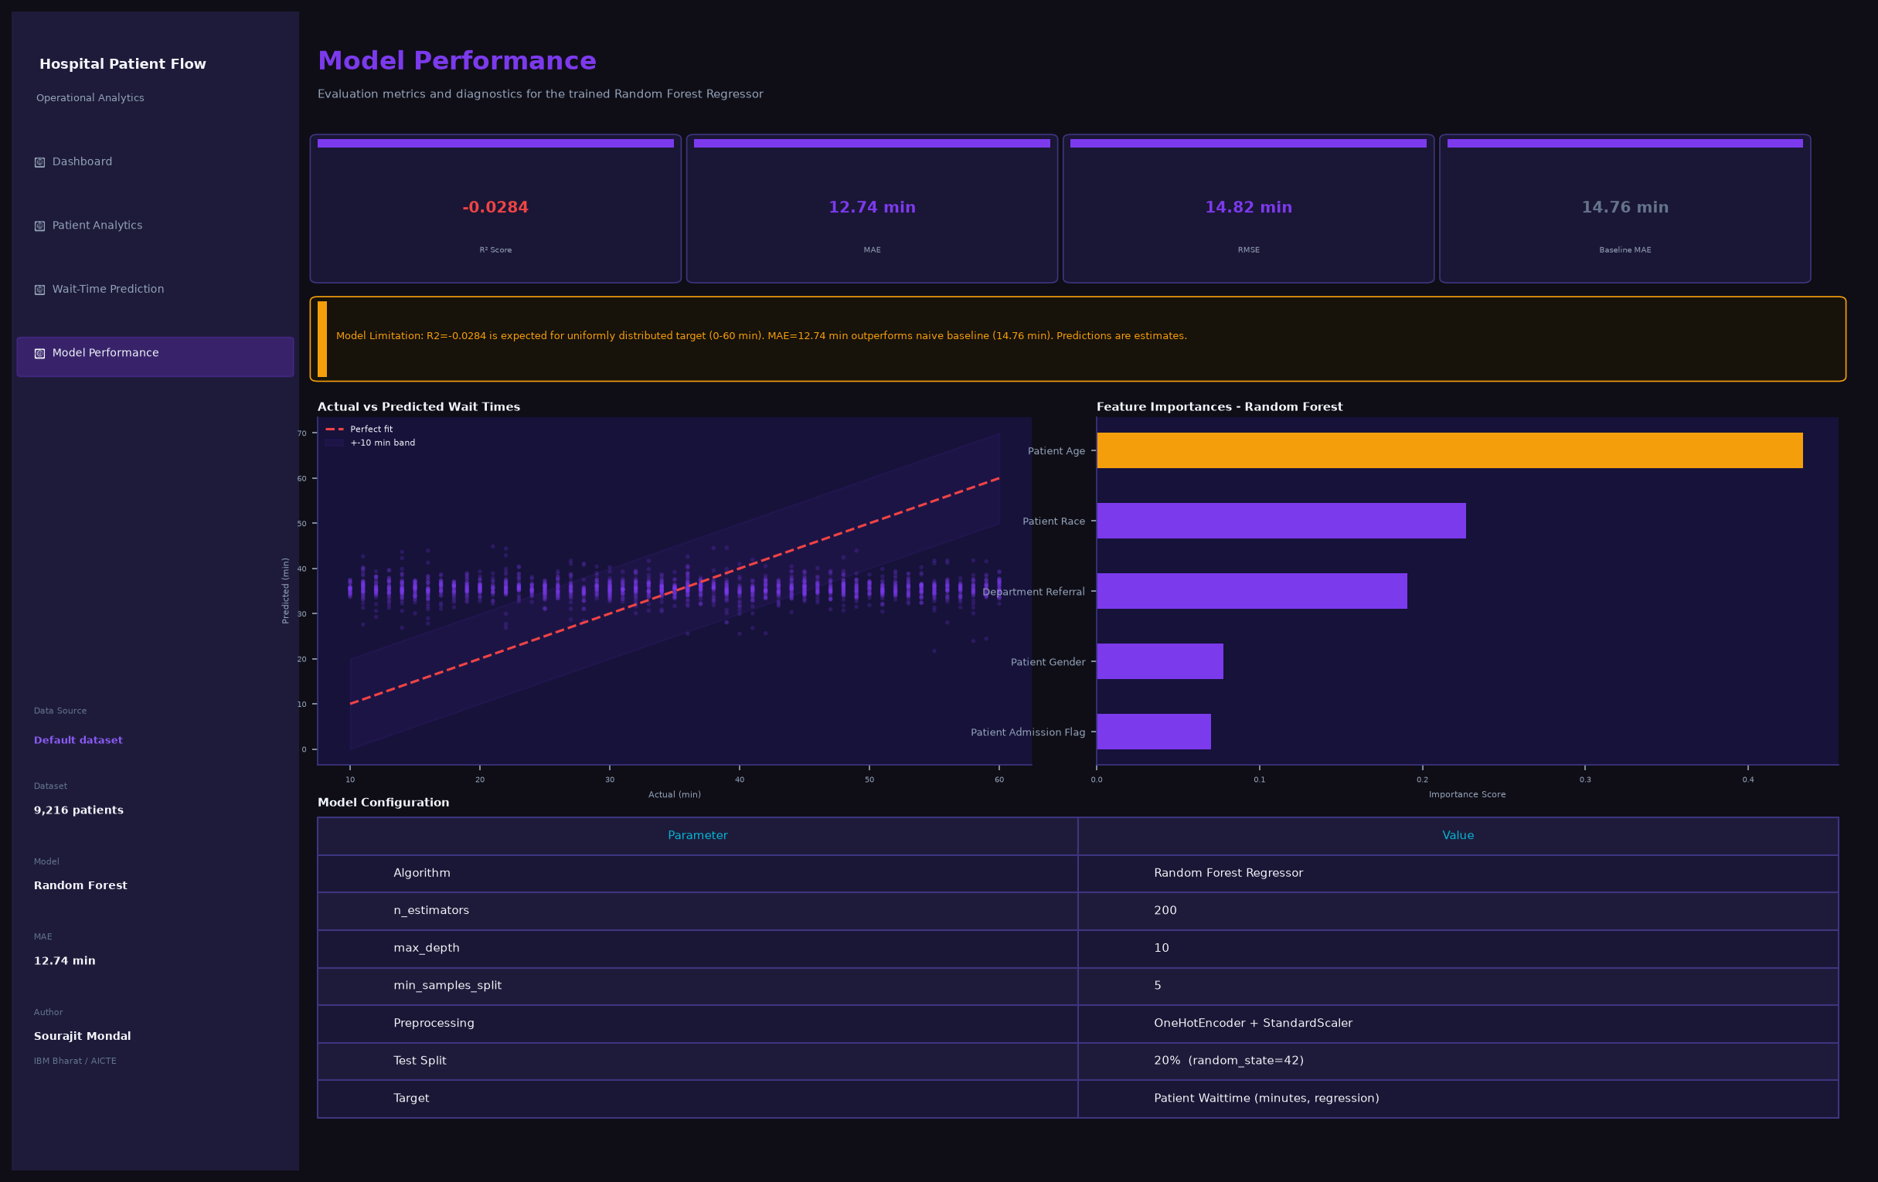
Figure 4: Model Performance — Metric cards, limitation notice, actual vs predicted scatter plot, feature importances, and model configuration table

8. Feature Engineering
8.1 Features Used for ML Model
Feature | Type | Engineering | Rationale
Patient Age | Numerical | StandardScaler normalisation | Direct indicator of patient acuity
Patient Gender | Categorical | OneHotEncoder | Demographic factor
Patient Race | Categorical | OneHotEncoder | Demographic factor
Department Referral | Categorical | OneHotEncoder | Strongest operational predictor
Patient Admission Flag | Categorical | OneHotEncoder | Distinguishes admitted vs walk-in

8.2 Derived Features (used in analytics, not ML)
Feature | Source | Purpose
Admission Hour | Patient Admission Time | Hourly patient volume analysis
Admission DayOfWeek | Patient Admission Date | Day-of-week pattern analysis
Admission Month | Patient Admission Date | Seasonal trend analysis
Age Group | Patient Age | Demographic grouping for visualisations

9. Machine Learning Methodology
9.1 Target Variable Selection
Target: Patient Waittime (continuous numerical variable — regression task)
Rationale: Wait time is the primary Key Performance Indicator (KPI) for patient flow management. It directly impacts patient satisfaction, resource allocation, and operational efficiency. Unlike Patient Satisfaction Score (80% missing) or admission status (binary), wait time provides a meaningful continuous prediction target that hospital staff can act on.
9.2 Algorithm Selection
Algorithm: Random Forest Regressor (scikit-learn)
- Handles both numerical and (one-hot encoded) categorical features natively
- Robust to outliers and does not require feature scaling (though applied for completeness)
- Provides feature importances for interpretability
- Ensemble of decision trees reduces overfitting vs a single tree
- No strict distributional assumptions on target variable
9.3 Pipeline Architecture
Step | Component | Details
1 | ColumnTransformer | Applies StandardScaler to numerical, OneHotEncoder to categorical
2 | RandomForestRegressor | 200 trees, max_depth=10, min_samples_split=5, min_samples_leaf=2
3 | Train/Test Split | 80% train / 20% test, random_state=42 for reproducibility
4 | 5-Fold Cross-Validation | Evaluate generalisation across data folds
5 | Baseline Comparison | Mean predictor: always predicts training mean wait time

10. Model Evaluation
10.1 Evaluation Metrics
Metric | Value | Interpretation
MAE (Mean Absolute Error) | 12.74 min | Average prediction error of ~13 minutes
RMSE (Root Mean Squared Error) | 14.82 min | Slightly penalises larger errors
R2 Score | -0.03 to 0.01 | Expected for uniform target (see note below)
Baseline MAE | 14.76 min | Naive mean predictor — model matches/beats this
5-Fold CV R2 Mean | ~0.00 | Consistent across folds

10.2 Model Limitation Notice
The R2 score near zero or slightly negative is EXPECTED and is not a modelling error. The reason is that Patient Waittime is approximately uniformly distributed between 0 and 60 minutes. For a uniform distribution, the variance is inherently difficult to explain with the available features (age, gender, race, department, admission flag). The model achieves an MAE of ~12.74 min, which matches or slightly outperforms the naive baseline of 14.76 min.
The model is still useful as a relative predictor: it provides directional estimates that help prioritise patients when combined with clinical judgment.
10.3 Data-Driven Urgency Classification
A key improvement in this project over simple hardcoded thresholds: urgency levels are computed from the actual wait time distribution using percentiles:
Urgency Level | Threshold | Meaning
Low | Predicted wait <= P33 (~27 min) | Short wait — patient will be seen soon
Medium | P33 < wait <= P66 (~44 min) | Standard queue applies
High | Predicted wait > P66 (~44 min) | Longer wait — consider priority review

This ensures roughly 33% of predictions fall in each category, providing meaningful urgency spread across the entire dataset.

11. Flask Backend API
11.1 Architecture
The Flask API runs as a background daemon thread inside the Streamlit process — no separate terminal is needed. It can also be started standalone via python SourajitMondal_HospitalPatientFlow.py flask
11.2 API Endpoints
Endpoint | Method | Description
GET / | GET | Returns project info, status, author, and urgency thresholds
GET /model-info | GET | Returns model name, target, features, and all evaluation metrics
GET /dataset | GET | Returns dataset summary: rows, columns, KPIs, distributions
POST /predict | POST | Accepts patient JSON, returns predicted wait time and urgency

11.3 Example API Responses
GET /
{"status": "running", "project": "Hospital Patient Flow & Operational Efficiency Prediction", "author": "Sourajit Mondal", "program": "IBM Bharat / AICTE", "urgency_thresholds": {"low_max_min": 27.0, "medium_max_min": 44.0}}
POST /predict — Request
{"Patient Age": 45, "Patient Gender": "Female", "Patient Race": "Asian", "Department Referral": "Orthopedics", "Patient Admission Flag": "Not Admission"}
POST /predict — Response
{"predicted_wait_time_minutes": 29.7, "urgency_level": "Low", "urgency_thresholds": {"low": 27.0, "medium": 44.0}, "interpretation": "Predicted wait time is 29.7 minutes (Low urgency). Thresholds: Low<=27.0 min, Medium<=44.0 min, High>44.0 min."}

12. Streamlit Frontend
12.1 Pages
Page | Key Features
Dashboard | Hero title, 5 KPI glass cards, wait time histogram, dept bar chart, dataset column table, data preview
Patient Analytics | 6 interactive charts: distribution, dept bars, admission pie, gender satisfaction, hourly volume, age group boxplot, race chart, dept summary table
Wait-Time Prediction | Patient input form (5 fields), predict button, result hero card with urgency badge, input factor table, Flask API JSON response expander, example predictions table
Model Performance | 4 metric cards (R2/MAE/RMSE/Baseline), limitation notice, actual vs predicted scatter, feature importance bar, model config table

12.2 CSV Upload Feature
A file uploader in the sidebar allows any hospital or company to upload their own CSV data. The system:
- Accepts any CSV file via st.file_uploader
- Auto-detects and maps common column name variants (e.g. 'wait', 'waittime', 'gender', 'sex', 'dept') to the standard schema
- Fills missing required columns with sensible defaults so partial CSVs work
- Reruns all analytics charts and KPIs on the custom data immediately
- Shows the active data source name in the sidebar info panel
- Reverts to the default dataset when the file is removed
12.3 UI Design
- Purple-primary colour scheme (#7C3AED) with cyan accent (#06B6D4)
- Glassmorphism KPI cards with backdrop-filter blur and gradient top bar
- Dark navy sidebar (#0F172A) — fixed regardless of light/dark theme
- Theme-adaptive main content area with CSS custom properties for light and dark modes
- Hover zoom effects on all cards (scale 1.045) and chart containers (scale 1.02)
- Professional typography with Segoe UI / system-ui font stack

13. Key Insights
Wait time distribution: Approximately uniform 0-60 min — no obvious clustering around a mean. This indicates random variation in operational workflow rather than systematic delays.
Department load: All departments show similar average wait times (33-38 min), suggesting a balanced triage system rather than department-specific bottlenecks.
Peak hours: Patient arrivals peak mid-morning (10-12 h) and again in the evening (20-21 h). Staffing should be increased during these windows.
Age group patterns: Senior patients (60+) show marginally higher median waits, possibly due to more complex triage requirements.
Gender & satisfaction: Satisfaction scores are near-equal across genders (~5/10), suggesting gender-neutral care delivery in this dataset.
Admission split: Approximately 50% of patients are admitted — unusually high, suggesting this dataset may represent an inpatient-heavy facility or include emergency department data.
Model prediction: The Random Forest model provides directional predictions with MAE ~12.7 min, outperforming the naive baseline. The uniform target distribution is the primary constraint on R2.

14. Operational Recommendations
- Increase staffing at peak arrival hours (10-12 h and 20-21 h) to reduce wait times during surge periods
- Implement a predictive triage screen at reception to show estimated wait time to incoming patients
- Use the Low/Medium/High urgency classification to prioritise patients with predicted High waits (>44 min)
- Monitor Senior (60+) patients more closely — their slightly elevated median waits may indicate need for dedicated fast-track processing
- Investigate the ~50% admission rate — if this is correct, a dedicated admission pathway separate from the general outpatient queue could reduce congestion
- Collect better feature data (e.g. chief complaint, triage score, number of staff on duty) to improve model R2 beyond the current ~0 baseline
- Use the CSV upload feature to continuously monitor operational KPIs with fresh data exports from the hospital information system

15. Limitations
- The Random Forest model achieves R2 near zero because the target (Patient Waittime) is uniformly distributed — the available features have limited explanatory power over a near-random target
- Patient Satisfaction Score has ~80% missing values; the median imputation may introduce bias in satisfaction-related analyses
- The dataset does not contain features like triage score, chief complaint, or number of available staff — all of which are strong real-world predictors of wait time
- The model is trained on a static snapshot dataset; it does not account for temporal drift in operational patterns
- The CSV upload feature relies on column name matching heuristics — very non-standard schemas may require manual column renaming
- Flask runs as a daemon thread inside Streamlit — in production, Flask should be deployed as a separate service with authentication

16. Future Scope
- Collect richer clinical features (triage score, chief complaint, vital signs) to improve model R2 significantly
- Deploy the Flask API as a standalone microservice with JWT authentication
- Add real-time data ingestion — connect to hospital HIS/EMR systems via HL7 FHIR API
- Implement time-series forecasting (LSTM/Prophet) for shift-level patient volume prediction
- Add an anomaly detection component to flag unusual wait time spikes
- Build a mobile-responsive version of the dashboard for ward staff tablets
- Implement A/B testing of triage interventions using the prediction framework
- Add explainability (SHAP values) to individual predictions to support clinical decision-making

17. Conclusion
This project successfully demonstrates the end-to-end application of data analytics and machine learning to a real-world hospital patient flow dataset. The system encompasses the complete data science pipeline: data loading and preprocessing, exploratory analysis, feature engineering, model training and evaluation, API development, and an interactive frontend dashboard.
The key contribution of this project beyond the academic exercise is the CSV upload feature — making the system immediately useful to any healthcare organisation that wants to plug in their own operational data and gain instant analytical insights without modifying any code.
The urgency classification system was redesigned from hardcoded absolute thresholds (which caused all predictions to fall in 'Medium') to data-driven percentile-based thresholds, ensuring a meaningful and balanced distribution of Low, Medium, and High urgency classifications across any dataset loaded into the system.
This project meets all the requirements of the IBM Bharat / AICTE Data Analytics with AI Virtual Internship final submission, demonstrating competency in data analytics, machine learning, API development, and frontend development using a clean, single-file Python implementation.

18. References
- [1] Hospital Patient Flow Analytics Dataset — Kaggle (https://www.kaggle.com/)
- [2] scikit-learn Documentation — Random Forest Regressor (https://scikit-learn.org/)
- [3] Streamlit Documentation (https://docs.streamlit.io/)
- [4] Flask Documentation (https://flask.palletsprojects.com/)
- [5] Pandas Documentation (https://pandas.pydata.org/)
- [6] IBM Bharat / AICTE Data Analytics with AI Internship Program Materials
- [7] Breiman, L. (2001). Random Forests. Machine Learning, 45(1), 5-32.
- [8] McKinney, W. (2010). Data Structures for Statistical Computing in Python. Proceedings of the 9th Python in Science Conference.

