**LATVIA UNIVERSITY OF LIFE SCIENCES AND TECHNOLOGIES**

**Faculty of Information Technologies**

**Mohammad saqib souran**

**Indian Premier League (IPL) Database**

**Data base project**

**Reviewer:**  Dr.sc.ing. asoc. prof. G. Vitols

*Signature, date*

**Author:**  ID. IT20111 M. Souran

*Signature, date*

**Jelgava 2021**

* **Contents**

Contents 2

Specification 3

1 ER model description 4

1.1 ER model 4

1.2 Relationship description 4

2 Data base description 5

2.1 Technical description of the project 5

2.2 Self-learned material and comments 5

Conclusions 6

References 7

* **Specification**

The section of hardware configuration is an important task related to the software development insufficient random-access memory may affect adversely on the speed and efficiency of the entire system. The process should be powerful to handle the entire operations. The hard disk should have sufficient capacity to store the file and application

Processor : Intel PentiumT4200/ Intel Core Duo 2.0 GHz / more

RAM : Minimum 1 GB RAM capacity

Hard disk : Minimum 40 GB ROM capacity

Cache Memory : L2-1 MB

GPU : Intel HD Graphics

A major element in building a system is the section of compatible software since the software in the market is experiencing in geometric progression. Selected software should be acceptable by the firm and one user as well as it should be feasible for the system.

This document gives a detailed description of the software requirement specification. The study of requirement specification is focused specially on the functioning of the system. It allows the developer or analyst to understand the system, function to be carried out the performance level to be obtained and corresponding interfaces to be established.

Software : PostgreSQL, Excel

Operation System : Windows 7 or Windows 8.1 or Windows 10

**Software Used**

**PostgreSQL** is the language used to manipulate relational databases. It is tied closely with the relational model. It is issued for the purpose of data definition and data manipulation. Program runs as a server providing multi-user access to a number of databases. PSQL is a multithreaded, multi-user SQL database management system (DBMS). It includes facilities to add, modify or delete data from the database, ask questions (or queries) about the data stored in the database and produce reports summarizing selected contents.

**Excel** database is typically a spreadsheet with rows and columns of data—organized and formatted in a way that allows spreadsheet formulas to use the data easily.

* **ER model description**

An entity–relationship model is usually the result of systematic analysis to define and describe what is important to processes in an area of a business. An E-R model does not define the business processes; it only presents a business data schema in graphical form. It is usually drawn in a graphical form as boxes (entities) that are connected by lines (relationships) which express the associations and dependencies between entities. An ER model can also be expressed in a verbal form, for example: one building may be divided into zero or more apartments, but one apartment can only be located in one building. Entities may be characterized not only by relationships, but also by additional properties (attributes), which include identifiers called "primary keys". Diagrams created to represent attributes as well as entities and relationships may be called entity-attribute-relationship diagrams, rather than entity-relationship models.

An ER model is typically implemented as a database. In a simple relational database implementation, each row of a table represents one instance of an entity type, and each field in a table represents an attribute type. In a relational database a relationship between entities is implemented by storing the primary key of one entity as a pointer or "foreign key" in the table of another entity. There is a tradition for ER/data models to be built at two or three levels of abstraction. Note that the conceptual-logical-physical hierarchy below is used in other kinds of specification, and is different from the three-schema approach to software engineering.

While useful for organizing data that can be represented by a relational structure, an entity-relationship diagram can't sufficiently represent semi-structured or unstructured data, and an ER Diagram is unlikely to be helpful on its own in integrating data into a pre-existing information system. Three main components of an ERD are the entities the relationship between those entities, and the cardinality, which defines that relationship in terms of numbers. Cardinality notations define the attributes of the relationship between the entities. Cardinalities can denote that an entity is optional (for example, an employee rep could have no customers or could have many) or mandatory (for example, there must be at least one product listed in an order.

* `**ER model**

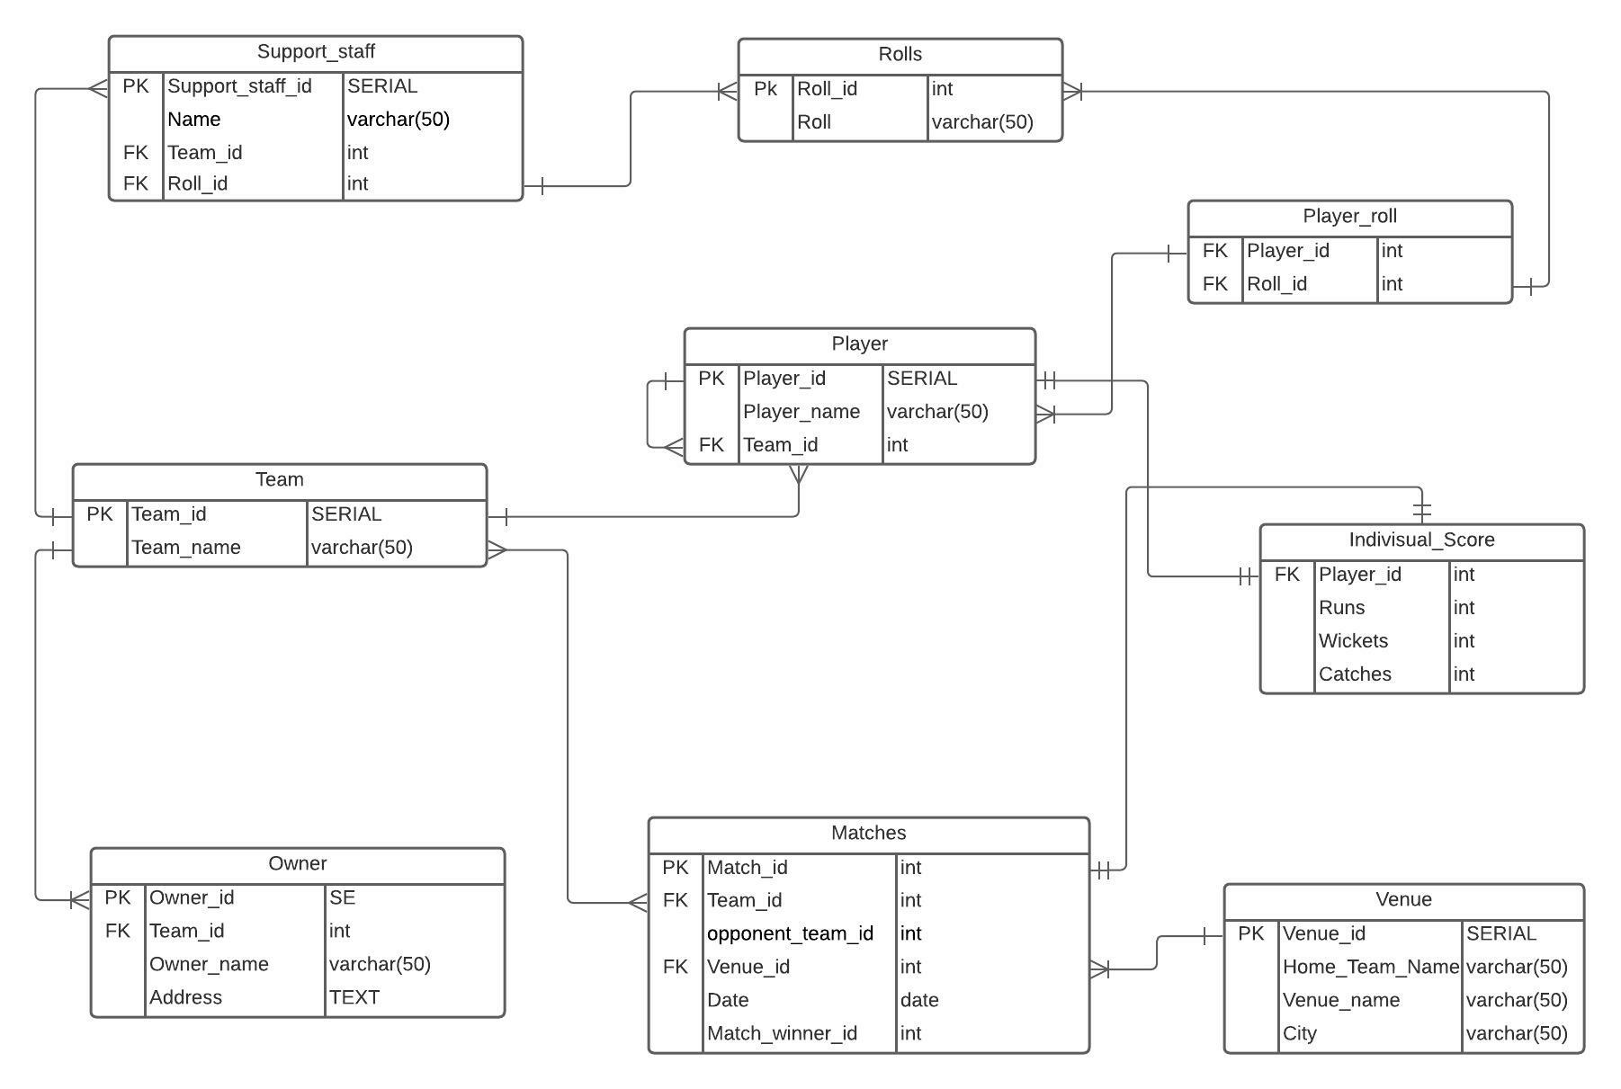

* **Relationship description**
* Table Team and Table Player use one to many relationship because one team can have many players but a player cannot play from more than one team.
* Table Team and Table Support_staff use one to many relationship because one team can have many supporting staffs like batting coach , bowling coach etc. but a support staff cannot be a coach from more than one team at a time.
* Table Team and Table owner use one to many relationship because team can have one or many owner but owner can own only one team in IPL.
* Table Team and Table Matches use one to many relationship because one will play many matches and a match must be play by two teams.
* Table Matches and Table venue use one to many relationship because a match be played only at one venue at a time
* Table Matches and Table Indivisual_Score use one to one relationship because it is an individual score by a player in a single match.
* Table Player and Table Indivisual_Score use one to one relationship because it shows the score of an individual player.
* Table Player and Table Rolls use many to many relationship with a bridge table named Player_roll because one player can have many rolls in a team like batsman as well as caption etc. and there can be many players of a single roll.
* Table Support_staff and Table Rolls use one to many relationship because a supporting staff can have only single role.
* **Data base description**
* **Technical description of the project**

Table No1. **Initial data**

|  |  |
| --- | --- |
| **Table name** | **Rows** |
| Team | Inserted 8 rows |
| Rolls | Inserted 7 rows |
| Support_staff | Inserted 16 rows |
| Owner | Inserted 8 rows |
| Player | Inserted 202 rows |
| Player_roll | Inserted 213 rows |
| Venue | Inserted 5 rows |
| Matches | Inserted 60 rows |
| Indivisual_Score | Inserted 202 rows |

Table No2. **Constraints**

|  |  |  |
| --- | --- | --- |
| **Table name** | **Column name** | **Constraint** |
| Team | Team_name | Maximum Variable character 50 |
| Rolls | Roll | Maximum Variable character 50 |
| Support_staff | Name | Maximum Variable character 50 |
| Owner | Owner_name | Maximum Variable character 50 |
| Player | Player_name | Maximum Variable character 50 |
| Venue | Home_Team_Name | Maximum Variable character 50 |
| Venue | Venue_name | Maximum Variable character 150 |
| Venue | City | Maximum Variable character 30 |

Table No3. **Queries**

|  |  |  |
| --- | --- | --- |
| **Query name** | **Code** | **Explanation** |
| Most run | File: queries.sql | Retrieves Top 3 run making Players |
| Most Wickets | File: queries.sql | Retrieves Top 3 Wicket taking Bowlers |
| Most Catches | File: queries.sql | Retrieves Top 3 Players who have grabbed most catches |
| Total Wins | File: queries.sql | Retrieves Total wins by a Team |
| Total Players | File: queries.sql | Retrieves Total Players in a Team |
| Batting Coach | File: queries.sql | Retrieves the name of Batting coach by teams |
| Nested Query | File: queries.sql | Retrieves Total players in a team and overall players in IPL |
| Recursive Query | File: queries.sql | Retrieves the Name of Players by Team ID |

Table No4. **Functions**

|  |  |  |
| --- | --- | --- |
| **Function name** | **Code** | **Explanation** |
| get_players_count | File: Functions.sql | Receives number and returns the count of Players that scored more than received number. |
| get_top_wicket_taker | File: Functions.sql | Receives number and returns all Players that took Wickets more than received number. |
| get_top_runner_player | File: Functions.sql | Receives number and returns the name of players that scored more than received number. |

* **Self-learned material and comments**

During this project I learned how to use functions and retrieve data by input.

During this project I learned how to use Recursive Query.

During this project I learned how to use nested Query.

During this project I just used skills developed during lectures and I did not learn anything extra.

* **Conclusions**

The project, developed using Postgre SQL and Excel is based on the requirement specification of the user and the analysis of the existing system, with flexibility for future enhancement. The expanded functionality of today’s software requires an appropriate approach towards software development. This IPL database management software is designed for people who want to manage various particulars can be known by recording them in the database. various records and particulars about match got increased rapidly. Thereby the numbers of matches and there is going to be increased day-by-day. And hence there is a lot of strain on the person who are watching the IPL to know about future matches and also to see the records done by various players and getting datils in fingertips. Identification of the drawbacks of the existing system leads to the designing of computerized system that will be compatible to the existing system with the system which is more user friendly and more GUI oriented.

* **References**

[1] Serge Abiteboul, Richard Hull, Victor Vianu,”Foundation of Databases: The Logical Level”, Facsimile, Pearson, 22 November 1994

[2] Ramakrishnan and Gehrke, “Database management systems”, 3rd Edition McGraw Hill 2014

[3] Raghu Ramkrishnan and Johannes Gehrke,” Database Management Systems”, 3rd Edition, McGraw Hill Education, 2014

[4] [http://stackoverflow.com](http://stackoverflow.com/)

[5] <https://www.w3schools.com>

[6] <https://www.postgresqltutorial.com>

[7] <https://www.postgresql.org>