**Deep Dive Into Buttons *& Clickable Widgets In Flutter***

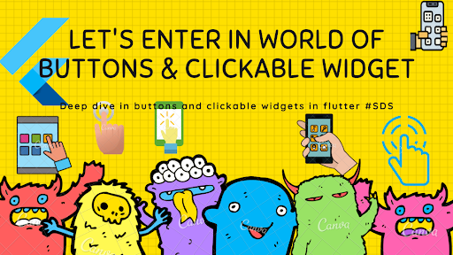

We can not imagine any language that has not click event because without click it’s very hard to trigger any actions . So here in flutter we are talking about buttons and clickable widgets very quickly in the flutter.

In this blog we are going to discuss pre-define buttons and clickable widgets in flutter as follows :

1. FlatButton
2. RaisedButton
3. FloatingActionButton
4. IconButton
5. InkWell
6. GestureDetector
7. DropdownButton
8. MaterialButton
9. OutlineButton
10. RadioButton
11. RadioListTileButton
12. PopupMenuButton

**FlatButton**

1. Simple button that has not much highlighted decoration, Mostly use on toolbar, dialog and etc.
2. FlatButton has two required property ***child****and****onPressed()***

FlatButton(  
 child: Text('I am FlatButton'),  
 onPressed: (){  
 print('You tapped on FlatButton');  
 },  
 ),

Here we are using **child** as Text Widget but you can use as you want and suitable for Flutter. **onPressed()** is simple ***voidCallback***that is call back with no argument and no return.

Below are more property of **FlatButton**widget.

Key key,  
 @required VoidCallback onPressed,  
 ValueChanged<bool> onHighlightChanged,  
 ButtonTextTheme textTheme,  
 Color textColor,  
 Color disabledTextColor,  
 Color color,  
 Color disabledColor,  
 Color highlightColor,  
 Color splashColor,  
 Brightness colorBrightness,  
 EdgeInsetsGeometry padding,  
 ShapeBorder shape,  
 Clip clipBehavior = Clip.none,  
 MaterialTapTargetSize materialTapTargetSize,  
 @required Widget child,

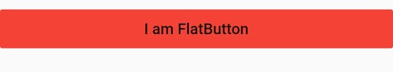

FlatButton

*Note*

You can find all the properties of any widget/method by short-cut Mac User — ***(Command+ClickOnWidget/Method)***for others may be use **Ctrl** instead of **Command.**

**RaisedButton**

1. It’s material button same like flatButton but it has elevation that will increase when it pressed.
2. Do not used with Widgets that has already raise-content like dialog, card etc. Use with flat content like long list, wide range of widget .

RaisedButton(  
 child: Text('I am RaisedButton'),  
 onPressed: (){  
 print('You tapped on RaisedButton');  
 },  
 ),

Below are more property of **RaisedButton**widget.

RaisedButton({  
 Key key,  
 @required VoidCallback onPressed,  
 VoidCallback onLongPress,  
 ValueChanged<bool> onHighlightChanged,  
 ButtonTextTheme textTheme,  
 Color textColor,  
 Color disabledTextColor,  
 Color color,  
 Color disabledColor,  
 Color focusColor,  
 Color hoverColor,  
 Color highlightColor,  
 Color splashColor,  
 Brightness colorBrightness,  
 double elevation,  
 double focusElevation,  
 double hoverElevation,  
 double highlightElevation,  
 double disabledElevation,  
 EdgeInsetsGeometry padding,  
 ShapeBorder shape,  
 Clip clipBehavior = Clip.none,  
 FocusNode focusNode,  
 bool autofocus = *false*,  
 MaterialTapTargetSize materialTapTargetSize,  
 Duration animationDuration,  
 Widget child,  
})

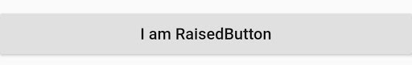

RaisedButton

**FloatingActionButton**

1. Simple circular icon with hover, mostly single per screen.
2. Display on screen for trigger positive action like, add, share or navigate to screen and etc.
3. Use child as **Icon**widget, not any rule you can also use whatever
4. Mostly use with **Scaffold** widget that has property name is ***floatingActionButton***

FloatingActionButton(  
 child: Icon(Icons.add),  
 onPressed: (){  
 print('You tapped on FloatingActionButton');  
 },  
 ),

Below are more property of **FloatingActionButton**widget.

FloatingActionButton({  
 Key key,  
 *this*.child,  
 *this*.tooltip,  
 *this*.foregroundColor,  
 *this*.backgroundColor,  
 *this*.focusColor,  
 *this*.hoverColor,  
 *this*.splashColor,  
 *this*.heroTag = *const* _DefaultHeroTag(),  
 *this*.elevation,  
 *this*.focusElevation,  
 *this*.hoverElevation,  
 *this*.highlightElevation,  
 *this*.disabledElevation,  
 @required *this*.onPressed,  
 *this*.mini = *false*,  
 *this*.shape,  
 *this*.clipBehavior = Clip.none,  
 *this*.focusNode,  
 *this*.autofocus = *false*,  
 *this*.materialTapTargetSize,  
 *this*.isExtended = *false*,  
})

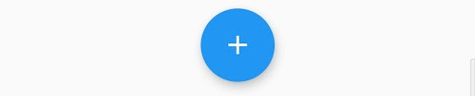

FloatingActionButton

**IconButton**

1. Simple display touchable icon, Trigger action when clicked.
2. Mostly use with AppBar widget with actions property.

IconButton(  
 icon: Icon(Icons.volume_up),  
 tooltip: 'Increase volume by 10%',  
 onPressed: () { print('Volume button clicked');},  
);

Below are more property of **IconButton**widget.

IconButton({  
 Key key,  
 *this*.iconSize = 24.0,  
 *this*.padding = *const* EdgeInsets.all(8.0),  
 *this*.alignment = Alignment.*center*,  
 @required *this*.icon,  
 *this*.color,  
 *this*.focusColor,  
 *this*.hoverColor,  
 *this*.highlightColor,  
 *this*.splashColor,  
 *this*.disabledColor,  
 @required *this*.onPressed,  
 *this*.focusNode,  
 *this*.autofocus = *false*,  
 *this*.tooltip,  
 *this*.enableFeedback = *true*,  
})

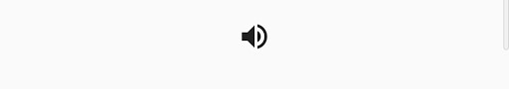

IconButton

**DropdownButton**

1. A material design button for selecting from a list of items.
2. The button shows the currently selected item as well as an arrow that opens a menu for selecting another item.
3. The **onChanged** callback should update a state variable that defines the dropdown’s value.

DropdownButton(  
 value: _selectedGender,  
 items: _dropDownItem(),  
 onChanged: (value){  
 _selectedGender =value;  
 setState(() {  
  
 });  
 },  
 hint: Text(" Select Gender "),  
),

Below are more property of **DropdownButton**widget.

DropdownButton({  
 Key key,  
 @required *this*.items,  
 *this*.selectedItemBuilder,  
 *this*.value,  
 *this*.hint,  
 *this*.disabledHint,  
 @required *this*.onChanged,  
 *this*.elevation = 8,  
 *this*.style,  
 *this*.underline,  
 *this*.icon,  
 *this*.iconDisabledColor,  
 *this*.iconEnabledColor,  
 *this*.iconSize = 24.0,  
 *this*.isDense = *false*,  
 *this*.isExpanded = *false*,  
 *this*.itemHeight = kMinInteractiveDimension,  
 *this*.focusColor,  
 *this*.focusNode,  
 *this*.autofocus = *false*,  
})

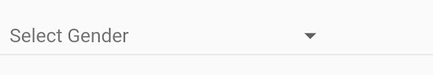

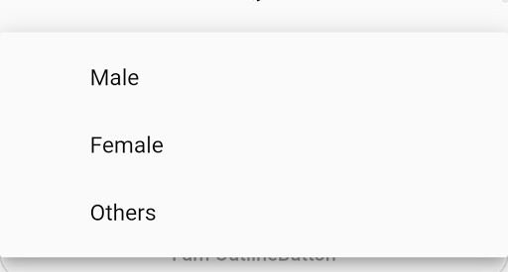

**MaterialButton**

1. The button’s size will expand to fit the child widget
2. MaterialButtons whose **onPressed** and **onLongPress** callbacks are null will be disabled.

MaterialButton(  
minWidth: 200.0,  
height: 35,  
color: Color(0xFF801E48),  
child: *new* Text('I am Material Button',  
style: *new* TextStyle(fontSize: 16.0, color: Colors.*white*)),  
onPressed: () {},  
),

Below are more property of **MaterialButton**widget.

MaterialButton({  
 Key key,  
 @required *this*.onPressed,  
 *this*.onLongPress,  
 *this*.onHighlightChanged,  
 *this*.textTheme,  
 *this*.textColor,  
 *this*.disabledTextColor,  
 *this*.color,  
 *this*.disabledColor,  
 *this*.focusColor,  
 *this*.hoverColor,  
 *this*.highlightColor,  
 *this*.splashColor,  
 *this*.colorBrightness,  
 *this*.elevation,  
 *this*.focusElevation,  
 *this*.hoverElevation,  
 *this*.highlightElevation,  
 *this*.disabledElevation,  
 *this*.padding,  
 *this*.shape,  
 *this*.clipBehavior = Clip.none,  
 *this*.focusNode,  
 *this*.autofocus = *false*,  
 *this*.materialTapTargetSize,  
 *this*.animationDuration,  
 *this*.minWidth,  
 *this*.height,  
 *this*.enableFeedback = *true*,  
 *this*.child,  
})

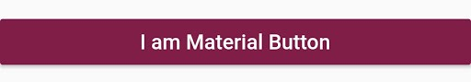

**OutlineButton**

1. Similar to a **FlatButton** with a thin grey rounded rectangle border.
2. The outline button’s border shape is defined by **shape** and its appearance is defined by **borderSide**, **disabledBorderColor**, and **highlightedBorderColor**.
3. By default the border is a one pixel wide grey rounded rectangle that does not change when the button is pressed or disabled.
4. By default the button’s background is transparent.
5. If the **onPressed** or **onLongPress** callbacks are null, then the button will be disabled and by default will resemble a flat button in the **disabledColor**.

OutlineButton(  
 child: *new* Text("Button text"),  
 onPressed: *null*,  
 shape: *new* RoundedRectangleBorder(borderRadius: *new* BorderRadius.circular(30.0))  
),

Below are more property of **OutlineButton**widget.

OutlineButton({  
 Key key,  
 @required VoidCallback onPressed,  
 VoidCallback onLongPress,  
 ButtonTextTheme textTheme,  
 Color textColor,  
 Color disabledTextColor,  
 Color color,  
 Color focusColor,  
 Color hoverColor,  
 Color highlightColor,  
 Color splashColor,  
 double highlightElevation,  
 *this*.borderSide,  
 *this*.disabledBorderColor,  
 *this*.highlightedBorderColor,  
 EdgeInsetsGeometry padding,  
 ShapeBorder shape,  
 Clip clipBehavior = Clip.none,  
 FocusNode focusNode,  
 bool autofocus = *false*,  
 Widget child,  
})

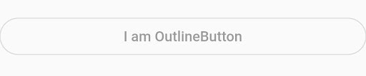

OutlineButton

**RadioButton**

1. The radio button itself does not maintain any state.
2. the radio invokes the **onChanged** callback, passing value as a parameter.
3. Most widgets will respond to **onChanged** by calling **State**.**setState** to update the radio button’s **groupValue**.

Radio(  
 value: 1,  
 groupValue: selectedRadio,  
 activeColor: Colors.green,  
 onChanged: (val) {  
 print("Radio $val");  
 setSelectedRadio(val);  
 },  
 ),

Below are more property of **Radio**widget.

Radio({  
 Key key,  
 @required *this*.value,  
 @required *this*.groupValue,  
 @required *this*.onChanged,  
 *this*.activeColor,  
 *this*.focusColor,  
 *this*.hoverColor,  
 *this*.materialTapTargetSize,  
 *this*.focusNode,  
 *this*.autofocus = *false*,  
})

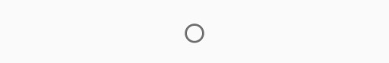

RadioButton

**RadioListTile**

1. A **ListTile** with a **Radio**. In other words, a radio button with a label.
2. The entire list tile is interactive: tapping anywhere in the tile selects the radio button.
3. The **value**, **groupValue**, **onChanged**, and **activeColor** properties of this widget are identical to the similarly-named properties on the **Radio** widget
4. The **title**, **subtitle**, **isThreeLine**, and **dense** properties are like those of the same name on **ListTile**.

RadioListTile(  
 value: 2,  
 groupValue: selectedRadioTile,  
 title: Text("Radio 2"),  
 subtitle: Text("Radio 2 Subtitle"),  
 onChanged: (val) {  
 print("Radio Tile pressed $val");  
 setSelectedRadioTile(val);  
 },  
 activeColor: Colors.red,  
 secondary: OutlineButton(  
 child: Text("Say Hi"),  
 onPressed: () {  
 print("Say Hello");  
 },  
 ),  
 selected: false,  
),

Below are more property of **RadioListTile**widget.

RadioListTile({  
 Key key,  
 @required *this*.value,  
 @required *this*.groupValue,  
 @required *this*.onChanged,  
 *this*.activeColor,  
 *this*.title,  
 *this*.subtitle,  
 *this*.isThreeLine = *false*,  
 *this*.dense,  
 *this*.secondary,  
 *this*.selected = *false*,  
 *this*.controlAffinity = ListTileControlAffinity.platform,  
})

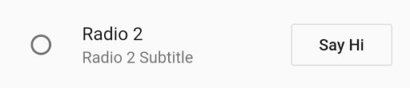

**PopupMenuButton**

1. Displays a menu when pressed and calls **onSelected** when the menu is dismissed because an item was selected.
2. The value passed to **onSelected** is the value of the selected menu item.
3. One of **child** or **icon** may be provided, but not both. If **icon** is provided, then **PopupMenuButton** behaves like an **IconButton**.
4. If both are null, then a standard overflow icon is created (depending on the platform).

PopupMenuButton<int>(  
itemBuilder: (context) => [  
PopupMenuItem(  
value: 1,  
child: Text("First"),),  
PopupMenuItem(  
value: 2,  
child: Text("Second"),),  
],  
),

Below are more property of **PopupMenuButton**widget.

PopupMenuButton({  
 Key key,  
 @required *this*.itemBuilder,  
 *this*.initialValue,  
 *this*.onSelected,  
 *this*.onCanceled,  
 *this*.tooltip,  
 *this*.elevation,  
 *this*.padding = *const* EdgeInsets.all(8.0),  
 *this*.child,  
 *this*.icon,  
 *this*.offset = Offset.*zero*,  
 *this*.enabled = *true*,  
 *this*.shape,  
 *this*.color,  
 *this*.captureInheritedThemes = *true*,  
})

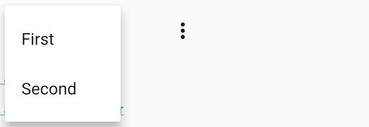

**Clickable widget**

We can make any widget clickable or you can give any widget capability to detect the gesture.

There are two widgets which helps us in flutter to give this functionality

1. InkWell
2. GestureDetector

**InkWell**

1. A rectangle area of the material that response on touch.
2. Simply you can wrap it to any material widget so that will be clickable.

InkWell(  
 onTap: () {  
 print('Clicked on URL by InkWell Widget');  
 },  
 child: Text("https://quickstartflutterdart.blogspot.in/",  
 style: TextStyle(  
 color: Colors.blue,  
 fontSize: 13,  
 decoration: TextDecoration.underline)),  
 );



**GestureDetector**

1. It’s work same like InkWell widget but it has more powerful click events.
2. It has many click/drag and other events.

GestureDetector(  
 onTap: () {  
 print('Clicked on URL by GestureDetector Widget');  
 },  
 child: Text("https://quickstartflutterdart.blogspot.in/",   
 style: TextStyle(  
 color: Colors.blue,   
 fontSize: 13,  
 decoration: TextDecoration.underline)  
 ),  
 );

It works same. But instead of onTap() it has so many other event.

this.child,  
this.onTapDown,  
this.onTapUp,  
this.onTap,  
this.onTapCancel,  
this.onDoubleTap,  
this.onLongPress,  
this.onLongPressUp,  
this.onVerticalDragDown,  
this.onVerticalDragStart,  
this.onVerticalDragUpdate,  
this.onVerticalDragEnd,  
this.onVerticalDragCancel,  
this.onHorizontalDragDown,  
this.onHorizontalDragStart,  
this.onHorizontalDragUpdate,  
this.onHorizontalDragEnd,  
this.onHorizontalDragCancel,  
this.onForcePressStart,  
this.onForcePressPeak,  
this.onForcePressUpdate,  
this.onForcePressEnd,  
this.onPanDown,  
this.onPanStart,  
this.onPanUpdate,  
this.onPanEnd,  
this.onPanCancel,  
this.onScaleStart,  
this.onScaleUpdate,  
this.onScaleEnd,  
this.behavior,  
this.excludeFromSemantics = false

