* **git --version**



* **mkdir gitpractice**
* **cd gitpractice**
* **git init**
* **touch test.txt**
* **git add test.txt**
* **git commit -m "new file added"**

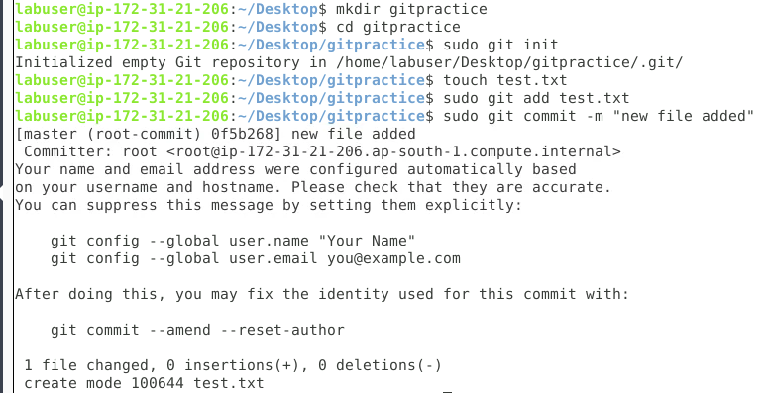

* **git status**
* **git config --global user.name = "Sourav"**
* **git config --global user.email - "sourav.chowdhury.tcs@gmail.com"**
* **git config user.name = "Sourav"**
* **git config user.email = " sourav.chowdhury.tcs@gmail.com"**

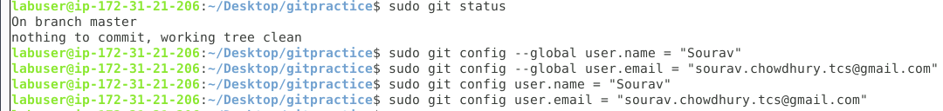

* **git remote add origin https://github.com/sourav-ch-tcs/bootcamp3.git**
* **git clone https://github.com/sourav-ch-tcs/bootcamp3.git**

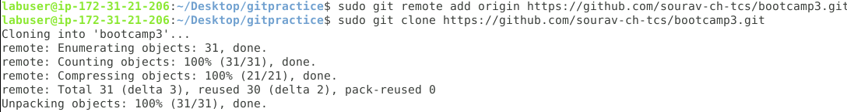

* **git pull origin master**

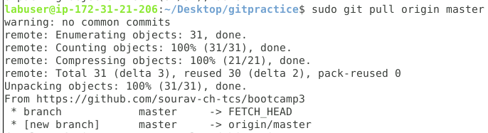

* **git push origin master**

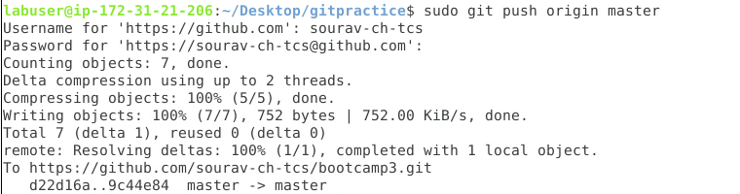

* **git branch**
* **git branch newbranch**
* **git branch -d newbranch**
* **git branch newbranch1**
* **git merge newbranch1**

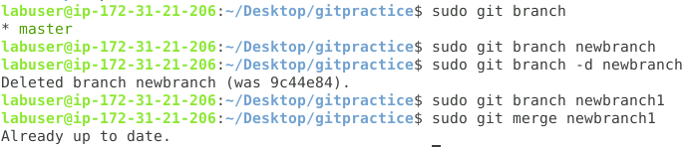

* **git stash**



* **git stash -u**



* **git stash list**



* **git stash apply**

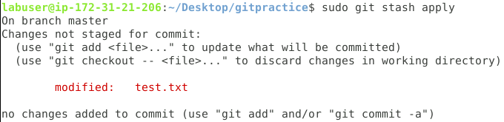

* **git log**

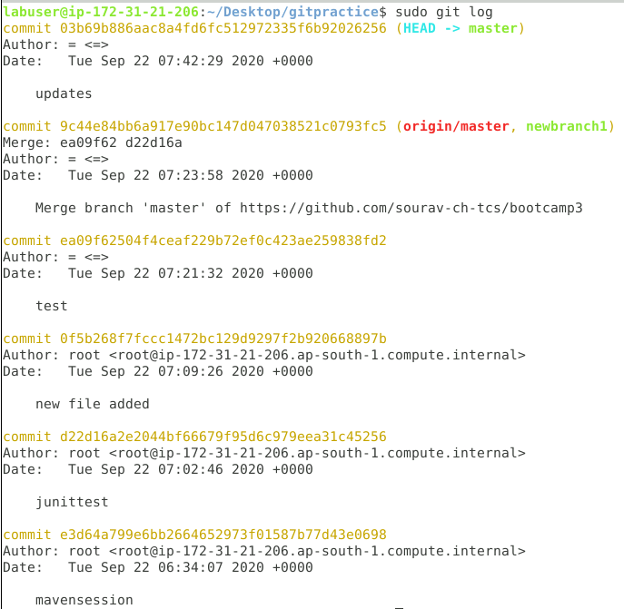

* **git rebase**



* **git log –oneline**
* **git revert 03b69b8**

