Pre-requests

1. Visual Studio Code
2. Node

On My local system:

> node –version v12.14.1

> npm –version 6.13.6

Steps Installing Cypress:

1. Creating a working directory, I have created a working directory in “F:\project\cy\RoadScheduling_Automation_Testing”.
2. Open cmd promt with the current working directory and execute the command npm init

e.g. F:\project\cy\RoadScheduling_Automation_Testing>npm init

it will initialize the package.json file, It may ask to fill the attribute

package name: (roadscheduling_automation_testing)

version: (1.0.0)

*description: road scheduling e2e automation testing

entry point: (index.js)

test command:

git repository:

*keywords: cypress e2e automation

*author: david systems

license: (ISC)

Note :(*) Attribute, I have filled/manipulated and rest attributes value are auto generated.

1. F:\project\cy\RoadScheduling_Automation_Testing> npm install cypress
2. Change scripts test in package.json :

"scripts": {

   "test": "cypress open"

 },

Visual Studio Code Extension:

1. code runner
2. npm intellisense
3. path intellisense

After changing the test script and running up with command

F:\project\cy\RoadScheduling_Automation_Testing> npm run test

You will see automatically all the files has been created :

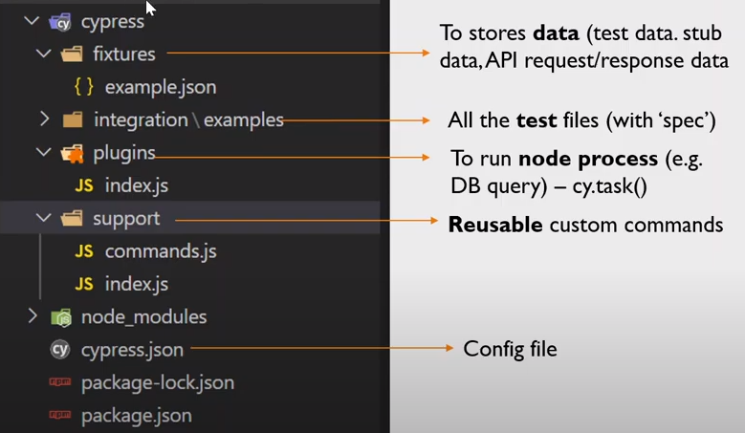

// force user.getName() to return "Jane"

cy.stub(user, 'getName').returns('Jane Lane')

// spy on updateEmail but do not change its behavior

cy.spy(user, 'updateEmail')

// spy on fail but do not change its behavior

cy.spy(user, 'fail')