Software Requirements Specification
for
Virtual Classroom System
Version 1.0

Prepared by
ERP TEAM
Dipanwita Kundu |  | dipanwitakundu02@gmail.com
Sourav Mukhopadhya |  | sourav11092002@gmail.com

Instructor:
Course:
Date:
Contents
1 Introduction 3
1.1 Document Purpose 3
1.2 Product Scope 3
1.3 Intended Audience and Document Overview 4
1.4 Definitions, Acronyms and Abbreviations 4
1.5 Document Conventions 4
1.6 References and Acknowledgments 5
2 Overall Description 7
2.1 Product Perspective 7
2.2 Product Functionality 7
2.3 Users and Characteristics 8
2.4 Operating Environment 9
2.5 Design and Implementation Constraints 9
2.6 User Documentation 10
2.7 Assumptions and Dependencies 10
3 Specific Requirements 11
3.1 External Interface Requirements 11
3.2 Functional Requirements 13
3.3 Non Functional requirements..........................................................................................14
4 System Design 15
4.1 Dataflow Diagram 15
4.2 Uml Diagrams..........................................................................................................................................18
5 SCOPE OF EXTENSION.....................................................................................................................................24

The Virtual Classroom System is designed to bridge the gap between traditional education and modern digital platforms by integrating the advantages of physical classrooms with the flexibility of online learning. This system eliminates geographical and commuting barriers, while still maintaining the structure, discipline, and interactive nature of a real classroom.

With a combination of synchronous (live classes, discussions, announcements) and asynchronous (recorded lectures, notes, assignments) learning methods, this platform provides a comprehensive collaborative learning environment for students.

The system is also built with a role-based dynamic permission model, allowing fine-grained control over features such as announcements, discussion forums, course management, and administrative tasks. This ensures scalability, security, and customizability for different institutions.

System Users

The platform identifies four primary categories of users, each with specific roles and privileges:

1. Student

Can access assigned courses, watch lecture videos (with progress lock/unlock system).

Sequential learning: next video/unit unlocks only after completing the previous one.

Can track overall course % completion.

Participate in discussion forums (faculty-monitored).

Receive approved announcements from faculty, HODs, or higher management.

Contact assigned faculty members for academic assistance.

2. Faculty (Teacher/Instructor)

Upload course materials (videos, notes, assignments).

Sequential unlocking of learning modules (controlled at the teacher’s level).

Create announcements for their assigned sections:

Sent first to Course Coordinator (CC).

Forwarded to HOD for approval.

Once approved, becomes visible to students.

Participate in discussion forums:

Can delete inappropriate messages (only if approved by HOD, or if granted direct permission by the Super Admin).

Monitor student progress reports and performance analytics.

Communicate with students via direct messages (if permitted).

3. College Management

This includes Dean, HODs, Principal with hierarchical permissions:

HOD (Head of Department)

Approves or rejects announcements from faculty.

Can send announcements to:

Teachers under their department.

Students of specific courses/sections.

Manage department-level discussion forums:

Can delete messages directly.

View department-wise student progress and faculty performance.

Dean

Higher-level authority than HOD.

Can make announcements to:

All students of the university.

All teachers of the university.

All HODs of the university.

All Deans of the university.

Manage discussion forums:

Can delete any message across the platform.

Monitor overall academic activities across departments.

Principal

Full oversight of all academic and administrative activities.

Supervises Deans and HODs.

Receives reports and analytics dashboards.

Can intervene in announcements, discussions, or permissions when required.

4. Administrator (Super Admin)

Controls the entire system configuration.

Manages dynamic permissions via a tick-box/array-based system:

Example: announcement: [faculty, hod, dean, principal]

Each digit/flag in the array represents who can access what level of feature.

Assigns or revokes permissions for announcements, discussion forums, video uploads, content approvals, user management, etc.

Only the Super Admin can:

Deactivate/Inactivate a user (with mandatory remarks stored for record).

Enable/disable features for any role dynamically.

Ensures system scalability, role-based security, and audit trails.

Key Features

Announcements Workflow:

Faculty → CC → HOD (approval) → Students.

HOD → Faculty + Students (specific).

Dean → All students, teachers, HODs, and deans.

Principal → Full visibility and monitoring.

Discussion Forum:

Students + Faculty collaborative learning space.

Faculty deletions require HOD approval (unless permitted by Super Admin).

HOD can delete directly in department forums.

Dean can delete across the platform.

Dynamic Permission System:

Feature access controlled via array-based permission mapping.

Example:

"discussionForum": {
"deleteMessage": [false, "hodApproval", true, true]
}

Faculty: needs HOD approval.

HOD: can delete directly.

Dean: full permission.

Super Admin: ultimate control.

Sequential Learning:

Students cannot skip ahead in courses.

Completion tracking with % progress indicator.

Analytics Dashboards:

Student: course completion & grades.

Faculty: student performance in their courses.

HOD/Dean: department/university-level performance.

Principal: global institutional insights.

Benefits

Flexibility: Learn anytime, anywhere without physical barriers.

Scalability: Role-based, dynamic permissions make it adaptable to any institution size.

Transparency: Structured approval workflow ensures accountability.

Collaboration: Students and teachers can interact in controlled forums.

Security: Super Admin retains final control over critical operations.

Document Purpose
The purpose of this document is to define the functional and non-functional requirements for the Online Course Learning Platform (OCLP). This platform will serve as the first module of a larger University Management System (UMS), designed to facilitate online education, streamline communication, and ensure scalability, flexibility, and security.

This SRS is intended for:

Project Managers → To plan and oversee development.

Developers → To implement functionality with reference to the requirements.

Testers → To design test cases and validate system compliance.

University Management → To ensure business and academic needs are met.

End Users (Students, Faculty, Coordinators, HODs, Deans, SuperAdmin) → To validate that the requirements address their academic and administrative needs.

Product Scope
The OCLP integrates the benefits of physical classrooms with the convenience of virtual learning, enabling synchronous and asynchronous education. It supports modular growth, allowing the system to scale up to 15–20 modules, eventually forming a comprehensive University Management System (UMS).

Key Features:

Student-Focused Learning: Videos, quizzes, discussion forums, and progress tracking.

Role-Based Dashboards: Separate dashboards for Students, Faculty, CC, HOD, Dean, and SuperAdmin with dynamic permissions.

Approval Workflows: Multi-level approval for video uploads, quiz creation, announcements, and content deletion.

RBAC Flexibility: Permissions are dynamic (tick-box / array system) and fully configurable by SuperAdmin.

Scalable Infrastructure: Kubernetes for auto-scaling, Redis caching, PostgreSQL for structured data.

Failover Handling: Separate servers for Student and Faculty/Admin roles to ensure uninterrupted teaching.

Security: Keycloak-based RBAC, data encryption, and audit logging.Intended Audience and Document Overview
The document is intended for the people of following profession:-

- Project managers-Project managers are those who supervise the entire project.

- Implementers or coding expertise-This category of professionals implements the design stated by the developers using programming languages. They are responsible for all the application modules and graphical user interfaces.

- Tester- This class of people test the developed system with the help of certain test cases and determine the efficiency and estimates the performance of the system.

- Documentation writers-Documentation writers prepare the user manuals and other necessary documents for proper setting of the system in a certain operating environment.

- Virtual Classroom Users-The people who wants the system in their Educational Institutes. They are responsible for quality of software requirement specification document through their valuable comments on the initial requirement documents.

Intended Audience and Document Overview

Project Managers: Understand feature priorities, modular architecture, and scalability considerations.

Developers: Reference for API design, data modeling, and workflow implementation.

Testers: Use-case scenarios and validation points for test case development.

Documentation Writers: Create user manuals and onboarding guides.

End Users (University Stakeholders): Ensure alignment with academic workflows.

Document Overview:

Section 2: System Overview

Section 3: Functional Requirements (by feature: video, quiz, announcement, forum, etc.)

Section 4: Non-Functional Requirements (security, scalability, performance)

Section 5: External Interfaces (UI/UX expectations, APIs)

Section 6: Data Requirements (ERD, permissions model, DB schema)

Section 7: Appendices & References

Definitions, Acronyms and Abbreviations
Users:

Student → Registered learners accessing courses and assessments.

Faculty → Course instructors uploading content and quizzes.

Course Coordinator (CC) → Manages course integrity, validates content/quizzes, coordinates faculty.

HOD → Oversees departmental activities, approves/rejects course content, quizzes, and announcements.

Dean → Creates university-wide courses, manages HODs, issues global announcements.

SuperAdmin → Master controller for all permissions, system monitoring, and user activation.

Terms:

Lecture → A video/PPT/reading material associated with a course.

Quiz → Assessment system with dynamic question pool generation.

Announcement → Official communication visible to specific roles/sections.

Discussion Forum → Course-based forum with moderation.

Dynamic Permissions → Array-based tick-box permission model managed by SuperAdmin.

Acronyms:

OCLP: Online Course Learning Platform

UMS: University Management System

RBAC: Role-Based Access Control

API: Application Programming Interface

UI/UX: User Interface / User Experience

DBMS: Database Management System

References and Acknowledgments
IEEE SRS Standards

Software Engineering: A Practitioner’s Approach by Roger S. Pressman

Kubernetes Documentation (https://kubernetes.io/docs/)

PostgreSQL Official Documentation (https://www.postgresql.org/)

Redis Documentation (https://redis.io/)

Keycloak Documentation (https://www.keycloak.org/)

Overall Description

Product Perspective
HTML CLIENT
[Admin, Management, Faculty, Student]
HTTP/HTTPS
Application Server
Database Server

2.1 Product Perspective

The proposed Virtual Classroom & Learning Management System (LMS) is designed to centralize and streamline the academic and administrative operations of an educational institution. Unlike traditional learning platforms where users self-register and manage profiles, this system ensures strict hierarchical role-based access and data integrity through centralized control by the Super Administrator.

The system integrates academic management (student learning, faculty teaching, assessments, announcements, and discussions) with administrative oversight (college management roles such as Deans, HODs, and Principals), thereby ensuring both academic efficiency and institutional governance.

At the core, the Super Admin acts as the primary controller of the ecosystem:

Department Creation & Management:
The Super Admin defines departments (e.g., Computer Science, Mechanical Engineering) within the institution.

Role & User Data Upload via CSV:
All user data—employees, students, faculty, HODs, Deans, and other stakeholders—is uploaded exclusively by the Super Admin via CSV file import or manual creation. No other user has permissions to onboard or modify institutional data at the global level.

Hierarchy Building:
After department creation, the Super Admin assigns a Dean to a department, uploads HOD details (mapped to respective departments), and then uploads faculty details. Each role and individual is tied directly to the department structure, ensuring seamless hierarchy mapping.

Dynamic Permissions:
Each feature (e.g., announcements, discussion forums, content upload, student tracking, etc.) is permission-driven, with granular control through feature arrays or permission digits. The Super Admin decides which role gets what level of access, ensuring scalable and dynamic functionality across departments.

Data Flow:
Once the hierarchical structure is established by the Super Admin, the system automatically enables the appropriate features for College Management, HODs, Faculty, and Students, maintaining a top-down control mechanism.

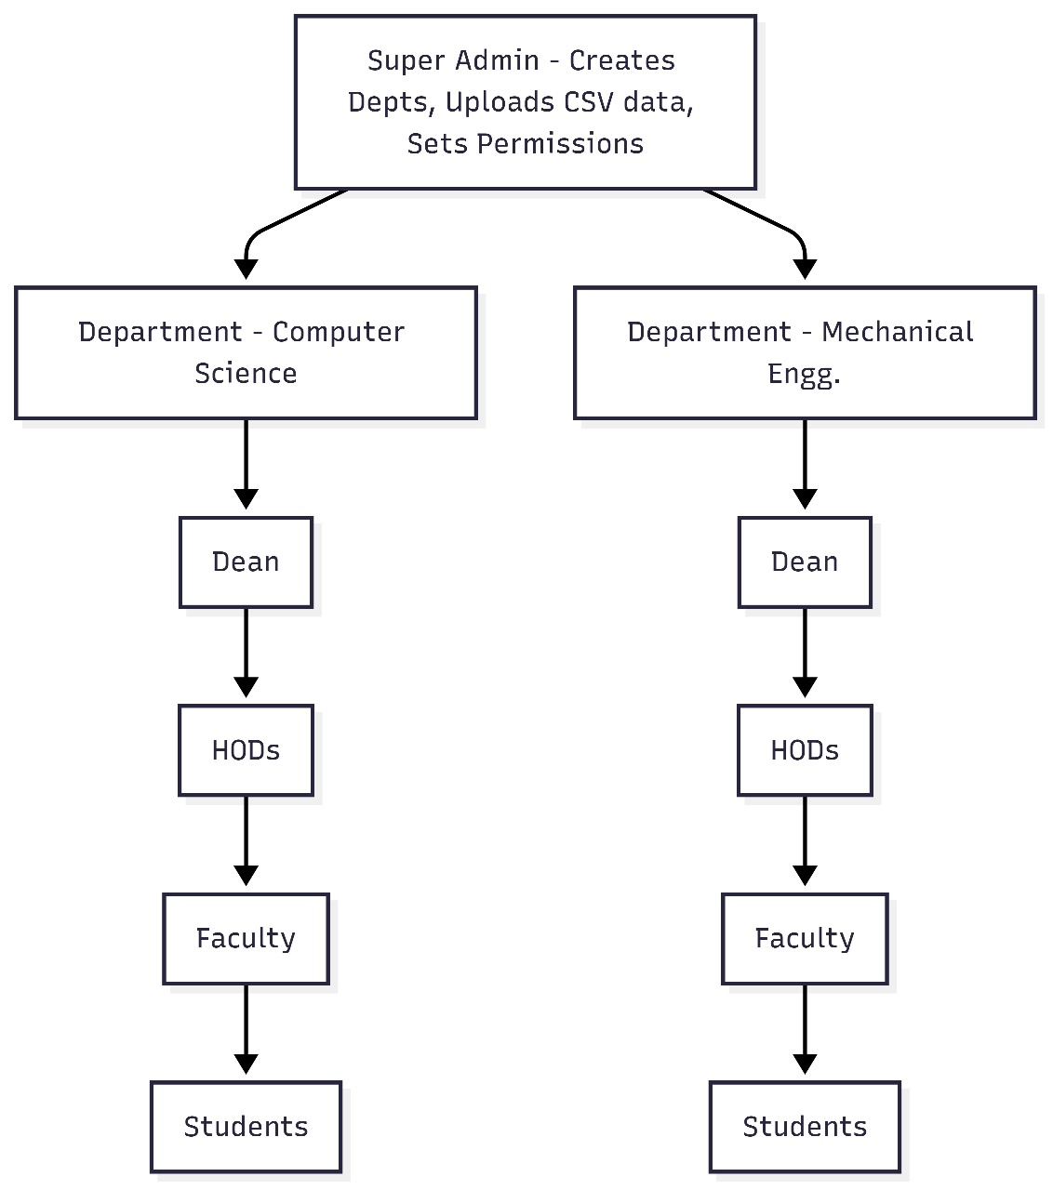

Core Functionality
Students: Enroll in assigned courses, attend lectures, view uploaded videos, access announcements, attempt quizzes, see progress reports, and participate in discussion forums.

Teachers: Upload videos, create quizzes, make announcements, and interact with students. Video and quiz uploads follow an approval workflow (CC → HOD → Dean).

Course Coordinators (CCs): Validate teacher uploads, distribute quizzes for peer approval, recommend content to HODs, and manage limited quiz updates.

HODs: Approve/reject course material, manage announcements for their department, approve quizzes into the question pool, delete messages in forums, and escalate content to Dean for permanent storage.

Deans: Create permanent courses, manage university-wide announcements, approve escalated videos/questions, and delete inappropriate forum messages.

SuperAdmin: Manage global permissions dynamically, assign sections, create courses, activate/deactivate users with remarks, and override any role.

Users and Characteristics
Users: Student, Teacher, Course Coordinator (CC), HOD, Dean, Administrator (SuperAdmin).

Student :

Can access only assigned sections and courses.

Participate in lectures (live or recorded), attempt quizzes, and see real-time evaluation results.

Can interact via discussion forums (with profanity filter).

Teacher :

Uploads videos (approved by CC → HOD).

Creates quizzes, distributed to other teachers for peer validation before reaching CC/HOD.

Limited (10 times/semester) question update requests.

Can announce only to assigned section, routed through CC/HOD.

Course Coordinator (CC) :

Validates teacher-uploaded content.

Distributes quiz questions to peer teachers for approval.

Recommends content/quizzes to HOD.

Can update quiz questions anytime with HOD approval.

Head of Department (HOD) :
Approves/rejects videos and quizzes.

Escalates recommended content to Dean for permanent storage.

Can issue announcements to department teachers, CCs, and their students.

Can delete messages directly from discussion forums.

Dean :

Creates and stores permanent courses and videos.

Can issue announcements university-wide (to all Deans, HODs, teachers, and students).

Can delete inappropriate forum messages.

Approves escalated content/questions for permanent storage.

Administrator (SuperAdmin)

Full control over user permissions via tick-box system.

Assigns sections, courses, and teachers to departments.

Creates new courses globally.

Activates/deactivates users with stored remarks.

Operating Environment
Software Interface

Client: Web Browser, Operating System (any)
Web Server: WAS, Operating System (any)
Data Base Server: DB2, Operating System (any)
Development End: WSAD, DB2, Rational Application Developer

Hardware Interface
CLIENT SIDE
 | PROCESSOR | RAM | DISK SPACE
INTERNET EXPLORER
6 AND ABOVE

SERVER SIDE
WEB SPHERE
APPLICATION SERVER
V5.0
DB2 V9.1 | GHz

Communication Interface
- Client on Internet will be using HTTP/HTTPS protocol.
- Client on Intranet will be using TCP/IP protocol.

Design and Implementation Constraints
- Frontend:
  - Next.js + Tailwind CSS for a responsive UI with SSR for performance and SEO.
- Backend:
  - Express.js for REST APIs and GraphQL for flexible data querying.
  - TypeScript for type safety.
- Database:
  - PostgreSQL for relational data storage, ACID compliance, optimized indexing for analytics, and large-scale queries (acting like MongoDB with auto-query handling).
- Containerization:
  - Docker to isolate services and simplify development & deployment.
- Orchestration & Scalability:
  - Kubernetes for auto-scaling, load balancing, and failover handling.
- Caching:
  - Redis for caching quiz results, session storage, and announcements.
- Authentication & RBAC:
  - Keycloak or custom Role-Based Access Control (RBAC) service for secure authentication and fine-grained permissions.
- Search & Analytics:
  - ElasticSearch (optional) for fast search within courses, students, and analytics.
- Monitoring & Alerts:
  - Prometheus + Grafana for monitoring system health and generating dashboards.
- Reverse Proxy & Load Balancing:
  - Nginx/HAProxy for traffic management and load balancing.

- Video lectures stored in cloud storage (e.g., AWS S3).

- All browsers must support HTML5 for embedded video/quiz content.

- Good internet connection is required for seamless streaming.

- Quiz update requests limited per semester (10 times per teacher).

- SuperAdmin can override all feature constraints.

User Documentation
- A README installation/setup guide.
- A User Manual detailing login, navigation, video/quiz uploads, announcements, and permissions.

- Admin Handbook explaining role management, user activation/deactivation, and feature permission tick-box system..

Assumptions and Dependencies
- Students are assigned to courses and sections by SuperAdmin or Dean.

- Videos uploaded by Teachers are valid for only one semester unless escalated by HOD → Dean.

- Quiz questions are stored in a permanent pool once approved by HOD.

- Permissions are dynamically configurable by SuperAdmin (no fixed role-based features).

- Financial transactions (if any, e.g., fees) are assumed to be handled outside this system.

- Stable cloud hosting is assumed for scalability.

Specific Requirements

External Interface Requirements

User Interfaces
Login UI :

Provides secure login for Students, Teachers, CCs, HODs, Deans, and SuperAdmin. Passwords are stored in encrypted format with role-based authentication.
Super Admin has additional privilege to activate/deactivate users and configure tick-box permissions.

Registration UI :

Allows new users (students, teachers, staff) to register into the system with image/OTP-based verification.
Super Admin must approve staff (Teacher, CC, HOD, Dean) registrations, while students are assigned automatically to their sections by Admin/Dean.

Announcement UI :

Teachers can post announcements for their assigned sections (approved by CC → HOD).

HODs can post announcements for their department (Teachers + CCs + Students under them).

Deans can post announcements university-wide (to all Deans, HODs, Teachers, and Students).

All announcement privileges are controlled dynamically by tick-box permissions from SuperAdmin.

Files UI :

Teachers can upload course materials (docs, PPTs, videos). Uploads are approved by CC → HOD.

CCs validate uploads, and HODs approve/reject content.

Deans can escalate approved files to permanent storage.

Students can download assigned course materials.

Exams UI / Quiz UI :

Teachers can create quizzes, distributed by CC to peer Teachers for approval, then forwarded to HOD.

Approved quizzes go into the course question pool.

Each Teacher can update a question up to 10 times per semester, while CCs can update anytime with HOD approval.

Exams UI has a timer, random question selection, and plagiarism protection.

Evaluation UI :

Faculty can publish evaluations after approval workflow.

Students can see evaluations and progress reports.

HODs/Deans can view aggregated results.

Discussion Forum UI :

Real-time chat and discussion board.

Teachers can request deletion of a message (with HOD approval).

HODs and Deans can directly delete inappropriate messages.

Super Admin can grant or revoke this privilege via tick-box.

Report UI :

Students: progress reports, attendance, quiz history.

Teachers: student performance analytics.

HODs/Deans: department/university-wide reports.

Admin: user activity logs, course reports.

Course UI :

Students: view assigned courses.

Teachers: manage assigned sections.

HOD/Dean: approve/create permanent courses.

Super Admin: full course management across university.

Hardware Interfaces
Client Devices:
Computer, laptop, or mobile device with:

Processor: Minimum Dual-Core (i3 recommended)

RAM: 2 GB minimum (4 GB recommended)

Disk: 1 GB free

Headset (mic + headphones), webcam (optional)

Stable internet (2 Mbps+)

Server Requirements:

Application Server: Quad-Core CPU, 8 GB RAM, 20 GB storage.

Database Server: Quad-Core CPU, 16 GB RAM, scalable disk (cloud-ready).

Software Interfaces
Database: PostgreSQL (preferred, relational with JSON support for permissions).

Application Server: Node.js / Java Spring Boot.

Frontend: React.js, Tailwind CSS.

Storage: Cloud storage (e.g., AWS S3) for video lectures.

Integration Interfaces:

JavaScript/REST APIs for client-server communication.

Encryption (JWT/OAuth2) for secure authentication.

Tick-box permissions stored as binary/array in DB for dynamic feature control.

Multimedia: HTML5-based streaming (no Flash dependency).

Communications Interfaces
Internet Clients: HTTPS (TLS 1.3) for secure external access.

Intranet Clients (Campus): TCP/IP protocol.

Server Communication: REST APIs over HTTPS.

Database Communication: Secured via role-based access and SSL.

Functional Requirements
- Students can enroll in assigned courses, view lectures (live/recorded), take quizzes, view attendance, and see progress reports.

- Teachers can upload materials, create quizzes, post section announcements (with CC/HOD approval).

- CC validates teacher uploads and quiz approvals before forwarding to HOD.

- HOD approves videos/quizzes, manages announcements for department, deletes forum messages.

- Dean manages permanent courses, approves escalated content, deletes forum messages, and makes global announcements.

- SuperAdmin dynamically controls all permissions via tick-box system, creates courses, assigns sections, and manages users.

- Discussion forums support chat and asynchronous communication.

- Reports are generated at student, teacher, HOD, Dean, and Admin levels.

- User deactivation can only be done by SuperAdmin, with remarks stored for audit.

- All workflows follow multi-level approval chains (Teacher → CC → HOD → Dean).

Non-functional Requirements
Reliability:
Video/audio quality must be clear and synchronized.
Approval workflows ensure only validated content is published.

Responsiveness:
Average system response time < 3 seconds for user actions.
Real-time chat and announcement delivery.

Availability:
System should be available 24x7 with 99.9% uptime.
Backup & recovery system ensures no data loss.

Scalability:
Supports thousands of concurrent users (students, teachers, admins).
Cloud deployment for elastic scaling.

Security:
HTTPS with TLS 1.3 encryption.
Passwords stored in salted hash format.
Fine-grained dynamic permissions via tick-box arrays.

Role-based access enforced at database and application layers.
Only Super Admin can deactivate users.

SYSTEM DESIGN
Design is the meaningful engineering representation of a software product to be built. Software design translates requirements into an architecture, data structures, interfaces and components necessary to implement the system. This chapter documents the design of the Virtual Classroom / Online Course Learning Platform (OCLP). It includes Data Flow Diagrams (DFDs), Use-case descriptions, and Sequence diagrams for the major scenarios.

There are two kinds of high-level diagrams included here:

Data Flow Diagrams (DFDs) — show how data moves through the system

UML Diagrams — Use Cases and Sequence Diagrams — show behaviour and interaction ordering. There are 2 types of diagrams to represent the implementation of system.

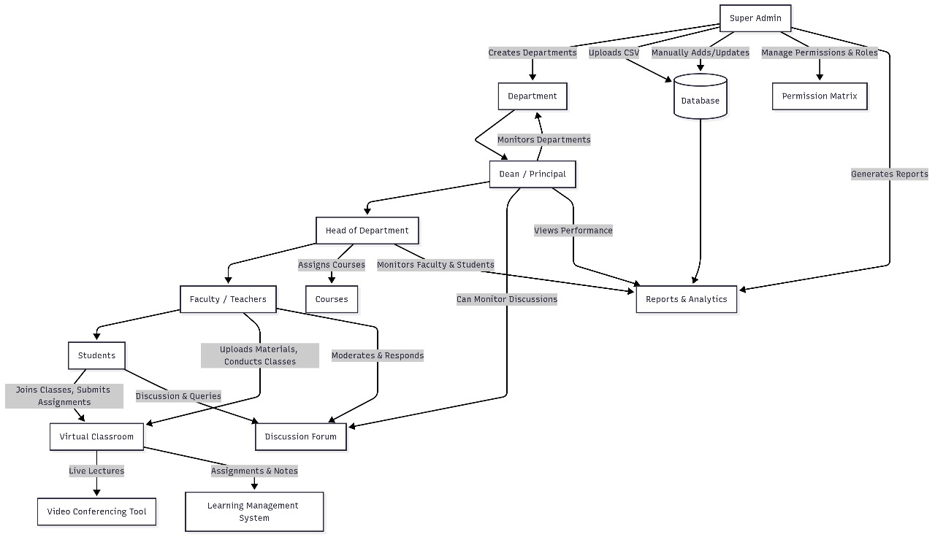

Data Flow Diagram
DFDs model the proposed system logically. They are used as the basis for structural design and for deriving components, interfaces, and data stores.

Level 0 DFD

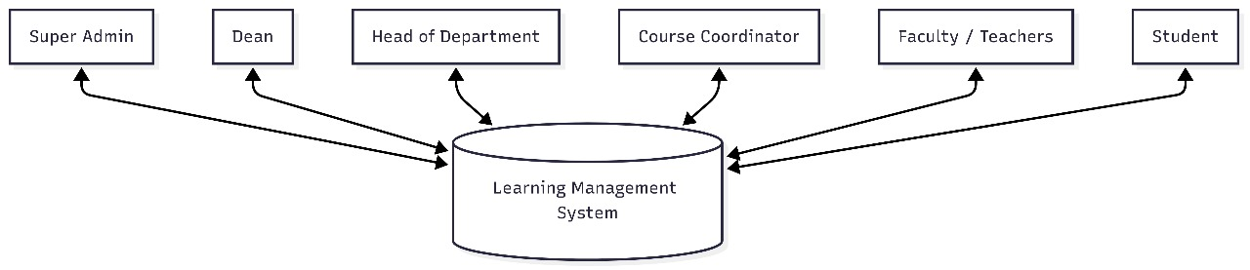

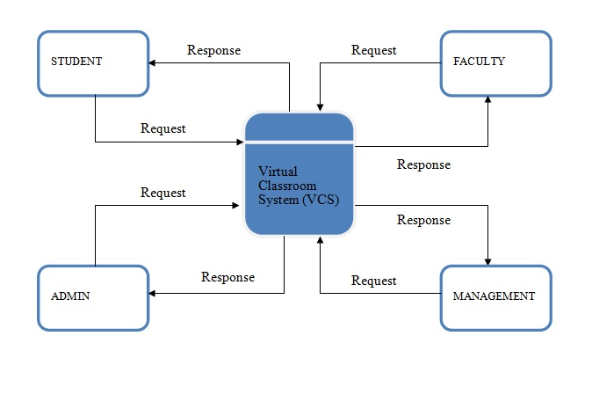
Level 1 DFD

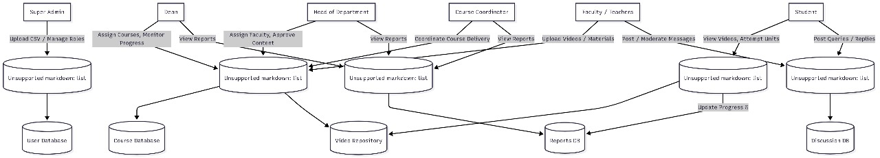

Level 2 DFD

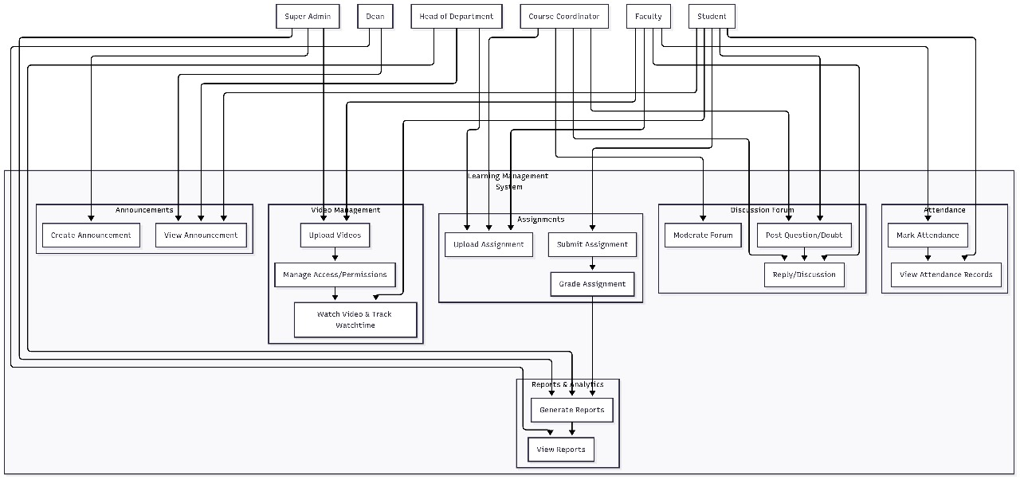

UML Diagram

Use case Diagram
A use case diagram is a type of behavioural diagram created from a Use-case analysis. The purpose of use case is to present overview of the functionality provided by the system in terms of actors, their goals and any dependencies between those use cases.

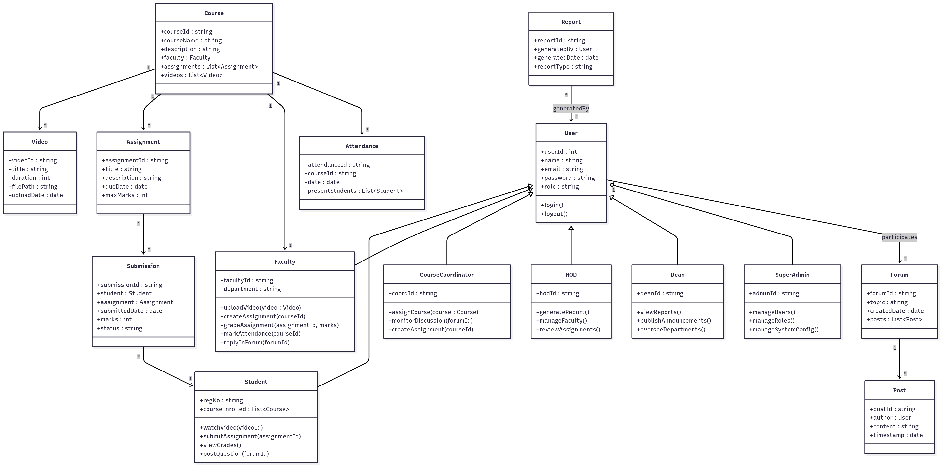

Uploading Rules:

Super Admin

Uploads videos permanently.

Visible to all students enrolled in that course.

Stored until manually removed by Super Admin or Dean.

Faculty

Uploads video → forwards to CC → HOD.

If HOD approves only → visible to selected sections; removed automatically at semester end.

If Dean approves (forwarded by HOD) → visible to all sections under that course; stored permanently (removable only by Dean or Super Admin).

Removal Rules:

Super Admin / Dean

Can remove any video (Super Admin’s own uploads or faculty uploads that became permanent).

Faculty

Can request removal of only videos uploaded by them.

Request goes through CC → HOD for approval.

If approved → system removes video.

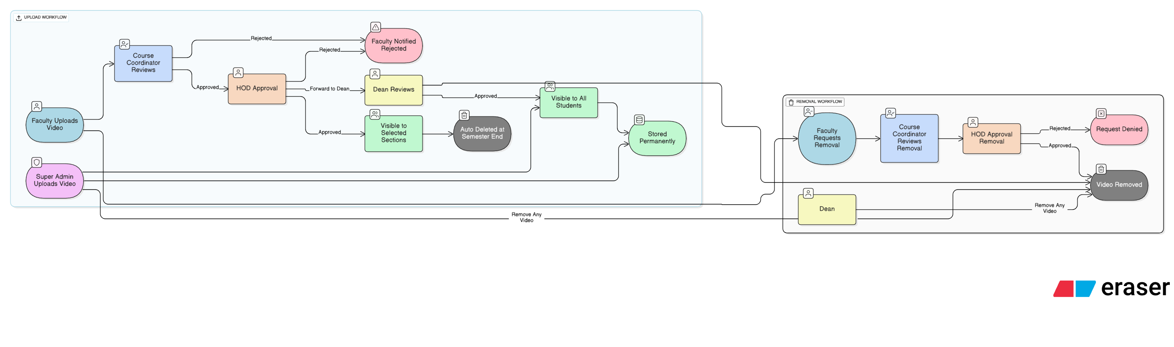

Updated Clarification of Announcements Feature :

Super Admin

Can post permanent or institute-wide announcements.

Can grant special rights (via checkbox) to any faculty/CC/HOD/Dean to post institute-wide announcements.

Can remove any announcement.

Dean

Default: Can post institute-wide announcements.

Auto-expiry will apply unless set as permanent (special case).

Can remove any announcement.

HOD

Posts subject-specific announcements (visible only to students of their department/subject).

Must approve announcements from CC and Faculty before they become visible.

Can remove announcements within their department.

Course Coordinator (CC)

Can draft course-level announcements.

Must get approval from HOD before they go live.

Announcements have auto-expiry after a set duration.

Faculty

Can draft section/course-level announcements.

Must get approval from HOD before publishing.

Can be granted special institute-wide posting rights by Super Admin.

Announcements also have auto-expiry.

Students

Can only view announcements relevant to their enrolled courses/sections.

Expired announcements disappear automatically.

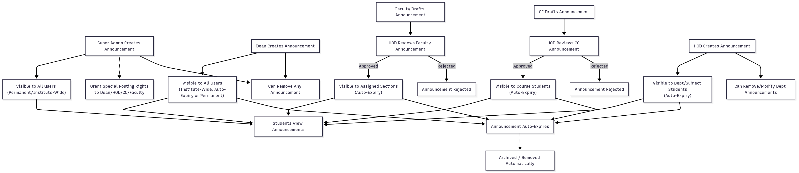

Student-wise Report Access Levels

Faculty

Can generate reports only for students in their own sections.

Example: Faculty teaching “CS101” Section A → sees progress for students of Section A only.

Class Coordinator (CC)

Can generate reports for all sections of a particular course.

Example: CC for “CS101” → sees student-wise report across Section A, B, C.

Head of Department (HOD)

Can generate reports for all courses & sections under the department.

Example: HOD of CSE → sees student-wise report for CS101, CS201, etc. across all sections.

Dean

Has visibility across the entire school/faculty (multiple departments).

Example: Dean of Engineering → can view student-wise reports for any student in CSE, ECE, IT, etc.

Super Admin

Global visibility: all schools, all departments, all students.

Student

Can only view own report (progress %, assignments, grades, modules).

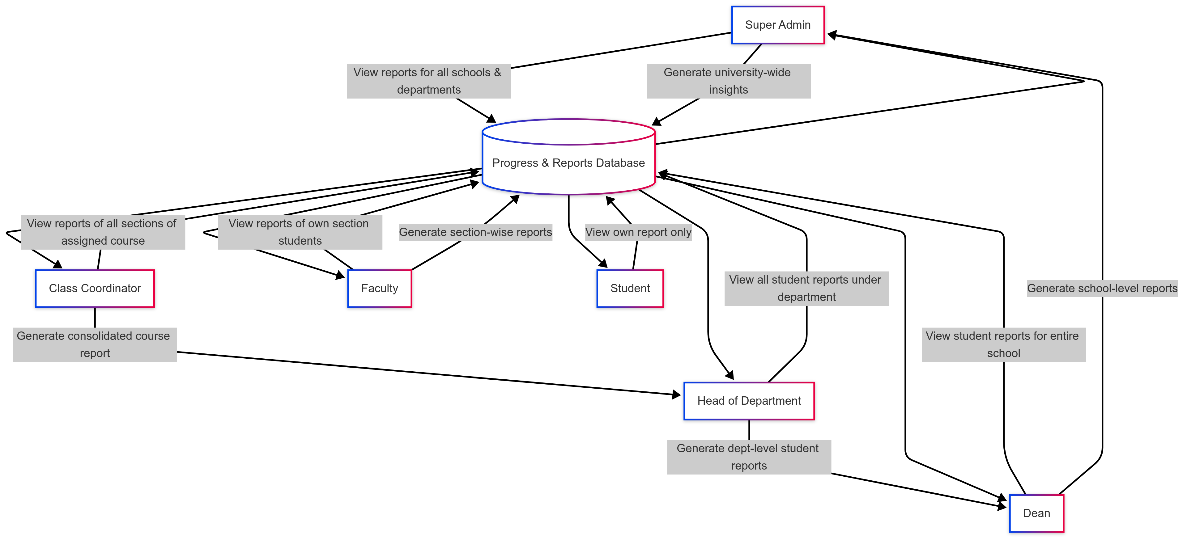

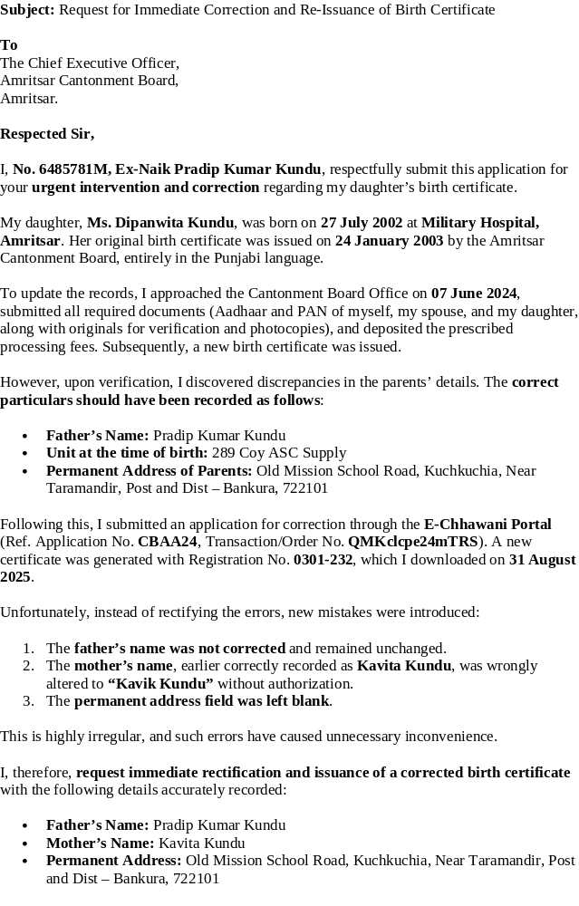

Discussion Forum Module – Description

The Discussion Forum provides a structured communication platform for academic interactions within a university. It is section-wise and course-wise specific, and roles have clearly defined access, moderation, and participation rules.

1. Forum Creation

Forums are automatically created when the Super Admin or Dean uploads a CSV file containing students, faculty, and HODs with their assigned courses and sections.

Each forum is unique to a section-course combination.

2. Participation

Students: Can post queries, participate in discussions, and reply within their assigned course-section forums.

Faculty: Can interact with their assigned section students, clarify doubts, and moderate discussions (with HOD/CC approval).

Course Coordinator (CC): Oversees discussions for their course across sections, engages in forums, and moderates requests.

HOD: Can view, participate, and intervene in all forums under their subject.

Dean: Has full visibility across all forums under the school/university.

3. Moderation Rules

Faculty may request deletion of posts, but only for their own sections.

Such requests go to the Course Coordinator, who forwards them to the HOD for approval.

HOD and Dean have direct authority to delete posts without intermediate approval.

4. Content Filtering

An automated filter detects and flags inappropriate/bad language.

Filtered content is hidden immediately and flagged for review by the HOD and Dean.

5. Access Control

Super Admin can mark any user (student, faculty, CC, or even HOD) as read-only, disabling their ability to post messages.

Such users can still view forum content but cannot contribute text.

6. Visibility Scope

A forum is only visible to members of the specific section and course.

Faculty, CC, HOD, and Dean roles see all relevant forums as per their assignments.

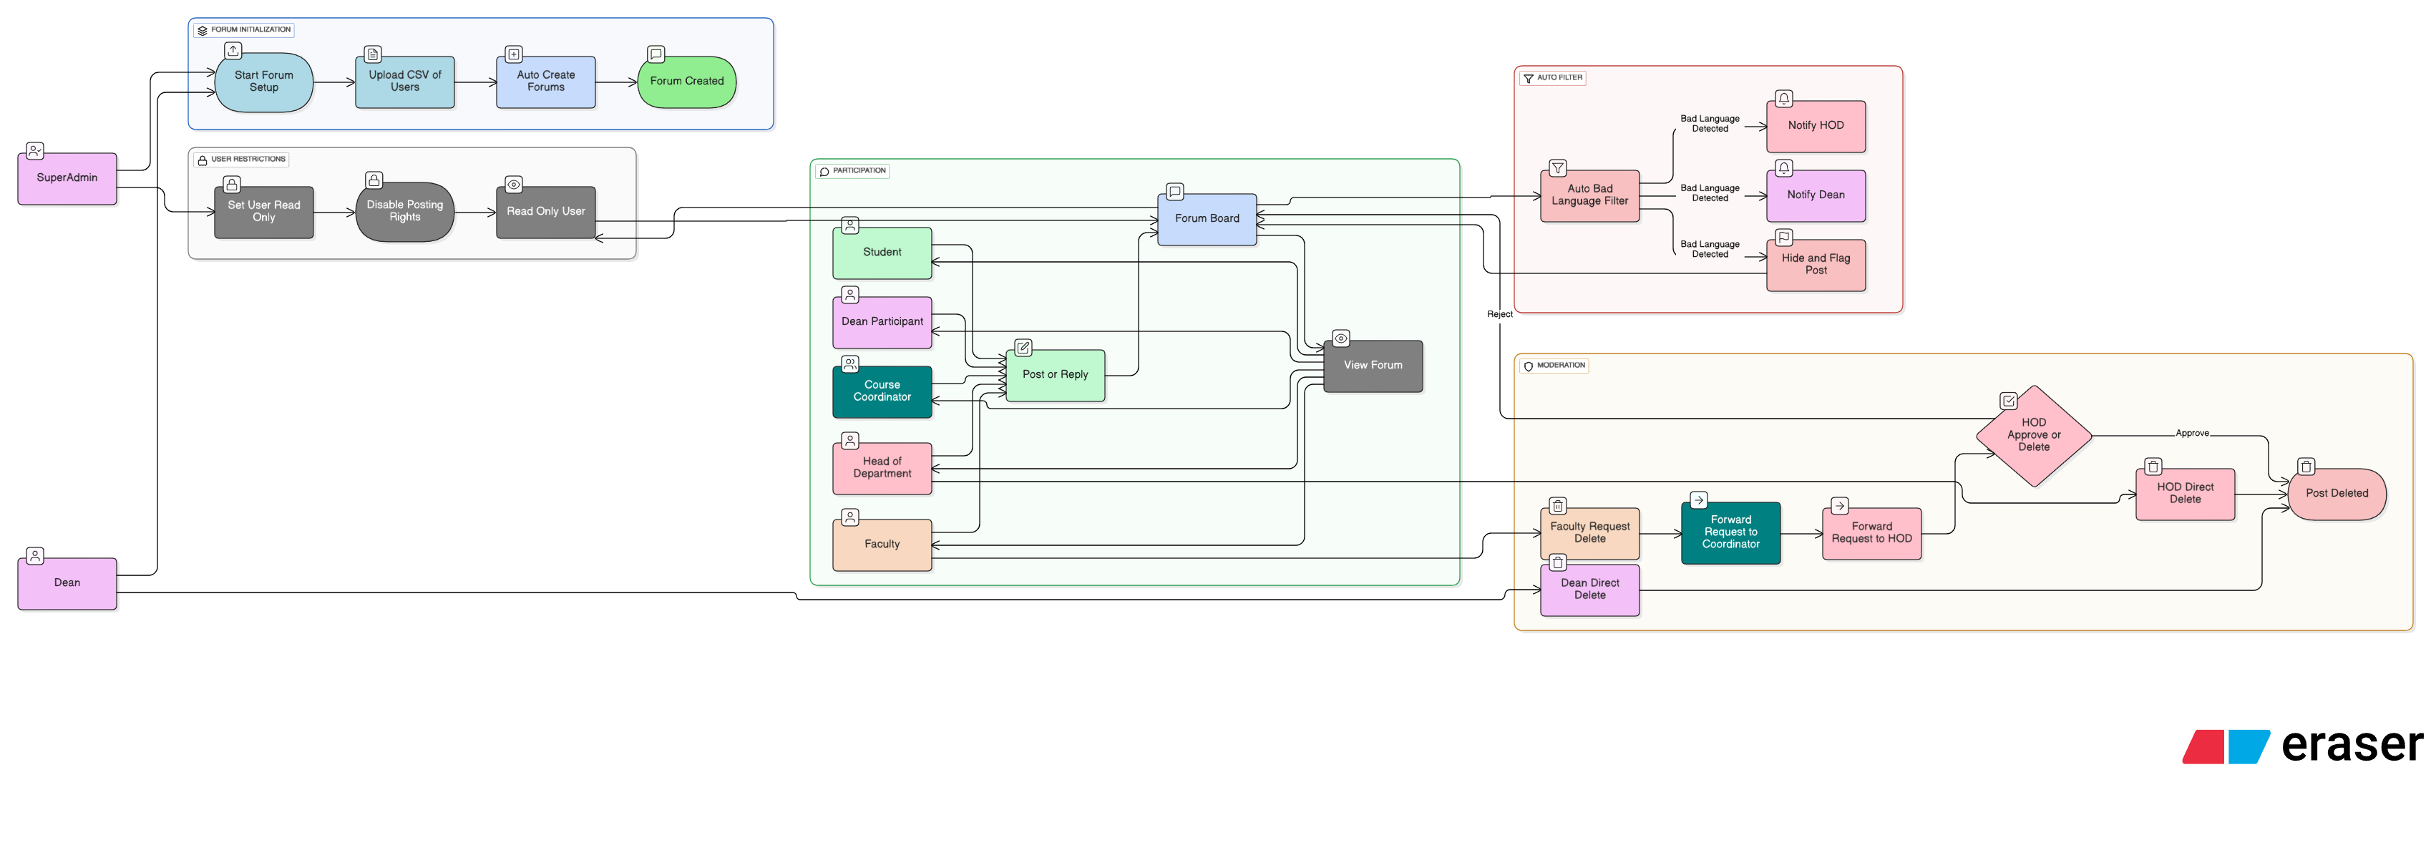

SCOPE OF EXTENSION
- The Virtual Classroom System can be extended to be used by WAP enabled devices. This service can be extended to be accessible through GPRS so that the registered users can share and access information "on the move".

- The Virtual Classroom System can be extended to include various extra-curricular activities that will simulate in the overall development of a child.

📘 Course Management – Feature Description

📘 Course Management – Feature Description

Overview
Course Management is the backbone of the system, defining how Subjects → Courses → Roles (HOD, CC, Faculty, Students) are structured and linked. The workflow begins with Super Admin, who creates subjects, assigns HODs, and maps courses to coordinators and faculty.

Role-wise Responsibilities

Super Admin

Create subjects at the school/university level.

Create courses under each subject.

Assign HODs for each subject.

Upload CSVs (students, faculty, sections) → auto-generate structure and forums.

Dean

Monitor subject/course coverage across all HODs under their school.

Can intervene in structure if required.

HOD (Head of Department)

Approve/review course content flow and assignments.

Assign CCs (Course Coordinators) to specific courses.

Ensure coverage of syllabus across all courses under the subject.

Course Coordinator (CC)

Manage the structure of assigned courses.

Assign faculty to modules within a course.

Ensure faculty uploads (videos, assignments) align with approved flow.

Faculty

Upload and manage teaching materials, videos, assignments for their assigned modules.

Follow sequence-based video unlocking (to prevent skipping).

Students

Access only their assigned courses (mapped via CSV upload).

Auto-unlock flow (complete one video to unlock the next).
Cannot drag/skip progress bar.
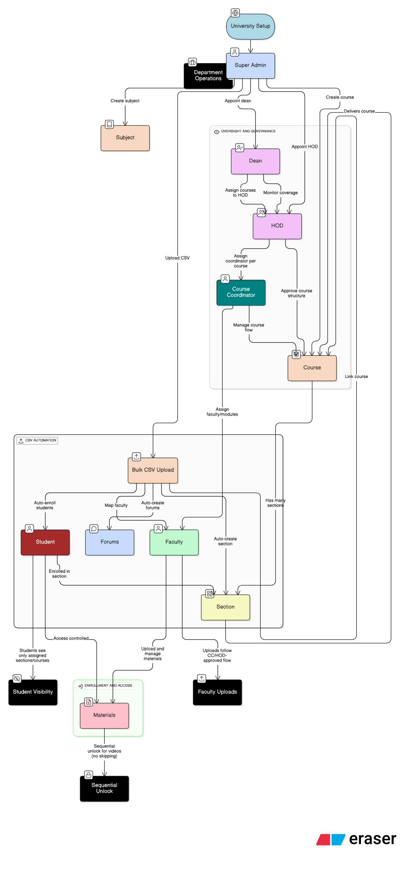
📘 Assessment & Quizzes – Role-wise Functionality

Super Admin:

System-level monitoring of assessment usage across all schools.

Upload CSV (faculty/student mappings) → assessments auto-linked to courses/sections.

Dean:

Track and compare assessment performance across departments.

Generate consolidated reports.

HOD:

Monitor performance in subjects under their department.

Approve assessment frameworks/rubrics defined by CC.

Course Coordinator (CC):

Design course-level assessments (quizzes, assignments, projects).

Define grading rubrics & evaluation policies.

Assign to faculties for execution.

Faculty:

Create quizzes & assignments for their modules.

Grade/evaluate submissions.

Provide feedback to students.

Student:

Attempt assigned quizzes/assignments.

View grades & feedback.

Track completion status in progress tracking module.
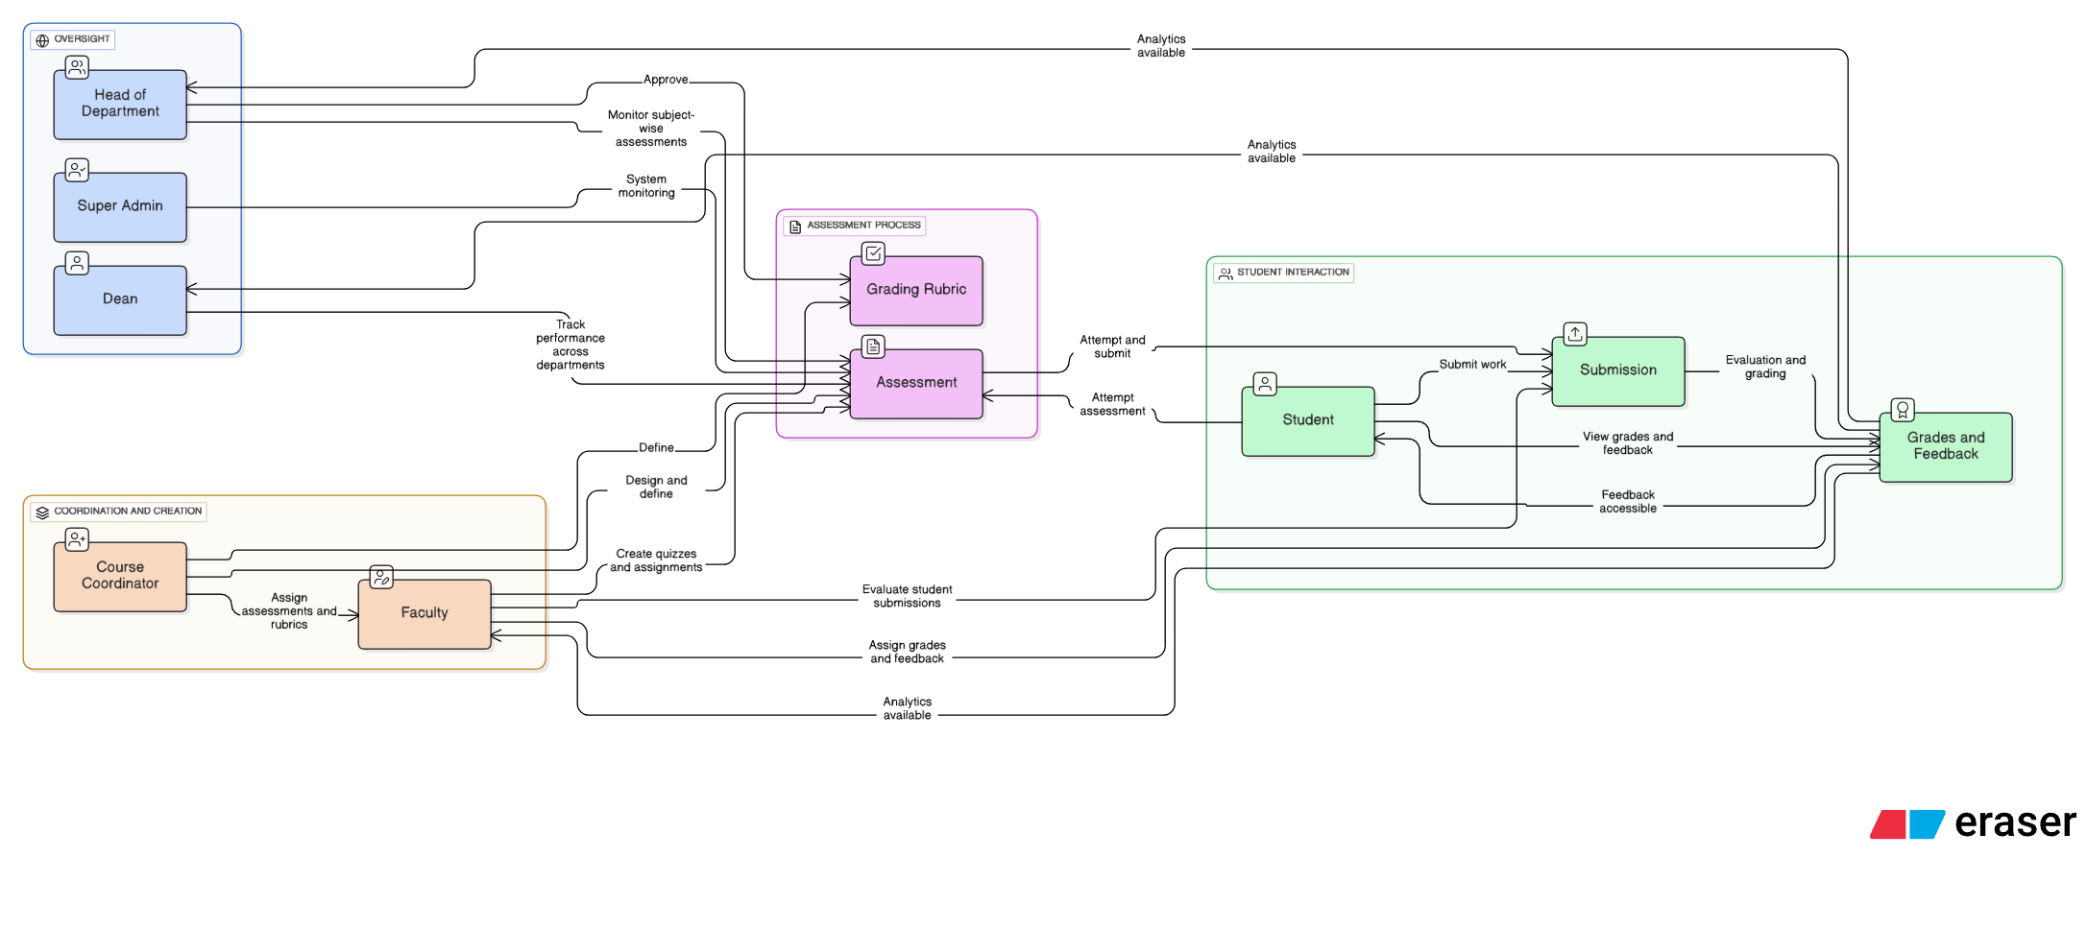
📌 Reports & Analytics Workflow

Dean

Gets institution-level insights: completion % across all departments.

Can compare HOD-wise performance.

HOD

Gets subject-level analytics: engagement of students & faculty.

Can detect low-performing subjects.

Course Coordinator (CC)

Gets course-level analytics: completion rates, quiz performance, activity.

Can refine course structure.

Faculty

Gets class-level reports: student-wise completion %, weak students list, pending tasks.

Helps in intervention.

Students

Get personal dashboards: completed modules, pending videos, grades, feedback.

Helps them self-track progress.

📌 Data Flow:

Student activity (videos, quizzes, assignments) generates raw data →

Faculty sees class reports →

CC aggregates for course-level →

HOD aggregates for subject-level →

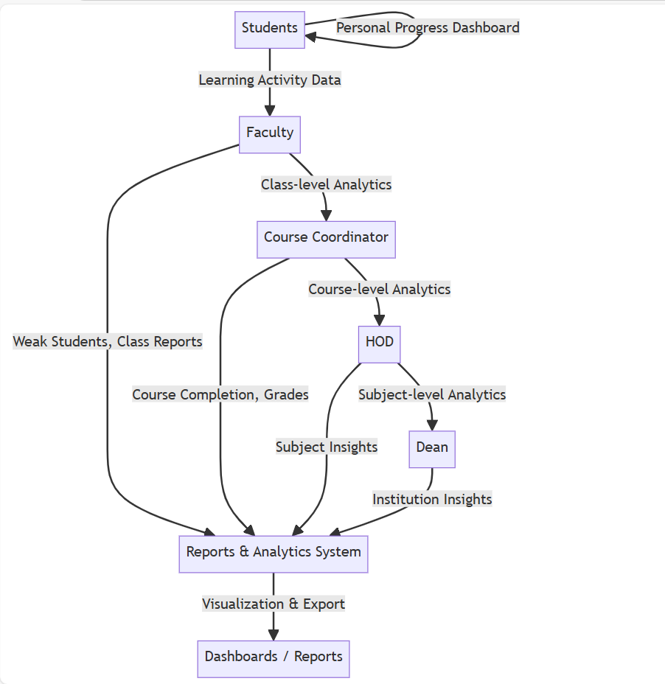
Dean sees institute-wide analytics.

📌 Content Moderation Workflow

Student

Can report inappropriate content (in announcements, videos, or forums).

Faculty is the first line of moderation.

Faculty

Reviews student reports.

Can remove/flag inappropriate student posts.

Escalates flagged content to Course Coordinator (CC) / HOD.

Course Coordinator (CC)

Moderates course-level content.

Reviews escalated content from faculty.

Can remove or escalate further to HOD.

HOD

Oversees subject-level moderation.

Can disable/remove flagged content across courses in their subject.

Escalates severe cases to Dean.

Dean

Has institute-wide authority.

Can remove or disable any inappropriate content across all departments.

Final decision-maker in disputes.
