Binary Bomb(Group 2) Phase 01- “Acquiring the string”

Phase 1 is about giving a string to Dr. Evil. If the given string matches the string of Dr Evil then the phase 1 of the bomb will bediffused. But i don’t know what is the string that is set by Dr Evil, Its my work to find the correct string so that the bomb will be diffused. Since I am working on bomb 002 of group 2, each string varies from bomb to bomb. The string which I got from phase_1 bomb 003 is “Public speaking is very easy” After putting this string the phase_1 of bomb 002 will be diffused.
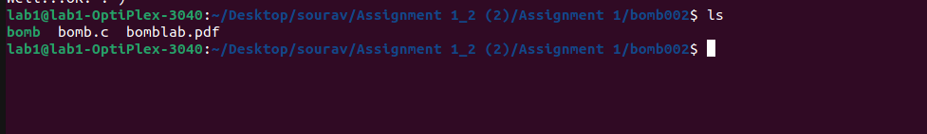

After opening the terminal and wrote the “objdump -d bomb > bomb.s” command. This command will disassemble all of the code and major functionof the objdump -d is it reads the assembler code and displays information about one or more object files.

As we can see that a new file is added which has the extension “.s” which means it is the assembly file, which means all the source code inside the bomb.s will be in assembly form. The next command I used is the “gdb” command which is the debugger for C. The gdb command will help to run a program up to certain point then stop and print out the values of certain variables at that point. After that we have to set the break point at phase 1 in-order to stop at phase_1 for debugging purpose. After setting the break-point we can run the program using “run” command.

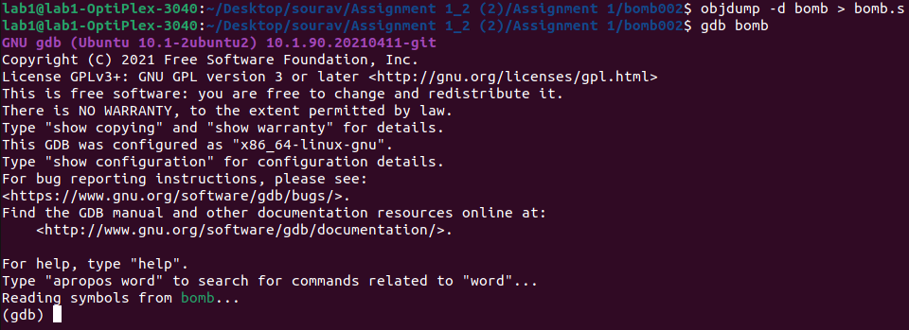

as you can see that I have to input some string. I gave a test string (which can be any string of your choice). The bomb will not blast since we have already set the break-point. After giving the random string we can command the “disas” command to go inside the assembly code of the phase_1.

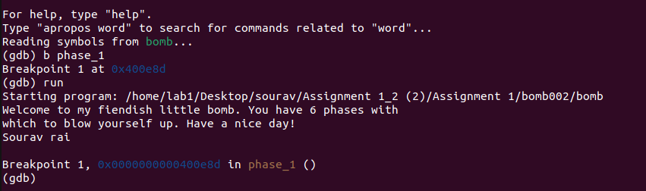

“disas” command to open the assembly file.

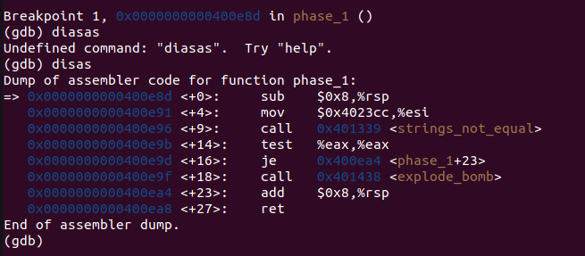

Now use the “disas” command to open the assembly file. After opening the dissembler we can see at line number that the input is string since From the above code in line number <+9> we have a callq function which calls <strings_not_equal> that means we know the input is a string and not a integer. In line <+14> the assembler is testing eax register with eax register.The source eax contains the user input string (the string which we type) and the destination eax contains the real string that Dr. Evil has set. So this function compares the strings and if the strings are equal, it jumps into line <+16> which says je(jump if equal to) so if the both strings matches than it will jump to line <phase_1+23> . Else it will jump to callq and the bomb willbe exploded.

After this we can check that the input we gave is stored in th $eax register.For that we have to command “p/x $eax” to get the address of eax register. The address was found as “0x6037a0” After that we have to command “x/ 25c 0x6037a0”. This will give the test string we gave ealier. So from this we know that the string we give is stored inside the eax register.
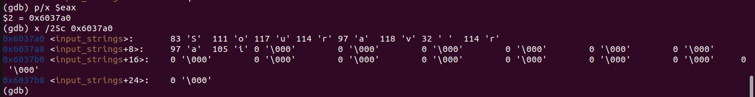

To get the final string which Dr. Evil has set we have to give the fixed address of the eax register which we will get from the disas of phase_1 at linenumber <+4> since the value of esi is been moved to 0x4023b0. Copy this address and put it inside the “x / 40c 0x4023b0” We will getting the string which was set by Dr.Evil. Here we did 40c to get the 40 characters of the string.

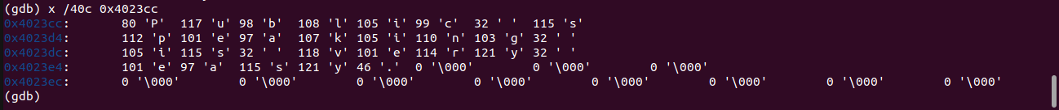

In-order to check if this string is correct or not we have do “strings bomb” toget all the strings of the bomb.

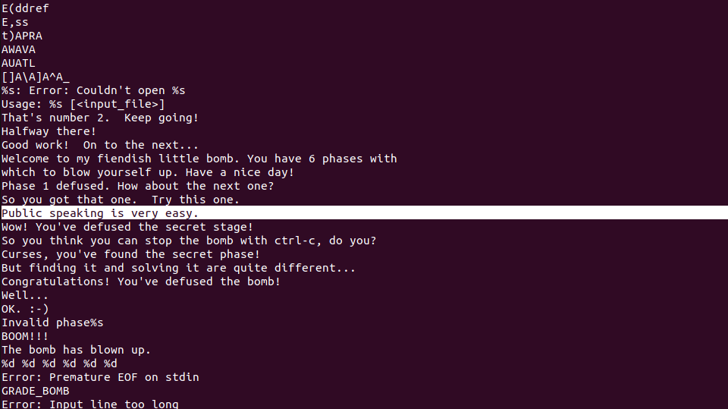

Finally we got the string now run the bomb file by commanding “./bomb” and write the string “Public speaking is very easy.” And the bomb at phase_1 will be diffused.

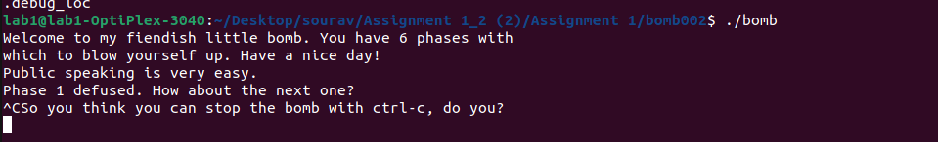

phase 1 over!!

Binary Bomb(Group 2)
Phase 02 “Cracking The Code”
The first phase was finding the correct string and matching it with the Dr.Evil’s string. If the correct string was given than the bomb at phase 1 will be diffused and if not it will blast. Well the second phase is about giving a set of six inputs. The inputs were found to be “1 2 4 8 16 32”. After putting these six digit number in the phase_2 of bomb 002 will be diffused.

First of all it will be easier and less time consuming if we save the acquired string of phase_1 inside a txt file so that we don’t have to write the string again and again. I saved it as a answers.txt file.

After diffusing the first phase we have to again go to the gdb debugger and this time we have to set the break-point at phase_2 because now we have to stop at phase_2. After setting the break-point we can run using “r text.txt” since the string of phase_1 is saved inside the answers.txt file so we don’t have to type in again and again. After running the program, it will ask input for second phase. Since we don’t know the input, we have to give some random inputs.

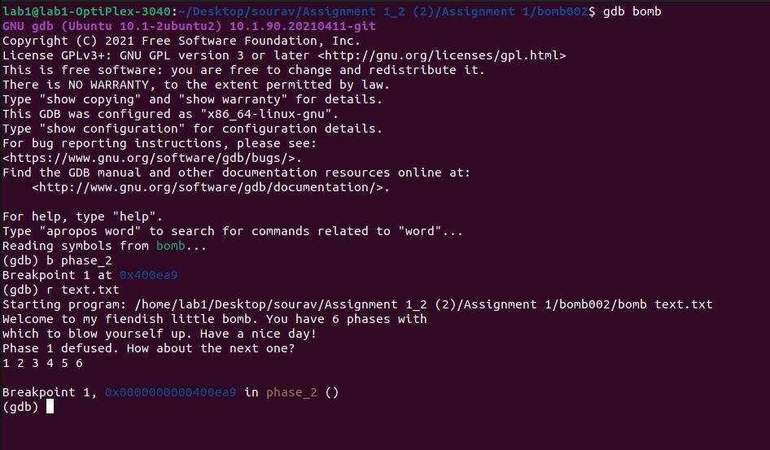

Go to the dissassamble to know the actual assembler code.

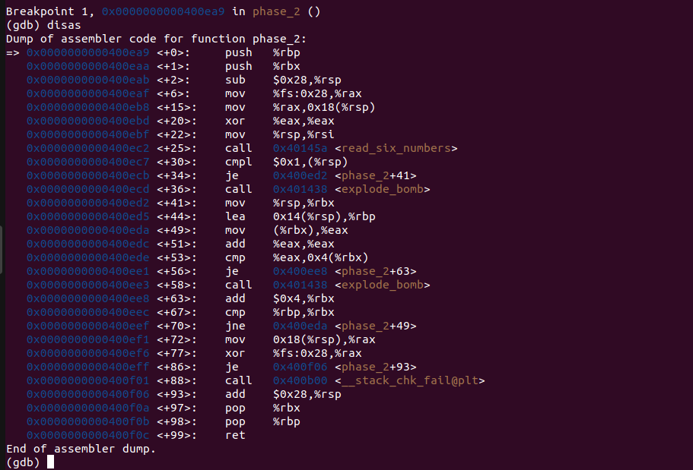
In the above image we got a small clue in line <+25> which has a callq function that says We got the hint that the input for phase_2 there is 6 integers. Below the callq function there is cmpl function which compares 0x1 and first integer(%rsp). So lets directly jump into line <+30> and compre the two integers. For directly jumping into the particular line we have to use (until *address present in that line) and disas. In this case we will use (until *0x0000000000400ec7), so as we can see we are in line <+30> so lets compare the two integers. in order to find the values of the register in rsp we can do “i r” command which is information register and displays the information/ values of every register.

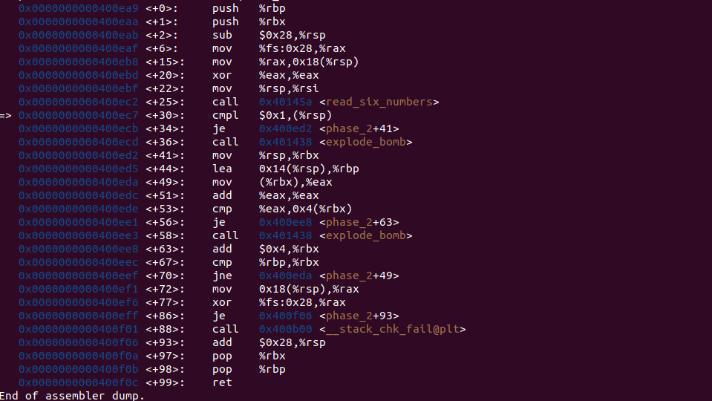

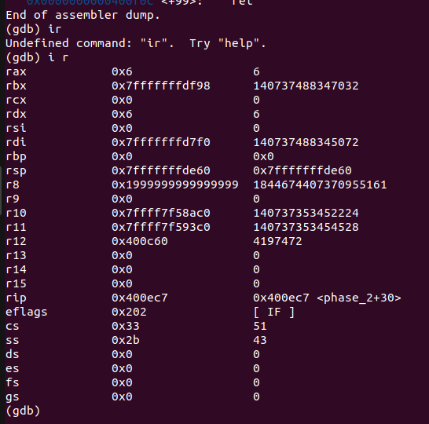

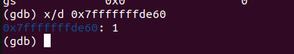
We found the value of rsp register but the value is in hexa form so we have to convert it into decimal form. In-order to convert the number into decimal we have to command “(x/d(number))”.

As we can see that the value we got after converting is “1”. So we have to compare (1 and 1). Since 1 and 1 are equal so we move to next function <+34> which is je function (jump if equal) after going to the next function it will jump to <+41> and the bomb will not be exploded. So from here we know that the first input should be equal to 1, otherwise the function will move towards something that will explode the bomb.

As you can see below that I have put 1 in the first place and I don’t know the other values. So the first input is 1.

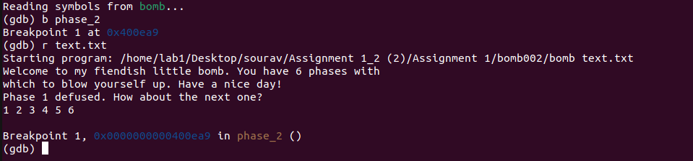

Now again we will go inside the disassemble and look for next value. Next up we will go to second compare function which compares (1 and %rsp). For that we have to find the value of rsp.

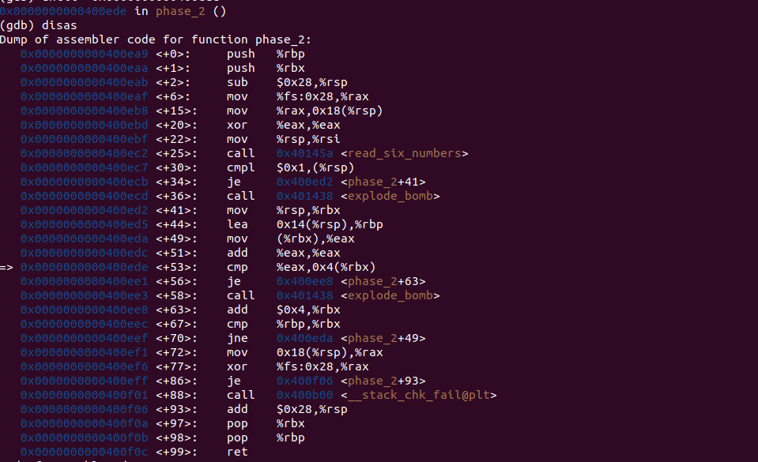

Now we found out the value of eax to be 2 and rbx to be 2, now we should know that they both are equall and when they both are equall it will move to the line <+56> which has je function thus not exploding the bomb. We can test for correction.

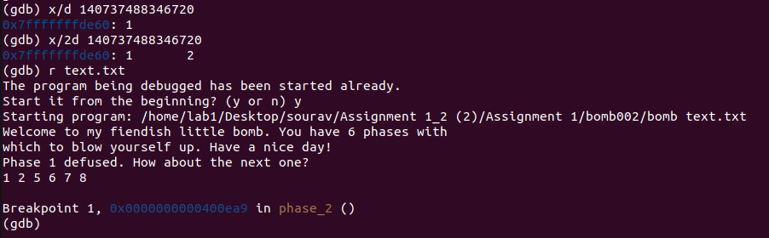

Since we got the two values out of six missing numbers. Now we will navigate back to disas, and find the next cmp statement. Which is on line <+49>.

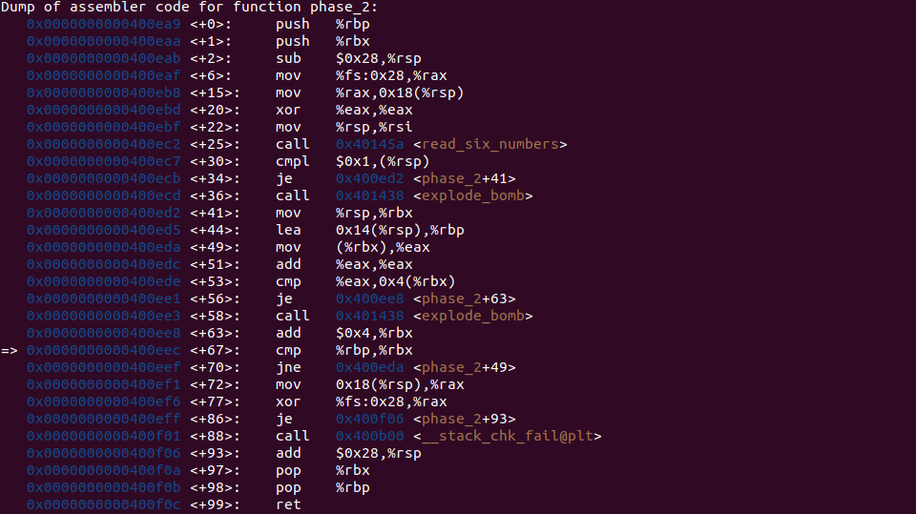

We can see that rpb and rbx is being compared . We can find that rbp and rbx has a value of 8 and 2 respectively, which are not equal and the next line will be executed. The next line <+76> will navigate us back to line number <+49>. we will come back to line number <+53> which is a compare statement comparing eax and rbx.

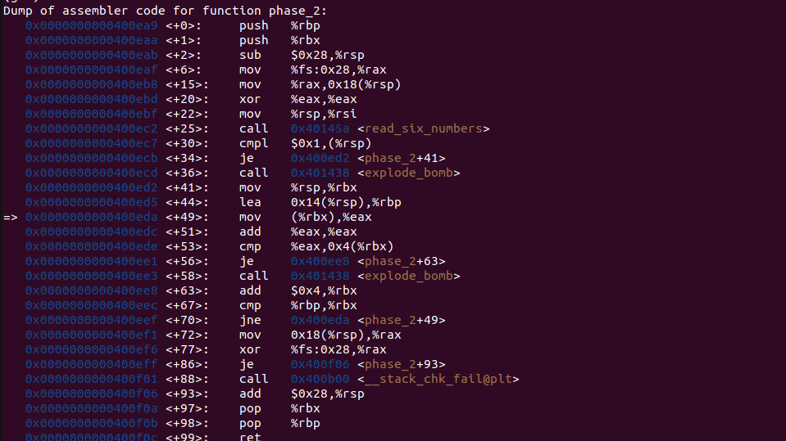

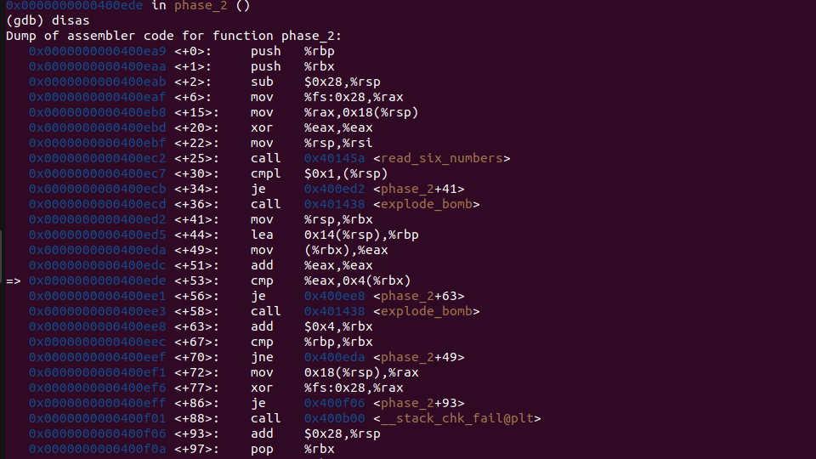

Now we can see that the vaule of eax and rbx has changed, we can see that the eax has the value 4 and eax has vaule 2 which are not equal. But we should know that they should be equal and execute the je command otherwise the bomb will explode. From here we get a hint that the next value should be 4 otherwise the bomb will explode.

We should put 4 as a new input and test the input.

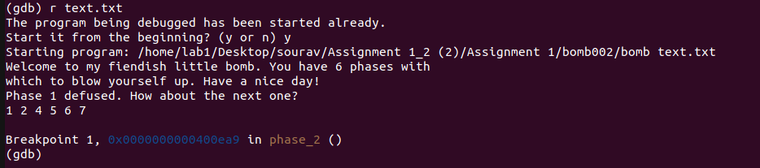

From this we also get a hint that what will be the other preceeding numbers. It can be (2^0,2^1,2^2,2^3,2^4,2^5), let’s test it out.

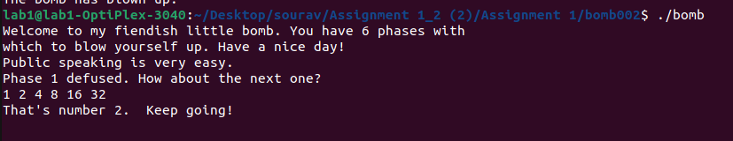
YES !!!!! , we guessed it right the numbers were 1,2,4,8,16 and 32 which defuse the phase 02 of the group 2 bomb.

Phase 2 Over!!!

