Phase 3

In phase 3 we have to enter 2 integer in order to proceed to next phase. How we know it should be 2 integer is because of this comment vi bomb.s where we can see the assembly code.
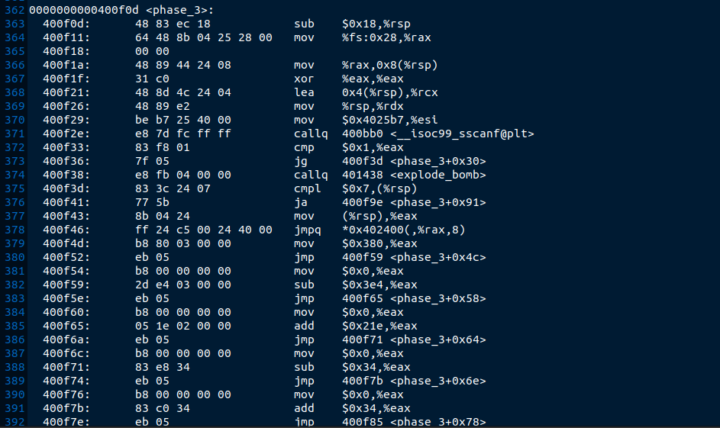
Step 1:
First we have to enter gdb bomb command in order to enter the assembly code and we have to set break point for phase 3 so that bomb donot defuse when we enter the value for phase 3 . so I have enter 4 and 3 as a input for phase 3.
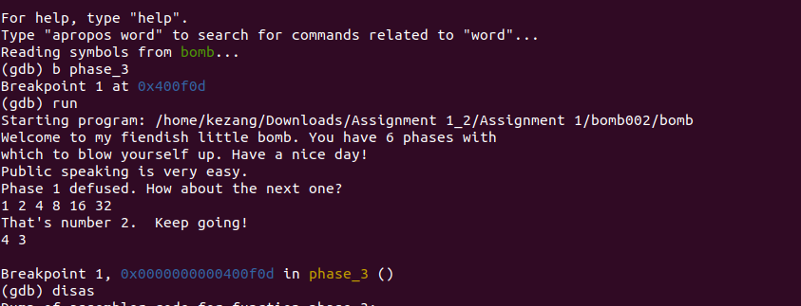

Step 2:

After completion of above step I have used disas command to enter into phase 3 assembly code and I have shifted the execution of code using u* address of place where we want to shift and run the program.
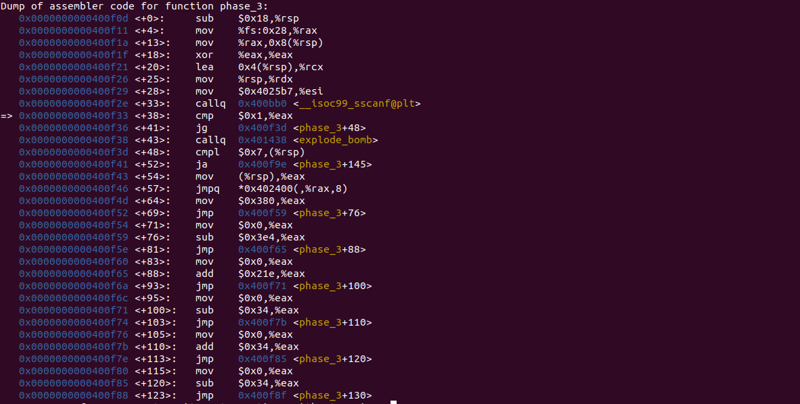
Step 3:

I have used ni and disas command to execute the program line by line till it reach to compare the rsp and eax where we compare rsp and eax to jump to phase_3+172 line.

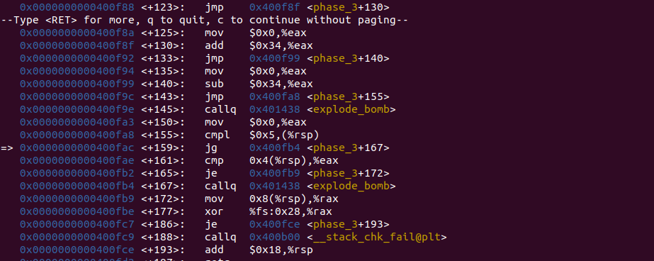

Step 4:

After finding the value for rsp we get 4 and for eax we get 0 so it will not jump to phase_3+172 line instead will cause the bomb to explode so we get hint that key for phase 3 will be 4 and 0.

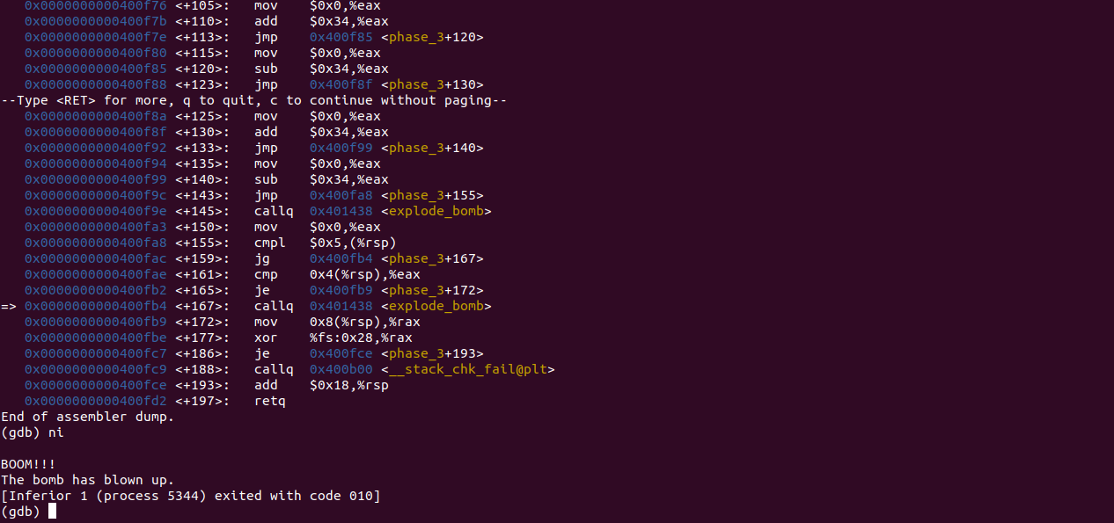
Step 5:

From above step we are able to get hint of answer that could be our key for the phase 3 because we have got 4 and 0 so we can guess that it will be addition of same number till 2 integer. So we get the key for the phase 3 is 4 0 so when we put key for phase 3 we are able to defuse the bomb.
