Pedestal Test Room - Project Report
This document contains the system design and architecture diagrams for the Pedestal Test Room project.

1. Use Case Diagram
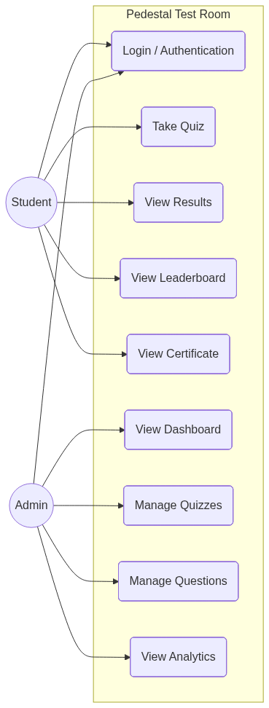

2. System Design Architecture
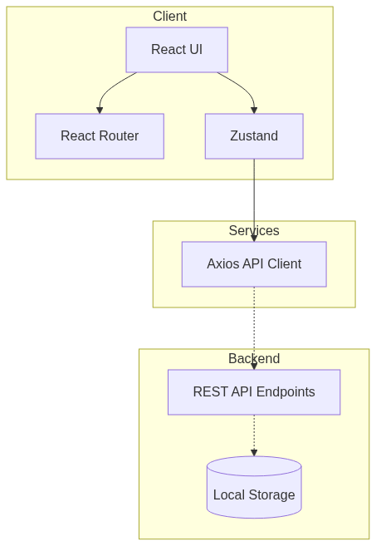

3. Entity-Relationship (ER) Diagram
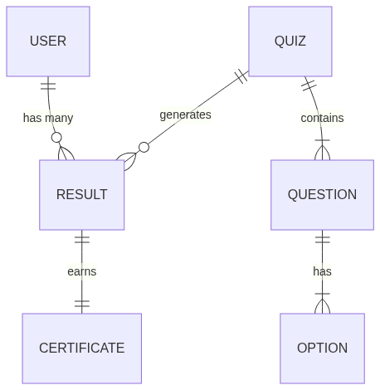

4. Activity Diagram
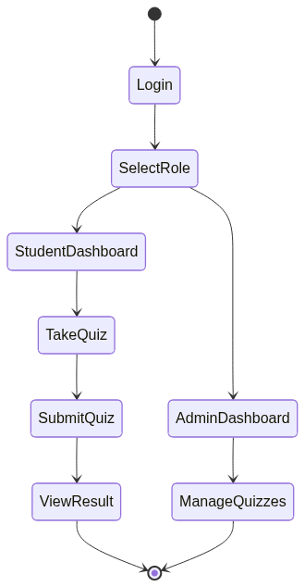

5. Sequence Diagram
