**INDEX and MATCH Function in Excel**

INDEX and MATCH is the most popular tool in Excel for performing more advanced lookups.

This is because INDEX and MATCH are incredibly flexible – you can do horizontal and vertical lookups, 2-way lookups, left lookups, case-sensitive lookups, and even lookups based on multiple criteria.

This is because INDEX and MATCH are incredibly flexible – you can do horizontal and vertical lookups, 2-way lookups, left lookups, case-sensitive lookups, and even lookups based on multiple criteria.

**The INDEX Function**

The INDEX function in Excel is fantastically flexible and powerful. INDEX retrieves the value at a given location in a range. For example, let's say you have a table of planets in our solar system (see below), and you want to get the name of the 4th planet, Mars, with a formula. You can use INDEX like this:

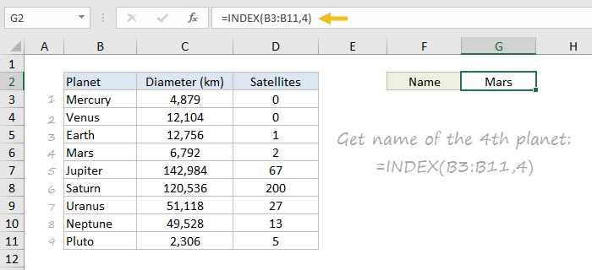

To summarize, INDEX gets a value at a given location in a range of cells based on numeric position. When the range is one-dimensional, you only need to supply a row number. When the range is two-dimensional, you'll need to supply both the row and column number.

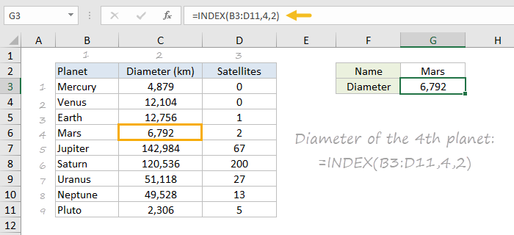

**The MATCH function**

The MATCH function is designed for one purpose: find the position of an item in a range.

For example, we can use MATCH to get the position of the word "peach" in this list of fruits like this:

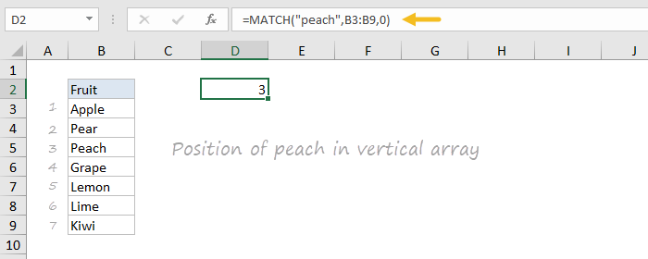

MATCH doesn't care if a range is horizontal or vertical, as you can see below:

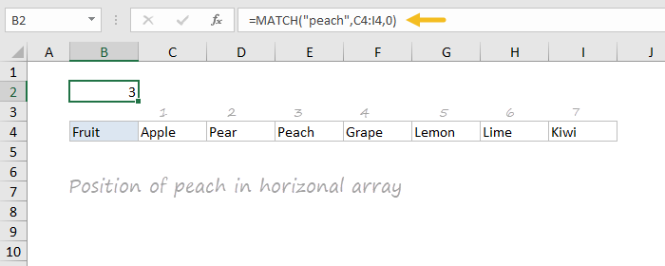

**INDEX and MATCH together**

INDEX finds the lookup value by column and row numbers, and MATCH provides those numbers. That's it!

e.g. This table showing a list of salespeople and monthly sales numbers for three months: January, February, and March. Let's say we want to write a formula that returns the sales number for February for a given salesperson.

=INDEX(C3:E11,MATCH(H2,B3:B11,0),2)

MATCH finds "Frantz" and returns 5 to INDEX for row.

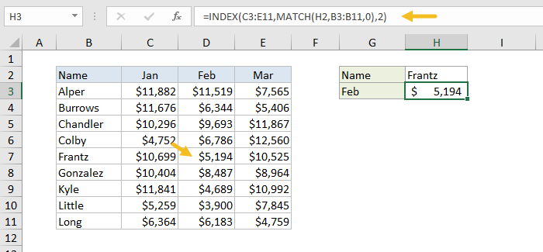

**Two-way lookup with INDEX and MATCH**

Previously, we used the MATCH function to find the row number dynamically, but hardcoded the column number. How can we make the formula fully dynamic, so we can return sales for any given salesperson in any given month?

The trick is to use MATCH twice – once to get a row position, and once to get a column position.

=INDEX(C3:E11,MATCH(H2,B3:B11,0),MATCH(H3,C2:E2,0))

