Conditional Formatting

Conditional formatting is used to change the appearance of cells in a range based on your specified conditions.

The conditions are rules based on specified numerical values or matching text.

Changing the appearance of cells can visually highlight interesting data points for analysis.

The browser version of Excel provides a number of built-in conditions and appearances:

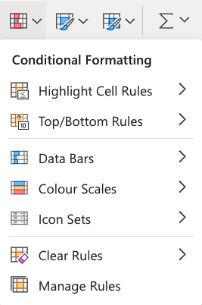

**Note**: The web browser version of Excel only offers a selection of built-in conditional formatting options. The Excel application has the option of creating fully customized conditional formatting rules.

**Conditional Formatting Example;**

Here, the Speed values of each pokemon is formatted with a Colour Scale:

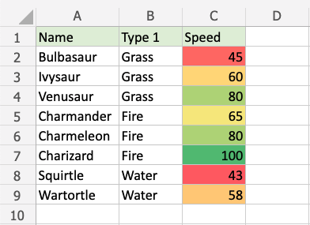

Note: Excel has several different colour scales to pick from.

**Colour Scale Formatting Example**

Highlight the Speed values of each Pokemon with Colour scale conditional formatting.

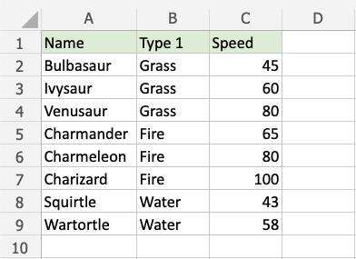

Conditional formatting, step by step:

1. Select the range of Speed values C2:C9

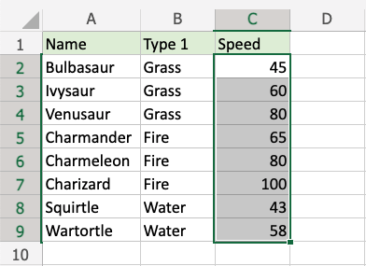

1. Click on the Conditional Formatting icon  in the ribbon, from the Home menu
2. Select the Colour Scales from the drop-down menu

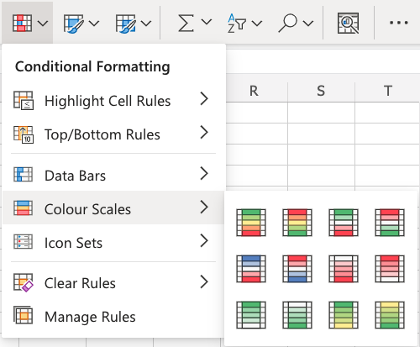

There are 12 Colour Scale options with different colour variations.

The colour on the top of the icon  will apply to the highest values.

1. Click on the "Green - Yellow - Red Colour Scale" icon
2. 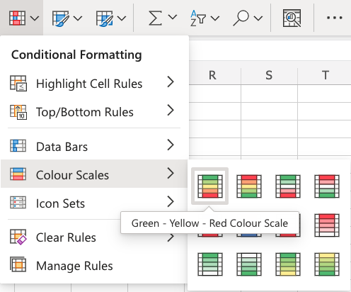

Now, the Speed value cells will have a coloured background highlighting:



Dark green is used for the highest values, and dark red for the lowest values.

Charizard has the highest Speed value (100) and Squirtle has the lowest Speed value (43).

All the cells in the range gradually change colour from green, yellow, orange, then red.

* Highlight Cell Rules

Highlight Cell Rules is a premade type of conditional formatting in Excel used to change the appearance of cells in a range based on your specified **conditions**.

The conditions are rules based on specified numerical values, matching text, calendar dates, or duplicated and unique values.

Here is the Highlight Cell Rules part of the conditional formatting menu:

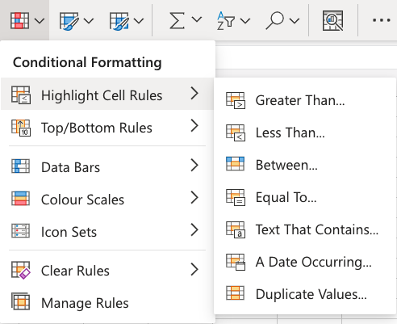

* Appearance Options

The web browser version of Excel offers the following appearance options for conditionally formatted cells:

* Light Red Fill with Dark Red Text
* Yellow Fill with Dark Yellow Text
* Green Fill with Dark Green Text
* Light Red Fill
* Red Text
* Red Border

Here is how the options look in a spreadsheet:

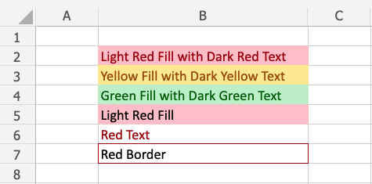

Cell Rule Types

Excel offers the following cell rule types:

* [Greater Than...](https://www.w3schools.com/excel/excel_cf_greater_than.php)
* [Less Than...](https://www.w3schools.com/excel/excel_cf_less_than.php)
* [Between...](https://www.w3schools.com/excel/excel_cf_between.php)
* [Equal To...](https://www.w3schools.com/excel/excel_cf_equal_to.php)
* [Text That Contains...](https://www.w3schools.com/excel/exceL_cf_text_that_contains.php)
* [A Date Occurring...](https://www.w3schools.com/excel/excel_cf_date_occurring.php)
* [Duplicate/Unique Values](https://www.w3schools.com/excel/excel_cf_duplicate_unique.php)

Highlight Cell Rule Example

The "Equal To..." Highlight Cell Rule will highlight a cell with one of the appearance options based on the cell value being **equal** to your specified value.

The specified value could be a particular number or particular text.

In this example, the specified value will be "48".

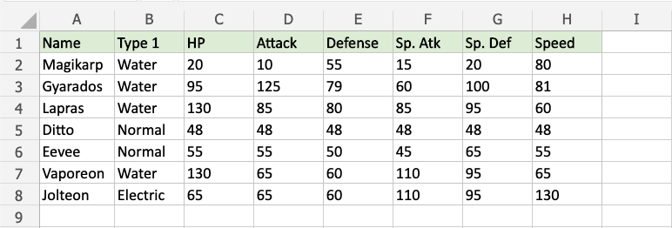

You can [choose any range](https://www.w3schools.com/excel/excel_ranges.php) for where the Highlight Cell Rule should apply. It can be a a few cells, a single column, a single row, or a combination of multiple cells, rows and columns.

Let's apply the rule to all of the different stat values.

"Equal To..." Highlight Cell Rule, step by step:

1. Select the range C2:H8 for all of the stat values

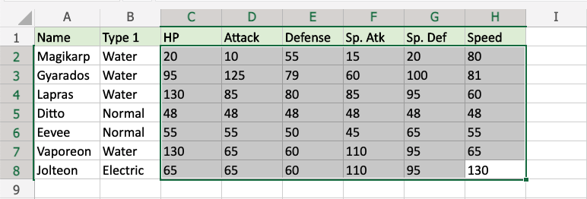

1. Click on the Conditional Formatting icon  in the ribbon, from **Home** menu
2. Select the **Highlight Cell Rules** from the drop-down menu
3. Select the **Equal To...** from the menu

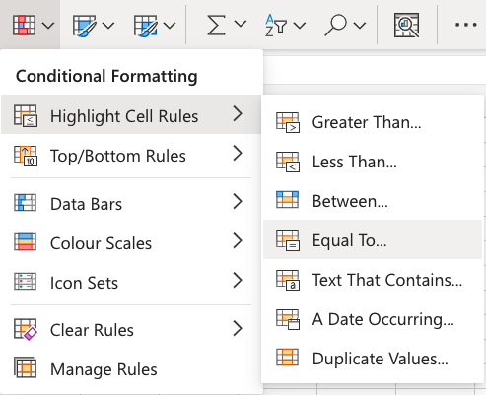

This will open a dialog box where you can specify the value and the appearance option.

1. Enter 48 into the input field
2. Select the appearance option "Yellow Fill with Dark Yellow Text" from the dropdown menu

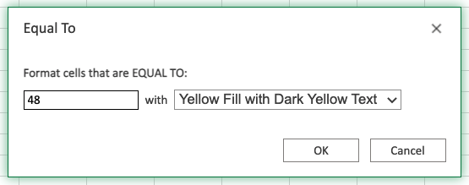

Now, the cells with values equal to "48" will be highlighted in yellow:

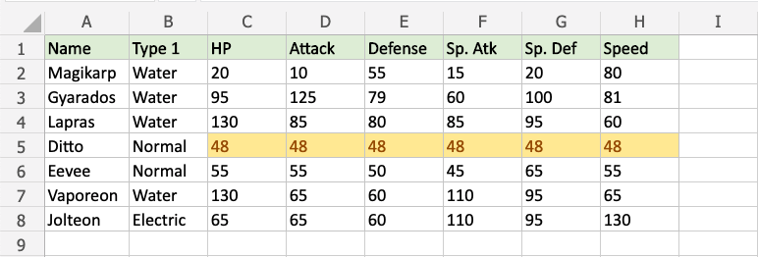

All of Ditto's stat values are 48, so they are highlighted.

* Top/Bottom Rules

Top/Bottom Rules are premade types of conditional formatting in Excel used to change the appearance of cells in a range based on your specified **conditions**.

Here is the Top/Bottom Rules part of the conditional formatting menu:

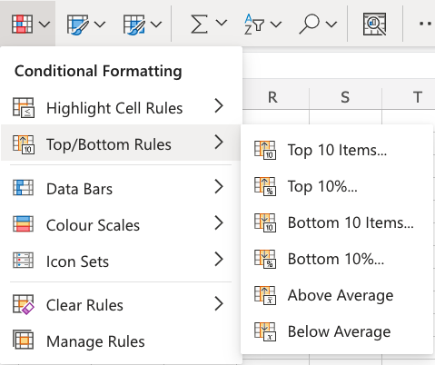

Appearance Options

The web browser version of Excel offers the following appearance options for conditionally formatted cells:

* Light Red Fill with Dark Red Text
* Yellow Fill with Dark Yellow Text
* Green Fill with Dark Green Text
* Light Red Fill
* Red Text
* Red Border

Here is how the options look in a spreadsheet:



* Top/Bottom 10 Items Example

The "Top 10 Items..." and "Bottom 10 Items..." rules will highlight cells with one of the appearance options based on the cell value being the top or bottom values in a range.

Note: The default number of items is 10, but you can specify any whole number up to 1000 for Top/Bottom Items to be highlighted.

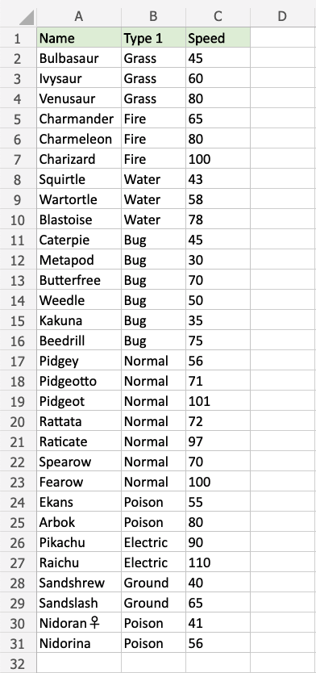

## Above and Below Average Rules

Above and Below Average Rules are premade types of conditional formatting in Excel used to change the appearance of cells in a range based on your specified **conditions**.

Above and Below Average Rules are found in the **Top/Bottom Rules** part of the conditional formatting menu:



You can [choose any range](https://www.w3schools.com/excel/excel_ranges.php) for where the Highlight Cell Rule should apply. It can be a a few cells, a single column, a single row, or a combination of multiple cells, rows and colums.

Let's first apply the **Above Average** rule to the HP values.

"Above Average" Rule, step by step:

1. Select the range C2:C11 for HP values

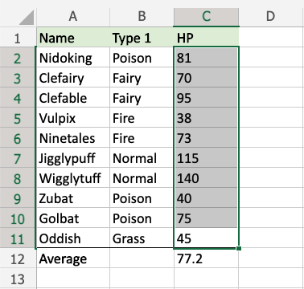

1. Click on the Conditional Formatting icon  in the ribbon, from **Home** menu
2. Select the **Top/Bottom Rules** from the drop-down menu
3. Select **Above Average** from the menu

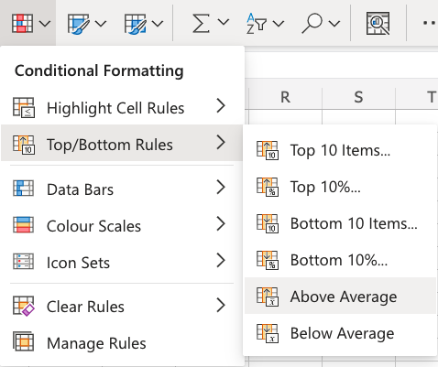

This will open a dialog box where you can specify the value and the appearance option.

1. Select the appearance option "Green Fill with Dark Green Text" from the dropdown menu

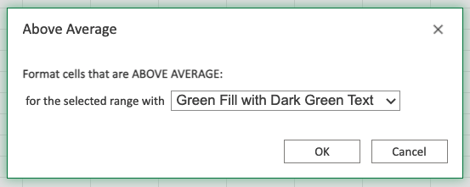

Now, the cells with above average HP values (more than 77.2) will be highlighted in green:

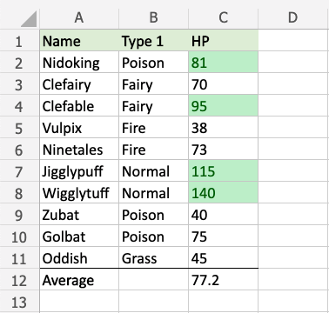

Notice that there are more below average values than above average values. Why could this be?

The number of above or below average value cells in a range will depend on the actual values in the range.

If some values in the range are extra-large this will increase the average by a lot.

Let's add a fictional Pokemon with a very high HP stat value to illustrate this:

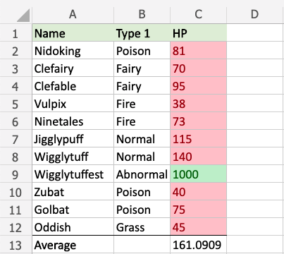

Now, only Wigglytuffest has an above average HP stat value, and every other Pokemon has below average HP stat values.

* Data Bars

Data Bars are premade types of conditional formatting in Excel used to add coloured bars to cells in a range to indicate how large the cell values are compared to the other values.

Here is the Data Bars part of the conditional formatting menu:

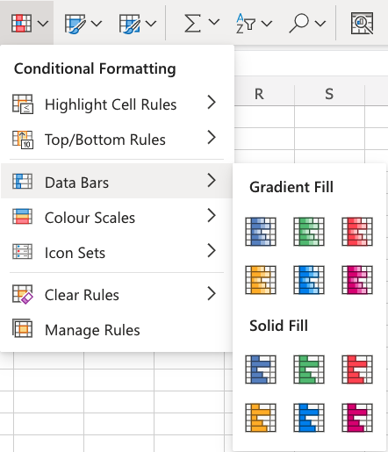

* Data Bars Example

Let's apply the **Data Bars** conditional formatting to the Speed values.

"Data Bars", step by step:

1. Select the range C2:C10 for Speed values

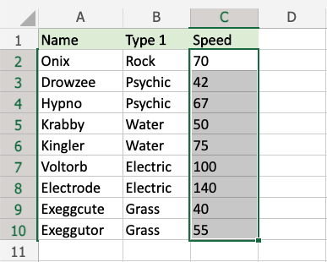

1. Click on the Conditional Formatting icon  in the ribbon, from **Home** menu
2. Select **Data Bars** from the drop-down menu
3. Select the "Green Data Bars" colour option from the **Gradient Fill** menu

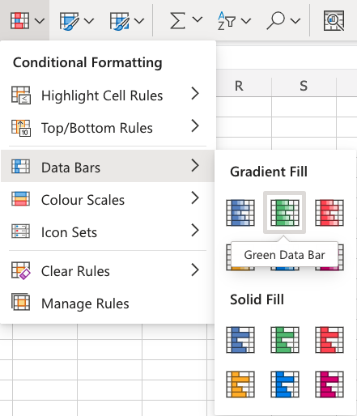

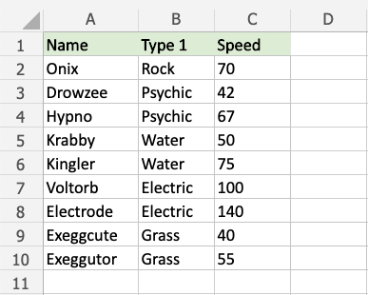

Now, all of the Speed value cells have a green bar showing how big the value is compared to the other values in the range:

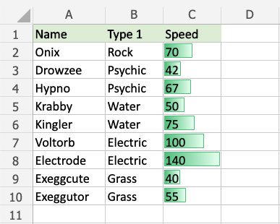

Electrode has the highest value, 140, so the bar fills the entire cell.

The other bars are scaled relative to the highest value and 0 by default.

Exeggcute has the lowest value, 40, so this is the shortest bar. Though, it is larger than 0, so there is still a small bar.

Let's see what happens if we add a fictional Pokemon with a 0 Speed value:

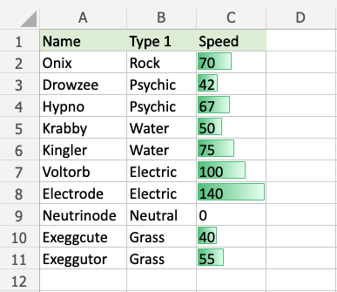

The fictional Neutrinode has a Speed value of 0, so this becomes an invisible "minimum" bar.

Let's see what happens if we add another fictional Pokemon with a negative Speed value:

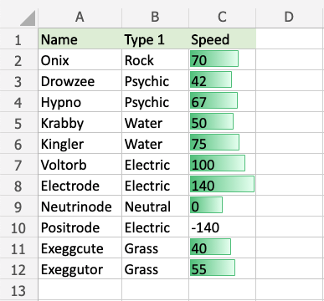

Now, the fictional Positrode has the lowest Speed value, -140, so this becomes an invisible "minimum" bar.

**Notice that all the other bars have now been scaled relative to the new minimum (-140).**

Neutrinode's Speed value of 0 is now in the middle between -140 and 140, so the cell has a bar filling half the cell.

Electrode still has the highest Speed value, 140, so this bar still fills the entire cell.

* Excel Manage Rules

Conditional Formatting rules can be managed and removed using the **Clear Rules** and **Manage Rules** features.

Here is the Clear Rules part of the conditional formatting menu:

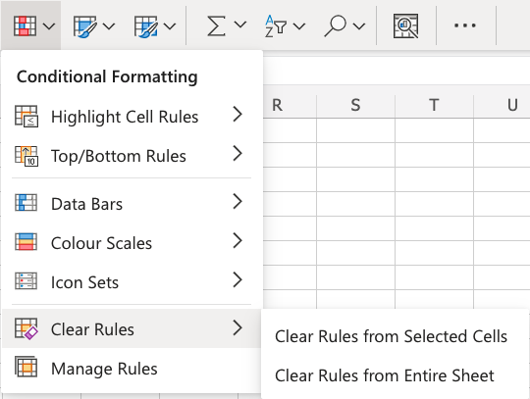

You can remove all the rules from a **selected range of cells** or from the entire spreadsheet using the **Clear Rules** menu options.

* Conditional Formatting - Manage Rules Example

You can also use the **Manage Rules** menu option to clear conditional formatting rules.

Let's remove the **Color Scale** rule applied to all the Stat values:

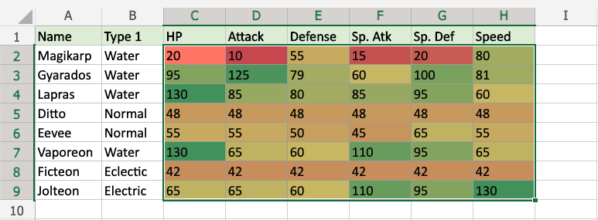

Select the range C2:H9.

Select the **Manage Rules** option from the Conditional Formatting menu  in the **Home** menu.

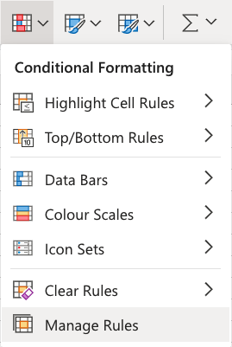

This box will appear on the right-hand side of your spreadsheet:

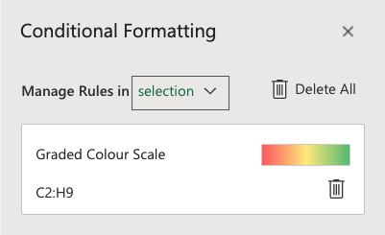

This will show all the active rules that are applied to the selected range.

It will also indicate which cells the rule is applied to. Which, in this example, is C2:H9.