* **Pivot Chart**
* Pivot Chart is the best type to present data in the form of graphs for the analysis of data in excel.
* The most useful feature is the possibility of quickly changing the portion of data displayed, like a PivotTable report. It makes Pivot Chart ideal for presentation of data.
* **Difference a Pivot Chart and a Normal Chart**
* A standard chart use range of cells, on the other hand, a pivot chart is based on data summarized in a pivot table.
* A pivot chart is already a dynamic chart, but you have to make changes in data to convert a standard chart into a dynamic chart.
* **Steps to Create a Pivot Chart in Excel**

You can create a pivot chart by using two ways. One is to add a pivot chart in your existing pivot table, and other is to create a pivot chart from scratch.

**1. Create a Pivot Chart from Scratch**

Creating a pivot chart from scratch is as simple as creating a pivot table. All you need, a data sheet.

You use steps in all versions of EXCEL

* Select any of the cells in your data sheet and go to Insert Tab → Charts → Pivot Chart.

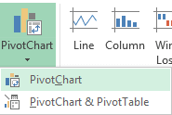

* The pop-up window will automatically select the entire data range and you have the option to choose the place where you want to insert your pivot chart.

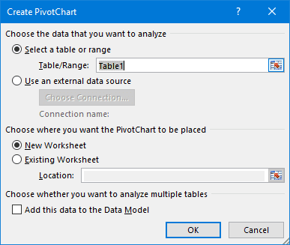

* Click OK.
* Now, you have a blank pivot table and pivot chart in a new worksheet.

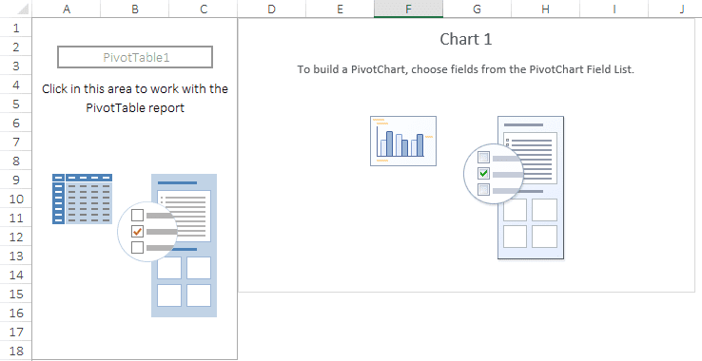

Important Note: When you insert a pivot chart it will automatically insert a pivot table along with it. And, if you just want to add a pivot chart, you can add your data into Power Pivot Data Model.

* In pivot chart fields, we have four components like we have in a pivot table.
  + Axis: Axis in pivot chart is as same as we have rows in our pivot table.
  + Legend: Legend in pivot chart is as same as we have columns in our pivot table.
  + Values: We are using quantity as values.
  + Report Filter: You can use report filter to filter your pivot chart.

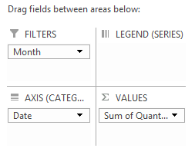

* So, here is your fully dynamic pivot chart.

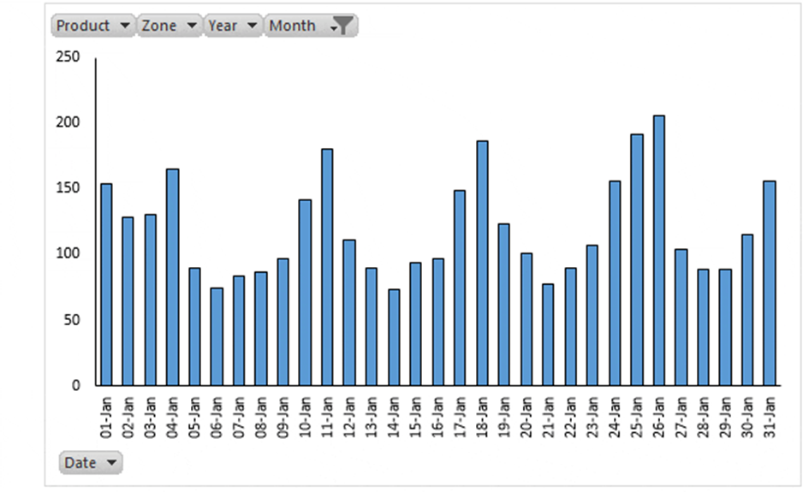

**2. Create a Pivot Chart from Existing Pivot Table**

If you already have a pivot table in your worksheet then you can insert a pivot chart by using these simple steps.

* Select any of the cells from your pivot table.

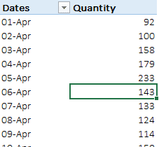

* Go to Insert Tab → Charts → Pivot Chart and select the chart which you want to use.

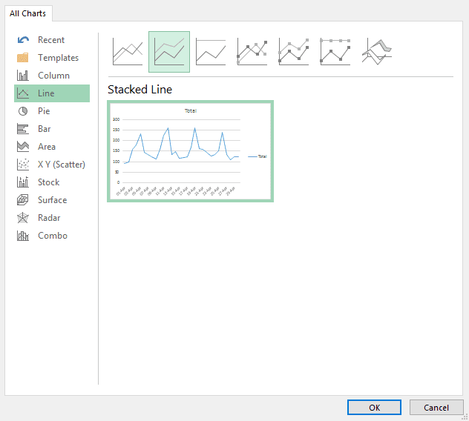

* Click Ok.

It will insert a new pivot chart in the same worksheet where you have your pivot table. And, it will use pivot table rows as axis and columns as the legend in pivot chart.

Important Note: Another smart and quick way is to use shortcut key. Just select any of the cells in your pivot table and press F11 to insert a pivot chart.

* **More Information about Pivot Charts**

Managing a pivot chart is simple and here is some information which will help you do it smoothly.

**1. Change Chart Type**

When you enter a new pivot chart, you have to select the type of the chart which you want to use. And, if you want to change the chart type you can use following steps for that.

* Select your pivot chart and go to Design Tab → Type → Change Chart Type.

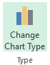

* Select your favourite chart type.

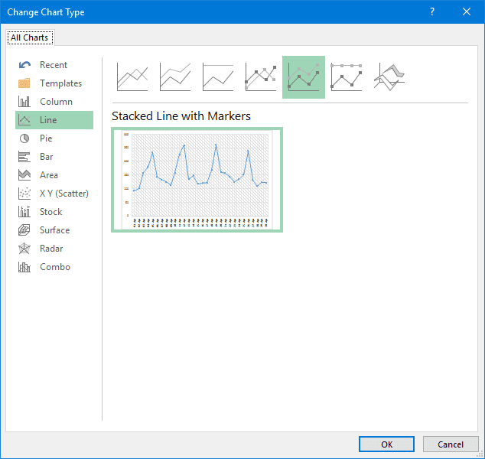

* Click OK.

**2. Refresh a Pivot Chart**

Refreshing a pivot chart is just like refreshing a pivot table. If your pivot table is refreshing automatically, then your pivot chart will also update along with that.

**Method-1**

* Right-click on your chart.
* And then click on pivot chart options.

right click on excel pivot chart to activate refresh option

* Go to data tab and tick mark “Refresh data when open a file”.

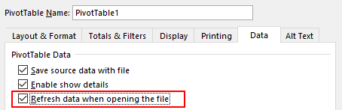

* Click OK.
* **Advantages for Pivot Tables**

**1. They allow you to see how the data works.**  
Pivot tables are one of the only tools available to users that can provide deep insights into analytics data. Multiple reports can be generated with this tool off the same collected data within a single file.

**2. It can work with SQL exports.**  
If the pivot table is being used on Microsoft Excel, then the tool is able to work with any SQL export.

**3. The data is easier to segment.**  
Analytics that are gathered into a spreadsheet or database are easier to segment thanks to pivot tables.

**4. You can create instant data.**  
Whether you program equations directly into the pivot table or you rely on formulas, instant data can be created with this tool.

**5. Pivot table creates accurate reports faster**

It can help any user in creating or formulating reports and presentations in a very efficient and reliable way.

**6. Pivot tables can help in making decisions faster**

With the fast-pacing demand in the modern world, quicker decision making is very important. This is true especially for business leaders and managers. A pivot table can be a great tool in doing that. It saves a lot of time.