SQL stands for **Structured Query Language** which is basically a language used by databases. This language allows to handle the information using tables and shows a language to query these tables and other objects related (views, functions, procedures, etc.). Most of the databases like SQL Server, Oracle, PostgreSQL, MySQL, MariaDB handle this language (with some extensions and variations) to handle the data

Edgar Frank Codd while he worked for IBM invented the relational database in the 70s.

The SQL definition is a language to define database objects and manipulate the data.

SQL

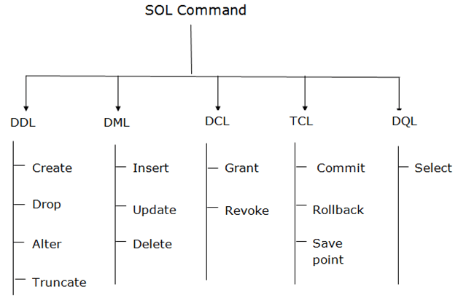

### 1. Data Definition Language (DDL)

* DDL changes the structure of the table like creating a table, deleting a table, altering a table, etc.
* All the command of DDL are auto-committed that means it permanently save all the changes in the database.

Here are some commands that come under DDL:

* CREATE
* ALTER
* DROP
* TRUNCATE

**a. CREATE** It is used to create a new table in the database.

**Syntax:**

1. CREATE TABLE TABLE_NAME (COLUMN_NAME DATATYPES[,....]);

**Example:**

1. CREATE TABLE EMPLOYEE (Name VARCHAR2(20), Email VARCHAR2(100), DOB DATE);

**b. DROP:** It is used to delete both the structure and record stored in the table.

**Syntax**

1. DROP TABLE table_name;

**Example**

1. DROP TABLE EMPLOYEE;

**c. ALTER:** It is used to alter the structure of the database. This change could be either to modify the characteristics of an existing attribute or probably to add a new attribute.

**Syntax:**

To add a new column in the table

1. ALTER TABLE table_name ADD column_name COLUMN-definition;

To modify existing column in the table:

1. ALTER TABLE table_name MODIFY(column_definitions....);

**EXAMPLE**

1. ALTER TABLE STU_DETAILS ADD(ADDRESS VARCHAR2(20));
2. ALTER TABLE STU_DETAILS MODIFY (NAME VARCHAR2(20));

**d. TRUNCATE:** It is used to delete all the rows from the table and free the space containing the table.

**Syntax:**

1. TRUNCATE TABLE table_name;

**Example:**

1. TRUNCATE TABLE EMPLOYEE;

### 2. Data Manipulation Language

* DML commands are used to modify the database. It is responsible for all form of changes in the database.
* The command of DML is not auto-committed that means it can't permanently save all the changes in the database. They can be rollback.

Here are some commands that come under DML:

* INSERT
* UPDATE
* DELETE

**a. INSERT:** The INSERT statement is a SQL query. It is used to insert data into the row of a table.

**Syntax:**

1. INSERT INTO TABLE_NAME
2. (col1, col2, col3,.... col N)
3. VALUES (value1, value2, value3, .... valueN);

Or

1. INSERT INTO TABLE_NAME
2. VALUES (value1, value2, value3, .... valueN);

**For example:**

1. INSERT INTO javatpoint (Author, Subject) VALUES ("Sonoo", "DBMS");

**b. UPDATE:** This command is used to update or modify the value of a column in the table.

**Syntax:**

1. UPDATE table_name SET [column_name1= value1,...column_nameN = valueN] [WHERE CONDITION]

**For example:**

1. UPDATE students
2. SET User_Name = 'Sonoo'
3. WHERE Student_Id = '3'

**c. DELETE:** It is used to remove one or more row from a table.

**Syntax:**

1. DELETE FROM table_name [WHERE condition];

**For example:**

1. DELETE FROM javatpoint
2. WHERE Author="Sonoo";

### 3. Data Control Language

DCL commands are used to grant and take back authority from any database user.

Here are some commands that come under DCL:

* Grant
* Revoke

**a. Grant:** It is used to give user access privileges to a database.

**Example**

1. GRANT SELECT, UPDATE ON MY_TABLE TO SOME_USER, ANOTHER_USER;

**b. Revoke:** It is used to take back permissions from the user.

**Example**

1. REVOKE SELECT, UPDATE ON MY_TABLE FROM USER1, USER2;

### 4. Transaction Control Language

TCL commands can only use with DML commands like INSERT, DELETE and UPDATE only.

These operations are automatically committed in the database that's why they cannot be used while creating tables or dropping them.

Here are some commands that come under TCL:

* COMMIT
* ROLLBACK
* SAVEPOINT

**a. Commit:** Commit command is used to save all the transactions to the database.

**Syntax:**

1. COMMIT;

**Example:**

1. DELETE FROM CUSTOMERS
2. WHERE AGE = 25;
3. COMMIT;

**b. Rollback:** Rollback command is used to undo transactions that have not already been saved to the database.

**Syntax:**

1. ROLLBACK;

**Example:**

1. DELETE FROM CUSTOMERS
2. WHERE AGE = 25;
3. ROLLBACK;

**c. SAVEPOINT:** It is used to roll the transaction back to a certain point without rolling back the entire transaction.

**Syntax:**

1. SAVEPOINT SAVEPOINT_NAME;

### 5. Data Query Language

DQL is used to fetch the data from the database.

It uses only one command:

* SELECT

**a. SELECT:** This is the same as the projection operation of relational algebra. It is used to select the attribute based on the condition described by WHERE clause.

**Syntax:**

1. SELECT expressions
2. FROM TABLES
3. WHERE conditions;

**For example:**

1. SELECT emp_name
2. FROM employee
3. WHERE age > 20;

**NUMERICAL FUNCTIONS**

Functions For Numeric Data: –

1. ROUND
2. TRUNCATE
3. CEILING
4. FLOOR
5. ABS
6. RAND

ROUND: –

“ROUND” function is used for rounding a Number.

Example: –



Result;-

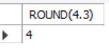

If decimal value < 0.5 “ROUND” converts it into the closest least number.

Change the query –



Result:-



if the decimal value is >= 0.5 “ROUND” converts it into the closest greater number.

TRUNCATE: –

* “TRUNCATE” function is used to remove the digits in decimal value after the precision
* Only keep the digits in decimal till 2 places and truncate the rest which results in “4.35”.

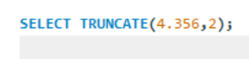

Result:-

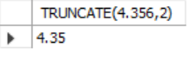

CEILING: –

* “CEILING” returns the smallest integer that is greater than or equal to a given number.

Example: –



Result:-

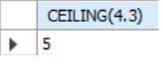

* This returns “5”, because 5 is the smallest integer that’s greater than 4.3.

“FLOOR” is exact oppose to “CEILING”.

* “FLOOR” returns the largest integer that is smaller than or equal to a given number

Example: –



Result:-

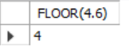

This returns “4”, because 4 is the greatest integer that’s smaller than 4.6.

ABS: –

* “ABS” stands for “ABSOLUTE” value
* “ABS” function returns, positive version of the number you give to it

Example:-

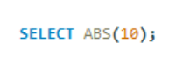 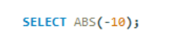

Result:-

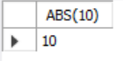 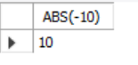

* Both of the queries return the same output , that is “10” .

RAND: –

* “RAND” function returns a random floating point value between the range 0 to 1.

Example:

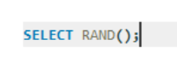

Result:-

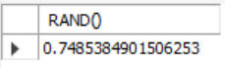 This query returns a value between 0 and 1, try to run it again the value changes as they are being generated randomly.

# **STRINGS FUNCTIONS**

Functions: –

1. UPPER
2. LOWER
3. LENGTH
4. LEFT
5. RIGHT
6. SUBSTRING
7. LTRIM
8. TRIM
9. LOCATE
10. REPLACE
11. CONCAT

UPPER: –

Going to upper case all your characters you pass into it.

Example: –

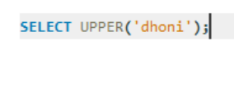

Result:-

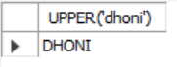

LOWER: –

Which lower cases all the characters.

Example: –



Result:-

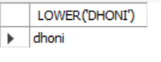

LENGTH: –

LENGTH finds out the length of a given string.

Example: –

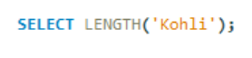

Result:-



LEFT: –

“LEFT” is used to return a specified number of characters from the left of the string.

It takes in 2 arguments one is the actual string the other is an integer which determines the characters upto which it should return from left.

Example: –

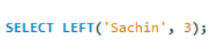

Result:-

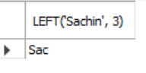

RIGHT: –

“RIGHT” is used to return a specified number of characters from the right of the string.

Example: –



Result:-

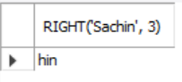

SUBSTRING: –

The “SUBSTRING” function extracts a substring from a given string.

It takes in 3 arguments:

String

Start position

Length from start position

Example: –

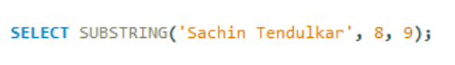

Result:-

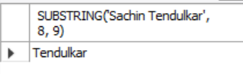

It starts at 8th index which is “T” and picks 9 characters from there, so you get “Tendulkar” in the result.

*Note: –* 3rd argument is optional, if it’s not specified “SUBSTRING” select all the characters from start position.

LTRIM: –

“LTRIM” is short for “LEFT TRIM”.

The LTRIM function removes all the spaces to the LEFT of the string.

Example: –

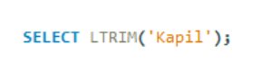

Result:-

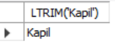

When you run this query, you get “Kapil” with all spaces removed on the left side.

“RTRIM” is similar to “LTRIM”, but it removes all the spaces to the RIGHT of the string.

TRIM: –

“TRIM” is a combination of both “LTRIM” and “RTRIM”, it removes all spaces to the left and right of the string.

Query: –

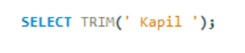

Result:-

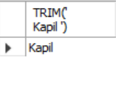

Have spaces to the both side, when you run the query we get “Kapil” with spaces removed on left and right.

These TRIM functions become really handy while improving the Data quality by removing unwanted spaces.

LOCATE: –

The LOCATE function returns the position of the first occurrence of a substring in a string.

*It takes in 2 arguments:*

1. Substring
2. Original string

Example: –

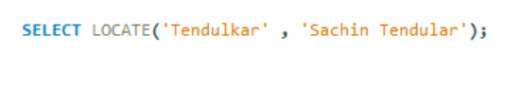

Result:-

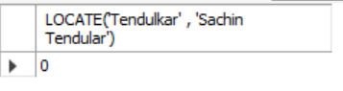

The result is 8 because the substring “Tendulkar” occurs at the 8th position of the whole text.

Get the result if “T” is small as LOCATE performs case-insensitive search.

If the substring is not found within the original string, this function returns 0.

REPLACE: –

“REPLACE” function replaces all the occurrences of a substring within a string.

It takes in 3 arguments.

1. Original string
2. Substring you want to replace
3. Substring with which you want to replace

Example: –

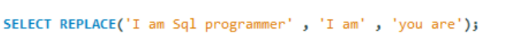

Result:-

