# **SQL Data Types**

Data types are used to represent the nature of the data that can be stored in the database table.

Data types mainly classified into three categories for every database.

* String Data types
* Numeric Data types
* Date and time Data types

**String Data types**

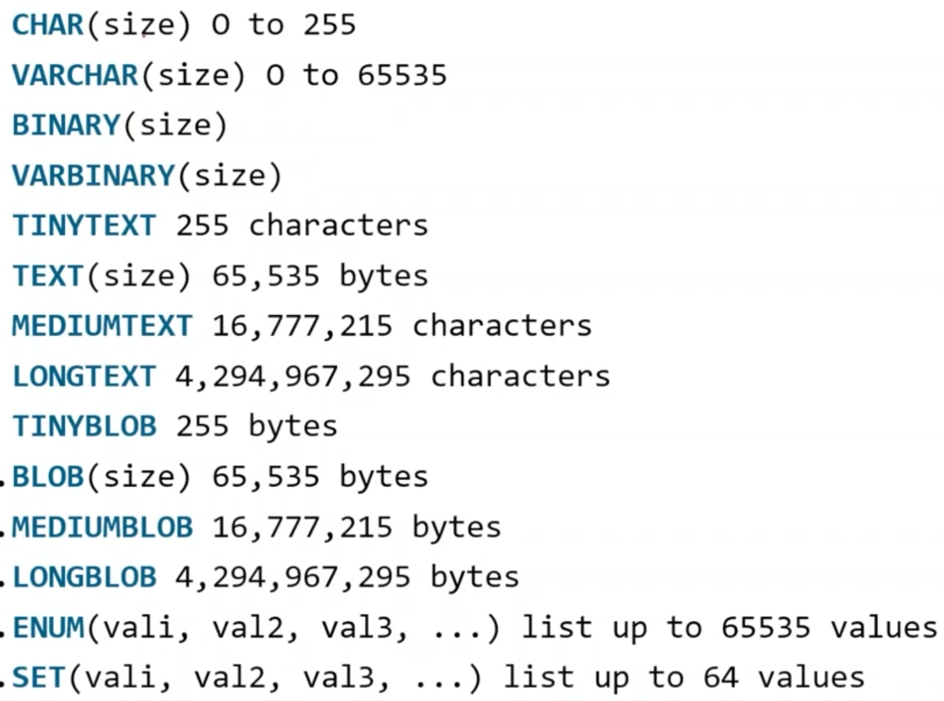

**Numeric Data types**

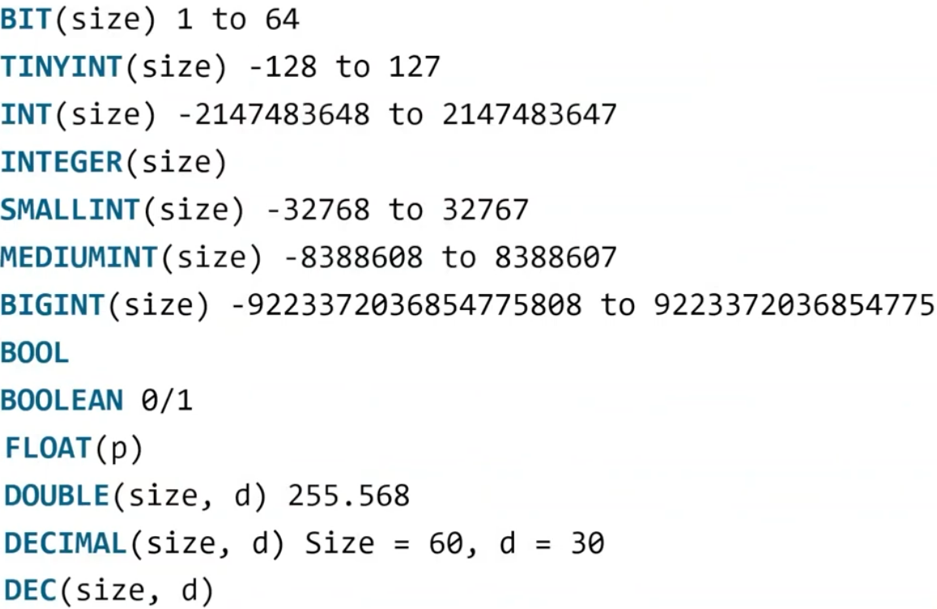

**Date and time Data types**

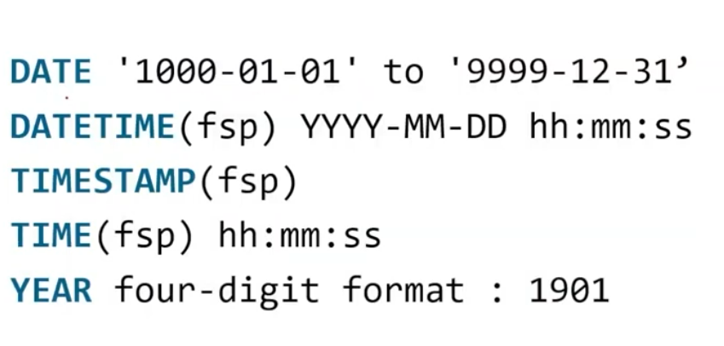

**Constraints that MySQL supports: –**

NOT NULL

UNIQUE

PRIMARY KEY

CHECK

DEFAULT

AUTO_INCREMENT

**NOT NULL**

This constraint tells that we cannot store a null value in a column. That is, if a column is specified as NOT NULL then we will not be able to store null in this particular column any more.

**UNIQUE**

This constraint when specified with a column, tells that all the values in the column must be unique. That is, the values in any row of a column must not be repeated.

**PRIMARY KEY**

A primary key is a field which can uniquely identify each row in a table. And this constraint is used to specify a field in a table as primary key.

**CHECK**

This constraint helps to validate the values of a column to meet a particular condition. That is, it helps to ensure that the value stored in a column meets a specific condition.

**DEFAULT**

This constraint specifies a default value for the column when no value is specified by the user.

**AUTO_INCREMENT**

Auto-increment allows a unique number to be generated automatically when a new record is inserted into a table.

By default the initial value of AUTO_INCREMENT would be 1 and will increase 1 after every insertion.

**Alter**

ALTER TABLE is used to add, delete/drop or modify columns in the existing table.

Stddata table:

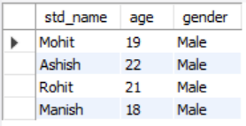

Alter query



Result:

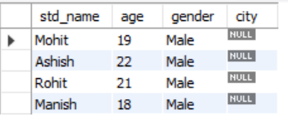

**Drop**

The SQL DROP command is used to remove an object from the database. If you drop a table, all the rows in the table is deleted and the table structure is removed from the database. Once a table is dropped we cannot get it back, so be careful while using DROP command.

Create a table stddata.

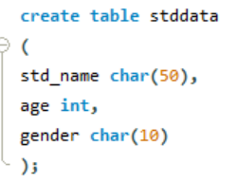

stddata table

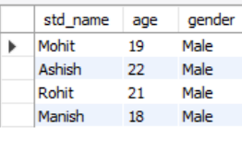

Use drop command

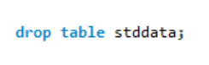

Result:





**TRUNCATE**

This command is used to delete all the rows from the table and free the space containing the table.

Use Truncate command

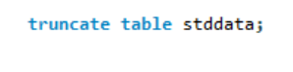

Result:

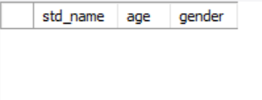

**Insert**

INSERT INTO statement is used to insert data into a table. It is called a Data Manipulation Language. It uses the table name and column names and values as inputs and performs the insertion of values into the table.

Example:

Syntax:-INSERT INTO <<table name>> VALUES (<<val1>>, <<val2>>, …..);



**Update**

The UPDATE statement is used to modify the values in a table. It is also called a Data Manipulation Language. It uses the names of the table, column, and values as inputs and performs the modification of values on the table.

Example:

**Syntax:**UPDATE <<table name>> SET <<col1>>=<<val1>>, <<col2>>=<<val2>>,… WHERE <<criteria is met>>;

Customer table1

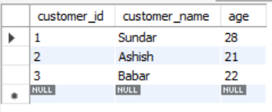

Update query

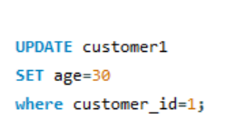

Result:-

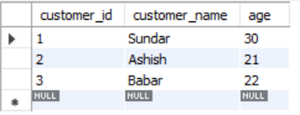

**Delete**

Customer1 table

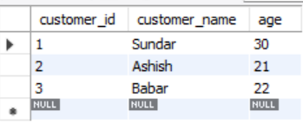

Delete query

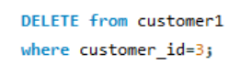

Result:-

