**SQL JOIN**

The SQL Joins clause is used to combine records from two or more tables in a database. A JOIN is a means for combining fields from two tables by using values common to each.

Create a table customer

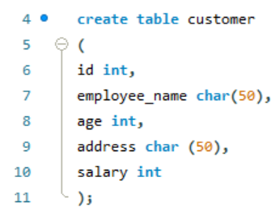

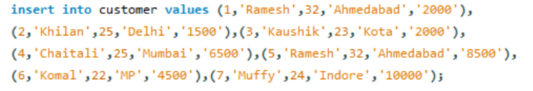

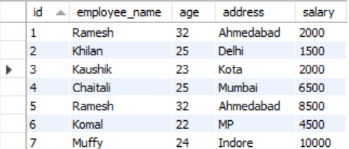

**INNER JOIN**

The inner join select records that have matching values in both the table.

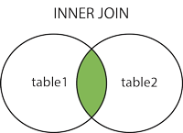

**Example: –**

Suppose you have two tables, orders and customers.

Customer table-

| customer_id | customer_name | phno. |
| --- | --- | --- |
| 1 | Rahul | 987457 |
| 2 | sachin | 567490 |
| 3 | Rohit | 578306 |
| 4 | Kohli | 958737 |

**Creating customer table in database**

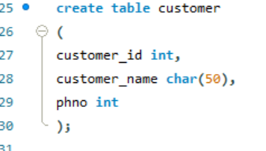

**Inserting values in the customer table**

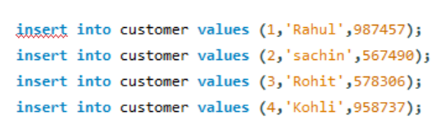

**Customer table**

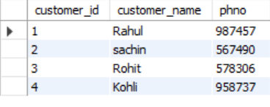

In the same way we create Order table

**Order1 Table**

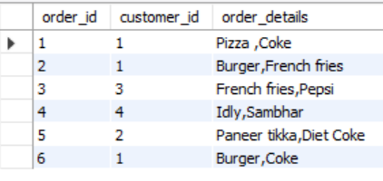

Query to join Customer table and Order1 table

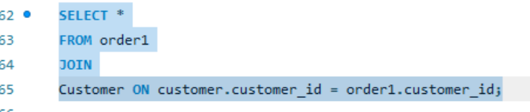

Output of Join Customer table and order table.

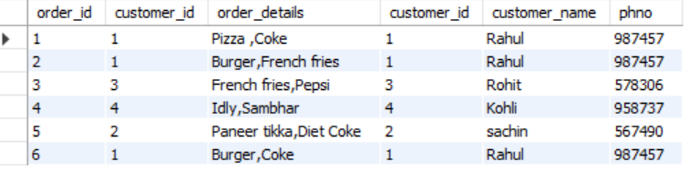

LEFT JOIN

The left join returns all records from the left table (table 1), and matched records from the right table(table 2).

The Left Join, which is also called the Left outer join, returns all the records which satisfy the conditions plus the records from the left table.

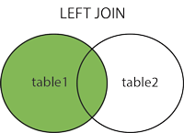

Create table Customer1

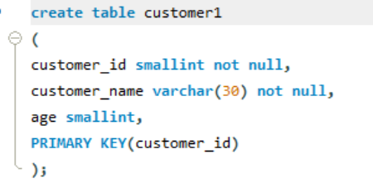

Inserting values into Customer1 table

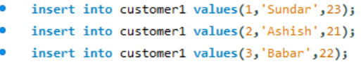

Customer1 table

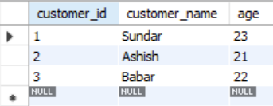

Create table Order2

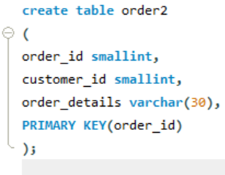

Inserting values into Order2 table

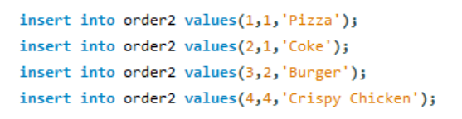

Order2 table

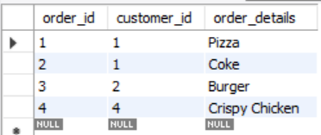

Query for LEFT JOIN

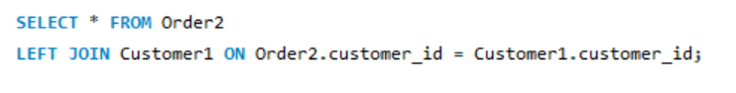

RESULT

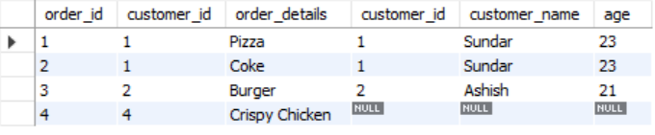

RIGHT JOIN

The Right join returns all records from the right table (table 2), and matched records from the left table(table 1) and returns all the records which satisfy the conditions plus the records from the right table.

Use the same two tables Customer1 and order2.

Customer1



Order2



Apply RIGHT JOIN Query

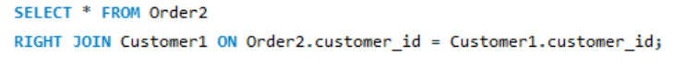

Result

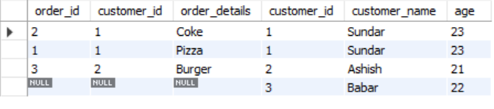

The result and the last row has its left table fields as nulls because the “customer_id” hasn’t placed any orders.

**OUTER JOIN**

This join is also called as FULL join, it returns all the records which satisfy the conditions plus the records from the left table as well as the right table.

