**SUB QUERIES**

A Subquery is a query inside another query, it is used to return data which is further used inside the where clause as a filter.

These subqueries can be used to select, update, insert and delete along with all the conditional operators such as equal to, less than, greater than, in and between.

Create table studentmarks

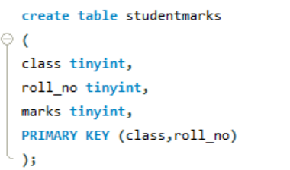

Insert into table Studentmarks

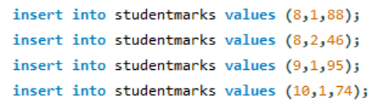

Studentmarks table

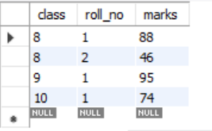

Students tables

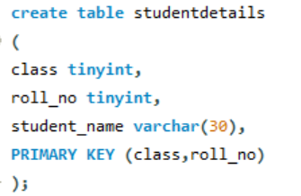

Insert into table

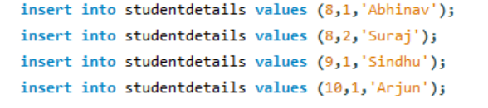

**Student details Table**

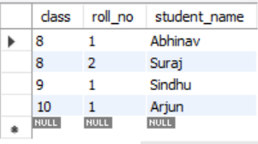

**Fetch the value of highest marks from StudentMarks table**

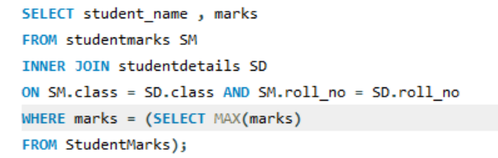

**Result**

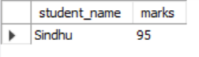

**Example: –**

Imagine re-correction has happened in the school and the teacher revealed that “Six marks were reduced from the paper of Highest marks student in re-correction”.

Create table studentmarks



Run a Query

