GlycoLens Milestone 1 Progress Report
Technical feasibility, quantified results, and Milestone 2 priorities
Prepared by | Sourav Patil
Prepared for | Professor Haibo Yang
Date | October 1, 2026

Executive Summary
Milestone 1 is complete as a technical-feasibility milestone. The primary dataset can be converted into leakage-safe meal windows, Chronos-2 can produce a two-hour forecast through the common adapter, the forecast contract can travel through a FastAPI and Next.js application boundary, the local database enforces ownership controls, and the pinned py-mgipsim virtual-patient scenario runs reproducibly.
This result establishes readiness for Milestone 2. It does not yet establish forecast accuracy, clinical validity, or treatment usefulness. TimesFM was optional for Milestone 1 and has not been integrated. The next phase must benchmark model quality across participant-aware splits and connect the meal and nutrition workflow to the working forecast interface.

Project Goal
GlycoLens is a mobile-first research application for understanding how a planned or logged meal relates to a two-hour glucose forecast for a person with Type 1 Diabetes. The project evaluates existing pretrained time-series models instead of training a large model from scratch. The application will combine verified meal nutrition, recent CGM and insulin context, model uncertainty, and the user's own meal history.

Milestone 1 Conclusion
- The course-defined feasibility and planning requirements are satisfied.
- One pretrained model, Chronos-2, runs on a real eligible T1D-UOM context and returns a valid 24-point forecast.
- The synthetic application boundary, local database contract, and offline py-mgipsim scenario are executable and tested.
- TimesFM, full model benchmarking, and the real meal-to-model application flow remain Milestone 2 work and do not block Milestone 1 closure.
- Research data, application data, credentials, and generated artifacts remain separated.
- The system remains a research prototype and does not recommend insulin doses or provide treatment guidance.

Verified Milestone 1 Status
The status below reconciles the original Milestone 1 checklist with the implemented repository and final closure audit. Complete for Milestone 1 means the required planning or feasibility evidence exists; it does not mean the full capstone feature or benchmark is finished.
Milestone 1 item | Current status | Evidence and boundary
Literature survey and model matrix | Complete | Candidate roles, evidence, risks, and selection criteria are documented.
T1D-UOM provenance and audit | Complete | V1.0.4 is pinned and 386,564 core rows were audited.
Meal-centered preprocessing | Complete for M1 | The pipeline produced 927 strict, leakage-safe windows.
Evaluation and leakage protocol | Complete for M1 | Future CGM is separated from model input. Final split freeze and sensitivity analysis move to M2.
Common forecast adapter | Complete | One immutable request/result contract supports baselines and pretrained adapters.
Persistence baseline | Complete for M1 | The adapter and real-window smoke path work. The participant-aware benchmark remains M2.
Chronos-2 smoke test | Complete | The pinned CPU model returned 24 finite, non-crossing q10/q50/q90 points.
TimesFM smoke test | Not completed; non-blocking | The M1 plan said if possible. Chronos-2 satisfies the pretrained-model feasibility criterion.
Runtime, memory, and quantiles | Complete | Load time, first/warm latency, peak RSS, output shape, and quantile ordering were recorded.
Next.js and FastAPI skeleton | Complete for M1 | The browser consumes a typed synthetic forecast. Real model execution is not yet in the request path.
Database migration | Complete locally | Ten tables, pgvector, constraints, indexes, RLS, and 20 pgTAP tests passed. No hosted project was linked.
py-mgipsim scenario | Complete | The pinned ExtHovorka/OpenLoop day produced 288 samples twice with byte-identical output. It remains offline.
Milestone presentation | Complete | The seven-slide editable RIT deck passed package, layout, privacy, and visual checks.

Repository and Reproducibility
The implementation is organized as a modular monolith with separate research, backend, frontend, database, and simulation modules. Package versions, model revisions, dataset provenance, database migrations, and simulator source revisions are pinned. Raw research data, model weights, credentials, generated figures, and local database state are excluded from Git.
Repository: github.com/sourav1859/GlycoLens

Dataset Audit and Meal Windows
The primary dataset is T1D-UOM V1.0.4, pinned to Zenodo DOI 10.5281/zenodo.17361905 and release commit ea52718b41cd27286df46acf87825555d4ec0463. The audit covered 62 CSV files and 386,564 rows across CGM, nutrition, bolus insulin, and basal insulin.
Measure | Result | Interpretation
Participants | 17 total | Small cohort; suitable for retrospective feasibility and participant-aware evaluation
Multimodal cohort | 15 participants | CGM, nutrition, and at least one insulin stream are available
All four core streams | 13 participants | CGM, nutrition, bolus, and basal data are all present
Valid loaded meals | 3,884 | Meal events evaluated under the initial strict policy
Eligible windows | 927 | Each contains 24 history points and 24 held-out target points
Eligibility yield | 23.87% | Enough windows for benchmarking, but filtering sensitivity must be studied

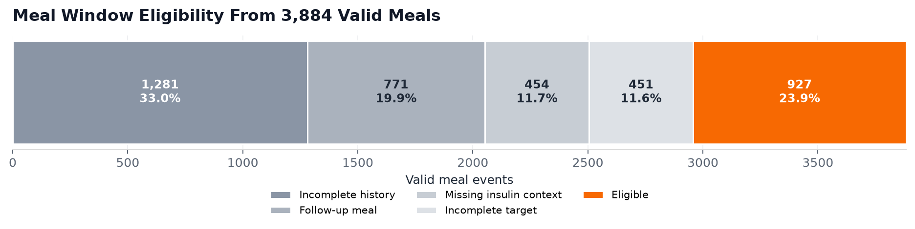
Figure 1. Sequential first-failure outcomes under the initial meal-window policy. Categories are mutually exclusive by construction.

Important Data Findings
- The source timestamps are day-first even though the upstream README describes month-first formatting. Parsing the wrong order could silently move records to the wrong date.
- The pipeline excludes 253 conflicting CGM timestamp groups instead of averaging them and excludes meals without a precise time.
- Every accepted window enforces the meal-time boundary, rejects a second meal in the forecast horizon, and keeps future CGM outside model-visible input.
- The 927 windows demonstrate usable volume, but the 17-participant cohort does not support broad population claims.

Forecasting and Application Results

Forecast Contract and Baseline
The common ForecastModelAdapter interface now supports baseline and pretrained models without changing the application. ForecastRequest contains only information available at forecast time. ForecastTarget stores future CGM separately for later evaluation. The persistence baseline runs through the same interface and provides a deterministic reference for Milestone 2.

Chronos 2 Technical Feasibility
The pinned amazon/chronos-2 checkpoint produced 24 five-minute q10, q50, and q90 forecast points from 24 historical CGM points on CPU. The result contained finite, non-crossing quantiles, and the adapter received no held-out future CGM. The final closure rerun recorded the measurements below.
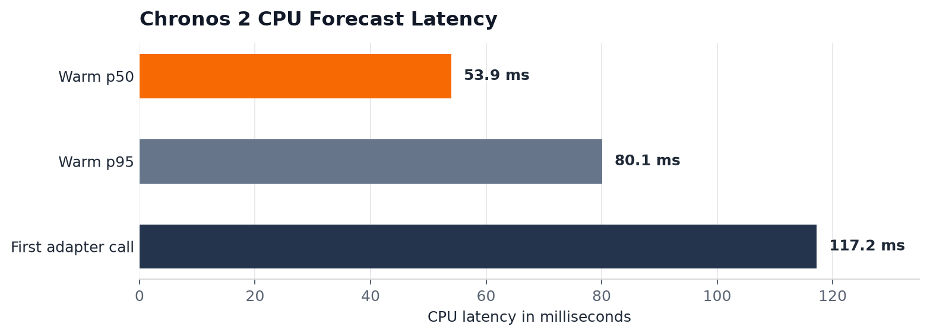
Figure 2. Machine-specific CPU smoke-test latency. Model load was 22.61 seconds and observed peak process memory was 810.91 MiB.
These timings demonstrate that local CPU inference is practical for a capstone prototype. They do not measure prediction quality. The smoke test used one eligible CGM-only window, so the model still requires a participant-aware accuracy and calibration benchmark.

Working Application Boundary
- FastAPI exposes a health route and a typed synthetic forecast route.
- The Next.js PWA displays 24 history points, 24 forecast points, the q10-q90 interval, and 30-, 60-, and 120-minute summaries.
- The interface includes loading, failure, retry, accessibility, uncertainty, and no-dosing messages.
- The public demonstration remains synthetic; real Chronos-2 execution is currently a separate research command.

Database Simulator and Validation

Local Application Database
The local Supabase migration creates ten application tables for users, CGM, insulin, activity, foods, meals, meal items, forecasts, forecast points, and meal outcomes. It also enables pgvector, creates constraints and indexes, and applies row-level security to every exposed table. The research dataset is not stored in the application database.

Virtual Patient Scenario
The pinned py-mgipsim ExtHovorka/OpenLoop scenario produced 288 five-minute samples over one synthetic day. Two real executions produced byte-identical output. The simulated glucose range was 106.62 to 141.78 mg/dL, with a mean of 118.62 mg/dL. This result validates deterministic software execution, not physiological realism or treatment safety.

Final Validation Record
Validation area | Result
Python regression suite | 73 passed; 1 explicit simulator opt-in skip
Real simulator integration | 11 passed, including two real executions
Frontend behavior | 3 files and 5 tests passed
Frontend static and build checks | ESLint, TypeScript, and production build passed
Database behavior | Clean reset, no lint errors, and 20 pgTAP tests passed
Repository skills | 9 validated with 0 failures
Privacy checks | No private academic addresses or absolute local paths detected
Presentation | 7 slides, 2 editable charts, 1 editable table, and complete visual review

Safety Boundary
GlycoLens remains a research prototype. It does not recommend insulin doses, control a pump, diagnose disease, claim clinical accuracy, or provide treatment instructions. Demonstration data are synthetic or de-identified, and credentials and row-level research data remain outside the repository.

Critical Assessment and Next Steps

What Milestone 1 Proves
- The chosen dataset can support hundreds of strict meal-centered evaluation windows.
- The leakage boundary is enforceable in code, and the same forecast contract can support multiple model adapters.
- Chronos-2 can run locally on CPU and return the required two-hour probabilistic shape.
- The API, browser visualization, local database, and simulator are executable foundations for the working prototype.

What Remains Unproven
- Forecast accuracy, calibration, and reliability across participants have not been measured.
- Chronos-2 currently supports only the CGM-only configuration; insulin and nutrition context still require a compatible adapter or representation strategy.
- TimesFM has not been integrated, and the final model comparison is still open.
- The application does not yet connect meal capture, nutrition resolution, real model inference, persistence, and retrieval in one user flow.
- The local Supabase work has not been deployed to a hosted project, and no real-user study is in scope without additional review.

Milestone 2 Priorities
Priority | Planned work | Expected evidence
1 | Freeze participant-aware train, validation, and test definitions | Reproducible evaluation cohorts with no temporal or participant leakage
2 | Benchmark persistence and Chronos-2 over the eligible event set | MAE, RMSE, horizon errors, calibration, latency, memory, and failed-run rate
3 | Add the planned context comparisons | CGM-only, CGM plus insulin, and CGM plus insulin and nutrition results
4 | Implement meal and nutrition capture with provenance | A verified meal object ready for forecasting
5 | Connect the model boundary to the working application | Meal to nutrition to forecast to visualization demonstration
6 | Add persistence and first similar-meal retrieval | Saved meal and forecast records with owner-isolated retrieval

Advisor Feedback Requested
- Confirm the primary evaluation metrics and whether uncertainty calibration should be a required Milestone 2 result.
- Confirm whether TimesFM should remain a required comparison or stay optional while the end-to-end application is completed.
- Confirm whether the next demonstration should prioritize the nutrition-to-forecast user flow or broader model comparison first.
Evidence sources. The detailed evidence is recorded in the repository's Milestone 1 closure audit, data-pipeline report, Phase 1 through Phase 6 reports, measurement protocol, planning pack, and validated Milestone 1 presentation.

