Algorithms :

0

3 1

2

**From this alogorithm we are finding the best node at which we can create substation .**

Slots requried to move from one node to other are , 0-------🡪1 S(1), 1-------🡪2 S(2) and 3----🡪1 S(3).

Where a in S(a) denote the number of slots required. On taking node 1 as intermediate we can minimise the to slot and this can be varified by applying Dijkstra’s on each one and the matric we get are given below.

|  |  |  |  |  |
| --- | --- | --- | --- | --- |
|  | 0 | 1 | 2 | 3 |
| 0 | 0 | 1 | 3 | 4 |
| 2 | 3 | 2 | 0 | 5 |
| 3 | 4 | 3 | 5 | 0 |

*(Not taking node 1 because we are proving that it is best node for substation,or it will not affect the result ) . Now add each column :-

|  |  |  |  |
| --- | --- | --- | --- |
| Node 0 | Node 1 | Node 2 | Node 3 |
| 7 | 6 | 8 | 9 |

Clearly from the summation table sum of slot required is minimum when we craete substation at node 1. Now suppose we have to send information to rest or some particular node there is two possibility i.e either slot required is less from source node or newly created substaion . we can check it from the matrix . For example let we have source node 0 and substaion node 1 and destination node 3 then two possibility is:-

1. We can send data from node 0 and for this we required 7 slots and other
2. We can send data from node 1 i.e substation and for this we required 6 slots .

So information/data will transfer from substation

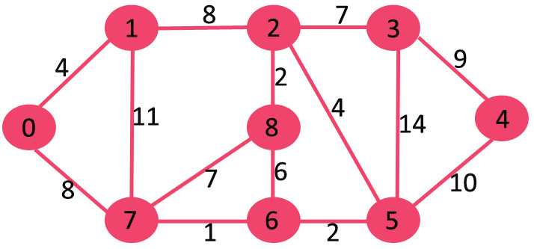

|  |  |  |  |  |  |  |  |  |  |
| --- | --- | --- | --- | --- | --- | --- | --- | --- | --- |
|  | 0 | 1 | 2 | 3 | 4 | 5 | 6 | 7 | 8 |
| 0 | 0 | 4 | 12 | 19 | 21 | 11 | 9 | 8 | 14 |
| 1 | 4 | 0 | 8 | 15 | 22 | 12 | 12 | 11 | 10 |
| 2 | 12 | 8 | 0 | 7 | 14 | 4 | 6 | 7 | 2 |
| 3 | 19 | 15 | 7 | 0 | 9 | 11 | 13 | 14 | 9 |
| 4 | 21 | 22 | 14 | 9 | 0 | 10 | 12 | 13 | 16 |
| 5 | 11 | 12 | 4 | 11 | 10 | 0 | 2 | 3 | 6 |
| 6 | 9 | 12 | 6 | 13 | 12 | 2 | 0 | 1 | 6 |
| 7 | 8 | 11 | 7 | 14 | 13 | 3 | 1 | 0 | 7 |
| 8 | 14 | 10 | 2 | 9 | 16 | 6 | 6 | 7 | 0 |

.