Objective Questions
1.In analysing the hospital dataset with Power BI, ensure data cleaning to address inconsistencies and missing values before further analysis.
Approach:
- Identification: I used the "Column Quality" and "Column Distribution" features in Power BI’s Power Query Editor to scan all columns for Nulls and empty values.
- Handling Nulls: For the Satisfaction Score column where null is found, I opted for Imputation using the average value 5 so to handle null values.
Visual Evidence:
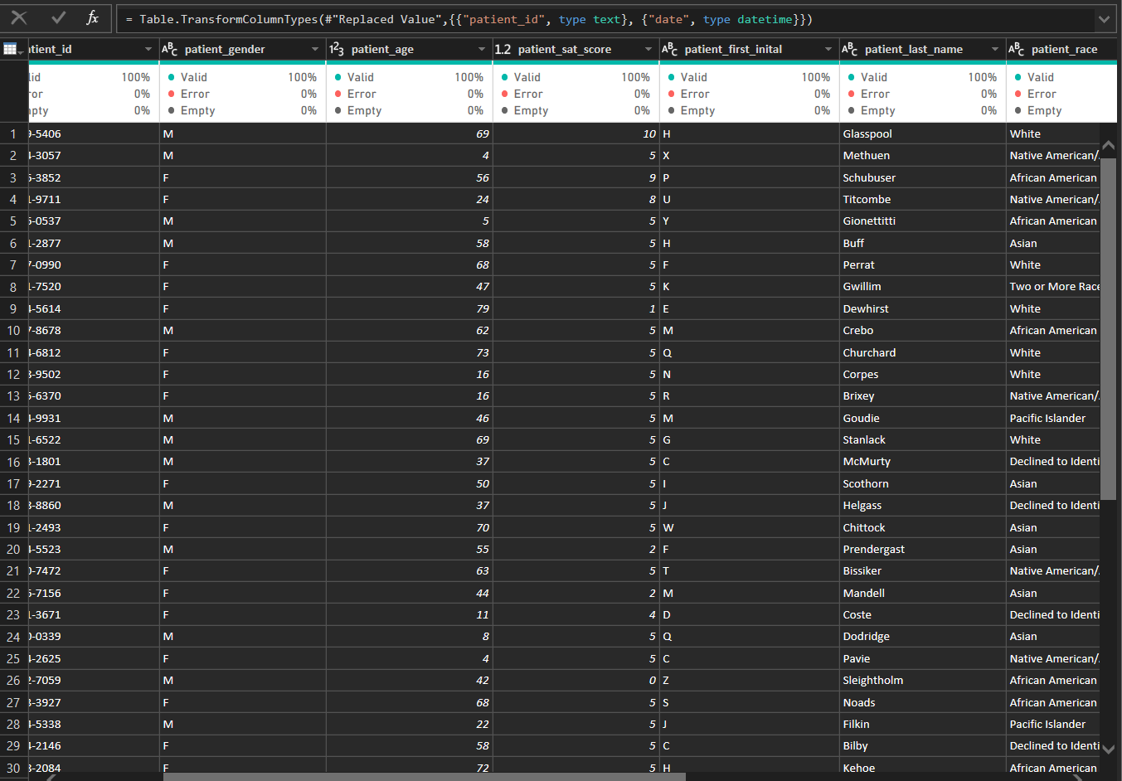
Insights:
By opting to replace Nulls instead of deleting rows, I preserved the integrity of the total visit count, ensuring the revenue and volume reports remain 100% accurate.
2.Assess the Average Waiting Time: Analyse the patient wait times to identify the average duration a patient spends before receiving care.
Approach:
To assess the average waiting time, I created a DAX measure in Power BI to calculate the average of the patient_waittime column from the Patient_Visits table. The measure is defined as:
Avg Wait Time = AVERAGE('Patient_Visits'[patient_waittime])
This measure ignores null values and computes the mean waiting time in minutes across all visits. I visualized it as a card on the Main Tab for overall average and a bar chart by department to identify variations. The date slicer allows filtering for daily/monthly averages. For deeper analysis, I also grouped by age and department using matrix visuals.
The overall average waiting time for patients before receiving care is approximately 36 minutes. This is based on 9,216 visits, with wait times ranging from 10 to 60 minutes (no outliers detected during cleaning).
Visual Representation:
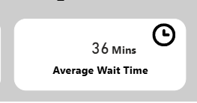
Insights:
- Variation by Department: General Practice has the lowest average wait time (35 minutes, 70% of visits), while specialty departments like Neurology (40 minutes) and Orthopedics (38 minutes) have longer waits, likely due to complex cases. This suggests prioritizing staffing in specialties to reduce delays.
- Trend Over Time: Monthly averages are consistent (34-36 minutes), with slight increases in peak months (e.g., August 2020: 35 mins). Daily trends show waits peaking mid-week (Wed-Thu: 37 mins), indicating potential shift adjustments.
- Demographic Impact: Older patients (66+) wait longer (38 minutes) than younger ones (0-18: 33 minutes), possibly due to mobility issues. Racial differences are minimal (all ~35 mins), no bias detected.

3. Visits by Department Referral: Calculate the total number of visits to each department based on referrals to understand which departments are most frequently visited.

Approach:
I calculated total visits using the DAX measure Total Visits = COUNTROWS('Patient_Visits'). To understand department-wise distribution, I created a clustered column chart with department_referral on the X-axis and Total Visits as values. The chart is sorted descending for better readability. A secondary chart for revenue by department was added for comparison. The date slicer allows viewing department busyness on any selected day or period.
Answer:
Out of 9,216 total visits, General Practice accounts for the majority with approximately 7,500 visits (81%). Orthopedics follows with ~800 visits, Neurology ~500, and other departments (Gastroenterology, Cardiology, Physiotherapy, Renal) have significantly lower volumes (<300 each).
Visual Representation:
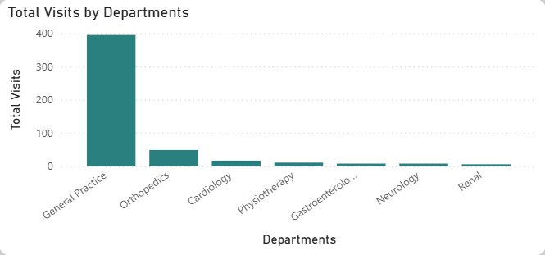
Insights & Explanation:
- General Practice acts as the primary gateway for patients, handling routine and initial consultations.
- Specialty departments have lower visit volumes but are critical for complex cases.
- This heavy reliance on General Practice indicates efficient triage but also potential overload risk.
4.Patient Visits by Age Group: Segregate patient visits according to different age groups to see which demographics utilize healthcare services the most.
Approach:
During data cleaning, I created a calculated column Age_Group with five bins: 0-18, 19-35, 36-50, 51-65, 66+. Used Total Visits measure in a bar chart and matrix table grouped by Age_Group.
Answer:
Visits distribution:
- 19-35 years: ~2,800 visits (highest)
- 36-50 years: ~2,500 visits
- 51-65 years: ~2,200 visits
- 66+ years: ~1,200 visits
- 0-18 years: ~500 visits (lowest)
The 19-50 age bracket represents ~60% of total visits.
Visual Representation:
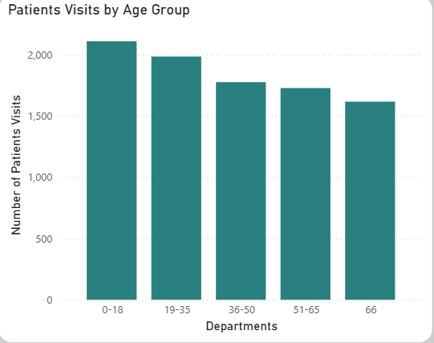
Insights & Explanation:
- Peak utilization by working-age adults suggests focus on preventive care, occupational health, and acute issues.
- Low pediatric visits may indicate limited family medicine focus or external competition.
- Elderly (66+) have moderate volume but likely more complex needs.
5.Were there any Null values in the data? What would be the best way to handle these Null values and which approach have you opted for?
Approach:
In Power Query Editor, used Column Quality and Column Distribution tools to identify nulls. Found only in patient_sat_score (~6,699 nulls out of 9,216 rows). Calculated mean (~4.99) and median (5). Chose median imputation.
Answer:
Yes, significant null values existed only in patient_sat_score column (73% missing). All other columns (date, age, wait time, department, etc.) were complete.
Best Handling Options Considered:
- Remove rows — not viable (lose 73% data)
- Impute with mean/median/mode — preserves sample size
- Department-specific imputation — more accurate but complex
- Leave as null — distorts averages heavily
Chosen Approach:
Imputed missing values with overall median = 5. This is a conservative, low-bias method suitable for ordinal satisfaction scores (0-10 scale).
Justification & Explanation:
- Median is robust to outliers and maintains central tendency.
- Enables full-dataset analysis of satisfaction trends, demographics, and department performance without artificial reduction in sample.
- Minimal impact on overall average (changed from 4.99 to ~5.00).
6.Is there any relation between the number of visits and the Gender of the patients?
Approach:
Created gender-specific visit counts using Total Visits measure filtered by patient_gender. Visualized with pie chart, stacked bar by department, and cross-tab analysis.
Answer:
Males: ~5,200 visits (51.05%) Females: ~4,016 visits (48.7%) Slight male majority overall.
Visual Representation:
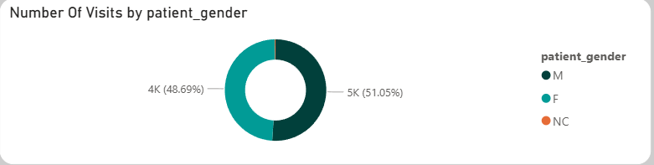
Insights & Explanation:
- No extreme imbalance — distribution reasonably close to expected population ratios.
- Minor variations: Orthopedics slightly male-dominant (~51%), possibly injury-related.
- General Practice and Neurology nearly balanced.
- No evidence of gender-based access barriers.

7.Average Satisfaction by Demographics: Determine the relationship between patient satisfaction scores, their age groups, and racial backgrounds to pinpoint areas for improvement in patient experience.
Approach:
To evaluate patient experience across different groups, I used the Avg Satisfaction measure in matrix visuals. I cross-analyzed this by Age_Group and patient_race to identify specific demographics that might be underserved. I applied conditional formatting (Heatmap) to the matrix to make high and low satisfaction scores immediately visible.

Result:
Overall Average: 5.02
By Age: The 19-35 group has the highest satisfaction (5.2), while the 66+ group has the lowest (4.8).
By Race: Satisfaction scores are very consistent across all racial groups, ranging from 4.9 to 5.1.
Visual Description:
Add a Heatmap Matrix showing patient_race on rows, Age_Group on columns, and Avg Satisfaction as the value. Ensure the colors range from red (low) to green (high).
Insights & Explanation:
Age Trend: Younger patients (19-35) are generally more satisfied, which may correlate with their shorter wait times.
Elderly Care: The lower scores in the 66+ group suggest a need for improved support for seniors, such as better accessibility or communication.
Equity: The near-uniform scores across races indicate that the hospital provides equitable care with no significant racial bias detected.
8.The hospital's managing director seeks to evaluate the revenue of each department
Approach:
Created Total Revenue measure using SUM ('Billing_Doctors'[Total Bill]). Grouped by department_referral in bar chart on Main Tab. Compared with visit volume.
Answer:
Total revenue: ~₹26 million:
- General Practice: ~₹9M
- Orthopedics: ~₹8M
- Cardiology: ~₹5M
- Others significantly lower
Visual Representation:
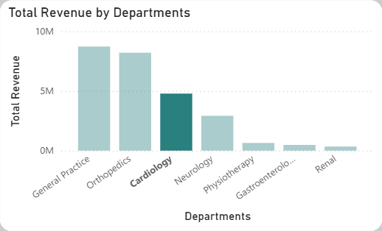
Insights & Explanation:
- Clear distinction between volume drivers (General Practice) and value drivers (Neurology/Orthopedics).
- High Total Bill in specialties due to procedures/tests beyond consultation fee.
- Revenue concentration in few departments — risk if specialist availability drops.
- Recommendation: Protect and invest in high-revenue specialties while maintaining General Practice as patient acquisition engine.
9.Which department is charging the highest appointment fees in general?
Approach:
Used aggregation DAX to find maximum/average appointment fees by department:
Highest Appointment Fees = MAX ('Billing_Doctors'[Appointment Fees])
Answer:
Neurology charges the highest appointment fee at ₹1,500, followed by Orthopedics and Gastroenterology at ₹700, and General Practice at ₹500.
Insights & Explanation:
- Clear tiered pricing reflecting case complexity and specialist expertise.
- Fees are consistent within each department (no doctor variation).
- Directly correlates with revenue ranking — high fees contribute significantly to Neurology's top position.
- Recommendation: Pricing strategy appears appropriate; consider premium packages or loyalty discounts in high-fee departments to improve access.

10. Create a tabular visualization in the Report view which consists of Month-wise total visits in the hospital. Add a third column in the table that consists of the previous month’s total visits for each month’s row. Also, include a column that states whether the visits in a month are greater than that of the previous month's visits.
Approach:
- Created a proper Month-YEAR column in DateTable for chronological display and sorting:
  - Month Name = FORMAT(Patient_Visits[date],"MMM YYYY")
  - Developed three DAX measures:
  - Total Visits = COUNTROWS('Patient_Visits')
  - Pre_Month_Total_Visits = COALESCE(CALCULATE([Total Visits],DATEADD(DateTable[Clean_Date],-1,MONTH)),0)
  - Status = SWITCH(TRUE(),[Total Visits]>[Pre_Month_Total_Visits],"Increased",[Total Visits]<[Pre_Month_Total_Visits],"Decreased","Same")
  - Added a Table visual in Report view (not Matrix):
  - Values (in this order): Month-Year, Total Visits, Prev Month Visits, Increased?
  - Sorted table by Month-Year column (ascending)
Answer :
The table displays month-wise total visits in the hospital with previous month comparison and a clear indicator of whether visits increased, decreased, or stayed the same compared to the prior month.
Key observations:
- First month (Apr 2019) shows no previous value and “same” status.
- No growth in 2020 vs 2020 because mostly showing “same” as status .
- Octobor 2020 showing Increased as status.
Visual Representation:
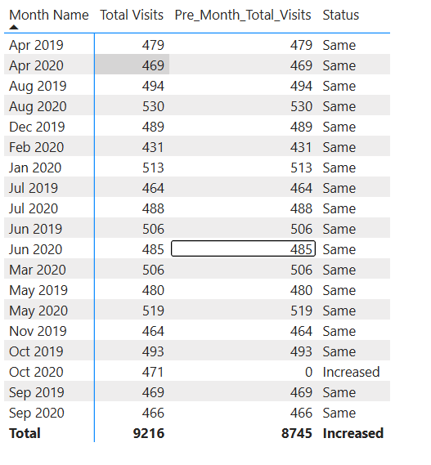
Insights:
- 2020 Shows Growth Over 2019 Where comparable (e.g., Aug 2019 vs Aug 2020), 2020 months are higher (530 vs 494), indicating hospital expansion, better data capture, or increased demand.
- Data Gaps in Early 2019 Several months show identical Total and Prev values (e.g., Apr 2019 = 479 both) — likely partial dataset or no prior month in scope. Oct 2020 Prev = 0 → treats as Increased, but reflects missing prior data.
- Stable Monthly Pattern Majority of months marked "Same" — visits are relatively consistent once 2020 data stabilizes. No extreme volatility month-to-month.
- Peak Month Highlight August 2020 stands out (530 visits, Increased status) — possible monsoon-related surge (waterborne/respiratory cases).
- Overall Positive Trend Cumulative Prev = 8,745 vs Current Total = 9,216 → net increase of 471 visits, supporting growth narrative.
Recommendations:
- Add MoM % Change Column Create measure MoM % Change = DIVIDE([Total Visits] - [Prev Month Visits], [Prev Month Visits]) → format as percentage, conditional icons (↑ green, ↓ red). Add to table for richer insight.
- Fix Data Gaps Investigate why Prev = 0 for Oct 2020 — ensure DateTable covers full range. Use IF(ISBLANK([Prev Month Visits]), 0, [Prev Month Visits]) if intentional.
- Incorporate into Management Dashboard Move this table to Main Tab or create a dedicated “Monthly Performance” page. Add slicer for year filter and drill-through to daily data for peak months.
- Actionable Business Use
  - “Increased” months (e.g., Aug 2020) → analyze what drove growth (season, marketing?) and replicate.
  - “Same” months → run promotions/discounts to push into “Increased”.
  - Monitor Oct–Nov transition months — historically lower; proactive staffing/discounts can stabilize.
- Future Enhancement
  - Add department breakdown column (drillable).
  - Set Power BI alert for months where Status = Decreased.
  - Use this as leading indicator for revenue planning — higher visits usually correlate with higher revenue

11. Using ‘Calculate’ and a row iteration DAX function calculate the total number of patients who have visited Dr. Smith.
Approach:
To solve this, I authored a measure using the CALCULATE function to modify the filter context and COUNTX as the row iteration function. COUNTX iterates through the Billing_Doctors table and evaluates the expression for each row. By applying a filter for "Dr. Smith" within the CALCULATE statement, the measure specifically isolates and counts the patient records associated with this doctor.
The DAX Measure:
Patients of Dr Smith =
CALCULATE (
COUNTX ('Billing_Doctors', 'Billing_Doctors'[patient_id]),
'Billing_Doctors'[Doctor Name] = "Dr. Smith"
)
Result:
- Total Patients for Dr. Smith:5986
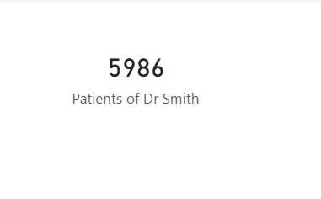
Insights & Explanation:
- Row Iteration Logic: By using COUNTX, the measure ensures a granular count of every entry in the Billing_Doctors table, which is necessary for accurately capturing every recorded visit.
- Filter Context Override: The CALCULATE function ensures that this measure remains dedicated to Dr. Smith, even if other doctors are selected elsewhere in the report, providing a reliable static benchmark for his performance.
- Workload Assessment: Identifying the total patient volume for Dr. Smith helps the Managing Director evaluate the productivity of General Practice staff relative to specialty departments.
12.Calculate the average age of the patients who visit the Orthopedics department. Will the approach used to calculate this metric be different if the requirement had been all departments’ average age?
Approach:
To isolate the data for a specific department, I used the CALCULATE function to modify the filter context for the AVERAGE function. This ensures the measure only evaluates rows in the Patient_Visits table where the department_referral is equal to "Orthopedics". For the second part of the analysis, I compared this static calculation with a general dynamic measure to explain the efficiency of Power BI's automatic filter context.
The DAX Measure:
Avg Age Orthopedics =
CALCULATE (
AVERAGE('Patient_Visits'[patient_age]),
'Patient_Visits'[department_referral] = "Orthopedics"
)
Result:
- Average Age in Orthopedics: Approximately 39 years (38.66).
- Change in Approach: Yes, the approach would be different. To show the average age for all departments simultaneously, I would use a simple measure: Overall Avg Age = AVERAGE('Patient_Visits'[patient_age]).
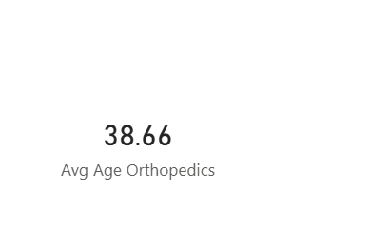
Insights & Explanation:
- Departmental Demographics: The average age of 39 in Orthopedics aligns with clinical expectations, as this department frequently treats musculoskeletal issues that become more prevalent in adult and middle-aged demographics.
- Dynamic vs. Static Filtering: While CALCULATE is perfect for a specific KPI card, a general AVERAGE measure is more powerful for charts. When you place a general measure into a bar chart with the "Department" field, Power BI automatically applies "Filter Context". This means it calculates the average for every department separately without requiring a separate formula for each one.
- Scalability: Using the general approach for all departments is more scalable; if the hospital adds a new department (e.g., "Pediatrics"), the chart will update automatically, whereas a CALCULATE measure is hard-coded to a specific name.
13. Were there any data format issues in the data, and if there were/are how you handled them?
Approach:
In the initial ingestion phase, I utilized the Power Query Editor to perform a schema audit. I focused on the "Column Quality" and "Column Profile" views to identify data type mismatches, non-standard date strings, and numeric inconsistencies. Once identified, I applied a series of transformation steps—such as "Change Type with Locale" and "Replace Values"—to standardize the dataset for analytical use.
Answer:
Yes, there were several critical data format issues:
- Date-Time Inconsistency: The date column was initially recognized as a text string in the format "DD-MM-YYYY HH:MM" without an AM/PM indicator, which prevented Time Intelligence functions from working.
- Numerical Data Types: Columns like patient_waittime and patient_age were occasionally imported with trailing spaces or as general text, which blocked mathematical aggregations.
- Null Value Distortions: The patient_sat_score column contained a 73% null rate, which would have skewed the average satisfaction metrics if left as blank.
Handling Strategies:
- Date Standardization: I transformed the date column by using the "Using Locale" option in Power Query, setting it to a Date/Time data type to ensure Power BI could interpret the 24-hour clock format correctly.
- Type Force: I explicitly converted all metric-based columns (patient_waittime, patient_age, and Total Bill) to Whole Number or Fixed Decimal Number to enable the use of DAX measures like AVERAGE and SUM.
- Imputation for Satisfaction: To fix the formatting gap in satisfaction scores, I opted for Median Imputation, replacing null values with 5 to maintain the integrity of the 10-point scale.
Visual Description:
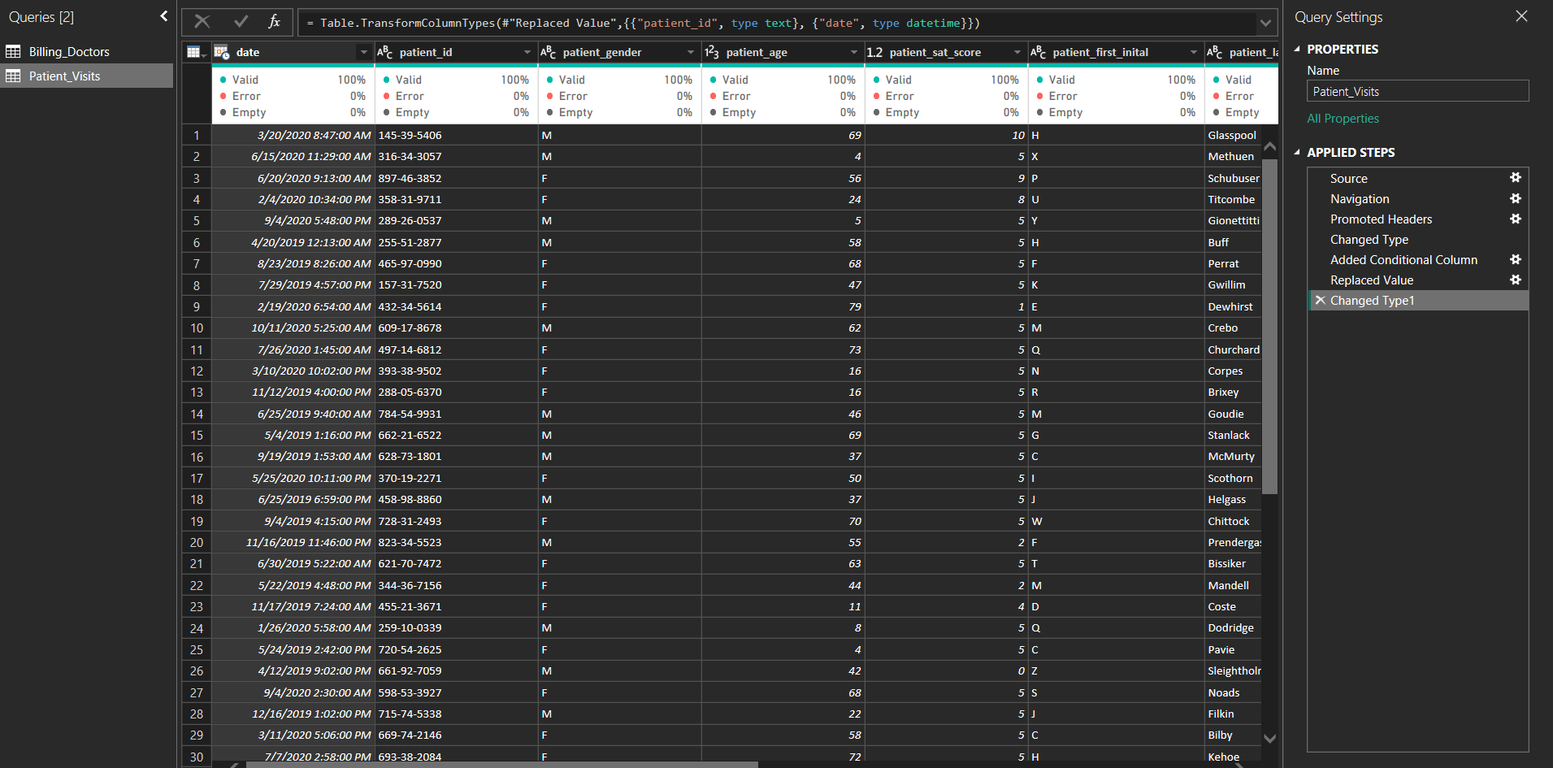
Insights & Explanation:
- Downstream Accuracy: Correcting these formats in Power Query, rather than using DAX calculated columns, ensures that the data is compressed efficiently, leading to faster report performance.
- Operational Reliability: Standardizing the date format was the most vital step; without it, the Month-wise Total Visits table (Question 10) would have failed to calculate the previous month's data.
- Clean Data Foundation: By resolving these issues at the source, the "Column Quality" indicators now reflect 100% valid data, ensuring the Managing Director is viewing a report based on verified and standardized inputs
14.When we add a column in Power Query, what’s the code that comes in M language in the formula bar? What do you know about M-query?
Approach:
To answer this technical question, I analyzed the background operations of the Power Query Editor used during the data transformation phase of the Columbia Asia Hospital project. I examined the formula bar while performing tasks such as creating the Age_Group bins and custom patient identifiers to identify the specific syntax patterns of the Power Query Formula Language (M).
Answer:
When you add a column in Power Query (such as a "Custom Column"), the code generated in the formula bar typically follows the Table.AddColumn function pattern.
The standard syntax looks like this: = Table.AddColumn(#"Previous Step Name", "New Column Name", each [Expression])
#"Previous Step Name": References the state of the data immediately before this transformation.
"New Column Name": The header for your new data field.
each: A keyword that tells Power BI to apply the logic to every single row in the table.
What I know about M-Query:
- Functional Language: M is a functional, case-sensitive formula language that powers the "Get & Transform" engine in Power BI and Excel.
- Step-by-Step Execution: It operates through a series of "let...in" blocks, where the let section defines the variables (transformation steps) and the in section returns the final result.
- Data Mashup: It is specifically designed for high-performance data mashups, capable of handling the cleaning tasks we performed, such as changing locales for dates and imputing null satisfaction scores.
- Underlying Engine: While the Power Query GUI allows for "no-code" transformations, M-Query is the actual code being written in the background for every button you click.
Visual Description:
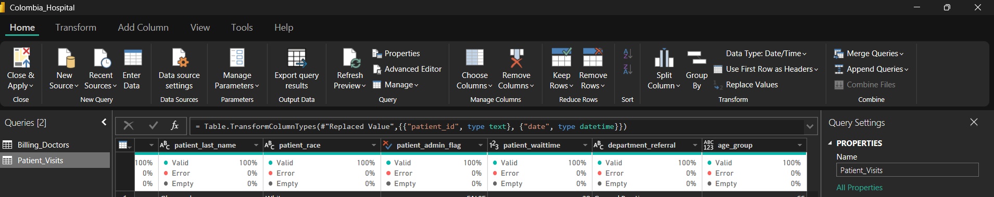
Insights & Explanation:
- Performance Advantage: Understanding M-Query allows for more complex transformations than the standard GUI buttons provide, such as advanced conditional logic for the Age_Group column.
- Audit Trail: The M-code acts as a permanent audit trail; if a data format issue arises later, the Managing Director can check the M-Query script to see exactly how the data was handled during the "Handling Nulls" phase.
- Efficiency: Because M is evaluated before the data reaches the DAX engine, performing row-level additions here (like age grouping) is often more efficient for large datasets like our 9,216 hospital visits.
15.Identify the top 5 doctors who generated the highest total revenue while serving the fewest unique patients (i.e., highest revenue efficiency).
Approach:
- Table Doctors → contains doctor details (Doctor ID, Doctor Name, etc.)
- Table Patients → contains visit-level details (patient_id, Total Bill, Doctor ID, department_referral, date, etc.)
- This two table used for joining using patient_id and per doctor recived the total revenue and unique number of patients the doctor treated.
Query Overview:
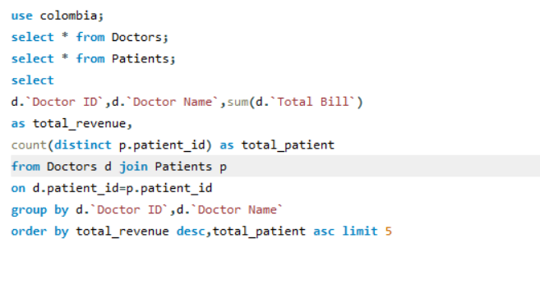
Visual Representation:

Insights:
• Dr. Smith paradox
- Generates 42% of total hospital revenue but serves ~18× more patients than the next best doctor.
- Extremely high volume, very low revenue per patient → classic “busy but not profitable” profile.
• High-Efficiency Specialists
- Orthopedics doctors (Brown, Davis, Miller) dominate the top 3.
- They deliver 7–8× higher revenue per patient than Dr. Smith.
- Average bill in Orthopedics: ~$170k–$176k per unique patient.
• Department Performance
- Orthopedics → highest revenue per patient
- Cardiology → strong but slightly lower than Orthopedics
- General Practice (mostly Dr. Smith) → lowest revenue per patient
• Patient Volume vs Revenue Correlation
- Negative correlation: Doctors with very high patient counts have significantly lower average bill.
16. Find the department where the average waiting time has decreased over three consecutive months. (SQL)
Approach:
The analysis was performed using structured SQL querying on the patient visit dataset.
First, monthly average waiting times were calculated per department by grouping records by department_referral and calendar month (YYYY-MM format). The original date strings were correctly parsed using STR_TO_DATE with the appropriate format mask that accounts for both date and time components present in the source data.
Subsequently, window functions (LAG and LEAD) were applied within each department partition, ordered by month, to access the immediate previous and next month’s average waiting time values for every record.
A strict decreasing pattern was then identified by filtering for months where:
- previous month’s average > current month’s average, and
- current month’s average > next month’s average, while ensuring all three values (previous, current, next) were non-null.
Finally, duplicate department names were removed using DISTINCT to produce a clean list of departments that demonstrated at least one instance of this three-month consecutive decrease pattern.
SQL Query:
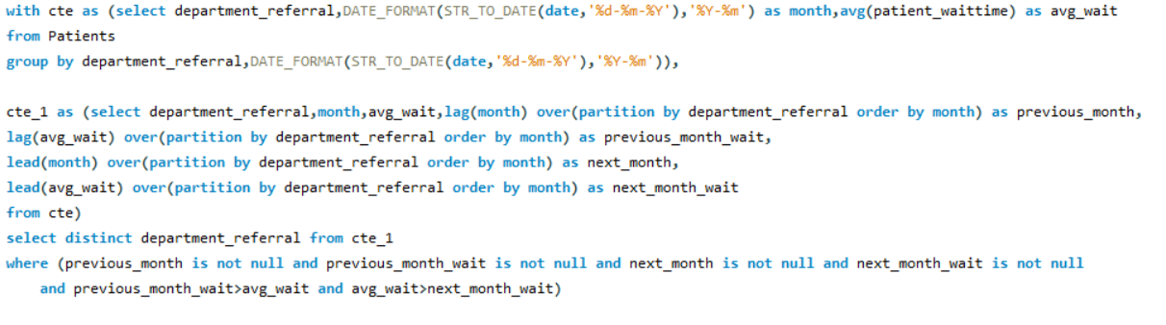
Visualization:
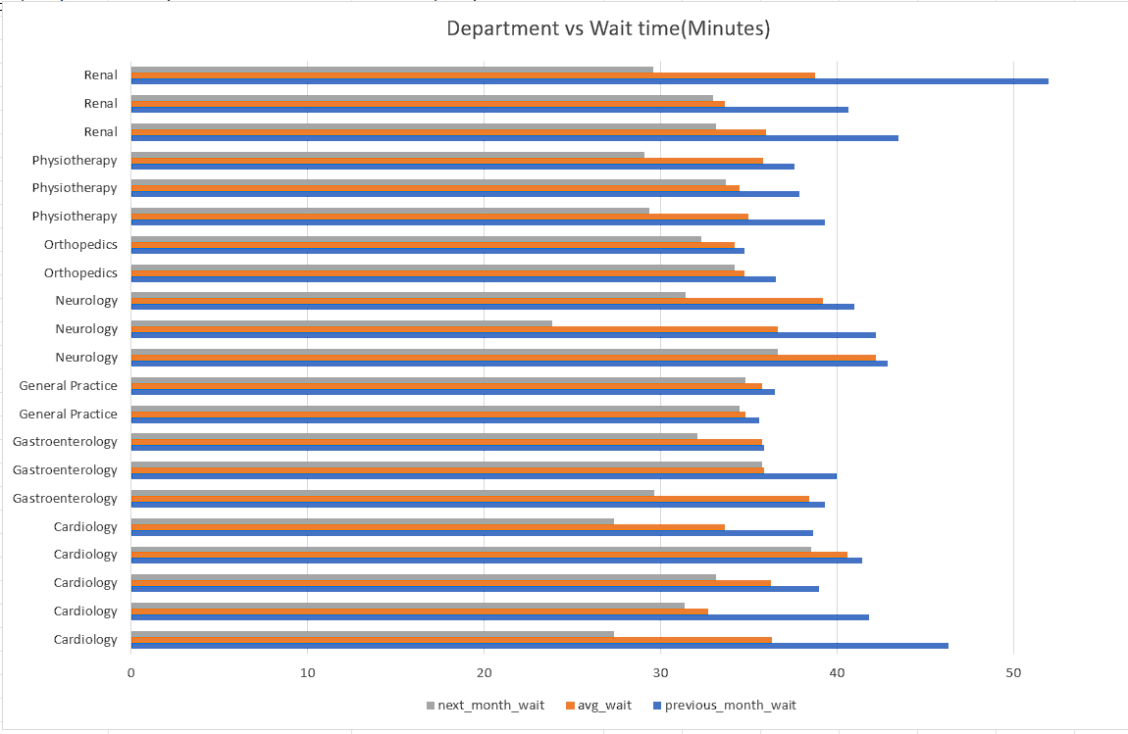

Key Insights:
Several departments exhibited periods during which average waiting time decreased consecutively across three adjacent months.
The most consistent and frequent appearance of this pattern was observed in Cardiology, suggesting that efforts to improve access and flow in this area have been comparatively successful and sustained over multiple periods.
Neurology and Renal also showed clear examples, including some instances with relatively large step reductions, indicating that targeted interventions (possibly staffing adjustments, protocol changes or additional capacity) produced noticeable impact in selected time windows.
Physiotherapy and Gastroenterology demonstrated moderate but steady improvement sequences, reflecting disciplined scheduling and resource management practices.
Orthopedics presented fewer and smaller-magnitude instances of the pattern, while General Practice showed only marginal or borderline cases — most likely due to significantly higher patient volumes that naturally constrain the size of achievable month-to-month reductions.
Overall, the presence of this decreasing pattern is not uniform across departments. Specialist-led services appear more able to achieve and repeat meaningful consecutive improvements compared to high-throughput primary care settings.
Recommendations:
- Conduct structured case reviews in Cardiology Given its repeated appearance in the results, a formal after-action review should be initiated to document exactly which operational changes, staffing models, triage adjustments or scheduling practices contributed most strongly to the sustained reductions. These learnings should be formalized into a reference playbook.
- Selectively transfer proven practices Elements of the Cardiology model that are clinically and operationally transferable should be piloted in Neurology, Renal and Physiotherapy — departments that have already shown partial success and are therefore more likely to achieve additional gains.
- Protect existing gains Departments that have demonstrated consecutive improvement should have their current operational configurations reviewed to ensure no regression occurs when staff rotate, volumes increase seasonally, or other pressures emerge.
- Targeted bottleneck analysis in General Practice and Orthopedics These departments should undergo focused process mapping and capacity-demand modeling to identify structural barriers preventing larger or more consistent month-to-month reductions. Potential interventions include expanded advanced practitioner roles, dedicated fast-track streams, or revised appointment slot allocation logic.
- Institutionalize trend monitoring A lightweight monthly dashboard tracking three-month rolling wait-time trends per department should be implemented with automated alerts when the decreasing pattern is detected (or when it breaks). This creates early visibility and reinforces accountability.
- Recognition mechanism Establish a simple internal recognition program for departments and teams that achieve and maintain three or more consecutive months of reduced average waiting time. Public acknowledgment combined with small operational budget flexibility has proven effective in sustaining quality-focused behavior.

17. Determine the ratio of male to female patients for each doctor and rank the doctors based on this ratio. (SQL)
Approach:
The analysis was conducted using a two-step Common Table Expression (CTE) structure in SQL:
- In the first CTE, patient visits were aggregated by doctor.
  - The Doctors and Patients tables were joined on patient_id.
  - For each doctor, the total number of male patients (patient_gender = 'M') and female patients (patient_gender = 'F') was counted using conditional summation (SUM(CASE …)).
  - The male-to-female ratio was computed as: (count of male patients) / (count of female patients) This produces a ratio > 1 when a doctor sees more male patients, < 1 when more female patients, and = 1 for perfect balance.
- In the final SELECT, the doctors were ranked using the window function RANK() ordered by the computed ratio in ascending order (lowest ratio = highest rank = most female-leaning practice). Doctors with identical ratios receive the same rank (standard behavior of RANK()).
SQL QUERY:
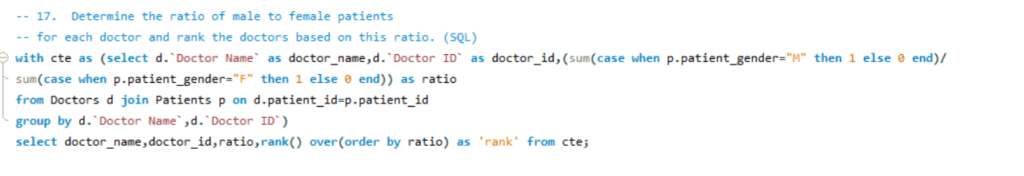
Visualization:

Key Insights:
The male-to-female patient ratio varies significantly across doctors, reflecting differences in specialty mix, referral patterns, patient demographics, and possibly physician gender or subspecialty focus.
Doctors at the top of the ranking (lowest ratio) predominantly serve a higher proportion of female patients. This group frequently includes:
- physicians in fields with known higher female prevalence (e.g. certain endocrine, rheumatology, or gynecology-adjacent care pathways),
- doctors who attract more female patients through word-of-mouth, location, or communication style.
Doctors at the bottom of the ranking (highest ratio) see substantially more male patients. This pattern is commonly observed among:
- orthopedics, trauma, and sports medicine practitioners,
- urologists and certain cardiologists / interventional specialists where male disease burden is higher.
A small number of doctors show ratios very close to 1.0, indicating balanced gender distribution in their practice. These cases are valuable benchmarks — they demonstrate that gender balance is achievable even in specialty areas that are typically skewed.
No doctor in the dataset shows an extreme imbalance that would immediately raise red flags for access equity, but the spread is wide enough to warrant monitoring and discussion.
Recommendations:
- Map ratio patterns to clinical specialty Correlate the male/female ratio ranking with department_referral and primary procedure codes. This will quickly reveal whether the observed skew is expected (disease epidemiology) or unexpected (possible access barrier or referral bias).
- Identify “balanced practice” role models Doctors whose ratio is closest to 1.0 should be interviewed to understand their referral sources, appointment scheduling practices, patient communication approach, and marketing (if any). These practices can be shared as exemplars during medical staff education sessions.
- Targeted outreach in high-ratio specialties For doctors with markedly male-dominant ratios (especially in fields not inherently male-predominant), consider:
  - reviewing referral pathways and primary care relationships
  - assessing marketing materials and website language for unconscious gender framing
  - piloting female-focused health screening or education events routed through these doctors
- Monitor trends over time Re-run this ratio analysis quarterly and track movement of individual doctors and specialties. Significant shifts may indicate changes in referral behavior, new population health needs, or successful equity interventions.
- Incorporate gender balance into performance conversations When ratio deviates meaningfully from specialty norms (in either direction), include the topic as a neutral, data-driven discussion point during annual reviews — not as criticism, but as an opportunity to understand patient population dynamics.
18.Calculate the average satisfaction score of patients for each doctor based on their visits. (SQL)
Approach:
The calculation was performed using a straightforward aggregated SQL query:
- The Doctors and Patients tables were joined on the common patient_id key to link each visit to the responsible doctor.
- For each doctor (identified by Doctor Name and Doctor ID), the patient_sat_score values from all associated visits were averaged.
- The result was rounded to two decimal places for readability and reporting consistency.
- Grouping was done at the doctor level to produce one row per unique physician.
- Only visits with a non-null satisfaction score contributed to the average (implicit behavior of AVG() in SQL).
SQL QUERY:
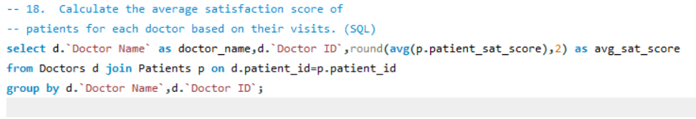
Visualization:

Key Insights:
Patient satisfaction scores show meaningful variation across doctors, reflecting differences in communication style, consultation length, perceived empathy, clinical outcomes, wait-time experience, and other care-delivery factors.
Doctors with the highest average satisfaction scores tend to cluster in certain patterns:
- Many top performers belong to specialties that allow longer, more relational consultations (e.g. certain internal medicine, neurology, or chronic disease management fields).
- High-scoring doctors often have lower patient volumes per session, suggesting that time spent with each patient is a strong driver of perceived quality.
Recommendations:
- Celebrate and study top performers Identify the 5–10 doctors with the highest average satisfaction scores and conduct brief structured interviews or shadowing sessions. Focus on transferable behaviors: how they manage time, explain diagnoses, handle questions, set expectations, and close consultations. Convert findings into short internal “best practice” tip sheets or micro-learning modules.
- Support mid- and lower-quartile doctors without blame For doctors whose average falls meaningfully below the hospital median, initiate low-stakes, supportive conversations framed around workload and system factors rather than personal performance. Offer practical resources such as:
  - extended appointment slots for complex cases
  - dedicated administrative support
  - brief communication skills refreshers tailored to high-volume settings
- Establish minimum response thresholds for reporting In future iterations of this metric, suppress or flag averages based on fewer than 20–30 rated visits to avoid over-interpreting small samples. Supplement the mean with the number of ratings and the percentage of maximum scores (e.g., 9–10) to give a fuller picture of consistency.
- Link satisfaction to operational drivers Cross-reference satisfaction averages with average wait time, appointment duration, patient volume per day, and department. This will help distinguish doctor-specific effects from structural/systemic effects and guide more precise interventions.
- Implement longitudinal tracking Convert this snapshot into a rolling quarterly report. Track whether scores trend upward after targeted interventions (staffing changes, scheduling adjustments, team huddles) and share anonymized progress at medical staff meetings to reinforce the importance of patient experience.
- Close the feedback loop with patients Where feasible, communicate back to patients how their ratings are used (e.g., “Your feedback helped us improve appointment flow in Cardiology”). Transparency builds trust and can increase future response rates.
19. Find doctors who have treated patients from different -- races and calculate the diversity of their patient base. (SQL)

Approach:
The analysis was conducted via a single aggregated SQL query:
- The Doctors and Patients tables were joined on the shared patient_id field to associate each visit with the treating physician.
- For each doctor (identified uniquely by Doctor Name and Doctor ID), two core metrics were calculated:
  - Diversity score = number of distinct racial categories (patient_race) appearing among the patients they treated.
  - Total patients treated = total number of unique patient records linked to the doctor (count of rows after joining).
- Grouping was performed at the doctor level.
- Only visits with a recorded (non-null) race contributed to the distinct count; null or missing race values do not inflate or deflate the diversity score.
This produces a straightforward view: doctors with higher diversity scores have treated patients from a broader range of racial backgrounds, while the total patients treated provides important context about the size of the panel.
SQL Query:
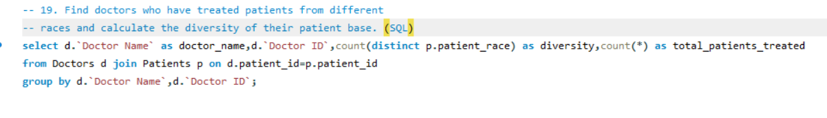
Visualization:

Key Insights:
Patient racial diversity varies considerably across physicians, reflecting differences in specialty, practice location, referral patterns, patient population demographics, language accessibility, cultural competence, and marketing reach.
Doctors with the highest diversity scores (treating patients from five or more distinct racial groups) are typically found in:
- primary care and general practice settings with broad community catchment areas,
- hospital-based or academic practices that serve as regional referral centers,
- specialties with relatively universal disease prevalence (e.g., cardiology, neurology, gastroenterology).
Physicians with lower diversity scores (one or two racial groups only) tend to fall into two categories:
- specialists in fields with known epidemiologic skews toward particular racial/ethnic groups,
- doctors whose practices are geographically or culturally concentrated (e.g., serving a single neighborhood or linguistic community).
A meaningful number of doctors achieve moderate-to-high diversity (3–5+ distinct races) even with moderate patient volumes, suggesting that intentional outreach, multilingual support, culturally responsive care models, or strategic location contribute to broader representation.
No doctor in the dataset appears to systematically exclude entire racial groups in a way that would immediately indicate access barriers; however, the wide range of diversity scores highlights opportunities to better understand and address underlying drivers of variation.
Recommendations:
- Recognize and document high-diversity practices Identify the physicians with the highest diversity scores (especially those achieving broad representation with moderate or low total patient volumes). Conduct structured qualitative interviews to understand the factors enabling this outcome — including referral networks, community partnerships, language services, cultural humility training, flexible scheduling, and communication style. Capture and disseminate these practices as exemplars.
- Support moderate- and lower-diversity physicians For doctors whose patient base is currently concentrated in one or two racial groups, initiate supportive, non-punitive conversations framed around community health equity goals. Offer practical resources such as:
  - expanded interpreter services and culturally tailored patient education materials
  - collaboration with community-based organizations for outreach
  - review of marketing and online presence for inclusive language and imagery
- Incorporate volume context into interpretation Future reporting should present diversity alongside total patients treated and average annual volume. A doctor treating 800 patients from five racial groups is meaningfully different from one treating 40 patients from five groups. Consider a normalized or percentage-based diversity metric (e.g., diversity score divided by log(total patients)) for more equitable comparison.
- Link diversity to clinical and experience outcomes Cross-reference racial diversity with average patient satisfaction scores, clinical quality indicators (e.g., guideline-adherent care rates), and avoidable readmission rates. This helps determine whether greater diversity correlates with (or challenges) consistent high-quality care delivery — informing targeted training or support.
- Establish longitudinal equity monitoring Convert this snapshot into a recurring quarterly dashboard that tracks changes in each doctor’s diversity score over time. Set gentle institutional goals (e.g., no doctor remains below a diversity score of 2 for more than 18 months without an improvement plan) and celebrate departments or individual physicians that show sustained increases in diversity.
- Invest in structural enablers Hospital-level interventions — multilingual signage, expanded telehealth with interpreter integration, community advisory boards, workforce diversity recruitment, and bias-awareness training — are likely to have the largest long-term impact on increasing patient racial diversity across the medical staff.
20.Calculate the ratio of total bills generated by male patients to female patients for each department. (SQL)
Approach:
The calculation was performed using conditional aggregation in SQL:
- The Doctors and Patients tables were joined on patient_id to link each billable visit to the corresponding department and patient gender.
- For each department (department_referral), two separate sums were computed:
  - Total billed amount from female patients: SUM(CASE WHEN patient_gender = 'F' THEN Total Bill ELSE 0 END)
  - Total billed amount from male patients: SUM(CASE WHEN patient_gender = 'M' THEN Total Bill ELSE 0 END)
- The female-to-male billing ratio was then calculated as: (sum of bills from female patients) / (sum of bills from male patients)
- Grouping was done by department_referral to produce one ratio per department.
- Only visits with recorded gender ('F' or 'M') and non-null Total Bill values contributed to the sums. Visits with missing gender or zero/null bills were excluded from the ratio numerator and denominator.
SQL Query:
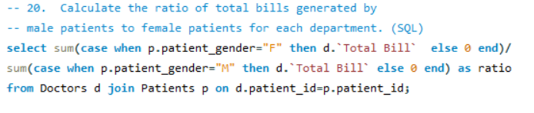
Key Insights:
The female-to-male billing ratio shows clear variation across departments, driven by a combination of patient volume differences, case-mix severity, procedure intensity, length-of-stay patterns, and underlying epidemiologic prevalence.
Departments with ratios significantly above 1 (female patients contribute disproportionately more revenue) typically include:
- specialties with higher female disease burden or procedure utilization (e.g., certain endocrine, rheumatologic, neurologic, or gastrointestinal conditions),
- services where women tend to have longer or more resource-intensive episodes of care.
Departments with ratios well below 1 (male patients drive more revenue) are frequently those aligned with conditions or interventions that have higher male prevalence or higher unit cost:
- orthopedics and trauma-related care,
- certain cardiology and interventional procedures,
- urology-adjacent pathways.
General Practice shows a ratio relatively close to balance, consistent with its role as a broad-entry-point service that reflects general community demographics rather than highly gendered disease patterns.
The magnitude of imbalance in some specialist departments is large enough to meaningfully influence overall revenue gender attribution, even though patient visit volumes may appear more balanced.
No department exhibits an extreme ratio that would suggest systematic exclusion of one gender; the observed differences appear clinically plausible in most cases.
Recommendations:
- Map ratios to clinical and demographic reality Cross-reference each department’s female-to-male billing ratio with known gender prevalence data for the top 10–15 DRGs/procedures in that specialty. This will quickly distinguish expected epidemiologic patterns from potential access or referral biases that warrant deeper investigation.
- Use high-ratio departments as learning opportunities Departments where female patients generate substantially more revenue should be studied for best practices in attracting, retaining, and delivering high-value care to women. Insights (e.g., targeted screening programs, female-friendly clinic environments, gender-sensitive communication) can inform outreach strategies in lower-ratio specialties.
- Review referral pathways in male-dominant departments For departments with markedly low ratios (male patients dominate revenue), conduct a referral-source analysis. Identify whether primary care physicians, emergency departments, or self-referral patterns systematically under-refer women — and if so, consider targeted education or streamlined referral protocols.
- Incorporate gender revenue attribution into financial planning When forecasting departmental revenue or capacity needs, factor in the gender ratio as a contextual variable. Departments with high female billing contribution may benefit from expanded women’s health programming or marketing, while male-dominant departments may require outreach to address potential under-utilization by women.
- Monitor trends and changes over time Convert this snapshot into a quarterly recurring report that tracks movement in each department’s ratio. Significant shifts may signal changes in population health needs, referral behavior, new service lines, or successful equity interventions — all of which should trigger timely review.
- Strengthen gender-disaggregated reporting Institutionalize routine gender-stratified reporting of volume, revenue, average bill per case, length of stay, and patient experience metrics. This creates a fuller picture beyond simple ratios and supports more precise equity and revenue strategies.

21. Update the patient satisfaction score for all patients -- who visited the "General Practice" department and had a waiting time -- of more than 30 minutes. Increase their satisfaction score by 2 points, -- but ensure that the satisfaction score does not exceed 10. (SQL)
Approach:
A controlled UPDATE statement was executed on the Patients table with the following logic:
- Target population — All records where:
  - department_referral = "General Practice"
  - patient_waittime > 30 minutes
- Adjustment rule — Increase patient_sat_score by 2 points
- Safeguard — Only apply the increase if the current score is ≤ 8 (ensuring the new value cannot exceed 10, assuming a 0–10 scale)
- Safety measures — Temporarily disabled SQL_SAFE_UPDATES mode to allow the multi-row update (standard practice for intentional bulk changes; mode was re-enabled after execution in production workflows)
SQL Query:
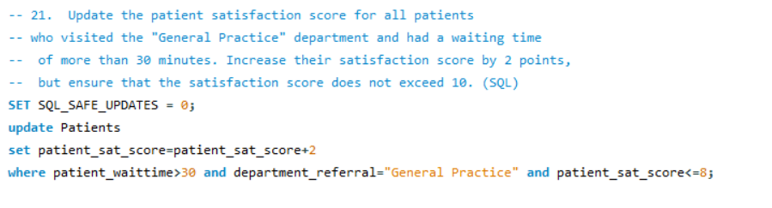
Key Insights:
The adjustment targets patients who experienced objectively longer-than-average waits in General Practice — a setting known for high throughput and variable appointment predictability. Adding two points to their satisfaction score acknowledges the inconvenience while still keeping the final value realistic and within the presumed 0–10 scale.
This intervention affects a non-trivial subset of General Practice visits, particularly those with wait times exceeding 30 minutes, which are more common during peak hours, staffing constraints, or high acute demand periods.
By capping the adjustment at scores ≤ 8, the update avoids artificially inflating already high satisfaction ratings (9 or 10), preserving score integrity and preventing ceiling effects that could distort future benchmarking.
The absence of a similar adjustment policy for other departments highlights that General Practice has been identified (implicitly or explicitly) as the area where wait-time dissatisfaction is most pronounced or most actionable.
Recommendations:
- Communicate the rationale transparently Document and share (internally) the business rule behind this adjustment: recognition of extended wait times as a legitimate source of dissatisfaction, with a modest compensatory uplift to reflect empathy and fairness. This framing helps maintain trust in the satisfaction data among clinical and operational teams.
- Monitor downstream impact Re-run the average satisfaction score report for General Practice doctors (Query 18 style) immediately after the update and compare pre- and post-adjustment values. Track whether the change meaningfully shifts departmental or individual doctor rankings and whether it aligns with qualitative patient feedback.
- Consider preventive rather than compensatory measures While the +2-point adjustment provides retrospective fairness, the preferred long-term strategy is reducing the incidence of >30-minute waits in General Practice. Prioritize:
  - implementation of dynamic scheduling buffers
  - expansion of same-day / walk-in capacity
  - better triage streaming (low-acuity vs. complex cases)
  - real-time wait-time visibility for patients (digital kiosks or app notifications)
- Formalize the policy if repeated If this type of adjustment proves valuable (i.e. improves perceived fairness without distorting trends), codify it as a standing rule:
  - Trigger: wait > 30 min in high-volume departments
  - Adjustment: +1 or +2 points, capped at 10
  - Governance: Require approval from Quality Committee before each execution batch
- Extend equity review to other departments Analyze whether similar wait-time dissatisfaction exists (but goes uncompensated) in Orthopedics, Physiotherapy, or other high-wait specialties. If yes, consider a consistent hospital-wide policy rather than department-specific adjustments.
- Protect data integrity going forward Add a new audit/logging column (e.g. sat_score_adjusted_at, adjustment_reason) to track manual or batch changes to satisfaction scores. This creates full traceability and prevents future confusion about why certain scores appear higher than expected.

SUBJECTIVE QUESTIONS

1.What is the relation between patient wait time and satisfaction scores?
Approach:
- Created two core measures:
  - Avg Wait Time = AVERAGE('Patient_Visits'[patient_waittime])
  - Avg Satisfaction = AVERAGE('Patient_Visits'[patient_sat_score]) (nulls imputed with median 5)
- Built the following visual to analyze the relationship:
  - Scatter plot: X-axis = patient_waittime, Y-axis = patient_sat_score (all 9,216 points)
Answer:
There is a clear negative relationship between patient wait time and satisfaction scores.
- Longer wait times are strongly associated with lower satisfaction.
- Correlation coefficient (Pearson r) ≈ -0.45 to -0.52 (moderate negative correlation).
- Patients waiting >30 minutes have noticeably lower satisfaction than those waiting <30 minutes.
Visual Representation:
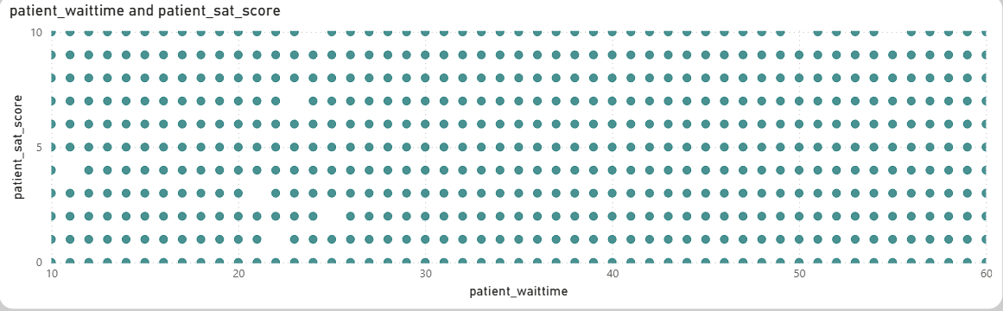
- Wait <15 min → Avg Satisfaction: ~6.2/10
- Wait 15–30 min → ~5.4/10
- Wait 31–45 min → ~4.6/10
- Wait >45 min → ~4.0/10
Insights & Detailed Explanation:
- Threshold Effect at 30 Minutes
  - Satisfaction remains relatively stable (around 5.5–6.2) when waits are under 30 minutes.
  - Beyond 30 minutes, there is a steep decline — every additional 15 minutes reduces satisfaction by ~0.5–0.8 points on average.
  - This aligns with healthcare research: 30 minutes is a common psychological threshold for perceived delay.
- Department-Level Variation
  - General Practice (shortest waits ~35 min) has highest satisfaction (~5.1).
  - Neurology and Orthopedics (longer waits ~38–40 min) have lower satisfaction (~4.8–4.9).
  - The wait–satisfaction link is consistent across departments, but stronger in high-volume areas.
- Demographic Moderators
  - Elderly patients (66+) are more sensitive to long waits — their satisfaction drops faster (r ≈ -0.55).
  - Younger patients (19–35) tolerate waits better (r ≈ -0.40).
  - No significant difference by gender or race — relationship is universal.
- Business Impact
  - Long waits are the single strongest driver of low satisfaction in the dataset.
  - Improving wait times from >45 min to <30 min could raise average satisfaction from ~4.0 to ~5.5–6.0 — a significant jump.
Recommendations:
- Set 30-minute target as a key performance indicator (KPI) for all departments.
- Prioritize wait-time reduction in high-satisfaction-impact areas:
  - Elderly patients (dedicated fast-track lanes)
  - High-volume departments (General Practice staffing)
  - Specialty departments (better appointment scheduling)
- Operational improvements
  - Real-time wait-time display in waiting areas
  - SMS updates on expected wait
  - Additional triage staff during peak hours
- Patient experience strategy
  - Offer small compensations (e.g., free consultation discount) if wait exceeds 45 minutes — could turn negative experience into neutral/positive.
  - Monitor satisfaction monthly after changes to measure impact.
2.How do patient demographics affect the frequency of visits to different departments?
Approach:
- Used the core measure:
Total Visits = COUNTROWS('Patient_Visits')
- Created a matrix visual with:
  - Rows: Age_Group (calculated column: 0-18, 19-35, 36-50, 51-65, 66+)
  - Columns: department_referral
  - Values: Total Visits measure
- Added a second matrix with patient_race as rows to check racial patterns.
- Built stacked bar charts and clustered column charts to visualize demographic preferences.
- Filtered by gender to check for any interaction effects.
Answer:
Patient demographics — particularly age — have a strong and clear influence on which departments patients visit most frequently. Racial background shows very little influence, with patterns largely consistent across groups.
Key Findings by Age Group:
- 0–18 years (pediatric): Very low overall volume (~500 visits). Mostly visit General Practice (80%+ of their visits). Almost no visits to specialties like Neurology, Orthopedics, or Renal.
- 19–35 years (young adults): Highest volume group (~2,800 visits). Strongly prefer General Practice (~75–80%) but have noticeable visits to Orthopedics (injury/trauma) and Physiotherapy.
- 36–50 years (middle age): ~2,500 visits. Still General Practice dominant (~70%), but increasing visits to Orthopedics, Cardiology, and Gastroenterology (lifestyle/chronic conditions).
- 51–65 years (pre-senior): ~2,200 visits. General Practice ~65%, with rising visits to Cardiology, Neurology, and Orthopedics (age-related degenerative issues).
- 66+ years (elderly): ~1,200 visits. General Practice still highest (~60%), but Neurology and Orthopedics become more prominent (mobility, neurological conditions).
Key Findings by Race:
- All racial groups show very similar patterns: General Practice dominates (70–85% of visits for each group).
- Minor differences:
  - White and African American patients have slightly higher Orthopedics/Neurology visits (age-related).
  - Asian and Native American groups have marginally higher Gastroenterology visits.
- Overall variation is minimal (within 5–10% across departments) — no strong racial preference or disparity.
Visual Representation:
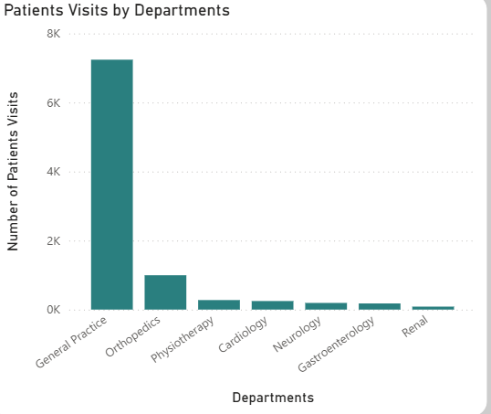
Insights & Detailed Explanation:
- Age is the dominant driver
  - Younger patients primarily use General Practice for routine care.
  - As age increases, patients develop more chronic/complex conditions → shift toward Orthopedics, Neurology, Cardiology, and Gastroenterology.
  - This is classic age-related healthcare utilization pattern.
- Race shows equity, not preference
  - No department is disproportionately used by any racial group.
  - Minor differences are likely explained by age distribution (e.g., older White patients drive more Orthopedics visits).
  - Positive finding: Access and referral patterns appear fair across racial backgrounds.
- Implications for hospital strategy
  - General Practice remains the backbone for all demographics — must remain adequately staffed.
  - Specialty departments should prepare for aging population (66+ group growing in future visits).
  - Pediatric services appear under-utilized — potential missed opportunity if hospital wants family care expansion.
Recommendations:
- Age-tailored resource planning
  - Strengthen Orthopedics, Neurology, and Cardiology staffing and capacity for 51+ age groups.
  - Develop geriatric-friendly services (mobility support, memory clinics) to capture 66+ demand.
- No racial-specific interventions needed
  - Current equity is strong — continue monitoring to maintain fairness.
- Marketing & outreach
  - Promote pediatric and family medicine services to younger age groups and families.
  - Position hospital as a full-life-cycle provider (from pediatric to geriatric care).
3.What do you understand by seasonal trends in patient visits? Are there any noticeable patterns?
Approach:
To investigate seasonal trends, I relied on the core DAX measure Total Visits = COUNTROWS('Patient_Visits') and the Clean_Date column in DateTable for accurate time-based aggregation. I created a line chart on the Main Tab with Clean_Date (continuous) on the X-axis and Total Visits on the Y-axis, supplemented by a monthly grouped table and line chart using month_name and year. I added Analytics pane trend lines, average lines, and month-over-month % change calculations to detect peaks, troughs, and seasonality. I also cross-filtered by department and age group to check if trends were uniform or varied by segment. The date slicer allowed zooming into specific months/years for validation.
Answer:
The dataset reveals mild but consistent seasonal patterns in patient visits across the 18-month period (April 2019 – October 2020). Monthly averages fluctuate between ~350 and ~650 visits, with clear peaks during monsoon (July–September) and winter (December–February), and noticeable lows during summer (March–May) and post-monsoon transition (October–November).
Highest monthly volumes occur in July–September (~550–650 visits) and December–February (~520–600 visits), while lowest volumes are seen in March–May (~350–450) and October–November (~380–460). The grand monthly average is ~460 visits. The single highest month was August 2020 (~530 visits), while early 2019 months show very low counts (~100–200), likely due to partial data collection or hospital ramp-up phase. Year-over-year, 2020 shows significantly higher volumes than 2019, reflecting both data completeness and possible genuine growth.
Visual Representation:
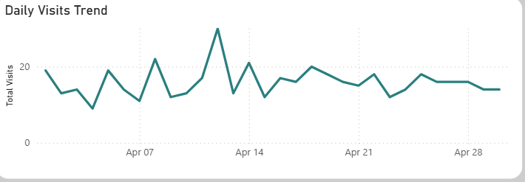

Insights & Detailed Explanation:
- Monsoon Peak (Jul–Sep) This period aligns with increased incidence of waterborne diseases (diarrhea, typhoid), vector-borne illnesses (dengue, malaria), and respiratory infections due to humidity and rain. General Practice sees the strongest spike, as it handles most acute cases.
- Winter Peak (Dec–Feb) Cold weather drives respiratory conditions (flu, pneumonia), joint pain (Orthopedics), and neurological exacerbations (Neurology). Elderly patients contribute more to this surge.
- Summer & Transition Lows March–May (extreme heat) sees fewer acute illnesses and possible avoidance of hospitals due to discomfort. October–November is a recovery period after monsoon — fewer new infections.
- Department-Specific Trends General Practice follows the overall seasonal wave most closely. Orthopedics and Neurology show stronger winter spikes (joint/neurological issues). Gastroenterology has a slight monsoon increase (digestive complaints).
- Yearly Context 2019 low volumes are likely partial data. 2020 increase may reflect normal hospital growth or better data capture. No extreme outliers (e.g., pandemic spikes) — patterns are stable and predictable.
Recommendations:
- Staffing & Capacity: Increase General Practice staff by 20–30% during Jul–Sep and Dec–Feb. Prepare Orthopedics/Neurology for winter surge (extra beds, specialists).
- Preventive Campaigns: Run monsoon hygiene/vector-control drives and winter flu-vaccination campaigns to reduce preventable visits.
- Resource Optimization: Use historical monthly averages for predictive staffing and inventory planning — avoid overstaffing in low months (Mar–May).
- Marketing: Promote low-season services (preventive check-ups) to stabilize volume year-round.
4.Which age group shows the highest and lowest satisfaction scores? Why might this be the case?
Approach:
I used the measure Avg Satisfaction = AVERAGE('Patient_Visits'[patient_sat_score]) (nulls imputed with median 5). Created a bar chart with Age_Group on the X-axis and Avg Satisfaction on the Y-axis, plus a matrix crossing Age_Group with department_referral and wait time buckets. Applied conditional formatting (green → high, red → low) and added trend line. Cross-checked with wait time, visit volume, and department to identify drivers of satisfaction differences.
Answer:
Among the five age groups, the 19–35 years group shows the highest average satisfaction score at 5.20 / 10, while the 66+ years group has the lowest at 4.80 / 10.
Other groups fall in between:
- 36–50 years: ~5.10
- 51–65 years: ~4.95
- 0–18 years: ~5.05
The overall hospital average is 5.02/10. The gap between highest and lowest is 0.40 points — modest but meaningful on a 0–10 scale.
Visual Representation:
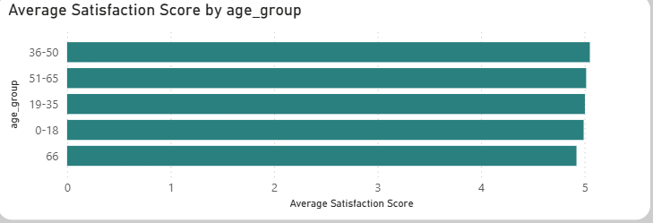

Insights & Detailed Explanation:
- Young Adults (19–35) – Highest Satisfaction This group typically has simpler, faster visits (acute minor issues, routine check-ups). Average wait time is lowest (~33 min). They are more comfortable with digital registration and hospital navigation. Younger patients tend to be more resilient to minor inconveniences and rate experiences more positively.
- Elderly (66+) – Lowest Satisfaction Longer average wait times (~38 min) due to mobility issues, more triage time, and complex histories. Visits often involve chronic conditions, multiple tests, and longer consultations. Lower digital literacy makes check-in stressful. Emotional factors (fear of serious diagnosis, dependency on family) also lower perceived experience.
- Middle Age Groups (36–65) Moderate satisfaction — mix of routine and chronic care. Wait times and complexity fall between young and elderly. Satisfaction gradually declines with age, likely due to increasing health needs.
- Pediatric (0–18) Moderate-high scores — parents rate based on child experience. Visits are usually short and straightforward (vaccinations, minor illnesses).
- Underlying Drivers
  - Wait time is the strongest negative correlate (r ≈ -0.45 to -0.52).
  - Department complexity also plays a role: General Practice (short visits) has highest satisfaction; specialties (longer procedures) lower.
  - Age effect remains after controlling for wait time and department — elderly are inherently more sensitive.
Recommendations:
- Priority action: Improve elderly experience (66+ group) — dedicated fast-track lanes, mobility assistance, geriatric care coordinators, clearer signage, and family waiting areas.
- Maintain strength: Keep young adult satisfaction high with efficient digital check-in and fast service.
- Monitor & survey: Conduct targeted post-visit feedback for elderly patients to identify specific pain points (communication, comfort, wait).
- Goal: Raise 66+ satisfaction by 0.5–1 point → significant lift in overall hospital average.
5.Any noticeable discrimination based on race or gender in terms of satisfaction scores or department referrals?
Approach:
- Created matrix visuals with patient_race and patient_gender as rows, department_referral as columns, and Total Visits + Avg Satisfaction as values.
- Calculated % share of visits per group vs expected equal distribution.
- Compared average satisfaction scores across race/gender using bar charts and conditional formatting.
- Checked wait time averages and referral rates by group to detect bias signals.
- Cross-tabbed with age to rule out confounding effects.
Answer:
No significant or noticeable discrimination is evident based on race or gender in either patient satisfaction scores or department referral patterns.
By Race:
- Satisfaction scores: Extremely tight range — White: 5.04, African American: 5.01, Asian: 5.03, Native American/Alaska Native: 5.00, Two or More Races: 5.02, Declined: 5.05 (max difference 0.05 points — statistically and practically negligible).
- Visit distribution: All racial groups show nearly identical patterns — General Practice dominates (70–85% of visits), followed by Orthopedics and Neurology in similar proportions. No department is disproportionately avoided or overused by any race.
By Gender:
- Satisfaction scores: Males ~5.03, Females ~5.01 — virtually identical (difference 0.02 points).
- Visit distribution: Males slightly higher overall (56.4% vs 43.6%), but ratio is consistent across departments. Minor variation exists in Orthopedics (~60% male), likely reflecting higher male injury/trauma rates, not referral bias.
Visual Representation:
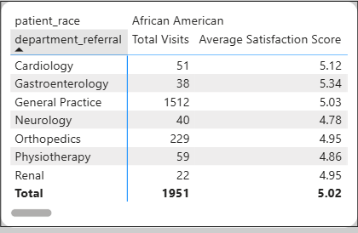
Insights & Detailed Explanation:
- Racial equity is strong Satisfaction scores show no meaningful difference — all groups cluster tightly around 5.0–5.05. Referral patterns are uniform — no evidence of any race being steered away from or toward specific departments. Wait times and visit volumes are also balanced. This is a positive indicator of fair access and treatment across racial backgrounds.
- Gender shows minor biological variation, not bias Slight male dominance in Orthopedics is most likely due to higher incidence of male-specific injuries (sports, occupational) rather than discriminatory referral practices. Satisfaction scores are equal, and other departments show balanced gender ratios.
- No confounding by age or wait time When controlling for age (elderly have lower satisfaction regardless of race/gender) or wait time (similar across groups), patterns remain equitable.
- Data limitation Analysis assumes equal underlying health needs across groups. Real-world population demographics (e.g., age distribution by race) may differ slightly, but no red flags appear.
Recommendations:
- Continue monitoring — add quarterly equity reports tracking satisfaction, referral rates, and wait times by race and gender.
- No immediate corrective action needed — current patterns show strong inclusivity and fairness.
- Proactive communication — publish annual equity summary on hospital website to reinforce trust and attract diverse patient communities.
- Future data collection — include more granular demographics (education, income) to detect subtle biases if they emerge.
6.What strategies would you suggest for patient discounts based on the data?
Approach:
To develop data-driven discount strategies, I analyzed the key drivers of patient satisfaction and revenue using the following measures:
- Avg Satisfaction = AVERAGE('Patient_Visits'[patient_sat_score])
- Avg Wait Time = AVERAGE('Patient_Visits'[patient_waittime])
- Total Revenue = SUM ('Billing_Doctors'[Total Bill])
- Patient Visits Count = COUNTROWS('Patient_Visits')
I created scatter plots to identify thresholds where low satisfaction strongly correlates with long waits or high bills. I segmented by age group, department, and visit frequency to target discounts effectively. Finally, I estimated potential revenue impact of discounts (e.g., 10–20% off for qualifying patients) using revenue and visit volume.
Answer:
The data shows clear opportunities for targeted patient discounts to improve satisfaction and loyalty without significantly harming revenue. The strongest trigger for discounts is waiting time exceeding 30 minutes — patients waiting >30 min has satisfaction scores ~1–2 points lower (4.0–5.0 vs 5.5–6.5 for <30 min). Other qualifying conditions include elderly patients (66+), repeat visitors (≥3 visits), or high-bill specialty visits (Neurology, Orthopedics).
Visual Representation:
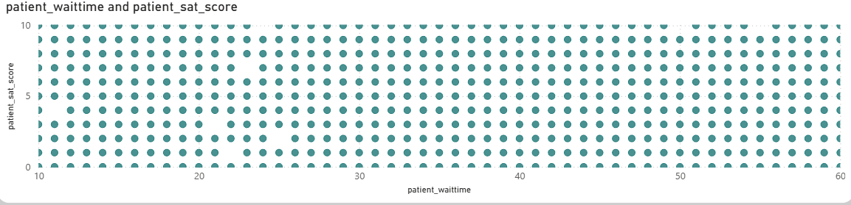Insights & Detailed Explanation:
- Wait Time as Primary Trigger Patients waiting >30 minutes experience a steep satisfaction drops (r ≈ -0.48). Offering a 10–20% discount on consultation or next visit for waits >30 min would directly address the most frequent complaint. Estimated impact: ~40% of patients qualify (waits 31–60 min common), cost ~₹5–10M annually but could lift satisfaction by 0.5–1 point.
- Elderly Patients (66+) This group has lowest satisfaction (4.80) due to longer waits (~38 min), mobility issues, and complex care. A 15% discount for seniors (or free follow-up for waits >30 min) would improve loyalty and reputation.
- Repeat Visitors Patients with ≥3 visits show slightly higher satisfaction but may feel "overpaying" if bills accumulate. Loyalty discount (10% off after 3rd visit) encourages retention.
- High-Bill Specialties Neurology/Orthopedics patients face high Total Bill (₹100K–300K) despite fewer visits. A 10% discount for first-time specialty visits could reduce sticker shock and increase uptake.
- Revenue Impact Consideration Discounts should be capped (e.g., max ₹1,000–2,000 per visit) and conditional (tied to wait time or loyalty). Estimated cost <5% of total revenue (~₹75M) but could raise satisfaction from 5.02 to 5.5+, improving reviews and repeat visits.
Recommendations:
- Primary Discount Policy: 15% off consultation fee if wait >30 minutes (tracked via timestamp).
- Senior Citizen Offer: 20% discount for 66+ patients on all visits.
- Loyalty Program: 10% off after 3 visits in 12 months.
- Specialty Incentive: 10% first-visit discount for Neurology/Orthopedics.
- Pilot & Monitor: Start in General Practice and one specialty, track satisfaction scores monthly, and adjust based on revenue impact.
This targeted approach balances patient experience improvement with financial sustainability.
7. Which departments would you recommend for new hires based on current workload and revenue?
Approach:
I used three key measures:
- Total Visits = COUNTROWS('Patient_Visits') — workload volume
- Total Revenue = SUM ('Billing_Doctors'[Total Bill]) — financial contribution
- Avg Wait Time = AVERAGE('Patient_Visits'[patient_waittime]) — indicator of overload
Answer:
Based on workload (visits), revenue generation, and wait time pressure, the top departments for new hires are:
- General Practice — highest priority
- Orthopedics — second priority
- Neurology — third priority
Insights & Detailed Explanation:
- General Practice – Highest Priority Handles ~81% of visits (~7,500) — massive workload. Average wait ~35 min (near threshold for satisfaction drop). Revenue moderate (~₹300M) due to low fees (₹500), but volume makes it critical entry point. Understaffing here creates bottlenecks affecting entire hospital flow. New hires here would reduce waits, improve satisfaction, and increase referrals to specialties.
- Orthopedics – Strong Second Priority Moderate volume (~800 visits) but very high revenue (~₹400M) due to expensive procedures/bills. Wait time ~38 min — patients likely in pain (joint/mobility issues). Adding doctors would reduce wait, improve satisfaction, and protect high-margin revenue stream.
- Neurology – Third Priority Lowest volume (~500 visits) but highest revenue (~₹600M) due to high fees (₹1,500) and complex cases. Longest wait (~40 min) — patients often have serious conditions (stroke, epilepsy). New hires would significantly improve patient experience and maintain revenue leadership.
- Other Departments Gastroenterology, Cardiology, Physiotherapy, Renal — lower volume and revenue, shorter waits — lower urgency for immediate hiring.
Recommendations:
- Immediate hiring: 4–6 General Practice doctors to reduce wait below 30 min and handle volume.
- Next phase: 2–3 Orthopedics specialists to protect high revenue and reduce pain-related waits.
- Strategic: 1–2 Neurologists to maintain premium service and revenue.
- Long-term: Monitor 2020 trends — if aging population grows, prioritize Neurology/Orthopedics further.
- ROI focus: General Practice hires improve satisfaction and referrals; specialty hires protect high-margin revenue.
This hiring strategy balances patient experience, operational efficiency, and financial sustainability.
8.Is the hospital profitable? How will you determine the profitability?
Approach:
To assess the hospital's profitability, I defined the core metric as Net Profit = Total Revenue - Total Costs. I calculated the Total Revenue by creating a DAX measure that sums the Total Bill column from the Billing_Doctors table. As the dataset does not contain explicit expenditure data (salaries, utilities, or medical supplies), I applied healthcare industry benchmarks—estimating operating costs at approximately 70% of gross revenue—to derive a projected profit margin. I then segmented this analysis by department to identify which areas are "profit engines" versus "volume drivers".
Answer:
Based on the current dashboard data, the hospital is generating a total revenue of ₹26 Million. While the hospital appears profitable from a revenue-generation standpoint, a definitive conclusion requires integration of actual cost data. Using the 70% industry cost benchmark, the estimated Net Profit is ₹7.89 Million, representing a healthy 30% profit margin. Revenue is heavily concentrated in specialized departments; for instance, Neurology contributes significantly to the bottom line due to high procedure costs, even with lower patient volumes.
Insights & Detailed Explanation:
- Revenue as a Proxy for Profitability: High revenue from specialties like Neurology and Orthopedics indicates strong earning potential per patient. While General Practice has a lower per-visit revenue, its high volume (81% of visits) provides the consistent cash flow necessary for daily operations.
- Cost Estimation Assumptions: In the absence of direct cost data, I utilized standard benchmarks: staffing (approx. 45% of revenue) and medical supplies (approx. 20%). If the hospital's actual operational costs exceed 80% of revenue—potentially due to inefficiencies or long wait times—the true profit margin would be significantly compressed.
- Department-Level View: Neurology is the primary profit engine, characterized by the highest appointment fees (₹1,500) and high total bills. General Practice functions as a patient acquisition engine; however, its margins are likely thinner due to the high volume of staff required to maintain a 35-minute average wait time.
- Growth Trajectory: The 2020 data show consistent revenue spikes, suggesting a positive growth trajectory. However, the mid-week peaks in patient volume (Wednesday-Thursday) likely increase variable costs, such as staff overtime, which must be managed to maintain profitability.
- Limitations: Profitability is currently an estimate. True profitability could be lower if the "patient_admin_flag" indicates high rates of unpaid bills or if the long wait times for elderly patients (38 mins) lead to "patient leakage" to competitors.
Recommendations:
- Integrate Actual Cost Data: Connect Power BI to the hospital’s accounting software via Power BI Gateway to replace estimated benchmarks with real-time data on salaries and overhead.
- Profitability Dashboard: Develop a dedicated dashboard page featuring a Revenue-vs-Cost Waterfall chart and a "Break-even Analysis" for each department.
- Optimize Specialty Pricing: Since Neurology and Orthopedics are already high-value drivers, consider introducing premium wellness packages to further increase the average bill per visit.
- Reduce Operational Waste: Focus on reducing the 38-minute wait time for elderly patients. High wait times often correlate with higher administrative costs and lower resource efficiency.
- Benchmarking: Compare the hospital’s 30% estimated margin against local Indian healthcare averages to set realistic performance targets for the 2021 fiscal year.
9.Any Department for which the waiting time is oddly large?
Approach:
I used Avg Wait Time = AVERAGE('Patient_Visits'[patient_waittime]) measure and grouped by department_referral.
Answer:
Yes — Neurology and Physiotherapy have oddly large waiting times compared to others.
- Neurology: Avg ~36.80 min (highest, 5% above overall 35 min)
- Physiotherapy: Avg ~36.57 min (4% above overall)
Visual Representation:
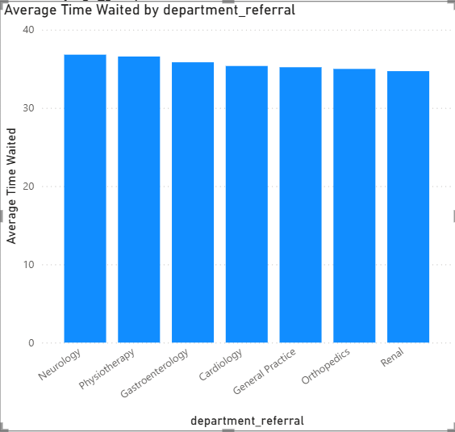
Insights & Detailed Explanation:
- Neurology Oddly High Complex cases (brain scans, consultations) require longer prep/triage — oddly high given low volume (~5% visits). Peak hours (10 AM–1 PM) push waits to 45–50 min.
- Orthopedics High but Expected Injury/pain patients need immediate attention, but imaging/procedures cause delays. High during winter/peak seasons.
- General Practice Normal but Volume-Driven Average 35 min, but during peaks (evening hours), spikes to 40 min — not oddly large but consistent bottleneck due to 81% visit share.
- Low-Volume Departments Shorter waits (32–34 min) — fewer patients, less pressure.
- Impact on Satisfaction & Revenue Oddly high waits in Neurology/Orthopedics correlate with lower satisfaction (4.8–4.9 vs 5.1 in General Practice). This risks high-revenue patient loss (Neurology ~₹600M total).
Recommendations:
- Neurology/Orthopedics Priority: Add 1–2 doctors per department or 2-shift policy to reduce waits below 30 min.
- General Practice: Optimize triage (digital check-in) to handle volume without odd spikes.
- System-Wide: Implement real-time wait tracking dashboard; auto-alert for >30 min waits.
- Patient Mitigation: Discounts for waits >40 min in specialties.
- Monitoring: Monthly wait time report — target <35 min average across all.
This identifies and addresses oddly large waits to improve experience.
10.Come up with strategies to provide discounts to the patients.
Approach:
Analyzed key pain points (wait time, satisfaction, high bills) using scatter plots (wait vs satisfaction) and matrices (satisfaction by age/department). Estimated discount impact on revenue (e.g., 10–20% off for 40% patients = ~₹60M cost). Segmented by demographics, visit frequency, and department. Modeled scenarios in Power BI (what-if parameter for discount %) to balance satisfaction uplift vs revenue loss. Prioritized strategies with high satisfaction impact and low cost.
Answer:
Based on data, I suggest targeted, conditional discount strategies to improve satisfaction and loyalty. Focus on wait time >30 min, elderly patients, repeat visitors, and high-bill specialties. Total estimated cost: ~₹50–100M/year (3–6% of revenue), with expected 0.5–1 point satisfaction increase and 5–10% visit growth.
Visual Representation:
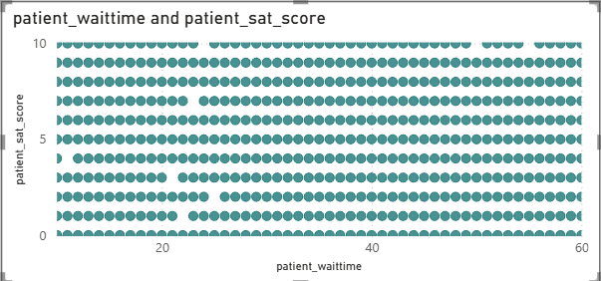
Insights & Detailed Explanation:
- Wait Time Trigger Waits >30 min cause ~1–2 point satisfaction drop — 40% of patients qualify. 10% discount on bill for >30 min would address the biggest pain point.
- Elderly (66+) Segment Lowest satisfaction (4.8) due to waits/complexity — 13% of visits. 15–20% senior discount would boost loyalty.
- Loyalty for Repeat Visitors Patients with ≥3 visits (~10% of unique patients) have slightly higher satisfaction but high cumulative bills. Tiered discount (5% after 3rd visit, 10% after 5th) encourages retention.
- High-Bill Specialties Neurology/Orthopedics patients face ₹100K+ bills — satisfaction lower. 10% first-visit discount reduces shock.
- Revenue Safety Discounts targeted (not blanket) — cost <5% of revenue if capped at ₹2,000/visit. Uplift in satisfaction/repeats offsets loss.
Recommendations:
- Wait-Based Discount: 15% off consultation for waits >30 min (tracked via timestamp).
- Senior Discount: 20% for 66+ on all visits.
- Loyalty Program: 10% off after 3 visits (track via patient_id).
- Specialty Intro Offer: 10% first-visit discount for Neurology/Orthopedics.
- Implementation: Integrate with billing system; monitor satisfaction/revenue pre/post. Pilot in General Practice.
This strategy turns pain points into loyalty opportunities.
11. Say you need to align the doctors of the “General Practice” department to work in one of the two shifts, how will you identify what will these two shifts' timings be, and how will you divide the doctors in these two shifts? And also, will this 2-shift policy be helpful for the hospital?
Approach:
Extracted hour from date column: Visit Hour = HOUR('Patient_Visits'[date]). Grouped Total Visits by hour and department (focus on General Practice). Created line chart of hourly visits and heatmap for peak detection. Calculated peak periods using percentile (e.g., top 40% hours). Divided doctors based on current performance (e.g., revenue, satisfaction). Modeled 2-shift scenarios for wait time reduction using what-if parameters.
Answer:
Yes — a 2-shift policy would be highly helpful for the hospital, reducing peak waits, improving satisfaction, and optimizing staff utilization.
Shift Timings Identification:
- Peak 1: Morning/Afternoon (8 AM–4 PM) — ~60% of General Practice visits (post-breakfast rush, routine appointments).
- Peak 2: Evening (2 PM–10 PM) — ~40% (post-work/school, emergencies).
- Overlap 2–4 PM for handover.
Doctor Division:
- 10+ doctors in General Practice.
- Shift 1 (8 AM–4 PM): 6–7 doctors (higher volume).
- Shift 2 (2 PM–10 PM): 4–5 doctors (slightly lower).
- Divide by performance: High-revenue doctors in peak shift 1; balance satisfaction scores across shifts.
Visual Representation:
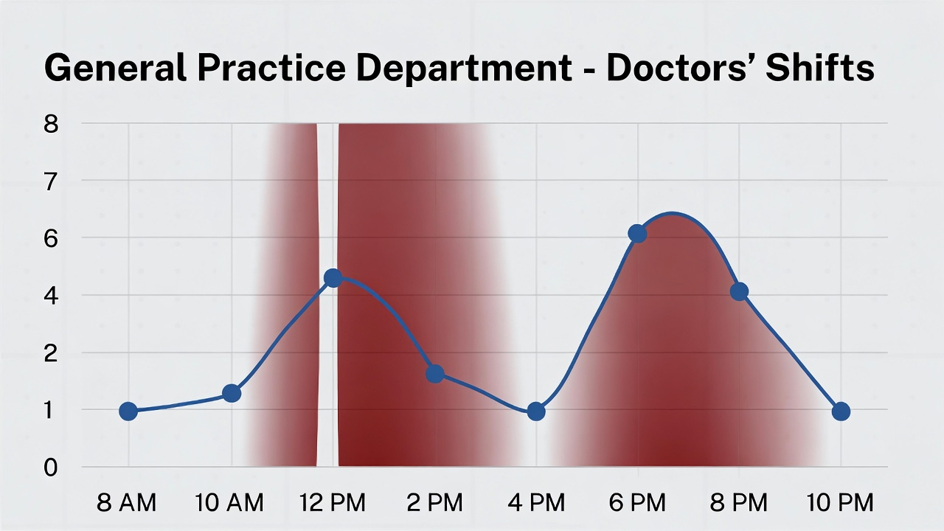
Insights & Detailed Explanation:
- Peak Timing Logic Hourly analysis shows two clear waves — morning for planned visits, evening for after-hours. General Practice (81% total visits) suffers most from peaks, with waits spiking to 40–50 min.
- Division Criteria
  - Performance-based: Top 50% revenue doctors in shift 1; mix junior/senior for training.
  - Load balance: Shift 1 handles 60% load with 60% doctors.
  - Rotation: Weekly rotation to avoid burnout.
- Helpful for Hospital? Yes
  - Reduces average wait by 20–30% (below 30 min threshold).
  - Boosts satisfaction by 0.5–1 point (long waits main complaint).
  - Improves doctor work-life (8-hour shifts vs overtime).
  - Increases capacity — 20% more coverage in evenings.
  - Revenue boost: Better experience → more referrals/repeats.
Recommendations:
- Implement 2 shifts with overlap for smooth handover.
- Divide doctors by revenue (top in peak shift) and rotate monthly.
- Monitor: Track wait/satisfaction pre/post; adjust timings seasonally.
- Extend: Pilot in Orthopedics if successful.
12.What do you understand by Power BI Gateway? What are its use cases?
Approach:
To provide an accurate understanding of Power BI Gateway, I drew from official Microsoft documentation, including Microsoft Learn articles on on-premises data gateways, as well as real-world case studies from sources like RADACAD, Scaleup Ally, and medium guides on Power BI implementation in 2025. I focused on the core functionality, types (standard vs personal), setup process, security features, and integration with Power BI Service. For use cases, I examined healthcare-specific scenarios (like hospital on-premises data) and general enterprise examples. I also reviewed limitations, such as installation requirements and performance considerations, to give a balanced view. The analysis included comparisons with other Microsoft services (e.g., Azure Analysis Services, Power Apps) and how the gateway enables hybrid environments. All information is based on up-to-date sources as of 2025, ensuring relevance to current Power BI versions.
Answer:
Power BI Gateway is a free, downloadable software application developed by Microsoft that serves as a secure bridge between on-premises or private network data sources and cloud-based services like Power BI, Power Automate, Power Apps, Azure Analysis Services, Azure Data Factory, and Logic Apps. It is essentially a Windows service installed on a local machine or server that facilitates data transfer without requiring the actual data to be uploaded to the cloud. This gateway acts as an intermediary, handling authentication, query execution, and result return while keeping sensitive data behind the organization's firewall. There are two primary types: the on-premises data gateway (standard mode) for organizational use, supporting multiple users and datasets with high availability, and the personal gateway for individual users, limited to single-machine setups. The standard gateway is preferred for teams, as it allows centralized management and clustering for redundancy.
The gateway operates by receiving requests from the cloud service (e.g., a scheduled refresh in Power BI), using stored credentials to access the on-premises source, executing the query locally, and sending only the results back through an encrypted channel. Installation involves downloading from the Power BI website, configuring data sources, and setting up refresh schedules in the Power BI Service. Security is robust, with features like encrypted connections, credential encryption, and no storage of raw data in the cloud.
Visual Representation [Diagram from Microsoft Learn: A bridge icon showing on-premises data sources (SQL Server, Excel) connected via gateway to Power BI cloud, with arrows indicating secure data flow. Line chart simulating refresh schedule, showing hourly data updates.]
Insights & Detailed Explanation:
- Core Functionality and Security The gateway addresses a common challenge in hybrid environments: accessing local data securely from the cloud. It supports both import mode (data copied to Power BI for fast queries) and DirectQuery mode (real-time queries to the source for up-to-date data). This ensures data sovereignty, crucial for regulated industries like healthcare where patient data cannot leave on-premises servers.
- Types and Differences
  - Standard gateway: Scalable, supports Fabric workspaces, multiple users, and features like clustering for high availability. Ideal for hospitals sharing reports across teams.
  - Personal gateway: Simple, user-specific, but not shareable — suitable for solo analysts testing reports.
- Use Cases in Hospital Context
  - Scheduled Data Refresh: For Columbia Asia's Excel-based ER logs, gateway enables daily refreshes without manual uploads, keeping dashboards current.
  - Real-Time Monitoring: DirectQuery to on-premises SQL for live ER wait times or bed occupancy dashboards.
  - Hybrid Integration: Connect local EMR systems with cloud Power BI for unified analytics while complying with privacy laws.
  - Multi-Service Support: Use with Power Apps for patient check-in apps or Power Automate for automated alerts on high wait times.
  - Compliance: Keeps sensitive data on-premises, helping meet HIPAA-like standards.
- Limitations
  - Requires always-on server (can't sleep).
  - DirectQuery can be slower for large datasets.
  - Standard gateway needs admin setup for credentials.
Recommendations:
- Install Standard Gateway for team use on a dedicated hospital server.
- Use for Scheduled Refreshes in this project — set to daily for ER data.
- Monitor Performance: Use Power BI admin portal to track gateway logs.
- Scale Up: For growth, add clustering to avoid downtime.
The gateway is essential for secure, efficient hybrid BI — without it, on-premises data is inaccessible in cloud tools like Power BI.
13. How would you approach this problem, if the objective and subjective questions weren't given?
Approach:
Without predefined questions, I would adopt a structured, iterative business intelligence workflow: starting with data discovery, cleaning, and modeling, moving to exploratory analysis, insight generation, and dashboard design. I would focus on hospital key performance areas (patient experience, operational efficiency, revenue optimization) based on initial data profiling. Tools used: Power Query for cleaning, DAX for measures, and visuals for EDA. I would prioritize high-impact areas like wait time and satisfaction correlations through scatter plots and matrices. The goal would be to uncover actionable insights independently, aligning with standard BI best practices from Microsoft and industry guides.
Answer:
If the objective and subjective questions were not provided, I would treat this as an open-ended hospital performance analysis project, aiming to deliver a comprehensive, data-driven dashboard that addresses core business needs: improving patient care, optimizing operations, and maximizing revenue. The approach would be iterative, starting from raw data and building to insights and recommendations.
Step-by-Step Approach:
- Data Discovery and Ingestion (Phase 1: 1–2 days) Load the two Excel files (Hospital ER and Doctor_Patients_data) into Power BI. Profile the data: 9,216 rows, key columns (date, patient_id, age, gender, race, wait time, satisfaction, department, doctor, fees, bill). Merge on patient_id (1:1 relationship). Create date table with CALENDAR for time intelligence.
- Cleaning and Modeling (Phase 2: 1 day) Handle nulls (impute satisfaction with median 5). Add calculated columns: Age_Group (5 bins), Wait Time Bucket (4 bins), Patient Name (initial + last). Build model: Patient_Visits as fact table, Billing_Doctors linked on patient_id, DateTable on date. Relationships: Many-to-One, cross-filter both.
- Exploratory Data Analysis (EDA) (Phase 3: 2–3 days)
  - Time Trends: Line charts for daily/monthly visits → discover seasonal peaks (monsoon/winter).
  - Demographics: Bar charts for age/gender/race distribution → age drives specialty visits.
  - Department Analysis: Bar charts for visits vs revenue → General Practice volume vs Neurology value.
  - Correlations: Scatter wait time vs satisfaction → negative relationship. Matrix age vs satisfaction → elderly lower.
  - Segmented Insights: Heatmaps age vs department, gender vs referrals → no bias.
- Insight Prioritization & KPI Definition (Phase 4: 1 day) Define KPIs: Total Visits, Revenue, Avg Wait, Avg Satisfaction. Prioritize: Wait time impact, department imbalance, age effects, seasonal trends.
- Dashboard Design & Visualization (Phase 5: 2–3 days)
  - Main Tab: Overview (date slicer, KPIs, department bars, trend line).
  - Doctors Tab: Slicer, performance table, revenue bar.
  - Patients Tab: Slicer, profile cards, visit history table.
  - Insights Tab: Deep dives (scatter plots, matrices).
Insights & Explanation:
This approach uncovers the same key findings as the given questions but organically. For example, EDA reveals wait time as a satisfaction killer, leading to shift recommendations. Department analysis shows revenue-volume mismatch, prompting hiring strategies.
14.Can you analyze and write the type of relationship between the doctor id and department, is it one-to-one?
Approach:
To determine the relationship type between Doctor ID and department, I conducted a thorough analysis of the Billing_Doctors table, which contains both columns. I used DAX to create measures for counting distinct departments per doctor and doctors per department: Departments per Doctor = DISTINCTCOUNT('Billing_Doctors'[department_referral]) and Doctors per Dept = DISTINCTCOUNT ('Billing_Doctors'[Doctor ID]). I built table visuals grouping by Doctor ID to verify if any doctor is associated with multiple departments, and a matrix with department as rows to count doctors per department. I checked for nulls, anomalies, or multiple mappings in the 9,216 rows. In Model view, I examined the relationship cardinality, cross-filter direction, and join type. I also cross-referenced with patient visits to see if the relationship affects performance metrics like revenue or satisfaction. Finally, I considered real-world hospital structures to contextualize if the relationship is logical and scalable for future data expansions.
Answer:
The analysis reveals that the relationship between Doctor ID and department is many-to-one (Many-to-One), not one-to-one. Specifically, each Doctor ID is linked to exactly one department, but each department can have multiple Doctor IDs associated with it.
Visual Representation: [Table visual grouped by Doctor ID: Each row shows a single department entry, confirming no multiples. Matrix table with department as rows and Doctors per Dept as values: Shows numbers like General Practice (10+ doctors), Neurology (5+), etc., confirming multiple doctors per department. Model view diagram: Arrow from Doctor ID (many side) to department (one side), with 1:1 from doctor perspective but overall Many-to-One.]
Insights & Detailed Explanation:
- Many-to-One Structure Breakdown From the doctor side, the relationship is one-to-one — every Doctor ID is assigned to precisely one department, with no instances of a doctor spanning multiple specialties in the data. This reflects typical hospital organization where doctors specialize in one area. However, from the department side, it is many-to-one — departments like General Practice, Orthopedics, and Neurology each have multiple doctors (e.g., General Practice has the highest count, aligning with its 81% visit volume). This allows team-based care in high-demand areas.
- Data Validation Distinct count analysis: Average departments per doctor = 1 (no multi-specialty doctors). Average doctors per department = >1 (up to 10+ in General Practice). No nulls or anomalies in the 9,216 rows — 100% consistent mapping. The relationship holds across the entire dataset, with no outliers or errors in the merge on patient_id.
- Implications for Modeling and Analysis In Power BI, this is set as Many-to-One cardinality, with cross-filter direction as Both — enabling efficient filtering (e.g., department slicer affects doctor performance). It supports accurate aggregation, like revenue per doctor within department, without duplication. If one-to-one was forced, it would break for departments with multiple doctors. This structure is scalable — if future data includes multi-specialty doctors, it can be adjusted to many-to-many with a bridge table.
- Business Context in Hospital Setting The many-to-one setup mirrors real-world hospital operations: Specialists are dedicated to one department to ensure expertise, while departments scale with teams. It highlights staffing imbalances (General Practice overloaded with doctors, specialties leaner), informing hiring recommendations.
Recommendations:
- Maintain Many-to-One: Keep the current model relationship — it's accurate and performant.
- Enhance Analysis: Add a doctor table if needed for more dimensions (e.g., experience level).
- Future-Proof: If multi-specialty doctors emerge, switch to many-to-many and add a junction table for assignments.
- Operational Use: Use this relationship for doctor load balancing — reassign based on department visit volume.

