Real Time Object Detection Using YOLO
A Project Report
Submitted by
Sourav Kumar – 231B349
Garv Gang – 231B113
Tryambkesh Sharma – 231B366
Under the guidance of: Dr. Animesh Kumar Dubey

May- 2026
Submitted in partial fulfilment for the award of the degree
of
BACHELOR OF TECHNOLOGY
IN
COMPUTER SCIENCE AND ENGINEERING

JAYPEE UNIVERSITY OF ENGINEERING & TECHNOLOGY,
AB ROAD, RAGHOGARH, DT. GUNA-473226 MP, INDIA

DECLARATION
We hereby declare that the work reported in the B.Tech. 6th semester project entitled as “Real Time Object Detection Using YOLO” in partial fulfillment for the award of degree of Bachelor of Technology submitted at Jaypee University of Engineering and Technology, Guna, as per best of my knowledge and belief there is no infringement of intellectual property right and copyright. In case of any violation we will solely be responsible.

Sourav Kumar
Er. No: 231B349

Garv Gang
Er. No: 231B113

Tryambkesh Sharma
Er. No: 231B366

Department of Computer Science and Engineering
Jaypee University of Engineering and Technology
Guna, M.P., India
Date:

CERTIFICATE
This is to certify that the work titled “Real Time Object Detection Using YOLO” submitted by Sourav Kumar, Garv Gang, and Tryambkesh Sharma in partial fulfillment for the award of degree of Bachelor of Technology of Jaypee University of Engineering & Technology, Guna has been carried out under my supervision. As per best of our knowledge and belief there is no infringement of intellectual property right and copyright. Also, this work has not been submitted partially or wholly to any other University or Institute for the award of this or any other degree or diploma. In case of any violation concern student will solely be responsible.

Signature of Supervisor
Dr. Animesh Kumar Dubey
Assistant Professor
Department of CSE, JUET Guna
Date:

ACKNOWLEGMENT

We would like to express our sincere gratitude to Dr. Animesh Kumar Dubey for his invaluable guidance, constant encouragement, and insightful suggestions throughout the development of our minor project titled “Real Time Object Detection Using YOLO.” His expertise in the domain and continuous support played a crucial role in helping us understand and implement key concepts in Computer Vision and Deep Learning effectively.
we also extend our heartfelt thanks to the faculty members of the department for their continuous support, and to our peers for their cooperation and constructive suggestions during the development of this project. Their contribution has been crucial in the successful realization of this work.

Thanking you

Sourav Kumar

Garv Gang

Tryambkesh Sharma

ABSTRACT

The rapid advancement of computer vision technologies has enabled intelligent systems to interpret and analyze visual data in real time. Object detection, a fundamental task in computer vision, plays a critical role in applications such as surveillance, autonomous driving, and traffic monitoring. This project presents the design and implementation of a real-time object detection system using the YOLO (You Only Look Once) architecture, which is known for its high speed and accuracy due to its single-stage detection mechanism.
The proposed system is capable of detecting multiple objects simultaneously within a video stream or image input and classifying them into predefined categories with bounding box localization. YOLO processes the entire image in a single forward pass, making it significantly faster compared to traditional region-based methods while maintaining competitive accuracy.
The model is trained on standard datasets and optimized for real-time performance, enabling deployment on systems with limited computational resources. The system is integrated with a user-friendly interface that allows real-time visualization of detected objects along with confidence scores.
Experimental results demonstrate that the proposed approach achieves efficient detection with high accuracy and low latency, making it suitable for real-world applications such as traffic surveillance, security systems, and smart city solutions. The project highlights the effectiveness of YOLO in balancing speed and accuracy, and provides a scalable framework for further enhancements, including custom object detection and edge-device deployment.

List of Figure
Figure 3.1 ……...……………………………………………………………. 18
Figure 4.1 …..….………………...….………………………………………. 25
Figure 4.2 …………………………………………………………………… 25
Figure 5.1 …………………………………………………………………… 28
Figure 5.2 …………………………………………………………………….33

List of Table
Table 5.1 ……………………………………………………………..………31

Table of Contents
ACKNOWLEGMENT iii
ABSTRACT iv
CHAPTER 1: INTRODUCTION 8
1.1 Background of the Study 8
1.2 Problem Statement 8
1.3 Objectives 9
1.4 Scope of the Project 10
1.5 Organization of the Report 11
CHAPTER 2: LITERATURE REVIEW 13
2.1 Existing Systems 13
2.2 Limitations of Existing Work 14
2.3 Needs for Proposed System 15
CHAPTER 3: METHODOLOGY 17
3.1 System Architecture 17
3.2 Design Methodology 19
CHAPTER 4: IMPLEMENTATION AND TESTING 22
4.1 Tools and Technologies Used 22
4.2 Implementation Detail 22
4.3 Testing Methods 23
4.4 Test Results 24
CHAPTER 5: TESTING AND VALIDATION 27
5.1 Result Analysis 27
5.1 Performance Evaluation 27
5.3 Discussions 33
CHAPTER 6: CONCLUSION AND FUTURE WORK 35
6.1 Conclusion 35
6.2 Future Work 35
REFERENCES 37

CHAPTER 1: INTRODUCTION

1.1 Background of the Study
In recent years, computer vision has emerged as a critical field within artificial intelligence, enabling machines to interpret and analyze visual data from the real world. One of its most impactful applications is in traffic analytics, where automated systems are used to monitor vehicle movement, detect objects, and improve urban transportation efficiency [9], [11].
With the rapid increase in the number of vehicles, traditional traffic monitoring methods such as manual counting and sensor-based systems have become inefficient, expensive, and difficult to scale. As a result, there is a growing demand for intelligent video-based systems capable of extracting meaningful insights from traffic footage [9].
Object detection plays a fundamental role in such systems, as it allows identification and localization of multiple objects within an image or video frame. Modern deep learning models, particularly the YOLO (You Only Look Once) family, have significantly improved the speed and accuracy of object detection by processing the entire image in a single pass [1], [2], [3].
However, beyond detection, practical traffic systems require additional capabilities such as object tracking, vehicle counting, and speed estimation to provide complete situational [5], [6] awareness. Integrating these components into a unified pipeline enables real-time monitoring and decision-making [7], [11].
This project focuses on developing a real-time object detection, tracking, and vehicle analysis system using YOLO11, specifically optimized to run on CPU-based systems, making it suitable for deployment in resource-constrained environments.

1.2 Problem Statement
Despite significant advancements in object detection technologies, several challenges remain in implementing practical and scalable traffic monitoring systems [1], [2].
Traditional traffic monitoring approaches, including inductive loop sensors and manual observation, provide limited information and lack the ability to perform real-time analysis of multiple parameters such as object classification, movement tracking, and speed estimation. These systems are also costly to install and maintain.
On the other hand, many modern deep learning-based solutions rely heavily on high-performance GPU hardware, which is not always accessible or affordable, especially in developing regions or small-scale deployments. This creates a gap between advanced research solutions and real-world applicability [7], [11].
Additionally, achieving real-time performance on limited hardware while maintaining acceptable accuracy is a major challenge. Tasks such as multi-object tracking, vehicle counting, and speed estimation further increase computational complexity [5], [6], [7].
To address these challenges, this project aims to design and implement a computationally efficient system using YOLO11, capable of performing object detection, tracking, and vehicle analysis on CPU-based systems with limited resources, while still delivering reliable performance in real-time traffic scenarios.
1.3 Objectives
The primary objective of this project is to design and develop a real-time object detection and vehicle analysis system using the YOLO11 architecture, capable of operating efficiently on CPU-based systems. The system aims to integrate multiple computer vision tasks into a single pipeline for practical traffic monitoring applications [3], [7], [9].
The specific objectives of the project are as follows:
- To implement a real-time object detection system using YOLO11 (YOLO11n/YOLO11s) for identifying multiple classes of vehicles from images and video streams [3].
- To train the model on a custom subset of the BDD100K dataset (700 images) using the Ultralytics YOLO framework and evaluate its performance using standard metrics such as Precision, Recall, and mAP [1], [2], [3], [4].
- To optimize the training process for resource-constrained environments by configuring parameters such as batch size, image resolution, number of workers, and caching strategy for CPU-based execution [7].
- To develop a multi-object tracking system using ByteTrack that assigns unique IDs to detected vehicles and maintains their identity across frames [5], [6].
- To implement a vehicle counting mechanism based on a dual-line crossing approach, enabling accurate counting of vehicles moving in upward and downward directions.
- To estimate the relative speed of vehicles using pixel displacement across consecutive frames.
- To analyze model performance using training and validation graphs, including loss curves, precision-recall trends, and mAP metrics derived from the results dataset.
- To generate an annotated output video displaying detection bounding boxes, tracking IDs, speed estimation, counting results, and FPS in real time.
- To evaluate the trade-off between accuracy and computational efficiency, comparing configurations such as YOLO11n and YOLO11s under CPU constraints.
- To create a scalable and modular system that can be extended for real-world applications such as intelligent traffic monitoring, surveillance systems, and smart city infrastructure.

1.4 Scope of the Project
The scope of this project is focused on the development and implementation of a real-time object detection and vehicle analysis system using the YOLO11 architecture. The system is designed to operate efficiently on CPU-based environments, making it suitable for resource-constrained setups.
The project primarily deals with:
- Detection of multiple vehicle classes such as cars, buses, trucks, and motorcycles from images and video streams.
- Real-time processing of traffic video input using OpenCV and YOLO-based inference.
- Integration of multi-object tracking using ByteTrack to maintain consistent identities of detected vehicles across frames.
- Implementation of a vehicle counting system based on a dual-line crossing mechanism to determine directional movement (upward and downward).
- Estimation of relative vehicle speed using pixel displacement across consecutive frames.
- Visualization of results through annotated output videos displaying bounding boxes, tracking IDs, speed, count, and FPS.
The project is limited to:
- A custom subset of the BDD100K dataset (700 images) for training and evaluation.
- Execution on CPU hardware, which may impact training time and overall model performance compared to GPU-based systems.
- Speed estimation in terms of relative pixel movement, not real-world units such as km/h due to lack of camera calibration.
- Performance under standard lighting and traffic conditions and extreme weather or heavy occlusion scenarios may reduce accuracy [10], [12].
Despite these limitations, the system provides a practical, scalable, and cost-effective solution for real-time traffic monitoring and can be extended for advanced applications such as smart city systems and intelligent surveillance [9], [11].

1.5 Organization of the Report
This report is organized into six chapters, each covering a specific aspect of the proposed system, from introduction to conclusion. The structure ensures a logical flow of concepts, starting from the problem definition and progressing toward implementation, evaluation, and future improvements.
The chapters are organized as follows:
- Chapter 1: Introduction
This chapter presents the background of object detection and its importance in traffic monitoring systems. It defines the problem statement, objectives of the project, and provides an overview of the proposed system.
- Chapter 2: Literature Review
This chapter discusses existing research and techniques related to object detection, tracking, and deep learning models such as YOLO and Faster R-CNN. It highlights the strengths and limitations of previous approaches.
- Chapter 3: System Analysis and Design / Proposed Methodology
This chapter explains the system architecture, design methodology, and data flow. It describes how the dataset is prepared, how the model is trained, and how different modules interact within the system.
- Chapter 4: Implementation and Testing
This chapter details the tools and technologies used, implementation steps, and testing procedures. It also presents the results obtained from image-based and video-based testing.
- Chapter 5: Results and Discussion
This chapter analyzes the performance of the model using evaluation metrics and training graphs. It provides a detailed discussion of the results, strengths, and limitations of the system.
- Chapter 6: Conclusion and Future Work
This chapter summarizes the outcomes of the project and suggests possible improvements, such as occlusion-aware tracking and real-world speed estimation.
Overall, this structured organization ensures a comprehensive understanding of the system, from theoretical concepts to practical implementation and evaluation.

CHAPTER 2: LITERATURE REVIEW

2.1 Existing Systems
Object detection and tracking have evolved significantly over the past decade, becoming essential components in modern computer vision applications such as traffic monitoring, surveillance systems, autonomous driving, and smart city infrastructure [1], [2], [3]. Early approaches relied on traditional image processing techniques, including edge detection, background subtraction, and feature-based methods such as Histogram of Oriented Gradients (HOG) combined with Support Vector Machines (SVM). While these methods were computationally lightweight, they lacked robustness and failed to generalize well under varying lighting, scale, and environmental conditions.
With the advancement of deep learning, Convolutional Neural Networks (CNNs) have become the dominant approach for object detection [12]. CNN-based models automatically extract hierarchical features from images, enabling better representation and improved accuracy. Region-based models such as R-CNN introduced the concept of region proposals, where candidate object regions are generated and then classified. This was further improved by Fast R-CNN and Faster R-CNN, which reduced computational overhead and improved detection speed. However, despite their accuracy, these models still rely on multi-stage processing, making them less suitable for real-time applications [1], [2], [3].
To overcome these limitations, single-stage detectors such as YOLO (You Only Look Once) were introduced. YOLO models perform detection and classification in a single forward pass, significantly improving inference speed. The YOLO family has evolved through multiple versions, with improvements in accuracy, speed, and model efficiency. These models are particularly suitable for real-time applications, as they balance computational efficiency and detection performance.
In addition to detection, multi-object tracking has gained importance in applications where object movement analysis is required. Tracking algorithms such as ByteTrack and FairMOT are widely used to maintain object identities across frames [5], [6]. These algorithms assign unique IDs to detected objects and track their motion over time, enabling higher-level analysis such as counting, behavior monitoring, and trajectory prediction [7].
Modern systems often combine detection and tracking to create complete video analysis pipelines. These systems process video frames sequentially, apply object detection models, and use tracking algorithms to maintain consistency across frames. This integration enables advanced functionalities such as vehicle counting, anomaly detection, and traffic flow analysis.
The major techniques used in existing systems include:
- Traditional Methods (HOG, Background Subtraction) – Lightweight but less robust and inaccurate in complex environments
- Region-Based Detectors (R-CNN, Faster R-CNN) – High detection accuracy but computationally expensive
- Single-Stage Detectors (YOLO family) – Fast and efficient, suitable for real-time applications [4]
- Multi-Object Tracking Algorithms (ByteTrack) – Maintain object identity across frames [5], [6]
- Video-Based Analysis Systems – Combine detection and tracking for real-time applications [7], [11]
These approaches form the foundation of current research and industrial applications in object detection and tracking.

2.2 Limitations of Existing Work
Although significant progress has been made in object detection and tracking, existing systems still face several challenges when applied to real-world scenarios [1], [2]. These limitations become more prominent in dynamic environments such as traffic monitoring, where multiple objects move simultaneously under varying conditions [9], [11].
One of the major limitations is the high computational requirement of many advanced models. Region-based detectors, while accurate, require significant processing power and are often dependent on GPU-based systems. This makes them unsuitable for deployment in low-resource environments or edge devices [7].
Another critical issue is the difficulty in handling occlusion. In crowded scenes, objects often overlap or partially hide each other, leading to incorrect detections or loss of tracking identity. Most existing systems struggle to maintain consistent tracking IDs in such situations, resulting in counting errors or fragmented trajectories [5], [6].
Small object detection is another challenge. Objects that are far from the camera or occupy a small portion of the image are often missed by detection models. This is particularly problematic in traffic scenarios where distant vehicles need to be detected accurately for proper analysis [12].
Additionally, many existing systems focus only on detection without integrating higher-level analysis. While they can identify objects, they do not provide functionalities such as tracking, counting, or speed estimation. This limits their usefulness in applications requiring comprehensive analysis.
Environmental factors such as lighting conditions, weather changes, and camera quality also affect system performance. Models trained under controlled conditions may fail to perform effectively in low-light environments, fog, or rain [10], [12].
The key limitations of existing systems include:
- High Computational Cost – Dependence on GPU and high memory requirements
- Limited Real-Time Capability – Slower processing in multi-stage detection models
- Occlusion Handling Issues – Difficulty in tracking overlapping objects
- Poor Small Object Detection – Reduced accuracy for distant objects
- Lack of Integrated Functionality – Detection-only systems without analysis features
- Sensitivity to Environmental Conditions – Performance affected by lighting and weather
These limitations highlight the need for a more efficient, robust, and integrated system.

2.3 Needs for Proposed System
Considering the limitations of existing approaches, there is a clear need for a system that can provide accurate detection while also supporting real-time processing and advanced analytical capabilities [1], [2]. The proposed system aims to address these challenges by integrating multiple functionalities into a single pipeline [5], [6], [7].
The primary requirement is the ability to perform real-time object detection on CPU-based systems. This ensures that the system can be deployed in low-resource environments without requiring expensive hardware [7]. At the same time, the system must maintain high detection accuracy to ensure reliable results.
Another important requirement is the integration of tracking mechanisms. By incorporating algorithms such as ByteTrack, the system can maintain object identity across frames, enabling continuous monitoring and movement analysis [5], [6]. This is essential for applications such as vehicle counting and traffic flow analysis [9].
The system also needs to include analytical features such as counting and speed estimation. Vehicle counting provides insights into traffic density, while speed estimation helps in understanding movement patterns. These features transform the system from a simple detection model into a complete analysis tool.
Handling occlusion is another key requirement. The proposed system should be capable of maintaining tracking consistency even when objects overlap or are partially hidden [6]. This can be further improved in future work using occlusion-aware tracking techniques.
Scalability is also important. The system should be designed in a modular way so that it can be extended to larger datasets, additional object classes, or GPU-based environments in the future [7], [11].
The key requirements for the proposed system are:
- Real-Time Processing on CPU – Efficient execution without high-end hardware
- Accurate Object Detection – Reliable identification of vehicles and pedestrians
- Robust Tracking Mechanism – Consistent object IDs across frames
- Vehicle Counting System – Automated counting using line-crossing techniques
- Speed Estimation Capability – Motion analysis using displacement calculation
- Occlusion Handling Improvement – Better tracking in overlapping scenarios
- Scalable and Modular Design – Easy extension for future enhancements
The proposed YOLO11-based system is designed to fulfill these requirements by combining detection, tracking, counting, and motion estimation into a unified framework. This makes it suitable for real-world applications such as traffic monitoring, smart surveillance, and intelligent transportation systems.

CHAPTER 3: METHODOLOGY

3.1 System Architecture
The proposed system follows a structured pipeline-based architecture designed to perform vehicle detection, tracking, speed estimation, and counting using a YOLO11-based deep learning model [3]. The architecture is divided into multiple stages starting from dataset preparation to final output generation.
The overall system architecture of the proposed YOLO11-based vehicle detection and analysis system is illustrated in Figure 3.1. The architecture follows a sequential pipeline approach, where each module performs a specific task and passes the processed data to the next stage [7], [9].
The process begins with the dataset preparation stage, where raw images and videos are organized and verified. This is followed by the dataset configuration stage, where a YAML file is created to define dataset paths, class labels, and annotations required for training.
In the next stage, the model training module, the YOLO11 model is trained using the prepared dataset. The model learns to detect objects by extracting features through convolutional layers and predicting bounding boxes along with class probabilities. The trained weights are then stored for further use.
The model evaluation stage evaluates the trained model using performance metrics such as precision, recall, and mAP. These metrics help in assessing the accuracy and reliability of the model.
Following this, the training visualization module provides graphical analysis of the training process, including loss curves and accuracy trends. This helps in understanding model convergence and performance improvement over epochs.
Finally, the output layer represents the real-time application of the system, where video frames are processed to detect, track, and analyze vehicles. The output includes annotated frames with bounding boxes, object IDs, vehicle count, speed estimation, and FPS [5], [6].

Model Training
Model Evaluation
Dataset Configuration
Dataset Preparation
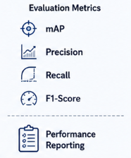
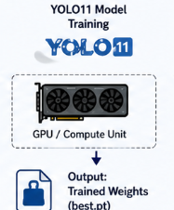

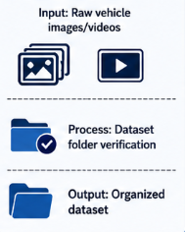

Training Visualization
Output Layer
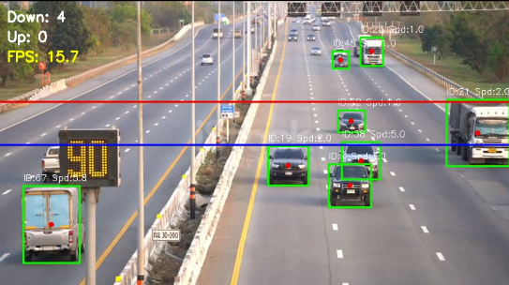
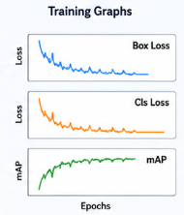

Figure 3.1: System architecture of the YOLO11-based vehicle detection, tracking, and analysis system
The overall workflow of the system consists of the following stages:
- Dataset Preparation – A custom subset of the BDD100K dataset (700 images) is organized in YOLO format. The dataset is structured with images and labels for training, validation, and testing.
- Dataset Configuration Module – A YAML file is created to define dataset paths and class labels. This file enables YOLO to correctly access and interpret the dataset during training.
- Model Training – The YOLO11 model (YOLO11n/YOLO11s) is trained using the Ultralytics framework. Training is performed on a CPU with optimized parameters such as batch size and image resolution.
- Model Evaluation – The trained model is evaluated using performance metrics such as Precision, Recall, and mAP. These metrics help in assessing detection accuracy and localization performance.
- Performance Analysis – Training results are analyzed using graphs generated from the results dataset. These include loss curves, mAP trends, and accuracy improvements over epochs.
- Video Processing – A traffic video (6.mp4) is processed frame-by-frame using OpenCV. Each frame is extracted and prepared for object detection and analysis.
- Object Detection – YOLO11 detects vehicles in each frame and generates bounding boxes. Each detection includes class labels and confidence scores for accurate identification.
- Object Tracking – ByteTrack assigns unique IDs to detected objects and maintains consistency across frames. This enables tracking of individual vehicles over time.
- Vehicle Counting – A dual-line crossing mechanism is used to count vehicles moving in different directions. The system updates counts based on object movement across predefined lines.
- Speed Estimation – The relative speed of vehicles is calculated using pixel displacement. The Euclidean distance between consecutive positions is used to estimate motion.
- Output Generation – The final output is an annotated video showing detection results and tracking IDs. Additional information such as vehicle count, speed, and FPS is displayed in real time.
This structured pipeline ensures that the system performs not only object detection but also higher-level analysis such as tracking, counting, and motion estimation in real time. The design emphasizes efficiency and scalability, allowing the system to operate effectively on CPU-based hardware with limited resources.

3.2 Design Methodology
The design methodology of the proposed system follows a systematic and modular approach to ensure efficient implementation of vehicle detection, tracking, and analysis [9]. The methodology is divided into multiple stages, starting from dataset preparation and progressing through model selection, training, and integration of analytical components.
The system is designed in such a way that each stage contributes to improving the overall performance while maintaining compatibility with CPU-based execution [7]. The methodology ensures that the model can perform real-time detection along with higher-level tasks such as tracking, counting, and speed estimation [5].

The key design steps involved in the system are as follows:
- Dataset Preparation – A subset of the BDD100K dataset (700 images) is selected and structured into training, validation, and test sets. The dataset is formatted in YOLO structure with images and corresponding label files.
- Dataset Configuration – A YAML file is created to define dataset paths, number of classes, and class names. This configuration file acts as an interface between the dataset and the YOLO training pipeline.
- Data Preprocessing – Images are resized to match model input size (416 or 640) and normalized. Annotations are converted into YOLO format with normalized bounding box coordinates.
- Model Selection – YOLO11 architecture is selected due to its real-time detection capability. YOLO11n is used for faster inference, while YOLO11s is used for improved accuracy comparison.
- Use of Pretrained Weights – Pretrained weights (yolo11n.pt / yolo11s.pt) are used as initialization. This helps the model learn faster and improves generalization on the custom dataset.
- Model Training – The model is trained using the Ultralytics framework on a CPU-based system. Parameters such as epochs, batch size, and image size are adjusted to balance performance and computational cost.
- Model Evaluation – The trained model is evaluated using metrics such as Precision, Recall, and mAP. These metrics provide insights into detection accuracy and localization quality.
- Performance Analysis – Training results are analyzed using graphs generated from the results dataset. Loss curves and mAP trends are studied to understand model behavior over epochs.
- System Integration – The trained model is integrated with video processing, tracking, counting, and speed estimation modules. This enables real-time analysis of traffic data.
The detection mechanism is based on YOLO’s bounding box prediction:
$$B=(x,y,w,h,c)$$
where $x,y$ represent center coordinates, $w,h$ represent width and height, and $c$ represents confidence score.
The evaluation of detection accuracy is performed using Intersection over Union (IoU) [1], [2]:
$$IoU=\frac{Area of Overlap}{Area of Union}$$
This structured design methodology ensures that the system remains modular, scalable, and efficient. It also allows easy experimentation with different configurations, making it suitable for both academic analysis and practical applications in traffic monitoring systems [9], [11].

CHAPTER 4: IMPLEMENTATION AND TESTING
This chapter presents the mathematical foundations and theoretical concepts underlying the proposed object detection, tracking, and vehicle analysis system [1]. The techniques discussed are based on deep learning principles used in YOLO (You Only Look Once), along with geometric and statistical methods for evaluating detection accuracy, tracking performance, and motion estimation [5], [6], [7].

4.1 Tools and Technologies Used
The proposed system was developed using a combination of deep learning frameworks and computer vision libraries to ensure efficient object detection and real-time video processing [9]. Python was used as the primary programming language due to its flexibility and wide support for machine learning and image processing tasks.
The implementation relied on the following key tools and technologies:
- Ultralytics YOLO (YOLO11n / YOLO11s) – for object detection
- OpenCV (cv2) – for video processing and frame manipulation
- ByteTrack Algorithm – for multi-object tracking and ID assignment
- NumPy – for numerical operations such as speed calculation
- Pandas & Matplotlib – for result analysis and graph plotting
- CPU-based environment – for training and inference on low-resource systems
The combination of these tools allowed the system to perform detection, tracking, and analysis efficiently while maintaining compatibility with standard hardware setups.

4.2 Implementation Detail
The implementation follows a structured pipeline starting from dataset preparation to real-time video analysis. The dataset was organized in YOLO format, and a configuration file (data_700.yaml) was used to define paths and class labels.
The main implementation steps include:
- Dataset Preparation – Structured images and labels into train, validation, and test sets
- Model Training – YOLO11 model trained using selected hyperparameters
- Model Validation – Performance evaluated using standard detection metrics
- Video Processing – Frames extracted using OpenCV
- Object Detection & Tracking – YOLO + ByteTrack integration
- Speed Estimation – Based on object displacement
- Vehicle Counting – Line-crossing logic
- Output Generation – Saved processed video
The YOLO model internally uses CNN layers to extract features and predict bounding boxes. Each detection is represented as:
$$B=(x,y,w,h,c)$$
where:
- $x,y$= center coordinates
- $w,h$= width and height of bounding box
- $c$= confidence score
The Intersection over Union (IoU), used during detection evaluation, is defined as:
$$IoU=\frac{Area of Overlap}{Area of Union}$$
These formulations help the model determine how accurately predicted boxes match the ground truth.

4.3 Testing Methods
To evaluate system performance, both quantitative and qualitative testing approaches were used. Quantitative testing focused on evaluating detection accuracy, while qualitative testing involved analyzing system behaviour on video data [1], [2], [3].
The testing methods include:
- Validation Testing – Evaluation on validation dataset
- Metric Analysis – Precision, Recall, mAP
- Accuracy-like Score – Derived from mAP@0.5
- Video Testing – Real-world traffic video analysis
- Tracking Evaluation – ID consistency check
- Counting Verification – Line-crossing accuracy
- Speed Evaluation – Consistency of motion estimation
- Edge Case Testing – Occlusion and fast movement
Precision and Recall are calculated as:
$$Precision=\frac{TP}{TP+FP} \\ Recall=\frac{TP}{TP+FN}$$
where:
- TP = True Positives
- FP = False Positives
- FN = False Negatives
The accuracy-like score used in this project is:
$$Accuracy=mAP@0.5×100$$
These metrics help evaluate how well the model detects and classifies objects.

4.4 Test Results
The testing results demonstrate that the proposed system performs effectively in detecting, tracking, and analyzing objects in both static images and real-time video scenarios [7], [9], [11]. The trained YOLO11 model achieved satisfactory performance on the validation dataset, showing good precision, recall, and mAP values [3]. These results indicate that the model is capable of accurately identifying objects and localizing them within the frame [1], [2].
To further validate the effectiveness of the model, qualitative testing was performed using sample images. The results of detection before and after applying the model are shown in the figures below.
Set 1: Human Detection Results
Before applying the YOLO model, the image contains multiple people in a real-world scene, but no annotations or labels are present. This makes it difficult to analyze object presence and distribution visually. As shown in Fig 4.1(a), the original image contains multiple people without any annotations, while Fig 4.1(b) illustrates the output of the YOLO model where individuals are successfully detected and labelled with bounding boxes [1], [2], [3].
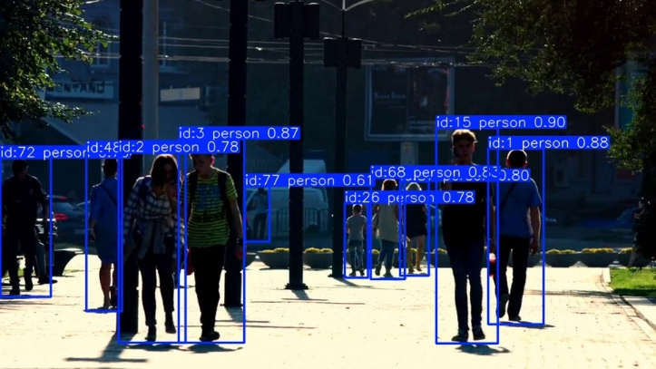
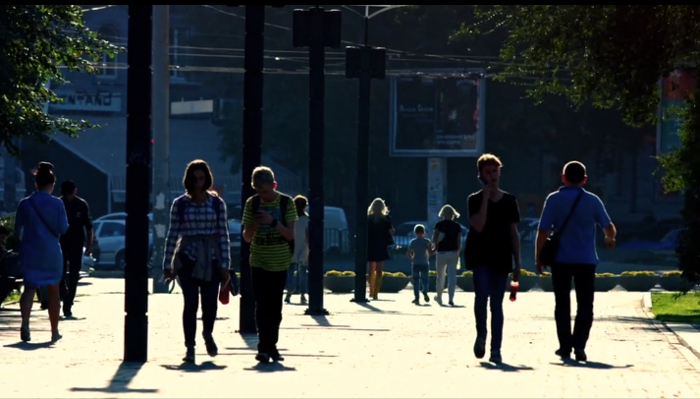
b. Labelled Image
a. Unlabelled Image

Figure 4.1: Human detection results (a) Unlabelled image, (b) Labelled image
After applying the YOLO model, the system successfully detects and labels each person with bounding boxes and confidence scores. This demonstrates the model's ability to identify multiple objects simultaneously [1].
Set 2: Vehicle Detection Results
In the second set, the original image contains multiple vehicles on the road without any annotations. The objects are visible but not categorized or quantified.
As shown in Figure 4.2(a), the original image contains vehicles without annotations, whereas Figure 4.2(b) shows the detected output where vehicles are correctly identified and labelled.
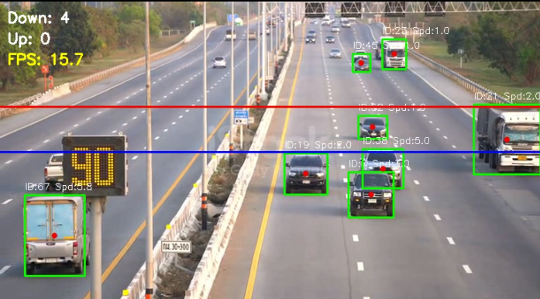
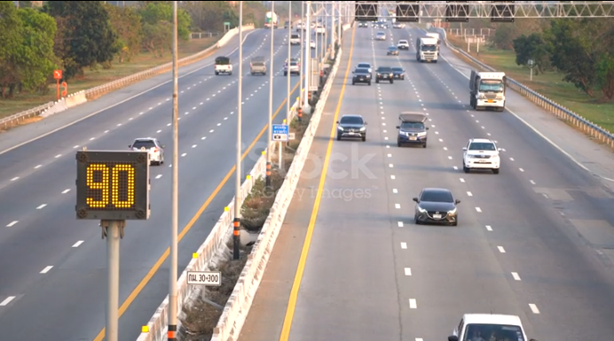
a. Original Image
b. Labelled Image

Figure 4.2: Vehicle detection results (a) Unlabelled image, (b) Labelled image
The qualitative results clearly show the effectiveness of the model in identifying both people and vehicles across different scenarios. The model is able to detect multiple objects in a single frame while maintaining accurate localization.
In addition to image-based testing, the system was also evaluated using video input. The model successfully performed object detection, tracking, and counting in real time [7] [9]. The ByteTrack algorithm maintained consistent IDs for moving objects, enabling accurate tracking across frames [5], [6].
The system also demonstrated reliable vehicle counting using the line-crossing method and provided consistent speed estimation based on object displacement. The real-time FPS displayed during processing confirms that the system can operate efficiently on CPU-based hardware.
However, some limitations were observed in challenging scenarios such as heavy occlusion, overlapping objects, and very small or distant objects. Despite these limitations, the overall performance of the system remains strong and suitable for practical applications such as traffic monitoring and analysis [11].

CHAPTER 5: TESTING AND VALIDATION

5.1 Result Analysis
The proposed YOLO11-based system demonstrates strong performance in object detection, tracking, and analysis tasks [3], [5], [6]. The model successfully detects multiple objects such as vehicles and people in both images and video frames, with accurate localization using bounding boxes [1], [2].
The qualitative results obtained from labelled outputs confirm that the system performs reliably under real-world traffic conditions [9], [11]. The integration of detection, tracking, and counting further enhances the analytical capability of the system [7].
The key observations from the results are:
- Accurate Object Detection – Objects are detected with high confidence values
- Multi-object Handling – Multiple objects are correctly detected in a single frame
- Consistent Output – Stable predictions across video frames
- Good Generalization – Performs well on unseen validation data
These results indicate that the trained YOLO11 model is capable of performing reliable object detection and forms a strong foundation for further performance evaluation.
The quantitative evaluation of the trained model further confirms its effectiveness. The model achieved an overall precision of 78.68%, recall of 73.36%, and mAP@0.5 of 82.27%, indicating strong detection capability on the validation dataset.

5.1 Performance Evaluation
The performance of the YOLO11 model was evaluated using multiple training graphs that represent the behaviour of the model across epochs [3]. These graphs provide insights into how the model learns, converges, and improves its detection capability over time [1], [2].

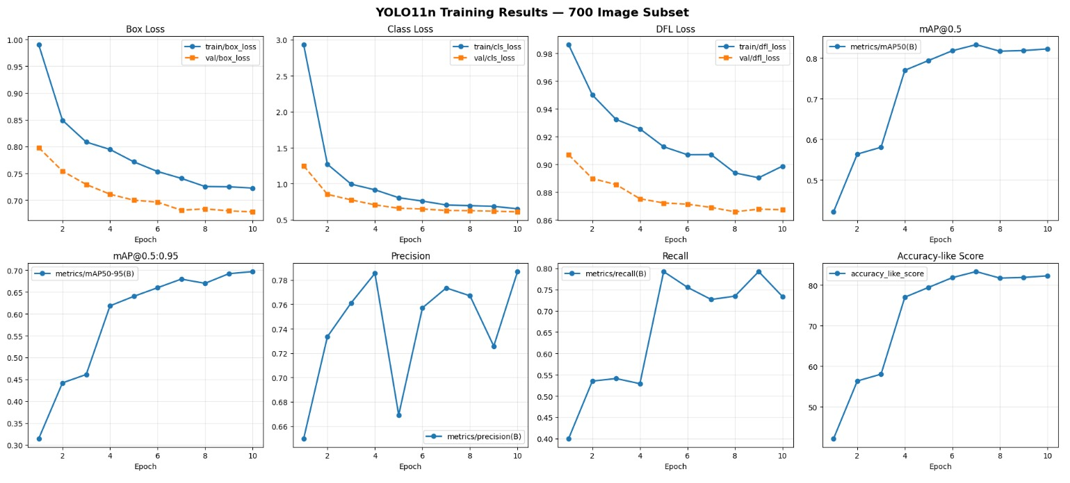
Figure 5.1: Training performance graphs showing loss, mAP, precision, recall, and accuracy-like score across epochs
1. Box Loss Analysis
The Box Loss represents the error in predicting bounding box coordinates. It measures how accurately the predicted box aligns with the ground truth.
From the graph, it can be observed that:
- The training box loss decreases from a high value (~0.99) to around (~0.72)
- The validation box loss also decreases consistently and remains lower than training loss
- The gap between training and validation loss is small, indicating good generalization
This decreasing trend shows that the model is learning to localize objects more accurately with each epoch and is not overfitting.
2. Class Loss Analysis
Class Loss measures the error in predicting the correct class label for each detected object.
Observations from the graph:
- A sharp decrease in class loss is observed in early epochs (rapid learning phase)
- After epoch 3–4, the loss stabilizes around a lower value (~0.6)
- Training and validation losses follow a similar trend
This indicates that the model quickly learns to classify objects correctly and maintains stable performance after initial training [3].
3. DFL (Distribution Focal Loss) Analysis
DFL Loss is used to improve bounding box regression by modeling probability distributions for box coordinates [3].
From the graph:
- DFL loss gradually decreases over epochs
- The reduction is smooth, indicating stable learning
- Validation DFL loss remains slightly lower than training loss
This confirms that the model is improving its bounding box precision and producing more accurate object localization [3].
4. mAP@0.5 Analysis
Mean Average Precision at IoU threshold 0.5 measures detection accuracy.
$$mAP=\frac{1}{N}∑AP_{i}$$
Observations:
- mAP increases rapidly from ~0.42 to ~0.80 within initial epochs
- After epoch 6, the improvement slows and stabilizes
- Final mAP remains above 0.80
This indicates that the model achieves strong detection performance and converges after sufficient training.
5. mAP@0.5:0.95 Analysis
This metric evaluates performance across multiple IoU thresholds, making it more strict.
Observations:
- Gradual increase from ~0.31 to ~0.69
- Improvement is steady but slower compared to mAP@0.5
- Indicates better bounding box precision over time
This shows that the model not only detects objects but also improves in precise localization.
6. Precision Analysis
Precision measures how many predicted objects are actually correct.
$$Precision=\frac{TP}{TP+FP}$$
Observations:
- Precision increases overall but shows slight fluctuations
- Temporary drop at mid-epochs indicates model adjustment
- Final precision reaches ~0.78
This suggests that the model reduces false positives over time and achieves reliable detection accuracy.
7. Recall Analysis
Recall measures how many actual objects are detected by the model.
$$Recall=\frac{TP}{TP+FN}$$
Observations:
- Recall improves significantly after early epochs
- Peaks around ~0.79 and remains stable
- Indicates that most objects in the image are successfully detected
This shows that the model is capable of detecting a high percentage of actual objects.
8. Accuracy-like Score Analysis
Since traditional accuracy is not suitable for object detection, an approximate metric is used:
$$Accuracy≈mAP@0.5×100$$
Observations:
- Accuracy increases steadily from ~42% to above ~82%
- Shows consistent improvement with training
- Stabilizes after epoch 6–7
This confirms that the model performance improves consistently and reaches a stable, high accuracy level.
Overall Interpretation of Training Graphs
The combined analysis of all graphs indicates that:
- The model converges properly with decreasing loss
- Performance metrics (mAP, Precision, Recall) improve steadily
- No significant overfitting is observed
- The model achieves a good balance between accuracy and generalization
These results confirm that the YOLO11 model is well-trained and suitable for real-time object detection tasks.
Numerical Performance Evaluation
In addition to graphical analysis, the model performance was quantitatively evaluated using validation metrics obtained after training.
The final evaluation results are as follows:

Table 5.1: Final Evaluation Results of the YOLO-Based Object Detection Model
Metric | Value | Percentage
Precision | 0.7868 | 78.68%
Recall | 0.7336 | 73.36%
mAP@0.5 | 0.8227 | 82.27%
mAP@0.5:0.95 | 0.6967 | 69.67%
Accuracy-like Score | 0.8227 | 82.27%
These values indicate that the model is able to detect objects with high accuracy while maintaining a good balance between false positives and false negatives.
Inference Speed Analysis
The system performance was also evaluated in terms of computational efficiency:
- Inference Time per Image: 151 ms
- Approximate FPS: 6.6 frames per second
- Total Validation Time: 26.3 seconds
These results show that the system is capable of near real-time processing even on a CPU-based setup.
Conclusion from Metrics
The combination of high mAP, balanced precision-recall values, and acceptable inference speed demonstrates that the proposed YOLO11-based system is both accurate and efficient, making it suitable for real-world applications such as traffic monitoring and vehicle analysis [9], [11].

5.3 Discussions
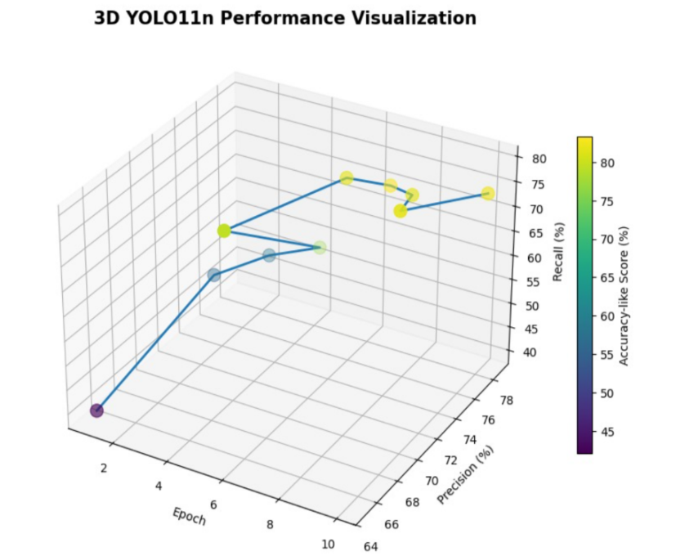
The results obtained from the experiments demonstrate that the proposed system performs effectively in real-time object detection and analysis tasks.
Figure 5.3: 3D visualization showing relationship between epochs, precision, recall, and accuracy-like score
3D Graph Analysis
The 3D visualization provides a deeper understanding of model performance:
- X-axis (Epochs) shows training progression
- Y-axis (Precision) represents detection correctness
- Z-axis (Recall) represents detection completeness
- Color gradient represents accuracy-like score
Key observations:
- Precision and Recall increase as epochs progress
- Accuracy-like score improves consistently (color shift toward higher values)
- Model stabilizes after mid-epochs (around epoch 6–8)
- Balanced growth of precision and recall indicates no overfitting

System Strengths
- Real-time Processing – Works efficiently on CPU
- Integrated Pipeline – Combines detection, tracking, counting, and speed estimation
- Stable Learning – Smooth convergence of loss functions
- Scalable Design – Can be extended with GPU or larger datasets
Limitations
- Small Object Detection Issues – Difficulty detecting distant objects
- Occlusion Problems – Overlapping objects affect tracking accuracy
- Speed Estimation Limitation
$$Speed=\sqrt{{\left(x_{2}-x_{1})^{2}+(y_{2}-y_{1}\right)}^{2}}$$
This provides only pixel-based speed, not real-world units
- Dependence on Image Quality – Performance affected by poor lighting
The experimental results confirm that the YOLO11-based system achieves a good balance between detection accuracy and computational efficiency. The combination of detection, tracking, counting, and speed estimation makes the system suitable for real-world applications such as traffic monitoring and intelligent transportation systems.

CHAPTER 6: CONCLUSION AND FUTURE WORK

6.1 Conclusion
The proposed YOLO11-based vehicle detection, tracking, and analysis system successfully demonstrates the application of deep learning in real-time traffic monitoring. The system integrates object detection, tracking, vehicle counting, and speed estimation into a unified pipeline.
The model was trained on a custom subset of the BDD100K dataset and achieved strong performance in terms of precision, recall, and mAP. The results confirm that the system is capable of detecting multiple objects accurately and maintaining consistent tracking across video frames.
The major achievements of the system are:
- Accurate detection of vehicles and pedestrians using YOLO11
- Efficient tracking of objects using ByteTrack
- Reliable vehicle counting using line-crossing technique
- Real-time performance on CPU-based systems
- Integration of speed estimation for motion analysis
Despite operating on limited hardware resources, the system maintains a good balance between accuracy and efficiency. The results validate that the proposed approach can be effectively used in traffic monitoring and intelligent transportation systems.

6.2 Future Work
Although the system performs effectively, several improvements can be made to enhance its performance and extend its real-world applicability.
The following enhancements can be considered in future work:
- Occlusion-Aware System
The current system faces challenges when objects overlap or are partially hidden. Future improvements can include occlusion-aware tracking models that use advanced techniques such as re-identification or temporal consistency to maintain object identity even during occlusion.
- Real-World Speed Estimation
Currently, speed is calculated in pixels per frame. This can be improved by calibrating the system using real-world measurements (distance, camera angle) to estimate speed in km/h.
- Use of Larger Dataset
Training the model on a larger and more diverse dataset can improve detection accuracy, especially for small or distant objects.
- GPU-Based Implementation
Deploying the system on GPU can significantly improve inference speed and enable real-time performance for high-resolution video.
- Multi-Class Traffic Analysis
Extending the system to include more object classes such as traffic signals, road signs, and pedestrians for comprehensive traffic monitoring.
- Integration with IoT Systems
The system can be connected to smart city infrastructure for automated traffic control and monitoring.
- Improved Tracking Algorithms
Advanced tracking methods such as DeepSORT or hybrid models can be used for better tracking accuracy.
- Low-Light and Weather Adaptation
Enhancing the model to perform effectively under poor lighting, fog, or rain conditions.

REFERENCES
[1] C.-Y. Wang, I.-H. Yeh and H.-Y. M. Liao, “YOLOv9: Learning What You Want to Learn Using Programmable Gradient Information,” arXiv preprint arXiv:2402.13616, 2024.
[2] A. Wang, H. Chen, L. Liu, K. Chen, Z. Lin, J. Han and G. Ding, “YOLOv10: Real-Time End-to-End Object Detection,” arXiv preprint arXiv:2405.14458, 2024.
[3] R. Khanam and M. Hussain, “YOLOv11: An Overview of the Key Architectural Enhancements,” arXiv preprint arXiv:2410.17725, 2024.
[4] M. Yaseen, “What is YOLOv8: An In-Depth Exploration of the Internal Features of the Next-Generation Object Detector,” arXiv preprint arXiv:2408.15857, 2024.
[5] Y. Zhang, C. Wang, X. Wang, W. Zeng and W. Liu, “FairMOT: On the Fairness of Detection and Re-Identification in Multiple Object Tracking,” International Journal of Computer Vision, 2021.
[6] P. Liao, F. Yang, D. Wu, B. Liu, X. Zhang and S. Zhou, “Enhanced Multi-Object Tracking: Inferring Motion States of Tracked Objects,” ACM Trans. Multimedia Computing, 2022.
[7] M. Kundurthi, T. Gurunathan, M. A. Khan, M. S. Raza and A. Gangopadhyay, “Real-Time Object Tracking on the Edge,” Proc. IEEE Edge Computing Conf., 2022.
[8] C. Jing, M. Su, C. Zhang and F. Teng, “A Global Attention Enhanced YOLOv8 Model for Outdoor Multi-Class Object Detection,” Proc. Int. Conf. Artificial Intelligence, 2023.
[9] D. Nimma, O. Al-Omari, R. Pradhan et al., “Object Detection in Real-Time Video Surveillance Using Attention-Based Transformer YOLOv8 Model,” IEEE Access, 2024.
[10] S. Basha and G. S. Ram, “Real-Time Object Detection in Low-Light Environments using YOLOv8: A Case Study with a Custom Dataset,” Proc. Int. Conf. Computer Vision, 2023.
[11] M. K. A. Maaroof and M. S. Bouhlel, “Real-Time Object Detection Using YOLO-8 Model: A Drone-Based Approach,” IEEE Access, 2025.
[12] X. Peng and H. Jiang, “A Review of Small Object Detection Based on Deep Learning,” IEEE Access, 2020.
[13] H. Song, T. A. Vu, S. Menon, S. Narasimhan and M. K. Jawed, “HiddenObject: Modality-Agnostic Fusion for Multimodal Hidden Object Detection,” IEEE TPAMI, 2023.
[14] Y. Zhang, D. Zhou, S. Chen, S. Gao and Y. Ma, “Single-Image Crowd Counting via Multi-Column Convolutional Neural Network,” Proc. IEEE CVPR, 2016.
Personal Details

Name: Sourav Kumar
Er. No: 231B349
Phone No: 9234395033
DOB: 24/01/2004
Email: kumarsourav2401@gmail.com
Signature


Name: Garv Gang
Er. No: 231B113
Phone No: 7851811259
DOB: 25/09/2004
Email: garvgang2004@gmail.com
Signature


Name: Tryambkesh Sharma
Er. No: 231B366
Phone No: 9407096428
DOB: 25/09/2004
Email: tryambkeshsharma617@gmail.com
Signature

