Contents in this project User Registration with Local PhpMyAdmin MySQL Database iOS Android Example Tutorial:

1. The first step is to install the Local PHP server software in your computer, We are using the XAMPP in our tutorial, So if you have n’t install the XAMPP then download from its [**official website**](https://www.apachefriends.org/download.html) , It’s free.

2. After installing the XAMPP just start the **Apache** and **MySQL** server.

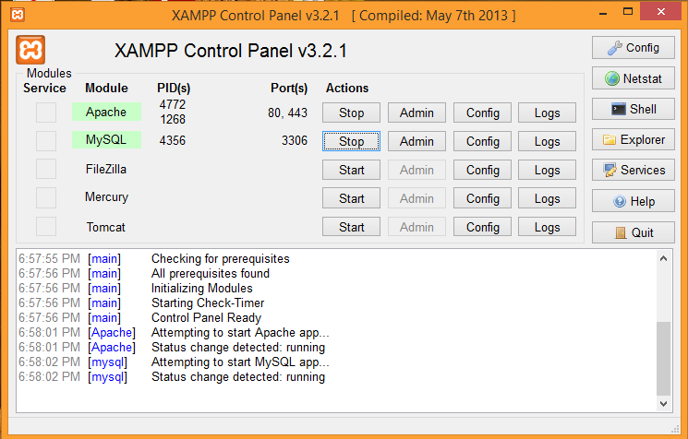

3. Create MySQL database and Table:

1. Next step is to create MySQL database in your local host PhpMyAdmin, So open your web browser(Google chrome, Mozilla Firefox etc.) and type  localhost/phpmyadmin and press enter, Now you’ll see the Localhost/PhpMyAdmin MySQL database control panel.
2. Click on New link to create new MySQL database.

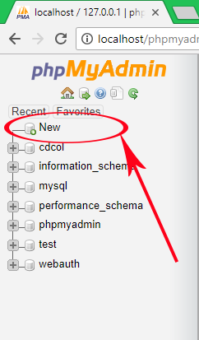

1. Enter the Database name, we are creating the Database named as **test**.

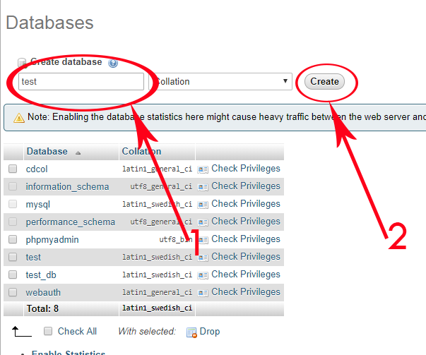

4.Next step is creating Table in your Local database, Enter table name as **user_details** with columns **4**.

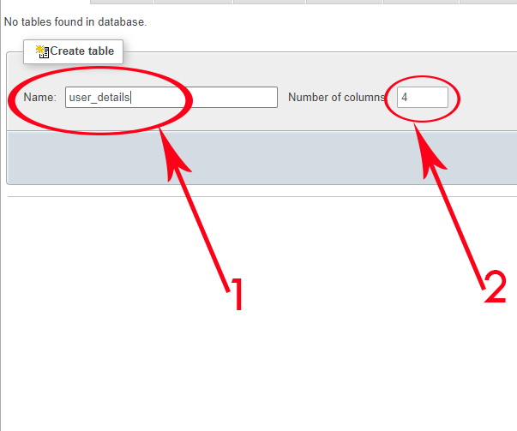

5.Enter columns name **id**, **name**, **email**, **password** with type **INT** and **VARCHAR**. Now make the id as auto increment and make the id is primary key. 

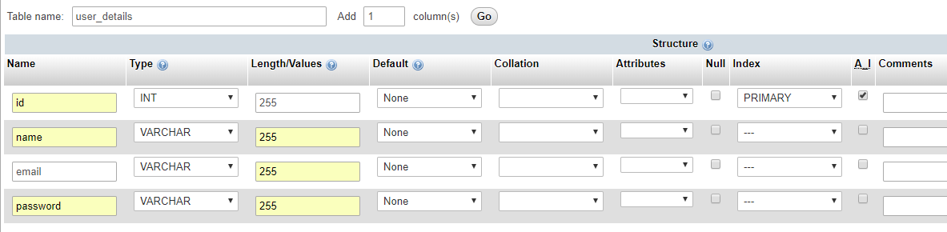

4. Creating PHP Files:

we have to create 2 php files first one is **dbconfig.php** and second is **user_registration.php** .

**Code for dbconfig.php file:**

This file contains all the most useful information about our server like server database username, host name, password and database name.

|  |  |
| --- | --- |
|  |  |

<?php

//Define your host here.

$HostName = "localhost";

//Define your database name here.

$DatabaseName = "user_registration";

//Define your database username here.

$HostUser = "root";

//Define your database password here.

$HostPass = "";

?>

**Code for user_registration.php file:**

This file is used to insert user registration information data into MySQL database table. We would call this file into our react native code.

<?php

// Importing DBConfig.php file.

include 'dbconfig.php';

// Creating connection.

$con = mysqli_connect($HostName,$HostUser,$HostPass,$DatabaseName);

// Getting the received JSON into $json variable.

$json = file_get_contents('php://input');

// decoding the received JSON and store into $obj variable.

$obj = json_decode($json,true);

// Populate User name from JSON $obj array and store into $name.

$name = $obj['name'];

// Populate User email from JSON $obj array and store into $email.

$email = $obj['email'];

// Populate Password from JSON $obj array and store into $password.

$password = $obj['password'];

//Checking Email is already exist or not using SQL query.

$CheckSQL = "SELECT * FROM user_details WHERE email='$email'";

// Executing SQL Query.

$check = mysqli_fetch_array(mysqli_query($con,$CheckSQL));

if(isset($check)){

$EmailExistMSG = 'Email Already Exist, Please Try Again !!!';

// Converting the message into JSON format.

$EmailExistJson = json_encode($EmailExistMSG);

// Echo the message.

echo $EmailExistJson ;

}

else{

// Creating SQL query and insert the record into MySQL database table.

$Sql_Query = "insert into user_details (name,email,password) values ('$name','$email','$password')";

if(mysqli_query($con,$Sql_Query)){

// If the record inserted successfully then show the message.

$MSG = 'User Registered Successfully' ;

// Converting the message into JSON format.

$json = json_encode($MSG);

// Echo the message.

echo $json ;

}

else{

echo 'Try Again';

}

}

mysqli_close($con);

?>

5.Create a folder name as **User_Project** inside **C:\xampp\htdocs\** like i did in below screenshot and copy the both **dbconfig.php** and second is **user_registration.php** PHP files inside this folder. We would now call these files with IP of our local system.

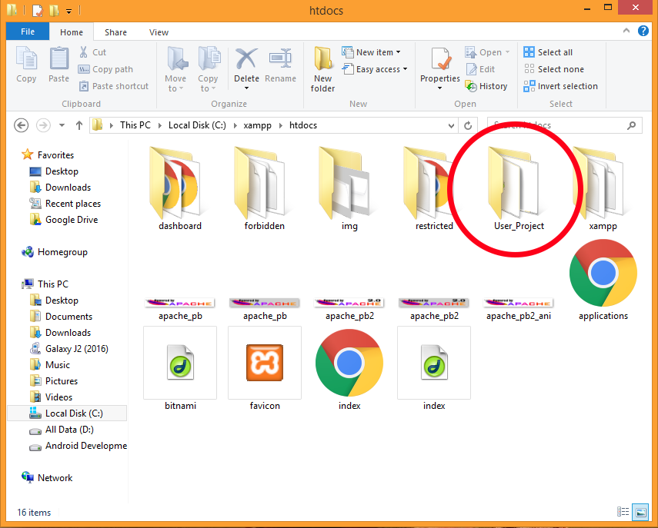

6. Open command prompt in windows and execute **ipconfig** command inside it to see your **system’s IP address**.

**Important Note :** After executing above command you’ll see many different IP address on your command prompt window, Now if you are connected to **WiFi network** then you need to copy/select the **IPv4** address under Wireless LAN Adapter WiFi block and if you are connected to LAN then select the IPv4 address under Ethernet Adapter.

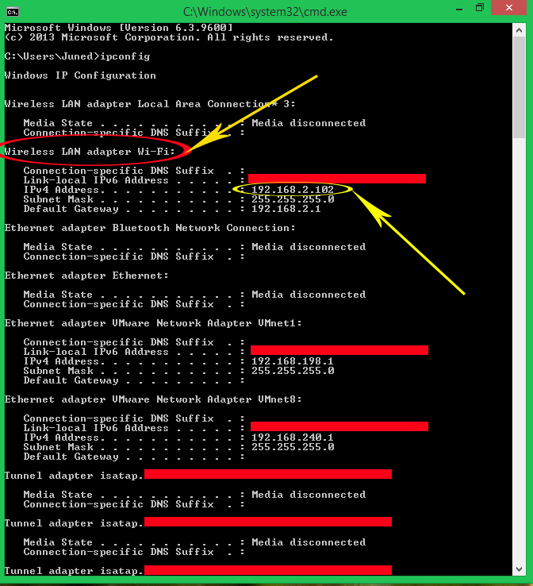

**7. Start Coding for Application :**

1. Open your project’s **App.js** file and import **StyleSheet**, **View**, **TextInput**, **Button**, **Text** and **Alert** component in your project.

**App.js**

import React, {Component} from 'react';

import { StyleSheet, View, TextInput, Button, Text, Alert } from 'react-native';

export default class App extends Component{

constructor() {

super()

this.state = {

UserName: '',

UserEmail: '',

UserPassword: ''

}

}

UserRegistrationFunction = () =>{

fetch('http://192.168.100.25/User_Project/user_registration.php', {

method: 'POST',

headers: {

'Accept': 'application/json',

'Content-Type': 'application/json',

},

body: JSON.stringify({

name: this.state.UserName,

email: this.state.UserEmail,

password: this.state.UserPassword

})

}).then((response) => response.json())

.then((responseJson) => {

// Showing response message coming from server after inserting records.

if(responseJson == "User Registered Successfully"){

Alert.alert(responseJson);

}else{

Alert.alert("User Registered Error!!");

}

}).catch((error) => {

console.error(error);

});

}

render() {

return (

<View style={styles.MainContainer}>

<Text style= {styles.title}>User Registration Form</Text>

<TextInput

placeholder="Enter User Name"

onChangeText={name => this.setState({UserName : name})}

underlineColorAndroid='transparent'

style={styles.TextInputStyleClass}

/>

<TextInput

placeholder="Enter User Email"

onChangeText={email => this.setState({UserEmail : email})}

underlineColorAndroid='transparent'

style={styles.TextInputStyleClass}

/>

<TextInput

placeholder="Enter User Password"

onChangeText={password => this.setState({UserPassword : password})}

underlineColorAndroid='transparent'

style={styles.TextInputStyleClass}

secureTextEntry={true}

/>

<Button title="Click Here To Register" onPress={this.UserRegistrationFunction} color="#2196F3" />

</View>

);

}

}

const styles = StyleSheet.create({

MainContainer :{

justifyContent: 'center',

flex:1,

margin: 10

},

TextInputStyleClass: {

textAlign: 'center',

marginBottom: 7,

height: 40,

borderWidth: 1,

borderColor: '#2196F3',

borderRadius: 5 ,

},

title:{

fontSize: 22,

color: "#009688",

textAlign: 'center',

marginBottom: 15

}

});