Contents

**No table of contents entries found.**

# Big Data

## HBase

Pre-requisites :

Job built on Talend Open studio for Big Data 6.4, using Hortonworks HDP 2.4

To run any Hbase Job, first we need to make sure these below services are running or not by command **“jps”**

* HMaster
* HRegionServer
* ThriftServer
* Zookeeper

If These services are not available, simply go to /root/ and run > sh start_hbase.sh, these services will come online. Shown below.

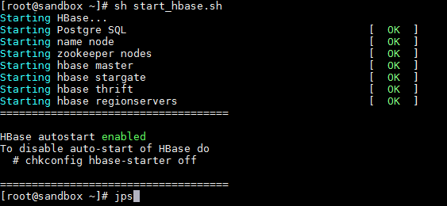

Now you are all set for HBase job design and execution.

Scenario:

1. Exchanging customer data with HBase

Drag and drop the following componets

tHBaseConnection, tFixedFlowInput, tHBaseOutput, tHBaseInput, tLogRow, tHBaseClose

Join them as show in the figure.

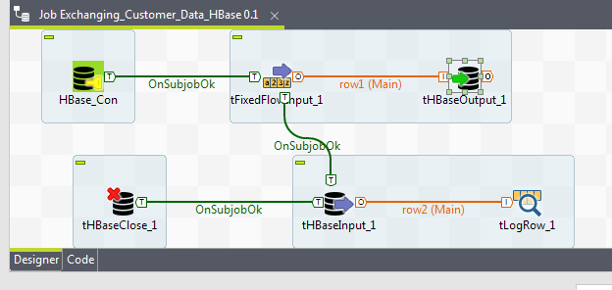

**Components settings:**

tHBaseConnection : 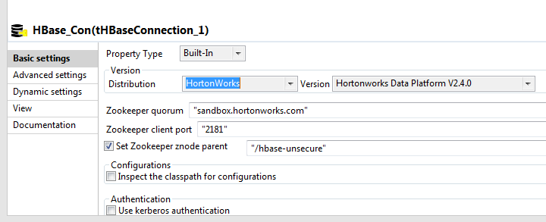

tFixedFlowInput : Define Schema 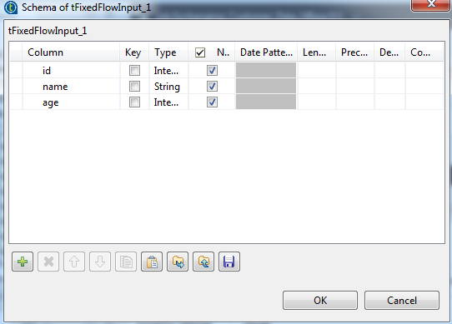

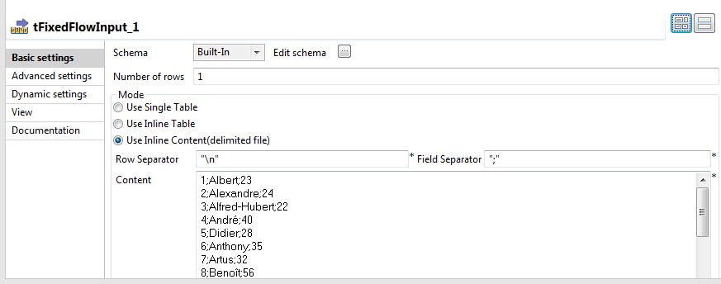

Data : 1;Albert;23

2;Alexandre;24

3;Alfred-Hubert;22

4;André;40

5;Didier;28

6;Anthony;35

7;Artus;32

8;Benoît;56

9;Catherine;34

10;Charles;21

11;Christophe;36

12;Christian;67

13;Clément ;64

14;Danniel;54

15;Elisabeth;58

16;Emile;32

17;Gregory;30

tHBaseOutput: Basic Setting tab 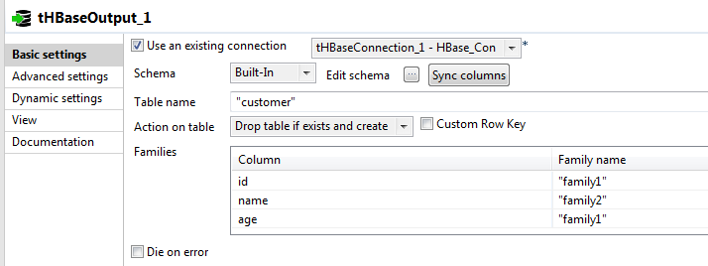

Advance setting tab 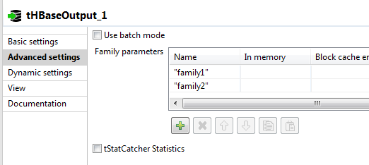

tHBaseInput: 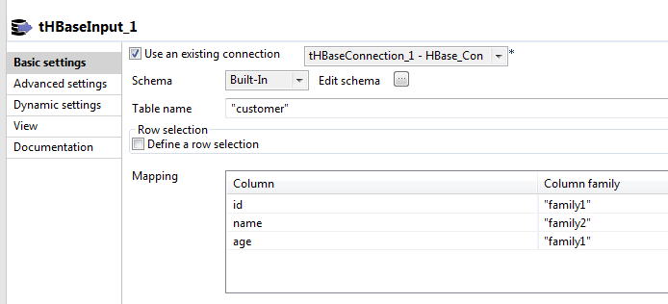

tLogRow:

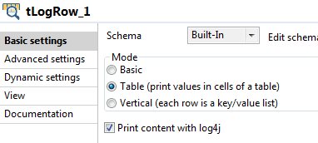

tHBaseClose :

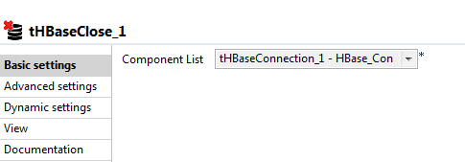

Run the job

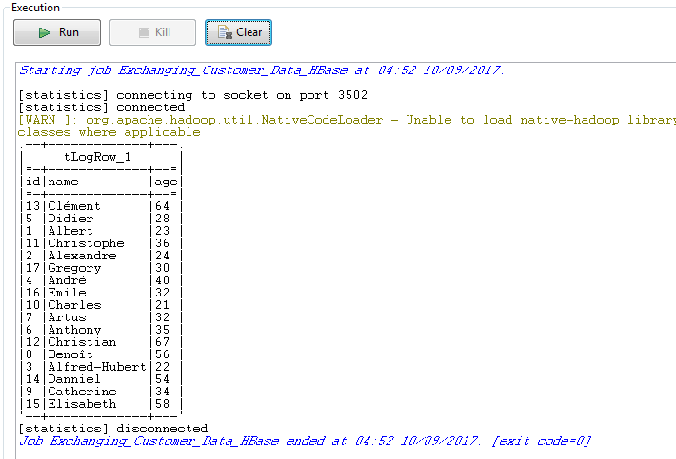

After successful run go to terminal in the virtual box and type

>hbase shell

It will open the hbase shell for hbase commands execution

Now type **list** list, it will list your existing table names

Hbase> list

You will be able to see **customer** table is created by this job, next

Hbase> scan 'customer'

ROW column is the key for hbase which is populated by talend and the data will be the concatenation of **jobname** it is inserted with the **data** values.

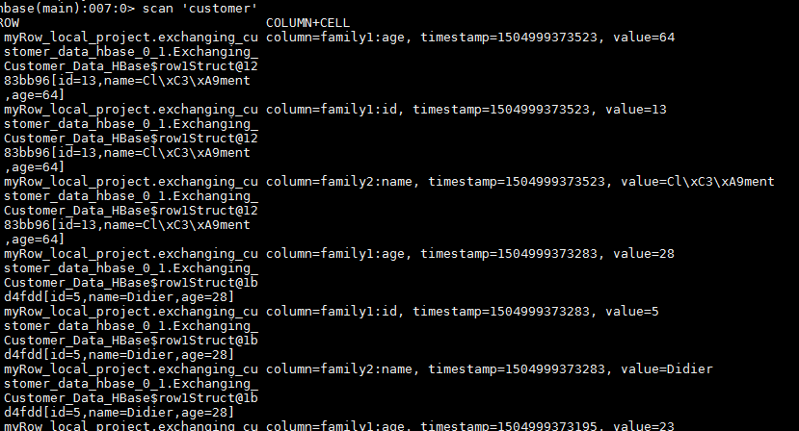

Error which might occure:

Table already exist error: Generally, HBase does not support the drop table which are **Enabled**,

So go to terminal and do

Hbase> disable ‘customer’

Hbase> drop ‘customer’

This will do the trick, but this is a manual process for each prior run.