***GraphQL***

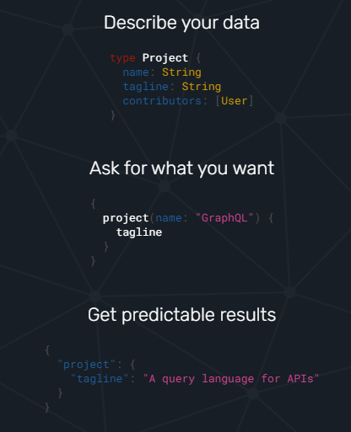

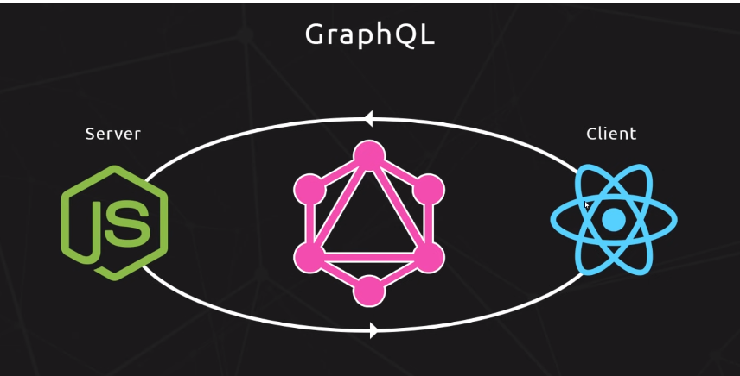

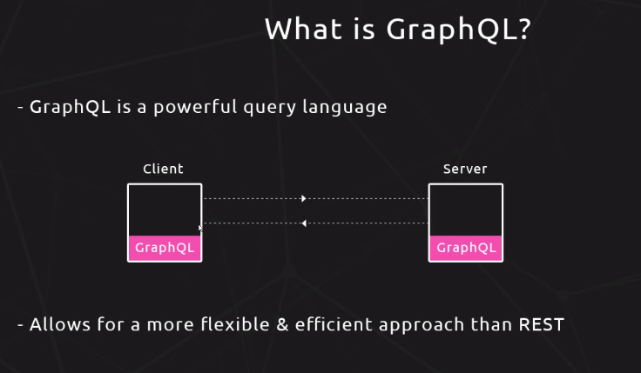

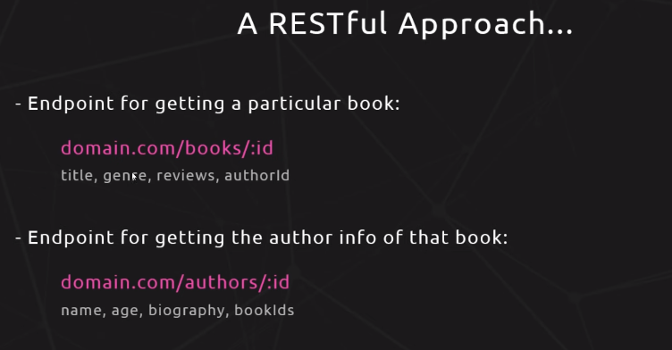

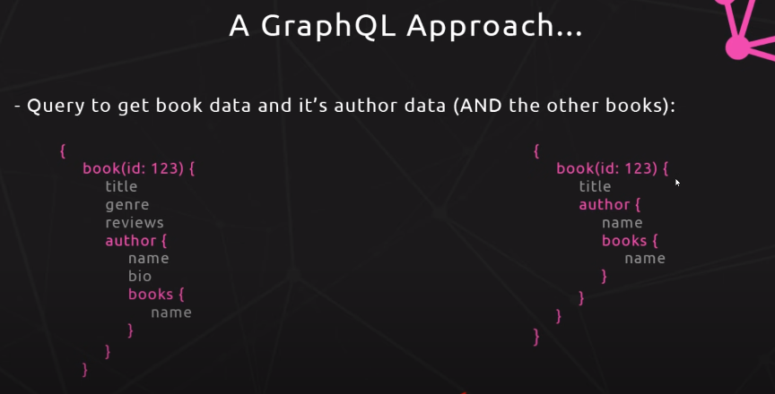

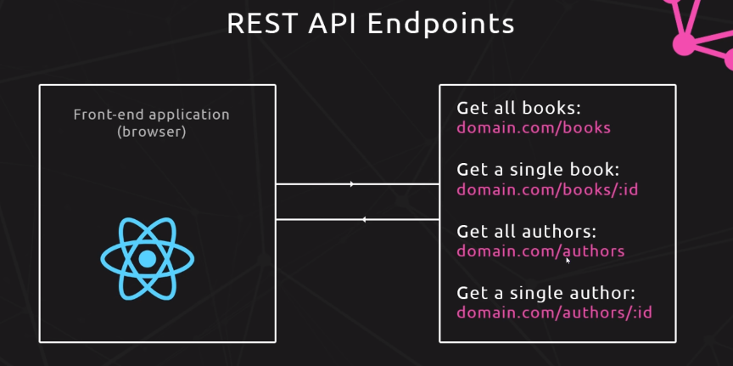

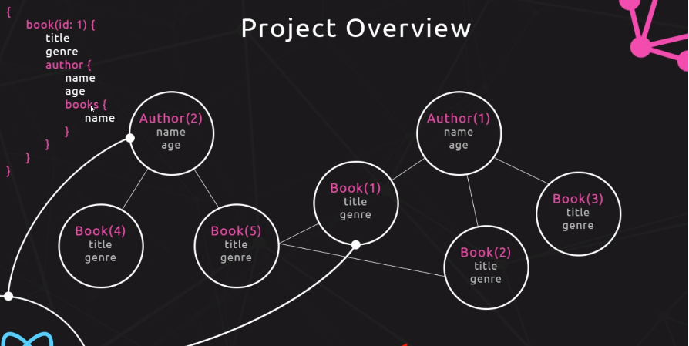

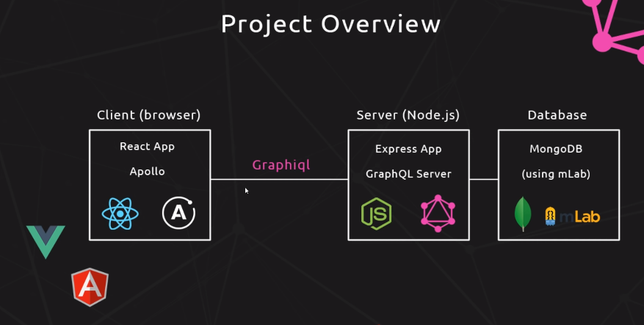

query AccountInfo {

uiapi {

query {

Account (where:{Name: { like: "ABC"}})

{

edges {

node {

Id

Name {

value

displayValue

}

CleanStatus{

value

displayValue

}

CreatedById{

value

displayValue

}

IsCustomerPortal{

value

displayValue

}

Contacts{

edges{

node{

Id

Name{

value

}

}

}

}

Opportunities{

edges{

node{

Id

Name{

value

}

}

}

}

Cases{

edges{

node{

Id

ApiName

}

}

}

}

}

}

}

}

}