PRODUCT DESIGN SPECIFICATION

RoleImpact Low-Fidelity Wireframes
  - Six-screen interaction model for the Access Change Impact Simulator
Version: v1.0
Date: August 12, 2026
Status: Approved PRD converted into build-ready screen structure

Design intent: Business consequences lead; relationship graphs support the explanation. Every destructive-looking action is explicitly framed as a read-only simulation against Harborline Commerce baseline v1.

1. Experience model
Primary path: Dashboard → New Simulation → Review Proposal → Run Analysis → Results → Test Recommendation → Save Scenario

Interaction decisions locked for implementation
- Use one persistent product shell: Dashboard, Explorer, and Simulations. Entity details and results are contextual views within that shell.
- Keep New Simulation to one focused page with three visible steps and an explicit safe-simulation notice.
- Place Business Impact before Technical Impact on Results; the graph follows the human-readable explanation path.
- Treat Test This Recommendation as part of the public MVP demo because it completes the approved user story and proves scenario isolation.
- Defer report export to the next milestone; keep Save Scenario in the MVP and preserve the report API boundary for later.

Responsive behavior
- Primary design target: 1280–1440 px laptop. At 736 px, the side navigation becomes a horizontal band and content stacks. At 360 px, all cards become single-column; the graph remains scrollable and the written conclusion remains complete.
- Mobile is not a core MVP requirement, but narrow layouts must not clip actions or hide the textual graph equivalent.

1. Dashboard
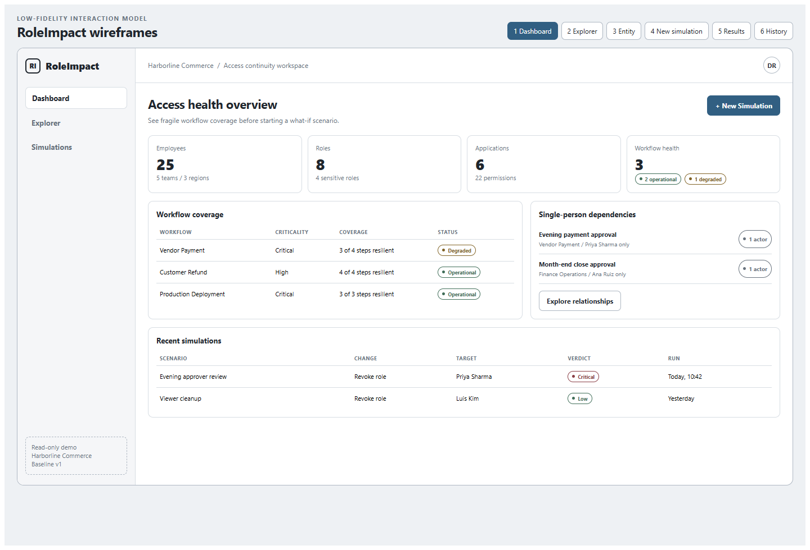
Wireframe 1 — Dashboard (low fidelity; layout and hierarchy only)
Purpose | Show organizational health, existing fragility, and recent scenario evidence before the user starts a simulation.
Primary action | New Simulation.
Core data | Entity counts, workflow statuses, single-person dependencies, recent simulations.
Key behavior | Workflow and dependency rows open focused Explorer views; recent scenarios open saved Results.
States | Loading skeletons, empty history, organization-load failure, no existing dependency risk.

2. Organization Explorer
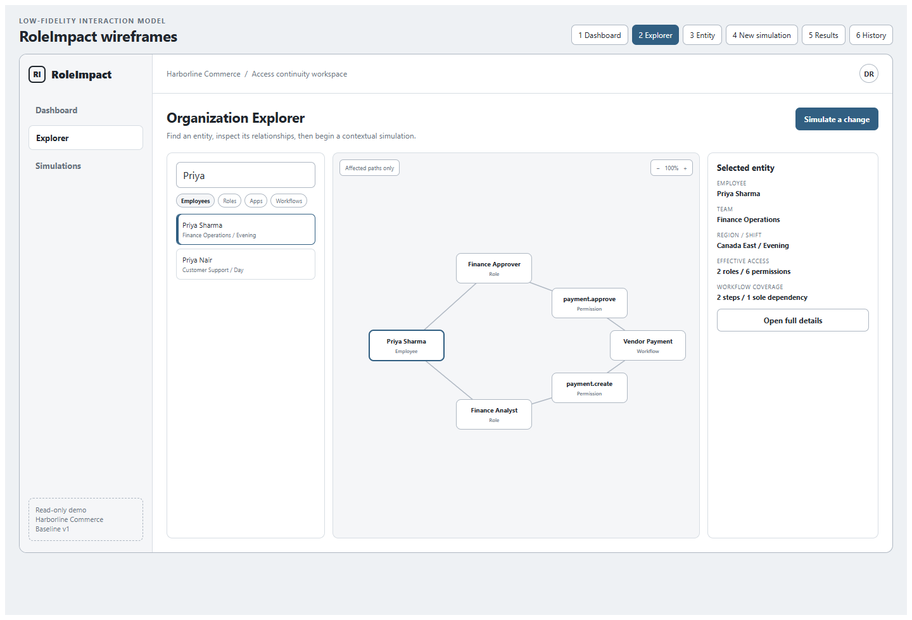
Wireframe 2 — Organization Explorer (low fidelity; layout and hierarchy only)
Purpose | Search entities and understand the relationship chain around an employee, role, app, permission, or workflow.
Primary action | Open full details or begin a contextual simulation.
Core data | Filterable entity list, affected-path graph, selected entity summary.
Key behavior | Selecting a node updates the side panel; default graph is filtered to decision-relevant paths.
Accessibility | The side panel and ordered relationship list provide the same information as the graph.

3. Entity Details
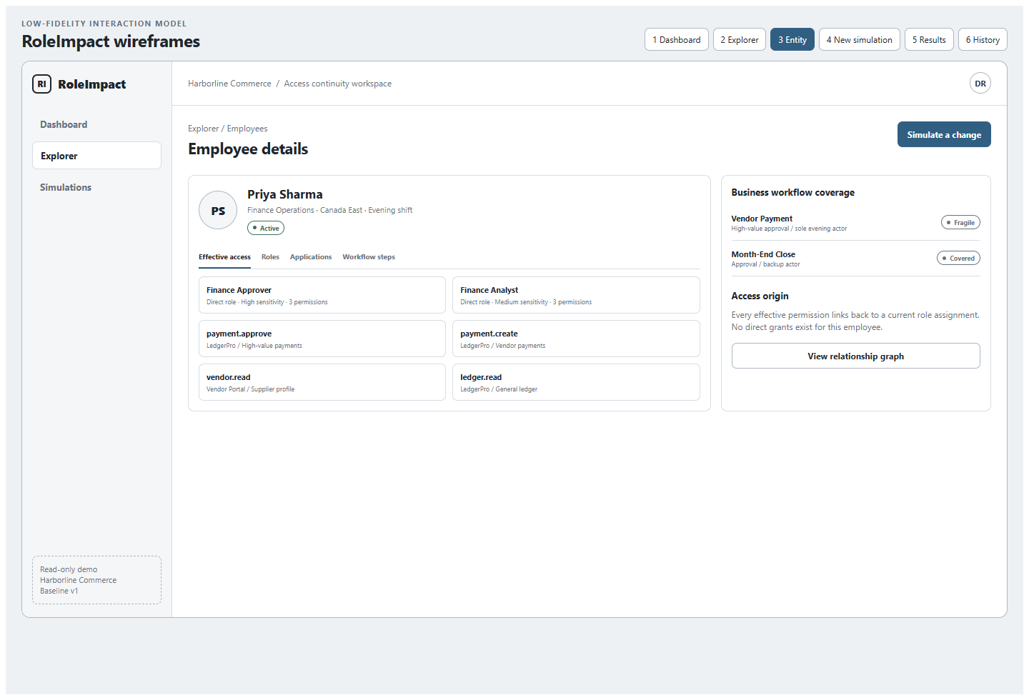
Wireframe 3 — Entity Details (low fidelity; layout and hierarchy only)
Purpose | Explain current effective access and business coverage before the user proposes a change.
Primary action | Simulate a Change with the entity preselected.
Core data | Status, team, region, shift, roles, effective permissions, applications, workflow steps, access origins.
Key behavior | Tabs switch access perspectives; every effective permission can reveal its role-assignment origin.
States | Inactive employee, no effective access, conflicting data marked inconclusive.

4. New Simulation
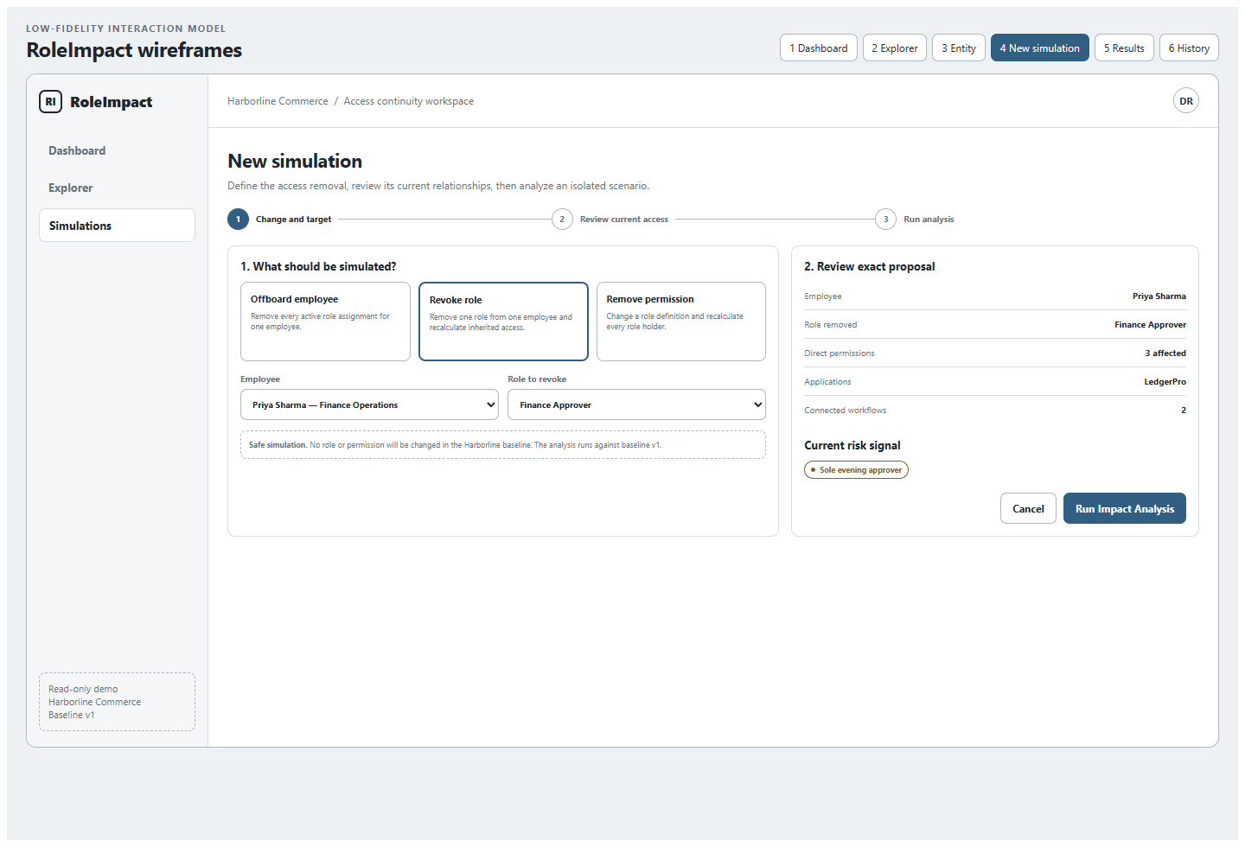
Wireframe 4 — New Simulation (low fidelity; layout and hierarchy only)
Purpose | Collect one supported change and let the reviewer confirm the exact current-state relationships before analysis.
Primary action | Run Impact Analysis.
Change types | Offboard employee; Revoke role from employee; Remove permission from role.
Validation | Targets must exist in baseline v1; role must be assigned; permission must belong to the selected role; contradictory input returns a field error.
Safety cue | Persistent statement that the baseline is immutable and no real access is modified.

5. Simulation Results
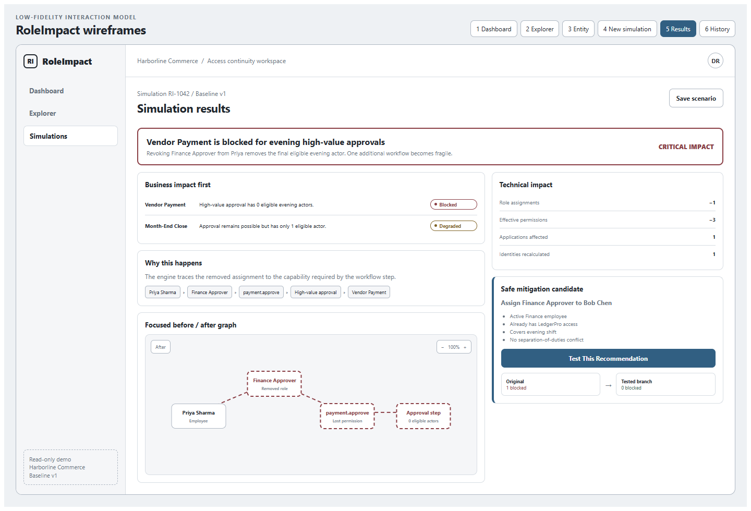
Wireframe 5 — Simulation Results (low fidelity; layout and hierarchy only)
Purpose | Support an approve/reject/revise decision with a plain-language verdict and traceable evidence.
Primary action | Test This Recommendation; Save Scenario is secondary.
Hierarchy | Verdict → business impact → explanation path → focused graph → technical impact → safe mitigation.
Graph semantics | Unchanged relationships are neutral; removed relationships are dashed red; blocked/degraded conclusions are labeled in text.
No recommendation | Show unmet constraints and state that no safe automatic recommendation exists.

6. Scenario History
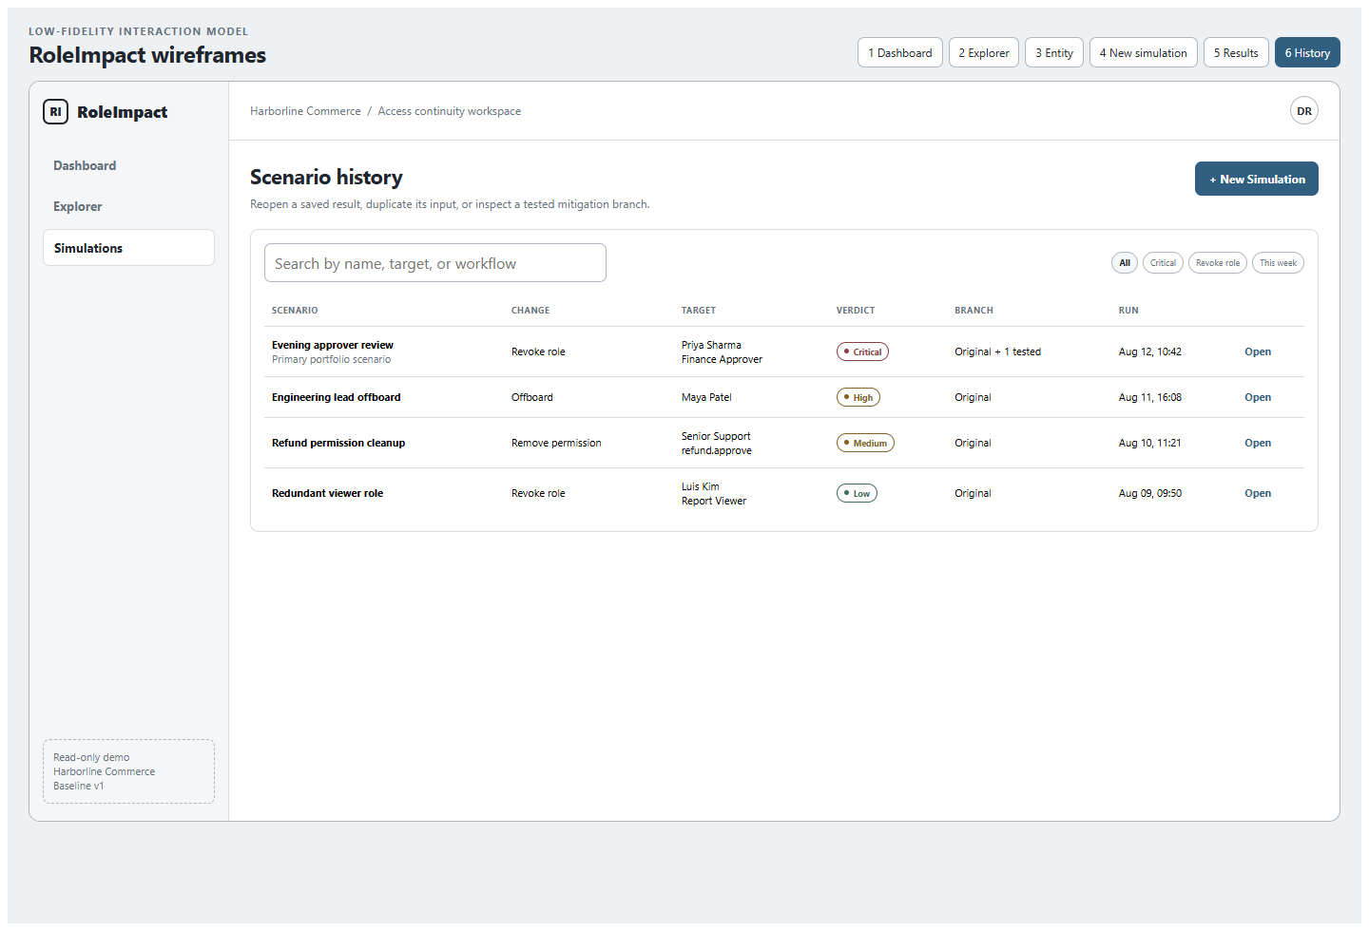
Wireframe 6 — Scenario History (low fidelity; layout and hierarchy only)
Purpose | Preserve audit evidence and reopen original or recommendation-test branches.
Primary action | Open a saved result; New Simulation remains available.
Core data | Name, change, target, verdict, branch count, run timestamp, optional reviewer notes.
Key behavior | Reopen is P0; duplicate and compare can follow after the first complete vertical slice.
Empty state | Explain what gets saved and offer New Simulation.

7. Cross-screen states and acceptance notes
State | Required behavior
Loading | Use local skeletons; retain screen heading and do not replace results with a full-page spinner.
Invalid data | Return an inconclusive analysis with the invalid entity/rule IDs. Never infer missing organizational facts.
No material impact | Show severity Low or None, preserve the technical diff, and state that workflows remain operational.
No recommendation | List unmet prerequisites and explain why every candidate was excluded.
Save conflict | Scenario result is immutable; name and reviewer notes may be updated with optimistic concurrency.
Graph fallback | Every graph has a textual relationship path and impact list for keyboard and screen-reader use.

Screen-level acceptance checklist
- Primary Priya Sharma scenario can be completed in under three minutes without documentation.
- Each screen has visible focus, keyboard-reachable controls, and a meaningful page heading.
- No simulation action changes baseline data; baseline version is visible at proposal and result time.
- Results remain understandable with the graph hidden.
- At common laptop widths, no key control or result requires horizontal page scrolling.

