TECHNICAL DESIGN SPECIFICATION

RoleImpact Technical Design
  - Final data schema, deterministic impact engine, REST boundaries, tests, and implementation stack
Version: v1.0
Date: August 12, 2026
Architecture: Two deployables + one PostgreSQL database; engine is a pure backend module

Recommendation: Build RoleImpact as a focused Java 21 / Spring Boot modular monolith with a React + TypeScript client and PostgreSQL. Keep the graph in relational tables, derive effective access, and avoid Neo4j, Kafka, Redis, Kubernetes, and real IAM integration for the MVP.

1. Decisions at a glance
Decision | Final choice
Backend | Java 21 + Spring Boot 3.5.x; Spring MVC, Bean Validation, Spring Data JPA, Flyway.
Frontend | React + TypeScript + Vite; TanStack Query, React Hook Form + Zod, React Flow, CSS/Tailwind utility layer as preferred.
Database | PostgreSQL 17; normalized baseline graph plus JSONB change/result snapshots for saved simulations.
Architecture | One Spring Boot API, one static React app, one database. Domain modules inside the API; no microservices.
Engine | Pure deterministic Java module: OrganizationSnapshot + SimulationChange → ImpactResult. No repository or HTTP dependency.
Deployment | Docker Compose locally; Render static site + Docker web service + managed Postgres for the public portfolio demo.
Scope | Recommendation testing is in the public MVP. Report export is P1 and consumes saved results without recalculation.

2. Architecture and boundaries
Architecture style. A small two-deployable system keeps the product understandable while adding meaningful Java/API depth for the target software-engineering roles. The backend remains a modular monolith; modules communicate through typed Java interfaces, not network calls.
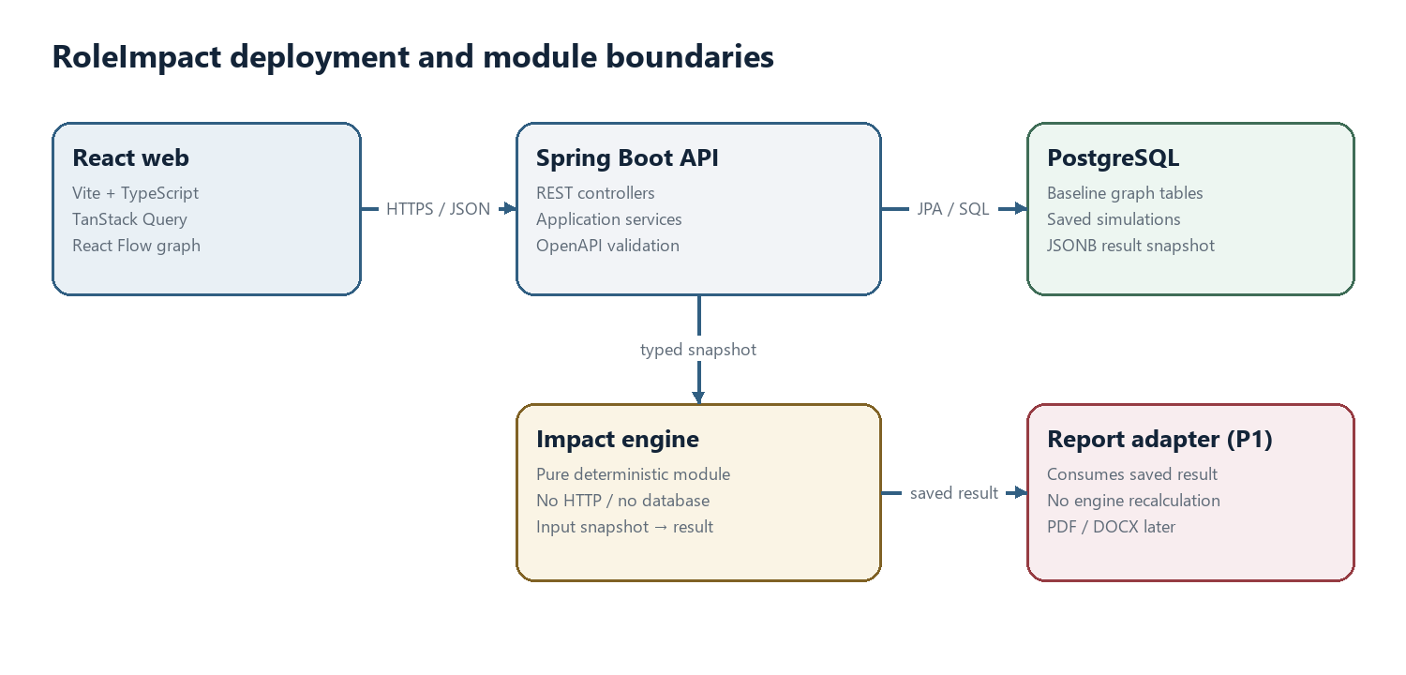
Figure 1 — Runtime and module boundaries

Backend modules
Module | Responsibility
catalog | Read/query organization entities and assemble immutable OrganizationSnapshot objects.
simulation | Validate a proposed change, invoke the engine, persist immutable result snapshots, and manage branches/notes.
impactengine | Apply the change, derive effective access, evaluate workflow coverage, create explanations, graph diffs, and recommendations.
reporting (P1) | Render an already-saved result. It must not invoke the engine or mutate scenario data.
shared | IDs, enums, error envelope, clock abstraction, canonical JSON/hash utilities.

Boundary rules
- The React client calls only /api/v1 and never reads PostgreSQL directly.
- Controllers map HTTP DTOs to application commands. They do not contain workflow rules or repository queries.
- The impact engine accepts a complete in-memory snapshot and returns a complete result. It imports no JPA, Spring MVC, or database classes.
- Repositories return domain projections; JPA entities are not serialized to the client.
- Saved result JSON is versioned. Reopening a scenario reads the saved result; it does not silently recalculate against a newer baseline.
- Only name and reviewer notes are mutable after save. Inputs, result, baseline version, and branch ancestry are immutable.

3. Final data schema
Schema rule: Relational tables are the source of truth. Effective permissions, step eligibility, workflow status, explanation paths, and graph diffs are derived. They are stored only inside an immutable simulation result for reproducibility.

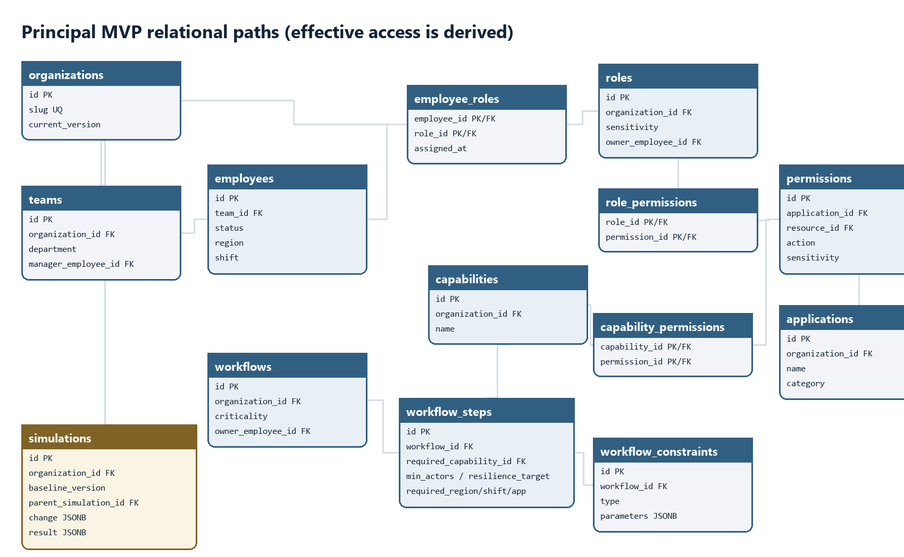
Figure 2 — Principal foreign-key paths; complete table definitions follow

3.1 Organization and access tables
Table | Important columns | Constraint / purpose
organizations | id uuid PK; slug varchar UQ; name; current_version int; created_at | Root aggregate; MVP seed contains Harborline Commerce.
teams | id uuid PK; organization_id FK; name; department; manager_employee_id FK nullable | Unique (organization_id, name).
employees | id uuid PK; organization_id FK; team_id FK; employee_no UQ; name; email; status; region; shift | status ACTIVE/INACTIVE; region and shift are constrained enums.
roles | id uuid PK; organization_id FK; name; description; sensitivity; owner_employee_id FK nullable | Unique role name per organization.
employee_roles | employee_id FK; role_id FK; assigned_at; assigned_by | Composite PK (employee_id, role_id). No overlapping history in MVP.
applications | id uuid PK; organization_id FK; name; category; owner_employee_id FK nullable | Unique app name per organization.
resources | id uuid PK; application_id FK; name; resource_type | Unique (application_id, name).
permissions | id uuid PK; organization_id FK; application_id FK; resource_id FK; action; sensitivity | Unique (application_id, resource_id, action).
role_permissions | role_id FK; permission_id FK | Composite PK. Role definition change removes one row in scenario memory only.

3.2 Capabilities and workflow tables
Table | Important columns | Constraint / purpose
capabilities | id uuid PK; organization_id FK; name; description | Business-facing ability such as Approve high-value payment.
capability_permissions | capability_id FK; permission_id FK | Composite PK. Any mapped effective permission satisfies the capability.
workflows | id uuid PK; organization_id FK; name; criticality; owner_employee_id FK | criticality CRITICAL/HIGH/MEDIUM/LOW.
workflow_steps | id uuid PK; workflow_id FK; step_key; name; position; required_capability_id FK; minimum_actors; resilience_target; required_department/region/shift/application_id nullable | Unique (workflow_id, step_key) and (workflow_id, position); resilience_target >= minimum_actors.
workflow_constraints | id uuid PK; workflow_id FK; type; parameters jsonb | Typed, validated parameters for SOD, EXCLUDE_EMPLOYEE, and DIFFERENT_ACTORS.
workflow_step_constraints | workflow_step_id FK; constraint_id FK | Composite PK; connects a constraint to participating steps.

3.3 Simulation persistence
Table | Important columns | Constraint / purpose
simulations | id uuid PK; organization_id FK; parent_simulation_id FK nullable; baseline_version; engine_version; idempotency_key nullable; request_hash; change_type; change_payload jsonb; result_status; result_payload jsonb; severity; name; reviewer_notes; created_at; completed_at | Original and tested-recommendation branches use the same table. Inputs and results are immutable; name/notes may change.
organization_versions | organization_id FK; version int; content_hash; created_at | Composite PK; records the seed version used for reproducibility without cloning every baseline row.

Indexes and integrity constraints
- Indexes on every foreign key plus employees(organization_id, status), employee_roles(role_id, employee_id), role_permissions(permission_id, role_id), workflow_steps(required_capability_id), and simulations(organization_id, created_at desc).
- CHECK constraints enforce known enums, positive positions, minimum_actors ≥ 1, and baseline_version ≥ 1.
- change_payload and result_payload require schema_version. Unique (organization_id, idempotency_key) plus request_hash makes retried POSTs safe while still allowing the same scenario to be intentionally run again under a new key.
- Foreign keys use RESTRICT for baseline catalog deletion. The MVP seeds data through Flyway and does not expose mutation endpoints.
- No graph database. The seed is small; indexed joins plus in-memory traversal are simpler, portable, and easier to test.

4. Impact-engine contract
Contract invariant. For the same canonical baseline snapshot, engine version, and change, the engine returns byte-equivalent canonical JSON and the same result hash. Timestamps and generated IDs are supplied by the application layer, not created inside the engine.

4.1 Java boundary
public interface ImpactEngine {
ImpactResult analyze(OrganizationSnapshot baseline, SimulationChange change);
}
public sealed interface SimulationChange permits
OffboardEmployee, RevokeEmployeeRole, RemoveRolePermission {}
record OffboardEmployee(UUID employeeId) implements SimulationChange {}
record RevokeEmployeeRole(UUID employeeId, UUID roleId) implements SimulationChange {}
record RemoveRolePermission(UUID roleId, UUID permissionId) implements SimulationChange {}

4.2 Input snapshot
Field | Type | Meaning
schemaVersion | string | Contract version, initially 1.0.
organizationId / baselineVersion | UUID / integer | Stable baseline identity.
employees / teams | arrays | Status and organizational attributes required for eligibility.
roles / assignments | arrays | Role definitions and current employee-role edges.
permissions / apps / resources | arrays | Technical access graph.
capabilities / mappings | arrays | Qualifying permission alternatives for each business ability.
workflows / steps / constraints | arrays | Ordered requirements, minimum coverage, and SOD rules.

4.3 Output contract
Field | Shape | Guarantee
resultStatus | COMPLETE | INCONCLUSIVE | INCONCLUSIVE includes typed data errors and no fabricated conclusion.
overallSeverity | CRITICAL | HIGH | MEDIUM | LOW | NONE | Computed from workflow status deltas and technical-only change.
executiveSummary | structured counts + message key + parameters | Frontend may render a sentence without changing the evidence.
changeSet | removed/added nodes and edges | Canonical direct changes applied to scenario memory.
technicalImpact | roles, permissions, apps, resources, identities | Before/after effective-access diff.
workflowImpacts | workflow and step evaluations | Baseline/scenario status, eligible actor IDs, failures, consequences.
explanationPaths | ordered typed nodes/edges | Every blocked/degraded conclusion has at least one exact path.
graphDiff | focused node/edge DTOs | Presentation projection; not the source of truth for the verdict.
recommendations | 0–2 candidates | Actions, restored steps, required grants, exclusions, rank breakdown.
diagnostics | engineVersion, resultHash, durationMs | durationMs is metadata excluded from deterministic result hash.

4.4 Evaluation pipeline
- Validate the snapshot and change. Return INCONCLUSIVE with entity/rule references for contradictions.
- Compute baseline effective permission sets and workflow-step eligibility.
- Copy the in-memory edge sets and apply exactly one proposed change.
- Find affected identities and capabilities from changed assignments or role-permission edges.
- Recompute only connected workflow steps, then evaluate minimum coverage and SOD constraints.
- Compare baseline and scenario to classify Operational, Degraded, or Blocked and calculate overall severity.
- Build explanation paths and a focused graph diff from stored predecessor links.
- Generate deterministic candidate actions; filter unsafe candidates, score the remainder, and return at most two.
- Canonicalize output ordering, compute resultHash, and return the immutable ImpactResult.

4.5 Eligibility, status, and severity
Rule | Final definition
Eligible actor | Active employee AND qualifying effective permission AND department/region/shift prerequisites AND not excluded. For assignment-level SOD, the proposed actor combination must remain satisfiable.
Operational | Every required step meets minimum_actors and configured resilience_target; all mandatory constraints are satisfiable.
Degraded | Workflow remains executable, but at least one step falls below its resilience_target or becomes a single-person dependency.
Blocked | At least one required step has no eligible actor or mandatory constraints cannot be satisfied.
Severity | Critical workflow blocked → Critical; non-critical blocked or critical degraded → High; non-critical degraded/new sole dependency → Medium; access-only diff → Low; no effective change → None.

4.6 Recommendation ranking
Candidate action in MVP: assign an existing role to one existing active employee. The engine does not create roles, clone permissions, or modify workflow policy.
Stage | Priority | Rule
Safety gate | Required | Active; prerequisites satisfied; application prerequisites satisfied; no SOD conflict; candidate not excluded.
New permissions | Primary | Fewer permissions added ranks first.
Organizational fit | Secondary | Same department/team, then region/shift fit.
Existing app access | Secondary | Prefer a candidate already using the application.
Coverage restored | Secondary | More blocked/degraded steps restored ranks higher.
Resilience | Tie-break | Prefer improvement in backup coverage; final tie-break is employee UUID ascending.
No-safe-option behavior: Return recommendations=[] plus excludedCandidateReasons grouped by unmet constraint. The API and UI must say that no safe automatic recommendation exists.

5. REST API boundaries
API style: JSON over HTTPS under /api/v1. OpenAPI is generated from the Spring API and used to generate the frontend TypeScript client. No GraphQL is needed for the MVP.

Verb | Path | Input / responsibility | Response
GET | /api/v1/dashboard | Counts, workflow health, dependencies, recent scenarios | DashboardSummary
GET | /api/v1/entities | type, q, team, status, page, size | Paged<EntitySummary>
GET | /api/v1/entities/{type}/{id} | Entity detail, access origins, workflow links | EntityDetail
GET | /api/v1/graph | focusType, focusId, scope=affected|neighborhood | GraphProjection
POST | /api/v1/simulations/validate | Change DTO + baselineVersion | ProposalPreview; no persistence
POST | /api/v1/simulations | Change DTO, baselineVersion, Idempotency-Key | 201 SimulationResultResource
GET | /api/v1/simulations | filters, cursor/page, sort | Paged<SimulationSummary>
GET | /api/v1/simulations/{id} | Saved immutable result and branch summary | SimulationResultResource
PATCH | /api/v1/simulations/{id} | name, reviewerNotes, expectedUpdatedAt | SimulationMetadata
POST | /api/v1/simulations/{id}/branches | Recommendation ID or explicit candidate action | 201 branched SimulationResultResource
GET | /api/v1/simulations/{id}/report | P1; format=pdf|docx | Generated report stream

5.1 Change request
{
"schemaVersion": "1.0",
"organizationId": "harborline-id",
"baselineVersion": 1,
"change": {
"type": "REVOKE_EMPLOYEE_ROLE",
"employeeId": "priya-id",
"roleId": "finance-approver-id"
}
}

5.2 HTTP behavior
Status | Meaning
200/201 | Successful query or newly computed saved simulation/branch.
400 | Malformed JSON or invalid enum/field shape.
404 | Organization, entity, simulation, or recommendation ID does not exist.
409 | Baseline version is stale; idempotency key reused with different input; metadata optimistic-lock conflict.
422 | Well-formed but invalid scenario: role not assigned, permission not on role, or contradictory baseline reference.
500 | Unexpected fault with trace ID; no internal stack or sensitive data returned.
Error envelope: { code, message, traceId, fieldErrors[], entityRefs[] }. All timestamps are UTC ISO-8601; all IDs are UUID strings; unknown response fields must be ignored by clients.

6. Test strategy
Testing principle. Correctness evidence matters more than coverage percentage. The suite must prove isolation, deterministic output, complete explanations, and the three supported change types.
Layer | Tool | What it proves | Gate
Pure unit | JUnit 5 + AssertJ | Effective access, eligibility predicates, SOD satisfiability, status/severity, graph diff, explanation paths, recommendation filtering/ranking. | Every rule branch and authored scenario.
Property/invariant | jqwik or custom generated fixtures | Same input → same hash; baseline unchanged; recommendation never worsens severity; every degraded/blocked result has a path; no duplicate nodes/edges. | 200+ generated cases in CI.
Persistence integration | Spring Boot + Testcontainers PostgreSQL | Flyway migrations, repository projections, JSONB round-trip, transaction rollback, idempotency, branch ancestry. | Real Postgres, never H2.
API contract | MockMvc/RestAssured + OpenAPI validation | DTO validation, status codes, error envelope, pagination, stale baseline conflict. | All public endpoints.
Frontend unit | Vitest + Testing Library | Form conditional fields, status rendering, explanation list, graph text alternative, recommendation states. | Critical components and hooks.
End-to-end | Playwright | Primary Priya flow, all three change types, no-impact case, no-safe-recommendation, save/reopen branch. | Chromium on every PR; broader matrix nightly if desired.
Accessibility | axe-core + keyboard scripts | Focus order, labels, contrast, dialogs, table semantics, graph alternative. | No serious/critical issues on six screens.
Performance | JUnit benchmark harness + timed API smoke | Seeded simulation p95 under 2 s; dashboard p95 under 500 ms after warm-up. | Stable local/CI profile; report hardware.

6.1 Golden acceptance scenarios
Scenario | Required assertion
Revoke Finance Approver from Priya | Vendor Payment blocked in evening; Month-End Close degraded; Critical; complete path; Bob recommended only if eligible.
Offboard sole release approver | Production Deployment blocked or degraded according to remaining actors and criticality.
Remove refund.approve from Senior Support | Every role holder recalculated; high-value refund step loses coverage; impacted identity list complete.
Revoke redundant viewer role | Technical diff exists; workflows remain operational; severity Low.
No safe candidate | recommendations empty; unmet shift/SOD/application constraints displayed.
Test Bob branch | Parent unchanged; branch restores coverage; branch references parent; result can be reopened exactly.

6.2 CI quality gates
- Backend unit and integration tests pass; Flyway migrates a blank database and seed dataset.
- Frontend typecheck, lint, unit tests, and production build pass.
- Generated OpenAPI client is current; a CI diff fails when backend contract changes are not regenerated.
- Playwright primary scenario passes against the full Docker Compose stack.
- No high-severity dependency or secret-scan findings; container health checks pass.
- The benchmark records p50/p95 and seeded dataset size; do not claim a performance number before measuring it.

7. Implementation stack
Layer | Choice | Rationale
Language/runtime | Java 21 LTS | Relevant to banking/platform roles and sufficient for modern Spring; avoids adopting a newer Java only for novelty.
API framework | Spring Boot 3.5.x + Maven | Mature stable line compatible with Java 21; Spring MVC, Validation, Actuator, Data JPA.
Database | PostgreSQL 17 + Flyway | Supported major version; SQL joins and JSONB snapshots cover the MVP without a graph database.
Frontend | React + TypeScript + Vite | Focused SPA, fast local setup, clear separation from Java API.
Server state/forms | TanStack Query; React Hook Form + Zod | Explicit request caching, mutations, conditional validation, and typed form errors.
Graph | @xyflow/react | Focused affected-path graph with keyboard-aware nodes; written explanation remains authoritative.
UI | Tailwind CSS + small reusable components | Fast portfolio polish; avoid bringing a complete enterprise design system.
Tests | JUnit 5, AssertJ, Testcontainers, Vitest, Testing Library, Playwright, axe-core | Covers domain, real Postgres, API, UI, E2E, and accessibility.
Local/CI | Docker Compose + GitHub Actions | One-command seed and repeatable full-stack checks.
Deploy | Render static site + Docker web service + managed Postgres | One platform for a public demo; use a persistent paid DB or reseed an ephemeral demo DB.
Observability | Spring Boot Actuator + structured JSON logs + traceId | Enough operational evidence without adding a metrics platform in MVP.
Version policy: Pin exact dependency versions in lockfiles/build files when implementation starts. This design names stable lines, not an instruction to upgrade automatically during the build.

8. Repository and delivery plan
roleimpact/
├── frontend/ # React + TypeScript SPA
├── backend/ # Spring Boot modular monolith
│ └── src/main/java/.../{catalog,simulation,impactengine,reporting,shared}
├── docs/ # PRD, wireframes, technical design, API examples
├── infra/ # docker-compose.yml and Render blueprint
├── .github/workflows/ # backend, frontend, e2e, security checks
└── README.md # problem, demo, architecture, metrics, trade-offs

Phase | Build | Exit condition
1. Foundation | Create repo, Flyway schema/seed, snapshot assembler, OpenAPI shell, frontend app shell. | Dashboard reads seeded Harborline data.
2. Vertical slice | Revoke-role change, effective access, Vendor Payment rules, basic Results. | Priya scenario returns correct blocked path.
3. Engine completeness | Other change types, all workflows, constraints, severity, explanations, recommendations. | Golden engine suite passes.
4. Product flow | Explorer, entity detail, result graph, branch test, save/reopen, error/empty states. | Six screens work end to end.
5. Portfolio proof | E2E/a11y/performance, Docker, deployment, README, demo video, measured resume bullets. | Public demo and CI are reproducible.

9. Explicitly deferred
- Real identity-provider, HR, ERP, cloud, or ticketing integrations.
- Authentication and multi-tenant administration; the public demo is read-only and synthetic.
- Neo4j, Kafka, Redis, Kubernetes, background queues, or multiple backend services.
- Generic policy language, time-bound grants, complex ABAC, and arbitrary workflow authoring.
- Report export until the core web experience and saved-result contract are complete.
- AI-generated recommendations. Any future language summary must cite deterministic evidence and remain non-authoritative.

10. Definition of ready for implementation
- The six wireframes and technical boundaries in this package are the implementation baseline.
- Schema changes require a Flyway migration and an updated diagram/table in this document.
- Engine contract changes require golden-test updates and OpenAPI response review.
- A vertical slice starts with Priya's role revocation; secondary screens must not delay that path.
- A stretch feature enters only after the end-to-end primary scenario, tests, and deployment work.

Appendix A. Authoritative implementation references
- Spring Boot stable versions and Java requirements: https://docs.spring.io/spring-boot/system-requirements.html
- PostgreSQL supported versions: https://www.postgresql.org/support/versioning/
- Vite React/TypeScript templates: https://vite.dev/guide/
- React Flow quick start and @xyflow/react package: https://reactflow.dev/learn
- Playwright Test documentation: https://playwright.dev/docs/api/class-test
- Testcontainers Spring Boot/Postgres guide: https://testcontainers.com/guides/testing-spring-boot-rest-api-using-testcontainers/
- Render multi-service deployment: https://render.com/docs/multi-service-architecture

