**Overview**

In this assignment, we will focus a bit more on the theoretical side. We will have a look at verifying real-time system by using the cyclic structured construct handled in the course and a simulation environment to automatically schedule a full timeline. The main purpose of the assignment is to expose the student to several ways of planning and verifying a real-time system in practice.

**Theory assignment**

1. T1(15, 1, 14) T2(20, 2, 26) T3(22, 3)
2. T1(4, 1) T2(5, 2, 7) T3(20, 5)
3. T1(5, 0.1) T2(7, 1) T3(12, 6) T4(45, 9)

Calculations for each step for finding the frame size for each task set

Resulting frame size for each task set

**Task 1:** Largest frame size equal to 5

**Task 2:** Largest frame size equal to 4, splitting T3 into T3.1(e= 4) and T3.2(e=1)

**Task 3:** Largest frame size equal to 4, splitting T3 into T3.1(e= 4) and T3.2(e=1)3. T1(5, 0.1) T2(7, 1) T3(12, 6) T4(45, 9)Largest frame size equal to 3, splitting T3 into T3.1(e= 3) and T3.2(e=3) and T4 into T4.1(e= 3),T4.2(e=3) and T4.3(e=3)

**Simulation assignment**

**Part 1**

Input the tasks T1(2, 0.5), T2(3, 1.2), T3(6, 0.5) and the RM scheduler into the SimSo simulator

* What is the utilization factor of the system and what is the value for Urm(3)

U= 0.73333 and Urm(3)= 0.779, therefore 0.73333 <= 0.779 the system is feasible

* What is the minimum/maximum/average response time of all tasks?

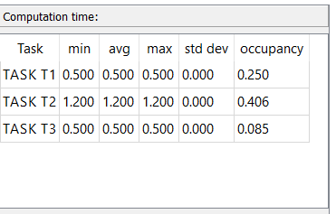

* Is any task missing the deadline? Which task? Where?

All deadlines are achieved, no change needed

* If a deadline is missed, could it be avoided by changing the scheduler?

All deadlines are achieved, no change needed

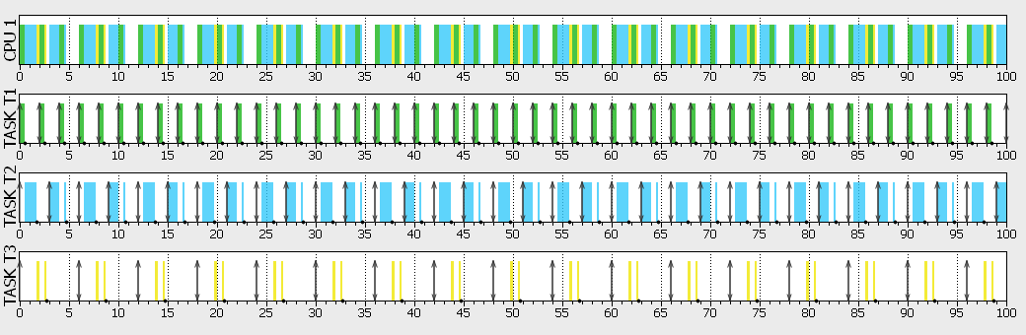

**Part 2**

Input the tasks T1(2, 0.5, 1.9) T2(5, 2) T3(1, 0.1, 0.5) T4(10, 5, 20) and the EDF scheduler into the SimSo simulator

* What is the utilization factor of the system and what is the value for Urm(4)

U = 1.25 and Urm(4) =0.7568, the system is not feasible due to U is greater than 1

* What is the minimum/maximum/average response time of all tasks?

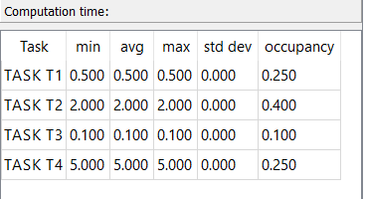

* Is any task missing the deadline? Which task? Where?

Yes, task 4 in time 30, 40 ,50, 60, 70 ,80,90, 100 ms based on log file

* If a deadline is missed, could it be avoided by changing the scheduler?

No the utilization is greater than 1system is not feasible

