HELP document:

RAPID SI GUI for post processing of multi voxel spectroscopic data

* Please note that this toolbox can load only raw data (.dat file)

Installation:

* Extract the file Rapid_gui.rar and add the folder as working directory in MATLAB.

Starting the GUI:

* In the command window of MATLAB type rapid_start. The GUI will show up.
* 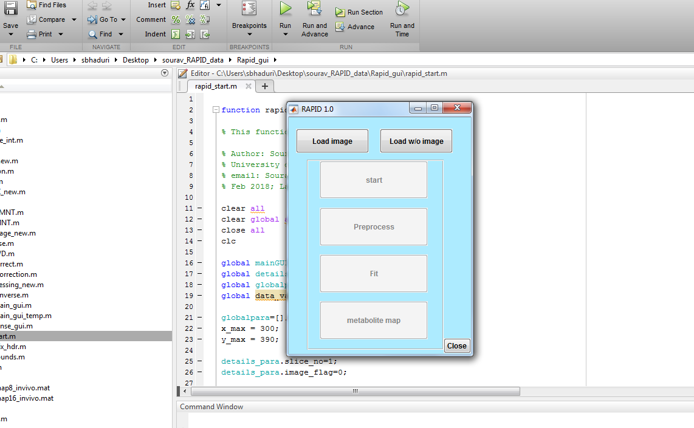
* If you want to load the MRI image before starting spectroscopic analysis click on Load image button, select the image file (eg. ‘’Invivo_T1_axial_image.dat’’) and then the MR images will be displayed. Scroll through the slice list
* 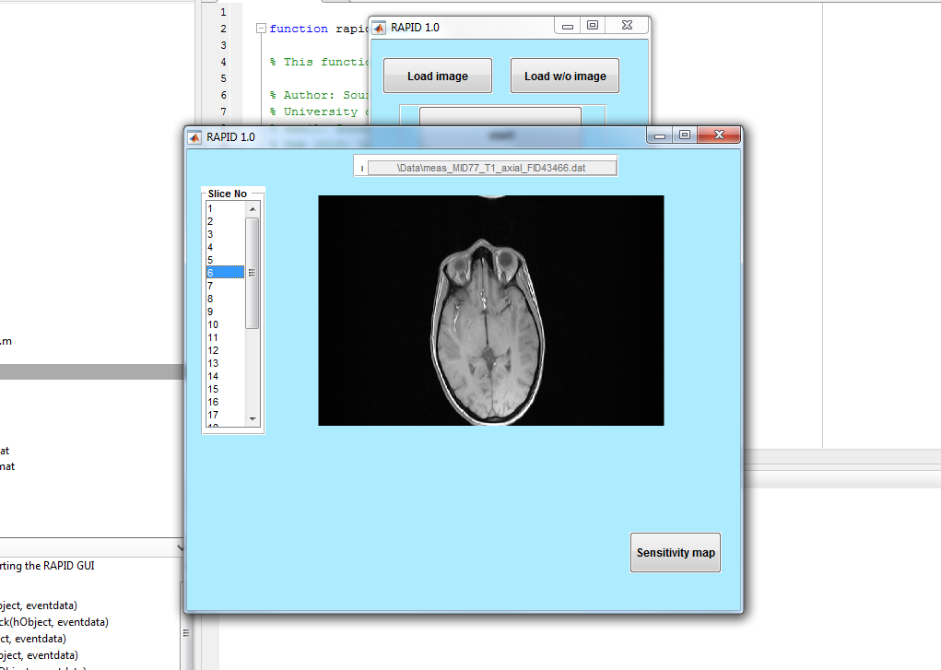
* If you want to activate parallel imaging, click on Sensitivity map button below, the sensitivity maps will be loaded. The approximate FOV can be drawn by dragging the mouse on the image to indicate the region where the spectroscopy was performed
* 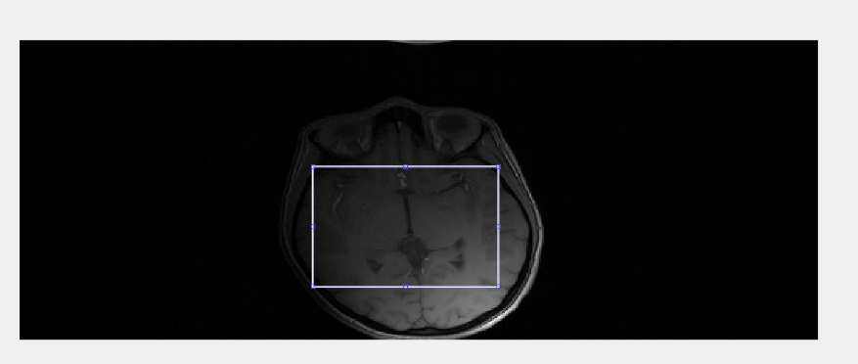
* If you want to perform spectroscopic data analysis without loading image then click on the Load w/o image button and then click on start button to load the RAPID data. First you have to select the .dat file corresponding to the encoded data (having higher file size, eg. ‘’Invivo_acceleration_factor_8.dat’’) and then you will be prompted to enter the reference data file (lesser file size, eg. ‘’Invivo_reference_signal.dat’’). After you enter the files you will be prompted to select which slice you want to analyze, and then the zerofill factor in the spatial domain to visualize the maps with better resolution
* 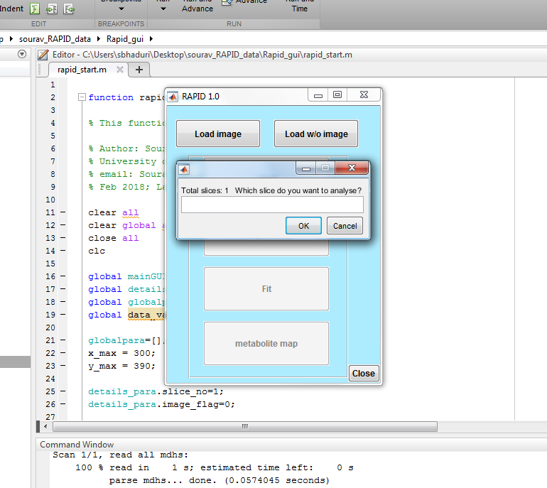 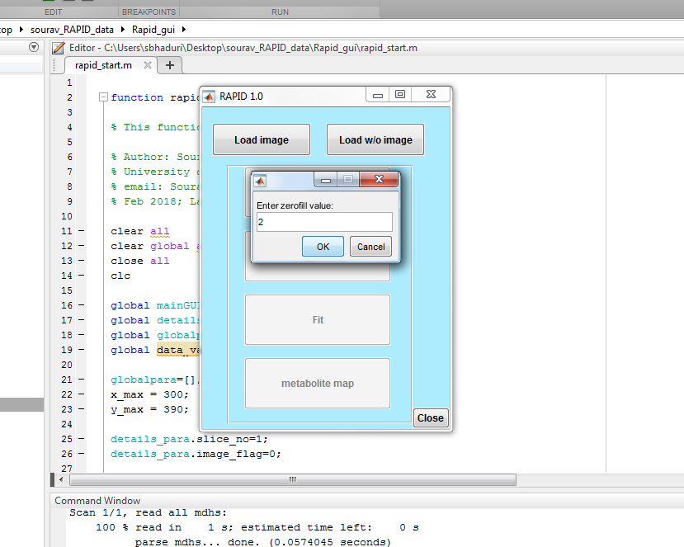
* After that you will be prompted to wait for the data to load. The Preprocess button will be activated for performing phase correction and apodization on the data voxel wise. Water suppression can also be performed for all the voxels by pressing the water suppress button.
* 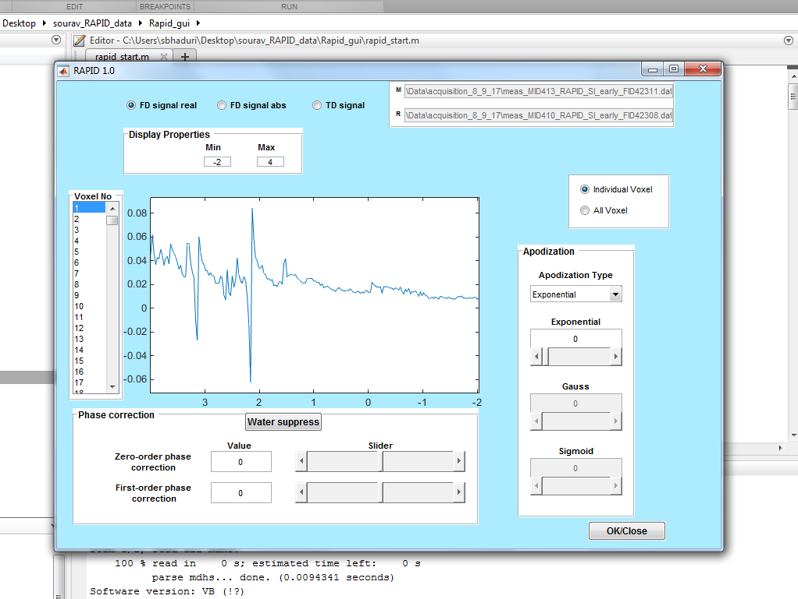
* The display segment can be changed by changing the display ppm range at the top of the window. The data can be displayed in frequency domain by clicking on FD signal real (for real part), FD signal abs (for absolute part) and in time domain by clicking on TD signal. The display range is -2 to 4 ppm in the figure which can be changed as desired. Zero-order phase correction can be used to perform zero order phase correction by entering value in the range –pi to pi or by moving the slider. First-order phase correction can be used to perform first order phase correction by entering value in the range –10 to 10 or by moving the slider. This can be done for individual voxels or for all the voxels by clicking on the respective button at the right hand top corner. Water suppress will suppress water peak from all the voxels.
* 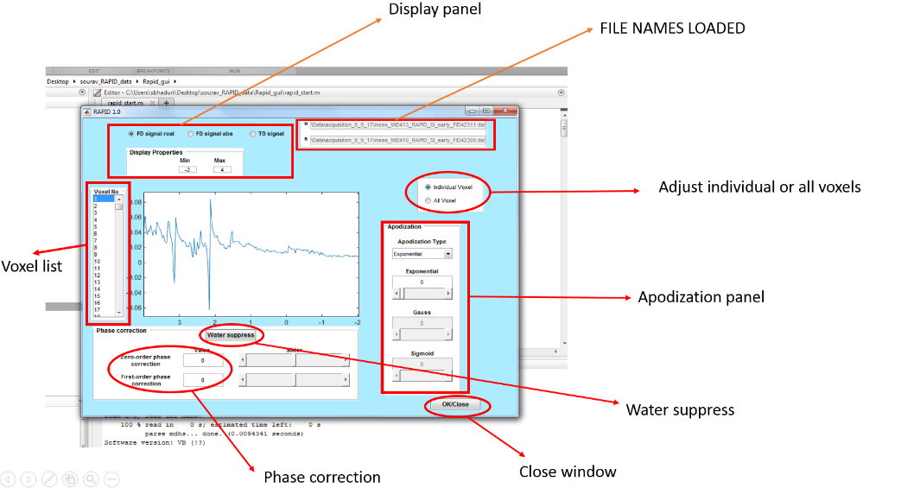
* After adjusting all the parameters close the window by clicking on the OK/Close button.
* In the next step the Fit button will be activated. You can click on the button to open the fitting window which looks like below
* 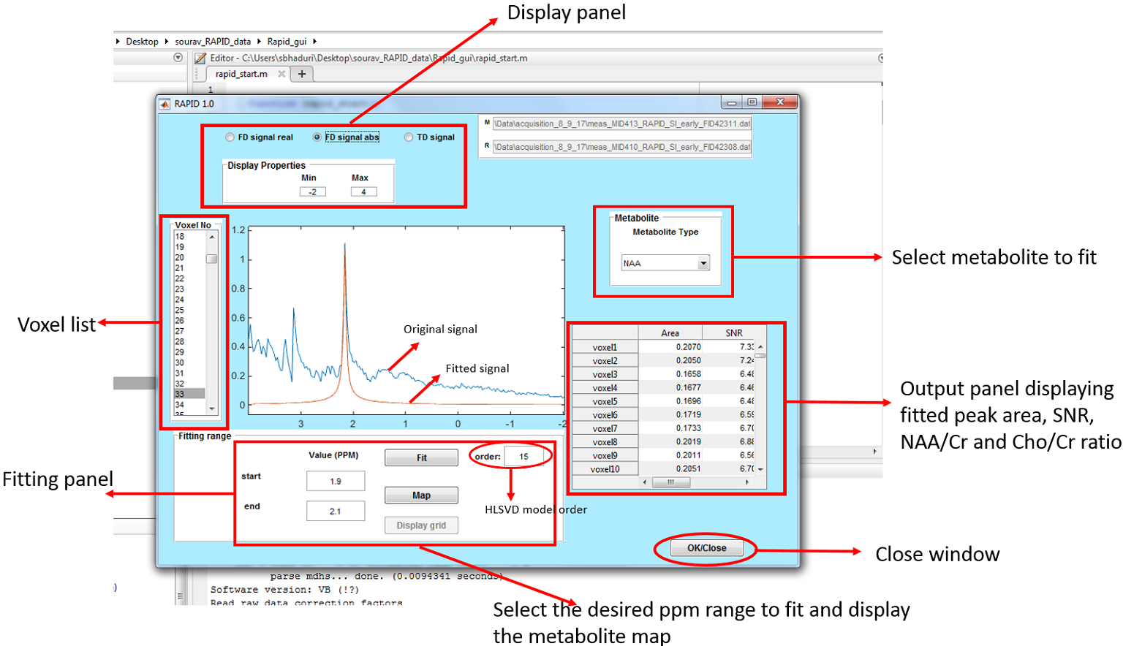
* Inside the fitting panel in the figure above, the desired start and end frequency of the peaks to be fitted can be given as input and the model order for HLSVD is set to 15 as default value. Inside the fitting panel you will find two buttons namely, Map, which displays the metabolite map for the desired frequency range or the metabolite type mentioned in the metabolite panel. When the map window opens, a certain voxel can be selected inside the map to display the spectra. Eg:
* 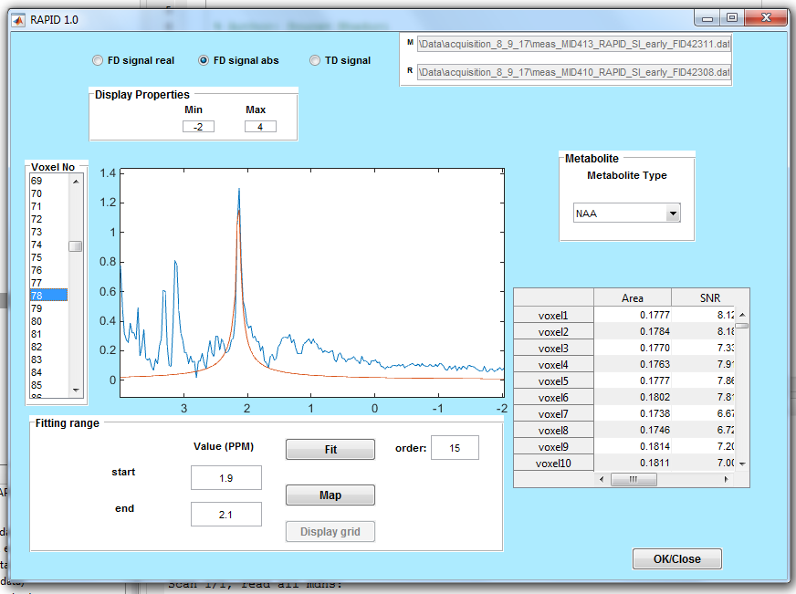 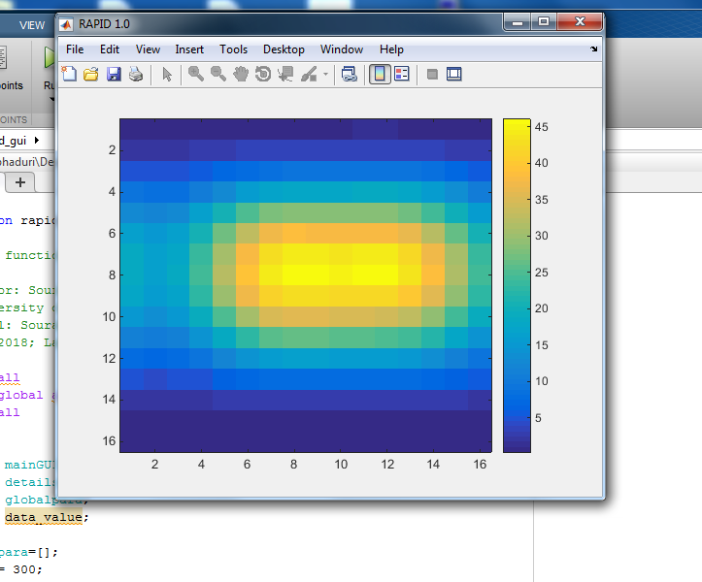
* After displaying the map the Display grid button is activated and can be clicked to view a grid of spectra. You will be prompted to enter the grid size. If you input a number (eg: 2), the map will show again and click on a voxel on the map, a 2x2 grid of spectra will appear indicating the signals in the voxels where you clicked on the map.
* 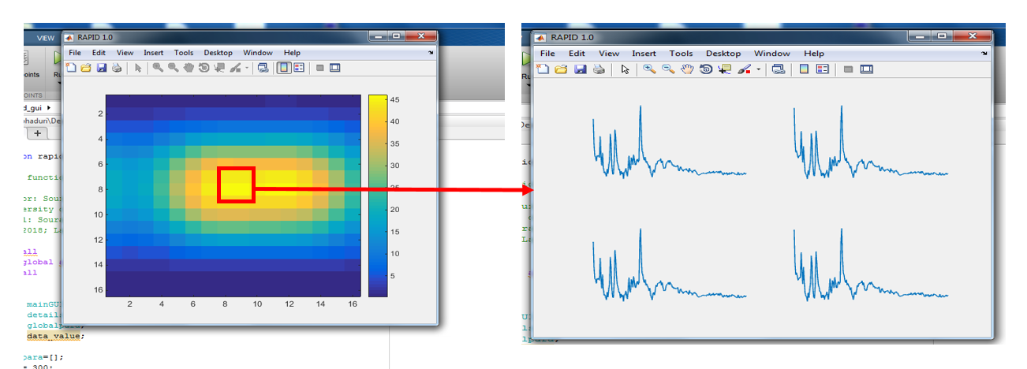
* After adjusting all the parameters close the window by clicking on the OK/Close button.
* Metabolite map button will be activated. If you click on it, the metabolite maps for all the default peaks like NAA, lactate, Creatine and Choline will be loaded as shown below
* 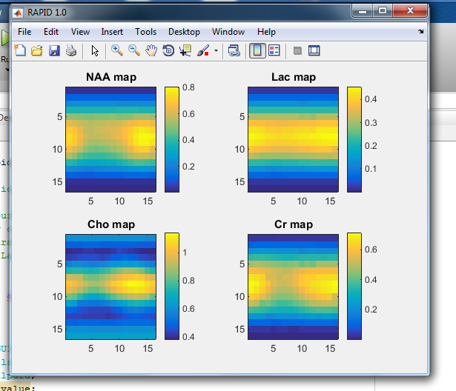
* If you are done with the analysis click on the Close button or if you want to start analyzing another data click on start again.

Afte