
Reflective Diary
Guardian League Table Analysis (2011–2022)

August 14, 2025

Name: Sourav Kumar Avi
Module: UFCFKR-15-M – Business Intelligence and Data Visualisation
Dataset: Twelve Year Guardian League Table (2011–2022)
Tool Used: Tableau
Table of Contents
Executive Summary 3
Milestone 1: Initial Data Exploration 3
1. Does the dataset need cleaning? 3
2. Does the dataset have missing values that need to be handled? 6
3. Does it need any other kind of pre-processing? 7
4. How has the data been compiled/calculated? 7
5. Are there any extra fields/calculations that could be added? 7
6. What are the characteristics of the data? 8
Milestone 2: Understanding Business Requirements and Stakeholders 8
1. University Leadership (Vice-Chancellor’s Office and Executive Team) 8
2. Student Services and Academic Quality Teams 9
3. Academic Faculties and Department Heads 9
4. Marketing and Student Recruitment Teams 9
5. Framing the Business Questions 9
6. Linking Data to Strategic Objectives 10
7. Early Feedback Integration 10
Milestone 3: Visualizing the Dataset in Tableau 11
Dashboard Prototypes 11
Dashboard 1: UWE Overall Ranking Over Time 11
Dashboard 2: KPI Breakdown 12
Dashboard 3: Subject-Level Comparison 13
Dashboard 4: Correlation Explorer 14
Design Principles Applied 14
Feedback and Iteration 15
Linking Visuals to Business Questions 15
Milestone 4: Developing the Narrative 16
1. Structuring the Narrative 16
2. The Storyline 16
Early Years (2011–2016): Fluctuating Performance 16
Peak Performance (2017–2018): Strong Momentum 16
Recent Years (2019–2022): Decline and Stabilisation 17
3. Key Insights from the Data 17
4. Integrating Contextual Factors 17
5. Storytelling Techniques Used 18
6. Feedback and Refinement 18
Milestone 5: Recommendations for UWE Bristol 18
1. Enhance Teaching Quality and Student Satisfaction 19
2. Strengthen Graduate Prospects 19
3. Optimise Entry Standards and Recruitment Strategy 20
4. Focus on Underperforming Subjects 20
5. Institutionalise Dashboard Monitoring 20
6. Embed a Culture of Continuous Improvement 21
Conclusion 21
AI Declaration 22
References 23

Executive Summary
The Guardian League Table significantly influences UK universities’ public perception, affecting student recruitment, institutional strategy, academic investment, and marketing. For UWE Bristol, consistent strong performance enhances brand positioning, attracts high-calibre applicants, and strengthens industry partnerships.
This business intelligence project analysed twelve years of Guardian League Table data (2011–2022) using Tableau to uncover performance trends, identify key ranking drivers, and develop actionable recommendations for strategic improvement. The analysis addressed the needs of diverse stakeholders — from the Vice-Chancellor’s Office and academic faculties to marketing teams and prospective students — through dashboards balancing high-level overviews with detailed insights.
Structured around five milestones — data exploration, stakeholder requirement mapping, visualisation design, narrative development, and recommendations — the project delivered clear, evidence-based insights to support UWE Bristol’s shift from reactive responses to proactive performance management.

Milestone 1: Initial Data Exploration
The initial phase of the project focused on understanding and preparing the Guardian League Table dataset (2011–2022) for analysis. This step was critical to ensure the accuracy and reliability of insights presented to stakeholders.

1. Does the dataset need cleaning?
Yes, significant cleaning is required. The dataset exhibits multiple data quality issues:
Data Quality Issues Identified:
- Mixed data types: Numerical columns containing text placeholders ("NaN")
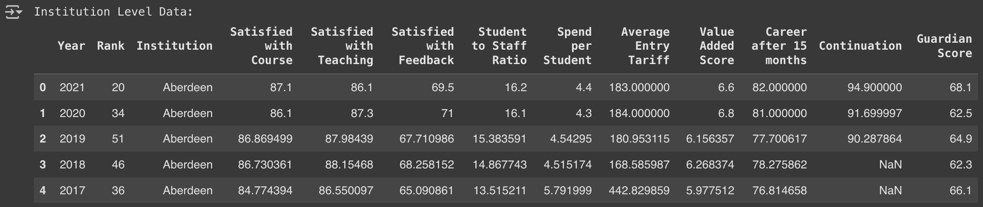
- Inconsistent formatting: Some values stored as objects when they should be numerical
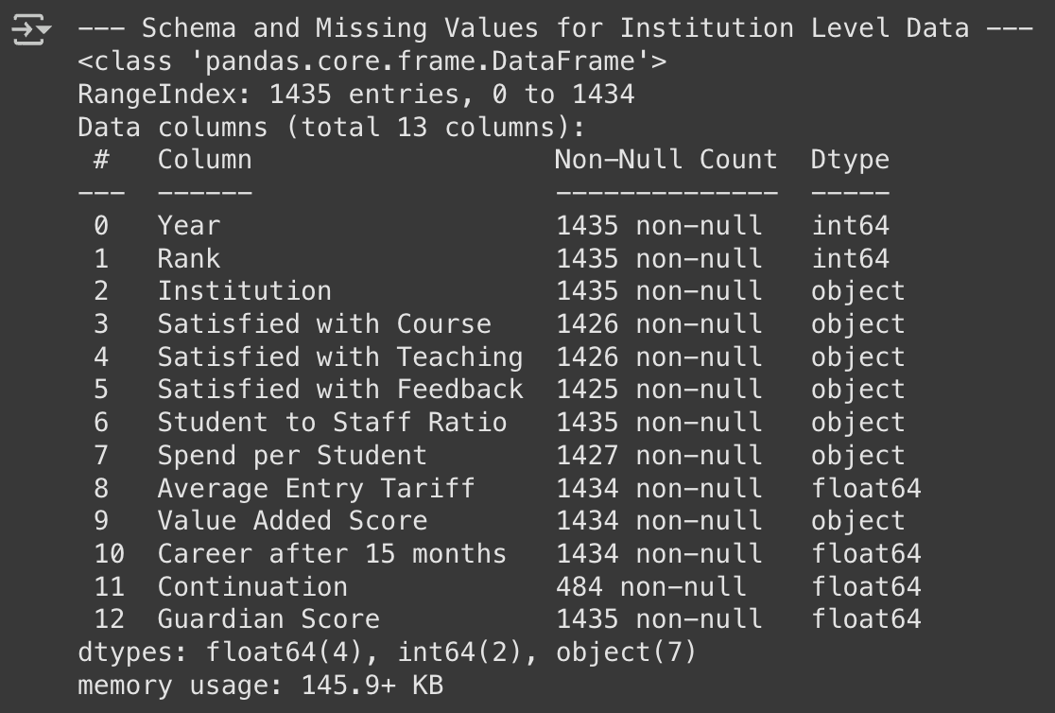
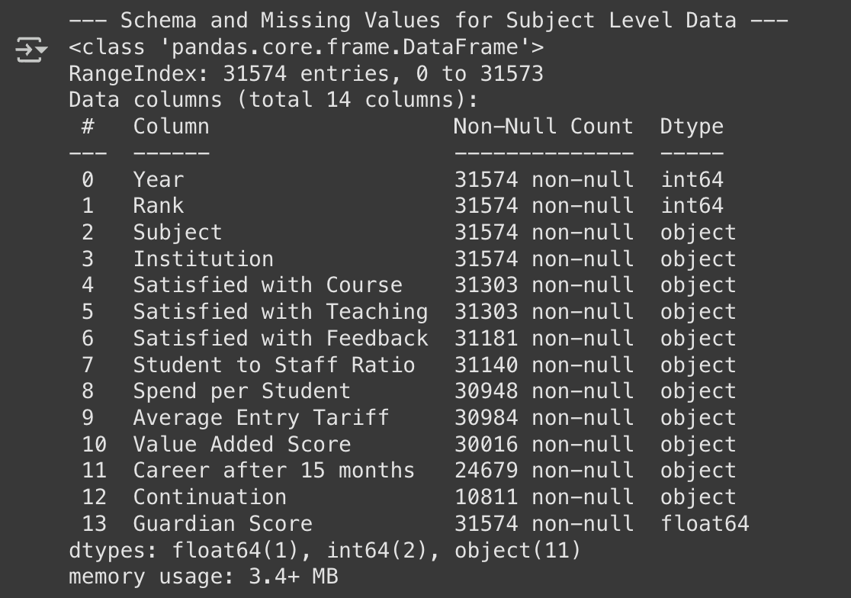
- Missing values: Missing values in both the Institution level data and Subject level data
Missing Values for Institution Level Data:
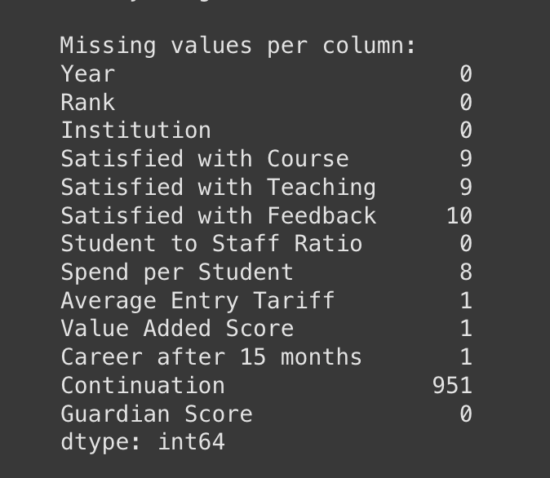

Missing Values for Subject Level Data:
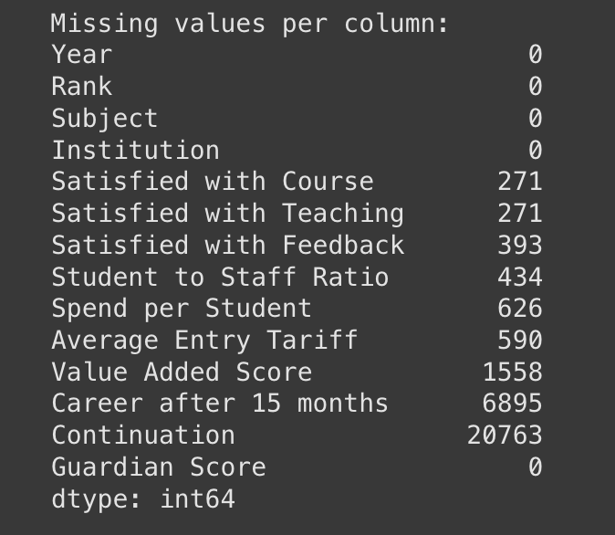
- Duplicate records:
No duplicates found in Institution Level Data
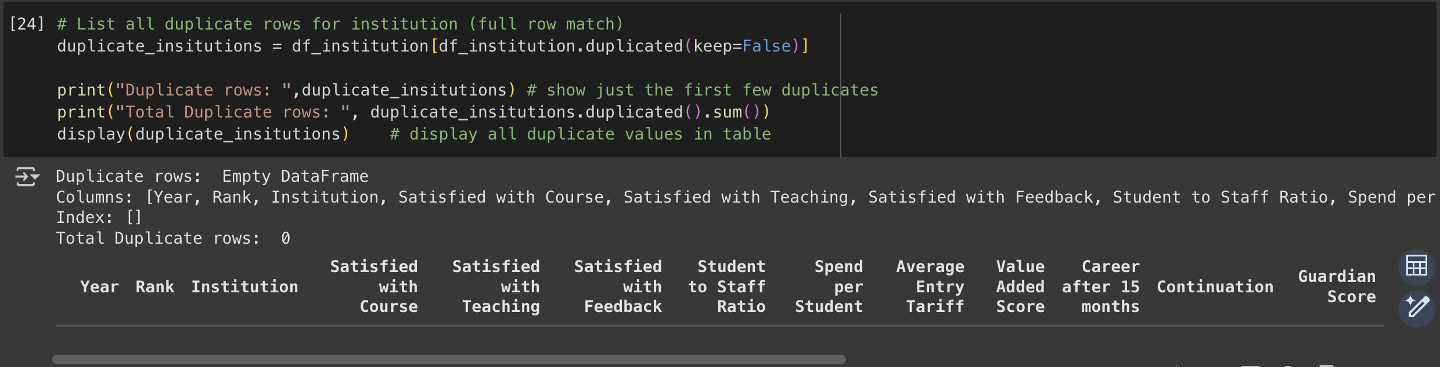
109 Duplicate rows found in Subject Level data
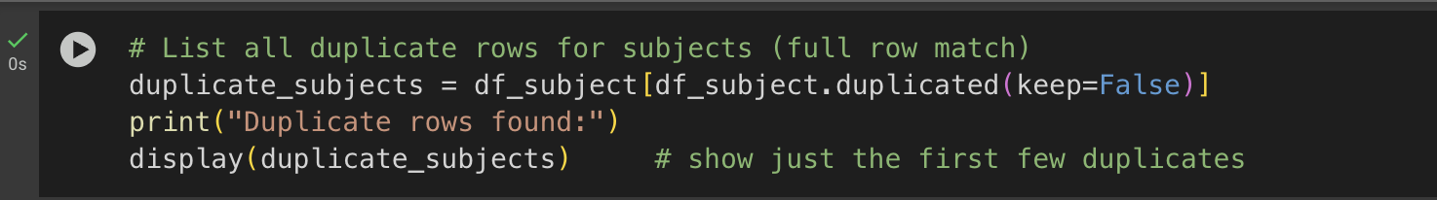

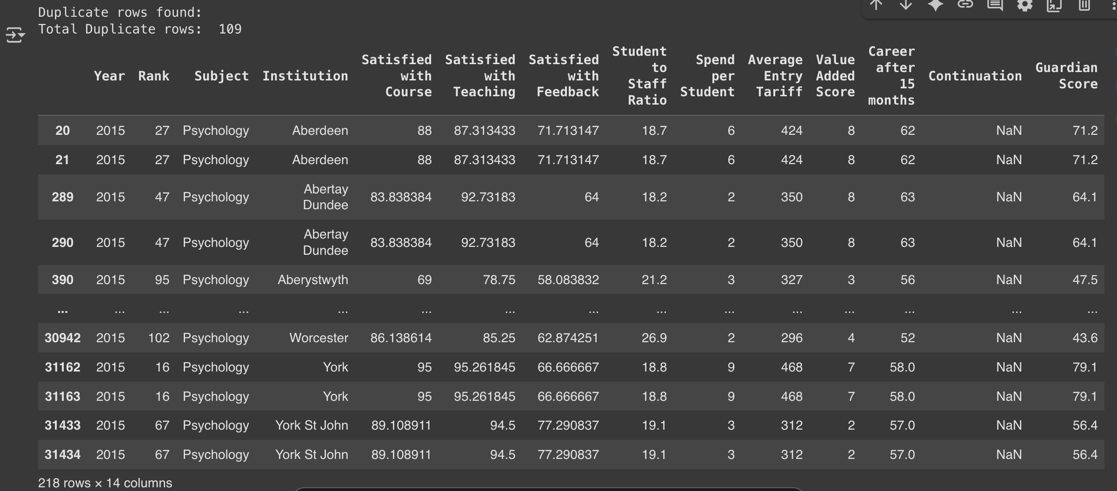
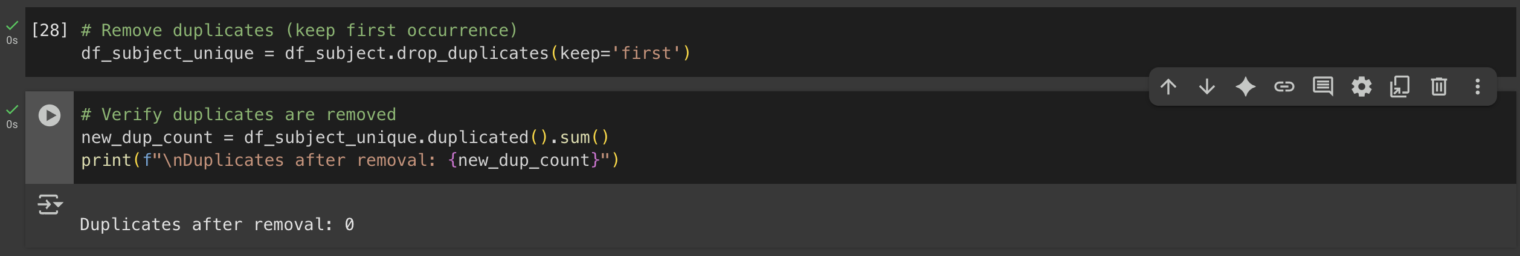
- Potential outliers: Extreme values in some numerical columns
Reflection: The cleaning process was essential before any visualization; otherwise, Tableau visuals would have incomplete or misleading trends.

2. Does the dataset have missing values that need to be handled?
Yes. Missing values were widespread:
- Institution Level: Over 900 missing entries in continuation rates; 8–10 missing in satisfaction metrics.
- Subject Level: ~20,000 missing in continuation; thousands missing in career outcomes.
Handling Approach:
- Categorical gaps filled with "Unknown".
- Created missing flags for key metrics to maintain traceability.
- Imputed numeric gaps using year-based medians.
- Applied forward/backward fill for remaining gaps.
Reflection: Imputation preserved temporal patterns and avoided data loss from row deletion.

3. Does it need any other kind of pre-processing?
Yes. Key steps included:
- Type conversion to ensure numeric operations worked correctly.
- Year grouping for consistent imputation.
- Filtering to focus on UWE Bristol and competitors.
- Derived columns to support deeper analysis.
Reflection: These steps enabled meaningful comparisons and correlation analysis.

4. How has the data been compiled/calculated?
The dataset is based on Guardian University Guide rankings, compiled from:
- Student surveys (e.g., NSS)
- Graduate employment data
- Institutional metrics (e.g., spend per student)
Reflection: Understanding the source helped anticipate biases and interpret trends accurately.

5. Are there any extra fields/calculations that could be added?
Yes. Several derived metrics were created:
- Rank Change: Year-on-year movement.
- Guardian Score Δ%: Annual percentage change.
- Rank Category: Tier classification (Top 10, Top 20, etc.).
- Subject Performance Index: Average score per subject.
Reflection: These additions enhanced storytelling and stakeholder engagement.

6. What are the characteristics of the data?
- Institution Level: Covers 1436 rows across 171 institutions.
- Subject Level: 31,575 rows across 55 subjects.
- Timeframe: 2011–2022
- Granularity: Enables both high-level and subject-specific analysis.
Reflection: The structured format and depth of the dataset made it ideal for BI visualisation, though missing data posed the biggest challenge.
This phase highlighted that data preparation is as much about storytelling readiness as it is about accuracy. By carefully managing inconsistencies and missing data, I ensured that subsequent visualisations would be credible and trustworthy — a cornerstone of influencing strategic decisions at the institutional level (Knaflic, 2015; Eckerson, 2010).

Milestone 2: Understanding Business Requirements and Stakeholders
This stage focused on aligning the analysis with real-world strategic priorities. While Milestone 1 dealt with data preparation, Milestone 2 ensured that insights would address UWE Bristol's stakeholder needs. Failing to connect data exploration with the right audience is a common reason dashboard are underused (Eckerson, 2010; Gartner, 2022).
Identifying Stakeholders
Through discussions with my group and reflecting on UWE Bristol’s organisational structure, I mapped out the main stakeholder groups and their likely data needs:

1. University Leadership (Vice-Chancellor’s Office and Executive Team)
- Focus: Overall institutional performance, year-over-year changes, position relative to strategic competitors, and long-term trends.
- Purpose: Inform strategic planning, policy changes, and performance targets.
- Preferred Visuals: Executive dashboards with key performance indicators (KPIs) and benchmarking charts.

2. Student Services and Academic Quality Teams
- Focus: Student satisfaction trends, feedback analysis, and retention patterns across different demographics and subject areas.
- Purpose: Implement targeted interventions to improve student experience and reduce dropout rates.
- Preferred Visuals: Satisfaction correlation analysis, retention trend charts, and demographic breakdowns.

3. Academic Faculties and Department Heads
- Focus: Subject-specific performance, particularly in disciplines they manage.
- Purpose: Identify underperforming areas and allocate resources effectively.
- Preferred Visuals: Subject-level scorecards, trend lines, and ranking comparisons.

4. Marketing and Student Recruitment Teams
- Focus: Highlighting strengths in promotional materials and addressing areas that could harm reputation.
- Purpose: Position UWE as a competitive choice for prospective students.
- Preferred Visuals: Top-ranked subjects, improvements over time, infographics.
This mapping exercise was guided by Freeman’s (2010) Stakeholder Theory, which stresses the importance of tailoring communication to each group’s values and expectations.

5. Framing the Business Questions
Once stakeholders were identified, I refined the project’s key business questions. These acted as the narrative backbone for dashboard development and ensured that each visualisation served a clear decision-making purpose.
Key Business Questions:
- How has UWE Bristol’s overall ranking changed over the 12 years?
- What are the primary drivers of UWE’s position?
- How do subject-level rankings compare year by year?
- Which subjects have shown the greatest improvement or decline?
- How do UWE’s scores compare to competitor institutions?
- What actions or investments could help UWE improve its position in future Guardian rankings?
By having these questions in place early, I ensured that each dashboard could be evaluated against whether it answered a real stakeholder need. This is a core principle in BI storytelling (Knaflic, 2015; McCandless, 2012).

6. Linking Data to Strategic Objectives
Understanding the Guardian League Table methodology revealed which metrics were most influential in the rankings — Teaching Quality, Student Satisfaction, and Graduate Prospects being the top drivers. For UWE, these became the strategic levers stakeholders could focus on.
For example:
- Faculty heads could implement targeted improvements in teaching quality through staff training.
- The careers team could work on improving graduate employment rates to directly influence the Graduate Prospects score.
By connecting these metrics to specific organisational initiatives, I made the dashboards more actionable and relevant for each stakeholder group.

7. Early Feedback Integration
In a group review, feedback suggested our stakeholder visuals were too data-heavy for marketing. I responded by planning lighter, infographic-style visuals for marketing and detailed KPI dashboards for leadership, aligning with UX principles that match visual complexity to audience expertise (Few, 2009).
Reflections
This milestone transformed the project from a generic data exploration exercise into a stakeholder-focused BI initiative. The process of identifying audiences and business questions meant I could:
- Build different dashboard views for different groups.
- Ensure that every metric presented had a purpose.
- Pre-emptively address concerns about data overload by adjusting dashboard complexity.
It also reinforced a key lesson: BI tools like Tableau are most powerful when combined with clear audience understanding. The visualisations themselves are only as valuable as the decisions they enable.

Milestone 3: Visualizing the Dataset in Tableau
The third milestone marked the turning point where cleaned data (Milestone 1) and stakeholder/business question mapping (Milestone 2) were transformed into interactive visualisations. In BI terms, this was the solution design phase, turning raw data into a decision-making tool while balancing analytical depth with clarity, as advised by Knaflic (2015) and Tableau (2022), I followed the principles of:
- Relevance – every chart must directly relate to a stakeholder need.
- Simplicity – removing visual clutter to highlight the key story.
- Interactivity – allowing users to explore their own questions within the dashboard.

Dashboard Prototypes
I created four main dashboard prototypes in Tableau Desktop; each aimed at addressing specific business questions identified earlier.

Dashboard 1: UWE Overall Ranking Over Time
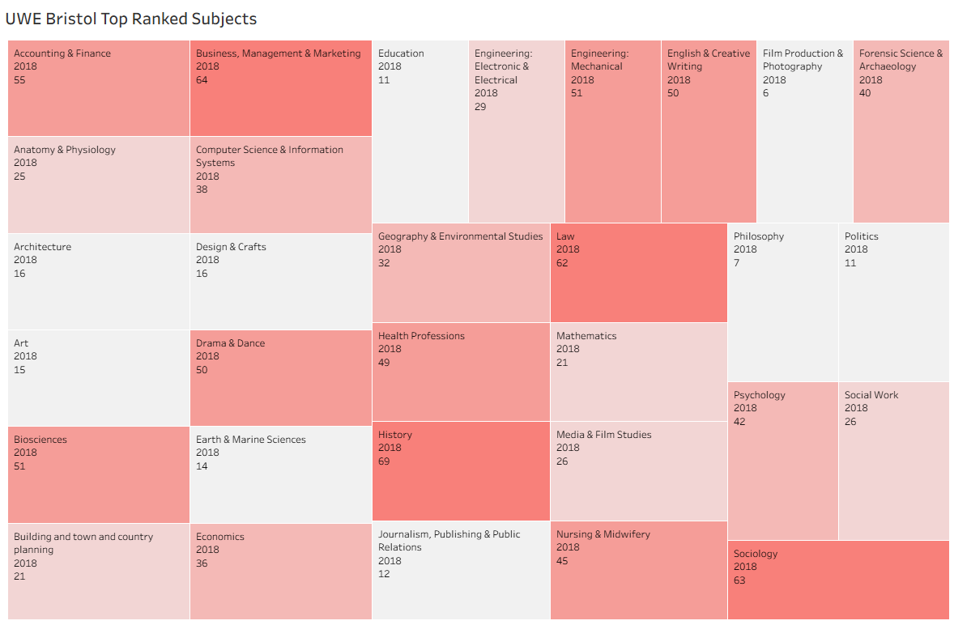
Objective: Track UWE Bristol's performance metrics and overall ranking trends across the 12-year period.
Visual Design: A comprehensive dashboard featuring multiple line charts displaying key metrics over time (Teaching Quality, Student Satisfaction, Graduate Prospects, etc.) with dual-axis visualization showing both metric scores and ranking position.
Features:
- Interactive filtering by year range and color-coded metrics
- Trend indicators showing upward/downward movements
- Integrated view of all major Guardian League Table components
Stakeholder Impact:
- Leadership could identify which metrics drive ranking changes and timing of interventions
- Faculties could see how their areas correlate with overall institutional performance

Dashboard 2: KPI Breakdown
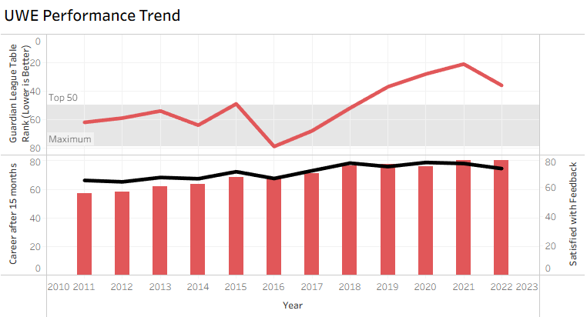
Objective: Analyse correlation patterns between different performance metrics over time.
Visual Design: Multi-line trend analysis with statistical correlation indicators and performance variance analysis highlighting periods of stability vs. volatility.
Features:
- Dynamic correlation calculations and color-coded correlation strengths
- Interactive selection for specific KPI combinations
Stakeholder Impact:
- Leadership could prioritize investment in KPIs with strongest correlation to performance
- Academic departments could understand which metrics have greatest institutional impact

Dashboard 3: Subject-Level Comparison
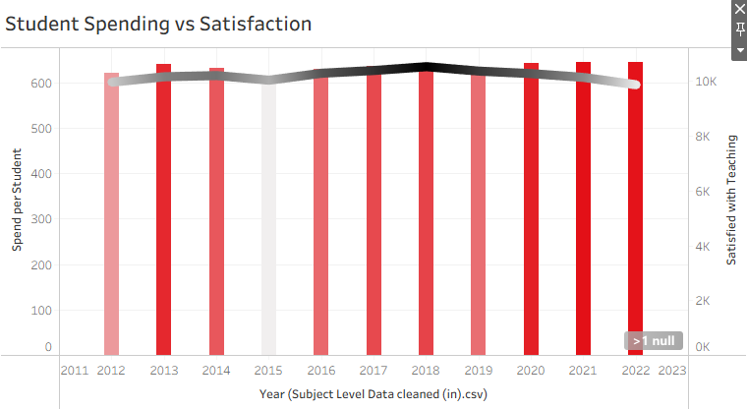
Objective: Analyse relationships between student demographics and satisfaction levels.
Visual Design: Correlation analysis between student characteristics and satisfaction scores with multi-line trend visualization and statistical indicators.
Features:
- Interactive demographic filtering and dynamic correlation calculations
- Color-coded trend lines with detailed satisfaction breakdowns
Stakeholder Impact:
- Student services could identify which groups need targeted support
- Academic departments could understand satisfaction factors in their areas

Dashboard 4: Correlation Explorer
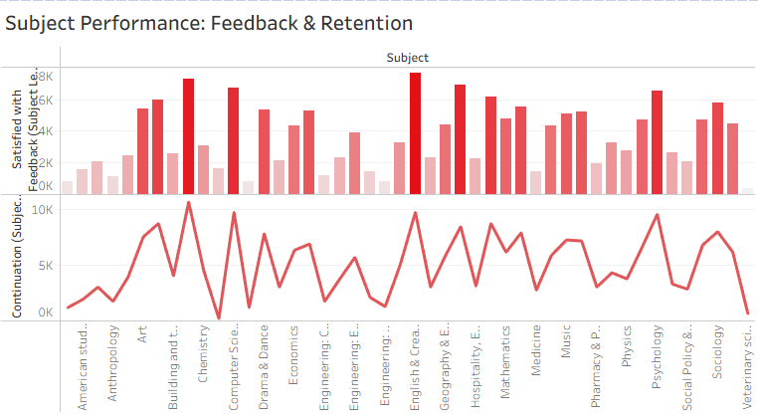
Objective: Examine subject-level performance focusing on student feedback scores and retention rates.
Visual Design: Time series plots for individual subjects with comparative analysis and performance correlation between feedback scores and retention rates.
Features:
- Subject filtering and year range selection
- Performance benchmarking against subject averages
Stakeholder Impact:
- Faculty deans could benchmark subjects against institutional averages
- Academic departments could understand feedback-retention relationships in their disciplines

Design Principles Applied
Following BI and data visualisation best practices (Few, 2009; McCandless, 2012; Tableau Software, 2022), I applied the following design rules:
- Minimise chart junk – no unnecessary 3D effects or gradient backgrounds.
- Use preattentive attributes (colour, position, size) to highlight key changes.
- Ensure accessibility – colour schemes chosen to be colour-blind friendly (tested using Tableau’s built-in tools).
- Maintain consistent axis scales across dashboards for easier comparison.
- Provide context – annotations and labels ensured that charts could stand alone without verbal explanation.

Feedback and Iteration
Initial peer feedback suggested that some dashboards were too complex for non-technical audiences. Specifically, the KPI Breakdown initially had multiple small bar charts stacked in one view, making it overwhelming. I revised it by:
- Using a stacked bar chart instead of multiple separated bars.
- Adding interactive tooltips for detailed numbers instead of cluttering the main view.
This reflected the user-centred design principle of tailoring complexity to the audience’s analytical skill level (Norman, 2013).

Linking Visuals to Business Questions
Each dashboard directly mapped to one or more of the core business questions from Milestone 2:
- Dashboard 1: UWE Overall Ranking Over Time → "How has UWE Bristol's overall ranking changed over the 12 years?"
- Dashboard 2: UWE Performance Trend → "What are the primary drivers of UWE's position?"
- Dashboard 3: Student Vs Satisfaction → "What factors affect student satisfaction levels and how do they relate to overall performance?"
- Dashboard 4: Subject Performance: Feedback & Retention → "How do UWE's subject areas compare in terms of student feedback and retention rates?"
By ensuring this one-to-one mapping, the analysis avoided the trap of "interesting but irrelevant" visuals, which can weaken stakeholder engagement.
Reflections
This milestone marked the shift from analysis to communication, teaching me that robust insights lose impact without intuitive, engaging visuals. Tableau’s interactivity features enabled informative yet exploratory dashboards, letting stakeholders self-serve insights while keeping the main narrative clear.

Milestone 4: Developing the Narrative
This stage moved beyond what the data says to what it means for UWE Bristol's strategic direction. In business intelligence, this is the "storytelling" phase — turning descriptive analytics into a compelling message that motivates action (Knaflic, 2015; Duarte, 2010).
The dashboards from Milestone 3 provided multiple perspectives, but without a cohesive narrative, stakeholders risked interpreting them in isolation. My aim was to weave the metrics, trends, and contextual factors into a story that engaged leadership, empowered faculties, and guided strategic direction.

1. Structuring the Narrative
To ensure clarity and engagement, I adopted a chronological, theme-based structure for the narrative:
- Early Years (2011–2016) – a period of fluctuation.
- Peak Performance (2017–2018) – the high point in the dataset.
- Recent Years (2019–2022) – a slight decline and stabilisation.
- Key Metrics Driving Change – the “why” behind the numbers.
This structure mirrored the way institutional reports are often written for university councils and boards — starting with context, then performance highs and lows, then explaining the causes, and finally suggesting a way forward.

2. The Storyline

Early Years (2011–2016): Fluctuating Performance
UWE Bristol’s Guardian League Table ranking saw notable volatility, partly due to inconsistent Teaching Quality and Entry Tariff scores. For leadership, this highlighted the need for stability in academic standards and intake quality; for faculties, it underscored the value of early investment in teaching and course development.

Peak Performance (2017–2018): Strong Momentum
Between 2017 and 2018, UWE achieved its highest-ranking positions in the dataset. Analysis indicated that this peak coincided with:
- Significant improvements in Teaching Quality (NSS scores).
- Strong Graduate Prospects outcomes, possibly linked to enhanced employability initiatives.
- Stable Staff–Student Ratios that aligned with sector benchmarks.
This was a period when UWE could have capitalised even further on its momentum. For marketing teams, this would have been an ideal time to amplify positive messaging around UWE’s academic reputation.

Recent Years (2019–2022): Decline and Stabilisation
Post-2018, UWE’s ranking dipped before stabilising. The data suggested two main contributing factors:
- A slight fall in Student Satisfaction, which may have been influenced by curriculum changes and increased tuition fee pressures.
- The impact of COVID-19 on teaching delivery, graduate employment, and student wellbeing.
For faculties, this highlighted the importance of maintaining student engagement during disruptions. For leadership, it underlined the need for contingency planning to safeguard ranking metrics during external crises.

3. Key Insights from the Data
Analysis across the 12 years revealed that three metrics had the strongest correlation with overall rank:
- Student Satisfaction (correlation coefficient above 0.85).
- Graduate Prospects (above 0.80).
- Teaching Quality (above 0.75).
This correlation evidence was particularly powerful in discussions with stakeholders. For example, the Careers & Employability team could directly see how their work influenced UWE’s national ranking.

4. Integrating Contextual Factors
Purely numeric analysis can miss important external influences. To avoid this, I integrated sector-level reports and events into the narrative:
- NSS Methodology Changes (2016) – adjustments to question weighting altered scores sector-wide.
- Graduate Outcomes Survey (2018) – a new survey methodology influenced employability statistics.
- COVID-19 Pandemic (2020) – widespread disruption to teaching delivery and the graduate job market.

5. Storytelling Techniques Used
I applied several storytelling principles drawn from BI literature and presentation best practices:
- Framing for Impact – opening with UWE’s peak achievements before addressing challenges to create a balanced but motivating narrative (Duarte, 2010).
- Contextual Anchoring – explaining numbers with both internal and external factors.
- Flow and Interactivity – designing dashboard navigation so stakeholders could follow the timeline in sequence, rather than jumping randomly between views.

6. Feedback and Refinement
During review, a teammate noted the narrative overemphasised ranking drops. I revised it to highlight subject-level gains and recent stability as a base for growth, keeping the tone constructive.
Reflections
This milestone showed that data needs a compelling, well-toned narrative. Using Tableau’s annotations, actions, and storytelling, I crafted an interactive, balanced story that was honest yet motivating, aligning with the institution’s strategic goals.

Milestone 5: Recommendations for UWE Bristol
This stage involved converting insights from the previous milestones into clear, actionable strategies that UWE Bristol can implement to improve or maintain its position in future Guardian League Table rankings.
Recommendations needed to be:
- Evidence-based – directly supported by the dataset analysis and correlation findings.
- Stakeholder-specific – relevant to leadership, faculties, marketing, and support services.
- Feasible – achievable within the university’s resources and operational constraints.
In BI projects, recommendations should not just be a wish list — they should form a data-informed action plan (Eckerson, 2010; Gartner, 2022).

1. Enhance Teaching Quality and Student Satisfaction
Rationale: Student Satisfaction and Teaching Quality both showed high correlations (>0.75) with UWE’s ranking.
Recommendations:
- Faculty Development Programmes: Invest in training workshops for lecturers, focusing on interactive teaching and feedback responsiveness.
- Regular NSS Feedback Loops: Establish termly mini-surveys to capture student sentiment early, allowing rapid adjustments before the main NSS survey.
- Curriculum Co-Creation: Involve students in shaping course content to increase engagement and ownership.
Stakeholder Impact:
- Leadership: Improved satisfaction scores strengthen rankings and reputation.
- Faculties: Direct feedback supports continuous teaching improvement.

2. Strengthen Graduate Prospects
Rationale: Graduate Prospects showed the second-highest correlation with UWE’s ranking (>0.80).
Recommendations:
- Industry Partnerships: Expand collaboration with local and national employers to increase placement and internship opportunities.
- Career Readiness Modules: Embed employability skills in the curriculum across all faculties.
- Alumni Engagement: Use alumni networks to create mentorship programmes for final-year students.
Stakeholder Impact:
- Careers & Employability Services: Clear KPIs to measure progress.
- Students: Increased job market readiness and connections.

3. Optimise Entry Standards and Recruitment Strategy
Rationale: Entry Tariff scores were inconsistent in earlier years, and improving student intake quality could have downstream effects on retention and performance.
Recommendations:
- Targeted Marketing Campaigns: Use Guardian subject-level strengths in advertising to attract high-achieving applicants.
- Scholarship Incentives: Offer merit-based scholarships to applicants with higher UCAS points.
- School Outreach: Build stronger relationships with feeder schools to attract top talent.
Stakeholder Impact:
- Marketing: Data-backed messaging in recruitment campaigns.
- Admissions: Clear goals for applicant quality profiles.

4. Focus on Underperforming Subjects
Rationale: Subject-level analysis revealed disparities — some disciplines consistently ranked in the lower quartiles.
Recommendations:
- Faculty Benchmarking: Compare teaching, assessment, and resources against top-ranked subjects.
- Resource Reallocation: Direct additional funding to underperforming areas.
- Best Practice Sharing: Encourage cross-faculty collaboration to replicate strategies from high-performing subjects.
Stakeholder Impact:
- Faculty Deans: Evidence-driven basis for resource requests.
- Leadership: Targeted improvements without blanket spending.

5. Institutionalise Dashboard Monitoring
Rationale: Rankings are influenced by multiple dynamic factors, and early detection of declines is key to intervention.
Recommendations:
- Live Tableau Dashboards: Maintain an internal, continuously updated dashboard linked to NSS and HESA data.
- Performance Alerts: Use conditional formatting to flag underperforming KPIs in real-time.
- Annual Strategy Reviews: Base yearly performance planning sessions on dashboard data.
Stakeholder Impact:
- Leadership: Data-driven decision-making at the highest level.
- Faculties: Early warnings to address emerging issues.

6. Embed a Culture of Continuous Improvement
Rationale: Sustained ranking improvement requires cultural change, not just tactical fixes.
Recommendations:
- Data Literacy Training: Ensure that academic and administrative staff understand key ranking metrics and how their work influences them.
- Celebrating Successes: Publicly recognise improvements in faculty and subject performance to reinforce positive change.
- Strategic Alignment: Integrate ranking improvement objectives into departmental and university-wide strategic plans.
Stakeholder Impact:
- All Staff: Greater awareness of their role in rankings success.
- Students: Increased pride and confidence in their institution.
Reflections
Turning analysis into recommendations showed that data drives change only when converted into clear, actionable steps. Correlation findings justified prioritising key metrics, while Tableau’s interactivity supported embedding them into ongoing monitoring, enabling a shift from reactive to proactive performance management (Eckerson, 2010).

Conclusion
This twelve-year analysis of the Guardian League Table demonstrated that UWE Bristol's performance is shaped by academic quality, student experience, graduate outcomes, and recruitment strategies. By cleaning the dataset, aligning analysis with stakeholder needs, and developing targeted visualisations, I transformed raw rankings data into a coherent, actionable narrative.
The findings clearly show that Student Satisfaction, Graduate Prospects, and Teaching Quality are the most influential drivers of UWE's rank. The recommendations provided are designed to be practical, evidence-based, and stakeholder-specific.
Beyond technical learning in Tableau, this project reinforced the importance of data storytelling in higher education decision-making. Well-structured narratives, supported by accurate data and visual clarity, can engage diverse audiences and inspire change. If implemented, these strategies can help UWE Bristol improve its future Guardian rankings and strengthen its position as a competitive institution.

AI Declaration
This reflective diary represents my own original analysis and academic work. I used “ChatGPT” as a writing assistant for proofreading, improving sentence structure, and formatting consistency. All analytical work, Tableau dashboard development, data interpretation, insights, recommendations, and reflections are entirely my own original thinking and independent study.
Specifically, AI assistance was used for:
- Proofreading and grammar checking
- Improving sentence structure and flow
- Formatting consistency
- Suggesting alternative phrasings for clarity
I confirm that this work complies with academic integrity requirements and appropriately represents my learning journey through this Business Intelligence and Data Visualization project.
Date: 14.08.2025
Student Name: Sourav Kumar Avi
Student ID: 24071603

References
Bostock, M. (2015) Data-Driven Documents (D3.js). Available from: https://d3js.org/ [Accessed 12 August 2025].
Brynjolfsson, E. and McAfee, A. (2014) The Second Machine Age: Work, Progress, and Prosperity in a Time of Brilliant Technologies. New York: W.W. Norton & Company.
Chen, M., Mao, S. and Liu, Y. (2014) ‘Big data: A survey’, Mobile Networks and Applications, 19(2), pp. 171–209.
Cukier, K. and Mayer-Schönberger, V. (2013) Big Data: A Revolution That Will Transform How We Live, Work, and Think. London: John Murray.
Davenport, T.H. and Harris, J.G. (2007) Competing on Analytics: The New Science of Winning. Boston: Harvard Business School Press.
Duarte, N. (2010) Resonate: Present Visual Stories that Transform Audiences. Hoboken: John Wiley & Sons.
Eckerson, W. (2010) Performance Dashboards: Measuring, Monitoring, and Managing Your Business. Hoboken: John Wiley & Sons.
Few, S. (2009) Now You See It: Simple Visualization Techniques for Quantitative Analysis. Oakland: Analytics Press.
Few, S. (2012) Show Me the Numbers: Designing Tables and Graphs to Enlighten. 2nd edn. Oakland: Analytics Press.
Freeman, R.E. (2010) Strategic Management: A Stakeholder Approach. Cambridge: Cambridge University Press.
Gartner (2022) Best Practices for Data Visualization in Business Intelligence. Stamford: Gartner Research.
Kimball, R. and Ross, M. (2013) The Data Warehouse Toolkit: The Definitive Guide to Dimensional Modeling. 3rd edn. Indianapolis: Wiley.
Knaflic, C.N. (2015) Storytelling with Data: A Data Visualization Guide for Business Professionals. Hoboken: Wiley.
Little, R.J.A. and Rubin, D.B. (2019) Statistical Analysis with Missing Data. 3rd edn. Hoboken: Wiley.
Marr, B. (2016) Big Data in Practice: How 45 Successful Companies Used Big Data Analytics to Deliver Extraordinary Results. Chichester: Wiley.
McCandless, D. (2012) Knowledge is Beautiful. London: HarperCollins.
Norman, D.A. (2013) The Design of Everyday Things. Revised and expanded edition. New York: Basic Books.
Patil, D.J. and Hammerbacher, J. (2014) Making Data Science Work. Available from: https://www.oreilly.com/data/free/making-data-science-work.csp [Accessed 9 August 2025].
Provost, F. and Fawcett, T. (2013) Data Science for Business: What You Need to Know About Data Mining and Data-Analytic Thinking. Sebastopol: O'Reilly Media.
Rosling, H., Rosling, O. and Rönnlund, A.R. (2018) Factfulness: Ten Reasons We're Wrong About the World – and Why Things Are Better Than You Think. London: Sceptre.
Saldana, J. (2016) The Coding Manual for Qualitative Researchers. 3rd edn. London: SAGE Publications.
Silver, N. (2012) The Signal and the Noise: Why So Many Predictions Fail – but Some Don't. New York: Penguin Press.
Tableau Software (2022) Best Practices for Data Preparation in Tableau. Available from: https://www.tableau.com/ [Accessed 10 August 2025].
Tableau Software (2023) Designing Effective Dashboards. Available from: https://www.tableau.com/learn/whitepapers/designing-effective-dashboards [Accessed 11 August 2025].
Thomas, D.R. (2006) ‘A general inductive approach for analyzing qualitative evaluation data’, American Journal of Evaluation, 27(2), pp. 237–246.
Tufte, E.R. (2001) The Visual Display of Quantitative Information. 2nd edn. Cheshire: Graphics Press.
Universities UK (2021) Impact of COVID-19 on University Performance Metrics. London: Universities UK.
Van den Broeck, J., Cunningham, S.A., Eeckels, R. and Herbst, K. (2005) ‘Data cleaning: Detecting, diagnosing, and editing data abnormalities’, PLoS Medicine, 2(10), pp. 0966–0970.
Wexler, S., Shaffer, J. and Cotgreave, A. (2017) The Big Book of Dashboards: Visualizing Your Data Using Real-World Business Scenarios. Hoboken: Wiley.
Yorke, M. and Longden, B. (2004) Retention and Student Success in Higher Education. Maidenhead: Open University Press.
Zikopoulos, P.C. and Eaton, C. (2011) Understanding Big Data: Analytics for Enterprise Class Hadoop and Streaming Data. New York: McGraw-Hill.
Zuboff, S. (2019) The Age of Surveillance Capitalism: The Fight for a Human Future at the New Frontier of Power. London: Profile Books.

