
Underwater Object Classification Using Deep Learning
Project Thesis

Submitted By

18-36019-1 | Mosrin Tasfia Armin
18-36696-1 | Barman Sourav
18-36926-1 | Ahmed Shahriar
18-37918-2 | Istiaq Md. Jamil

Department of Computer Science
Faculty of Science & Technology
American International University-Bangladesh

December ,2021

Declaration

We declare that this thesis is our original work and has not been submitted in any form for another degree or diploma at any university or other institute of tertiary education. Information derived from the published and unpublished work of others has been acknowledged in the text and a list of references is given.

_______________________________  Mosrin, Tasfia Armin  18-36019-1  Computer Science and Engineering | _______________________________  Barman Sourav  18-36696-1  Computer Science and Engineering
_______________________________  Ahmed Shahriar  18-36926-1  Computer Science and Engineering | _______________________________  Istiaq Md. Jamil  18-37918-2  Computer Science and Engineering

Approval

The thesis titled “Underwater Object Classification Using Deep Learning” has been submitted to the following respected members of the board of examiners of the department of computer science in partial fulfilment of the requirements for the degree of Bachelor of Science in Computer Science on (22th December, 2021) and has been accepted as satisfactory.

_______________________________  Dr. Debajyoti Karmaker  Associate Professor & Supervisor  Department of Computer Science  American International University-Bangladesh | _______________________________  Md. Nazmul Hossain  Lecturer & External  Department of Computer Science  American International University-Bangladesh
_______________________________  Dr. Md. Mahbub Chowdhury Mishu  Assistant Professor & Head  Department of Computer Science  American International University-Bangladesh | _______________________________  Professor Dr. Tafazzal Hossain  Dean  Faculty of Science & Information Technology  American International University-Bangladesh
_______________________________
Dr. Carmen Z. Lamagna
Vice Chancellor
American International University-Bangladesh

Acknowledgement

First and foremost, we thank Allah for keeping us safe and enabling us to complete this Thesis report.
We would like to express our wholehearted gratitude to the Faculty of Science and Technology for including Thesis three credit course in the academic curriculum of the graduating program, which allowed us to do research on a topic that might have a noteworthy encouragement on current science and technology.
We would like to express our gratitude to our thesis supervisors, Dr. Debajyoti Karmaker, Associate Professor, Department of Computer Science, Faculty of Science and Technology (AIUB), and Thesis External Supervisor, Md. Nazmul Hossain, Lecturer, Dept. of Computer Science, Faculty of Science and Technology (AIUB), for guiding us in a systematic and orderly manner.
Finally, we would like to express our gratitude to our honourable faculty member and the Department of Computer Science at American International University-Bangladesh for providing us with the opportunity to contribute our ideas and knowledge to the Thesis report, allowing us to complete a proper research project.

Abstract

Underwater object visualization and object image quality enhancement research is being happening for a long time. In the process of classification and identification of underwater objects, there are several methodologies and approaches followed in the researches where most prior methods came form Deep Learning based CNN models. In the vast marine aquaculture, object detection is one of the most complex stages where it is sub level divided into two individual parts where one is object classification and another one is object recognition. In this research, underwater object or image classification will be analysed and discussed where Transfer Learning with Deep Learning methods will be used for the classification results. The core reason behind the research is improvising conventional methods used to improve classification process and image enhancement process about the objects found in low and high turbid water. Performance metrics will be compared using the Transfer Learning also comparison will be discussed based on color correction of de-scattered image, quality enhancement and physical spectral characteristics. The experiment will focus on well performance of the proposed method for image or object classification.

Keywords: Deep Learning, object detection, object recognition, object classification, Transfer Learning

Table of Contents

- Title Page  - Declaration  - Approval  - Acknowledgement  - Abstract  - Table of Contents  Chapter 1: Introduction |  |  | 1  2  3  4  5  6  8
1.1 | Image Classification. |  | 8
1.2 | Transfer Learning. |  | 8
Chapter 2: Literature Review
Chapter 3: Research Methodology |  |  | 10
3.1 | Dataset |  | 16
3.2 | Model |  | 16
 | 3.2.1 | VGG16. | 16
 | 3.2.2 | ResNet50 | 19
Chapter 4: Experimental Result |  |  | 21
4.1 | Result |  | 21
Chapter 5: Discussion |  |  | 25
Chapter 6: Conclusion |  |  | 26
- Reference |  |  | 27

List of Tables

Table 4 A | Result of two models. | 12
Table 4-B | Traning Steps with loss and accuracy for ResNet50. | 17
Table 4-C | Traning Steps with loss and accuracy for VGG16. | 22

List of Figures

Fig. 1-1 | Transfer Learning Approach | 8
Fig. 3-1 | Dataset Images (Five Classes). | 16
Fig. 3-2 | Pre Traind Model VGG16 | 17
Fig. 3-3 | Desire output format in the last layer | 18
Fig. 3-4 | GlobalAveragePooling | 18
Fig. 3-5 | ReLU function | 19
Fig. 3-6 | Softmax function | 19
Fig. 3-7 | ResNet50 model | 20
Fig. 4-1 | ResNet50 Result Graph | 24
Fig. 4-2 | VGG16 Result Graph | 24

Chapter 1: Introduction

In the recent time of technology revolution, researchers showed vital interests on a special topic in Oceanology which is underwater object/image classification because of its massive applications on aquaculture, marine science, coral bay lives and so on. The challenging factors about exploring and detecting the underwater objects is the visuality clearance of them because of the underwater environment. There are several reasons works behind it like underwater light condition, spontaneous changes of underwater environment, unusual coastal wavelengths and the reasons goes on. Because of these reasons, a large community of researchers attracted on this problem solvency which is underwater image classification. For the last two decades these researches are going on and several techniques and methods are getting invented to inbound the solutions.

1.1 Image classification:
Image classification is a vital feature in image processing. The motivation of image classification is to assign images to topical classes [1]. There are two types of classification: supervised and unsupervised classification. The training of the framework, followed by testing, is the first stage in the picture categorization process. The training method entails shaping a customized description for a specific class based on the image's distinguishing qualities (framing a class). Depending on the kind of classification issue (binary classification or multi-class classification), the method is repeated for all classes [2-4]. Image classification have three procedures to classify the image, the procedure is input, learning and evaluation.

1.2 Transfer learning:
As illustrated in Figure.1-1, Transfer Learning is a machine learning approach that utilizes and transferred information obtained in prior tasks to tackle a new problem. Many pretrained networks have been trained on big datasets, including LeNet, Alexnet, VGG, GoogleNet, ResNet, and others. As a result, we may train the new model utilizing the knowledge of one of these pre-trained networks on a tiny dataset.

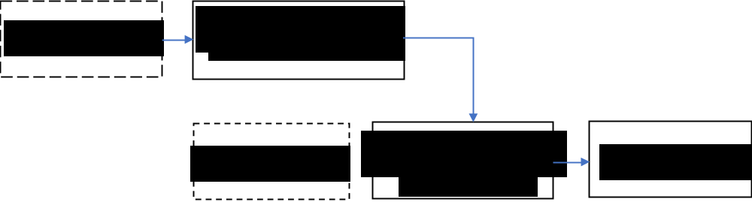
Figure 1-1: Transfer Learning Approach
Underwater image classification became complex challenge there are diverse forms of benthic species. They exhibit several kinds of class variation, complex boundaries, rapid changeable illumination conditions [5]. There are other objects which varies in time by time with the terms of color, texture, size and shape. This naïve category problems creates the classification process of this images a complex task. In recent researches, deep learning methods and approaches are getting highly configured for the classification process of the images. Deep leaning focuses on data transformation in the input level from low-level representation to high level representation. In the newest analysis of object detection in the deep sea or underwater the first stage analysis starts with image classification and in that process deep learning is used as image processing system. There are several classification processes where ConvNet models are used in the research process. In this stage of analysis, the focus remains on clarity of underwater object images, enhancement of images with color distortion fixes and object regional feature extraction. All of this experiment gets applied on ConvNet based models and architectures. In this scenario Transfer Learning term arrives. In order to train a ConvNet architecture with large number of data set, it requires a massive amount of data. On this case for the practical experimental process pretrained network models [6][7] are initialized for classification. The capability of utilizing stored output results on the newest experiment and the output utility transferring process can be summarized as Transfer Learning. It is used for the advantages of training time decreasing on a leaning model which often results in low level generalization error. To implement transfer learning there are several pretrained convolutional neural network models exists such as AlexNet [8], GoogleNet [9], ResNet [10] etc which are pretrained with real life images captured with aquabots and ROVs.

In this research, it will be described and discussed about the usage of Transfer Learning in the case of underwater object image classification. Firstly, the discussion will be based on the Image classification process with an applicable methodology on pretrained models using transfer learning. On the experimental process it will be evaluated that on which ConvNet model Transfer Learning approach gives the best outcome. The comparison on different models will be elaborated too. As per organized flow the paper will be structured as following (i) methodology using Transfer Learning for image classification (ii) Approached experimental method on Pretrained network models which are pretrained with real-life deep-sea object/image data (e.g., Fish, Plankton, Coral lives, Deep Sea objects etc.) (iii) Evaluated output and comparative result (iv) Comparative Performance Evaluation on different models and finally (v) Conclusion with relevant aspects and perspectives.

Chapter 2: Literature Review

In order to complete modern day research background study is a must. Number of researchers conducted so many experiments to provide a better outcome. Following those
studies and to complete the Underwater Object Detection process using machine learning background studies has also been conducted. Also, several reports directed to a path in order to complete this individual research. In the research of Underwater Object Detection using Machine Learning, background studies which are conducted are going to be described below.

Sejin Lee et al [11] has introduced Convolutional Neural Network (CNN) based underwater object classification from sonar images. The authors have chosen this particular imaging sonar among many other perceptual sensors because of its perceptual robustness. In this research the authors mainly focused on capturing best quality images by using simulator using sonar images in the underwater environment so that they can surpass data limitations. After the experiment was processed, it was described that a variant of deep learning methods gets applied to find out underwater images but the level of noise and environmental factors creates too much deviation to extract the expected and required outcome. After synthesizing the images and conducting an experiment with
reserve tank water it validates that the mentioned image synthesizing mimics the process with a solid real underwater image without actual performing dives. In this experiment
when data was captured from the simulator, it was considered to include various rotation, translation and scaling for the training dataset.

Dae-Hyeon Gwon et al [12] developed the Side Scan Sonar Module for Underwater Simulator (UWSim). Underwater simulators are indispensable for underwater engineers as they enable researchers to overcome inadequate data that is encountered during underwater experiments. The researchers have tried to obtain SSS images by using the Lambertian diffusion model. In the proposed system a black-brown-yellow colormap and Rayleigh noise and Speak noise are applied to reflect the physical characteristics of underwater noise. In this research many feature matching methods could not be successful for those sonar images. To overcome this problem, it has referred to an image pre-processing system. For the future implementation, researchers have planned to use a A-KAZE system matching for SSS bundle adjustment (BA). Then the result of SSS BA will be merged to the SLAM framework.

Minsung Sung et al [13] proposed a method by using Generative Adversarial Network which produced realistic sonar images and also the authors have used a ray-tracing algorithm in order to determine semantic information of the investigated scene. At the experimental beginning researchers had built a dataset to train the GAN. They have used indoor water tanks for conducting the experiment later and they process the outcome with a solid definitive result of less noisy ray tracing frequency. The data result outcome was 0.5367 for Cross correlation and SSIM ray tracing outcome was 0.2082. By concluding the experiment, the authors proposed that GAN is a machine learning model which can make a semantic map of a viewed scene from an original sonar image by segmentation applying a ray-tracing algorithm. The conducted research made such an outcome which makes a big impact for pre-processing of sonar images also it helps for the data augmentation of sonar images too.

Hong Liu et al [14] has accomplished research where they proposed a model which is the General Underwater Object Detector (GUOD) using a small underwater dataset with limited types of water quality. First, they introduced a data augmentation method Water Quality Transfer (WQT) to uplift the domain diversity of the original small dataset. Again, a novel model Domain Generalization YOLO (DG-YOLO) is proposed to overcome the challenges a general underwater object detector face. In this paper, it is demonstrated that the performance of DG-YOLO in an unspotted domain that can still not reach a similar level in the observed domains, there is still a lot to investigate in this field.

Keqing Zhu et al [15] conducted an underwater object classification method to solve the problem of insufficient training data by introducing a transfer learning approach. In this paper, an algorithm which is called Grabcut is used to segment the underwater object images and a CNN method is used to pre-trained with a auxiliary simulated dataset. In
this research, the target domain is used as synthetic aperture sonar (SAS) datasets for validation. As a source domain, simulated datasets are used. It provides a reference of some targeted classification problems under the circumstances of insufficient training data.

Avinash M, et al [16] used Tensorflow to train the model and faster R-CNN used as an algorithm of machine learning. For their trained dataset, they got clear feedback that it gave optimal accuracy. Various imputation like dehazing, scattering of light, RGB color fading becomes difficult to object detection. This type of machine learning algorithms and appropriate trained model and datasets can resolve it. In their work they found faster R-CNN most reliable algorithm, according to their paper, it takes 0.2s and training accuracy is almost 97.65%, which is better than the other algorithms like CNN, fast R-CNN, R-CNN.
Ning J, et al [17] have introduced a method where they first converted the image to a binary image. After that they used an OpenCV function to get the ellipse counted. There are two types of algorithms, one is two stages including R-CNN, Fast R-CNN, Faster R-CNN etc. and the other is one stage like YOLO, SSD. CNN type model mainly used for detecting the categories and positions of an object. Two stage models are higher accuracy, but slow in execution and the one stage models are quite opposite to them. According to their experimental data they used YOLOv3 and got much better results in an underwater complex environment than the traditional methods. In the dark underwater, other traditional methods have 75.4% accuracy, whereas YOLOv3 has 92.9%.

Long chen et al [18] addressed few problems and to solve the problems they proposed a deep neural network named Sample-WeIghted hyPEr Network (SWIPENet). Multiple hyper feature maps are used to improve the small object detection. The structure is based on several high resolutions and semantic-rich Hyper Feature Maps inspired by Deconvolutional Single Shot Detector (DSSD), the resolutions of feature maps increase by the multiple up-sampling deconvolution layers. This paper also presented a simple re-weighting algorithm which is Invert Multi-class Adaboost (IMA) for resolving the noise issue. The result of the method achieved a good amount of accuracy, but the time complexity is higher than a single model method. It has M time higher complexity.

Underwater object tracking Rahul M V, et al [19] proposed an approach which used a trained SN and an MNN. The paper demonstrated their proposed algorithm model gives a result which is considerable from the other models. HMM, LK method, twin CNN based model algorithms. Multiple Object Tracking Accuracy (MOTA) of 8.60 with standard deviation of 12.96 can handle this model.

Mostofa Sater et al [20] prepare a model in their paper for classifying objects. The paper has introduced a approach for underwater object classification which has six steps. They also used multi models in the proposed model. Multi-class SVM, KNN, CLBP applied in the paper. 27 models build by combining in each step for getting good amount of accuracy. Paper also describes benefits of using combine model.

Yasuhiro Tan et al [21] propose in his paper an algorithm for automatic detection of underwater objects in side-scan images based on machine learning employing boosting. Side-scan and forward-looking sonars are some of the most widely used imaging systems for obtaining large scale images of the seafloor, and their use continues to expand rapidly with their increased deployment on autonomous underwater vehicles. However, it is difficult to extract quantitative information from the images generated from these processes, particularly for the detection and extraction of information on the objects within these images. The detection of underwater objects using side-scan sonar imagery includes the exploration of wrecks and mapping of rocks on the seafloor.

Shihab Uddin et al [22] The aim of this study is to design an underwater system that is able to detect, recognize and classify objects from underwater images based on the especially need for providing an automatic system for underwater image processing. processing. Many researches had provided classification approaches for underwater classification. Marcos used feed-forward, back propagation neural network for classification, and they used Local Binary Pattern (LBP) as texture descriptor and Normalized Chromaticity Coordinates (NCC) or mean Hue Saturation Value (HSV) as color descriptor. Johnson-Roberson used Support Vector Machine (SVM) to classify both acoustic features and visual features sep-arately with assigned weight which are specified empirically. Shihabuddin used Complete Local Binary Pattern (CLBP), Gray Level Co-occurrence Matrix (GLCM), Ga-bor filter response, opponent angle and hue channel color histograms as feature descriptor. For classification they used either K-Nearest Neighbor (KNN), Support Vector Machine (SVM) or Probability Density Weighted Mean Distance (PDWMD).

Girish Gaude et al[23] The recent developments in underwater image enhancement, Object Tracking, Recognition and Machine Learning a significant and challenging task. Underwater object recognition is a cumbersome due to the change in water structure, seasonal, climatic changes, temperature variation and further degraded by a poor non-uniform source of artificial light. AUVs and ROVs equipped with underwater imaging sensor devices are also used in applications such as the collection of scientific data for monitoring and exploration of underwater resources. Image processing can be utilized to detect the face and object.

Hinton et al [24] proposed learning features using deep neural networks (DNNs) to address these short comings. All the known machine learning approaches especially those
using deep neural network in digital marine data analysis, image annotation, object detection and classification are discussed. They used Fast Region-based Convolutional Neural Network (Fast R-CNN) to detect object efficiently and accurately. The effectiveness, accuracy and robustness of any detection and classification algorithm can be increased significantly if both color and texture-based features are combined. Accumulation of hand-crafted features and neural network may bring better results for seagrass detection and classification. Therefore, the opportunity exists to develop an efficient and effective deep learning approach for underwater seagrass imagery, which will be the focus of our future work.

A.F.M. Saifuddin Saif [25] Focus on his research is a stepping stone of sensing underwater organisms using basic yet robust deep learning mechanism. Underwater Object Detection is one of the most challenging and unexplored domains in this area of Computer Vision. The appropriate answer for underwater object detection appeared to be convolutional Neural Networks (CNN), which are commonly used for computer vision models and classification in complicated situations. Furthermore, underwater imaging in both a static and dynamic environment was studied, and it was shown that item detection in a static environment provided greater accuracy and speed, despite being more difficult to manage in real life. All of this points to the conclusion that the problem described above can be handled using deep learning. Future work should include the development of robust and quick deep learning approaches for dynamic environments that can easily be implemented into an AUV for accurate object detection.

Fenglei Han et al [26] propose to take into account the features of underwater vision, various new image processing algorithms are offered to deal with low contrast and poorly lighted challenges. Because of the low-quality vision and small detection objects, the generally utilized approaches are ineffective for underwater detection. Weak illumination and low-quality picture augmentation are required for underwater vision as a pre-processing technique in an underwater environment. In this study, a combination of the max-RGB approach and the shades of gray method is used to improve underwater vision, and then a CNN (Convolutional Neural Network) method is used to solve the underwater image’s weakly lighted problem.

Mohammed Bennamoun et al [27] deal with all known machine learning algorithms in digital marine data analysis, image annotation, object detection, and classification, with a focus on those that use deep neural networks. For this deep learning they used most of the classification. They conceived and built an inception module with a convolutional layer for picture information extraction distortion minimization and maximization. Their network architecture emphasized better utilization of computational resources within the network. It has been discovered that more work has been done utilizing deep learning for coral detection and classification, but no work has been done for seagrass, which is as important for oceanic ecology.

Mostafa Satea Mohammed al [28] developed a process for this system uses multi-technique for each stage, resulting in 27 models produced by combining one technique from each step. The results of augmentation, segmentation, efficiency features, qualities of the selected classifiers, and dataset characteristics all play a role in underwater object categorization. The goal of this research is to create an underwater system that can recognize and classify things from underwater photos, with a focus on the requirement for an automatic underwater image processing system. Because of its ease of use, KNN is a great tool, and they employed it for this classification.

David P. Williams et al [29] the problem of underwater object categorization, there are two types of transfer learning: target-concept transfer and sensor transfer. For train this huge system, they used the CNN. And for train this CNN system they used SUS data from single sensor and adapting the other SAS information from another sensor. The efficacy of CNNs' transfer learning on MUSCLE data can be used with data from various side-looking sonar systems that operate at other frequency bands and create pictures with varied resolutions.

Naveen Kumar et al [30] developed a system for suggest a strategy for dealing with intra-class object variability in a side scan sonar image for object classification. Because of the great resolution of the sonar image, they used side-scan for this train. They discuss a solution for solving the object categorization problem utilizing sparse representation in this system. Non parametric approaches are a broad category that includes these methods. Because of its widespread use and superior performance, they chose the LASSO algorithm for this strategy.

Chapter 3: Research Methodology

3.1 Dataset
For the experiment we have chosen an open-source dataset from Kaggle [31]. There are around 3.4K images file under five classes in the dataset. It contains image data on Parrotfish, Water environment and terrain, Sargeant major fish, Atlantic tang and Trumpetfish. All the images have many dimensions, we have resized of 100x100. VGG data is augmented by “ImageDataGenerator”. For the training model there are 2504 images and 455 for validation images.

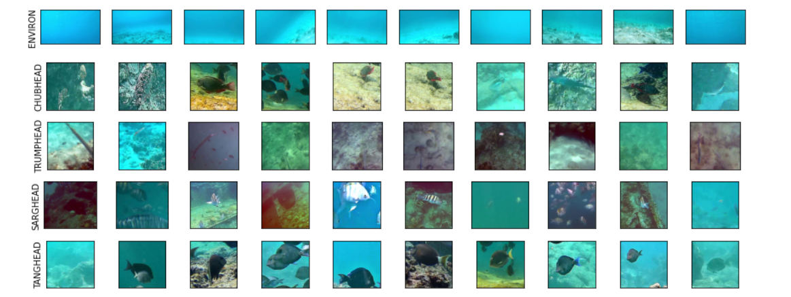
Figure 3-1: Dataset Images (Five Classes)

3.2 Model
3.2.1 VGG16
In this experiment we have used transfer learning and image classification model. We have used ResNet50 and VGG16. These are widely used for image classification. In VGG16, we used ImageNet as weight. When loading the model, the "include top" option can be set to False, which means that the fully-connected output layers of the model is used to generate predictions are not loaded, allowing for the addition and training of a new output layer.
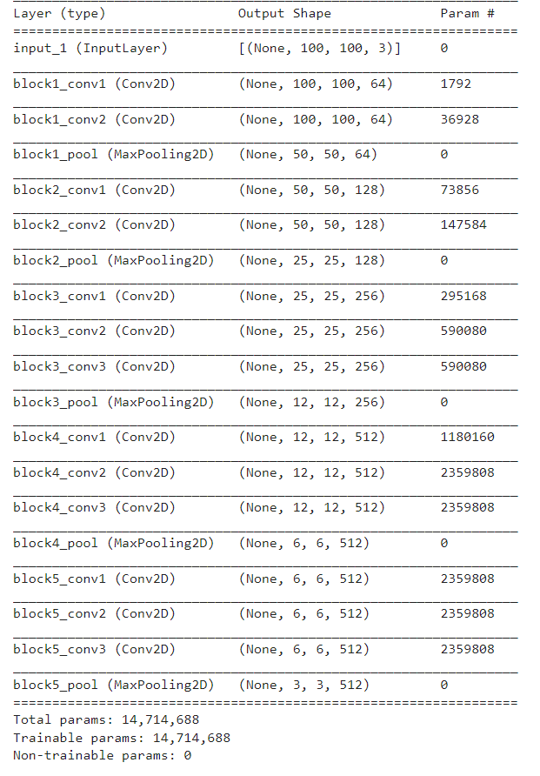
Figure 3-2: Pre Traind Model VGG16
When the “include top” is false to remove the classification layer that was trained on the ImageNet dataset and set the model as not trainable then it can be customized as the demand of the dataset or what the output wants.
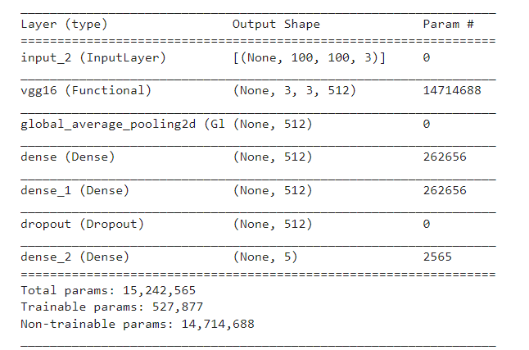
Figure 3-3: Desired output format in the last layer
For pooling layer there “GlobalAveragePooling2D” used. Puling means when a filter given an out of an image those output calculated into a method which is pooling. Here ‘GlobalAveragePooling2D” is used in the experiment.

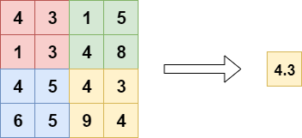

Figure 3-4: GlobalAveragePooling
The rectified linear activation function, or ReLU for short, is a piecewise linear function that, if the input is positive, outputs the input directly; else, it outputs zero. Whereas a model that utilizes it is quicker to train and generally produces higher performance, it has become the default activation function for many types of neural networks.[32]

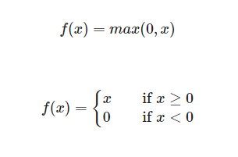
Figure 3-5: ReLU function

In a neural network's output layer, the softmax function is commonly utilized. The softmax function is often used in classification neural networks. The input is claimed as a member of the class by the neuron with the greatest value.
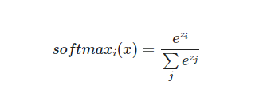
Figure 3-6: Softmax function

After fine-tuning the pre-trained model, learning rate was 1e-4. Tuned to get higher accuracy. Before the output layer there is a dropout layer, which is deleted based on a number that is provided as perimeter. It actually deletes random neurons connection so that the model would not be able to memories the learning. In other word to avoid the overfitting the model it is used.
The dissimilarity between the distribution of observed class labels and the expected probability of class membership is measured using cross entropy, a loss function. The option of having more than two classes is referred to as categorical. That’s why we used “sparse categorical crossentropy” as loss function.

3.2.2 ResNet50 Model
The second model that we have used in this experiment it is ResNet50. Building the model, we have used pretrained model ResNet50 called as pre-processed input. Data augmentation also done by ImageDataGenerator function. In ResNet50 model like VGG16 “ImageNet” weights is used.
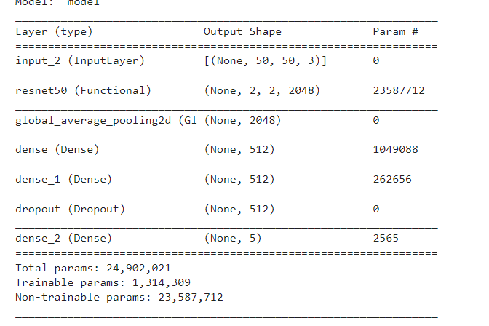
Figure 3-7: ResNet50 model
Other functions and perameters are same as pervious model. The main difference of the two model is in the layer archetucture. VGG has a sequence input to output. But in the ResNet model it is not followed. In ResNet update the weight it used backpropragation. One more thing which is made ResNet different from VGG that it has skip connection.

Chapter 4: Experimental Result

For this experimental procedure both physical hardware device and online platform “Kaggle”. The models were running several times in online. For the resource limitation it is ran with the Kaggle with the image size 224x224 but in the physical device it is 50x50. For GPU in physical device, it is Nvidia RTX 2060, in Kaggle online Tesla GPU found.
4.1 Results
According to the two model experiments, the following results have been achieved over the Dataset.
Name of Model | Train Accuracy | Train  Loss | Validation Accuracy | Validation Loss | Test Accuracy | Test Loss
ResNet50 | 95.47% | 0.11% | 90.23% | 0.30% | 94.11% | 0.29%
VGG16 | 91.21% | 0.23% | 89.84% | 0.37% | 88.24% | 0.57%
Table 4-A: Result of two model
The timings of each experiment, documenting each phase of the training process, are listed in the table below:
Name of Mode | Epoch | Loss | Accuracy
ResNet50 | [1/50] | 1.513 | 37.70
ResNet50 | [2/50] | 0.855 | 68.21
ResNet50 | [3/50] | 0.612 | 79.69
ResNet50 | [4/50] | 0.519 | 80.91
ResNet50 | [5/50] | 0.446 | 83.48
ResNet50 | [6/50] | 0.395 | 85.92
ResNet50 | [7/50] | 0.366 | 86.90
ResNet50 | [8/50] | 0.342 | 87.74
ResNet50 | [9/50] | 0.324 | 88.06
ResNet50 | [10/50] | 0.311 | 88.37
ResNet50 | Continue | Continue | Continue
ResNet50 | [21/50] | 0.198 | 91.74
ResNet50 | [22/50] | 0.209 | 92.90
ResNet50 | [23/50] | 0.184 | 93.21
ResNet50 | [24/50] | 0.196 | 92.90
ResNet50 | [25/50] | 0.186 | 92.32
ResNet50 | [26/50] | 0.178 | 93.03
ResNet50 | [27/50] | 0.170 | 93.53
ResNet50 | [28/50] | 0.183 | 92.98
ResNet50 | [29/50] | 0.180 | 93.43
ResNet50 | [30/50] | 0.173 | 92.72
ResNet50 | Continue | Continue | Continue
ResNet50 | [40/50] | 0.140 | 94.85
ResNet50 | [41/50] | 0.143 | 94.76
ResNet50 | [42/50] | 0.138 | 94.45
ResNet50 | [43/50] | 0.151 | 94.54
ResNet50 | [44/50] | 0.132 | 94.89
ResNet50 | [45/50] | 0.136 | 95.03
ResNet50 | [46/50] | 0.38 | 95.07
ResNet50 | [47/50] | 0.127 | 94.98
ResNet50 | [48/50] | 0.134 | 95.38
ResNet50 | [49/50] | 0.127 | 95.65
ResNet50 | [50/50] | 0.119 | 95.47
Table 4-B: Training Steps with loss and accuracy for ResNet50
Name of Mode | Epoch | Loss | Accuracy
VGG16 | [1/50] | 4.381 | 23.85
VGG16 | [2/50] | 2.276 | 45.38
VGG16 | [3/50] | 1.556 | 59.95
VGG16 | [4/50] | 1.244 | 67.85
VGG16 | [5/50] | 1.071 | 71.27
VGG16 | [6/50] | 0.958 | 74.29
VGG16 | [7/50] | 0.821 | 76.33
VGG16 | [8/50] | 0.747 | 77.44
VGG16 | [9/50] | 0.649 | 79.04
VGG16 | [10/50] | 0.643 | 79.84
VGG16 | Continue | Continue | Continue
VGG16 | [21/50] | 0.397 | 86.72
VGG16 | [22/50] | 0.399 | 86.32
VGG16 | [23/50] | 0.402 | 86.68
VGG16 | [24/50] | 0.397 | 86.46
VGG16 | [25/50] | 0.364 | 87.57
VGG16 | [26/50] | 0.369 | 87.03
VGG16 | [27/50] | 0.368 | 87.26
VGG16 | [28/50] | 0.334 | 87.92
VGG16 | [29/50] | 0.341 | 88.32
VGG16 | [30/50] | 0.339 | 88.50
VGG16 | Continue | Continue | Continue
VGG16 | [40/50] | 0.283 | 89.25
VGG16 | [41/50] | 0.289 | 89.65
VGG16 | [42/50] | 0.272 | 90.32
VGG16 | [43/50] | 0.264 | 89.79
VGG16 | [44/50] | 0.268 | 90.76
VGG16 | [45/50] | 0.274 | 90.41
VGG16 | [46/50] | 0.263 | 90.63
VGG16 | [47/50] | 0.242 | 91.21
VGG16 | [48/50] | 0.251 | 91.21
VGG16 | [49/50] | 0.229 | 91.61
VGG16 | [50/50] | 0.231 | 91.21

Table 4-C: Training Steps with loss and accuracy for VGG16
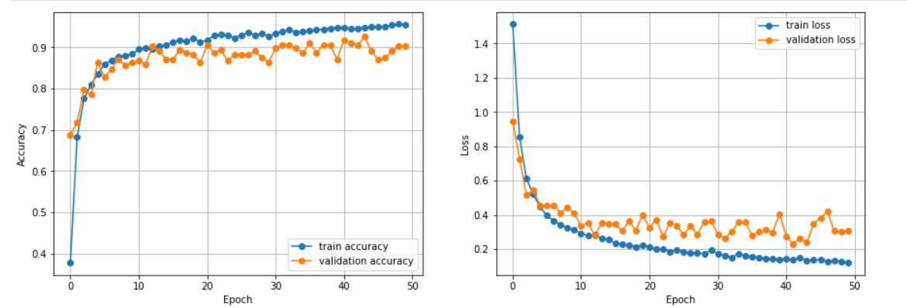
Figure 4-1: ResNet50 Result Graph
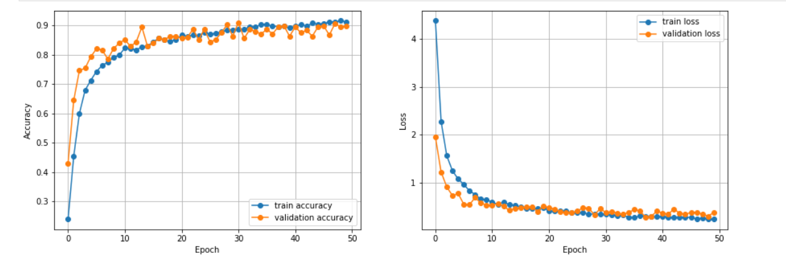
Figure 4-2: VGG16 Result Graph
Chapter 5: Discussion

In this paper, recent approaches for detecting the underwater object classification and classifying underwater objects using deep learning are discussed. In object image visualization, we proposed an underwater object classification method and attempted to detect the object in low and high water. The goal of image classification is to categorize photographs into thematic groups. To achieve detection and classification, we used a model of image categorization and transfer learning. ResNet50 and VGG16 were employed. Our paper's effectiveness and correctness meet the criteria for acceptance. The proposed method is appropriate for our underwater find the objects dataset, but it is not superior to traditional methods for other datasets.

Chapter 6: Conclusion

This study provides a fully automatic underwater object classification system with multi-model, this system uses multi-technique for each Step. It will focus on well performance of the proposed method for image or object classification. In this research, underwater object or image classification will be analysed and discussed where Transfer Learning with Deep Learning methods will be used for the classification results. Underwater object classification depends on the results of enhancement, segmentation, efficiency features, attributes of the selected classifiers and the characteristics of the dataset. The future work could be an underwater object classification that is able to deal with multi-object in the same image and/or overlapped objects.

References

[1] Lillesand T, Kiefer RW, Chipman J. Remote sensing and image interpretation. John Wiley & Sons; 2014.

[2] He K, Zhang X, Ren S, Sun J. Deep residual learning for image recognition. In proceedings of the conference on computer vision and pattern recognition 2016 (pp. 770-8). IEEE.

[3] Liu PH, Su SF, Chen MC, Hsiao CC. Deep learning and its application to general image classification. In informative and cybernetics for computational social systems (ICCSS), International Conference on 2015 (pp. 7-10). IEEE.

[4] He K, Sun J. Convolutional neural networks at constrained time cost. In conference on computer vision and pattern recognition 2015(pp. 5353-60). IEEE

[5] O. Beijbom, P.J. Edmunds, D. Kline, B. G. Mitchell, D. Kreigman et al. “Automated annotation of coral reef survey images,” in 2012 IEEE Conference on Computer Vision and Pattern Recognition (CVPR), pp. 1170-1177, IEEE, 2012

[6] Li, X., Shang, M., Qin, H., Chen, L.: Fast accurate fish detection
and recognition of underwater images with fast r-cnn. In: OCEANS’15 MTS/IEEE Washington, pp. 1-5. IEEE. (2015, October)

[7] Choi, S. Fish Identification in Underwater Video with Deep Convolutional Neural Network: SNU Medinfo at Life CLEF Fish task 2015. In CLEF (Working Notes). (2015)

[8] Krizhevsky, A., Sutskever, I., Hinton, G. E.: Imagenet classification with deep convolutional neural networks. In: Advances in neural information processing systems, pp. 1097-1105. (2012)

[9] Szegedy, C., Liu, W., Jia, Y., Sermanet, P., Reed, S., Anguelov, D.,Rabinovich, A.: Going deeper with convolutions. In: Proceedings of the IEEE conference on computer vision and pattern recognition, pp. 1-9. (2015)

[10] He, K., Zhang, X., Ren, S., Sun, J.: Deep residual learning for image recognition. In: Proceedings of the IEEE conference on computer vision and pattern recognition, pp. 770-778. (2016)

[11] Sejin Lee1 and Byungjae Park2 and Ayoung Kim3, “Deep Learning from Shallow Dives: Sonar Image Generation and Training for Underwater Object Detection”, arXiv:1810.07990v1.

[12] Dae-Hyeon Gwon1, Joowan Kim2, Moon Hwan Kim3, Ho Gyu Park4, Tae Yeong Kim5, Ayoung Kim, “Development of a Side Scan Sonar Module for the UnderWater Simulator”, doi:10.1109/URAI.2017.7992789 .

[13] Minsung Sung, Jason Kim, Meungsuk Lee, Byeongjin Kim, Taesik Kim, Juhwan Kim, and Son-Cheol Yu*, “Realistic Sonar Image Simulation Using Deep Learning for Underwater Object Detection”, doi.org/10.1007/s12555-019-0691-3.

[14] Hong Liu1,2, Pinhao Song1,2, Runwei Ding1,2*, “Toward Domain Generalization In Underwater Object Detection”, doi:10.1109/icip40778.2020.9191364.

[15] Keqing Zhu, Jie Tian*, Haining Huang*, “ Underwater object Images Classification Based on Convolutional Neural Network”, doi:10.1109/SIPROCESS.2018.8600472.

[16] Avinash M, Ritika K, Sneha M, “Underwater Object Detection using Tensorflow”, ITM Web Conference 32, ICACC-2020

[17] Ning J, Jinkel W, Linghui K, Shu Z, Junya D, “Optimization of Underwater Marker Detection Based on YOLOv3”. International Conference on Identification, Information and Knowledge in the internet of Things, 2020. Procedia Computer Science 187 (2021) 52–59

[18] Long C, Zhihhuha L, Lei T, Zheheng J, Shengke W, Junyu D, Huiyu Z, “Underwater object detection using Invert Multi-Class Adaboost with deep learning”. 2020 International Joint Conference on Neural Networks (IJCNN)

[19] Rahul M V, Revanur Ambareesh and Shobha G, “Siamese Network for Underwater Multiple Object Tracking”, ICMLC2017 ACM ICBN 978- 1-4503-4817-1/17/02.

[20] Mostafa Satea Mohammed, Hatem Awad Khater
Yasser Fouad Hassan and Ashraf Elsayed, “Proposed Approach For Automatic Underwater Object Classification” ICIC International, Volume 12, Number 12, December 2018

[21] Yasuhiro Tan, Joo Kooi Tan,Hyoungseop Kim,Seiji Ishikawa,”Detection of Underwater Objects Based on Machine Learning”,SICE Annual Conference

[22] Md. Moniruzzaman1, Syed Mohammed Shamsul Islam1,2(),Mohammed Bennamoun2, and Paul Lavery1” Deep Learning on Underwater Marine Object Detection: A Survey”,Springer International Publishing AG 2017J. Blanc-Talon et al. (Eds.): ACIVS 2017, LNCS 10617, pp. 150–160, 2017.

[23] Girish Gaude1*, Samarth Borkar2,”Comprehensive Survey on Underwater Object Detection and Tracking”,23/Nov/2018, Published: 30/Nov/2018
[24] Mostafa Satea Mohammed1, Hatem Awad Khater1, Yasser Fouad Hassan1 and Ashraf Elsayed1,2,”PROPOSED APPROACH FOR AUTOMATIC UNDERWATER OBJECT CLASSIFICATION”,ICIC Express Letters ICIC International c 2018 ISSN 1881-803X Volume 12, Number 12, December 2018

[25] Dipta Gomes,A.F.M. Saifuddin Saif,”Robust Underwater Fish Detection Using anEnhanced Convolutional Neural Network”,I.J. Image, Graphics and Signal Processing, 2021, 3, 44-54Published Online June 2021 in MECS

[26] Fenglei Han, Jingzheng Yao , Haitao Zhu, and Chunhui Wang,“ Underwater Image Processing and Object Detection Based on Deep CNN Method”,Received 18 January 2020; Revised 17 February 2020; Accepted 6 May 2020; Published 22 May 2020.

[27] Md Moniruzzaman, Syed Mohammed Shamsul Islam, Mohammed Bennamoun,
Paul Lavery, “ Deep Learning on Underwater Marine Object Detection”, Published November 2017/ DOI: 10.1007/978-3-319-70353- 4-13.

[28] Mostafa Satea Mohammed,Hatem Awad Khater, Yasser Fouad Hassan, “PROPOSED APPROACH FOR AUTOMATIC UNDERWATER OBJECT CLASSIFICATION”, Published Number 12, December 2018, DOI: 10.24507/icicel.12.12.1205 .

[29] David P. Williams, “CONVOLUTIONAL NEURAL NETWORK TRANSFER LEARNING FOR UNDERWATER OBJECT CLASSIFICATION”, Published NATO STO CMRE, La Spezia, Italy.

[30] Naveen Kumar, Qun Feng Tan, Shrikanth S. Narayanan∗, “OBJECT CLASSIFICATION IN SIDESCAN SONAR IMAGES WITH SPARSE REPRESENTATION TECHNIQUES”, Published 978-1-4673-0046-9/12/$26.00 ©2012 IEEE.

[31] https://www.kaggle.com/hiyaro/bluenetpenta

[32] Teh, Yee & Hinton, Geoffrey. (2001). Rate-coded Restricted Boltzmann Machines for Face Recognition. 13.

