1. PROGRAM TO WRITE THE FIRST 10 NUMBERS.

ANS:- for ( let i=0; i <10; i++) {

Console.log(i);

}

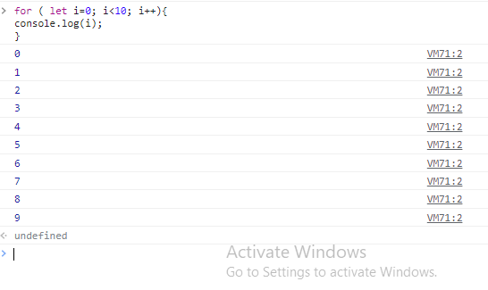

1. PROGRAM TO CALCULATE THE SUM OF FIRST 10 NUMBERS.

ANS:- let i, sum=0;

for (let i=0; i<10; i++){

sum=sum+i;}

console.log(sum);

Or,

let i, sum=0;

for (let i=0; i<10; i++){

sum=sum+i;

console.log(sum);}

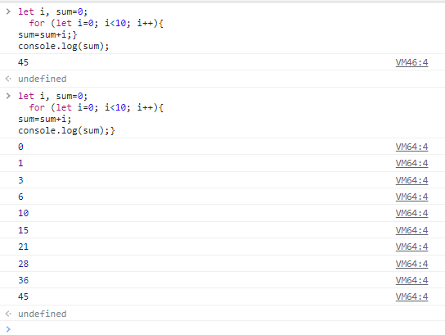

3.MAKE THE LOOP STOP WHEN i IS 5 .

ANS:- for(let i=0; i<10; i++ ){

console.log(i);

if(i==5) {break;}

}

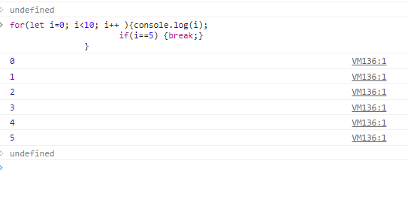

4.WRITE A PROGRAM TO PRINT DAY OF WEEK NAME USING SWITCH CASE.

ANS:- number=7

switch(number){

Case 0: print( “sunday’’)

Break;

Case 1: print (‘‘monday’’)

Break;

Case 2: print (‘’tuesday’’)

Break;

Case 3: print (“wednesday”)

Break;

Case 4: print (“thursday”)

Break;

Case 5: print (“friday”)

Break;

Case 6: print (‘saturday’)

Break;

Default : print ‘number is invalid’

Break;

}

5.WRITE A PROGRAM PRINT TOTAL NUMBER OF DAYS OF IN A MONTH USING SWITCH CASE.

ANS:-

month =12

Switch(month){

case 1:

print("31 days");

break;

case 2:

print("28/29 days");

break;

case 3:

print("31 days");

break;

case 4:

print("30 days");

break;

case 5:

print("31 days");

break;

case 6:

print("30 days");

break;

case 7:

print("31 days");

break;

case 8:

print("31 days");

break;

case 9:

print("30 days");

break;

case 10:

print("31 days");

break;

case 11:

print("30 days");

break;

case 12:

print("31 days");

break;

default:

print("Invalid input! Please enter month number between 1-12");

}